PRACTICAL-2

AIM : Develop static HTML5 skeletons for at least 10 StudentHub pages such as Home, About, Register, Login, Dashboard, Events, Profile, Contact, Admin, FAQ, and Feedback. Use semantic tags and accessibility-friendly structure.

INDEX.HTML :

<!DOCTYPE html>
<html lang="en">
<head>
<meta charset="UTF-8">
<meta name="viewport" content="width=device-width, initial-scale=1.0">
<title>StudentHub</title>

</head>
<body>
<header class="pagelist">
<img src="./studenthub.png" class="studenthub" alt="StudentHub Logo">
<h1>Welcome to StudentHub</h1>
<nav>
<a href="./login.html">Login</a>
<a href="./signup.html">Sign Up</a>
</nav>
</header>

<main>
<p>Your one-stop portal for attendance, timetables, fees, announcements, assignments, and more.</p>
</main>

<footer>
<p>&copy; 2026 Student Hub Portal</p>
</footer>
</body>
</html>

PREVIEW:

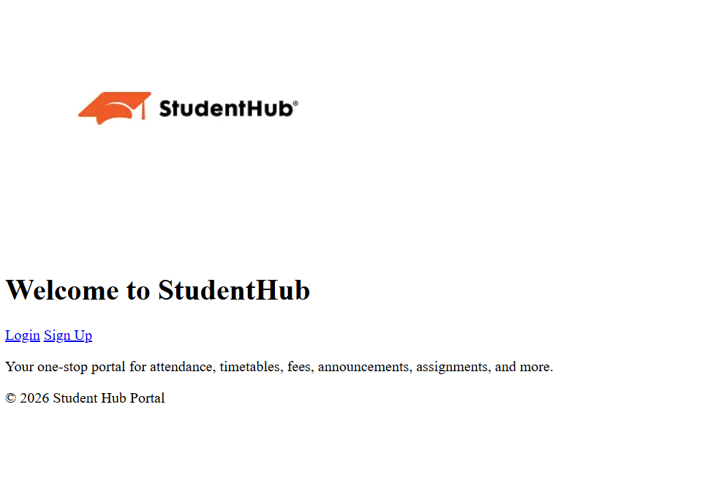

LOGIN.HTML :
<!DOCTYPE html>
<html lang="en">
<head>
<meta charset="UTF-8">
<meta name="viewport" content="width=device-width, initial-scale=1.0">
<title>Login - Student Hub Portal</title>
</head>
<body>
<header>
<h1>Student Hub Portal</h1>
</header>

<main>
<div class="auth-container">
<h2>Login</h2>
<form action="./home.html" method="post">

<label for="username">Username:</label>
<input type="text" id="username" name="username" required><br><br>

<label for="password">Password:</label>
<input type="password" id="password" name="password" required><br><br>

<label>
<input type="checkbox" name="remember"> Remember Me
</label><br><br>

<input type="submit" value="Login">
</form>
<div class="auth-links">
<p><a href="./signup.html">Don't have an account? Sign up here</a></p>
<p><a href="./forgot-password.html">Forgot Password?</a></p>
</div>
</div>
</main>

<footer>
<p>&copy; 2026 Student Hub Portal</p>
</footer>
</body>
</html>

PREVIEW :
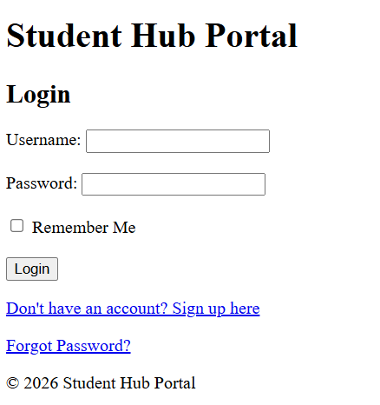

SIGN-UP.HTML :
<!DOCTYPE html>
<html lang="en">
<head>
<meta charset="UTF-8">
<meta name="viewport" content="width=device-width, initial-scale=1.0">
<title>Sign Up - Student Hub Portal</title>
<!-- <link rel="stylesheet" type="text/css" href="class.css"> -->
</head>
<body>
<header>
<h1>Student Hub Portal</h1>
</header>

<main>
<div class="auth-container">
<h2>Create Your Account</h2>
<form action="./home.html" method="post">
<fieldset>
<legend>Sign Up</legend>

<label for="username">Username:</label>
<input type="text" id="username" name="username" required><br><br>

<label for="email">Email:</label>
<input type="email" id="email" name="email" required><br><br>

<label for="password">Password:</label>
<input type="password" id="password" name="password" required autocomplete="new-password"><br><br>

<label for="confirm-password">Confirm Password:</label>
<input type="password" id="confirm-password" name="confirm-password" required><br><br>

<input type="submit" value="Sign Up">
</fieldset>
</form>
<div class="auth-links">
<p><a href="./login.html">Already have an account? Login here</a></p>
</div>
</div>
</main>

<footer>
<p>&copy; 2026 Student Hub Portal</p>
</footer>
</body>
</html>

PREVIEW :

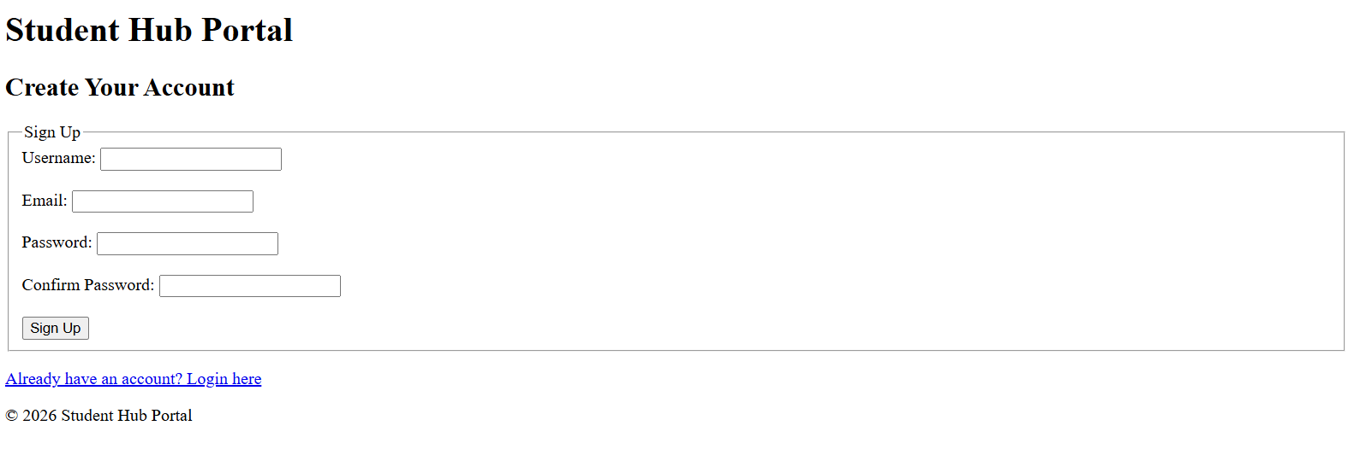

HOME :
<!DOCTYPE html>
<html lang="en">
<head>
<meta charset="UTF-8">
<meta name="viewport" content="width=device-width, initial-scale=1.0">
<title>Home - Student Hub Portal</title>
</head>
<body>
<header>
<h1>Student Hub Portal</h1>
<nav>

<a href="./profile.html">Profile</a>
<a href="./dashboard.html">Dashboard</a>
<a href="./contact.html">Contact Us</a>
<a href="./aboutus.html">About Us</a>
<a href="./settings.html">Settings</a>
<a href="./index.html">Logout</a>

</nav>
</header>

<main>
<h2>Welcome</h2>
<p>Select an option from the navigation menu to access your academic information.</p>
</main>

<footer>
<p>&copy; 2026 Student Hub Portal</p>
</footer>
</body>
</html>

PREVIEW:
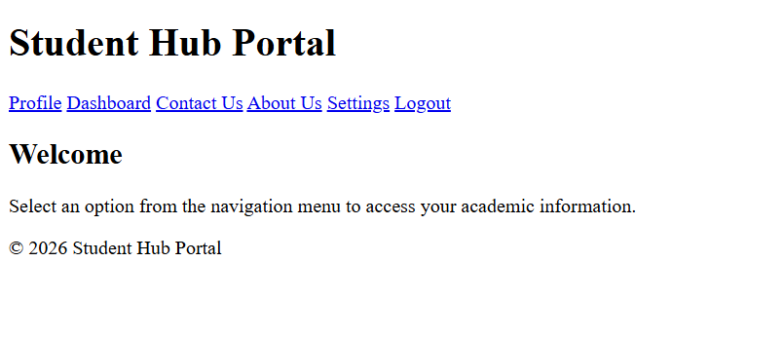
PROFILE.HTML :
<!DOCTYPE html>
<html lang="en">
<head>
<meta charset="UTF-8">
<meta name="viewport" content="width=device-width, initial-scale=1.0">
<title>Profile - Student Hub Portal</title>
</head>
<body>
<header>
<h1>Student Hub Portal</h1>
<nav>
<a href="./home.html">Home</a>
<a href="./dashboard.html">Dashboard</a>
<a href="./contact.html">Contact Us</a>
<a href="./settings.html">Settings</a>
<a href="./index.html">Logout</a>
</nav>
</header>

<main>
<h2>My Profile</h2>
<section class="profile-info">
<img src="./default-profile.png" alt="Profile Picture" class="profile-pic">
<p><strong>Name:</strong> AARAV HITESHKUMAR PATEL</p>
<p><strong>Roll Number:</strong> 25DCE072</p>
<p><strong>Course:</strong> B.Tech Computer Engineering</p>
<p><strong>Semester:</strong> 3</p>
<p><strong>Email:</strong> 25dce072@charusat.edu.in</p>
<p><strong>Phone:</strong> +91 84xxxxxx09</p>
</section>

<section class="academic-summary">
<h3>Academic Summary</h3>
<p><strong>Attendance:</strong> 85%</p>
<p><strong>Fees Status:</strong> Paid</p>
<p><strong>Latest Exam Result:</strong> SGPA 8.2</p>
</section>

<button onclick="window.location.href='./edit-profile.html'">Edit Profile</button>
</main>

<footer>
<p>&copy; 2026 Student Hub Portal</p>
</footer>
</body>
</html>

PREVIEW :

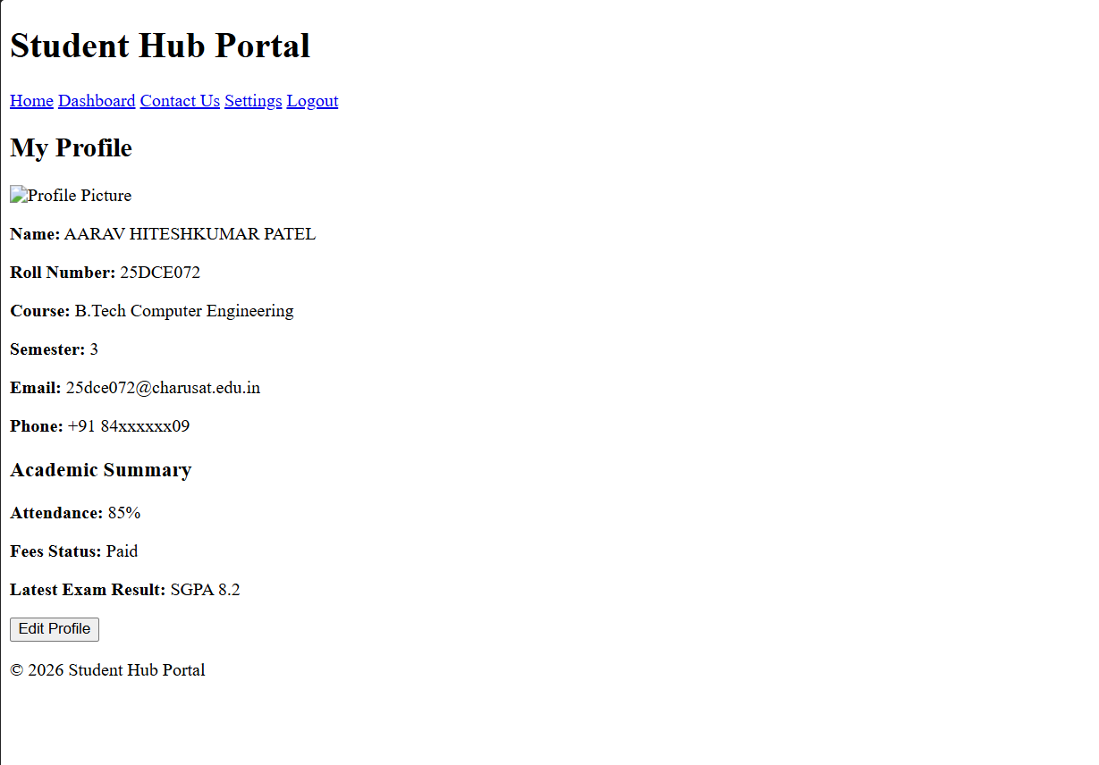

DASHBOARD.HTML :

<!DOCTYPE html>
<html lang="en">
<head>
<meta charset="UTF-8">
<meta name="viewport" content="width=device-width, initial-scale=1.0">
<title>Dashboard - Student Hub Portal</title>
</head>
<body>
<header>
<h1>Student Hub Portal</h1>
<nav>
<a href="./home.html">Home</a>
<a href="./profile.html">Profile</a>
<a href="./contact.html">Contact Us</a>
<a href="./settings.html">Settings</a>
<a href="./index.html">Logout</a>
</nav>
</header>

<main>
<h2>Welcome, [Student Name]</h2>
<section class="dashboard-cards">
<div class="card"><a href="./attendance.html">Attendance</a></div>
<div class="card"><a href="./timetable.html">Timetable</a></div>
<div class="card"><a href="./fees.html">Fees</a></div>
<div class="card"><a href="./announcement.html">Announcements</a></div>
<div class="card"><a href="./assignment.html">Assignments</a></div>
<div class="card"><a href="./exam.html">Exams</a></div>
</section>

<section class="notifications">
<h3>Latest Announcements</h3>
<ul>
<li>Exam schedule released for Semester 4</li>
<li>Assignment submission deadline: July 25</li>
</ul>
</section>
</main>

<footer>
<p>&copy; 2026 Student Hub Portal</p>
</footer>
</body>
</html>

PREVIEW :
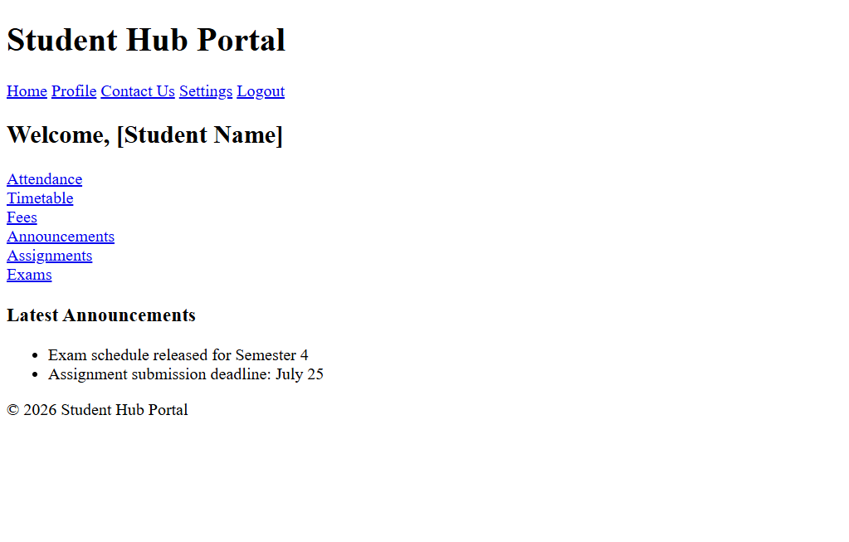

ATTENDANCE.HTML :
<!DOCTYPE html>
<html lang="en">
<head>
<meta charset="UTF-8">
<meta name="viewport" content="width=device-width, initial-scale=1.0">
<title>Attendance - Student Hub Portal</title>
</head>
<body>
<header>
<h1>Student Hub Portal</h1>
<nav>
<a href="./home.html">Home</a>
<a href="./dashboard.html">Dashboard</a>
<a href="./profile.html">Profile</a>
<a href="./contact.html">Contact Us</a>
<a href="./settings.html">Settings</a>
<a href="./index.html">Logout</a>
</nav>
</header>

<main>
<h2>Attendance Record</h2>
<section class="attendance-summary">
<p><strong>Overall Attendance:</strong> 85%</p>
<div class="progress-bar">
<div class="progress" style="width:85%"></div>
</div>
</section>

<section class="attendance-details">
<h3>Subject-wise Attendance</h3>
<table>
<thead>
<tr>
<th>Subject</th>
<th>Total Classes</th>
<th>Attended</th>
<th>Percentage</th>
</tr>
</thead>
<tbody>
<tr>
<td>Web Development</td>
<td>40</td>
<td>34</td>
<td>85%</td>
</tr>
<tr>
<td>Data Structures</td>
<td>35</td>
<td>30</td>
<td>86%</td>
</tr>
<tr>
<td>Database Management</td>
<td>28</td>
<td>24</td>
<td>85%</td>
</tr>
<tr>
<td>Operating Systems</td>
<td>32</td>
<td>26</td>
<td>81%</td>
</tr>
<tr>
<td>Computer Networks</td>
<td>30</td>
<td>27</td>
<td>90%</td>
</tr>
</tbody>
</table>
</section>
</main>

<footer>
<p>&copy; 2026 Student Hub Portal. All rights reserved.</p>
</footer>
</body>
</html>

PREVIEW :
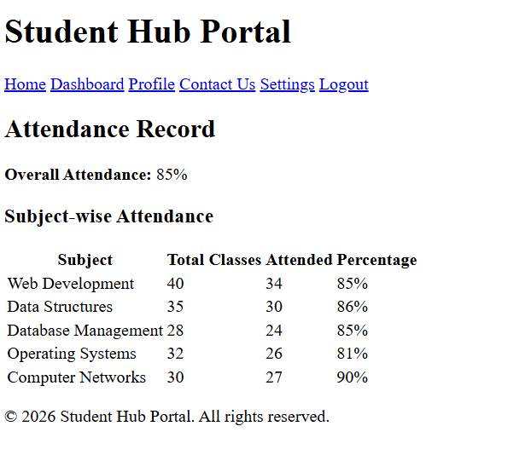
TIMETABLE.HTML :
<!DOCTYPE html>
<html lang="en">
<head>
<meta charset="UTF-8">
<meta name="viewport" content="width=device-width, initial-scale=1.0">
<title>Timetable - Student Hub Portal</title>
</head>
<body>
<header>
<h1>Student Hub Portal</h1>
<nav>
<a href="./home.html">Home</a>
<a href="./dashboard.html">Dashboard</a>
<a href="./profile.html">Profile</a>
<a href="./contact.html">Contact Us</a>
<a href="./settings.html">Settings</a>
<a href="./index.html">Logout</a>
</nav>
</header>

<main>
<h2>Weekly Timetable</h2>
<table class="timetable">
<thead>
<tr>
<th>Day</th>
<th>9:00 - 10:00</th>
<th>10:00 - 11:00</th>
<th>11:00 - 12:00</th>
<th>1:00 - 2:00</th>
<th>2:00 - 3:00</th>
</tr>
</thead>
<tbody>
<tr>
<td>Monday</td>
<td>Web Development</td>
<td>Data Structures</td>
<td>Database Systems</td>
<td>Maths</td>
<td>Elective</td>
</tr>
<tr>
<td>Tuesday</td>
<td>Operating Systems</td>
<td>Computer Networks</td>
<td>Web Development</td>
<td>Elective</td>
<td>Maths</td>
</tr>
<tr>
<td>Wednesday</td>
<td>Data Structures</td>
<td>Database Systems</td>
<td>Operating Systems</td>
<td>Computer Networks</td>
<td>Elective</td>
</tr>
<tr>
<td>Thursday</td>
<td>Web Development</td>
<td>Maths</td>
<td>Database Systems</td>
<td>Operating Systems</td>
<td>Computer Networks</td>
</tr>
<tr>
<td>Friday</td>
<td>Elective</td>
<td>Web Development</td>
<td>Data Structures</td>
<td>Database Systems</td>
<td>Maths</td>
</tr>
<tr>
<td>Saturday</td>
<td>Computer Networks</td>
<td>Operating Systems</td>
<td>Elective</td>
<td>Web Development</td>
<td>Seminar</td>
</tr>
</tbody>
</table>
</main>

<footer>
<p>&copy; 2026 Student Hub Portal. All rights reserved.</p>
</footer>
</body>
</html>

PREVIEW :
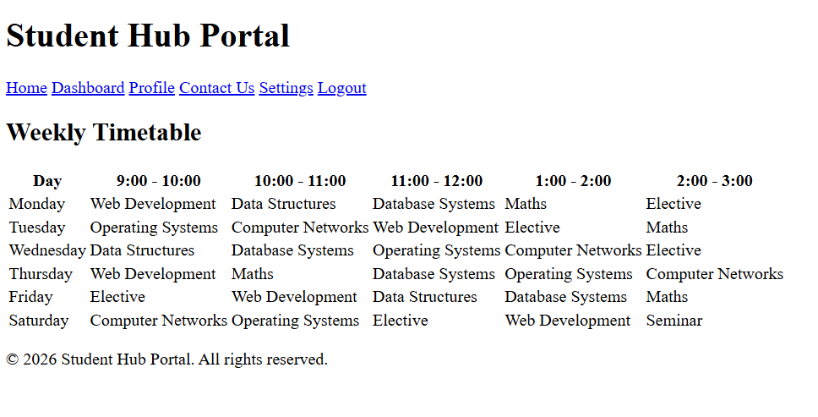
FEES.HTML :

<!DOCTYPE html>
<html lang="en">
<head>
<meta charset="UTF-8">
<meta name="viewport" content="width=device-width, initial-scale=1.0">
<title>Fees - Student Hub Portal</title>
</head>
<body>
<header>
<h1>Student Hub Portal</h1>
<nav>
<a href="./home.html">Home</a>
<a href="./dashboard.html">Dashboard</a>
<a href="./profile.html">Profile</a>
<a href="./contact.html">Contact Us</a>
<a href="./settings.html">Settings</a>
<a href="./index.html">Logout</a>
</nav>
</header>

<main>
<h2>Fees Details</h2>
<section class="fees-summary">
<p><strong>Total Fees:</strong> ₹70,000</p>
<p><strong>Paid:</strong> ₹40,000</p>
<p><strong>Balance:</strong> ₹30,000</p>
<p><strong>Next Due Date:</strong> 30 August 2026</p>
</section>

<section class="payment-history">
<h3>Payment History</h3>
<table>
<thead>
<tr>
<th>Date</th>
<th>Amount</th>
<th>Mode</th>
<th>Status</th>
</tr>
</thead>
<tbody>
<tr>
<td>01 Jan 2026</td>
<td>₹40,000</td>
<td>Online</td>
<td>Paid</td>
</tr>
<tr>
<td>30 Aug 2026</td>
<td>₹30,000</td>
<td>Offline</td>
<td>Due</td>
</tr>
</tbody>
</table>
</section>
</main>

<footer>
<p>&copy; 2026 Student Hub Portal. All rights reserved.</p>
</footer>
</body>
</html>

PREVIEW :
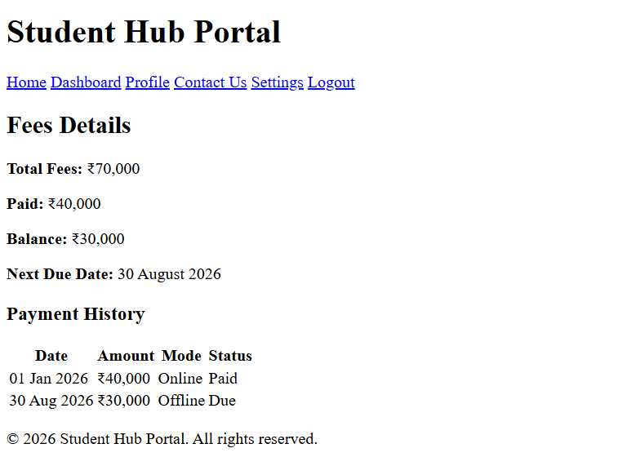

ANNOUNCEMENT.HTML :
<!DOCTYPE html>
<html lang="en">
<head>
<meta charset="UTF-8">
<meta name="viewport" content="width=device-width, initial-scale=1.0">
<title>Announcements</title>

</head>
<body>

<header>
<h1>Student Hub Portal</h1>
<nav>
<a href="./home.html">Home</a>
<a href="./dashboard.html">Dashboard</a>
<a href="./profile.html">Profile</a>
<a href="./contact.html">Contact Us</a>
<a href="./settings.html">Settings</a>
<a href="./index.html">Logout</a>
</nav>
</header>
<div class="auth messanger">
<h2>Announcements</h2>
<div class="announcement-box">
<h3>Announcement 1</h3>
<p>This is first announcement.</p>
</div>
<div class="announcement-box">
<h3>Announcement 2</h3>
<p>This is second announcement.</p>
</div>
<div class="announcement-box">
<h3>Announcement 3</h3>
<p>This is third announcement.</p>
</div>
<div class="announcement-box">
<h3>Announcement 4</h3>
<p>This is fourth announcement.</p>
</div>
</div>
<footer>
<h2>Contact Us</h2>
<p>You can reach us at:
<a href="mailto:25dce072@charusat.edu.in">25dce072@charusat.edu.in</a>
</p>
</footer>
</body>
</html>

PREVIEW :
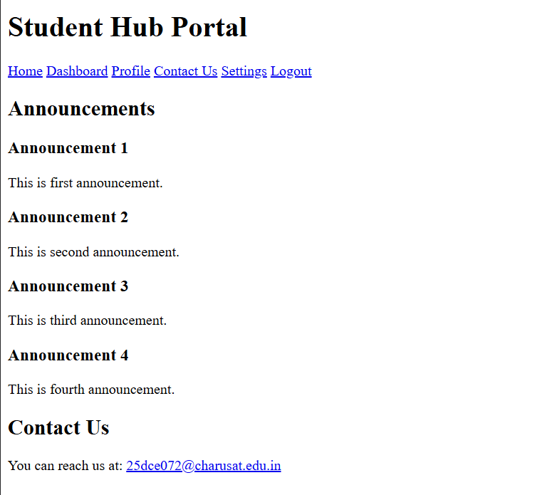
ASSIGNMENTS.HTML :
<!DOCTYPE html>
<html lang="en">
<head>
<meta charset="UTF-8">
<meta name="viewport" content="width=device-width, initial-scale=1.0">
<title>Assignment</title>
</head>
<body>
<header>
<h1>Student Hub Portal</h1>
<nav>
<a href="./home.html">Home</a>
<a href="./dashboard.html">Dashboard</a>
<a href="./profile.html">Profile</a>
<a href="./contact.html">Contact Us</a>
<a href="./settings.html">Settings</a>
<a href="./index.html">Logout</a>
</nav>
</header>
<div class="content">
<h1>Welcome to My Assignment</h1>
<p>This is a sample webpage created for practice. It includes basic HTML elements styled with CSS.</p>

<h2>Topics Covered</h2>
<ul>
<li>HTML Structure</li>
<li>CSS Styling</li>
<li>Lists and Buttons</li>
</ul>

<button>Click Me</button>
</div>
<footer>
<h2>Contact Us</h2>
<p>You can reach us at:
<a href="mailto:25dce072@charusat.edu.in">25dce072@charusat.edu.in</a>
</p>
</footer>
</body>
</html>

PREVIEW :
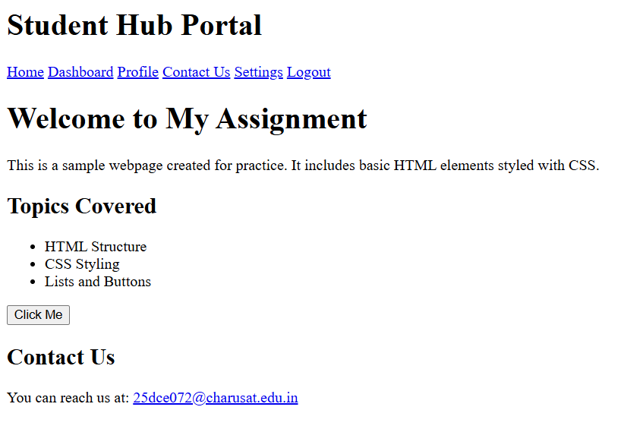

EXAMS.HTML :
<!DOCTYPE html>
<html lang="en">
<head>
<meta charset="UTF-8">
<meta name="viewport" content="width=device-width, initial-scale=1.0">
<title>Exams - Student Hub Portal</title>
</head>
<body>
<header>
<h1>Student Hub Portal</h1>
<nav>
<a href="./home.html">Home</a>
<a href="./dashboard.html">Dashboard</a>
<a href="./profile.html">Profile</a>
<a href="./contact.html">Contact Us</a>
<a href="./settings.html">Settings</a>
<a href="./index.html">Logout</a>
</nav>
</header>

<div class="exam-container">
<h2>Upcoming Exams</h2>
<table>
<tr>
<th>Subject</th>
<th>Date</th>
<th>Time</th>
</tr>
<tr>
<td>Discrete Mathematics</td>
<td>10 August 2026</td>
<td>10:00 AM</td>
</tr>
<tr>
<td>Fundamentals of Data Structure and Algorithm</td>
<td>12 August 2026</td>
<td>2:00 PM</td>
</tr>
<tr>
<td>Fundamentals of Computer Networks</td>
<td>14 August 2026</td>
<td>9:00 AM</td>
</tr>
<tr>
<td>Web Development Frameworks</td>
<td>16 August 2026</td>
<td>11:00 AM</td>
</tr>
<tr>
<td>Object Oriented Programming</td>
<td>18 August 2026</td>
<td>1:00 PM</td>
</tr>
</table>
</div>

<footer>
<p>&copy; 2026 Student Hub Portal. All rights reserved.</p>
</footer>
</body>
</html>

PREVIEW :
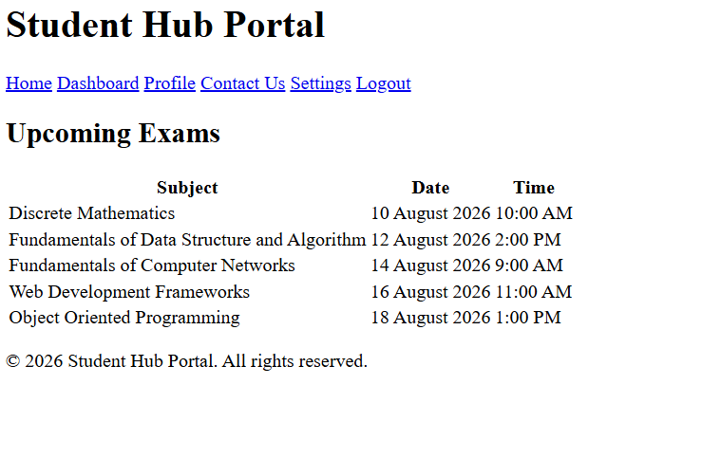
CONTACT.HTML :
<!DOCTYPE html>
<html lang="en">
<head>
<meta charset="UTF-8">
<meta name="viewport" content="width=device-width, initial-scale=1.0">
<title>Contact Us - Student Hub Portal</title>
</head>
<body>
<header>
<h1>Student Hub Portal</h1>
<nav>
<a href="./home.html">Home</a>
<a href="./dashboard.html">Dashboard</a>
<a href="./profile.html">Profile</a>
<a href="./aboutus.html">About Us</a>
<a href="./settings.html">Settings</a>
<a href="./index.html">Logout</a>
</nav>
</header>

<main>
<h2>Contact Us</h2>
<section class="contact-info">
<p><strong>Email:</strong> studenthub@university.edu</p>
<p><strong>Phone:</strong> +91 98765 43210</p>
<p><strong>Address:</strong> Student Hub Office, University Campus, Petlad, Gujarat, India</p>
</section>

<section class="contact-form">
<h3>Send us a message</h3>
<form>
<label for="name">Name:</label><br>
<input type="text" id="name" name="name" required><br><br>

<label for="email">Email:</label><br>
<input type="email" id="email" name="email" required><br><br>

<label for="message">Message:</label><br>
<textarea id="message" name="message" rows="5" required></textarea><br><br>

<button type="submit">Submit</button>
</form>
</section>
</main>
<footer>
<p>&copy; 2026 Student Hub Portal. All rights reserved.</p>
</footer>
</body>
</html>

PREVIEW :
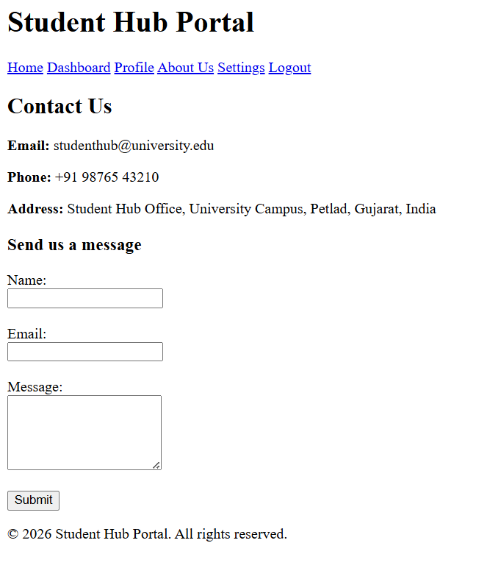
SETTINGS.HTML :
<!DOCTYPE html>
<html lang="en">
<head>
<meta charset="UTF-8">
<meta name="viewport" content="width=device-width, initial-scale=1.0">
<title>Settings - Student Hub Portal</title>
</head>
<body>
<header>
<h1>Student Hub Portal</h1>
<nav>
<a href="./home.html">Home</a>
<a href="./dashboard.html">Dashboard</a>
<a href="./profile.html">Profile</a>
<a href="./contact.html">Contact Us</a>
<a href="./aboutus.html">About Us</a>
<a href="./index.html">Logout</a>
</nav>
</header>

<main>
<h2>Settings</h2>

<section class="account-settings">
<h3>Account Settings</h3>
<ul>
<li><a href="./change-password.html">Change Password</a></li>
<li><a href="./update-email.html">Update Email/Phone</a></li>
<li><a href="./edit-profile.html">Edit Profile Picture</a></li>
</ul>
</section>

<section class="preferences">
<h3>Preferences</h3>
<form>
<label for="theme">Theme:</label>
<select id="theme" name="theme">
<option value="light">Light</option>
<option value="dark">Dark</option>
</select><br><br>

<label for="language">Language:</label>
<select id="language" name="language">
<option value="en">English</option>
<option value="hi">Hindi</option>
</select><br><br>

<label>
<input type="checkbox" name="notifications" checked> Enable Notifications
</label>
</form>
</section>

</main>

<footer>
<p>&copy; 2026 Student Hub Portal</p>
</footer>
</body>
</html>

PREVIEW :
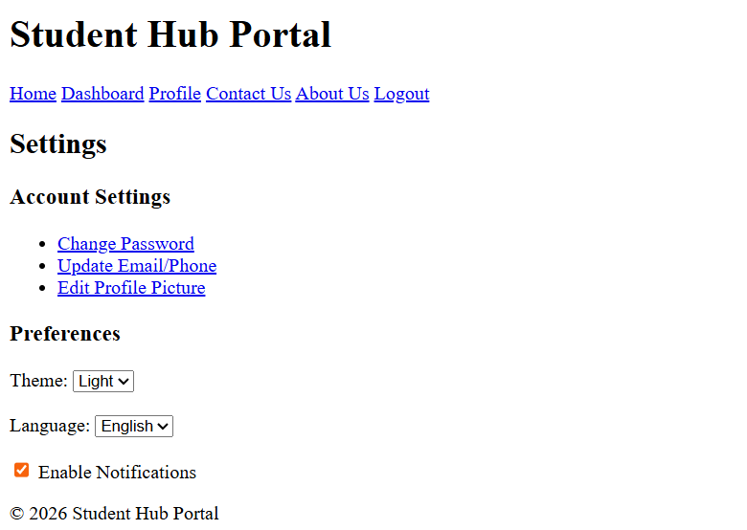

ABOUTUS.HTML :
<!DOCTYPE html>
<html lang="en">
<head>
<meta charset="UTF-8">
<meta name="viewport" content="width=device-width, initial-scale=1.0">
<title>About Us</title>
</head>
<body>
<header>
<h1>About Us</h1>
<nav>
<a href="./home.html">Home</a>
<a href="./services.html">Services</a>
<a href="./projects.html">Projects</a>
<a href="./contact.html">Contact</a>
<a href="./index.html">Logout</a>
</nav>
</header>

<div class="content">
<h1>Welcome to Our Page</h1>
<section>
<h2>Our Mission</h2>
<p>Our mission is to make learning simple, fun, and accessible for everyone.</p>
</section>
<section>
<h2>What We Do</h2>
<p>We create tutorials, projects, and resources to help students understand web development and programming.</p>
</section>
</div>
<footer>
<h2>Contact Us</h2>
<p>You can reach us at:
<a href="mailto:25dce072@charusat.edu.in">25dce072@charusat.edu.in</a>
</p>
</footer>
</body>
</html>

PREVIEW :
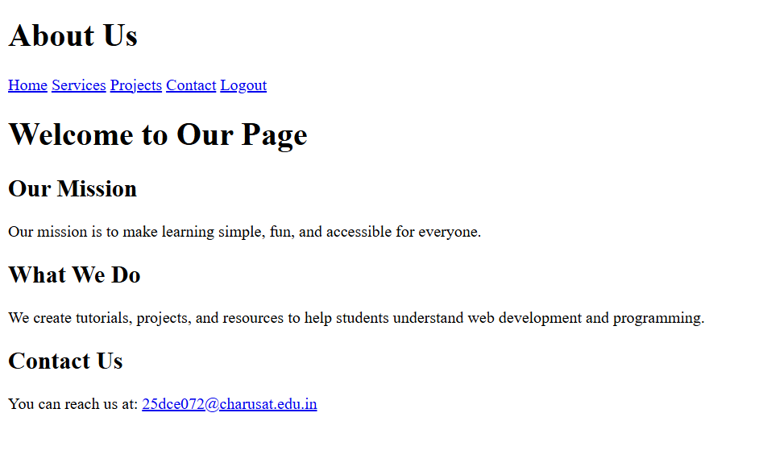

KEY QUESTIONS :

Q1. Are semantic tags such as header, nav, main, section, article, aside, and footer used properly?
- Yes, semantic HTML tags are used properly in most of the pages. The project uses tags such as <header>, <nav>, <main>, <section>, and <footer> to organize the page content.
- <header> – Used for the page heading/logo area.
- <nav> – Used for navigation links between pages.
- <main> – Used for the main content of the webpage.
- <section> – Used to divide content into meaningful sections.
- <footer> – Used for footer information.
- <article> and <aside> – These are not required on every page and are not widely used in the current project.
- Overall, the semantic structure is appropriate and can be improved further by using <article> and <aside> wherever their specific content structure requires them.

Q2. Are form labels, headings, image alt text, and navigation links accessible?
- Yes, the project includes important accessibility features.
- Form Labels – Form fields such as name, email, username, password, and message have <label> elements associated with the input fields.
- Headings – Headings such as <h1>, <h2>, and <h3> are used to organize the content.
- Image Alt Text – Images include alt attributes, for example:

<img src="./studenthub.png" alt="StudentHub Logo">
- Navigation Links – Navigation is provided using clear <a> links to move between different HTML pages.

- Therefore, the project follows basic accessibility practices, although the accessibility can be improved further by checking keyboard navigation, focus indicators, and meaningful link names.

Q3. Is the page structure consistent across all pages?
- Yes, the page structure is generally consistent across the Student Hub pages.
Most pages follow a common structure:
Header
↓
Navigation
↓
Main Content
↓
Sections
↓
Footer
The common navigation contains links such as Home, Dashboard, Profile, Contact, Settings, and Logout. The pages also use the same CSS file (class.css) for common styling.
Therefore, the overall page structure and navigation are consistent, which makes the website easier for users to understand and navigate.

