PRACTICAL-3

AIM: Design responsive layouts for Home, About, Registration, Dashboard, and Events pages using CSS Grid and Flexbox. Optional to use CSS framework such as Bootstrap or Tailwind. Ensure mobile-first responsiveness.

SOURCE CODE :

COMMON.CSS :
https://github.com/Aarav280907/WEB/blob/9a44b6229e079b0a26d7aa4ccb497a95c5fd2fae/Practical-1(Studenthub)/for_css/common.css

INDEX.CSS :
https://github.com/Aarav280907/WEB/blob/9a44b6229e079b0a26d7aa4ccb497a95c5fd2fae/Practical-1(Studenthub)/for_css/index.css

PREVIEW :
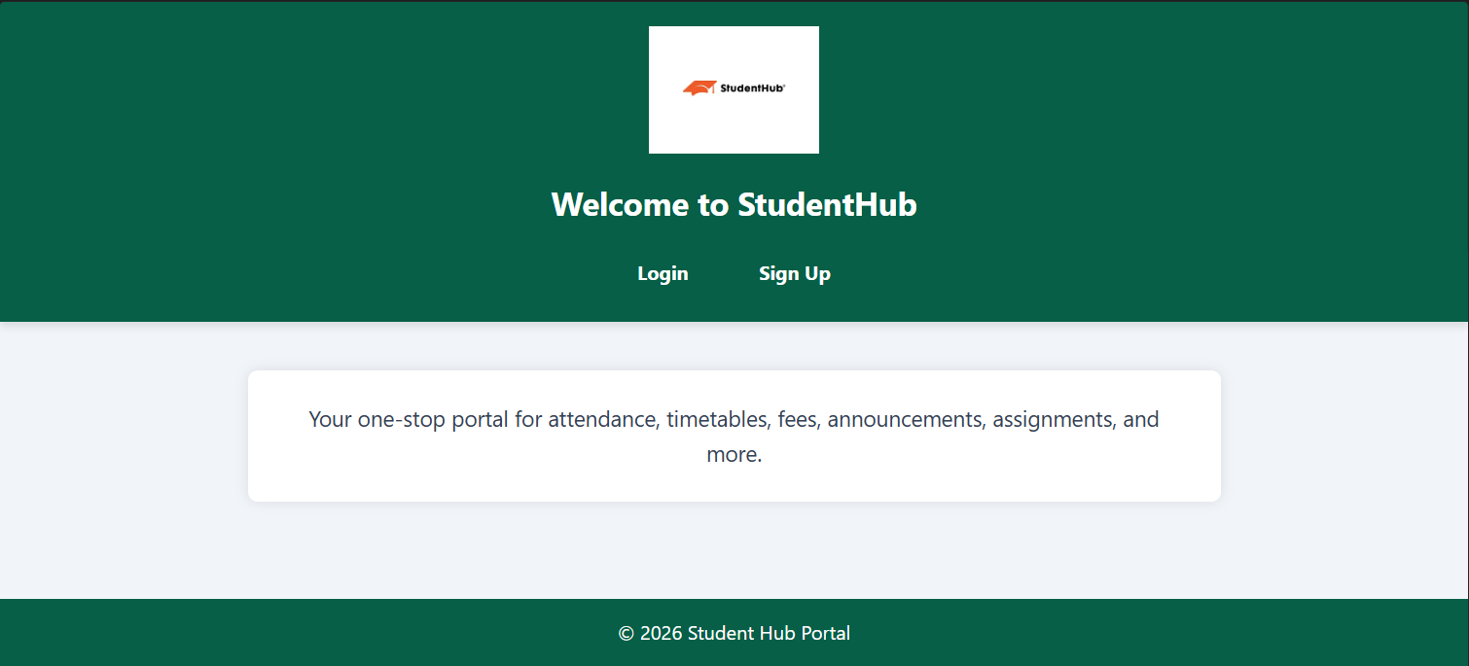

LOGIN.CSS :
https://github.com/Aarav280907/WEB/blob/9a44b6229e079b0a26d7aa4ccb497a95c5fd2fae/Practical-1(Studenthub)/for_css/login.css

PREVIEW :
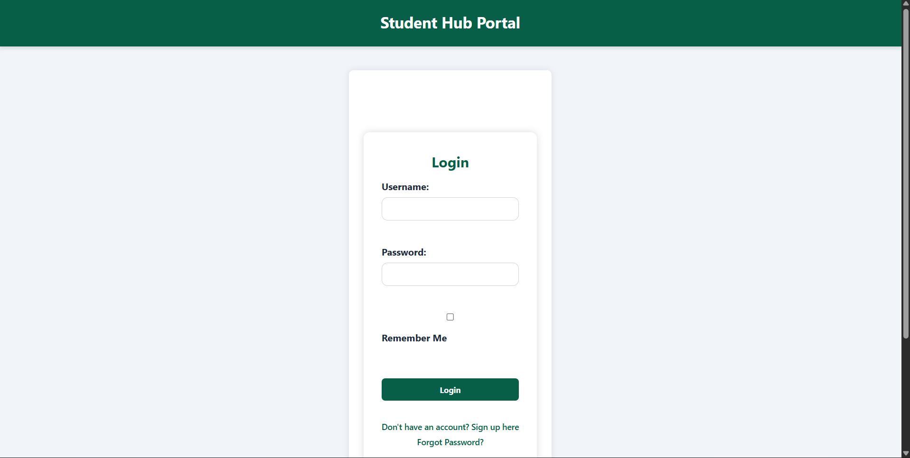

SIGNUP.CSS :
https://github.com/Aarav280907/WEB/blob/9a44b6229e079b0a26d7aa4ccb497a95c5fd2fae/Practical-1(Studenthub)/for_css/signup.css

PREVIEW :
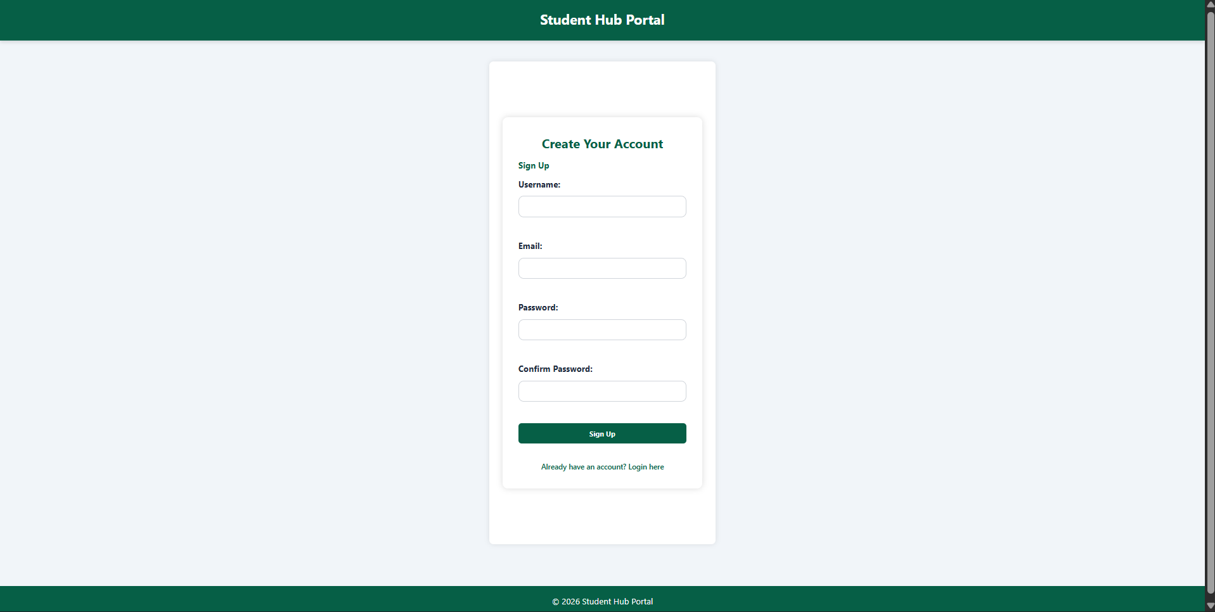

HOME.CSS :
https://github.com/Aarav280907/WEB/blob/9a44b6229e079b0a26d7aa4ccb497a95c5fd2fae/Practical-1(Studenthub)/for_css/home.css
PREVIEW :
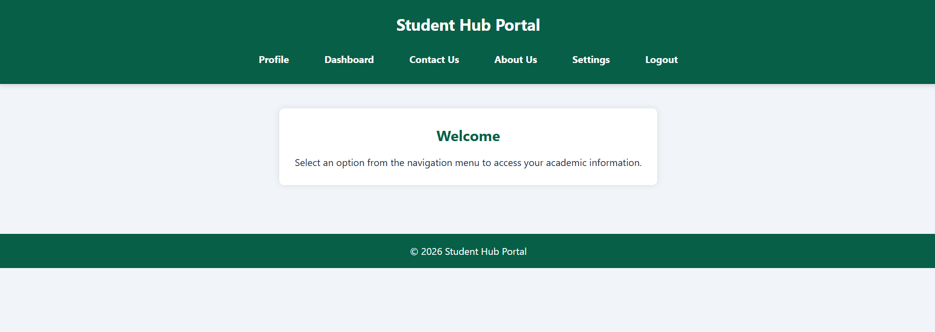

PROFILE.CSS :
https://github.com/Aarav280907/WEB/blob/9a44b6229e079b0a26d7aa4ccb497a95c5fd2fae/Practical-1(Studenthub)/for_css/profile.css
PREVIEW :
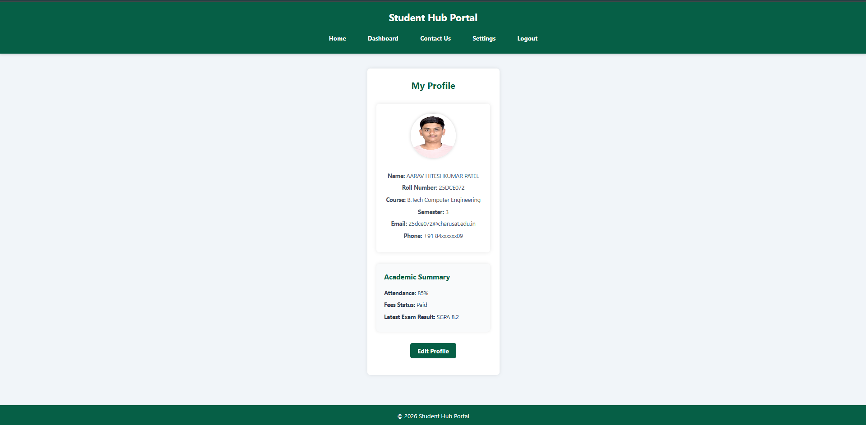

DASHBOARD.CSS :
https://github.com/Aarav280907/WEB/blob/9a44b6229e079b0a26d7aa4ccb497a95c5fd2fae/Practical-1(Studenthub)/for_css/dashboard.css
PREVIEW :
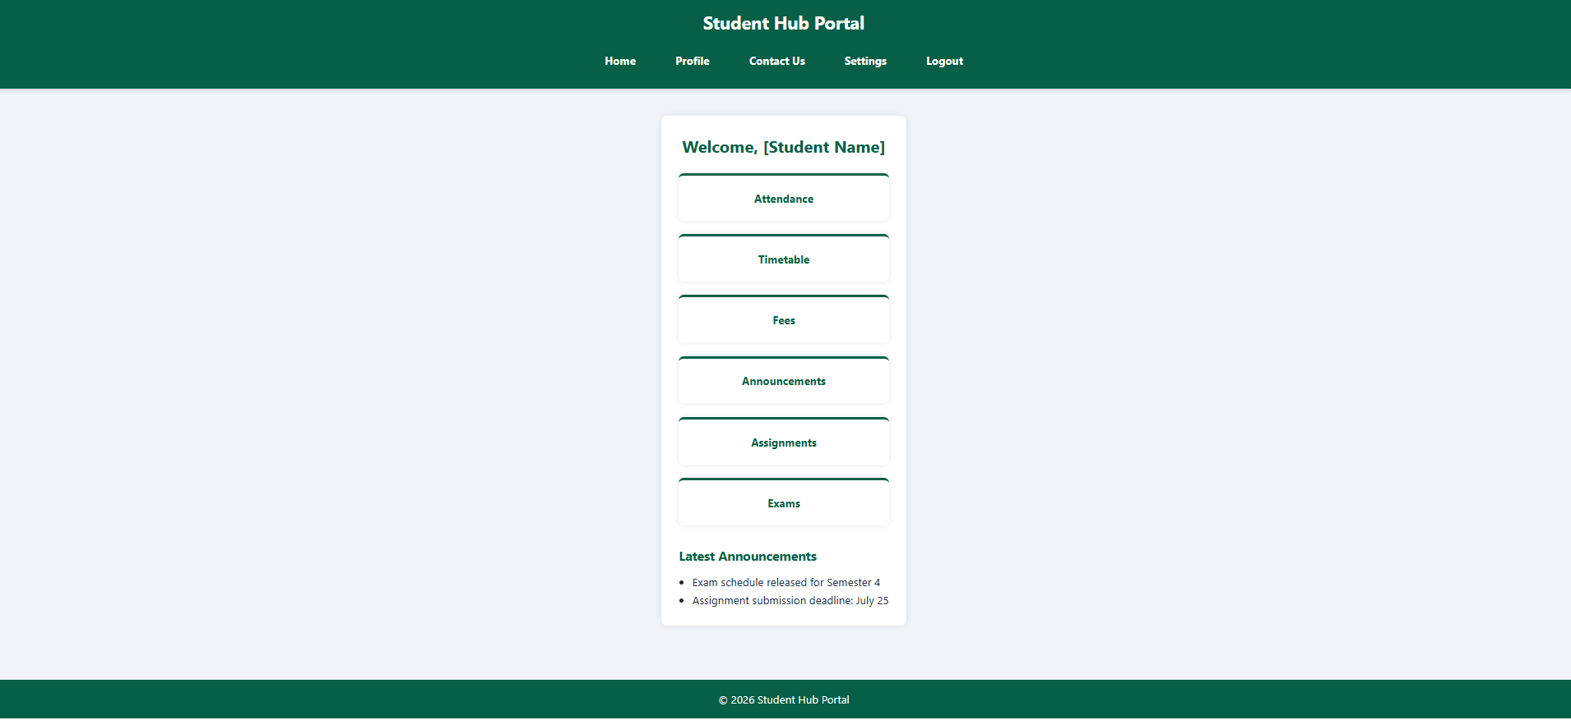

ATTENDENCE.CSS :
https://github.com/Aarav280907/WEB/blob/9a44b6229e079b0a26d7aa4ccb497a95c5fd2fae/Practical-1(Studenthub)/for_css/attendance.css
PREVIEW :
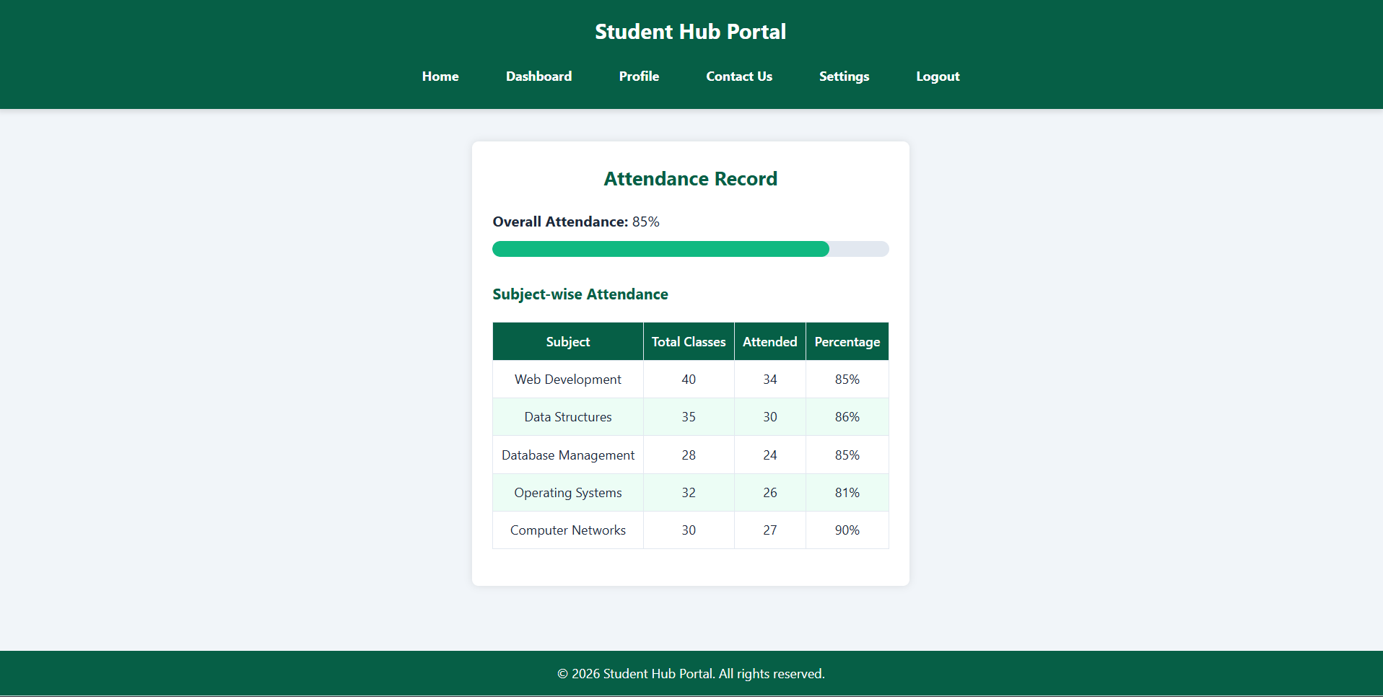
TIMETABLE.CSS :
https://github.com/Aarav280907/WEB/blob/9a44b6229e079b0a26d7aa4ccb497a95c5fd2fae/Practical-1(Studenthub)/for_css/timetable.css
PREVIEW :
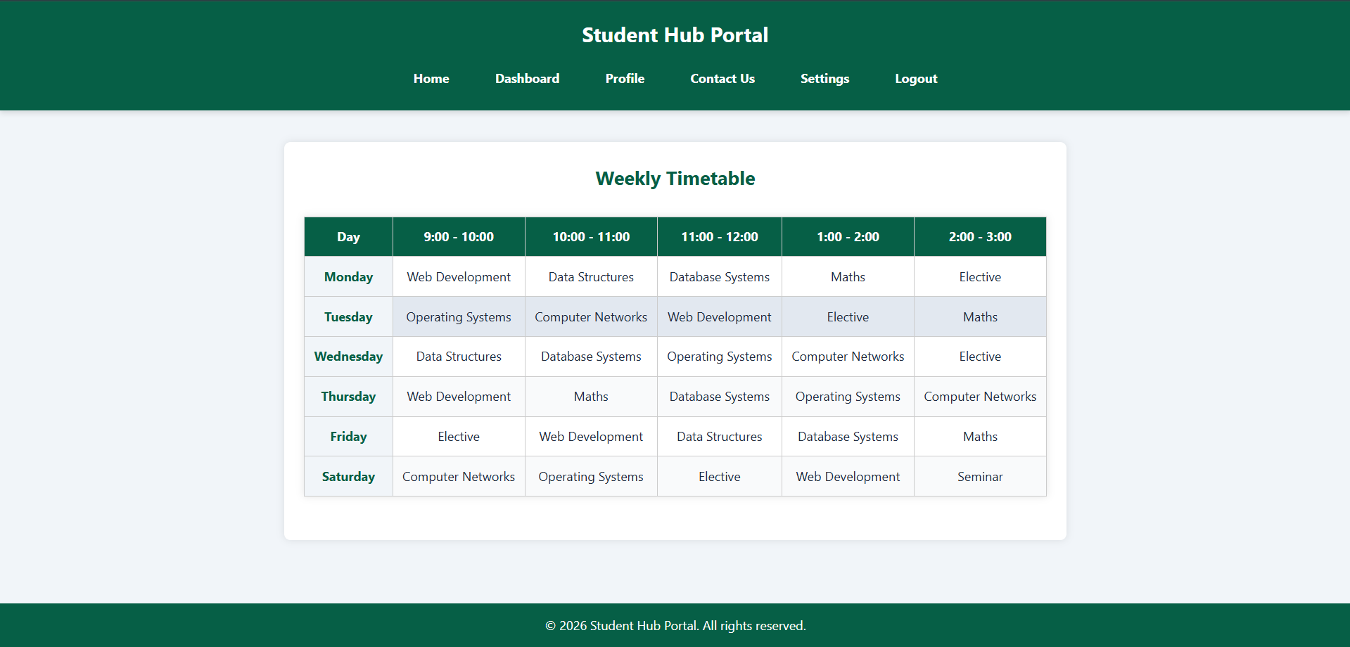

FEES.CSS :
https://github.com/Aarav280907/WEB/blob/9a44b6229e079b0a26d7aa4ccb497a95c5fd2fae/Practical-1(Studenthub)/for_css/fees.css

PREVIEW :
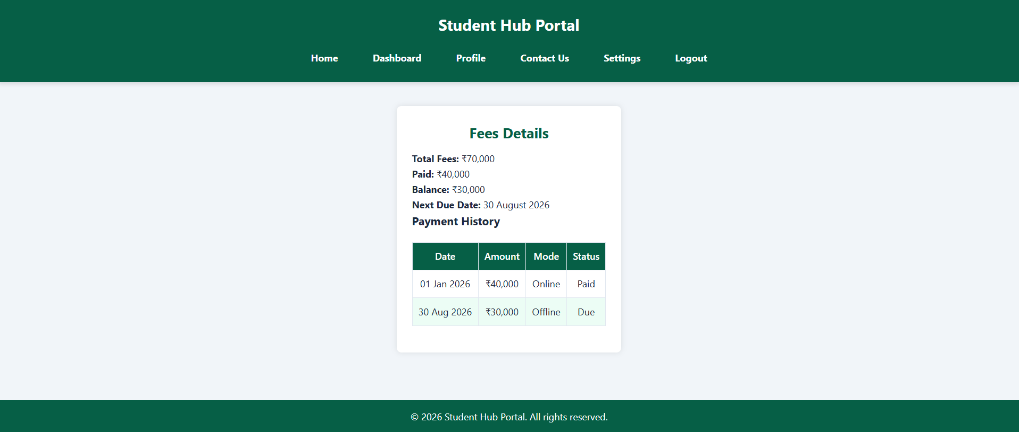
ANNOUNCEMENT.CSS :
https://github.com/Aarav280907/WEB/blob/9a44b6229e079b0a26d7aa4ccb497a95c5fd2fae/Practical-1(Studenthub)/for_css/announcement.css
PREVIEW :
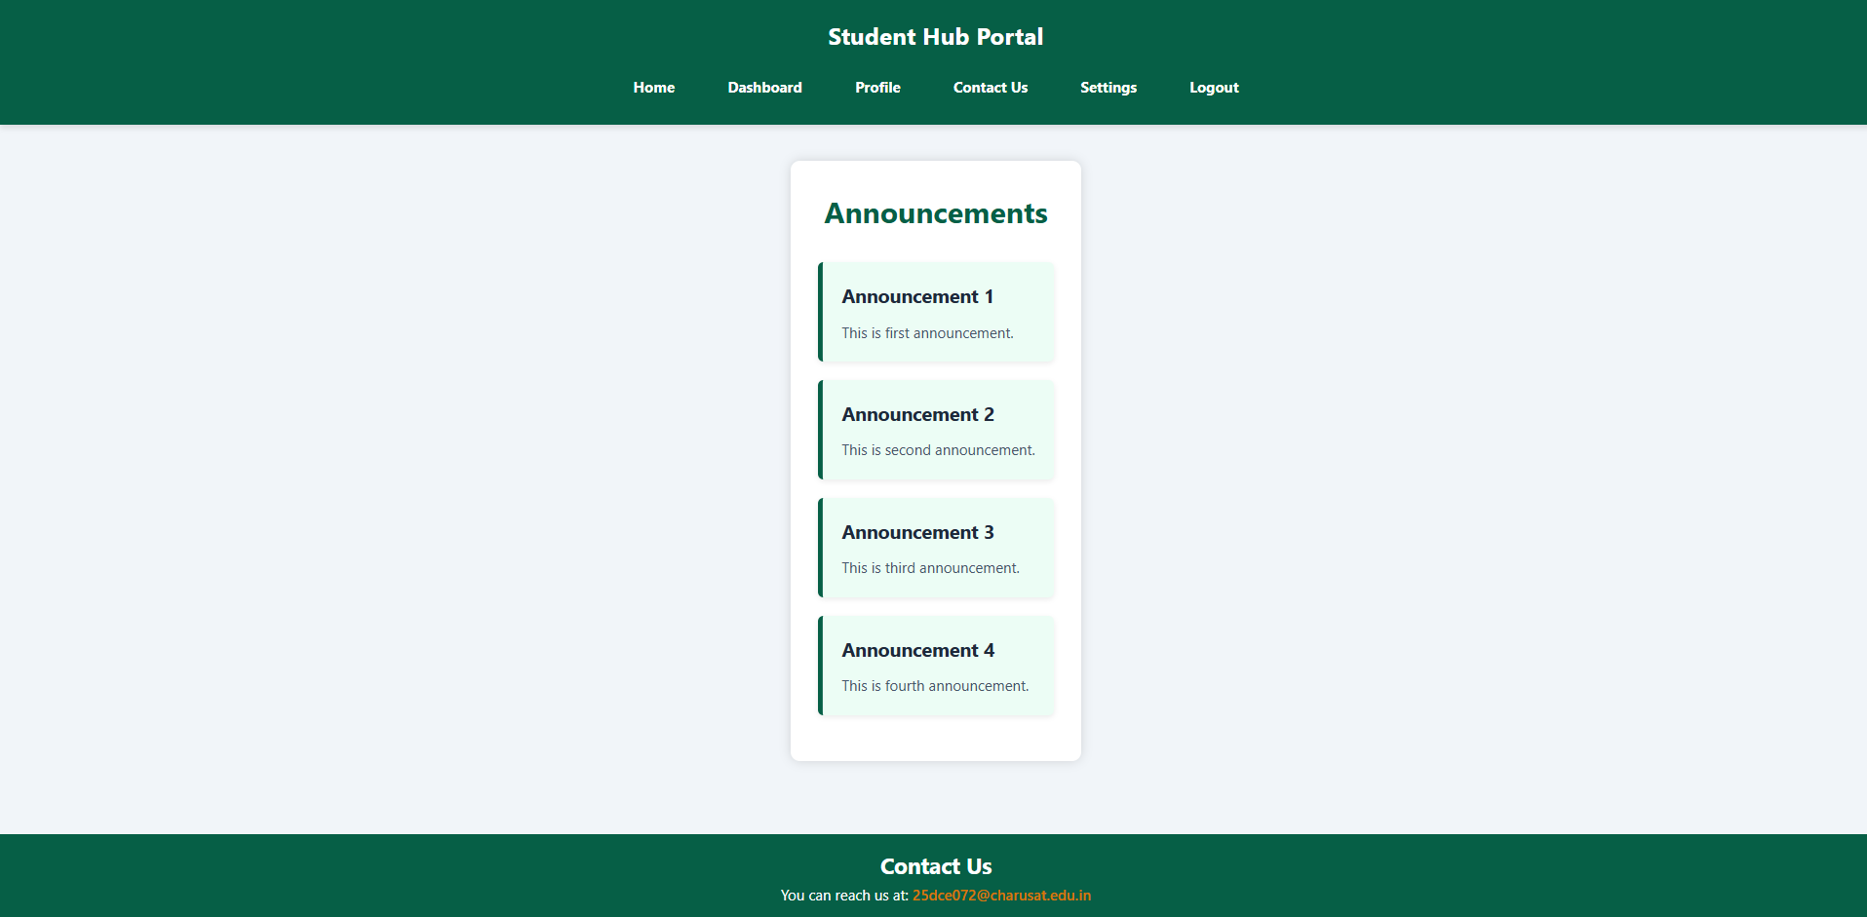

ASSIGNMENT.CSS :
https://github.com/Aarav280907/WEB/blob/9a44b6229e079b0a26d7aa4ccb497a95c5fd2fae/Practical-1(Studenthub)/for_css/assignment.css
PREVIEW :
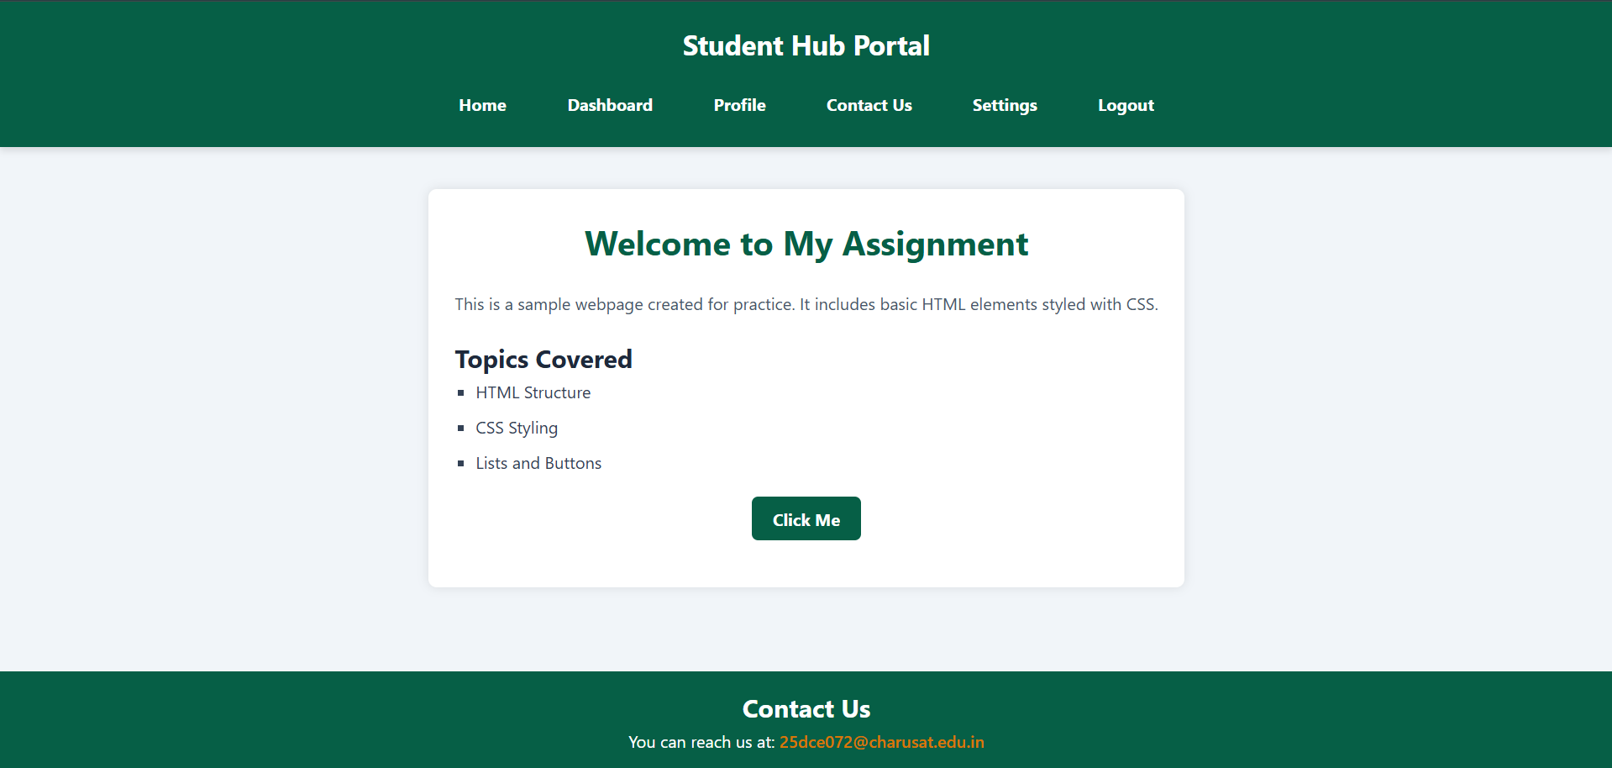
EXAM.CSS :
https://github.com/Aarav280907/WEB/blob/9a44b6229e079b0a26d7aa4ccb497a95c5fd2fae/Practical-1(Studenthub)/for_css/exam.css
PREVIEW :
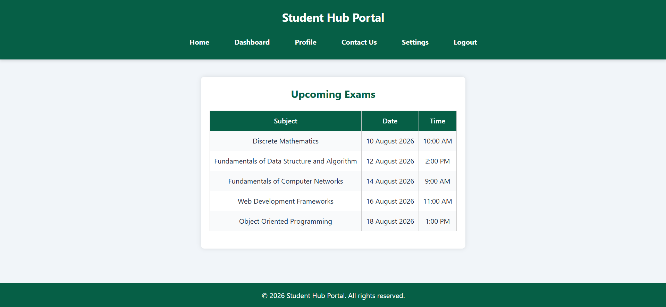

CONTACT.CSS :
https://github.com/Aarav280907/WEB/blob/9a44b6229e079b0a26d7aa4ccb497a95c5fd2fae/Practical-1(Studenthub)/for_css/contact.css
PREVIEW :
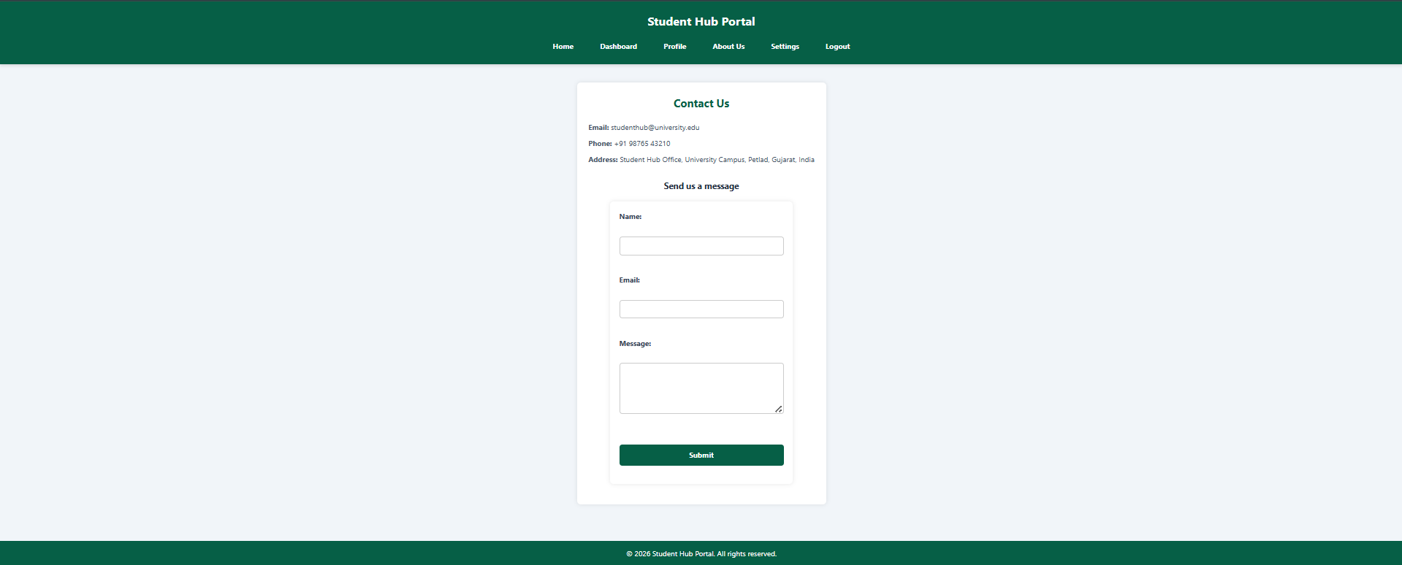

ABOUTUS.CSS :
https://github.com/Aarav280907/WEB/blob/9a44b6229e079b0a26d7aa4ccb497a95c5fd2fae/Practical-1(Studenthub)/for_css/aboutus.css

PREVIEW :
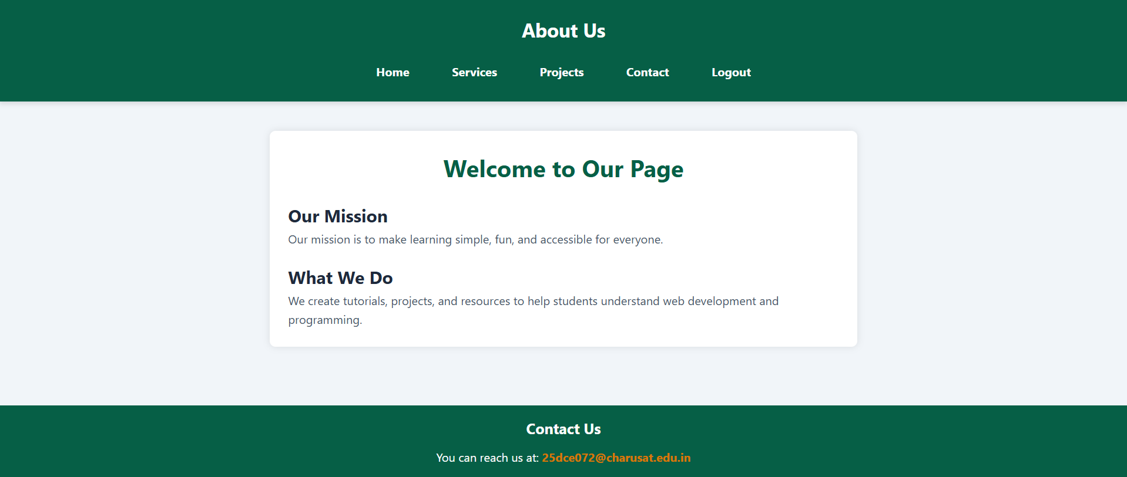

SETTINGS.CSS :
https://github.com/Aarav280907/WEB/blob/9a44b6229e079b0a26d7aa4ccb497a95c5fd2fae/Practical-1(Studenthub)/for_css/settings.css
PREVIEW :
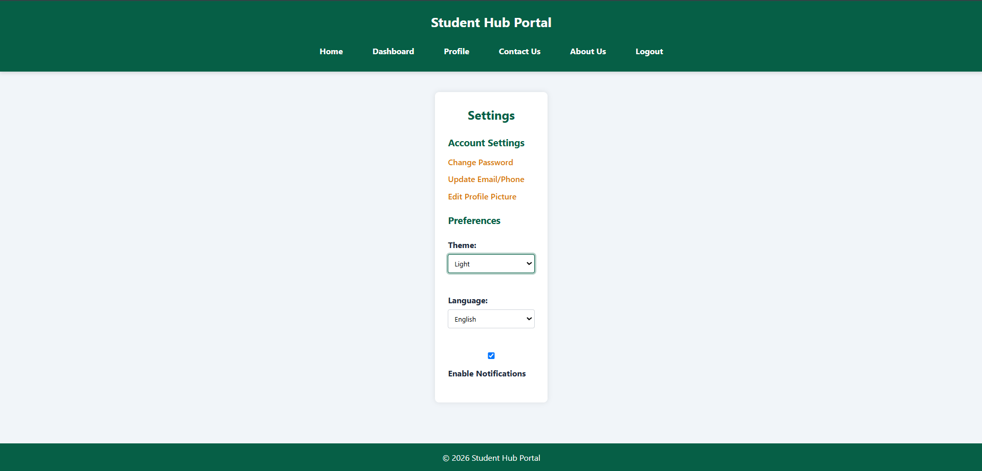

KEY QUESTIONS :

1. How does the layout adapt for mobile, tablet, and desktop screens?
The website uses responsive design. The layout changes according to the screen size.
- Mobile: Elements stack vertically and the content takes the available screen width.
- Tablet: Elements get more space and can be arranged in rows/columns.
- Desktop: More content can be displayed side-by-side.
- Bootstrap's responsive grid/classes help the website adjust automatically to different screen sizes.
- CSS properties such as width, max-width, display, flex, and responsive Bootstrap classes help maintain the layout.

2. Which layout technique is used and why?
The project mainly uses Flexbox and Bootstrap's Grid System.
- Flexbox → useful for arranging items in a row or column and aligning them.
- Bootstrap Grid → divides the page into responsive columns.
- These techniques make the layout easier to manage and responsive.
- I had use display:flex; which is used for arrangement of elements of container flexibly.

3. Are typography, spacing, colors, and contrast readable?
Yes. The design uses CSS and Bootstrap styling to maintain readability.
- font-size → controls text size.
- font-family → controls the font.
- font-weight → controls text thickness.
- padding → provides internal spacing.
- margin → provides external spacing.
- color → controls text color.
- background-color → controls background.
- Good contrast between text and background makes the content easier to read.
- border-radius and box-shadow are used to make cards and sections visually clear.

