PRACTICAL-3

AIM: Design responsive layouts for Home, About, Registration, Dashboard, and Events pages using CSS Grid and Flexbox. Optional to use CSS framework such as Bootstrap or Tailwind. Ensure mobile-first responsiveness.

SOURCE CODE :

COMMON.CSS :
https://github.com/Aarav280907/WEB/blob/9a44b6229e079b0a26d7aa4ccb497a95c5fd2fae/Practical-1(Studenthub)/for_css/common.css

INDEX.CSS :
https://github.com/Aarav280907/WEB/blob/9a44b6229e079b0a26d7aa4ccb497a95c5fd2fae/Practical-1(Studenthub)/for_css/index.css

PREVIEW :
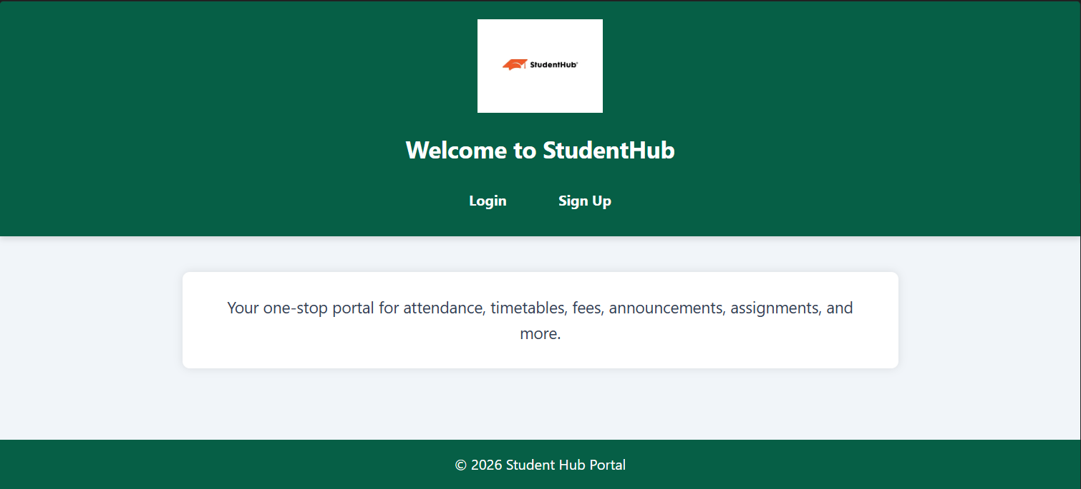

LOGIN.CSS :
https://github.com/Aarav280907/WEB/blob/9a44b6229e079b0a26d7aa4ccb497a95c5fd2fae/Practical-1(Studenthub)/for_css/login.css

PREVIEW :
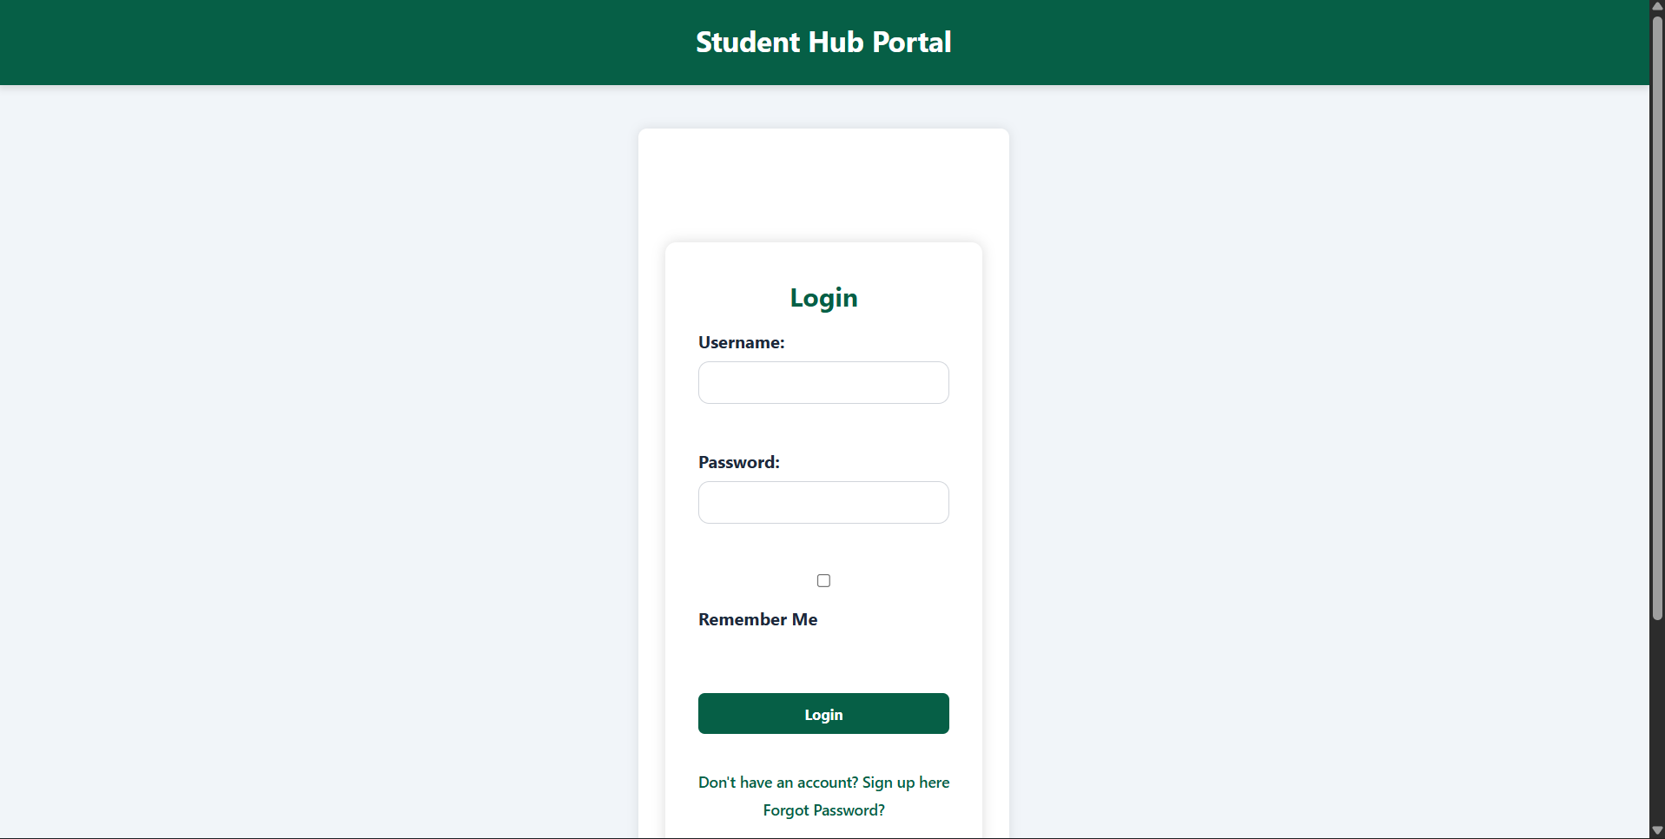

SIGNUP.CSS :
https://github.com/Aarav280907/WEB/blob/9a44b6229e079b0a26d7aa4ccb497a95c5fd2fae/Practical-1(Studenthub)/for_css/signup.css

PREVIEW :
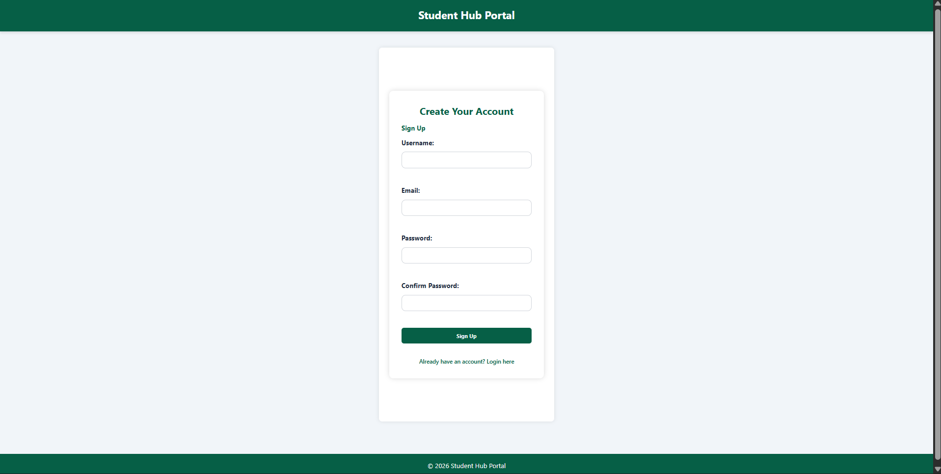

HOME.CSS :
https://github.com/Aarav280907/WEB/blob/9a44b6229e079b0a26d7aa4ccb497a95c5fd2fae/Practical-1(Studenthub)/for_css/home.css
PREVIEW :
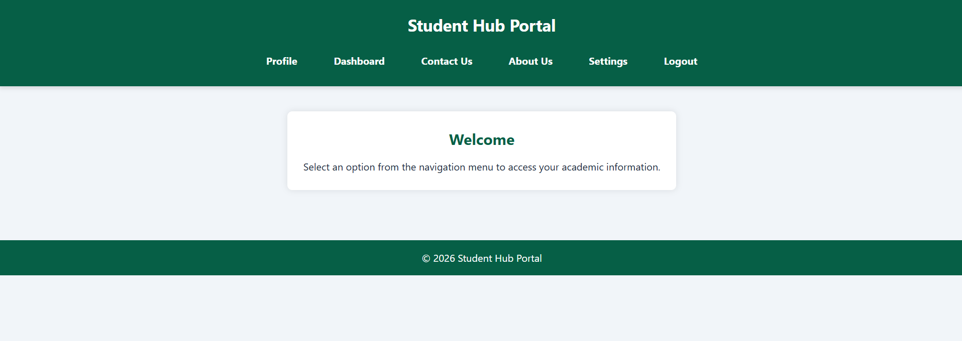

PROFILE.CSS :
https://github.com/Aarav280907/WEB/blob/9a44b6229e079b0a26d7aa4ccb497a95c5fd2fae/Practical-1(Studenthub)/for_css/profile.css
PREVIEW :
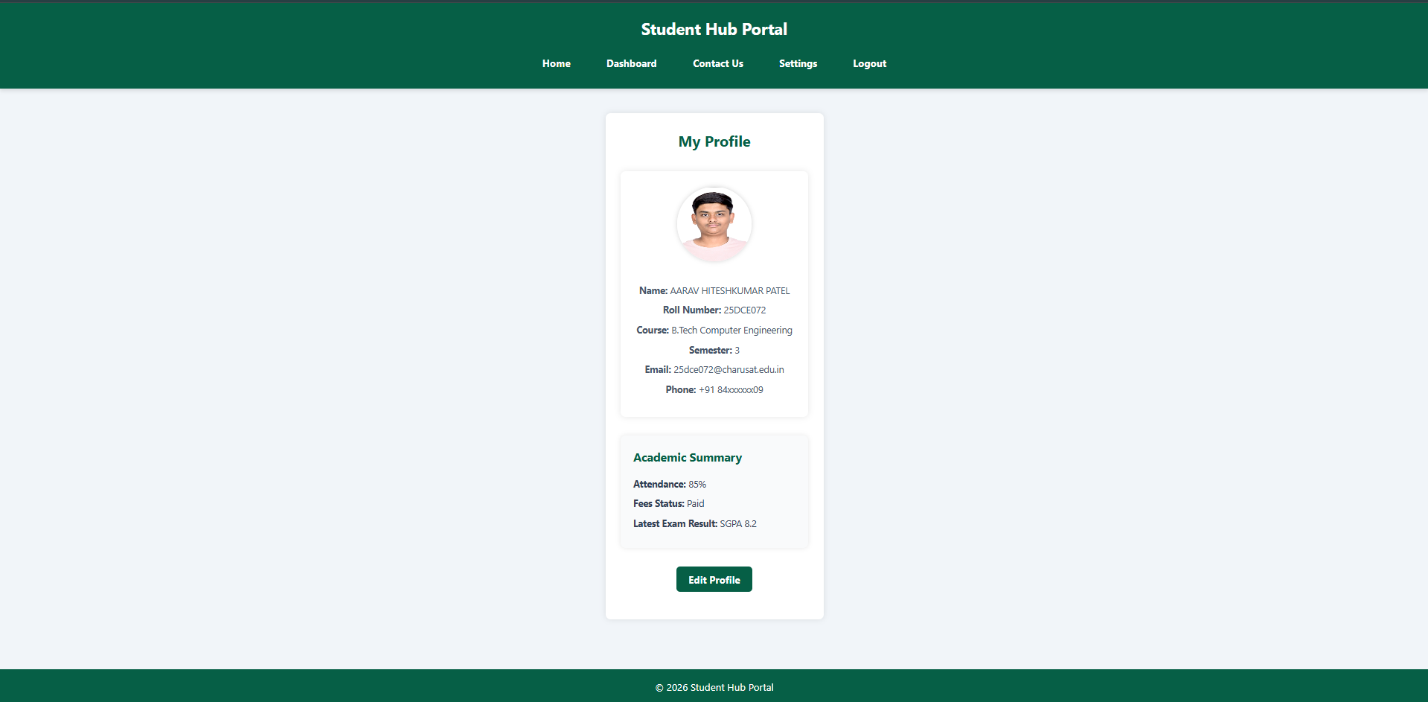

DASHBOARD.CSS :
https://github.com/Aarav280907/WEB/blob/9a44b6229e079b0a26d7aa4ccb497a95c5fd2fae/Practical-1(Studenthub)/for_css/dashboard.css
PREVIEW :
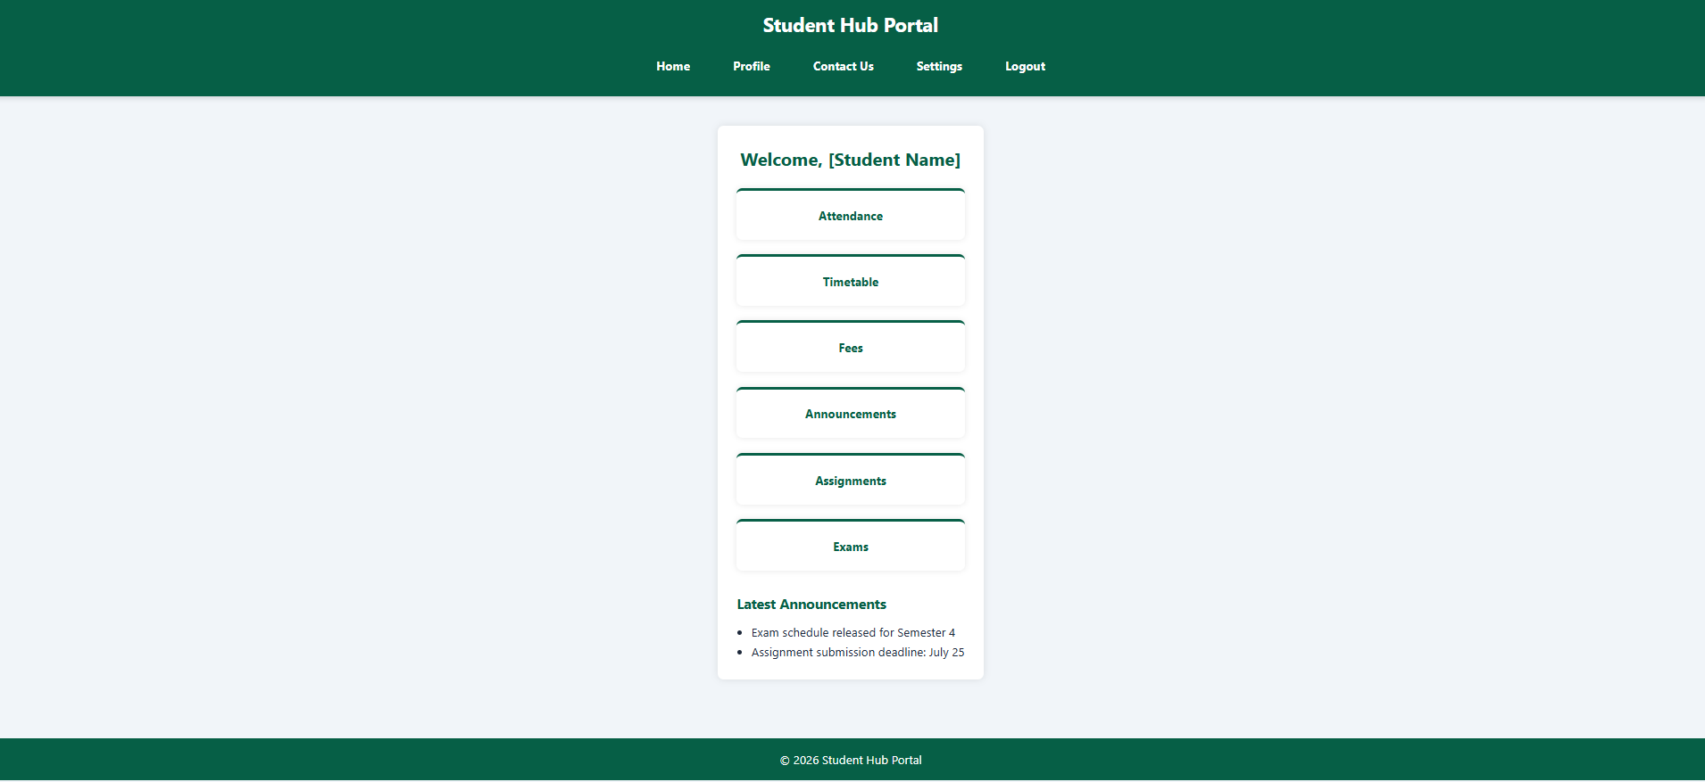

ATTENDENCE.CSS :
https://github.com/Aarav280907/WEB/blob/9a44b6229e079b0a26d7aa4ccb497a95c5fd2fae/Practical-1(Studenthub)/for_css/attendance.css
PREVIEW :
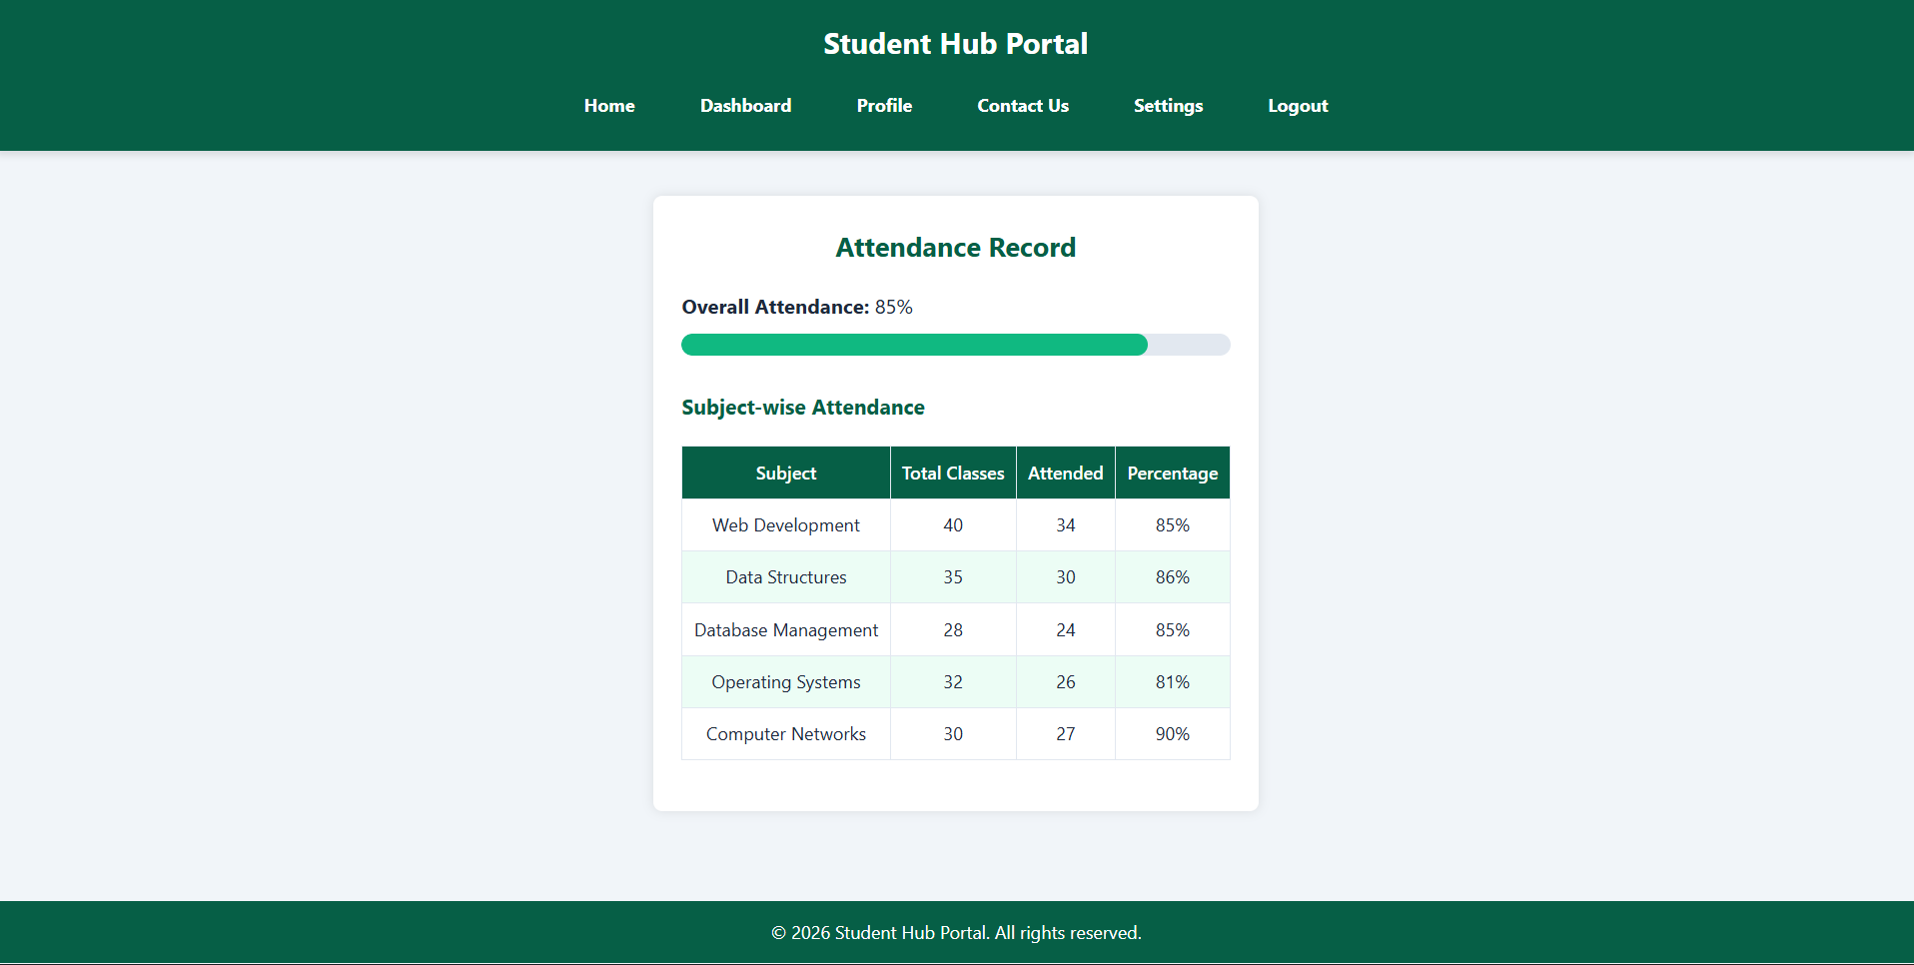
TIMETABLE.CSS :
https://github.com/Aarav280907/WEB/blob/9a44b6229e079b0a26d7aa4ccb497a95c5fd2fae/Practical-1(Studenthub)/for_css/timetable.css
PREVIEW :
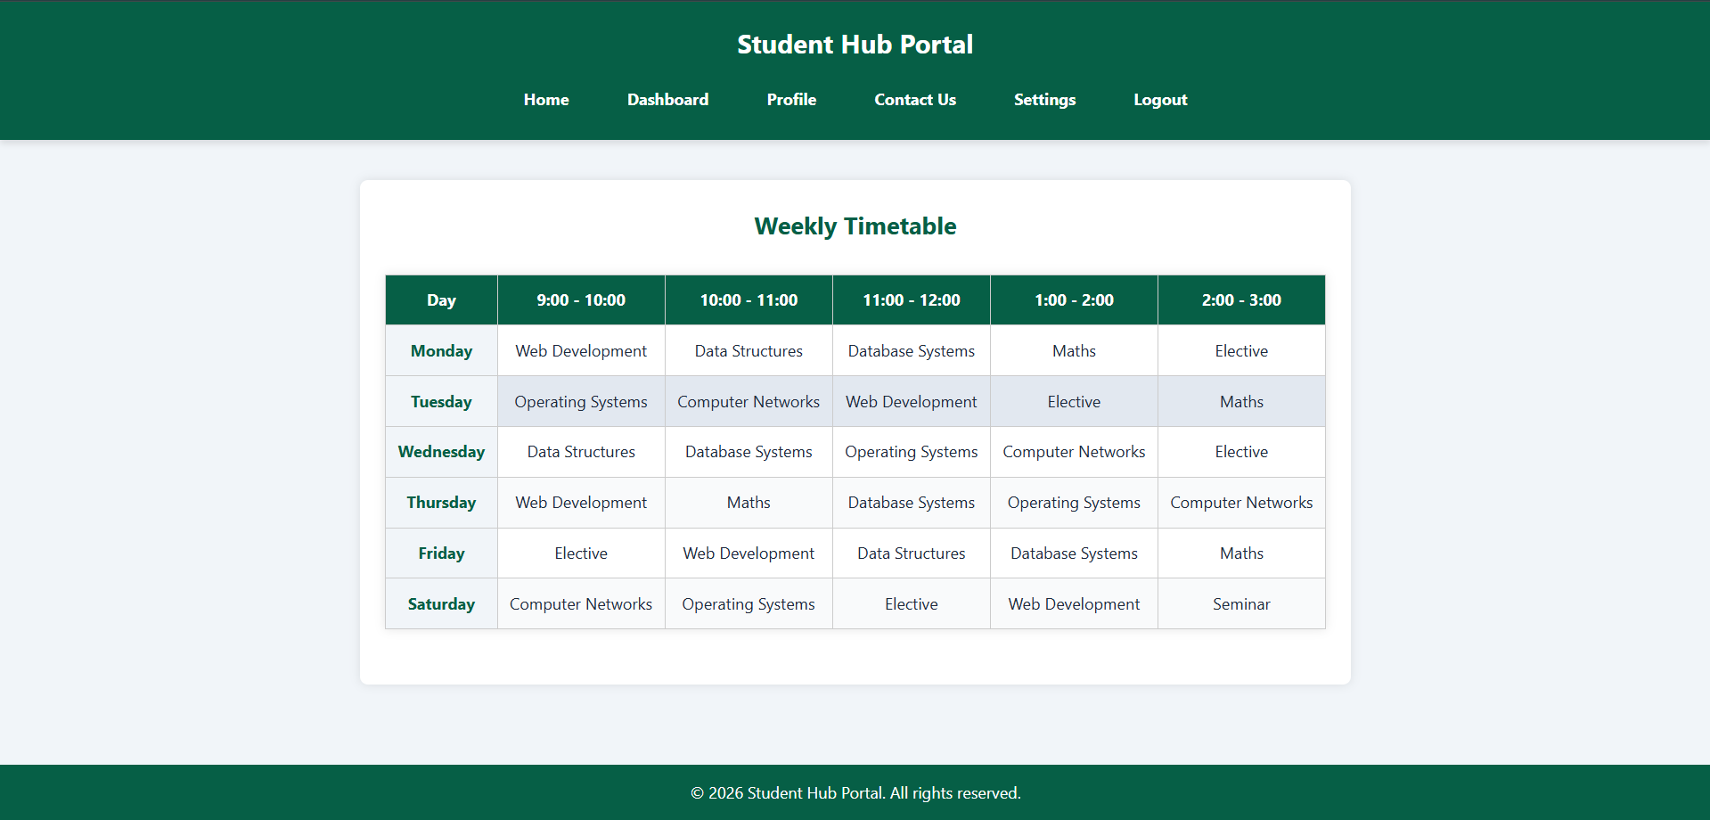

FEES.CSS :
https://github.com/Aarav280907/WEB/blob/9a44b6229e079b0a26d7aa4ccb497a95c5fd2fae/Practical-1(Studenthub)/for_css/fees.css

PREVIEW :
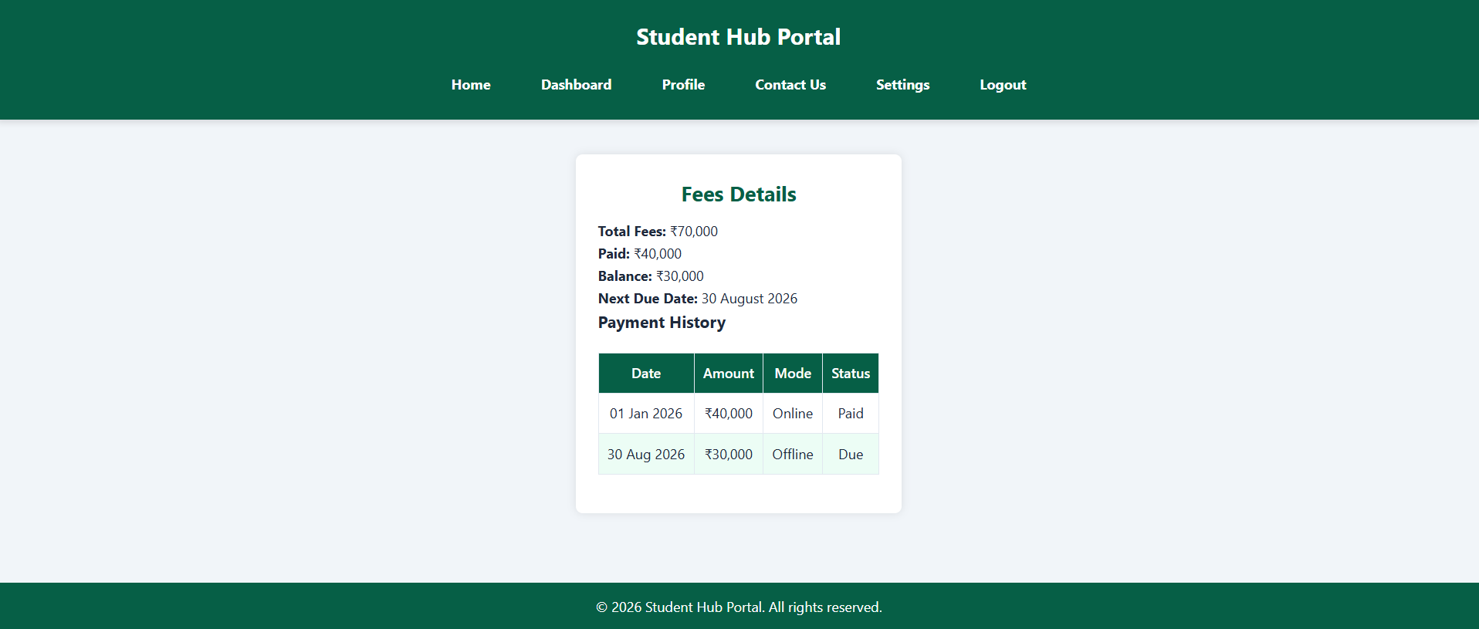
ANNOUNCEMENT.CSS :
https://github.com/Aarav280907/WEB/blob/9a44b6229e079b0a26d7aa4ccb497a95c5fd2fae/Practical-1(Studenthub)/for_css/announcement.css
PREVIEW :
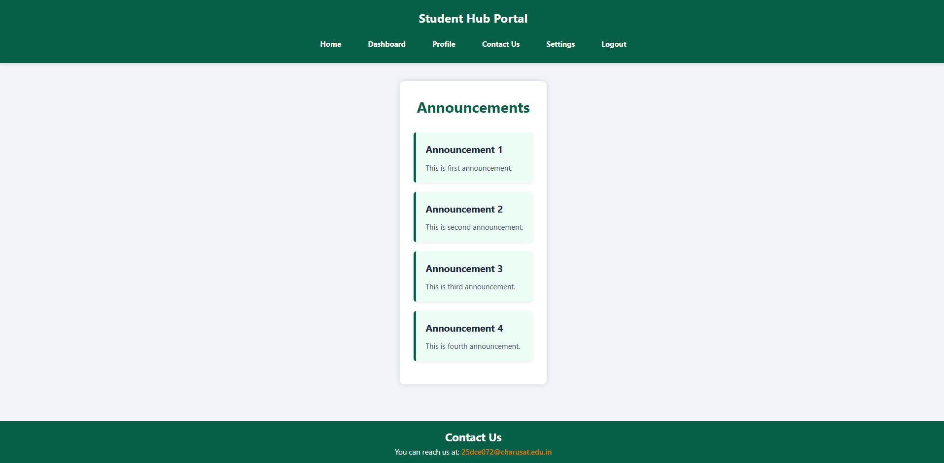

ASSIGNMENT.CSS :
https://github.com/Aarav280907/WEB/blob/9a44b6229e079b0a26d7aa4ccb497a95c5fd2fae/Practical-1(Studenthub)/for_css/assignment.css
PREVIEW :
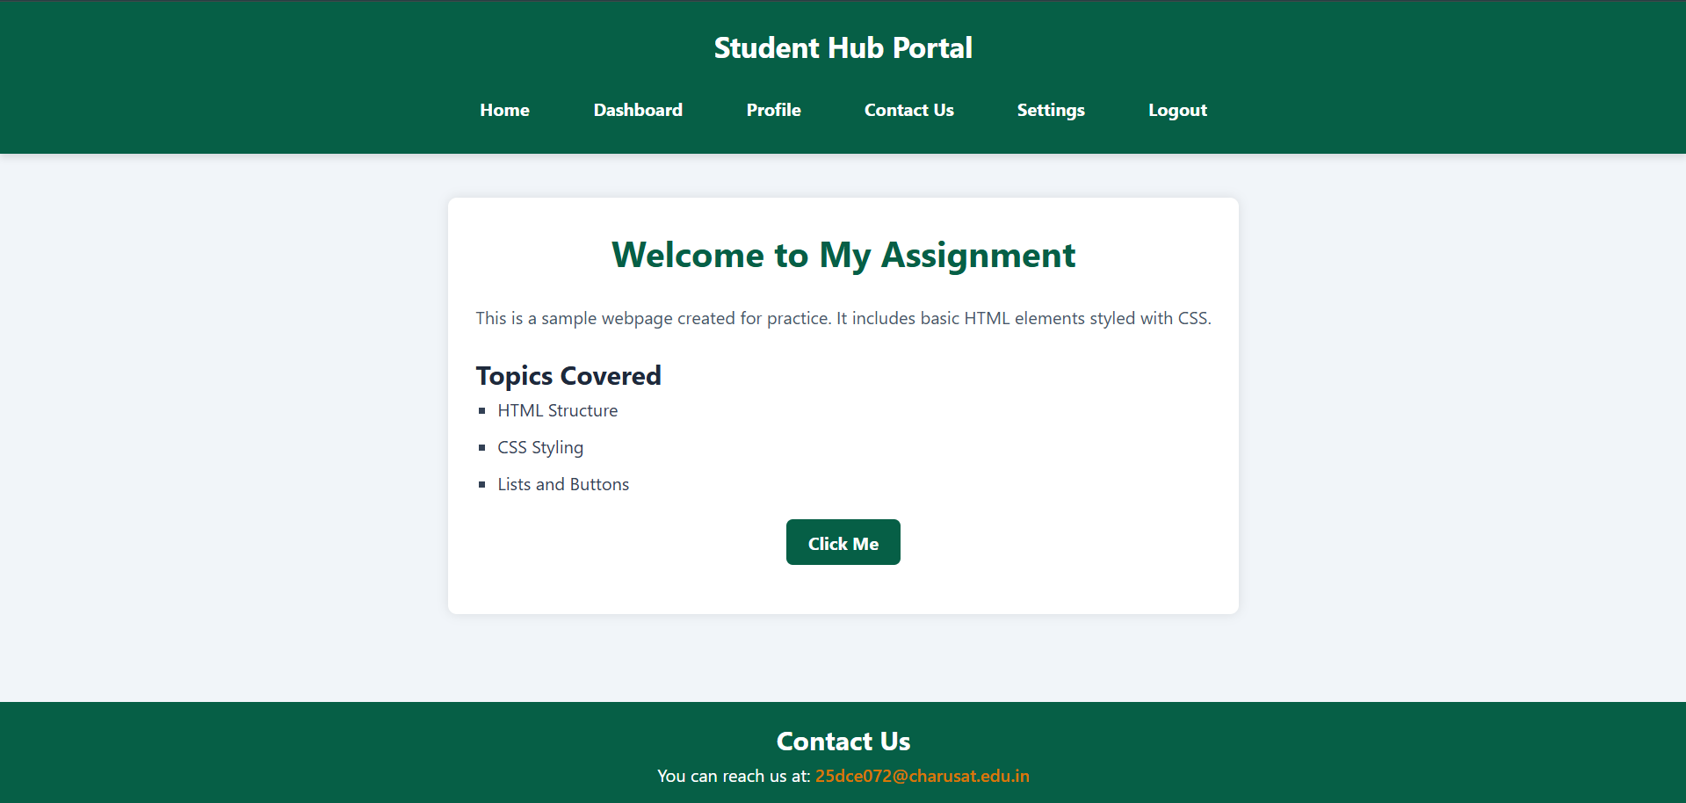
EXAM.CSS :
https://github.com/Aarav280907/WEB/blob/9a44b6229e079b0a26d7aa4ccb497a95c5fd2fae/Practical-1(Studenthub)/for_css/exam.css
PREVIEW :
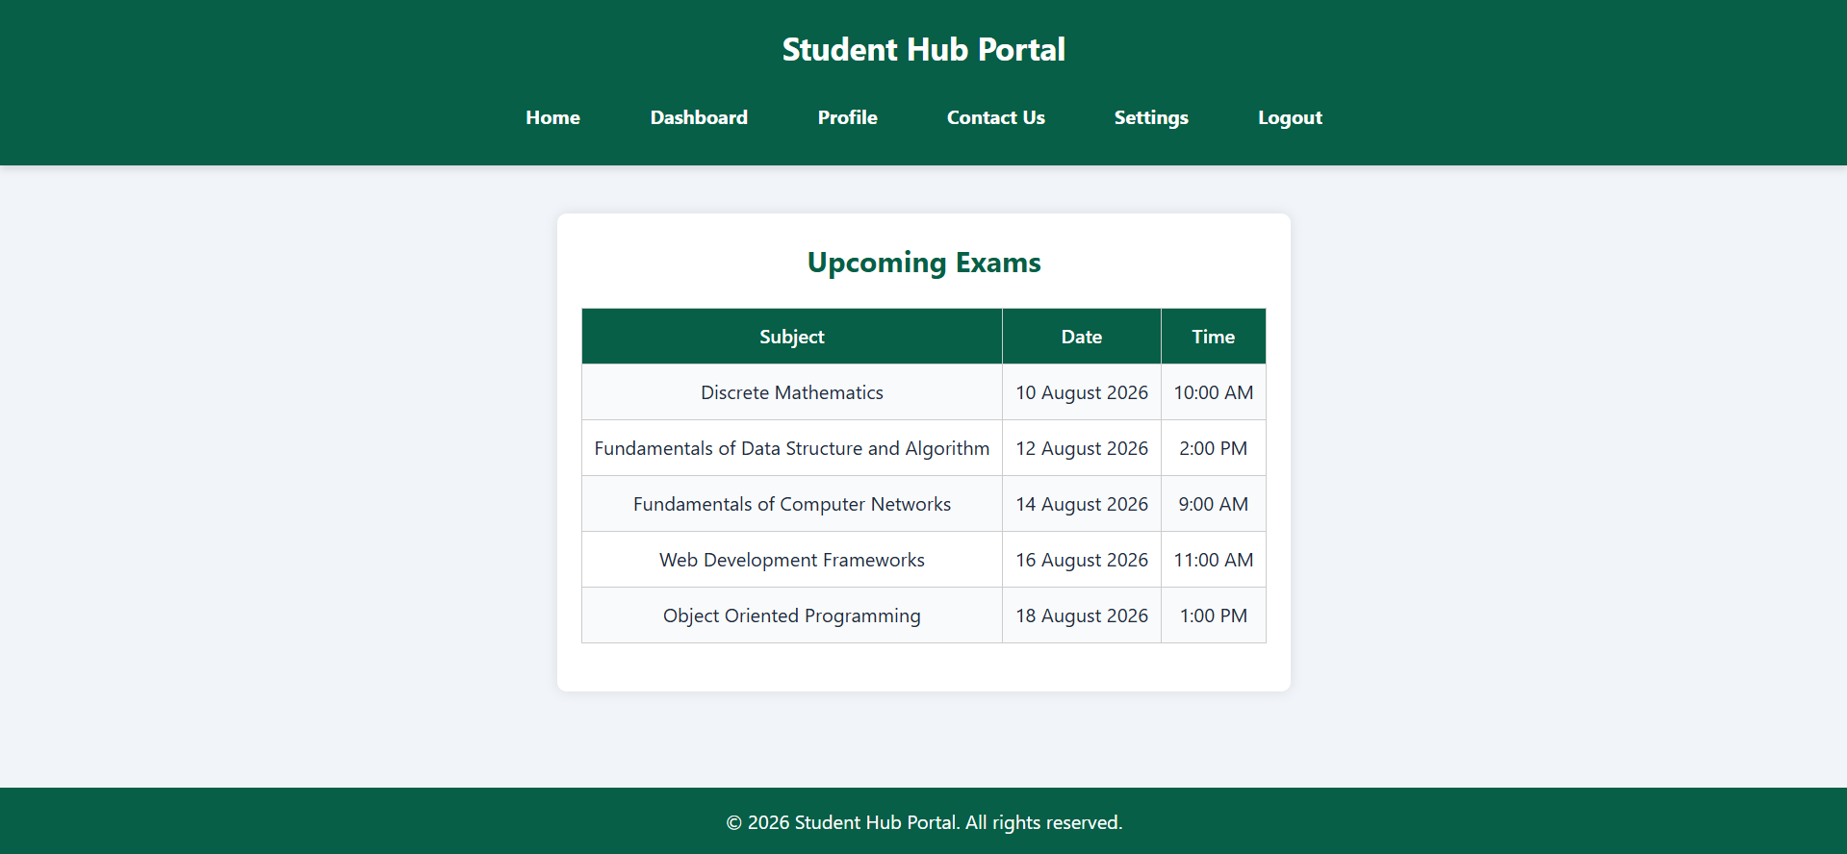

CONTACT.CSS :
https://github.com/Aarav280907/WEB/blob/9a44b6229e079b0a26d7aa4ccb497a95c5fd2fae/Practical-1(Studenthub)/for_css/contact.css
PREVIEW :
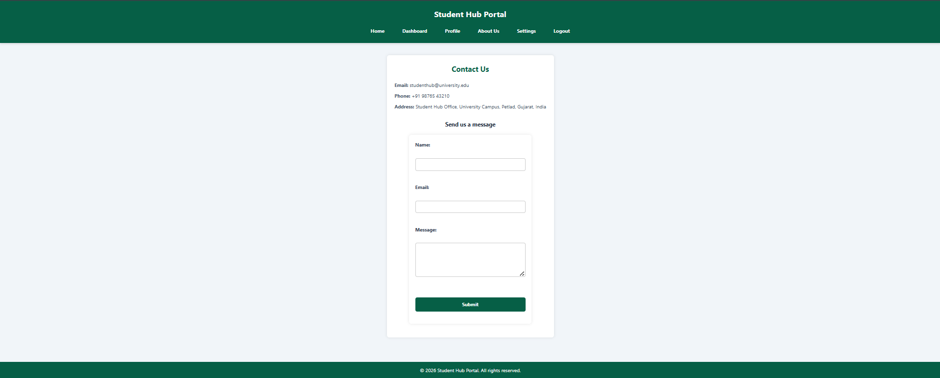

ABOUTUS.CSS :
https://github.com/Aarav280907/WEB/blob/9a44b6229e079b0a26d7aa4ccb497a95c5fd2fae/Practical-1(Studenthub)/for_css/aboutus.css

PREVIEW :
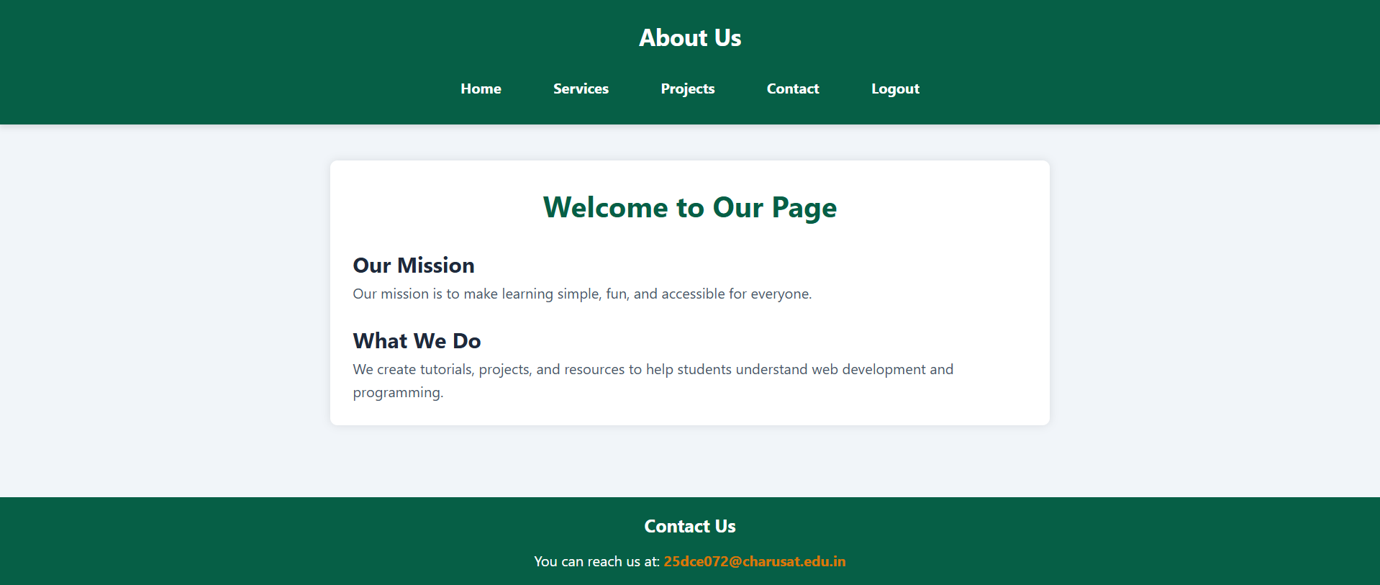

SETTINGS.CSS :
https://github.com/Aarav280907/WEB/blob/9a44b6229e079b0a26d7aa4ccb497a95c5fd2fae/Practical-1(Studenthub)/for_css/settings.css
PREVIEW :
