PRACTICAL-10

AIM: Implement login and logout with PHP sessions, role-based access (admin / student), idle timeout and a remember-me token.

SOURCE CODE :
https://github.com/Aarav280907/WEB/tree/main/Practical(1-4)(Studenthub)/Practical-10

PREVIEW:
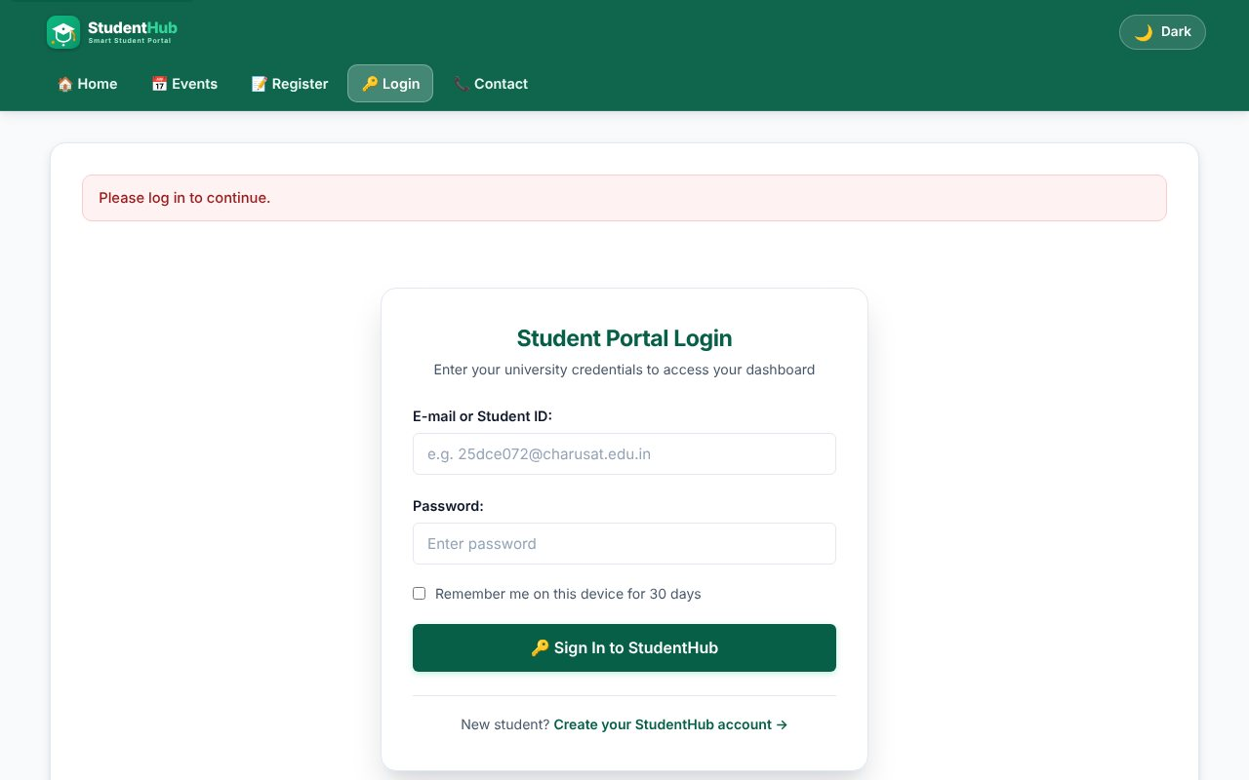
Opening a protected page without login redirects to the login page
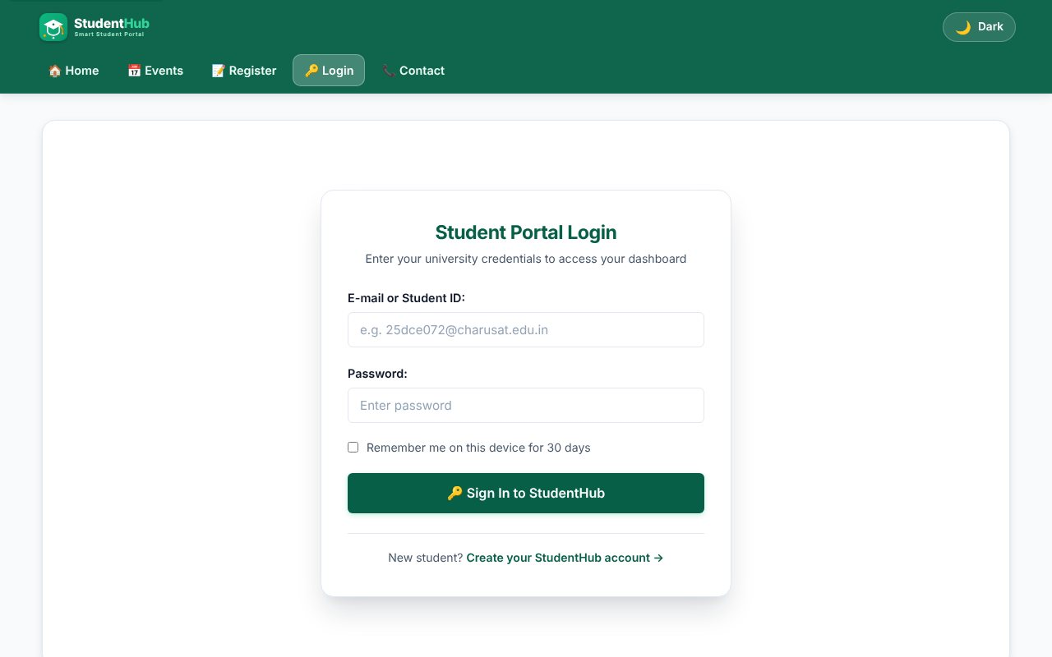
Login page (e-mail or roll number, password, remember me)
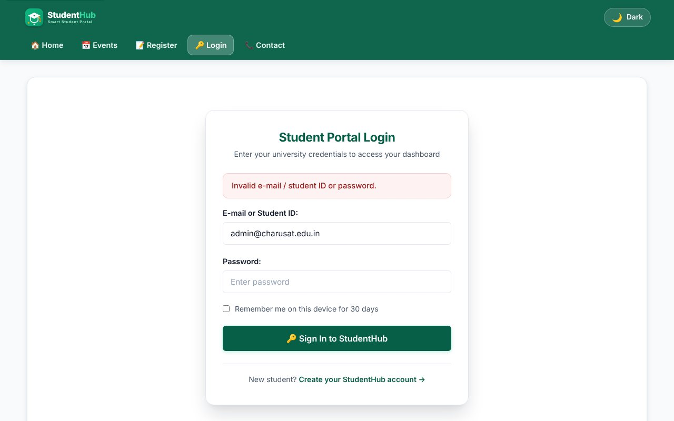
Failed login - wrong password
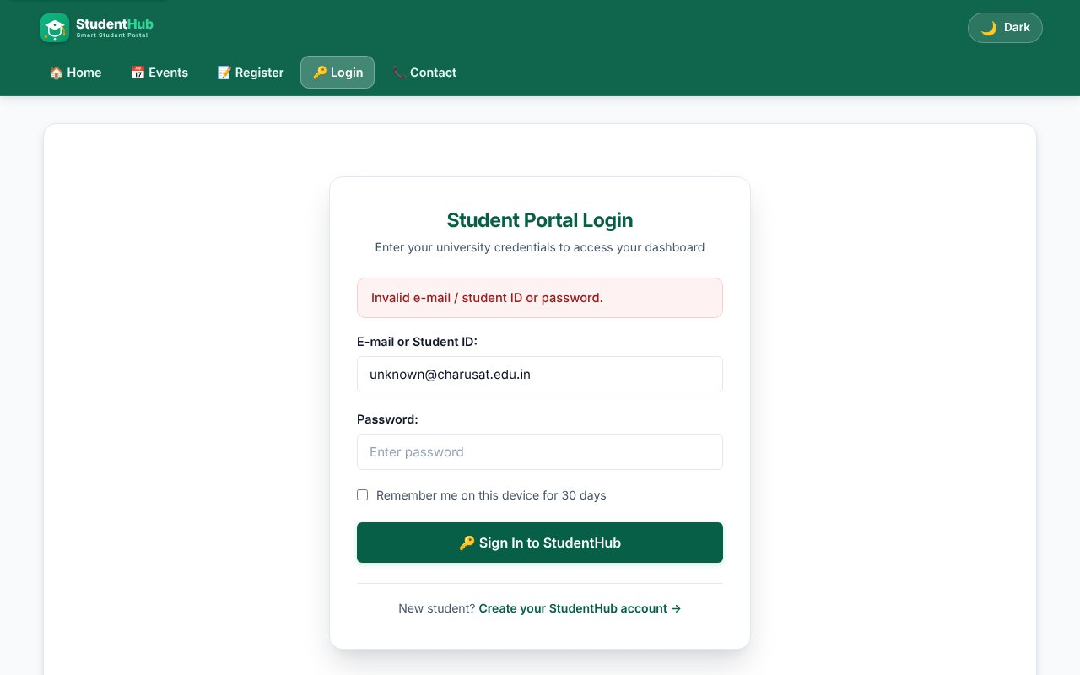
Unknown user gets the same generic message (no user enumeration)
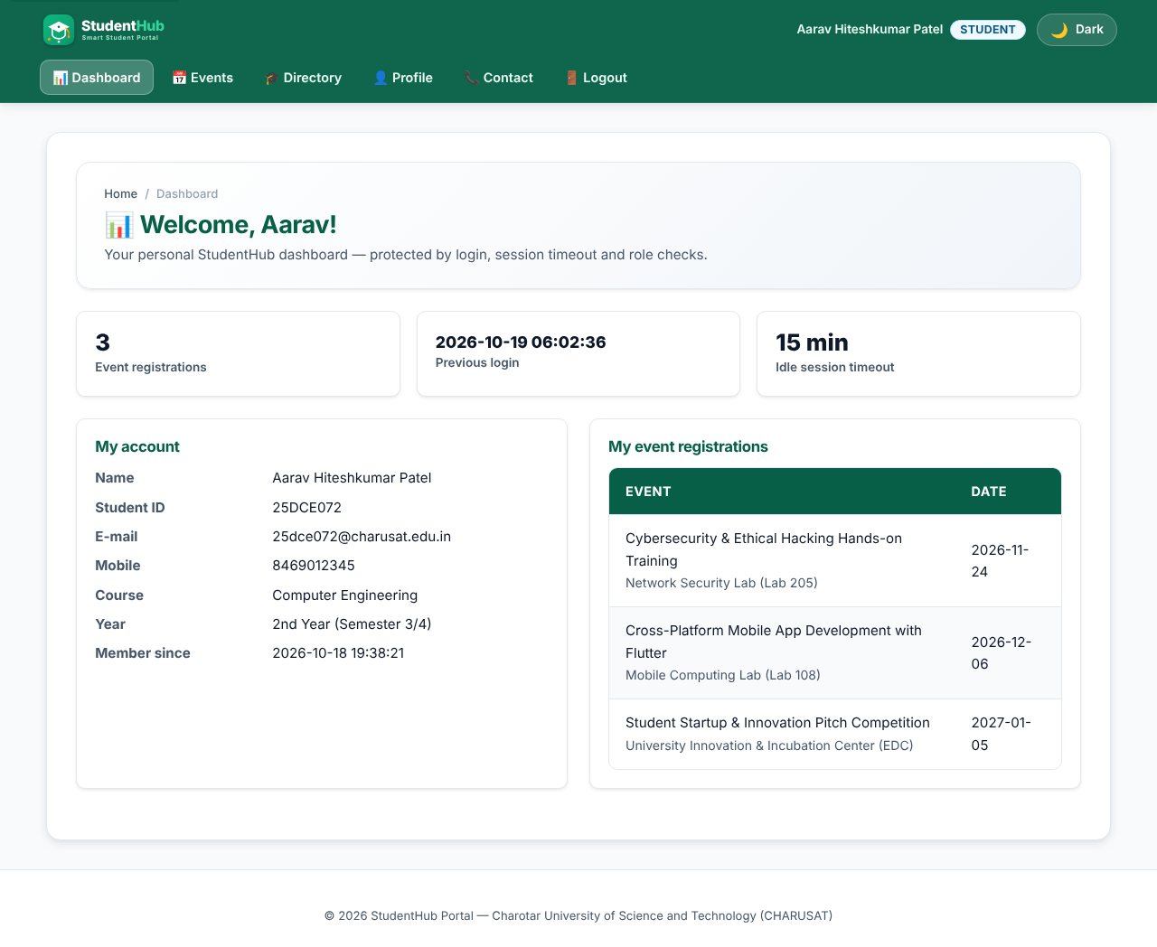
Student login success - student dashboard with previous-login time
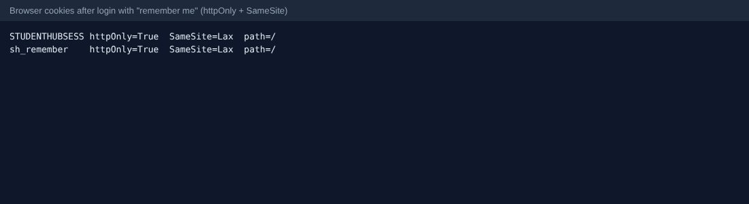
Cookie attributes: HttpOnly, SameSite; remember-me cookie
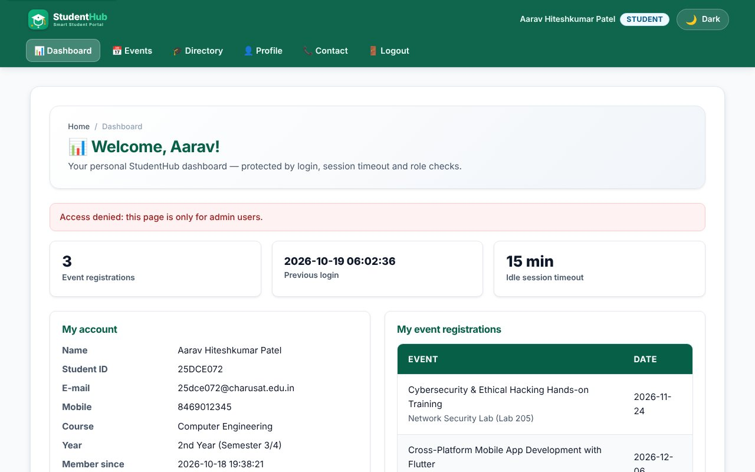
Unauthorized access: a student opening an admin page is sent back with "Access denied"
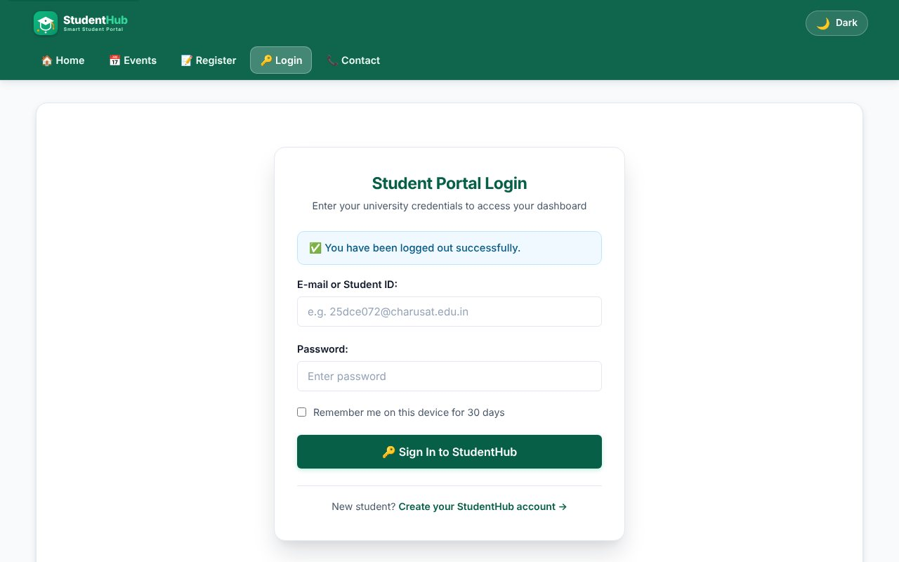
Logout - session destroyed, login page with message
After logout the dashboard is blocked again
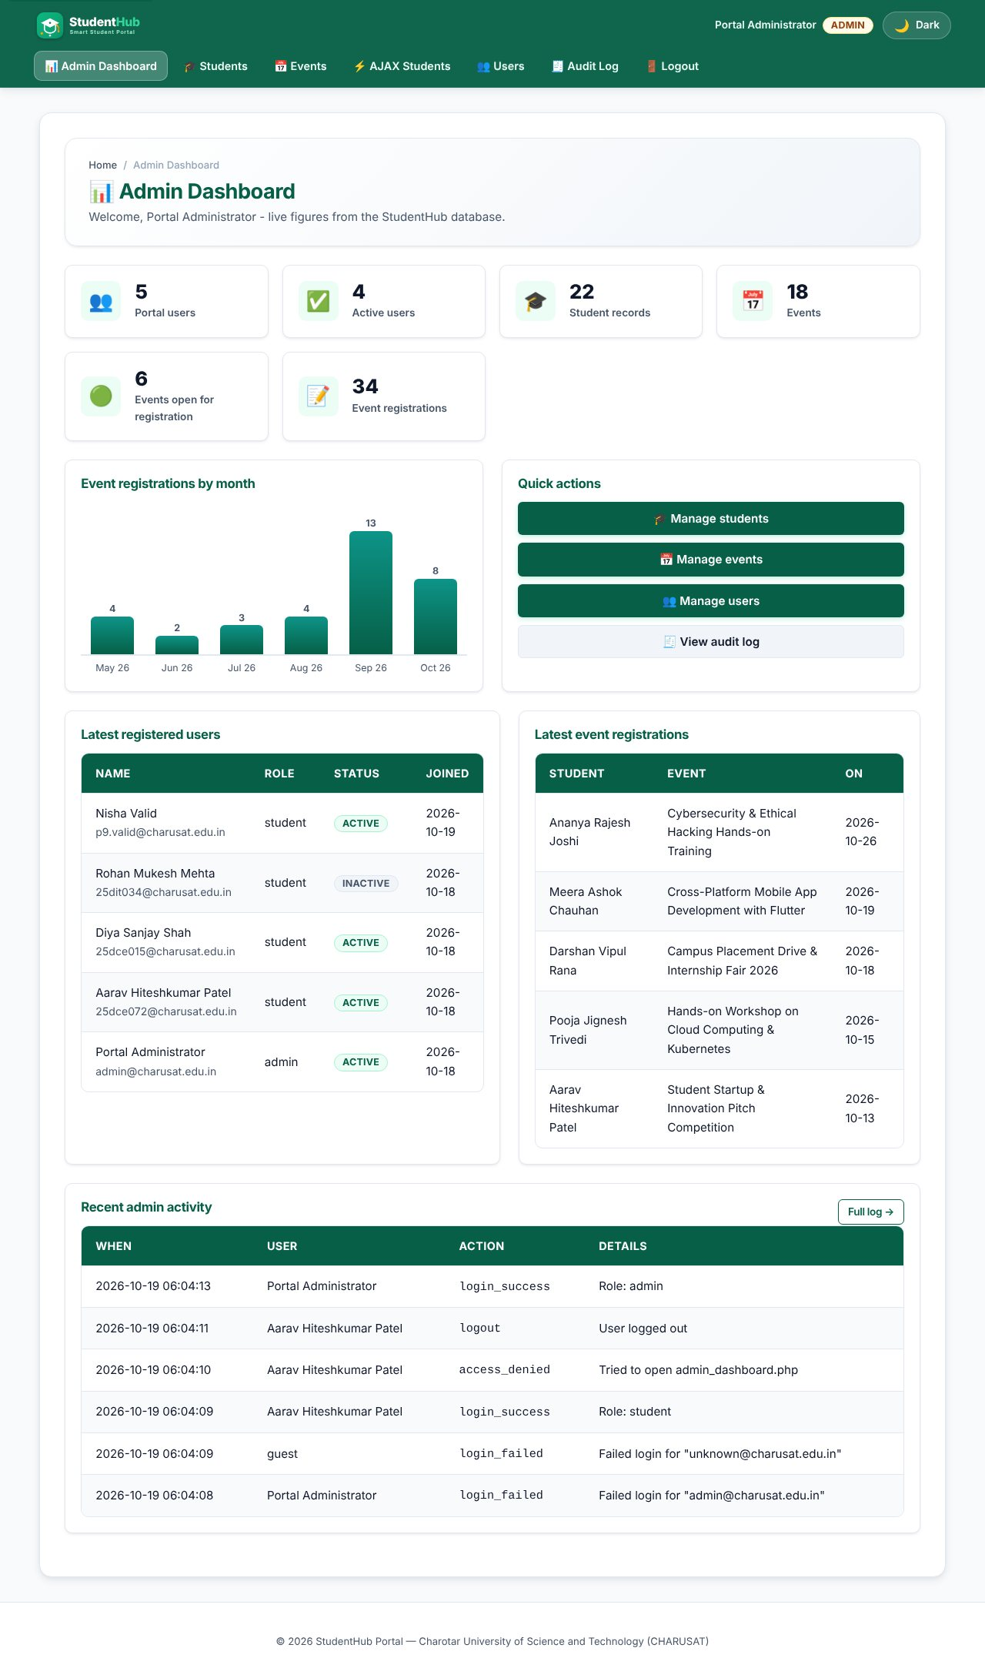
Admin login goes to the admin dashboard
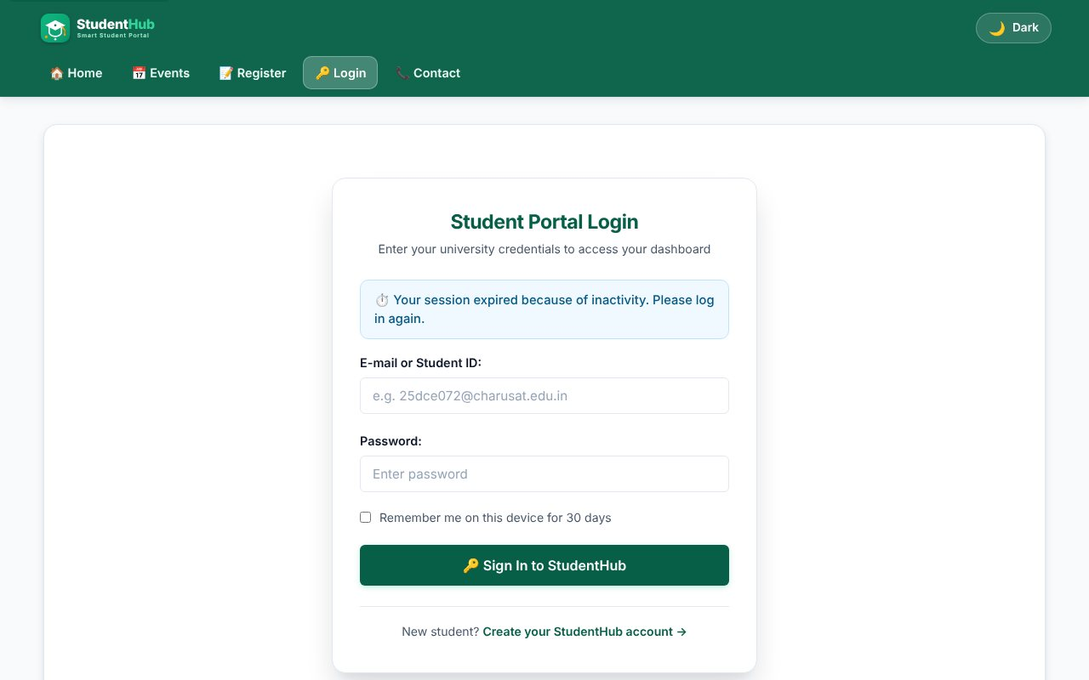
Idle timeout (test server set to 4 seconds): redirect to login with the timeout message
TEST CASES :
# | Input / action | Expected result | Result
1 | Open dashboard.php as guest | Redirect to login.php | Pass
2 | Correct e-mail + wrong password | "Invalid credentials" message, audit row login_failed | Pass
3 | Unknown user | Same message as test 2 | Pass
4 | Student logs in (roll number) | Student dashboard; session ID changes after login | Pass
5 | Admin logs in | Admin dashboard | Pass
6 | Student opens admin page | Access denied, redirected to own dashboard | Pass
7 | Logout | Session and cookie removed; back button cannot reopen the dashboard | Pass
8 | Stay idle longer than SESSION_TIMEOUT | Next request redirects to login?timeout=1 | Pass
9 | Inactive account with correct password | Login blocked | Pass
10 | 5 wrong passwords in a row | Login locked for 30 seconds | Pass
11 | Remember me, delete session cookie | Logged in again from the token; token rotated; old token rejected | Pass
12 | Cookie flags | HttpOnly and SameSite=Lax set on the session cookie | Pass

KEY QUESTIONS :

1. Are sessions started and destroyed securely?
Sessions use a fixed name, an HttpOnly cookie (JavaScript cannot read it), SameSite=Lax, Secure when HTTPS is used and session.use_strict_mode so unknown IDs are rejected. session_regenerate_id(true) is called right after a successful login to prevent session fixation. Logout empties $_SESSION, expires the cookie, calls session_destroy() and deletes the remember-me token from the database.
session_set_cookie_params(['lifetime' => 0, 'path' => '/', 'secure' => $https, 'httponly' => true, 'samesite' => 'Lax']);
ini_set('session.use_strict_mode', '1');
...
session_regenerate_id(true);

2. Is password_verify() used correctly?
Yes. The user row is loaded with a prepared statement and the typed password is compared with the stored hash only through password_verify(). The same error text is shown for "unknown user" and "wrong password", so an attacker cannot find out which e-mails exist.
if ($user && password_verify($password, $user['password_hash'])) {
login_user($conn, $user);
redirect($user['role'] === 'admin' ? ADMIN_HOME : STUDENT_HOME);
}

3. Is unauthorized dashboard access blocked?
Every protected page starts with require_login() or require_role('admin'). A guest is redirected to the login page; a logged-in student who requests an admin page gets an "Access denied" flash message and is sent to the student dashboard. The role is read from the session that was created from the database, never from a URL or form field.
$admin = require_role('admin'); // top of every admin page

4. Is session timeout implemented?
Yes. The time of the last request is stored in $_SESSION['last_activity']. On each request auth_boot() compares it with SESSION_TIMEOUT (15 minutes, changeable through config); if it is older, the timeout is written to the audit log, the session is destroyed and the user goes to login.php?timeout=1. For the screenshot a test server with a 4-second timeout was used.
if (time() - ($_SESSION['last_activity'] ?? 0) > SESSION_TIMEOUT) {
destroy_session();
redirect(LOGIN_URL . '?timeout=1');
}
$_SESSION['last_activity'] = time();

5. Are admin and student users redirected to the correct dashboards?
Yes, after login the role decides the target: admin -> Practical-14/admin_dashboard.php, student -> Practical-10/dashboard.php. Opening login.php while already logged in sends the user to the same place. The menu is also role based (guest, student, admin) so users only see links they may use.

6. Intermediate and advanced extensions
Last login: users.last_login is updated at each login and the previous value is shown on the dashboard. Remember me: a random selector:validator pair is placed in a cookie; only the SHA-256 hash of the validator is stored in remember_tokens, with an expiry. Every use issues a new token, and a stolen old token stops working. Deactivating a user (Practical 14) removes their tokens.

