PRACTICAL-11

AIM: Build student management (CRUD) with PHP and MySQL: list, add, edit, delete, search and filter, with at least 20 seeded records.

SOURCE CODE :
https://github.com/Aarav280907/WEB/tree/main/Practical(1-4)(Studenthub)/Practical-11

PREVIEW:
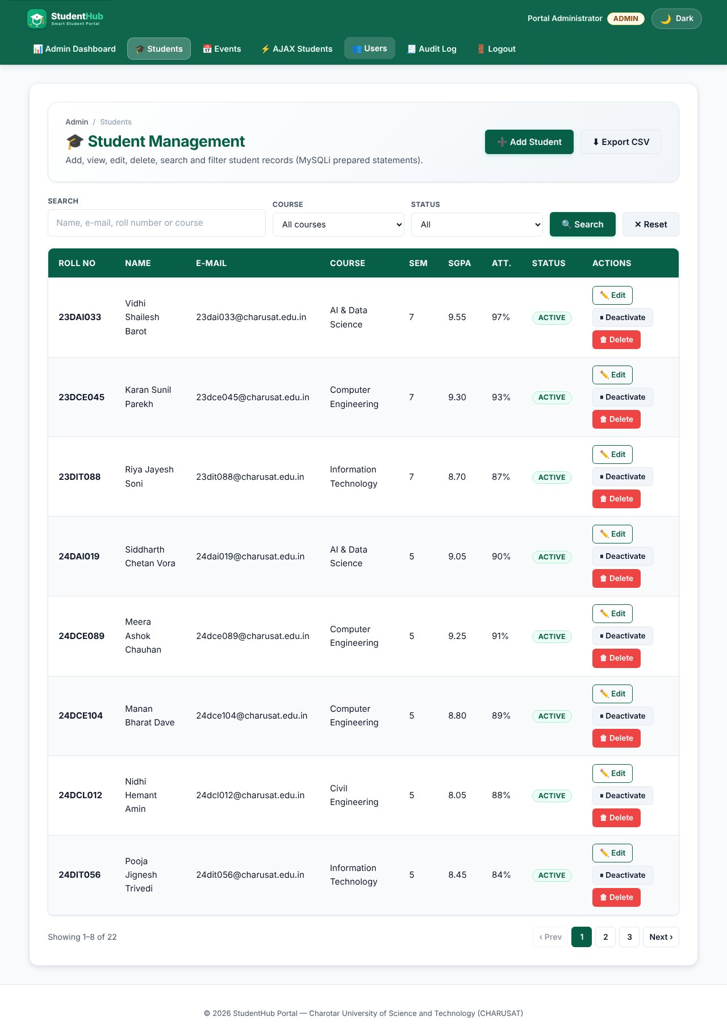
Student list: 22 seeded records, 8 per page, with pagination
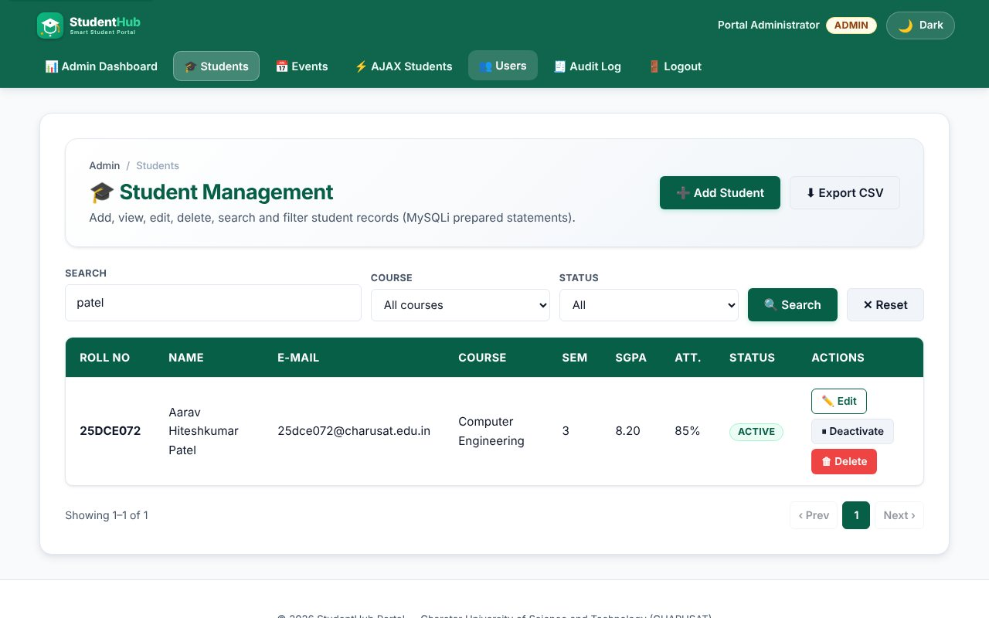
Search by name
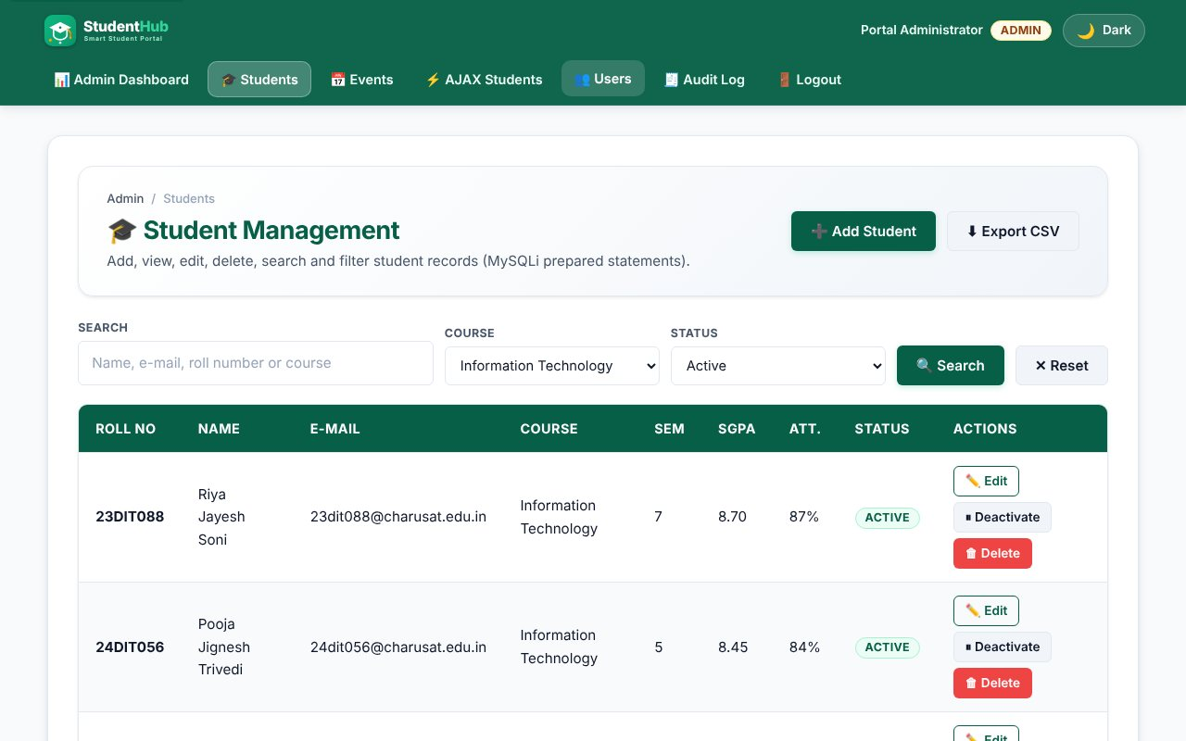
Course + status filter
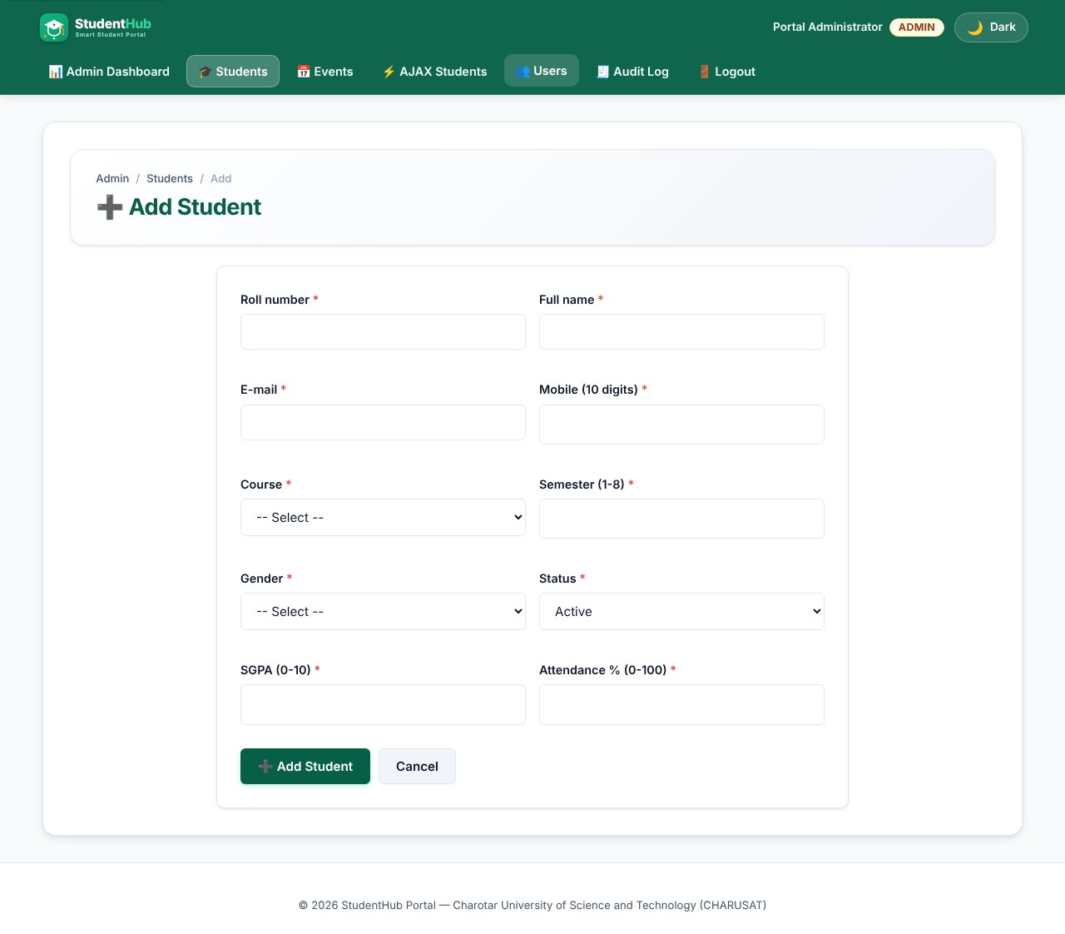
Add student form
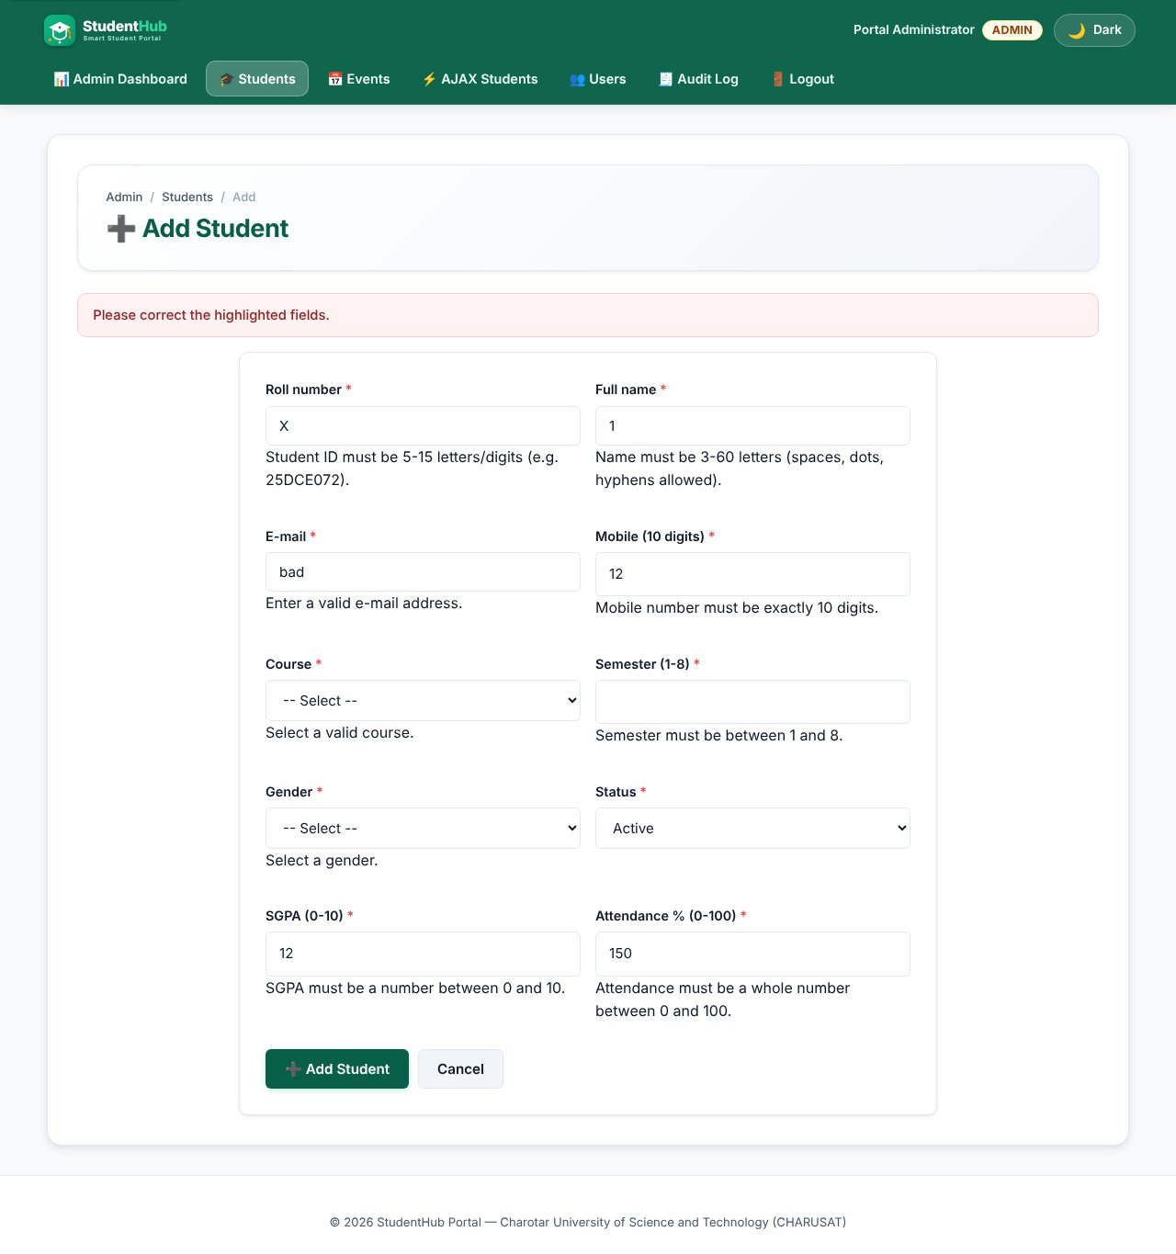
Server-side validation errors on the form
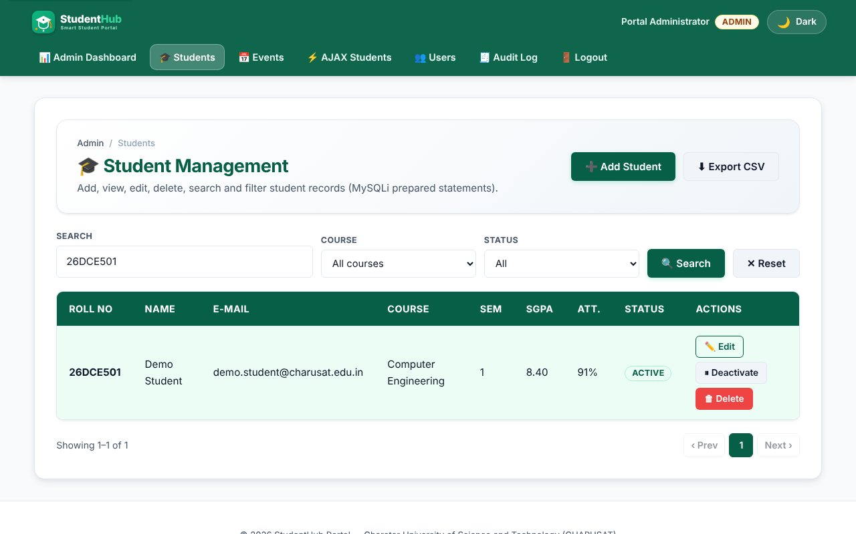
INSERT - new student shown after saving
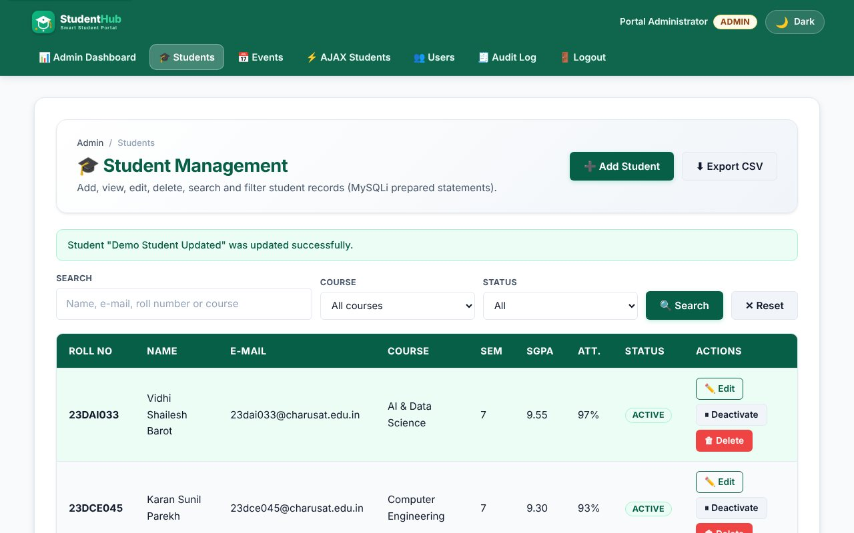
UPDATE - edited student saved
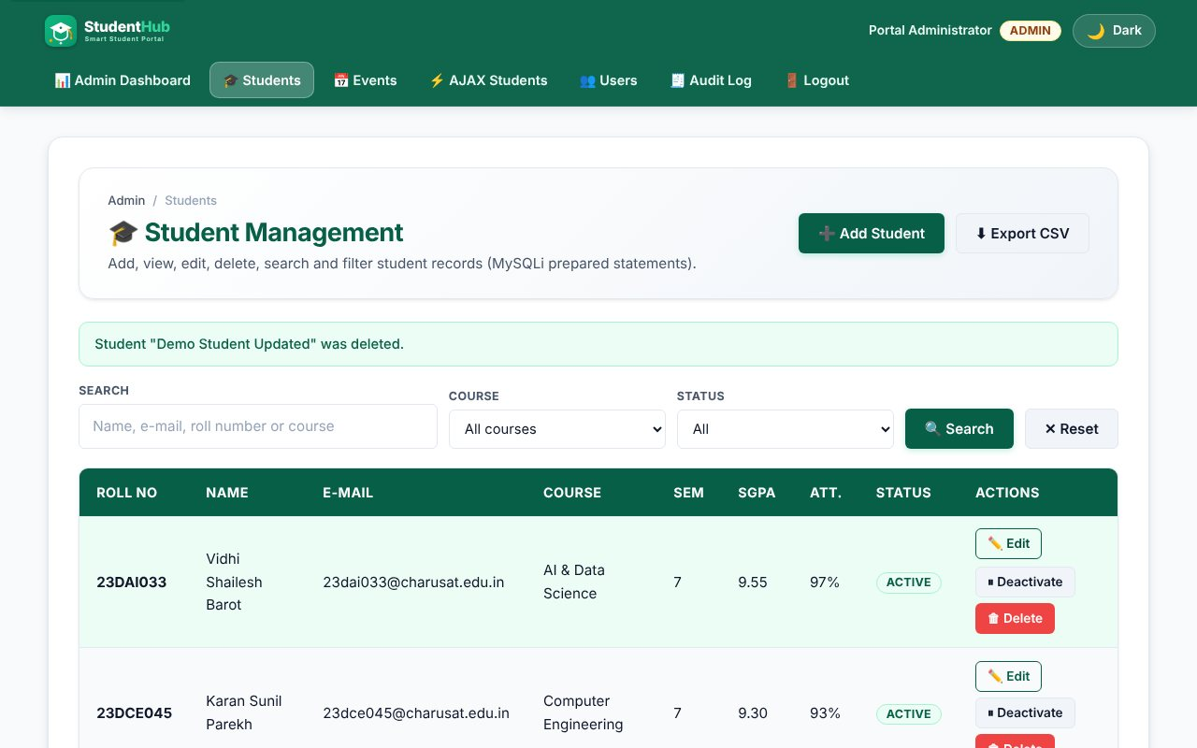
DELETE - after the confirmation dialog the record is removed
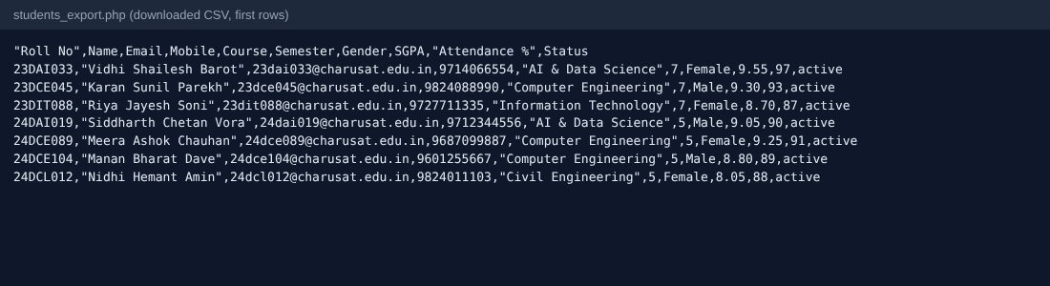
CSV export (intermediate extension)
TEST CASES :
# | Input / action | Expected result | Result
1 | Open list | 22 seeded students, page 1 shows 8 | Pass
2 | Search "patel" | Matching rows only (name, e-mail, roll number, course are searched) | Pass
3 | Search "%" | Treated as normal text, not a wildcard (LIKE escaped) | Pass
4 | Course + status filter | Filters combine with search and pagination | Pass
5 | Add valid student | INSERT; success message; audit log row | Pass
6 | Add duplicate roll number / e-mail | Error from the UNIQUE key (code 1062) | Pass
7 | Invalid e-mail, 2-digit mobile, SGPA 12, attendance 150 | Field errors, nothing saved | Pass
8 | Edit name | UPDATE; success message | Pass
9 | Delete | Browser confirm: "Delete ... permanently?"; row removed after OK | Pass
10 | Deactivate / Activate (soft delete) | Status switches; row is kept | Pass
11 | POST action with a bad CSRF token | "Invalid request" - nothing changes | Pass
12 | Student role opens the list | Access denied | Pass
13 | Export CSV | File with BOM, header row and the filtered rows | Pass

SQL dump:
Practical-11/students_dump.sql contains the students table and its 22 seeded rows.

KEY QUESTIONS :

1. Do SELECT, INSERT, UPDATE and DELETE work?
Yes, all four are used with prepared statements. SELECT: students_list.php (with COUNT(*) for pagination and LIMIT/OFFSET); INSERT and UPDATE: student_form.php (one form for add and edit, chosen by ?id=); DELETE and status change: student_action.php.
$stmt = $conn->prepare('INSERT INTO students (student_id, fullname, email, mobile, course, semester, gender, sgpa, attendance, status) VALUES (?,?,?,?,?,?,?,?,?,?)');
$stmt = $conn->prepare('UPDATE students SET fullname=?, ... WHERE id=?');
$stmt = $conn->prepare('DELETE FROM students WHERE id = ?');

2. Is search by name, e-mail and course implemented?
Yes. One text box searches name, e-mail, roll number and course with LIKE, and the Course and Status filters are added to the WHERE clause only when selected. The WHERE part is built from fixed text; the values are bound. like_escape() escapes % and _ so users cannot use them as wildcards.
$where[] = '(fullname LIKE ? OR email LIKE ? OR student_id LIKE ? OR course LIKE ?)';
$like = '%' . like_escape($q) . '%';

3. Are deletes confirmed?
Yes. The delete button is inside a form with data-confirm="Delete NAME permanently?"; portal-init.js shows window.confirm() and cancels the submit unless the user agrees. Deleting is also a POST request with a CSRF token (not a link), so another web page cannot trigger it.

4. Intermediate and advanced extensions
CSV export (students_export.php) writes the current search/filter result with a UTF-8 BOM for Excel and prefixes cells that start with =, +, - or @ to stop CSV formula injection. Soft delete: the Deactivate button sets status = 'inactive' instead of removing the row; the list can be filtered by status.

