PRACTICAL-12

AIM: Build event management (CRUD) with poster upload, server-side upload validation and success/failure messages.

SOURCE CODE :
https://github.com/Aarav280907/WEB/tree/main/Practical(1-4)(Studenthub)/Practical-12

PREVIEW:
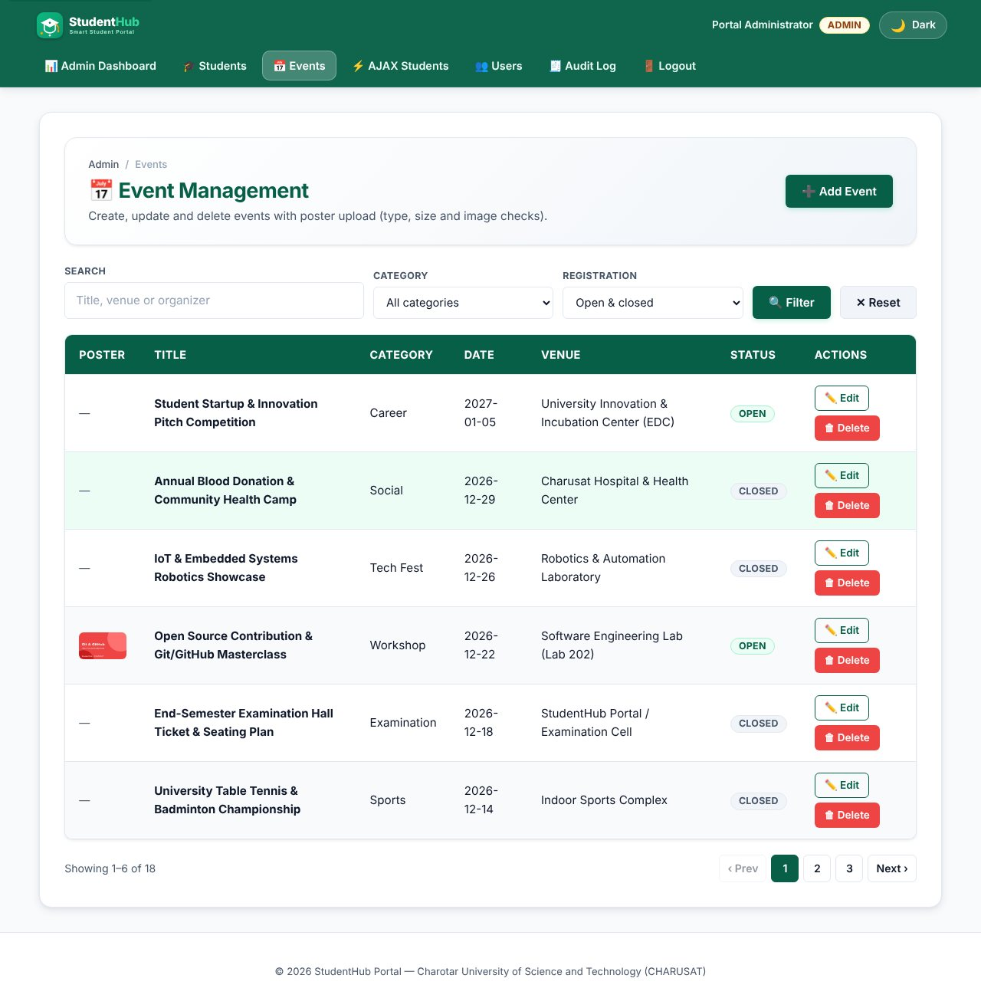
Event list with poster thumbnails
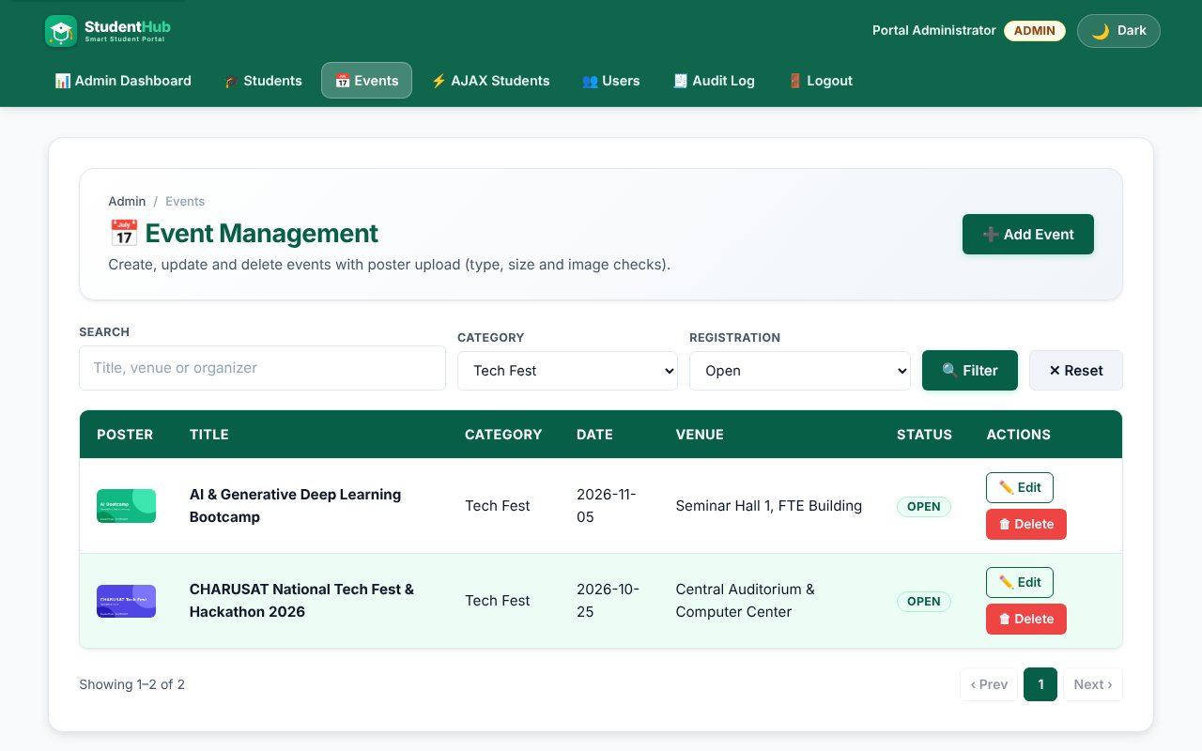
Category and open/closed filter (intermediate extension)
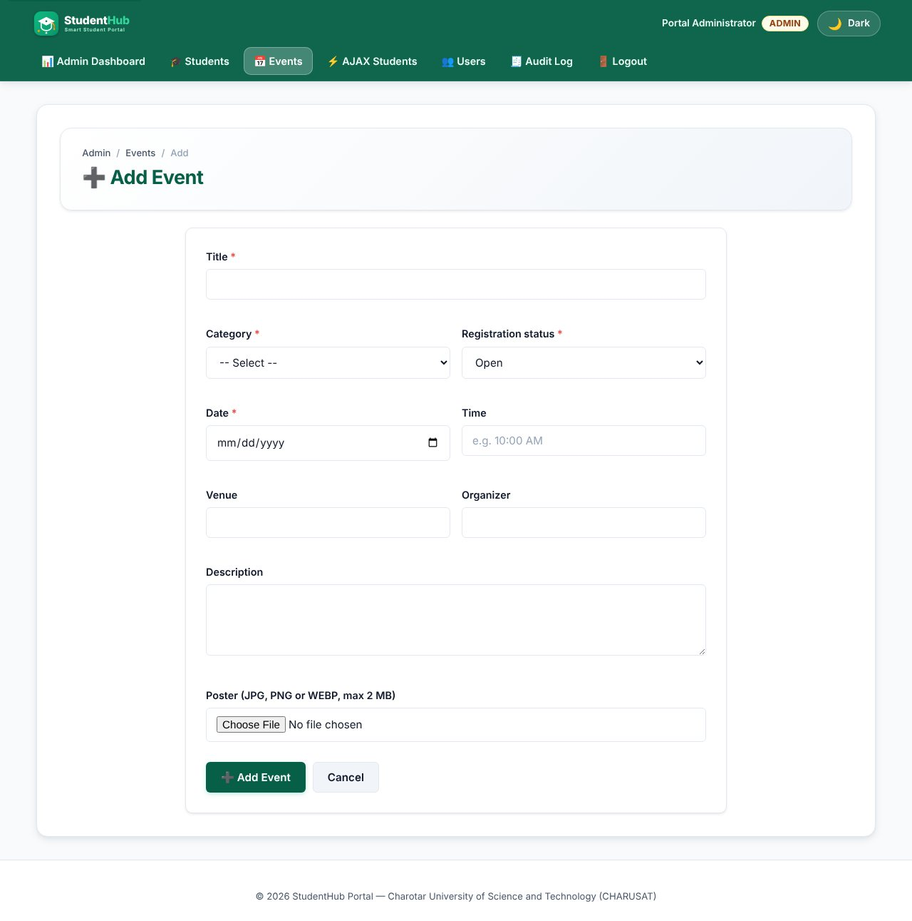
Add event form with poster field
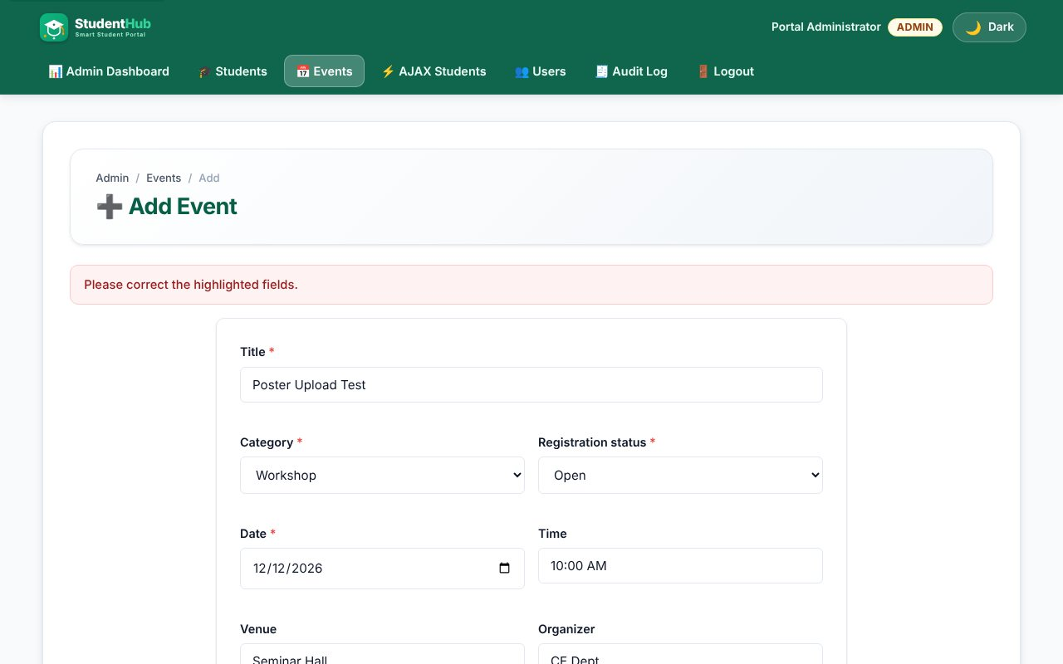
Upload validation: a PHP script renamed as a poster is rejected
Upload validation: a text file is rejected
Upload validation: a file larger than 2 MB is rejected
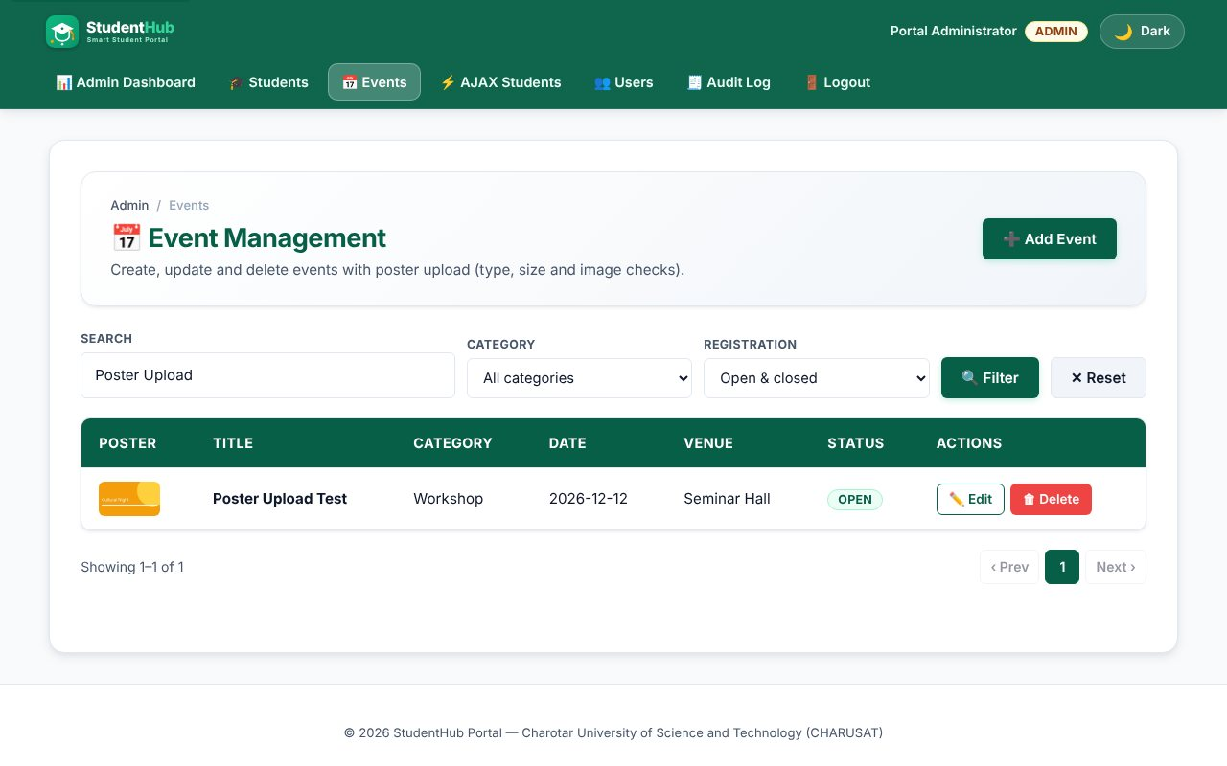
INSERT: event added with a valid JPG poster
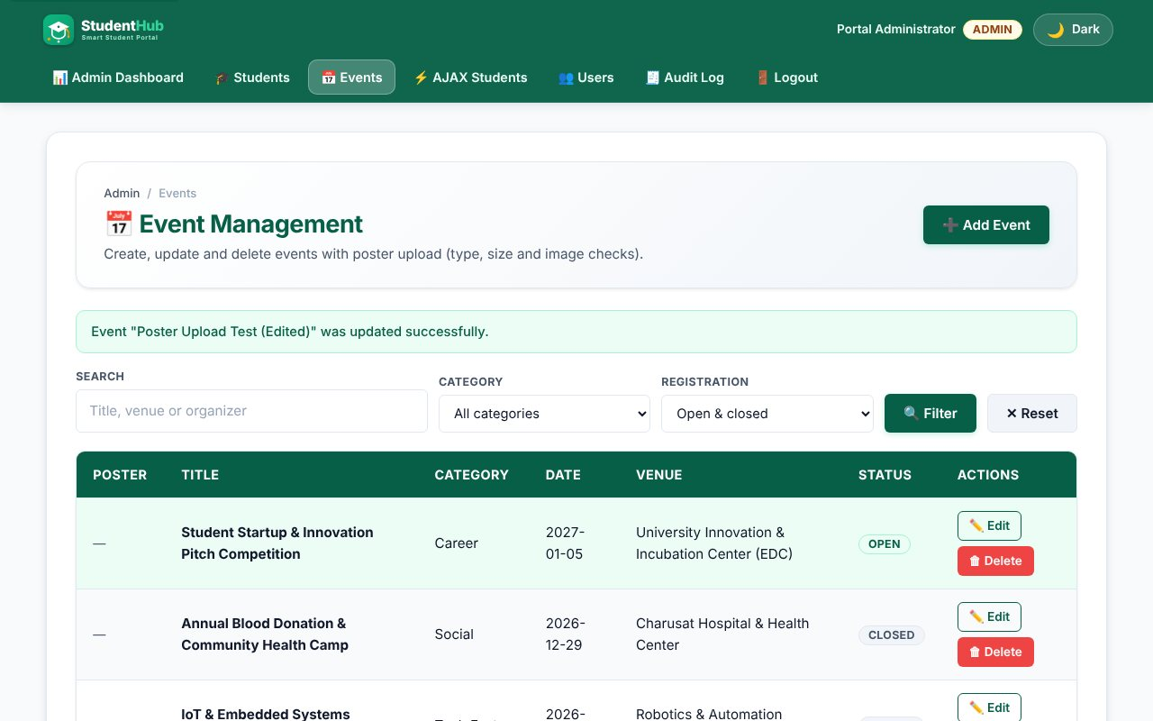
UPDATE: event edited (status closed)
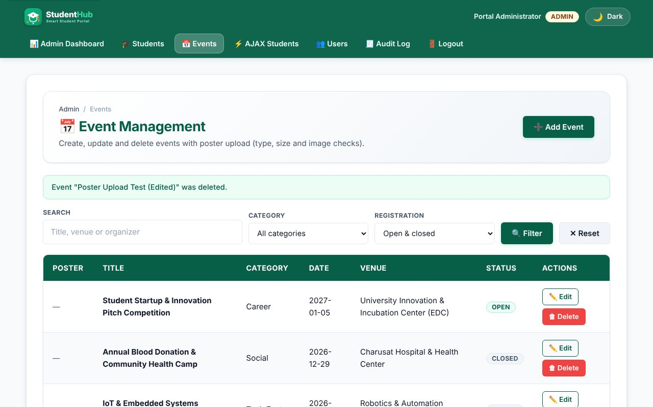
DELETE: event and its poster file removed
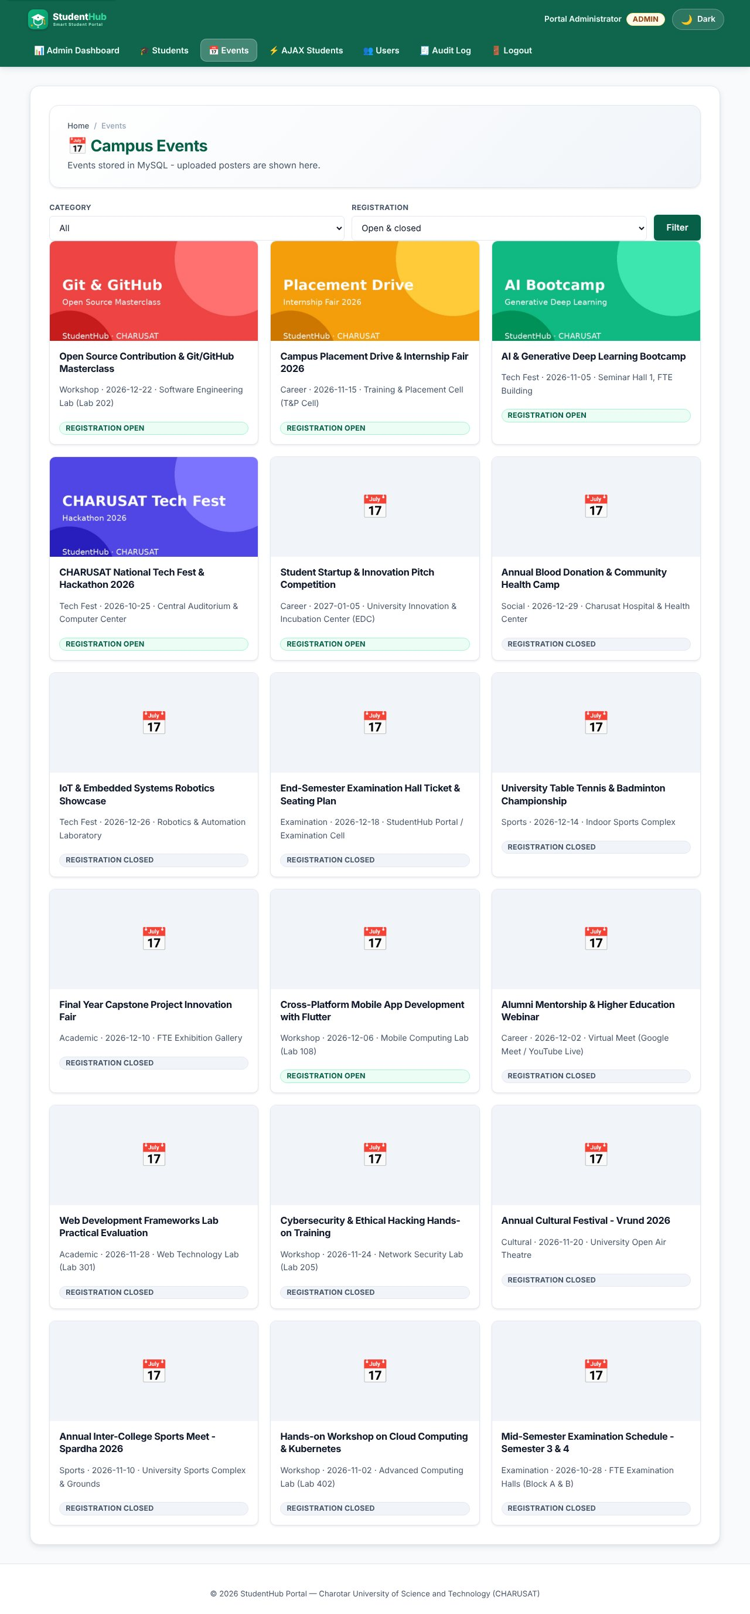
Public events page reading from MySQL with posters
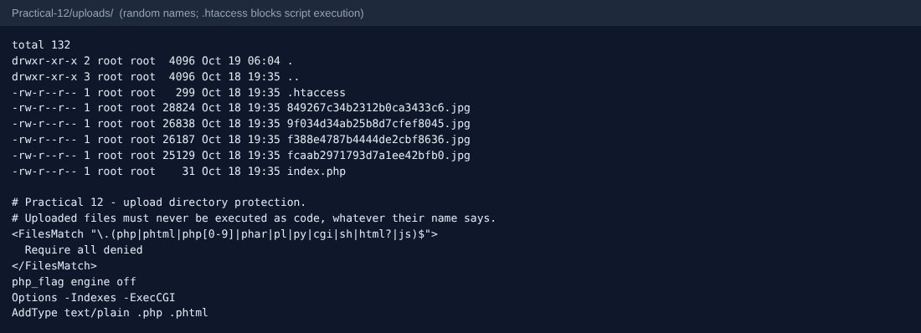
Upload folder: random file names and the protective .htaccess
TEST CASES :
# | Input / action | Expected result | Result
1 | Add event with valid poster (JPG) | Saved; file stored with a random name; audit log row | Pass
2 | evil.php as poster | Rejected - only JPG, PNG, WEBP allowed | Pass
3 | PHP code saved as fake.jpg | Rejected - real MIME type is text, not an image | Pass
4 | doc.txt | Rejected | Pass
5 | 4 MB random image | Rejected - larger than 2 MB | Pass
6 | No poster | Event saved without a poster (optional) | Pass
7 | Title "x" | Error: 5-150 characters | Pass
8 | Edit event, keep poster | Old poster kept | Pass
9 | Edit event, upload new poster | New file saved, old file deleted | Pass
10 | Delete event | Row and poster file removed; audit log row | Pass
11 | Filter category = Tech Fest, status = open | Only matching events | Pass

SQL dump:
Practical-12/events_dump.sql contains the events table with 18 rows; sample_posters.sql attaches the demo posters.

KEY QUESTIONS :

1. Do add, update and delete work?
Yes. events_admin.php lists and filters events, event_form.php inserts or updates (?id= decides), event_action.php deletes (POST + CSRF). Each change is written to audit_logs. If saving to the database fails after a file was stored, the new file is deleted again so no orphan files remain.

2. Is the UI linked to the database?
Yes. The admin list and the public gallery (events_public.php) are both read from the events table; the poster column stores only the file name and poster_url() builds a safe URL from it. Category and status come from white-lists (CATEGORIES, open/closed).

3. Are uploads validated for type and size?
Yes, in save_poster(): (1) the PHP upload error code is checked; (2) size <= 2 MB (also limited in the form with MAX_FILE_SIZE); (3) the real MIME type is read from the file content with finfo, not from the name the browser sends; only image/jpeg, image/png and image/webp pass; (4) getimagesize() must succeed, proving it is a real image; (5) the stored name is random (bin2hex(random_bytes(12))) with the extension taken from the detected MIME type, so a user can never choose the file name or extension.
$mime = (new finfo(FILEINFO_MIME_TYPE))->file($file['tmp_name']);
if (!isset(POSTER_TYPES[$mime])) return [null, 'Only JPG, PNG or WEBP images are allowed.'];
if (@getimagesize($file['tmp_name']) === false) return [null, 'The file is not a valid image.'];
$name = bin2hex(random_bytes(12)) . '.' . POSTER_TYPES[$mime];

4. Are success and failure messages shown?
Yes. A green flash message appears after add / update / delete (Post/Redirect/Get), and a red alert plus a message under the poster field appears for every failed validation or upload.

5. Advanced extension - image renaming, folder protection and audit log
Images are renamed randomly. Practical-12/uploads/.htaccess denies execution of .php/.phtml/.html/.js files and turns the PHP engine off in that folder, and an index.php returns 403 to avoid directory listing. Create, update and delete are recorded in audit_logs. Four sample posters are attached to seeded events by sample_posters.sql.

