PRACTICAL-14

AIM: Build the admin dashboard with role-based access, dynamic menu, live statistics and an audit log of important actions.

SOURCE CODE :
https://github.com/Aarav280907/WEB/tree/main/Practical(1-4)(Studenthub)/Practical-14

PREVIEW:
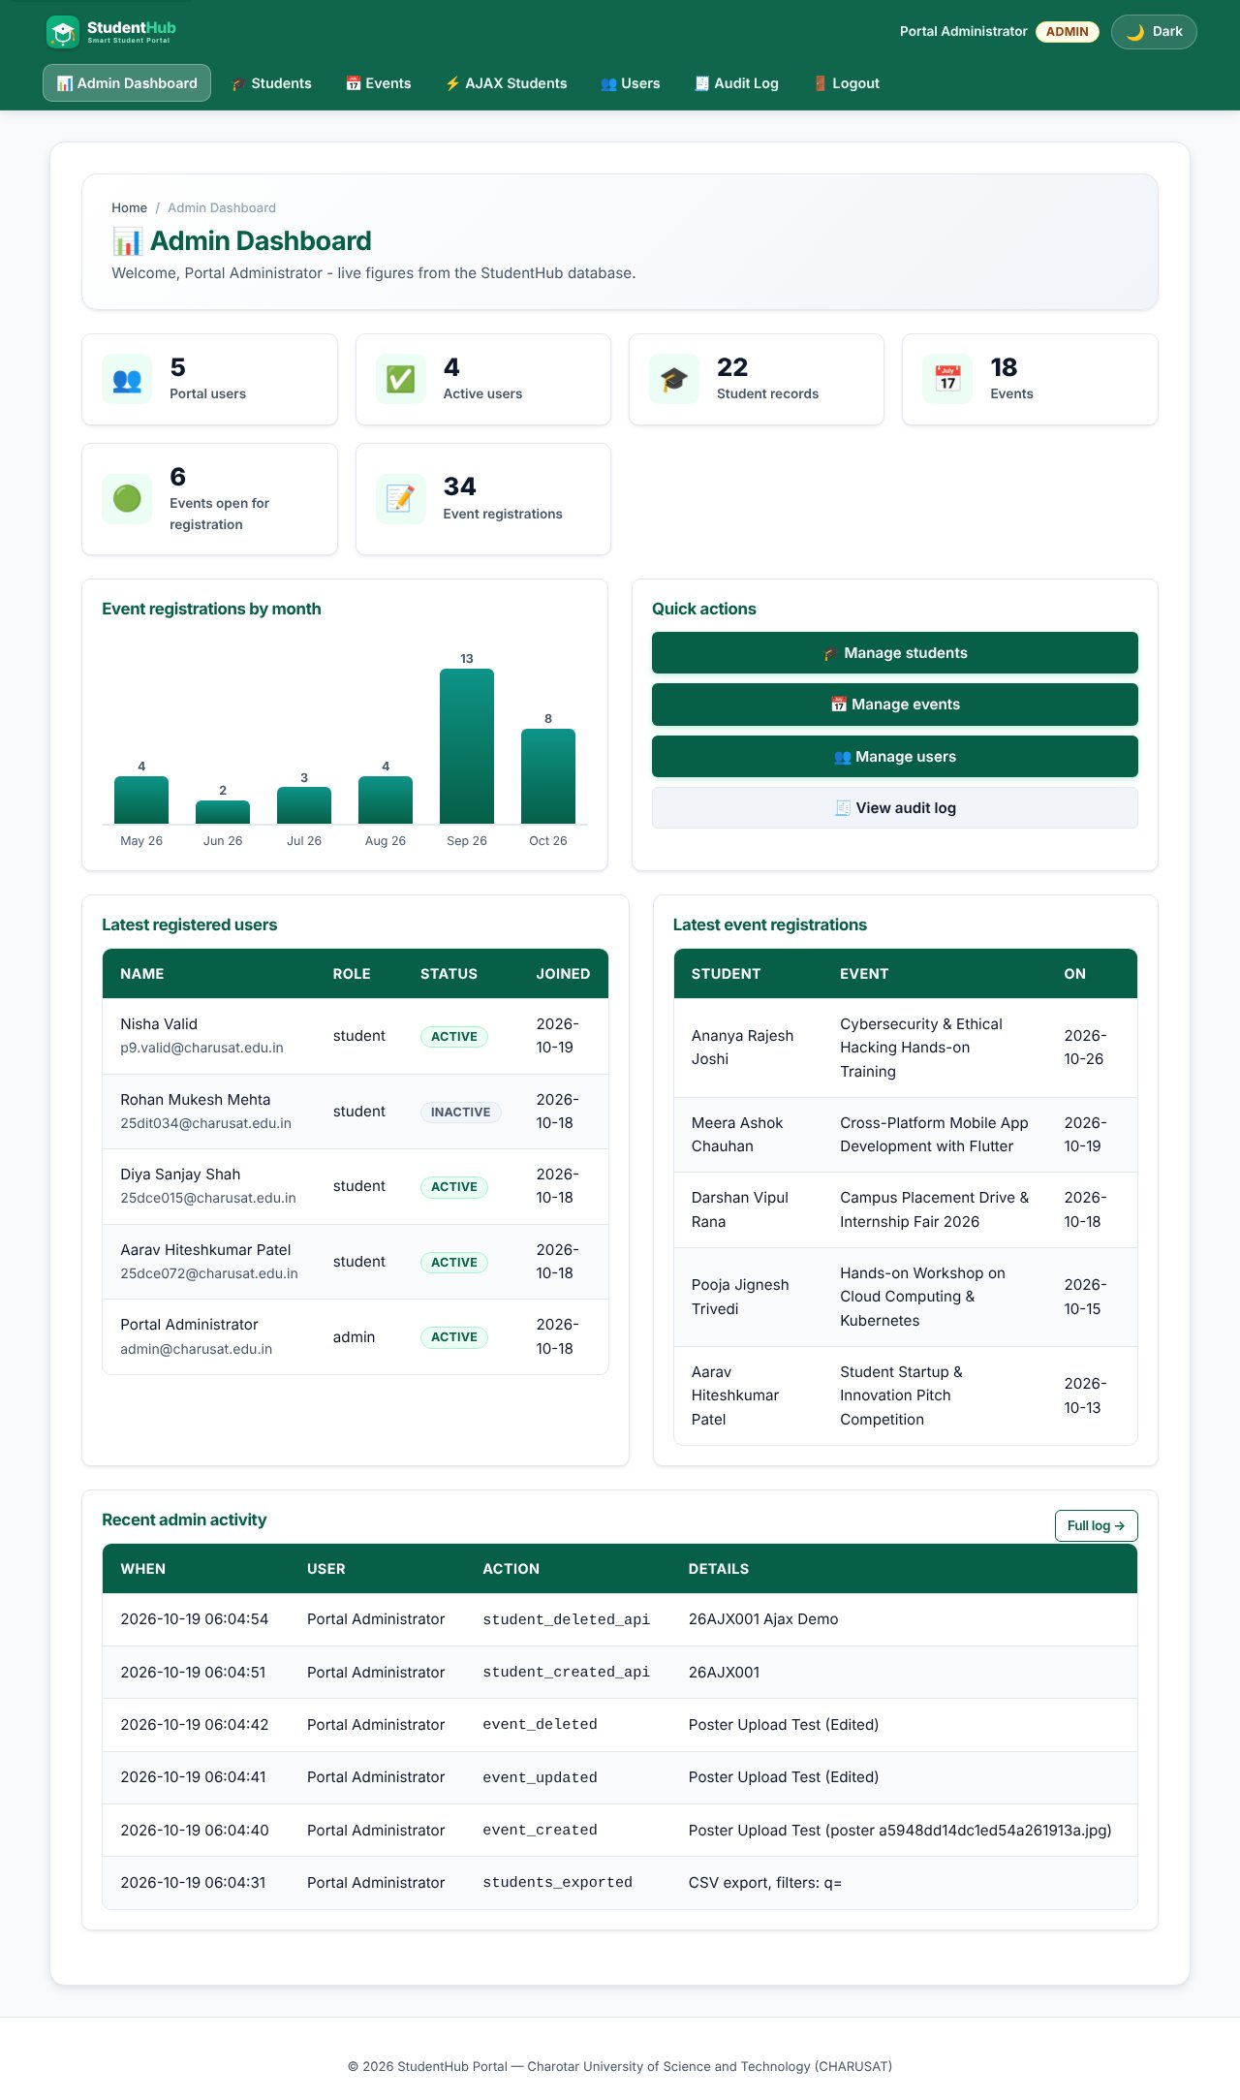
Admin dashboard: statistics from the database, registrations-by-month chart, latest users and registrations, recent audit rows
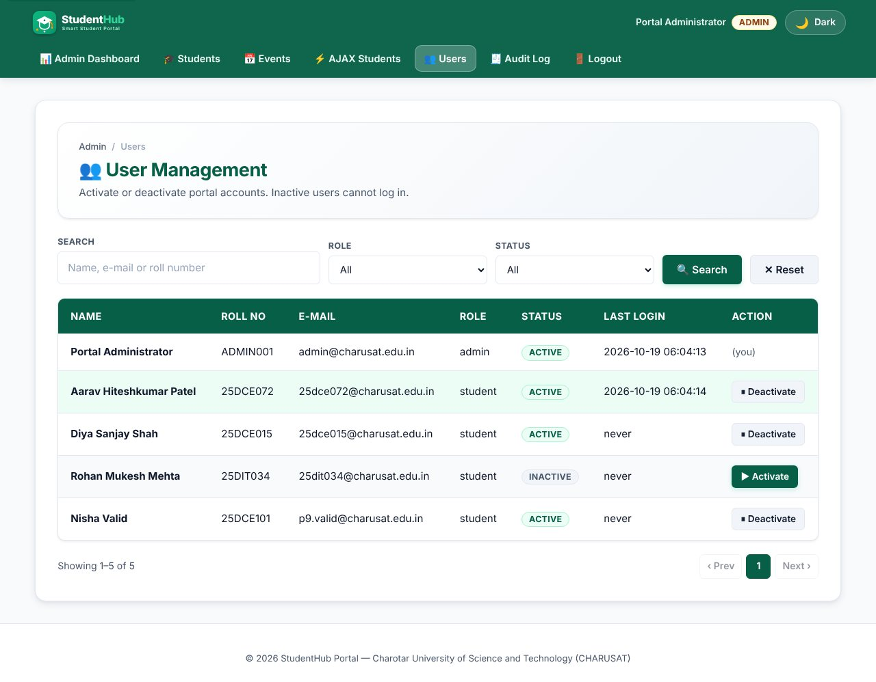
User management with active / inactive toggle
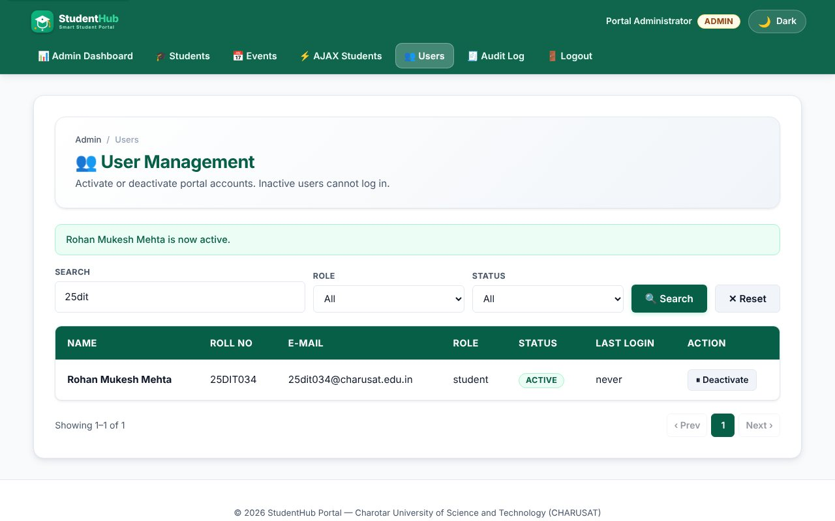
Toggling a user shows a message and is recorded in the audit log
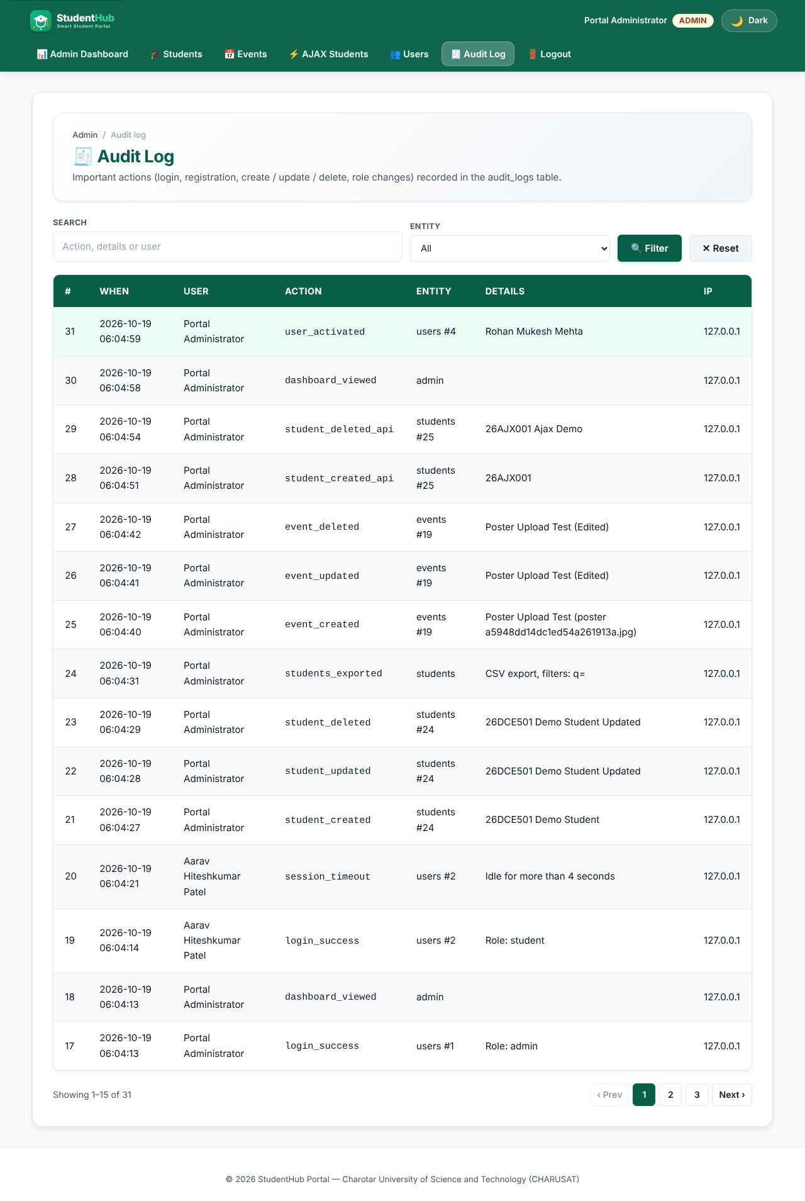
Audit log page
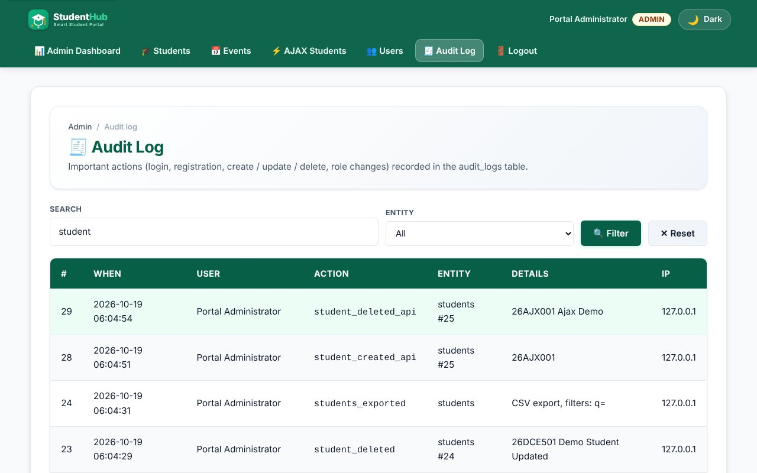
Audit log search filter
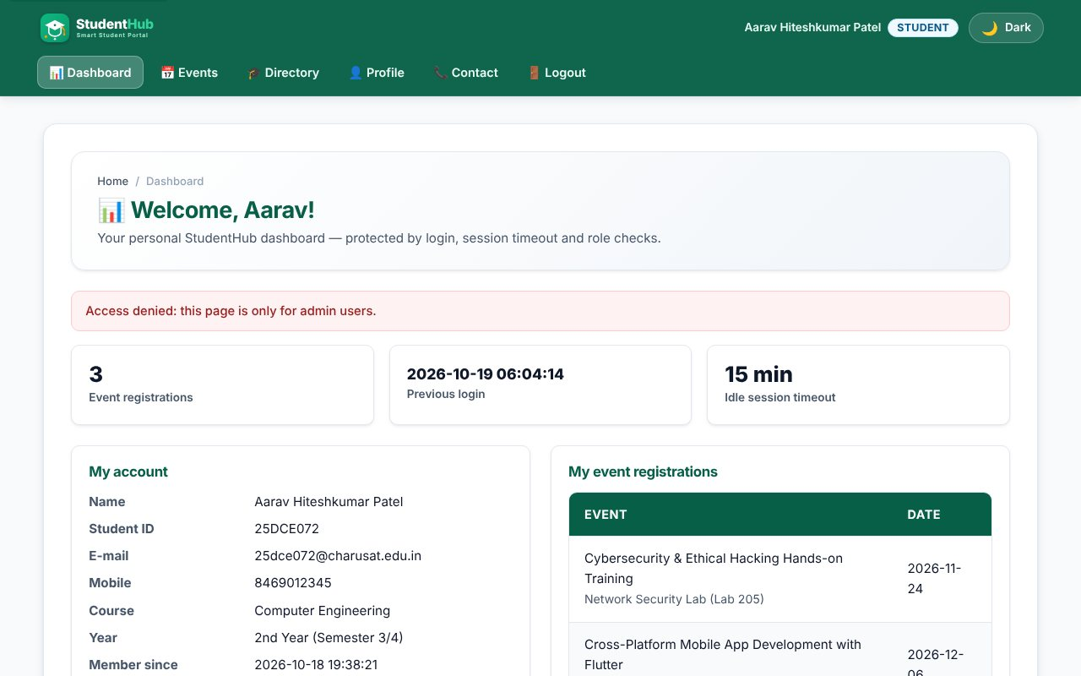
A student cannot open admin pages
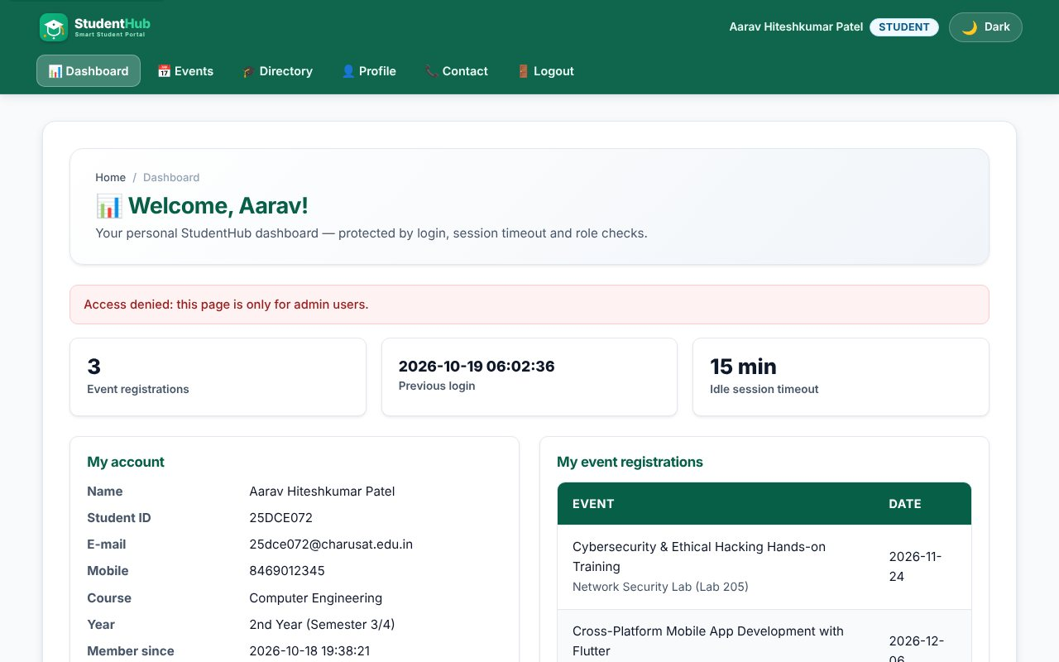
Unauthorized access redirect (student on admin page)
TEST CASES :
# | Input / action | Expected result | Result
1 | Guest opens admin_dashboard.php | Redirect to login | Pass
2 | Student opens dashboard / users / audit log | Access denied, redirected | Pass
3 | Admin opens dashboard | Numbers equal the database: 5 users, 22 students, 18 events, 34 registrations | Pass
4 | Admin deactivates another user | Status inactive; user cannot log in; audit row user_deactivated | Pass
5 | Admin deactivates himself | Refused: "You cannot deactivate your own account" | Pass
6 | Activate again | Status active; audit row user_activated | Pass
7 | POST toggle without CSRF token | Refused, nothing changes | Pass
8 | Audit log search "user_" | Only matching actions shown, newest first | Pass
9 | Create / update / delete student or event, login failures, timeouts | Each creates an audit_logs row (user, action, entity, details, IP, time) | Pass
10 | Menu as guest / student / admin | Different links for each role | Pass

KEY QUESTIONS :

1. Are dashboard values loaded dynamically?
Yes. Every number is a COUNT(*) query run on each page load (users, active users, students, events, open events, registrations). The bar chart is built from GROUP BY DATE_FORMAT(registered_at, '%Y-%m') for the last six months, and the latest users, registrations and audit rows come from JOIN queries. Nothing is hard-coded.
$res = $conn->query("SELECT DATE_FORMAT(registered_at,'%Y-%m') m, COUNT(*) c FROM registrations
WHERE registered_at >= DATE_SUB(DATE_FORMAT(CURDATE(),'%Y-%m-01'), INTERVAL 5 MONTH) GROUP BY m");

2. Is access restricted to admin?
Yes. Every page in Practical 14 begins with require_role('admin'). The check is on the server for each request, so hiding the menu link is only cosmetic.

3. Do role-based menus work?
Yes. sh_menu() in layout.php returns a different list of links for a guest (Home, Events, Register, Login, Contact), a student (Dashboard, Events, Directory, Profile, Logout) and an admin (Admin Dashboard, Students, Events, AJAX Students, Users, Audit Log, Logout). The active page is marked with aria-current="page".

4. Are important admin actions recorded in audit_logs?
Yes. audit_log($conn, $userId, $action, $entity, $entityId, $details) stores the user, action, entity, details, IP address and time with a prepared INSERT. It is called for registration, login success / failure / blocked / timeout, student and event create / update / delete (forms and API), user activate / deactivate and dashboard views. audit_logs.php lets the admin search and filter the entries.
audit_log($conn, $admin['id'], $new === 'active' ? 'user_activated' : 'user_deactivated', 'users', $uid, $u['fullname']);

5. Intermediate and advanced extensions
Active / inactive toggle in users.php (not for your own account; the user's remember-me tokens are removed when deactivated). Registrations-by-month bar chart, drawn with CSS and an aria-label that lists the values for screen readers.

