PRACTICAL-15

AIM: Integrate all modules of the StudentHub portal, test the complete system, finish the documentation and deploy it locally (Apache virtual host).

SOURCE CODE :
https://github.com/Aarav280907/WEB/tree/main/Practical(1-4)(Studenthub)/Practical-15

PREVIEW:
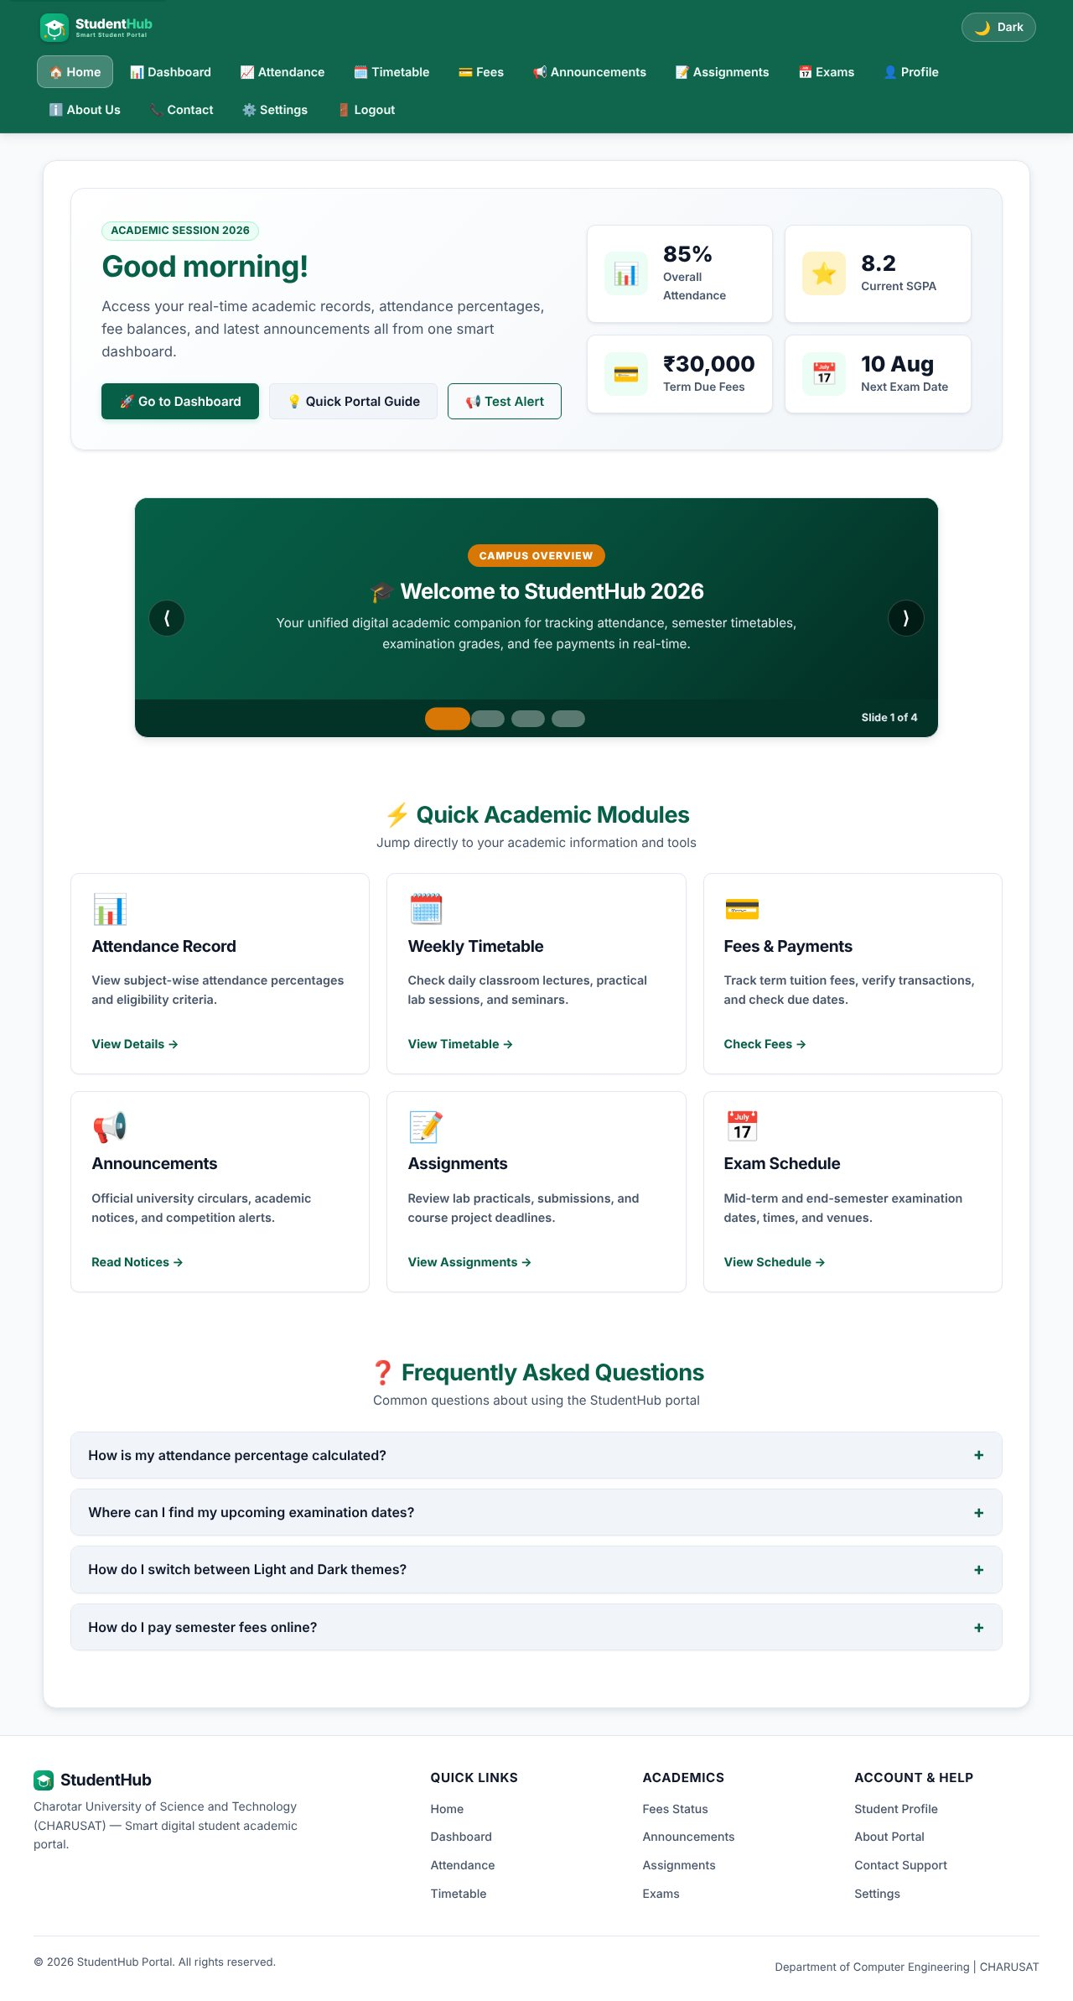
Home page - entry point of the portal
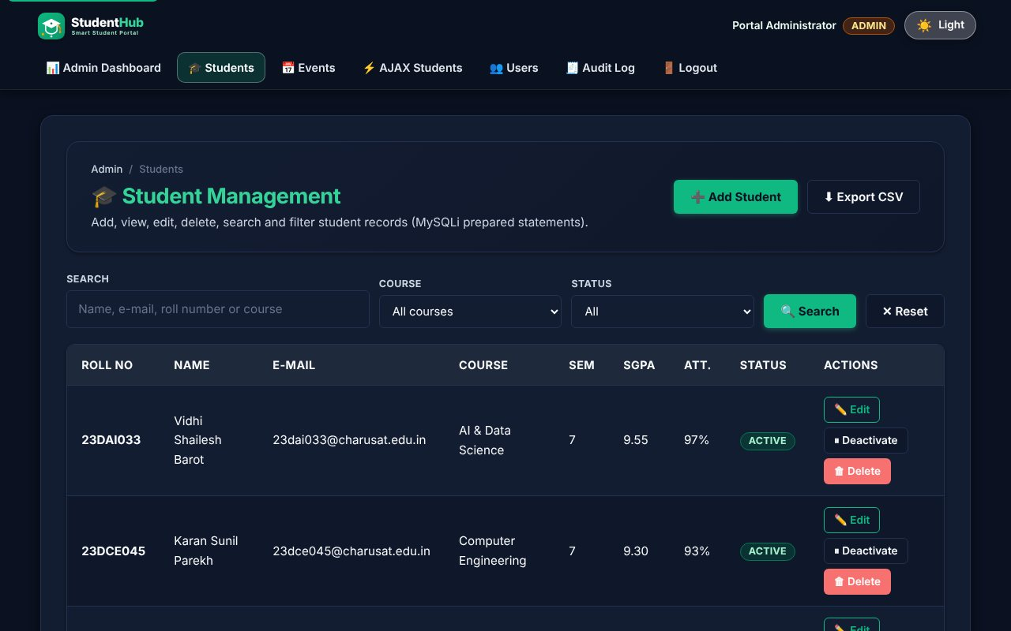
Dark theme on a PHP module page
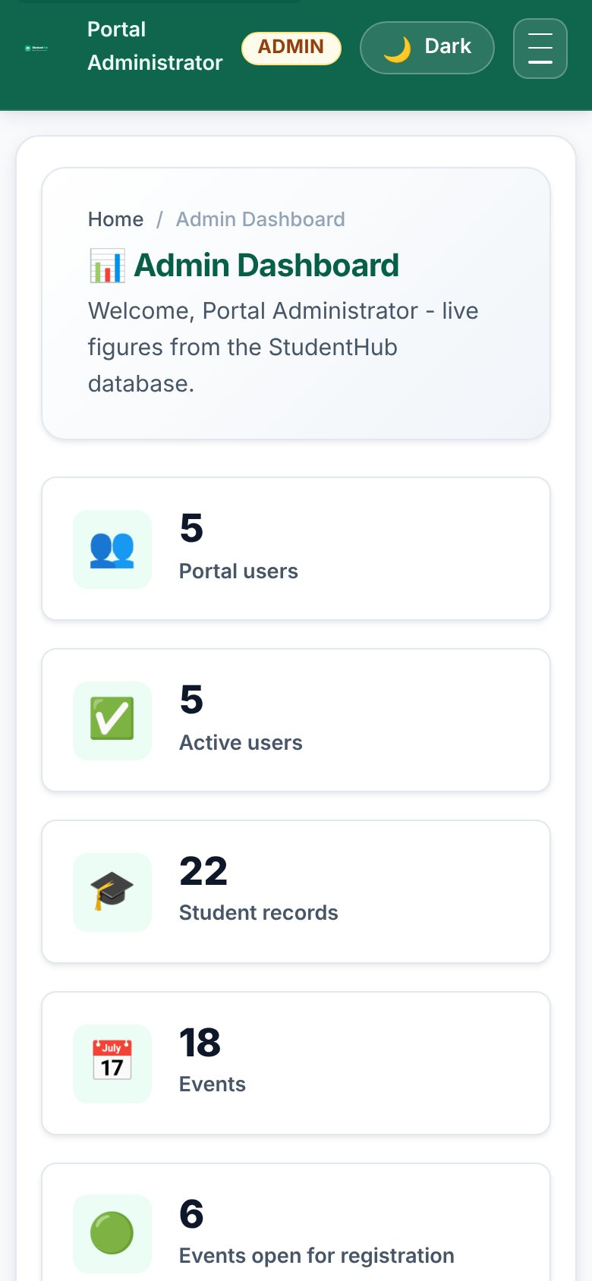
Mobile layout of the admin dashboard (390 px)
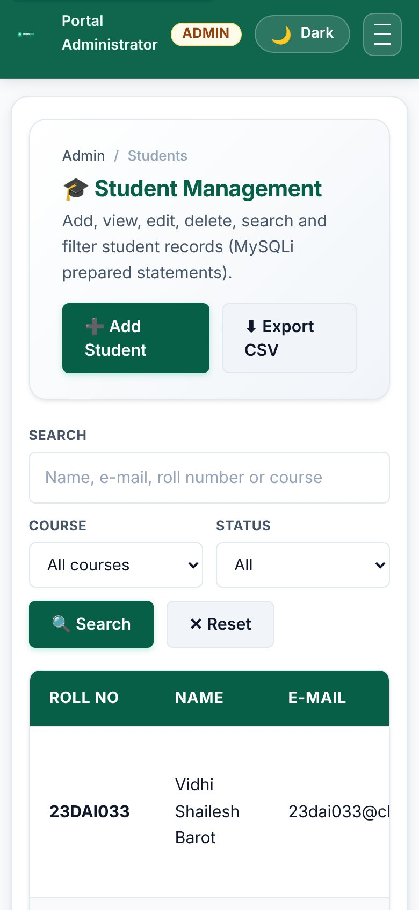
Mobile layout of the student list
TEST CASES :
# | Input / action | Expected result | Result
1 | P5 Validation | Inline errors, strength meter, CAPTCHA, aria-invalid | Pass
2 | P6 JSON | Search, filter, sort, pagination, error state | Pass
3 | P7 PHP form | POST validated; CSV + JSON files written | Pass
4 | P8 Database | Schema, FK/UNIQUE/CHECK, PDO + MySQLi connection | Pass
5 | P9 Registration | Hashed passwords, duplicates caught, CSRF | Pass
6 | P10 Sessions | Login, logout, roles, timeout, lock-out, remember-me | Pass
7 | P11 Students | CRUD, search, filter, CSV export, soft delete | Pass
8 | P12 Events | CRUD, poster upload validation | Pass
9 | P13 API | JSON endpoints, status codes, AJAX CRUD | Pass
10 | P14 Admin | Dashboard, user toggle, audit log | Pass
11 | Link check: crawl of 114 URLs as guest, student and admin | 0 broken links (no 4xx/5xx) | Pass
12 | PHP syntax check (php -l) on every .php file | No errors | Pass

KEY QUESTIONS :

1. Are all pages linked and navigable?
Yes. A crawler logged in as guest, student and admin and followed every link, image, stylesheet and script on the PHP pages and the HTML home page (114 URLs) - no response was 4xx or 5xx. Role-based menus link the modules to each other, and breadcrumbs show the position. The skip link, theme switch and hamburger menu are part of the shared header.

2. Do sessions, roles, validations and database operations work end to end?
Yes. The flow register (P9) -> login (P10) -> student dashboard, and login as admin -> dashboard (P14) -> students (P11) / events (P12) / AJAX (P13) / users / audit log was tested with scripted requests and with a real browser (Playwright); the screenshots in Practicals 5-14 were taken from that run. All write operations leave an audit_logs entry.

3. Are the security and accessibility checklists completed?
See the two tables below.

4. Is the documentation sufficient for installation and testing?
Yes. README.md in the project root explains requirements, installation (copy to htdocs, run Practical-15/reset_db.sh or import studenthub_full.sql, set DB credentials), demo logins, the folder structure, how to run each practical and how to test; Practical-15/TEST_REPORT.md lists every test case. Practical-15/studenthub.conf is a ready Apache virtual host.

5. Is the repository clean and properly committed?
Each practical is a separate folder so it can be committed separately with a clear message (for example "Practical 9: secure registration with password_hash"). The included .gitignore keeps logs, local settings and temporary files out of the repository; the repository contains only source, SQL, documents and screenshots. No real passwords or personal data are included - the seed data are demo records and the demo passwords are stored as bcrypt hashes.

SECURITY CHECKLIST :
Item | Done | Where
Prepared statements for every query | Yes | all PHP modules (MySQLi; PDO demo in P8)
Passwords hashed with password_hash / verified with password_verify | Yes | P9 register.php, P10 login.php
Output escaped with htmlspecialchars (e()) | Yes | includes/helpers.php
CSRF token on every POST form and on API writes (header) | Yes | helpers.php, api/bootstrap.php
Session cookie HttpOnly + SameSite, strict mode, ID regenerated on login | Yes | helpers.php, auth.php
Idle session timeout | Yes | auth_boot()
Role check on the server for every admin page / endpoint | Yes | require_role(), api_require_admin()
Brute-force slow-down on login (5 attempts / 30 s) | Yes | P10 login.php
Same error for unknown user and wrong password | Yes | P10 login.php
Upload: size, real MIME, getimagesize, random name, execution blocked | Yes | includes/upload.php, uploads/.htaccess
Remember-me token stored only as SHA-256 hash, rotated on use | Yes | auth.php, remember_tokens
Generic error messages; details only in the error log | Yes | db.php, api/bootstrap.php
CSV export protected against formula injection | Yes | P11 students_export.php
Audit log of important actions | Yes | audit_log(), P14
HTTPS and production DB user with limited rights | To do on a real server | README (deployment notes)

ACCESSIBILITY CHECKLIST :
Item | Done | Where
Semantic landmarks (header, nav, main, footer) and a skip link | Yes | layout.php, HTML pages
One h1 per page, headings in order | Yes | all pages
Every form control has a label | Yes | all forms
Errors announced with role="alert" and aria-invalid | Yes | forms, validation.js
Status messages use role="status" / aria-live | Yes | AJAX page, JSON pages
Current page marked with aria-current | Yes | menu
Images have alt text (posters: "Poster of ...") | Yes | P12 pages
Full keyboard operation, visible focus | Yes | all pages
Dialog is a native <dialog> (focus trap, Esc to close) | Yes | P13
Light/dark themes with sufficient contrast | Yes | common.css
Responsive layout down to 390 px | Yes | screenshots above

DEPLOYMENT :
Local deployment: copy the project to the web root (XAMPP htdocs or /var/www/studenthub), import Practical-15/studenthub_full.sql (or run Practical-15/reset_db.sh), check the credentials in Practical-8/db.php and open Practical-10/login.php. Intermediate extension: Practical-15/studenthub.conf is an Apache virtual host (studenthub.local) with directory-listing off, SQL/shell files denied and security headers. Advanced extension: the static part (Html folder, for_css, javascript, Practical-6 JSON) works without PHP and can be published on GitHub Pages; the PHP modules need a PHP host.

