PRACTICAL-5

AIM: Build a registration form with HTML5 input types and attributes, add JavaScript validation (regex, inline error messages, password strength meter) and verify accessibility.

SOURCE CODE :
https://github.com/Aarav280907/WEB/tree/main/Practical(1-4)(Studenthub)/javascript

PREVIEW:
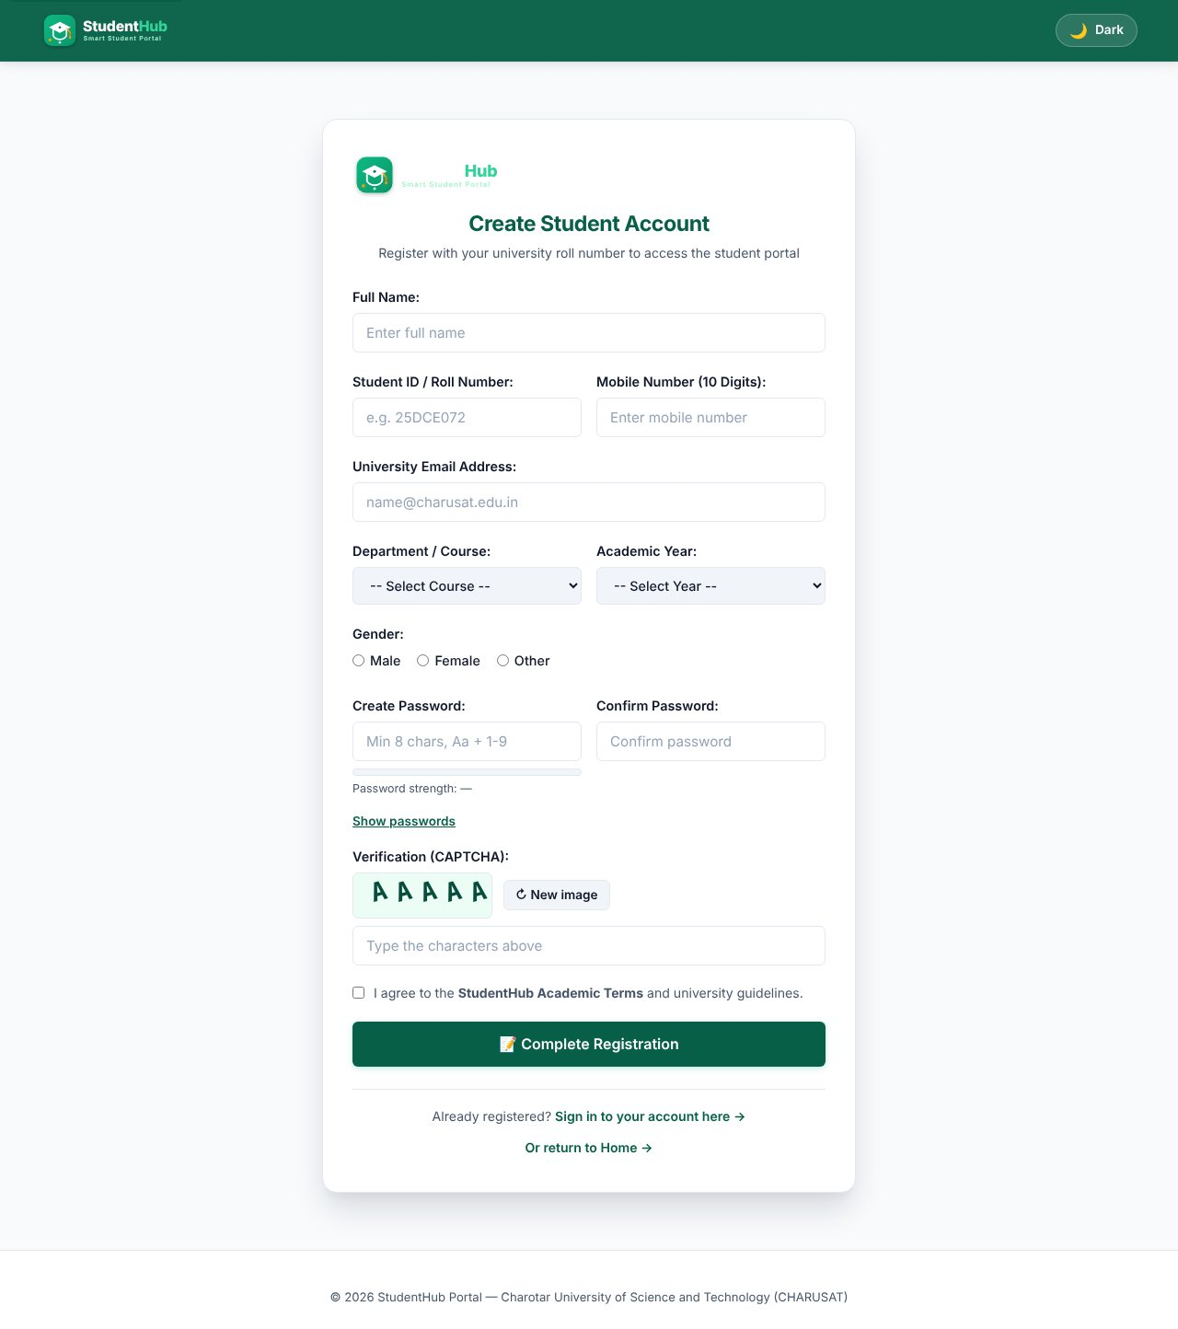
Registration form with HTML5 input types, labels and the Canvas CAPTCHA
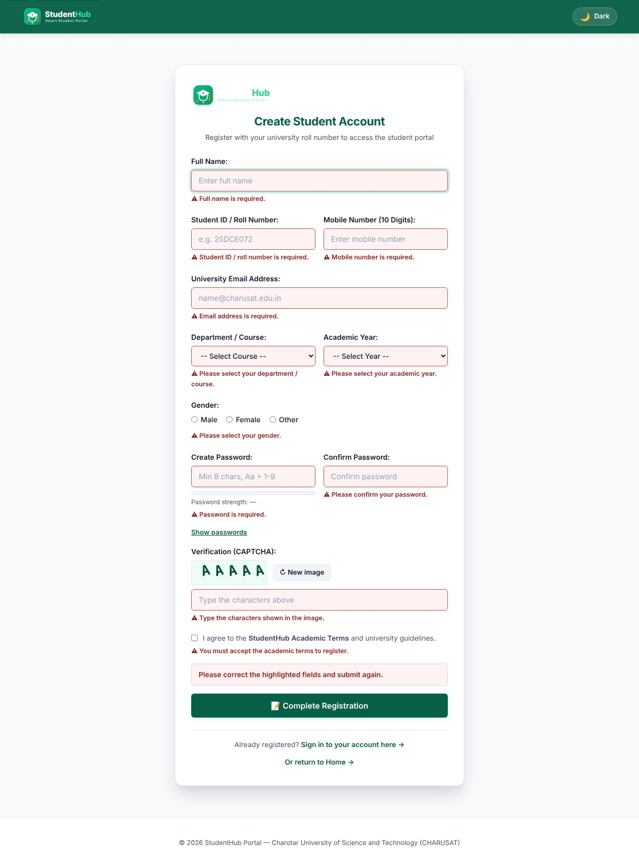
Submitting an empty form: an inline error appears next to every required field
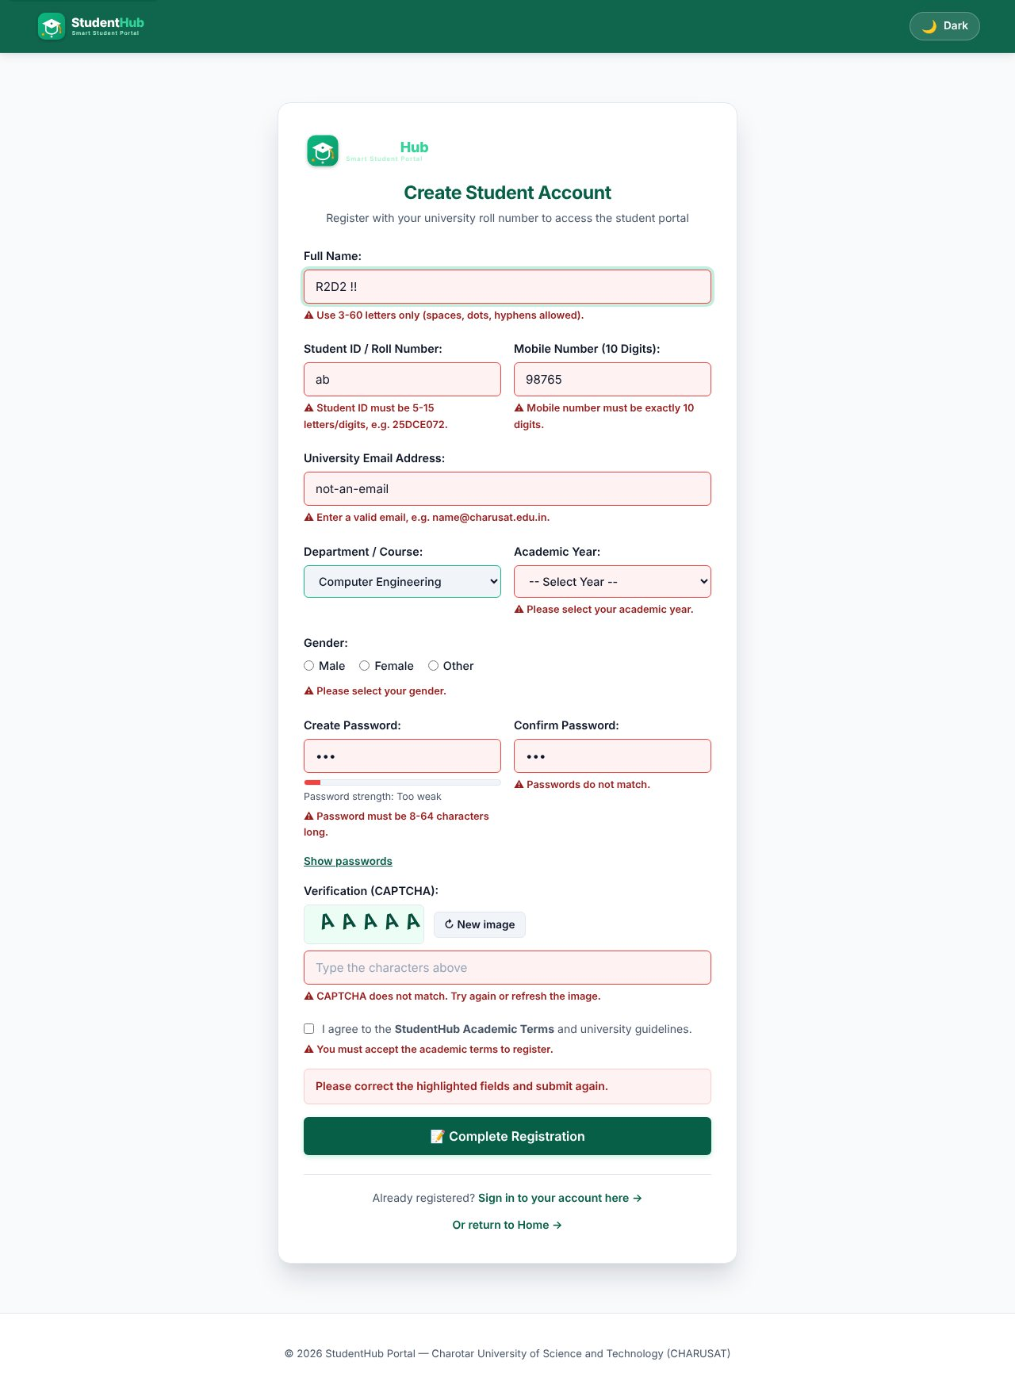
Invalid input: name with digits/symbols, short roll number, 5-digit mobile, bad e-mail, weak and mismatching passwords, wrong CAPTCHA
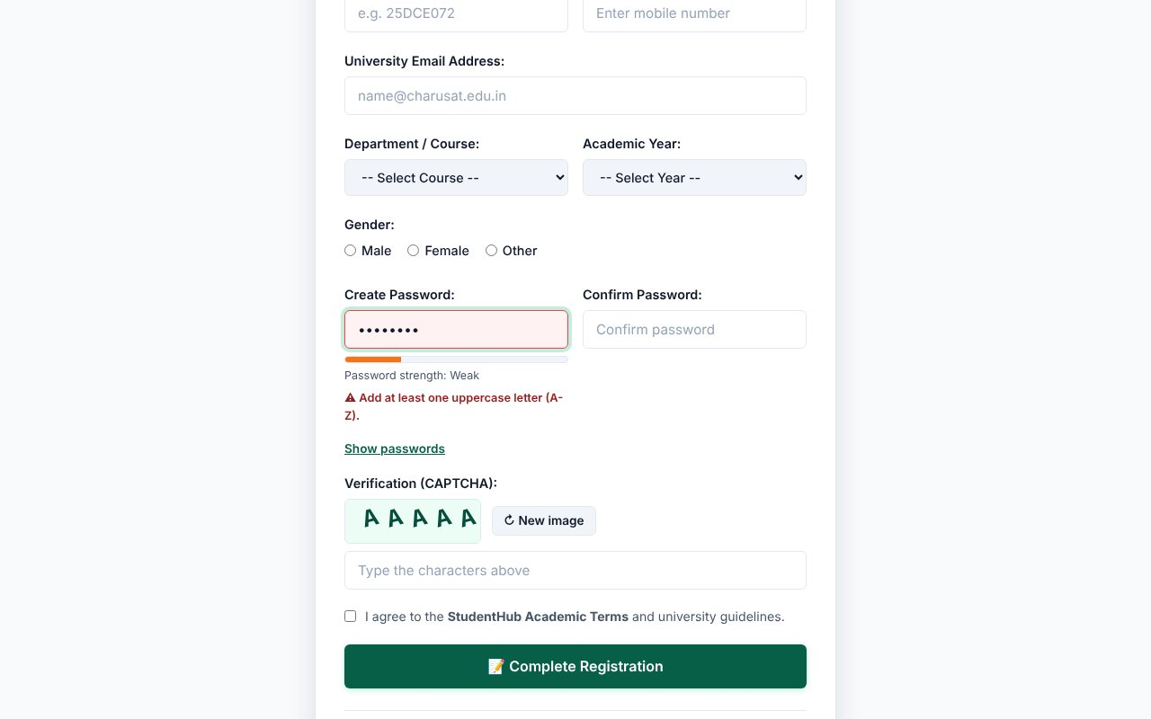
Password strength meter - "Too weak"
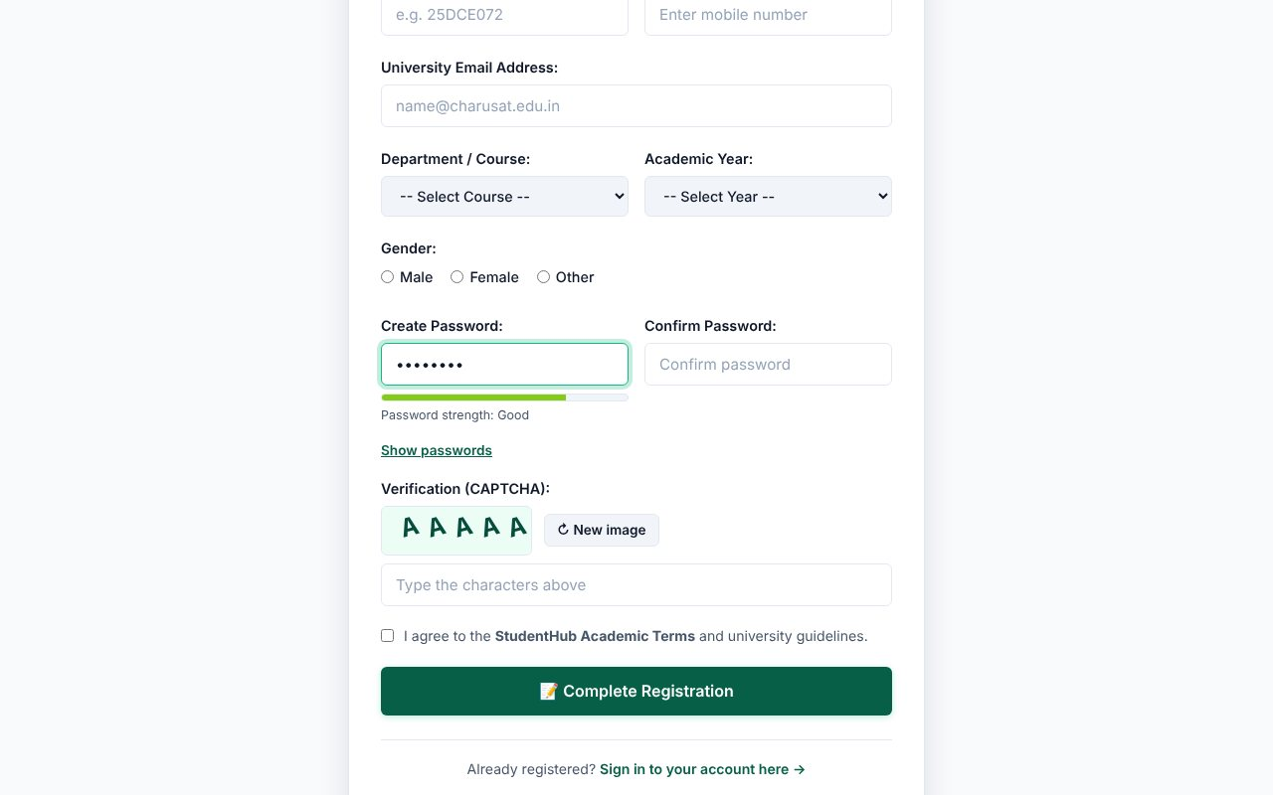
Password strength meter - medium
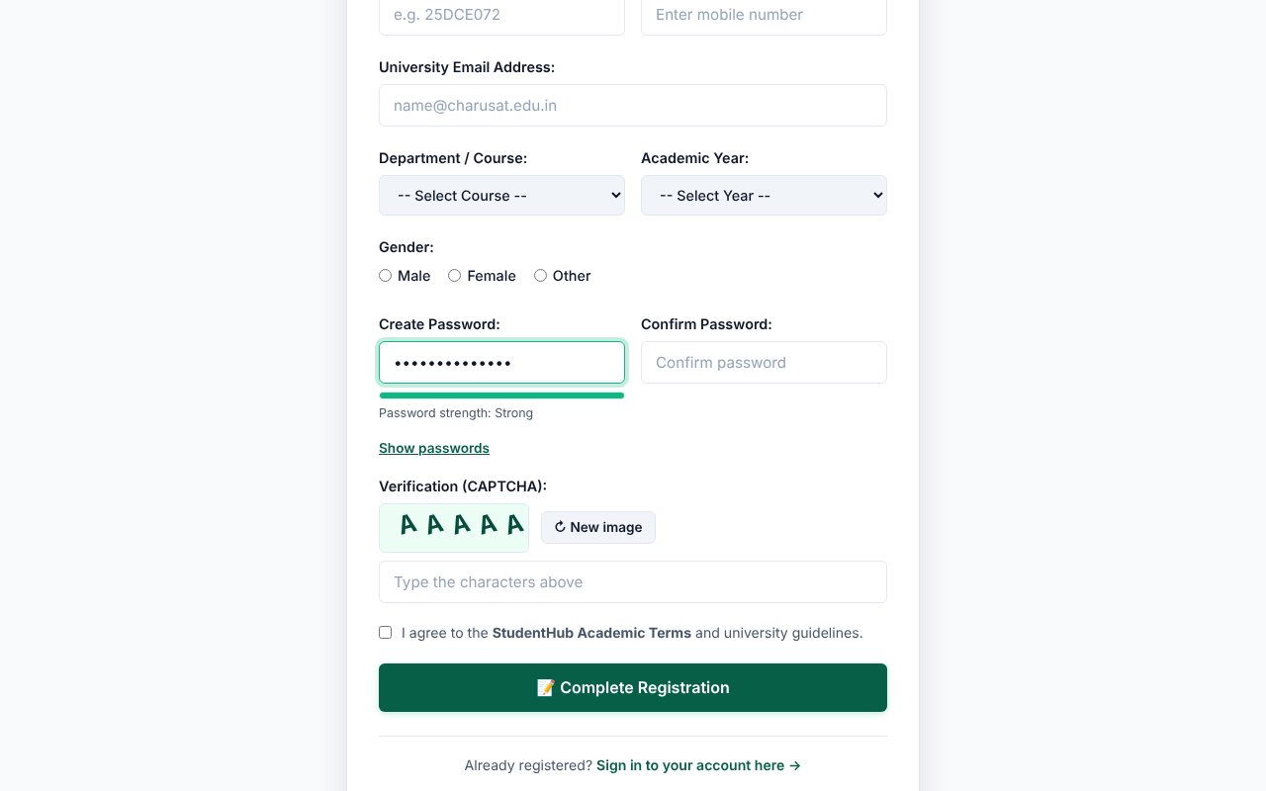
Password strength meter - strong
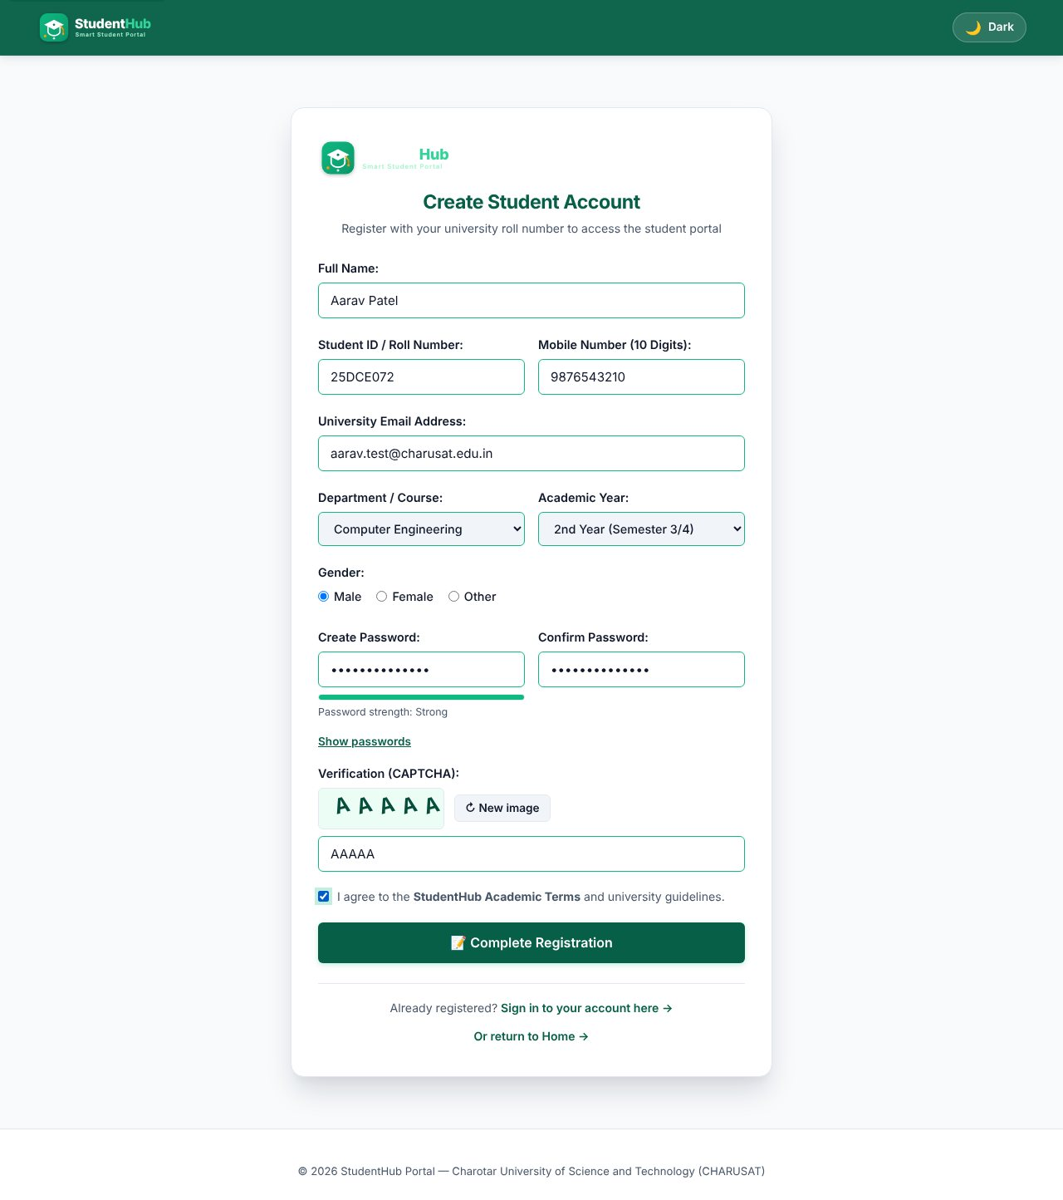
All fields valid: no error messages are shown
TEST CASES :
# | Input / action | Expected result | Result
1 | Submit the empty form | Required-field error under every field; summary "Please correct the highlighted fields"; focus moves to the first invalid field | Pass
2 | Full name = "R2D2 !!" | Error: letters, spaces, dots, hyphens only (3-60) | Pass
3 | Student ID = "ab" | Error: must be 5-15 letters/digits | Pass
4 | Mobile = "98765" (and typing letters) | Letters are filtered out while typing; 5 digits give "exactly 10 digits" error | Pass
5 | E-mail = "not-an-email" | Error: enter a valid e-mail | Pass
6 | Password = "abc" | Error: 8-64 characters; strength meter "Too weak" | Pass
7 | Password = "abcdefgh" / "Abcdefg1" / "Strong@Pass123" | Meter moves weak -> medium -> strong; the first two still fail the upper/lower/digit rule where applicable | Pass
8 | Confirm password differs | Error: Passwords do not match | Pass
9 | Wrong CAPTCHA text | Error: CAPTCHA does not match; a new image is generated | Pass
10 | Terms box not ticked | Error: you must accept the terms | Pass
11 | All valid values | No errors; the form is submitted to the PHP processor (Practical 7) | Pass

KEY QUESTIONS :

1. Are correct input types and attributes used?
Yes. The form uses type="email", type="tel" (with inputmode="numeric" and maxlength="10"), type="password", select lists, radio buttons and a checkbox. Attributes such as required, minlength, maxlength, autocomplete and aria-describedby are set, so mobile keyboards and password managers behave correctly.
<input type="tel" id="mobile" name="mobile" maxlength="10" inputmode="numeric" autocomplete="tel" required aria-describedby="mobile-error">
<span class="field-error" id="mobile-error" role="alert"></span>

The browser's own bubbles are switched off with novalidate so that all messages look the same and come from our JavaScript; the server repeats every check (Practical 7 and 9), so JavaScript is only a convenience, never the only protection.

2. Are errors displayed near the fields?
Yes. Each field has its own <span id="<name>-error" role="alert"> directly below it. The validator writes the message there, adds the class has-error to the field (red border) and sets aria-invalid="true". When the field becomes valid the message is cleared and is-valid is added. Validation also runs in real time on input, change and blur (intermediate extension), so the user sees the problem as soon as they leave the field.
const PATTERNS = {
fullname: /^[A-Za-z][A-Za-z .'-]{2,59}$/,
student_id: /^[A-Za-z0-9]{5,15}$/,
mobile: /^[0-9]{10}$/,
email: /^[^\s@]+@[^\s@]+\.[^\s@]{2,}$/
};

3. Is password strength checked?
Yes. The password must be 8-64 characters and contain an upper-case letter, a lower-case letter and a digit. In addition scorePassword() gives 0-4 points (length >= 8, length >= 12, mixed case, digit, special character) and the coloured bar under the field shows "Too weak / Weak / Good / Strong" while typing.
function scorePassword(value) {
let score = 0;
if (value.length >= 8) score++;
if (value.length >= 12) score++;
if (r.upper.test(value) && r.lower.test(value)) score++;
if (r.digit.test(value)) score++;
if (r.special.test(value)) score++;
return Math.min(score, 4);
}

4. Is the form keyboard and screen-reader accessible?
- Every input has a visible <label for="...">; the radio group is wrapped with role="radiogroup" and aria-labelledby.
- Error spans use role="alert", so a screen reader announces a message when it appears; invalid fields get aria-invalid="true".
- The whole form can be completed with Tab / Shift+Tab / Space / Enter; the first invalid field receives focus after a failed submit; a visible focus outline is kept.
- The CAPTCHA canvas has role="img" and an aria-label, and a "New image" button; "Show passwords" is a real <button>.
- Colour is never the only signal: errors also have an icon and text.

5. Advanced extension - custom CAPTCHA on Canvas
A 5-character code (no confusing characters such as 0/O or 1/I) is drawn on a <canvas> with random rotation, noise lines and dots. The typed text is compared with the code in JavaScript. It is a demonstration only: a client-side CAPTCHA cannot stop bots, which is stated in the code comments; real protection is the server-side CSRF token and validation.

