PRACTICAL-6

AIM: Load data from JSON files with the Fetch API and render it dynamically with search, filter, sort and pagination using modular JavaScript.

SOURCE CODE :
https://github.com/Aarav280907/WEB/tree/main/Practical(1-4)(Studenthub)/Practical-6

PREVIEW:
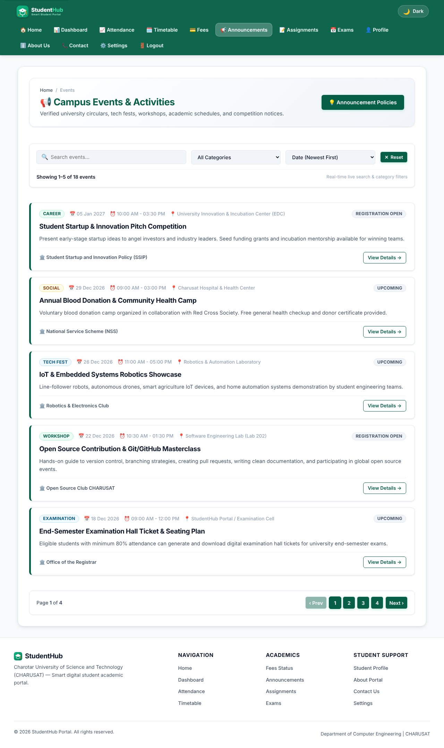
Events page - cards rendered from events.json
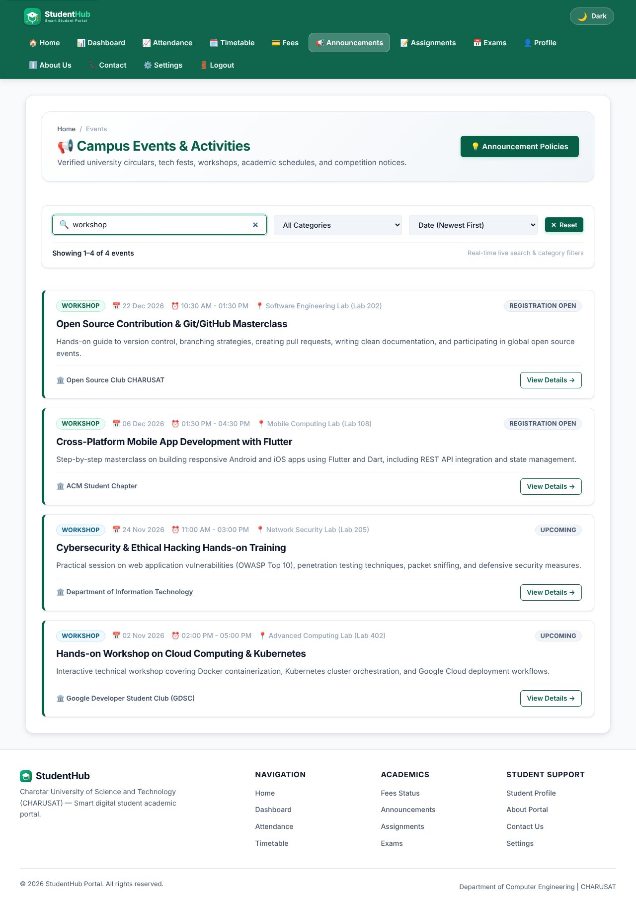
Search "workshop" - results filtered as the user types
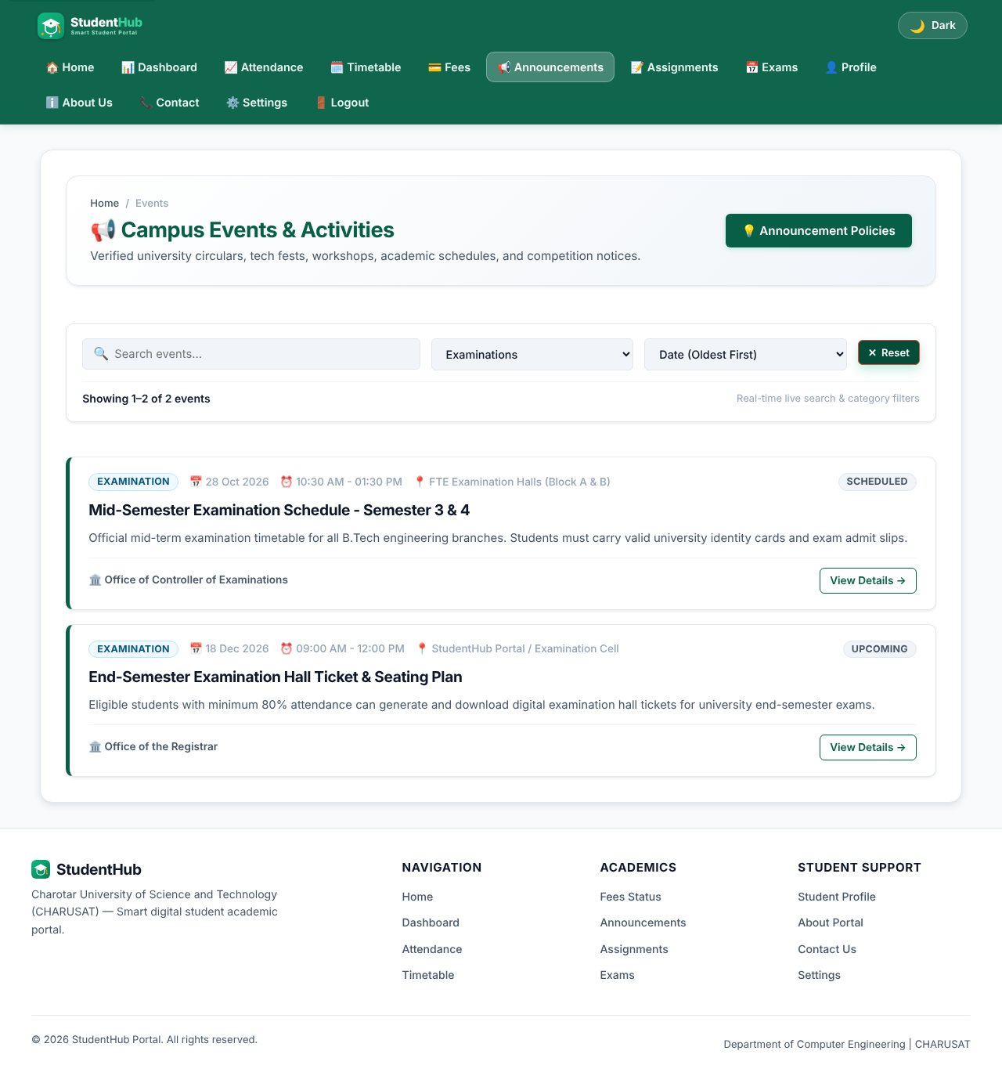
Category filter combined with a sort order
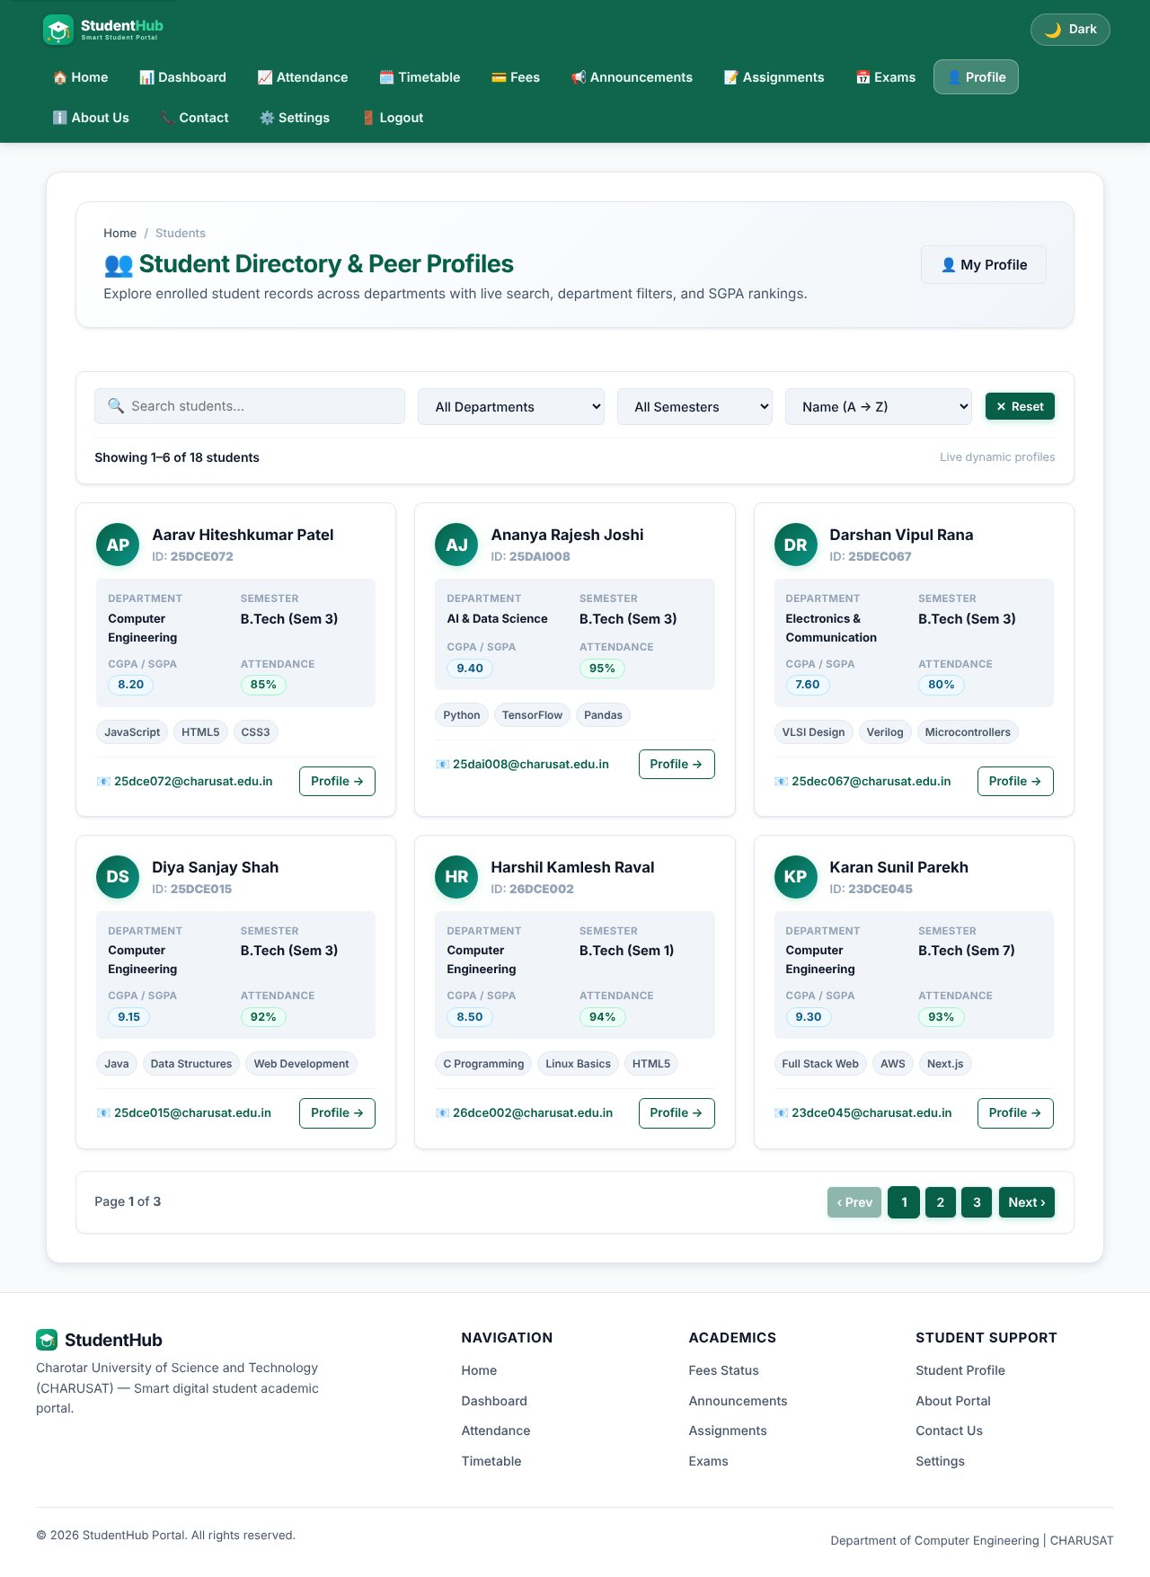
Student directory rendered from students.json
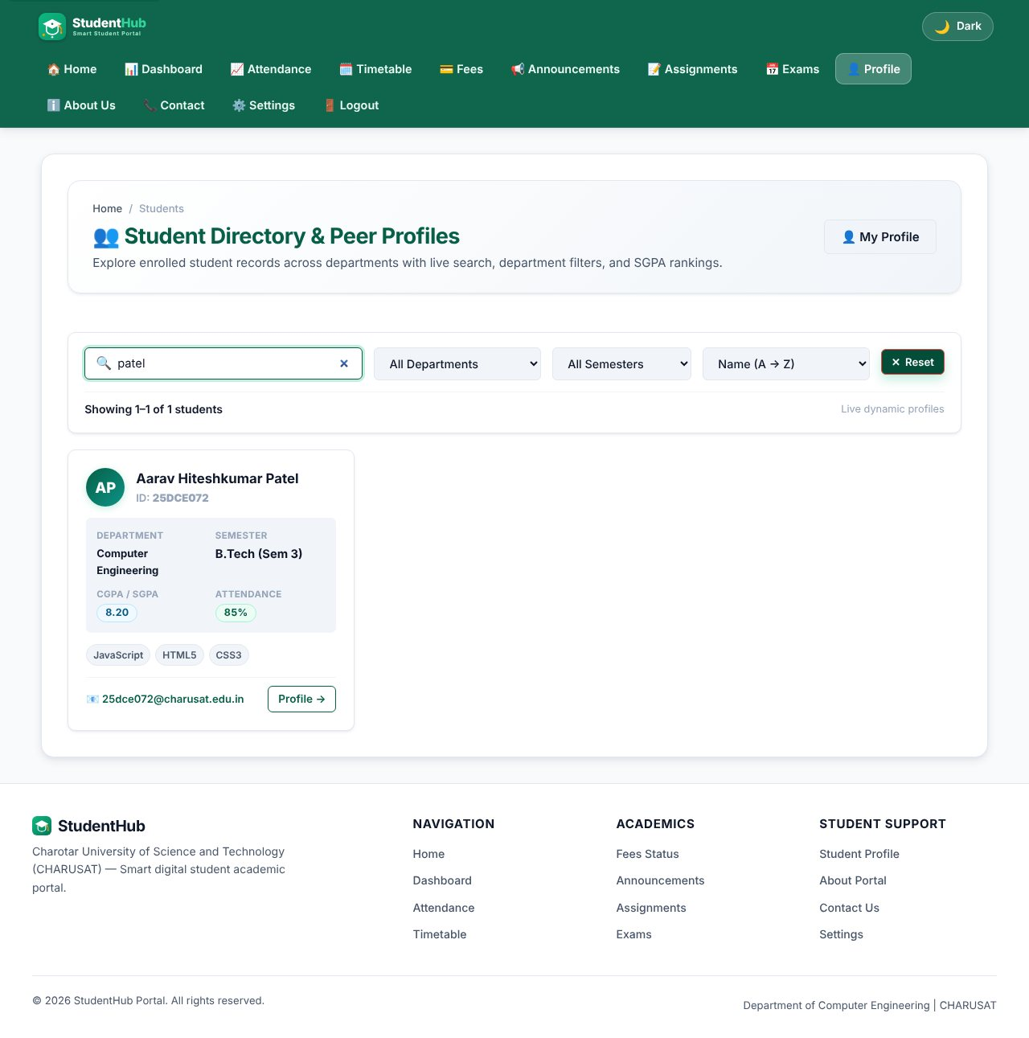
Student search "patel"
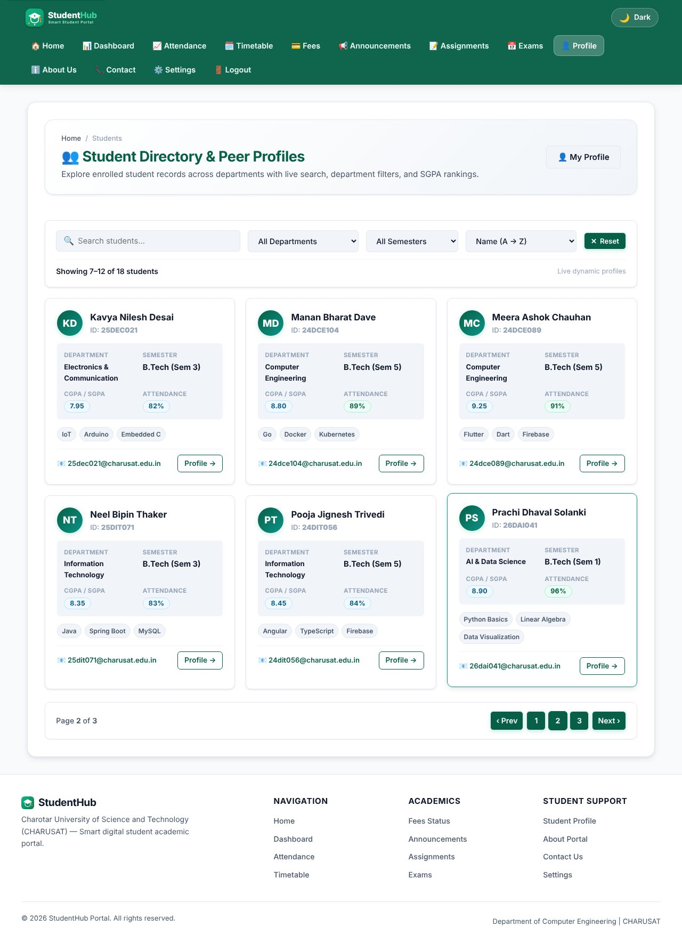
Pagination - second page of students
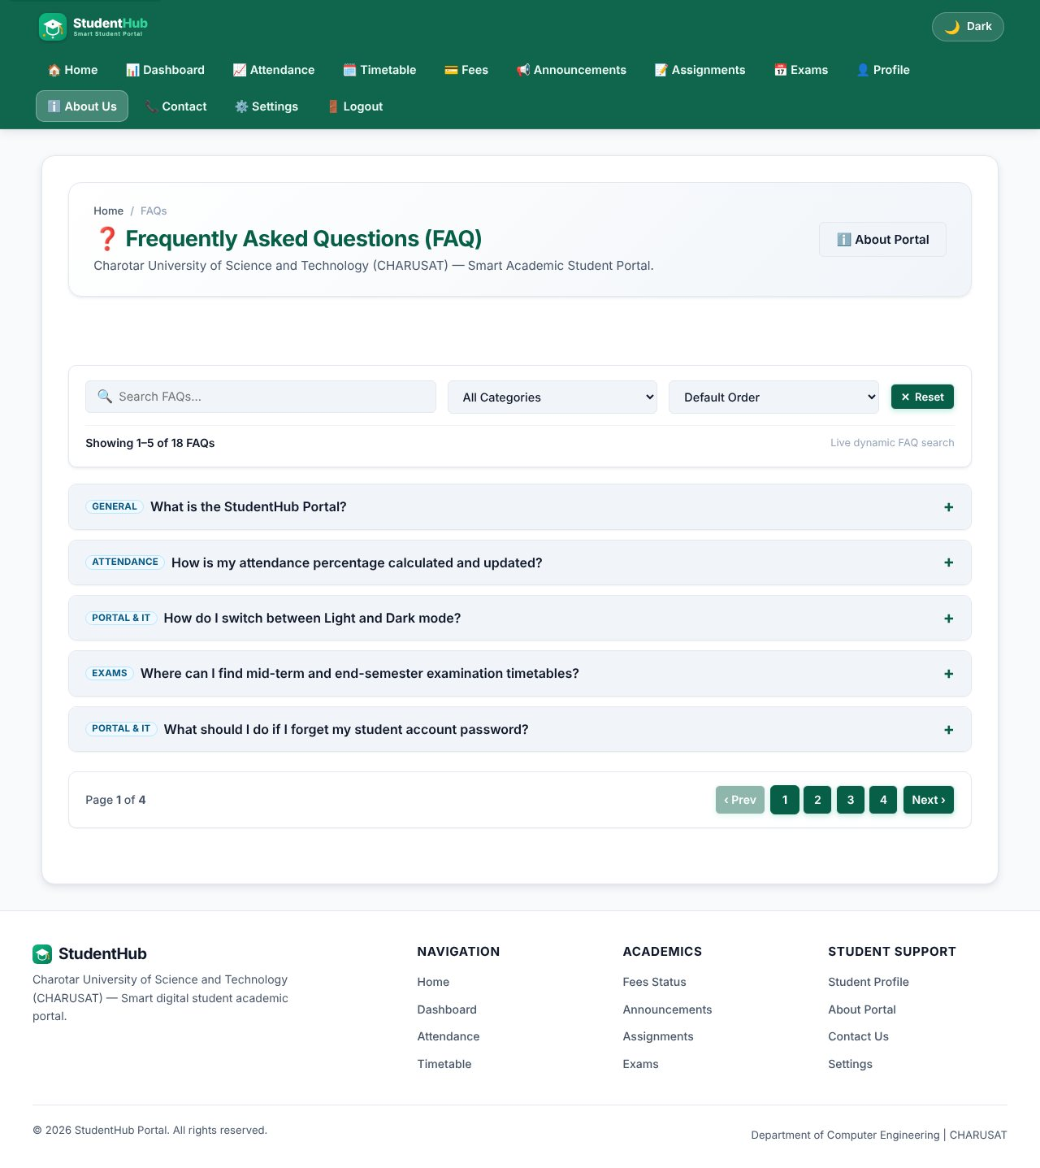
FAQ page rendered from faqs.json
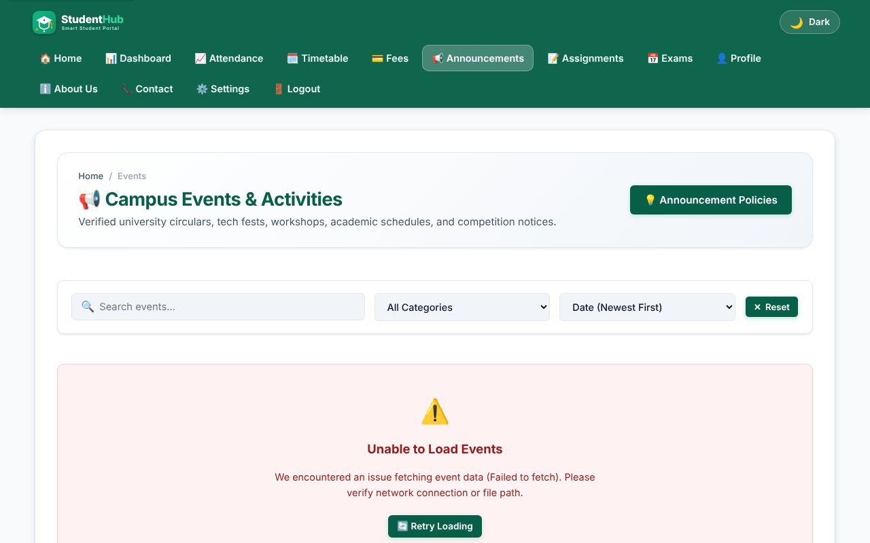
Error state when the JSON request fails (network blocked) with a Retry button
TEST CASES :
# | Input / action | Expected result | Result
1 | Open events page | 18 events loaded from events.json, loading text shown first | Pass
2 | Search "workshop" | Only matching events; count updates (5 events per page) | Pass
3 | Category = Workshop + sort | Filter and sort work together | Pass
4 | Search text with no match | Empty-state message with a "Clear all filters" button | Pass
5 | Students: next page | Next 6 records shown, pagination buttons update | Pass
6 | Block the .json request | Error card with a Retry button, no JavaScript error | Pass

KEY QUESTIONS :

1. How is JSON fetched, parsed and rendered?
fetch() is called inside an async function. The response is checked with response.ok, then response.json() parses the body to an array of objects. The array is stored once (allEvents) and every render is built from it with template strings and written with innerHTML after escaping the text.
const response = await fetch(url);
if (response.ok) {
fetchedData = await response.json();
}
...
container.innerHTML = pageItems.map(renderCard).join("");

2. Which array methods are used for search, filter, sort and pagination?
- filter() - keeps the items that match the search text and the selected category;
- sort() - orders by date (newest/oldest) or title with localeCompare();
- slice(start, start + perPage) - cuts the current page;
- map() / join() - turns the page items into HTML; forEach() - attaches button listeners.
let filtered = allEvents.filter(item => matchesText(item) && matchesCategory(item));
filtered.sort((a, b) => new Date(b.date) - new Date(a.date));
const paginatedItems = filtered.slice(startIndex, startIndex + itemsPerPage);

3. How are loading and error states handled?
Before the request a "Fetching ..." block with role="status" and aria-live="polite" is shown. If the request fails or the status is not OK, renderErrorState() shows a message with role="alert" and a Retry button that runs the fetch again. Several relative paths for the JSON file are tried so the page works from different folders. An empty result shows a separate empty-state with a "Clear all filters" button.

4. How is modularity maintained?
Each page has its own file (events.js, students.js, faq.js) wrapped in an IIFE so no variables leak to the global scope; only one object (window.StudentHubEvents = { init }) is exported. Data (JSON), logic (JS), structure (HTML) and style (CSS) are separate files, and the three modules follow the same structure (fetch, process, render, init).

