PRACTICAL-7

AIM: Process an HTML form with PHP using the POST method, validate and sanitize the input on the server and store the records in CSV and JSON files.

SOURCE CODE :
https://github.com/Aarav280907/WEB/tree/main/Practical(1-4)(Studenthub)/Practical-7

PREVIEW:
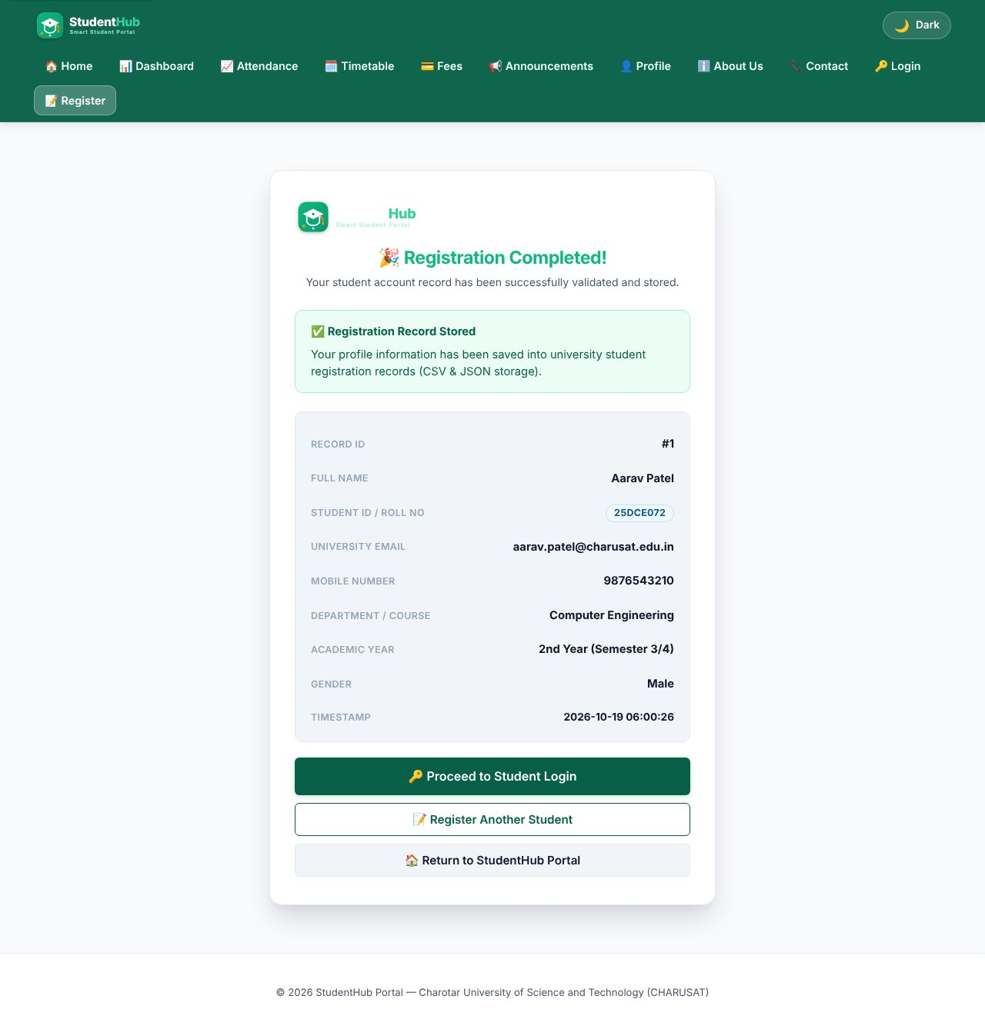
Valid registration - success page with the saved record
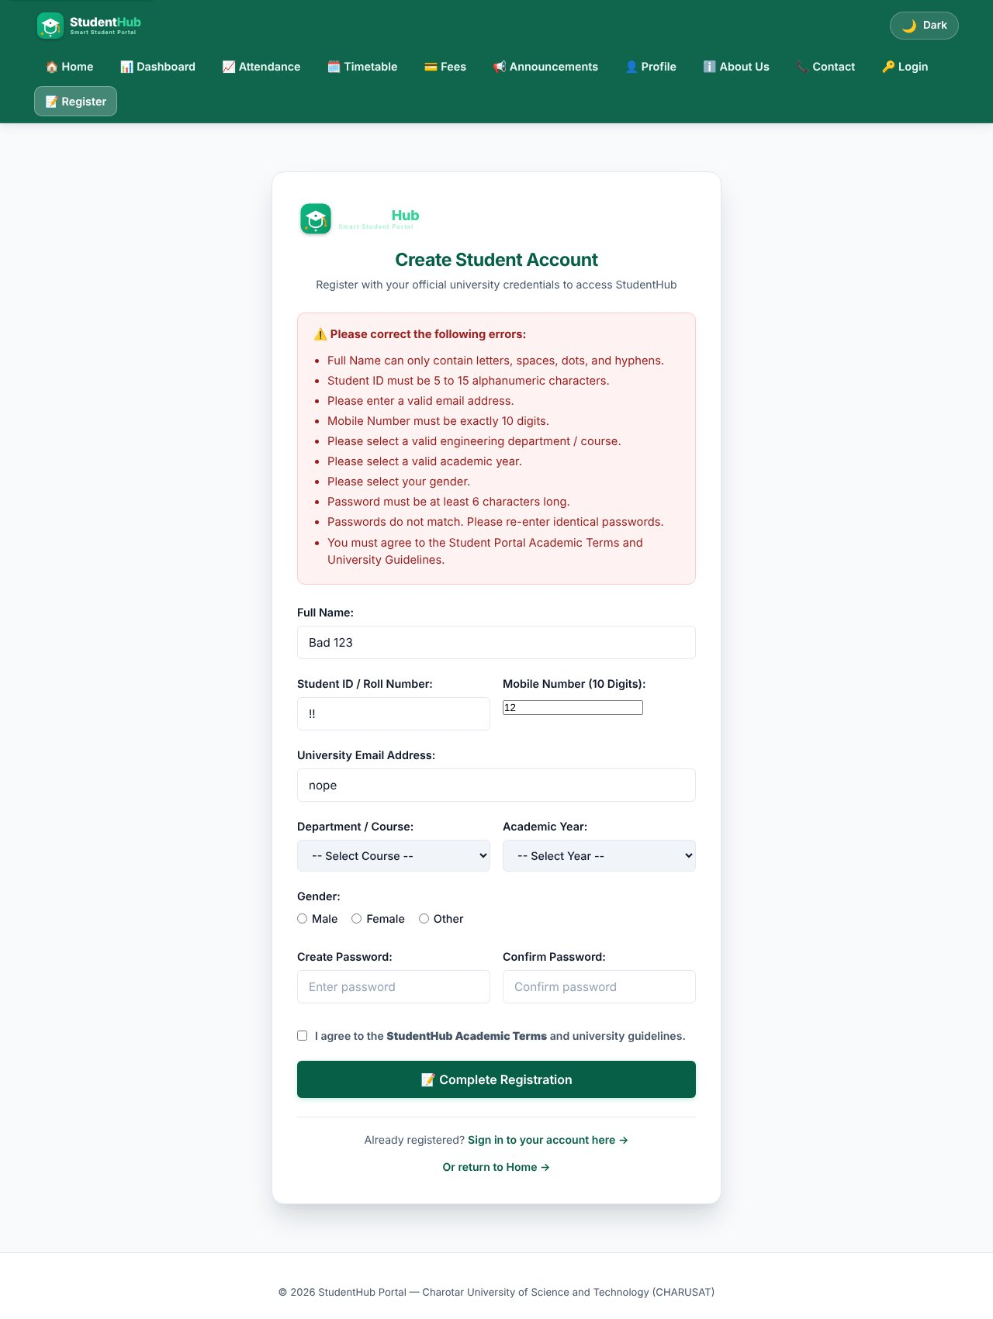
Server-side validation errors for invalid input (client JavaScript disabled)
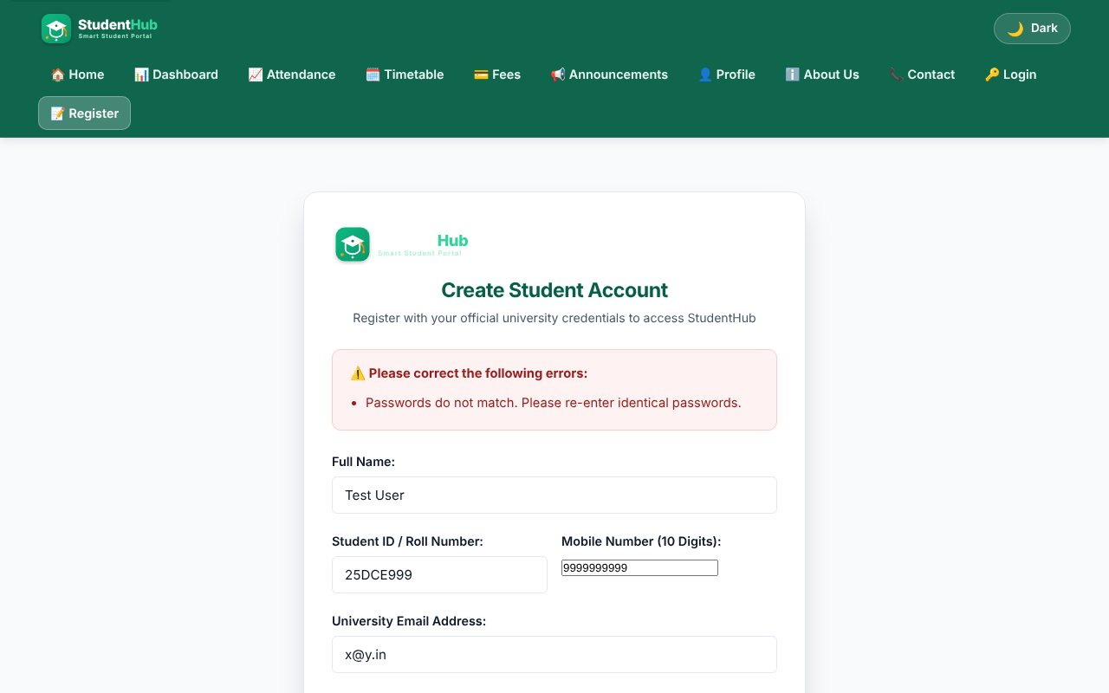
Server-side check: passwords do not match
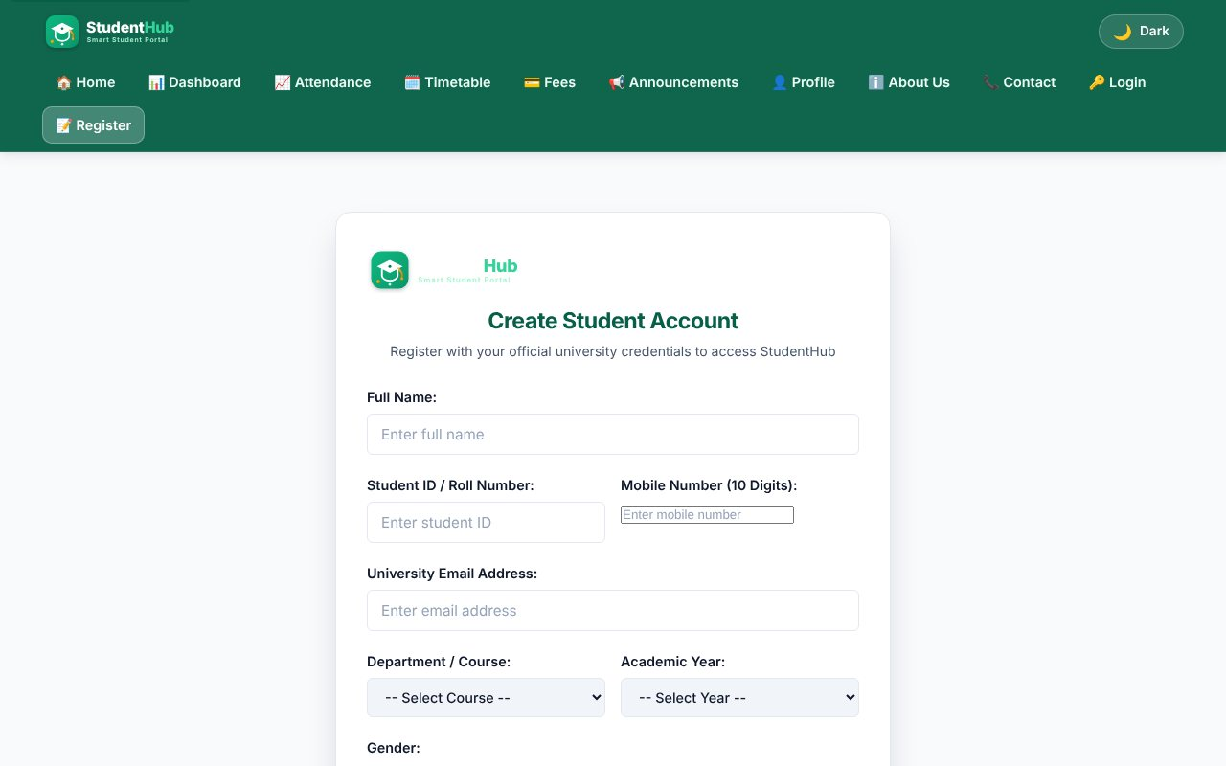
Opening the processor with GET shows the form again - nothing is written
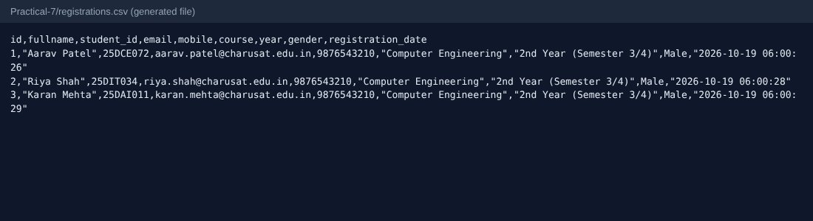
Generated file registrations.csv
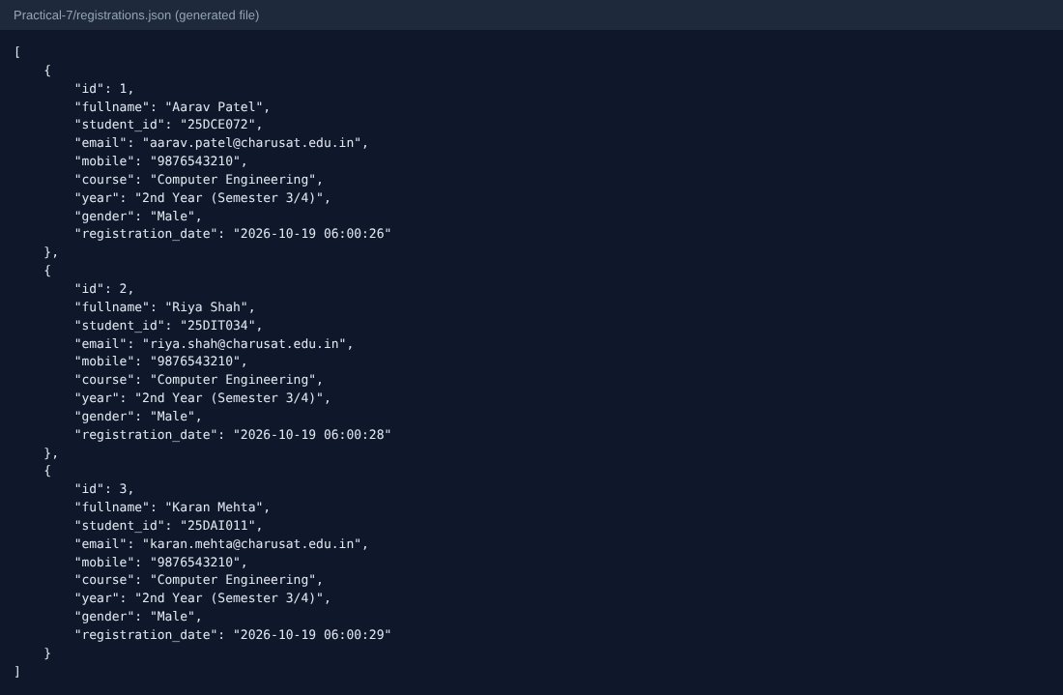
Generated file registrations.json
TEST CASES :
# | Input / action | Expected result | Result
1 | POST valid data (3 different students) | Success page; one row added to CSV and one object to JSON | Pass
2 | Name = "<b>Bad</b> 123", ID = "!!", mobile = "12", e-mail = "nope", short password | List of error messages, nothing stored | Pass
3 | Password and confirm password different | Error "passwords do not match" | Pass
4 | GET request to process_signup.php | No record is created; empty form shown | Pass
5 | HTML tags in name | Tags stripped by strip_tags and rejected by the name pattern | Pass
6 | Passwords in generated files | Not written to CSV/JSON (only profile fields) | Pass

Note on production use:
Practical 7 stores data in files only to learn form processing. Passwords are deliberately not stored here; real registration with password_hash() and a database is done in Practical 9.

KEY QUESTIONS :

1. Is POST used?
Yes. The form has method="post" and the script starts with if ($_SERVER['REQUEST_METHOD'] === 'POST'). Data never appears in the URL or the browser history, and opening the page with GET only shows the form.

2. Are inputs validated and sanitized on the server side?
Every field is trimmed and sanitized (strip_tags, FILTER_SANITIZE_EMAIL, preg_replace to keep digits only), then validated with the same rules as the JavaScript: length and character patterns, allowed values for course / year / gender (white-lists), e-mail with filter_var, password rules, terms accepted. All error messages are collected in an array and shown together; output is escaped with htmlspecialchars().
$fullname = trim(strip_tags($_POST['fullname'] ?? ''));
$mobile = preg_replace('/[^0-9]/', '', $_POST['mobile'] ?? '');
if (!in_array($course, $allowedCourses, true)) { $errors[] = 'Select a valid course.'; }

3. Is file writing safe?
Files are opened with a fixed path (never from user input), JSON is rewritten with json_encode after reading the old content, and the CSV is appended under flock(LOCK_EX) so two simultaneous users cannot corrupt the file. The CSV writer uses fputcsv, which quotes commas and quotes. The return values of file_put_contents / fopen are checked and a friendly error is shown if writing fails.
$fp = @fopen($csvFile, 'a');
if ($fp && flock($fp, LOCK_EX)) {
fputcsv($fp, [$id, $fullname, $student_id, $email, $mobile, $course, $year, $gender, $registration_date]);
flock($fp, LOCK_UN);
}

4. Are success and error responses clear?
Yes. A green success card shows the stored data; a red box lists every problem with a bullet; the form keeps the values the user typed (except passwords). A storage failure gives a separate message so the user knows it is not their mistake.

