PRACTICAL-8

AIM: Create the MySQL schema and ER model for StudentHub, connect with PDO / MySQLi using prepared statements and test the connection.

SOURCE CODE :
https://github.com/Aarav280907/WEB/tree/main/Practical(1-4)(Studenthub)/Practical-8

PREVIEW:
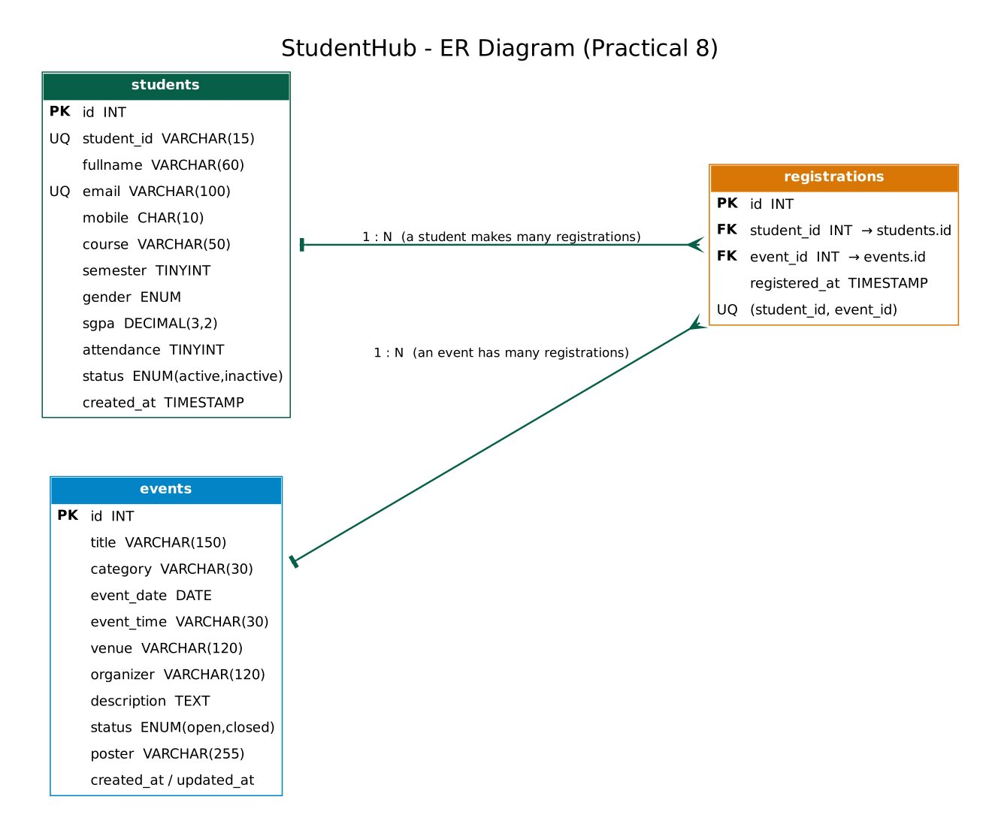
ER diagram: students 1-N registrations N-1 events
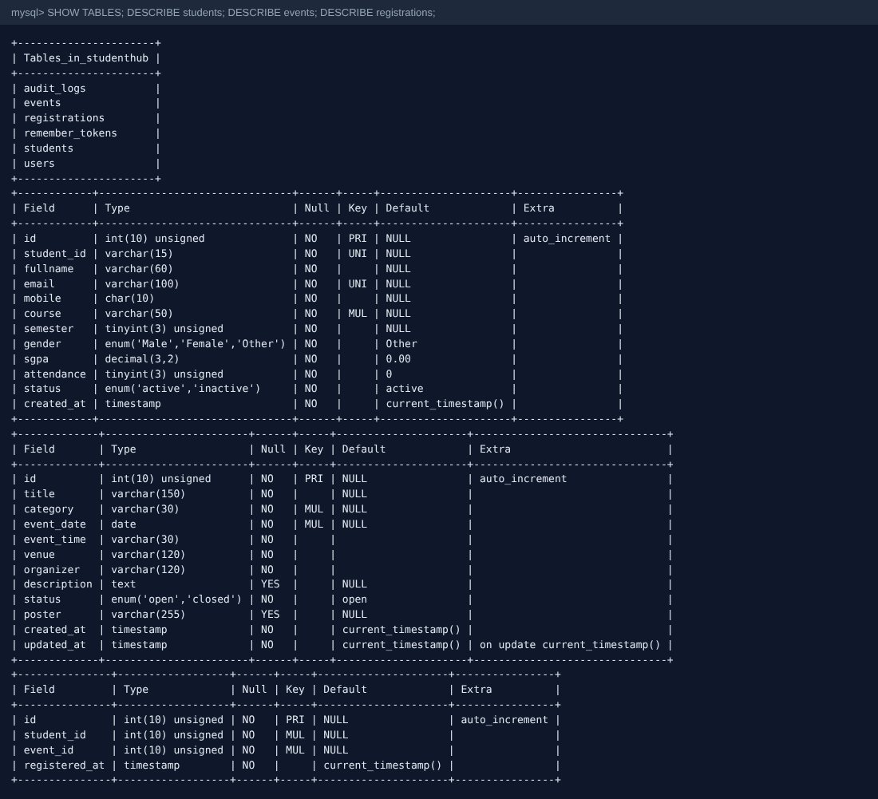
Tables created in the studenthub database (SHOW TABLES / DESCRIBE)
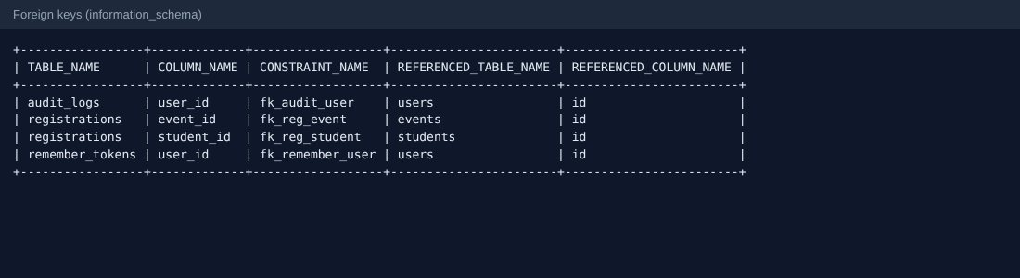
Foreign keys read from information_schema
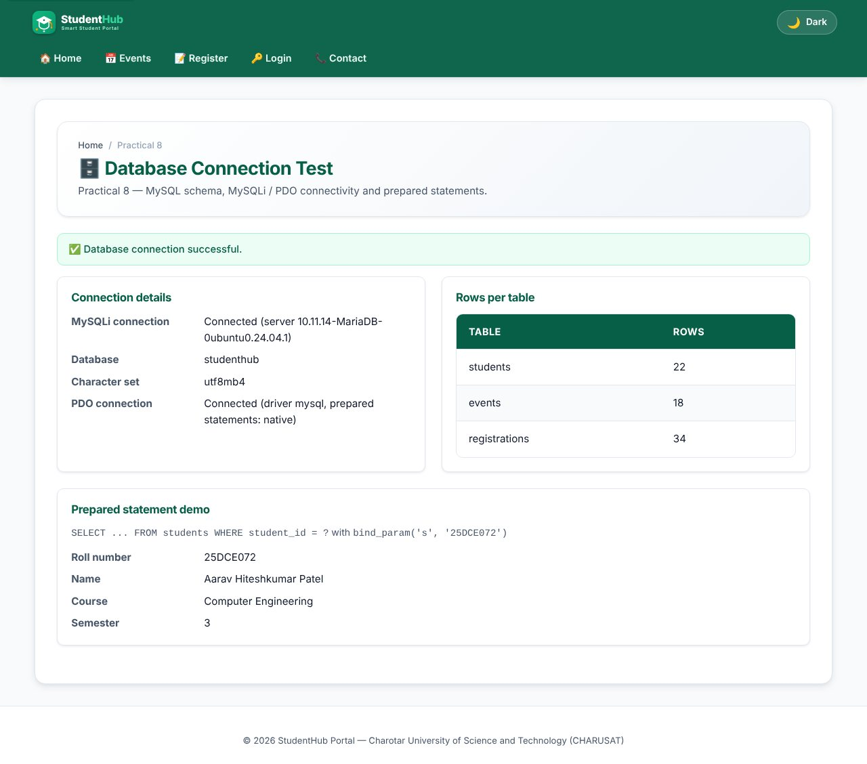
test_connection.php - MySQLi and PDO connected, row counts and a prepared-statement demo
TEST CASES :
# | Input / action | Expected result | Result
1 | Open test_connection.php with correct settings | Both connections successful; 22 / 18 / 34 rows | Pass
2 | Wrong DB password (SH_DB_PASS env) | Friendly "database temporarily unavailable" message (HTTP 503); details only in the error log | Pass
3 | Insert registration with unknown student_id | Rejected by the foreign key | Pass
4 | Insert the same student/event twice | Rejected by UNIQUE (student_id, event_id) | Pass
5 | SGPA 11 inserted directly | Rejected by the CHECK constraint | Pass

KEY QUESTIONS :

1. Is the schema normalized?
Yes, it is in third normal form. A student, an event and a registration are three separate entities. The many-to-many relation between students and events is resolved by the registrations table, so no event data is repeated in each student row and no student data in each event row. Each non-key column depends only on the primary key of its table.
students(id PK, student_id UNIQUE, fullname, email UNIQUE, mobile, course, semester, gender, sgpa, attendance, status)
events(id PK, title, category, event_date, event_time, venue, organizer, description, status, poster)
registrations(id PK, student_id FK, event_id FK, registered_at, UNIQUE(student_id, event_id))

2. Are primary and foreign keys correct?
Every table has an AUTO_INCREMENT INT UNSIGNED primary key. registrations.student_id references students(id) and registrations.event_id references events(id) with ON DELETE CASCADE, so deleting a student or event removes its registrations. UNIQUE keys on student_id and email prevent duplicate students, CHECK constraints keep sgpa between 0 and 10 and attendance between 0 and 100, and all tables are InnoDB (required for foreign keys) with utf8mb4.

3. Is the connection secure?
- Credentials are in one file (db.php) with environment-variable overrides, so they are not repeated in pages; the web server should not expose the SQL files.
- mysqli_report(MYSQLI_REPORT_ERROR | MYSQLI_REPORT_STRICT) turns errors into exceptions that are caught; the user sees a generic message and the real error goes to error_log().
- Only prepared statements with bound parameters are used - values never get concatenated into SQL.
- The charset is set to utf8mb4 on the connection; PDO uses ATTR_EMULATE_PREPARES = false so the server does the binding.
$stmt = $conn->prepare('SELECT student_id, fullname, course, semester FROM students WHERE student_id = ?');
$stmt->bind_param('s', $id);
$stmt->execute();
$row = $stmt->get_result()->fetch_assoc();

4. Intermediate and advanced extensions
PDO with prepared statements is in db_pdo.php (pdo_connect()). The stored procedures sp_register_student_for_event (checks that the event is open and the student is not already registered, then inserts the registration) and sp_event_registration_count are in stored_procedures.sql. The full dump is in studenthub_dump.sql.

