PRACTICAL-9

AIM: Implement secure user registration with MySQLi: prepared statements, password_hash(), duplicate checking and consistent frontend/backend validation.

SOURCE CODE :
https://github.com/Aarav280907/WEB/tree/main/Practical(1-4)(Studenthub)/Practical-9

PREVIEW:
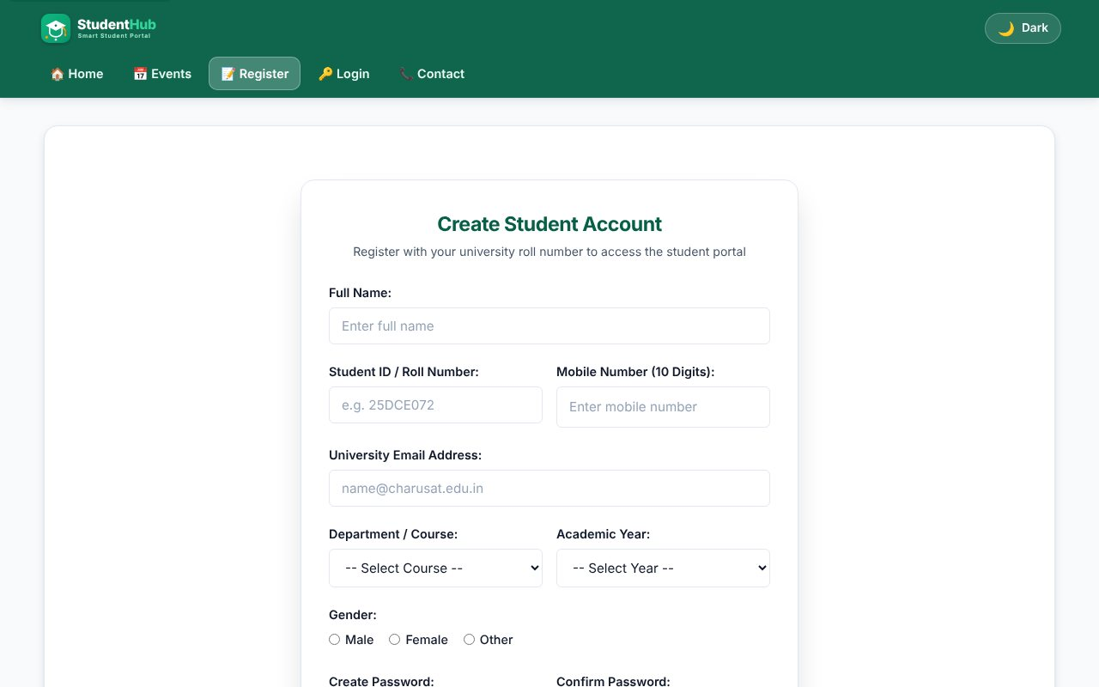
Registration form (same validated form as Practical 5, now saving to MySQL)
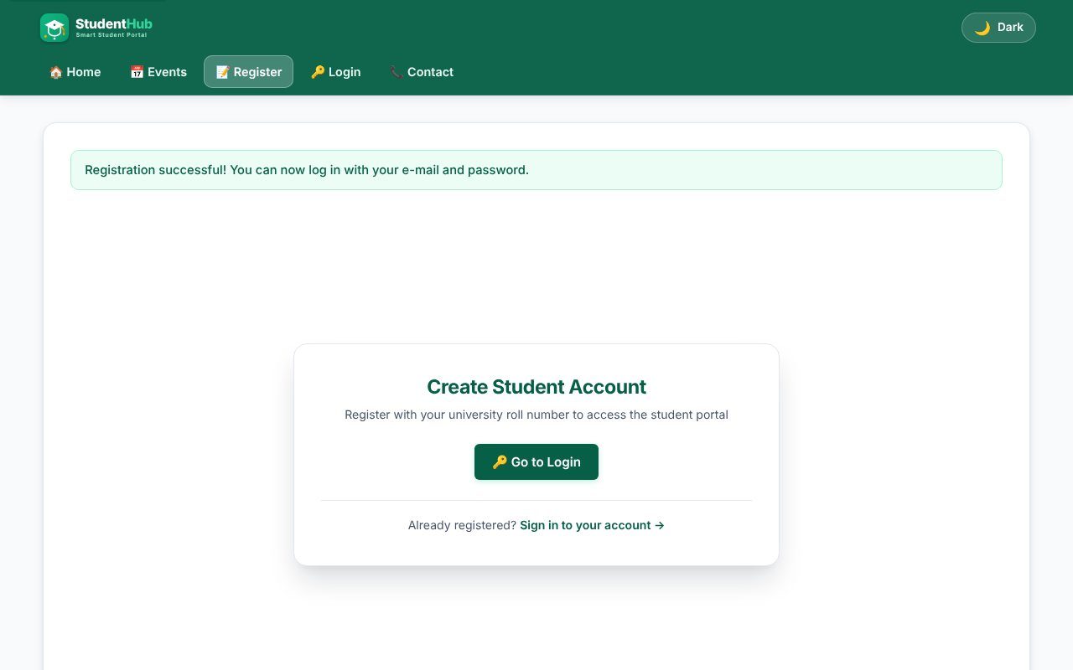
Valid registration - account created, redirected with a success message
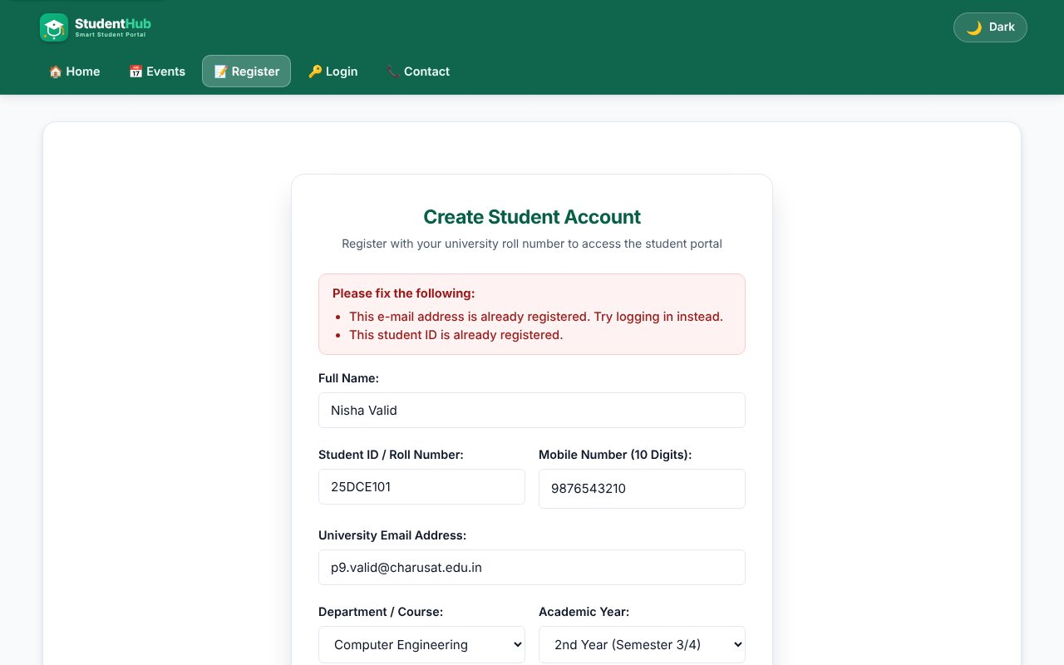
Duplicate e-mail and student ID are rejected
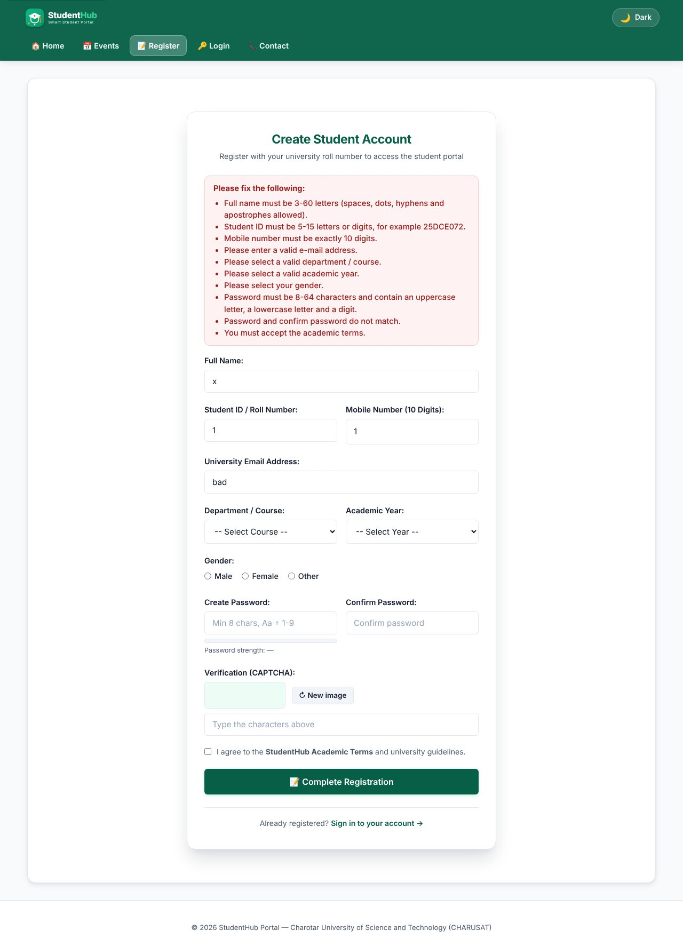
Server-side validation errors (client scripts blocked for this test)
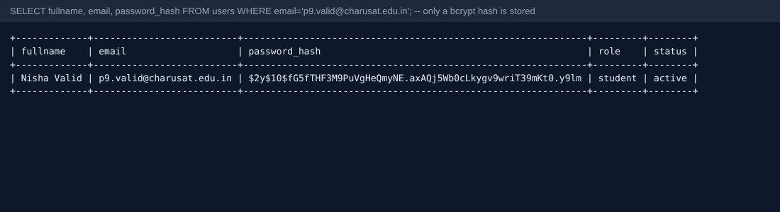
Only a bcrypt hash is stored in the users table
TEST CASES :
# | Input / action | Expected result | Result
1 | Valid data, new e-mail and roll number | Row inserted; flash message; audit_logs row "user_registered" | Pass
2 | Same e-mail and roll number again | Both "already registered" messages; no second row | Pass
3 | Name "x", ID "1", e-mail "bad", mobile "1", short passwords that differ | All field errors listed | Pass
4 | Name = Robert'); DROP TABLE users;-- | Rejected by the name pattern; even if it were accepted it is only bound as a parameter | Pass
5 | Name = <script>alert(1)</script> | Rejected; output is always escaped with e() | Pass
6 | POST without CSRF token | Rejected: "form session expired" | Pass
7 | password_verify(plain, stored hash) | true - the hash is valid and the plain text is not stored | Pass
8 | Two simultaneous submissions of the same user | Second one caught by MySQL error 1062 and shown as duplicate | Pass

KEY QUESTIONS :

1. Is password_hash() used?
Yes. The password is hashed with PASSWORD_DEFAULT (bcrypt today, with a random salt and cost factor inside the hash) before the INSERT. The column is VARCHAR(255) to allow future algorithms. The plain password is never stored, logged or shown. Login later uses password_verify().
$hash = password_hash($password, PASSWORD_DEFAULT);
$stmt = $conn->prepare('INSERT INTO users (fullname, student_id, email, mobile, course, year, gender, password_hash)
VALUES (?, ?, ?, ?, ?, ?, ?, ?)');
$stmt->bind_param('ssssssss', $fullname, $student_id, $email, $mobile, $course, $year, $gender, $hash);

2. Is the duplicate check done?
Yes, twice. First a prepared SELECT looks for the same e-mail or student ID and tells the user which one exists. Second, the UNIQUE keys in the table are the final guard: if two requests race, MySQL error 1062 is caught and turned into the same friendly message.
$stmt = $conn->prepare('SELECT email, student_id FROM users WHERE email = ? OR student_id = ?');
...
catch (mysqli_sql_exception $ex) { if ($ex->getCode() === 1062) { /* duplicate key */ } }

3. Are frontend and backend validations consistent?
Yes. The PHP rules are a copy of the JavaScript patterns of Practical 5 (name, roll number, 10-digit mobile, e-mail, password 8-64 with upper, lower and digit, course / year / gender white-lists, terms). JavaScript gives quick feedback; PHP is the real protection, so a user who disables JavaScript or posts with a tool still gets the same errors (test 3).

4. Advanced extension - CSRF token and audit log
csrf_token() creates a random token in the session, csrf_field() puts it in a hidden input and csrf_valid() compares it with hash_equals(). A successful registration is written to audit_logs (user, action, IP, time) with audit_log(). After success the page redirects (Post/Redirect/Get) so a refresh does not resubmit the form.

