Big Data Analytics for E-Commerce Customer Behavior Analysis and Product Recommendation System
Customer Behavior Analysis & Personalized Product Recommendations
Team members:
Aarav Sharma 23BLC1300
Niraj Agarwal 23BLC1198
Anubhav Singh Rathore 23BLC1280
Gemini Sharma 23BLC1010

Faculty:
Dharini R

Project detail | Value
Repository | https://github.com/Aarav3208/E-Com-BigData
Dataset | Online Retail II CSV
Technology | PySpark, Spark SQL, Spark MLlib ALS, React/Vite
Storage | Local Parquet and static JSON
Scope | No HDFS, MongoDB, APIs, Power BI, Kafka, Airflow, cloud or Kubernetes
Report date | 20 October 2026

Prepared for Big Data Analytics assessment

1. Abstract
This project delivers a complete local Big Data Analytics workflow for e-commerce transaction data. The solution loads the Online Retail II CSV with PySpark, applies reproducible transaction-cleaning rules, derives revenue and temporal features, stores processed data as Parquet, and produces Spark SQL reports. The completed system extends the analytics pipeline with genuine RFM segmentation, implicit-feedback ALS recommendations for unseen products, held-out recommendation evaluation, bounded static JSON exports, and a responsive React dashboard.
The final implementation processes 304,425 valid transaction rows. Current exports report 6,821,147.30 dataset monetary units in revenue, 14,683 distinct orders, 4,214 customers and 4,499 products. The dashboard exposes sales trends, product performance, customer segments, purchasing behavior, model evaluation and personalized recommendations without a backend service.

2. Problem Statement
Raw e-commerce files contain line items with inconsistent dates, cancellations, invalid quantities, missing customers and duplicates. Transaction lines do not directly answer which products generate revenue, which customers are valuable or inactive, whether customers return, or what new products could be recommended. The project addresses these needs with a distributed-data-oriented workflow and an actual-data dashboard.

Project objectives
- Build reliable Spark ingestion and cleaning.
- Produce sales, product and customer analytics.
- Classify customers using Recency, Frequency and Monetary value.
- Train ALS recommendations and exclude previously purchased products.
- Evaluate recommendations against held-out interactions and popularity.
- Serve calculated outputs through a static React dashboard.

3. Completion of Proposed Work
Planned work | Evidence | Status
Data loading/cleaning | PySpark loader and cleaner; date parsing, validation, cancellations and duplicates. | Complete
Feature engineering | Revenue and date/time features; customer/product Parquet aggregates. | Complete
Spark analytics | 14 reports including KPIs, monthly revenue/orders, products, behavior and segments. | Complete
RFM segmentation | Recency, distinct-invoice Frequency and Revenue-based Monetary rules. | Complete
ALS recommendations | Stable IDs, implicit quantity interactions, model persistence and unseen-product filtering. | Complete
Evaluation | Temporal holdout, RMSE, Precision, Recall, MAP, NDCG and popularity baseline. | Complete
Static export | Bounded deterministic JSON for all dashboard datasets. | Complete
React dashboard | Responsive charts, tables, filters, recommendations, evaluation and insights. | Complete

Reproducible commands
python main.py all
python main.py segment
python main.py recommend --top-n 10
python main.py evaluate-recommendations --top-n 10
python main.py export-json
cd frontend; npm run build
The final JSON files are in frontend/public/data and are consumed by the browser.

4. Methodology and Big Data Concepts
The architecture separates ingestion, cleaning, feature engineering, analytics, machine learning and presentation. Spark DataFrames and Spark SQL perform distributed transformations; Parquet provides columnar processed storage; JSON is a bounded presentation export for the static frontend.

Data preparation
- Normalize Customer ID to CustomerID.
- Parse InvoiceDate using MM-dd-yyyy HH:mm.
- Remove missing CustomerID or StockCode.
- Require positive Quantity and Price.
- Exclude invoices beginning with C.
- Remove duplicates and calculate Revenue = Quantity ? Price.

RFM and ALS
Recency is days since each customer?s latest purchase relative to the latest dataset date. Frequency is distinct invoice count. Monetary value is cleaned revenue. ALS uses summed purchased quantity as implicit interaction strength, deterministic hashed user/item IDs, and Spark MLlib latent factors. Candidates are generated, previous products are anti-joined, then unseen products are ranked and persisted.

Scalability and reliability
Aggregations remain in Spark, JSON collection is bounded, output ordering is deterministic, and empty states are handled in React. The Windows local filesystem adapter exists only for local Spark Parquet writes; HDFS is not used.

5. Outcome Demonstration: Sales and Products
KPI | Result
Total revenue | 6,821,147.30
Distinct orders | 14,683
Unique customers | 4,214
Unique products | 4,499
Average order value | 464.56
Valid transaction rows | 304,425

Monthly revenue sample
Period | Revenue
2009-01 | 43,894.87
2009-02 | 52,762.06
2009-03 | 67,413.62
2009-04 | 33,913.81
2009-05 | 9,803.05
2009-06 | 24,390.10
2009-07 | 33,002.49
2009-08 | 44,763.34
2009-09 | 30,763.17
2009-10 | 38,598.21

The React dashboard renders this export as a monthly line chart and provides a year filter that updates both revenue and order-volume charts. Highest and lowest months are calculated from the selected data, not hardcoded.

Top products by revenue
Product ID | Product | Revenue
22086 | PAPER CHAIN KIT 50'S CHRISTMAS | 35,434.08
22423 | REGENCY CAKESTAND 3 TIER | 106,114.38
22502 | PICNIC BASKET WICKER SMALL | 46,462.20
47566 | PARTY BUNTING | 39,506.07
84347 | ROTATING SILVER ANGELS T-LIGHT HLDR | 36,406.13
84879 | ASSORTED COLOUR BIRD ORNAMENT | 58,663.29
85099B | JUMBO BAG RED WHITE SPOTTY | 74,591.19
85123A | WHITE HANGING HEART T-LIGHT HOLDER | 105,906.63
M | Manual | 43,629.11
POST | POSTAGE | 53,098.73

A separate Spark report ranks products by quantity sold, allowing high-value and high-volume products to be compared.

6. Outcome Demonstration: RFM and Customer Behavior

RFM segment output
Segment | Customers | Share | Revenue
High-Value | 461 | 10.94% | 3,102,016.92
Inactive | 1,431 | 33.96% | 868,711.87
Occasional | 1,382 | 32.80% | 1,094,930.67
Regular | 940 | 22.31% | 1,755,487.84

Inactive is the largest segment by count with 1,431 customers (33.96%). High-Value contains 461 customers (10.94%) but contributes 3,102,016.92 monetary units, showing why RFM is more useful than count alone.

Purchasing behavior
Metric | Result | Definition
Repeat customers | 2,483 | More than one distinct invoice
One-time customers | 1,731 | Exactly one distinct invoice
Repeat purchase rate | 58.92% | Repeat customers / all customers
Average orders/customer | 3.48 | Distinct invoices / customers
Average spending | 1,618.69 | Cleaned revenue / customers

Purchase-frequency sample
Distinct orders | Customers
1 | 1731
2 | 820
3 | 515
4 | 345
5 | 176
6 | 147
7 | 109
8 | 75
9 | 51
10 | 36

Frequency distribution uses distinct invoices rather than transaction-line counts.

7. Outcome Demonstration: Recommendations and Evaluation
The dashboard allows a customer to select 5, 10 or 20 precomputed recommendations. Each row contains product ID, description, rank, ALS score and a New product label. Spark removes prior purchases before export; React does not retrain the model.
Output | Current result
Recommendation rows exported | 42,140
Customers represented | 4,214
Model | Implicit-feedback Spark MLlib ALS
Filtering | Left anti join against complete purchase history

8. Digital Documentation and Dashboard
The React dashboard is a static Vite client. It fetches analytics.json, customer_segments.json, products.json, recommendations.json and evaluation.json from frontend/public/data. No API server or mock dataset is involved.
- Overview KPI cards including average order value.
- Sales charts with year filters and month insights.
- Product revenue and quantity charts and tables.
- RFM distribution, percentages, revenue, search, segment filter and 10-row customer detail view.
- Repeat/one-time behavior and purchase-frequency distribution.
- ALS customer selector, 5/10/20 control, score explanation and empty states.
- ALS and popularity-baseline evaluation.
- Business insights generated from actual exports.
Artifact | Purpose
README.md | Setup, commands and metric definitions
VIVA_GUIDE.md | Viva-oriented technical explanation
frontend/src/main.jsx | Dashboard and data integration
frontend/src/style.css | Responsive presentation
frontend/public/data/*.json | Spark-generated dashboard data
data/processed/*.parquet | Processed and ML outputs
data/models/als | Persisted ALS model

This report provides the required abstract, problem statement, methodology, results and discussion, conclusion and future scope.

9. Web-Page Screenshots:

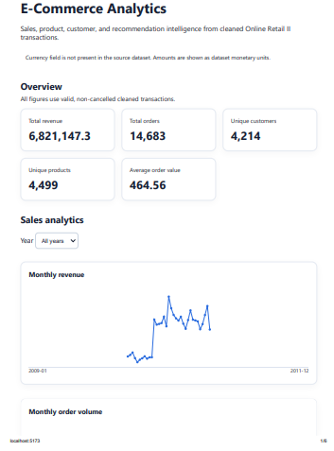

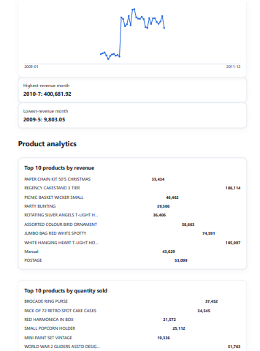

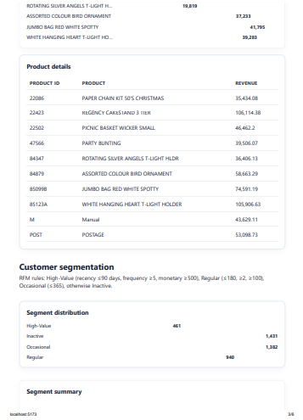

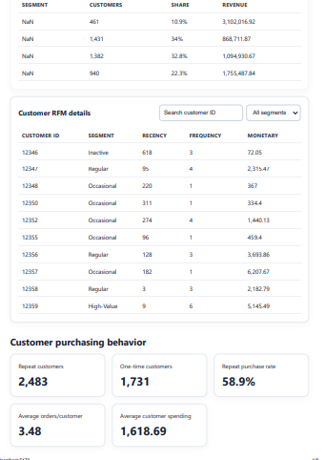

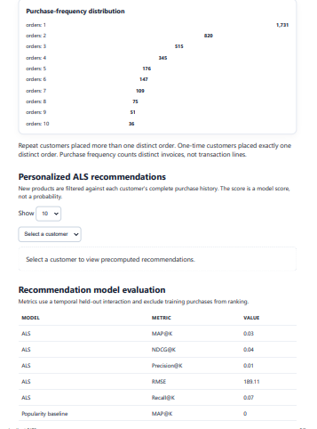

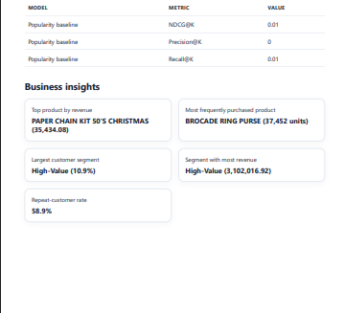

9. Understanding, Reflection and Q&A Readiness

Understanding and application
The project applies distributed DataFrame transformations, schema normalization, data-quality rules, Parquet storage, SQL aggregation, feature engineering, collaborative filtering, temporal evaluation, static data serving and responsive visualization. Spark owns the calculations while React presents consistent exported results.

What was learned
- Date parsing can remove every row and create misleading NULL/zero aggregates if the source format is not verified.
- Distinct invoices are required for order metrics.
- Implicit ALS scores are relative model scores, not probabilities.
- Anti-joining purchases is necessary for genuine new-product recommendations.
- Popularity is a useful interpretable baseline.
- Bounded driver collection and deterministic ordering are important for JSON exports.
- Local Windows Spark compatibility is separate from HDFS deployment.

Limitations and future scope
- The dataset has no currency field, so values are labelled dataset monetary units.
- ALS currently uses historical quantity interactions, not categories, text, seasonality or price.
- Static JSON is bounded; production systems could use pagination or a query service.
- Future work could add hybrid recommendations, freshness weighting, model versioning and automated refresh.

Conclusion
The proposed work is complete. The final system processes the dataset, produces reproducible analytics and ML outputs, demonstrates them in a responsive dashboard, and documents the design for assessment and viva discussion. All numerical evidence in this report comes from generated Spark exports.

