SOLVE FOR IITK

SnT Hackathon’23



**ENTREX**  
By Team **optiBrain**

# INTRODUCTION

*“On a daily basis, hundreds of students make entry and exit in the campus and are required to make entries in the register book at the gate. This poses to be quite cumbersome as often there is a crowd at the register table, causing issues to the Sis-Guard and hence leading to authentication issues. One such example of this issue is some students signing for several of their friends simultaneously.*

*Also using paperback registers for the entry-exit at the gates ends up using a lot of these new registers every week and makes maintenance of records a cumbersome task. This made us question the sustainability of the existing model in the long run and ponder over possible solutions for the same.”*

And so, we have successfully designed an app to deal with this situation. A one-stopsolution for resolving the issues related to the entry-exit problem on IITK gates.

The app has a simple UI, easy to use, that works on a very in-trend principle these days – ‘QR Scanning’!

All the student has to do is ‘Register’ on the app, and continue to ‘Login’, both just once! Note that only **@iitk.ac.in** email ids are accepted as valid entries here. A verification email will be sent their ‘iitk’ email id and they will be verified and registered.

Now, the ‘QR Scanner’ will be visible on the Home Page, with which one can scan the designated ‘refreshable’ QR Codes at the IITK gates and work as an alternative way of entry and exit showcasing the time and date of the scan!!

This project will also have a positive impact on the environment as lesser registers would be used, reducing paper usage overall by quite an amount!

# 

# FLOW OF WORK



We start off having made designs of all pages on Android Studio depending on the required windows in the app with their respective specific features.

We create a ‘Register’ and ‘Login’ system such that it only accepts @iitk.ac.in email entries and verifies a new account via a verification email at the registered email id.

We add the ‘QR Scanner’ after the Login page. For it to work, the app would require ‘user permissions’ to access the camera of the user’s device. This QR Scanner would only be able to validly scan specifically designated QR Codes available at the gates.

We further link the Register-Login, and QR Scanner to their respective datasheets to store the data entries of the users and scanned QR Codes in them, with the information pertaining to date and time of the scan.

# TOOLS USED

* **Android Studio**

Designing of the interface of the app and its various components done using this.

* **Firebase**

The user data at time of registration and email verification data will be stored here.

* **Google Collab**

Generation of QR Codes using python using this.

* **Google Sheets**

The data from the QR Scan is stored here, namely, date, time, email id and scan data.

* **Google Apps Script**

The medium through which data from QR Scan is stored on Google Sheets.

# 

# PROBLEMS FACED

During the implementation of the app, we had faced several problems– from errors in syntax and indexing to countless forms of errors and warnings. There were also problems faced with the implementations of functionality of the app, in the exact way as we had imagined it. Some of such problems were:

* During ‘Register-Login’ the app was registering any email id as valid. This problem was seeded out by adding the necessary True/False conditions.
* While making the QR Code, we could not find optimum ways of creating the QR and were not able to make it refreshable. Eventually using Google Collab eased our problems.
* There were also problems with the email verification being sent that could be easily sorted with a slight tweak in the working code.
* Also, the camera permissions were not being asked for. This also was sorted through tweaks in the code.
* Sending data entries to the spreadsheet and maintaining record for a particular id was also having problems as incorrect entries were being pushed in.

# 

# FUTURE MODIFICATIONS

* Making modification in the QR Scanner to work only when a particular ‘live’ QR Code is scanned. Currently, upon refreshing, the previous QR Codes are still valid upon scan.
* Making modification in the datasheet code, as we are getting an extra data entry after scanning two QR Code data from a single user.
* We can expand our app-pages beyond just entry-exit at IITK gates to inter-hall entries and exit.
* Separate option within the same app for entry-exit at the IITK gates when leaving for Home and returning. The QR Code will open into linked form that must be filled before leaving for Home. The form template has already been prepared but it hasn’t yet been integrated into the app.

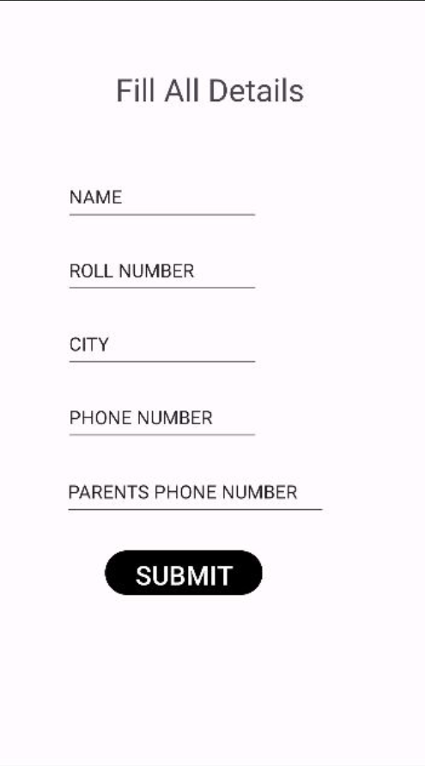

# THE END PRODUCT– ENTREX

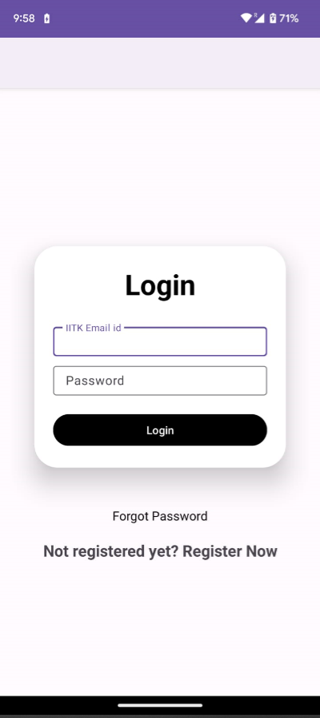 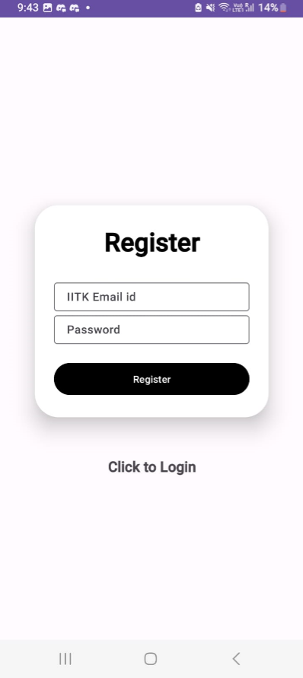

The login and Registering interface.

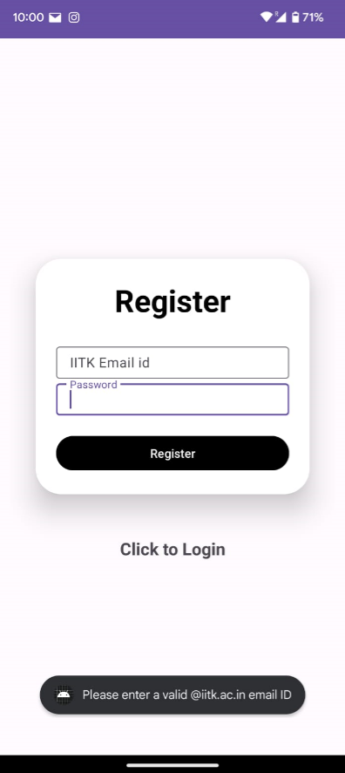 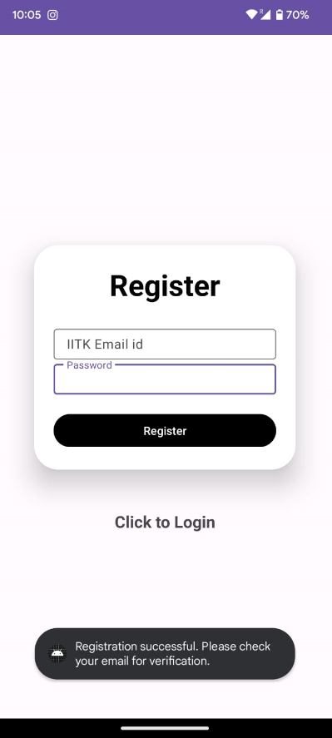

Only @iitk.ac.in email ids are allowed!

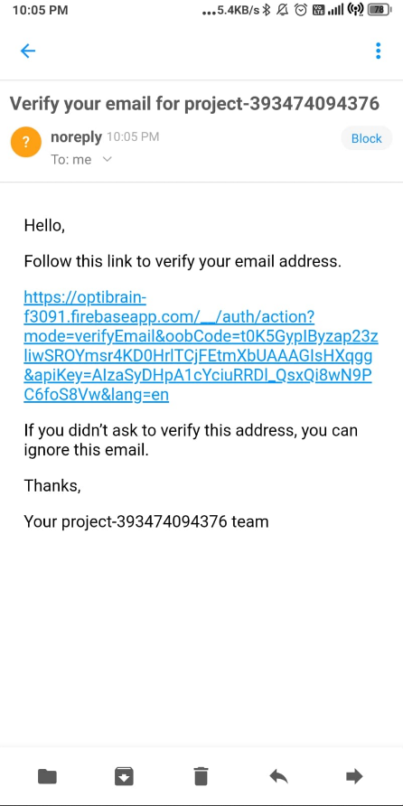 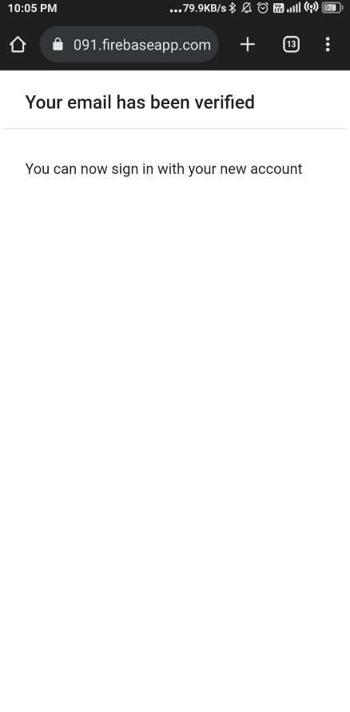

After registering, you will receive a verification email link. Upon clicking the link, verification has been completed!

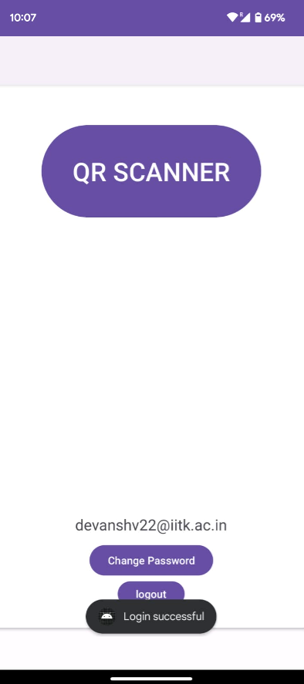 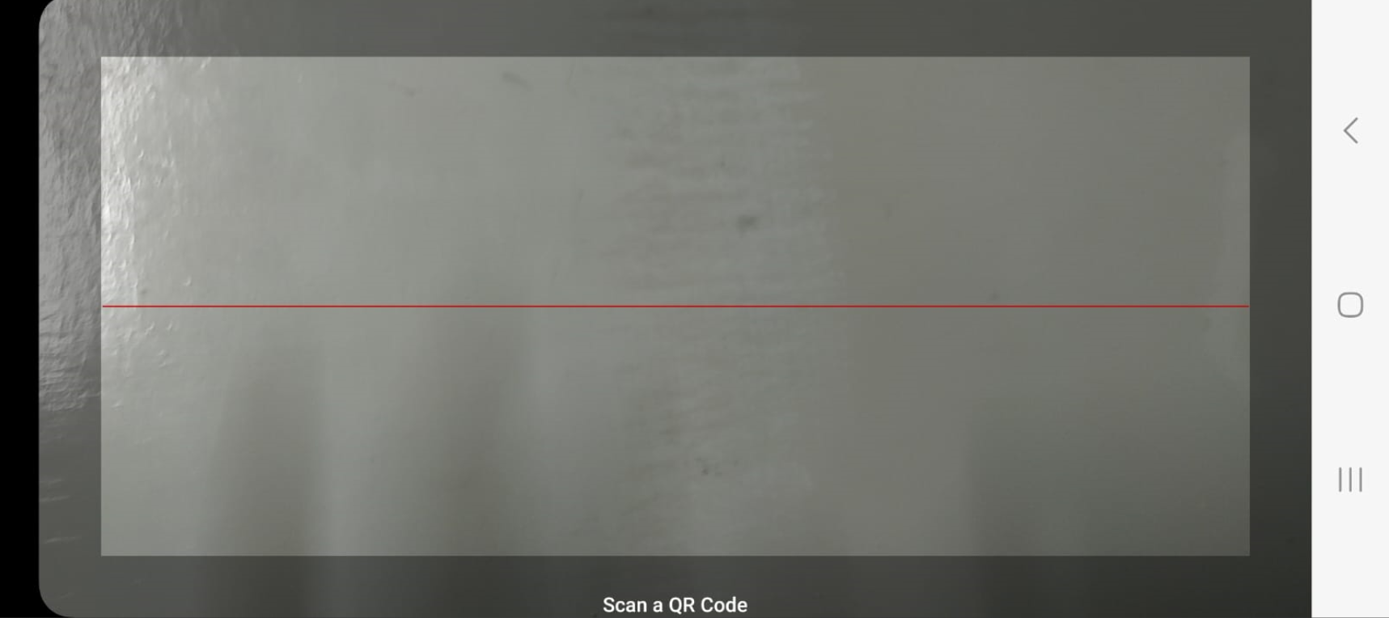

After login, QR Scanner would appear for use.

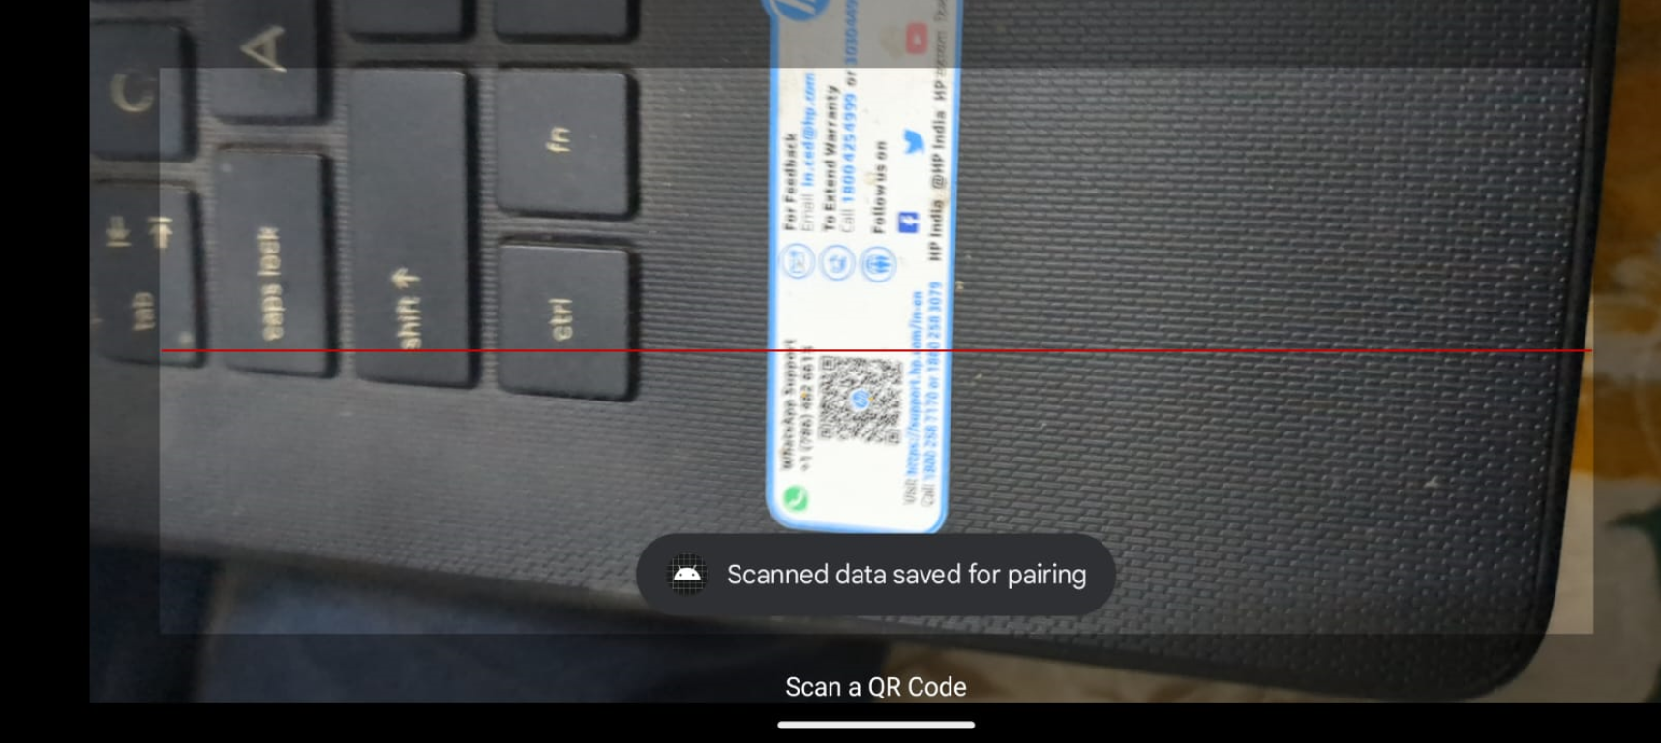 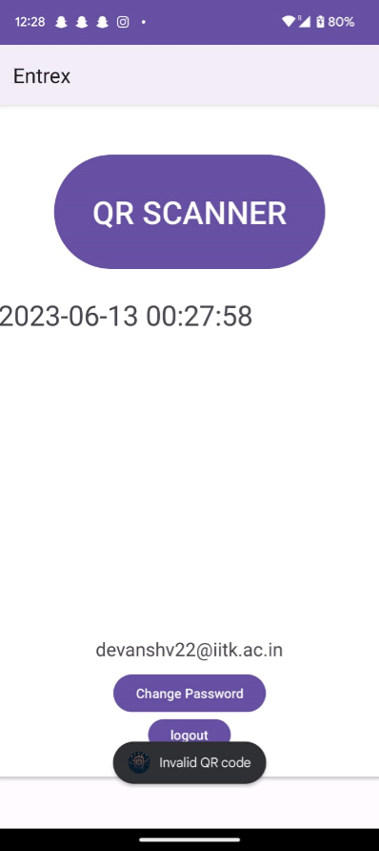

It distinguishes between different QRs…

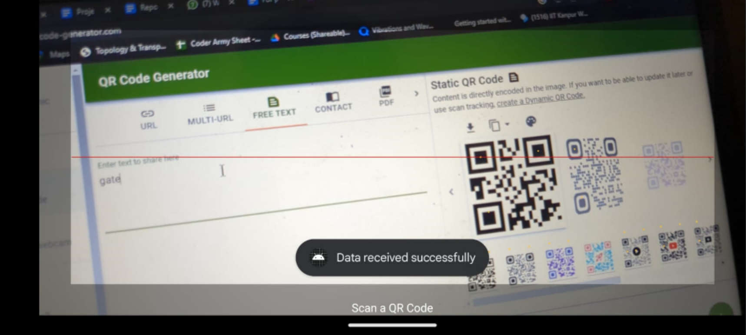 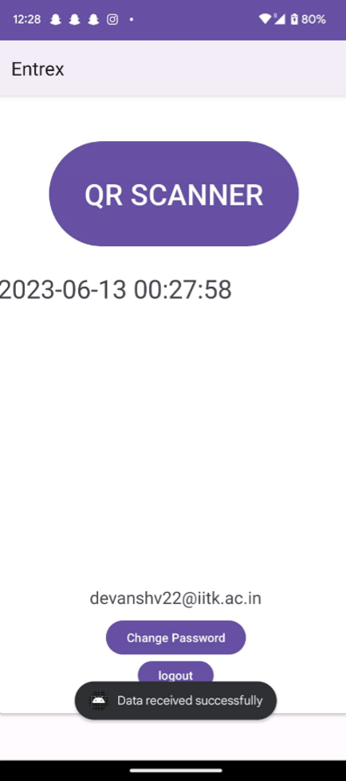

And the QRs assigned to respective gates at IITK!!

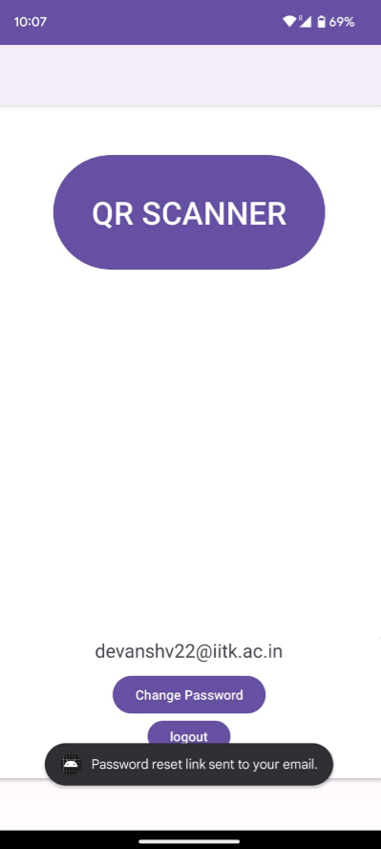 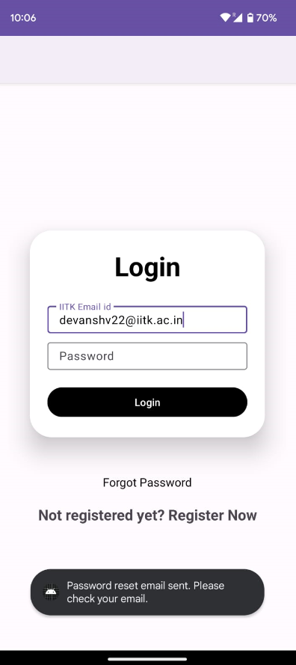

There is also ‘Change Password’ and ‘Forgot Password’!

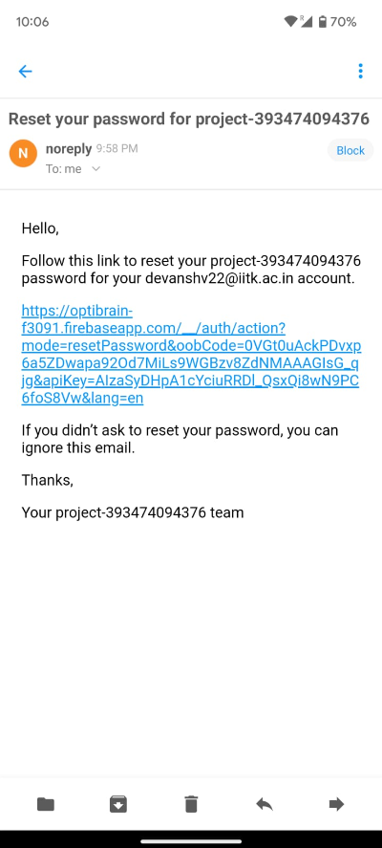 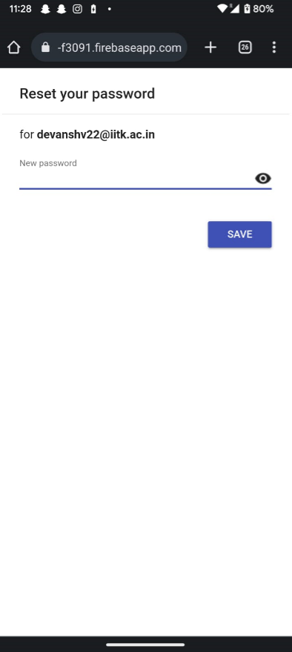

After that, you will receive a ‘Reset Password’ link via email to set ‘New Password’.

# HOW TO INSTALL

1. Click on *app-debug.apk*. Your device would ask for permission to install. You can download it from the GitHub repository.

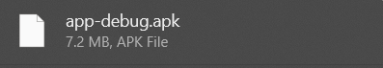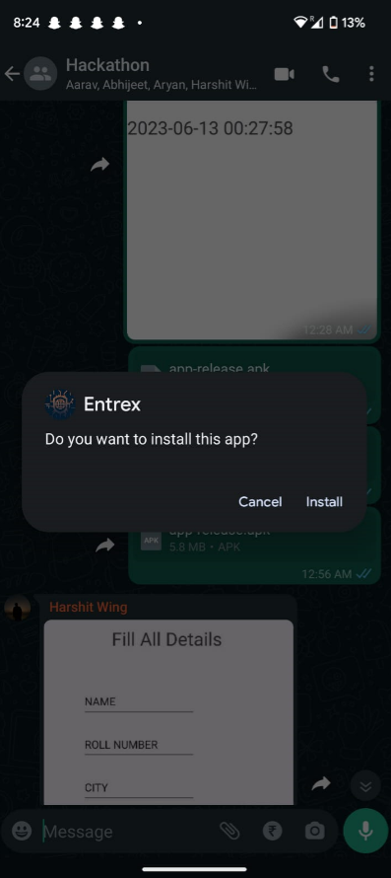

1. The app would show as ‘unsafe’ because it's not Google verified yet, continue by clicking on *More details*. Click on *Install anyway* to begin installation!

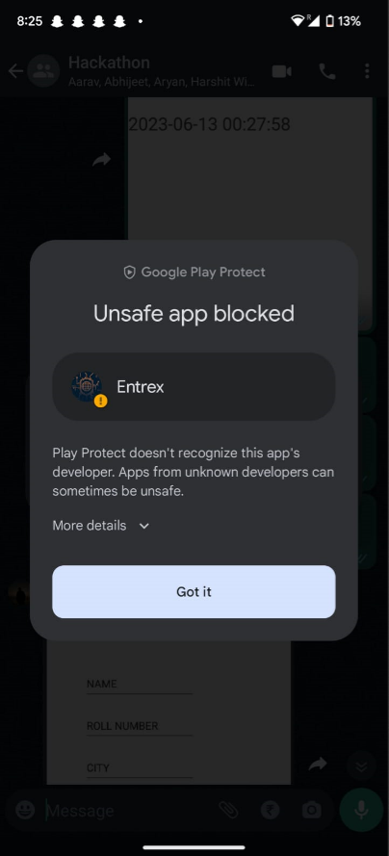 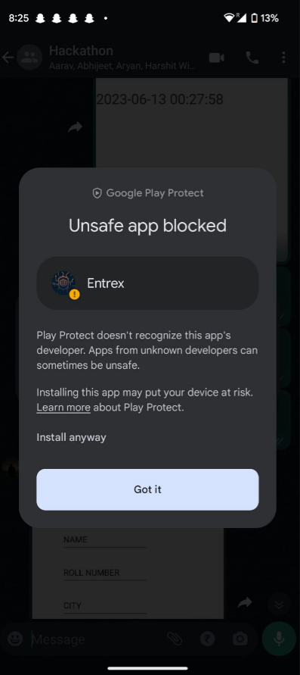

# 

# CONTRIBUTORS

Devansh Verma

Aryan Mittal

Harshit

Abhijeet Kumar

Aarav Aryaman

*For any queries contact:   
Team Leader Devansh Verma  
Email:* [*devanshv22@iitk.ac.in*](mailto:devanshv22@iitk.ac.in) *Phone: +91 70603 64751*