CIC IoV Dataset 2024

CICIoV2024: A Benchmark CAN Dataset to Evaluate IoV Security Solutions

The main goal of this research is to propose a realistic benchmark dataset to support the development of new cybersecurity solutions for IoV operations. To accomplish this, five attacks were executed against the fully intact inner structure of a 2019 Ford car, complete with all ECUs (Electronic Control Units). However, the vehicle was rendered immobile and incapable of causing any potential harm or injuries. Hence, all attacks were carried out on the vehicle without endangering the car's driver or passengers.

These attacks are classified as spoofing and Denial-of-Service (Dos) and were carried out through the CAN-BUS protocol. This effort establishes a baseline complementary to existing contributions and supports researchers to propose new IoV solutions to strengthen the overall security using different techniques (e.g., Machine Learning - ML).

The main contributions are:
- A
- B
- C

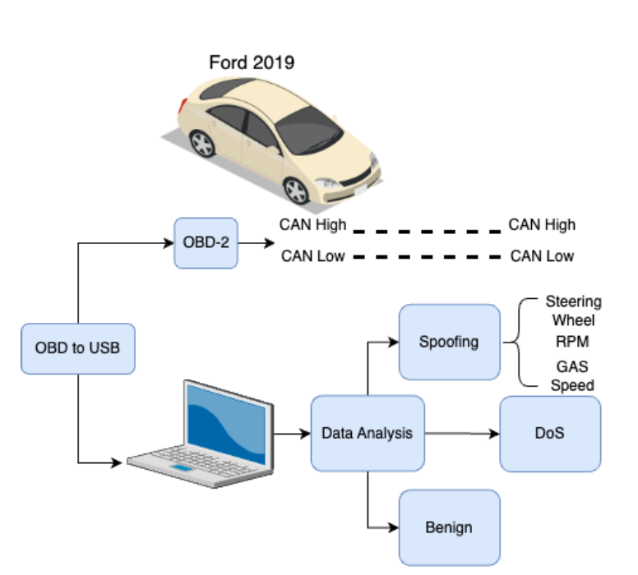

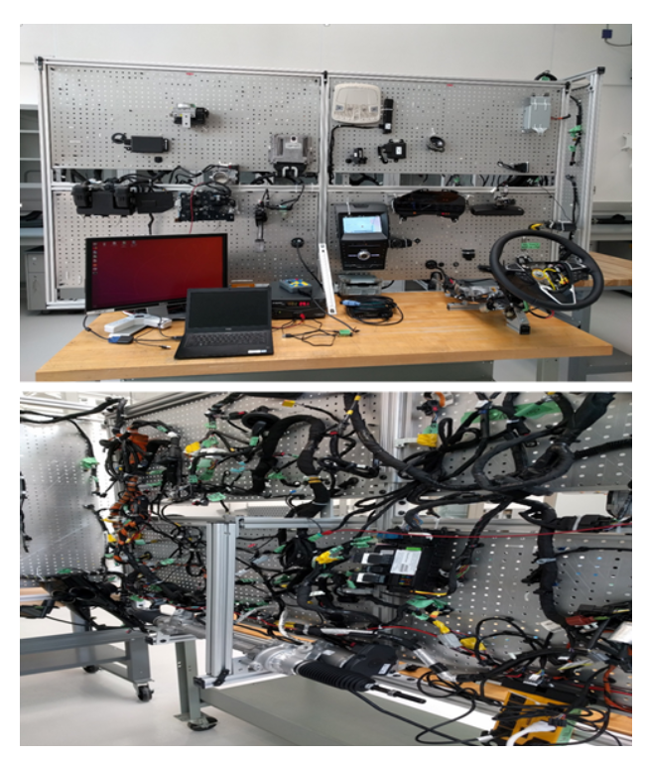

Data Description

Decimal Representation:
 | mean | std | min | 25% | 50% | 75% | max
ID | 537.207946 | 322.479994 | 65 | 357 | 516 | 578 | 1438
DATA_0 | 71.0865995 | 88.9771748 | 0 | 0 | 16 | 127 | 255
DATA_1 | 69.9892503 | 95.5837431 | 0 | 0 | 12 | 128 | 255
DATA_2 | 55.0112724 | 72.7658378 | 0 | 0 | 13 | 125 | 255
DATA_3 | 57.4536383 | 90.3207664 | 0 | 0 | 0 | 92 | 255
DATA_4 | 45.2851673 | 64.4583498 | 0 | 0 | 6 | 86 | 255
DATA_5 | 53.8826134 | 94.3361202 | 0 | 0 | 0 | 63 | 255
DATA_6 | 71.7491441 | 101.687183 | 0 | 0 | 0 | 138 | 255
DATA_7 | 60.2747691 | 99.9654672 | 0 | 0 | 0 | 80 | 255

Binary Representation:
 | mean | std | min | 25% | 50% | 75% | max
ID0 | 0 | 0 | 0 | 0 | 0 | 0 | 0
ID1 | 0 | 0 | 0 | 0 | 0 | 0 | 0
ID2 | 0 | 0 | 0 | 0 | 0 | 0 | 0
ID3 | 0 | 0 | 0 | 0 | 0 | 0 | 0
ID4 | 0 | 0 | 0 | 0 | 0 | 0 | 0
ID5 | 0 | 0 | 0 | 0 | 0 | 0 | 0
ID6 | 0.16952406 | 0.37521428 | 0 | 0 | 0 | 0 | 1
ID7 | 0.42718498 | 0.49466973 | 0 | 0 | 0 | 1 | 1
ID8 | 0.29153065 | 0.45446747 | 0 | 0 | 0 | 1 | 1
ID9 | 0.13162299 | 0.33808056 | 0 | 0 | 0 | 0 | 1
ID10 | 0.37840989 | 0.48499074 | 0 | 0 | 0 | 1 | 1
ID11 | 0.50427242 | 0.49998192 | 0 | 0 | 1 | 1 | 1
ID12 | 0.48455602 | 0.4997616 | 0 | 0 | 0 | 1 | 1
ID13 | 0.19254321 | 0.39429739 | 0 | 0 | 0 | 0 | 1
ID14 | 0.5746173 | 0.49440108 | 0 | 0 | 1 | 1 | 1
ID15 | 0.46847259 | 0.49900521 | 0 | 0 | 0 | 1 | 1
ID16 | 0.53340638 | 0.49888294 | 0 | 0 | 1 | 1 | 1
DATA_00 | 0 | 0 | 0 | 0 | 0 | 0 | 0
DATA_01 | 0 | 0 | 0 | 0 | 0 | 0 | 0
DATA_02 | 0 | 0 | 0 | 0 | 0 | 0 | 0
DATA_03 | 0 | 0 | 0 | 0 | 0 | 0 | 0
DATA_04 | 0 | 0 | 0 | 0 | 0 | 0 | 0
DATA_05 | 0 | 0 | 0 | 0 | 0 | 0 | 0
DATA_06 | 0 | 0 | 0 | 0 | 0 | 0 | 0
DATA_07 | 0 | 0 | 0 | 0 | 0 | 0 | 0
DATA_08 | 0 | 0 | 0 | 0 | 0 | 0 | 0
DATA_09 | 0.22309243 | 0.41631998 | 0 | 0 | 0 | 0 | 1
DATA_010 | 0.34454158 | 0.47521873 | 0 | 0 | 0 | 1 | 1
DATA_011 | 0.31769774 | 0.4655814 | 0 | 0 | 0 | 1 | 1
DATA_012 | 0.33472706 | 0.47189513 | 0 | 0 | 0 | 1 | 1
DATA_013 | 0.31426362 | 0.46422209 | 0 | 0 | 0 | 1 | 1
DATA_014 | 0.37693711 | 0.48461912 | 0 | 0 | 0 | 1 | 1
DATA_015 | 0.32008942 | 0.46651081 | 0 | 0 | 0 | 1 | 1
DATA_016 | 0.29611019 | 0.45654035 | 0 | 0 | 0 | 1 | 1
DATA_10 | 0 | 0 | 0 | 0 | 0 | 0 | 0
DATA_11 | 0 | 0 | 0 | 0 | 0 | 0 | 0
DATA_12 | 0 | 0 | 0 | 0 | 0 | 0 | 0
DATA_13 | 0 | 0 | 0 | 0 | 0 | 0 | 0
DATA_14 | 0 | 0 | 0 | 0 | 0 | 0 | 0
DATA_15 | 0 | 0 | 0 | 0 | 0 | 0 | 0
DATA_16 | 0 | 0 | 0 | 0 | 0 | 0 | 0
DATA_17 | 0 | 0 | 0 | 0 | 0 | 0 | 0
DATA_18 | 0 | 0 | 0 | 0 | 0 | 0 | 0
DATA_19 | 0.28475827 | 0.45129939 | 0 | 0 | 0 | 1 | 1
DATA_110 | 0.24356439 | 0.42923293 | 0 | 0 | 0 | 0 | 1
DATA_111 | 0.28651083 | 0.45213109 | 0 | 0 | 0 | 1 | 1
DATA_112 | 0.24899749 | 0.43243251 | 0 | 0 | 0 | 0 | 1
DATA_113 | 0.31631799 | 0.46503879 | 0 | 0 | 0 | 1 | 1
DATA_114 | 0.35077854 | 0.47721391 | 0 | 0 | 0 | 1 | 1
DATA_115 | 0.28126236 | 0.44961538 | 0 | 0 | 0 | 1 | 1
DATA_116 | 0.30358204 | 0.45980445 | 0 | 0 | 0 | 1 | 1
DATA_20 | 0 | 0 | 0 | 0 | 0 | 0 | 0
DATA_21 | 0 | 0 | 0 | 0 | 0 | 0 | 0
DATA_22 | 0 | 0 | 0 | 0 | 0 | 0 | 0
DATA_23 | 0 | 0 | 0 | 0 | 0 | 0 | 0
DATA_24 | 0 | 0 | 0 | 0 | 0 | 0 | 0
DATA_25 | 0 | 0 | 0 | 0 | 0 | 0 | 0
DATA_26 | 0 | 0 | 0 | 0 | 0 | 0 | 0
DATA_27 | 0 | 0 | 0 | 0 | 0 | 0 | 0
DATA_28 | 0 | 0 | 0 | 0 | 0 | 0 | 0
DATA_29 | 0.16682206 | 0.37281706 | 0 | 0 | 0 | 0 | 1
DATA_210 | 0.23185811 | 0.42201902 | 0 | 0 | 0 | 0 | 1
DATA_211 | 0.30791589 | 0.46163172 | 0 | 0 | 0 | 1 | 1
DATA_212 | 0.25489004 | 0.43579955 | 0 | 0 | 0 | 1 | 1
DATA_213 | 0.33766694 | 0.47291451 | 0 | 0 | 0 | 1 | 1
DATA_214 | 0.30989072 | 0.4624485 | 0 | 0 | 0 | 1 | 1
DATA_215 | 0.30772841 | 0.46155367 | 0 | 0 | 0 | 1 | 1
DATA_216 | 0.33122476 | 0.47065388 | 0 | 0 | 0 | 1 | 1
DATA_30 | 0 | 0 | 0 | 0 | 0 | 0 | 0
DATA_31 | 0 | 0 | 0 | 0 | 0 | 0 | 0
DATA_32 | 0 | 0 | 0 | 0 | 0 | 0 | 0
DATA_33 | 0 | 0 | 0 | 0 | 0 | 0 | 0
DATA_34 | 0 | 0 | 0 | 0 | 0 | 0 | 0
DATA_35 | 0 | 0 | 0 | 0 | 0 | 0 | 0
DATA_36 | 0 | 0 | 0 | 0 | 0 | 0 | 0
DATA_37 | 0 | 0 | 0 | 0 | 0 | 0 | 0
DATA_38 | 0 | 0 | 0 | 0 | 0 | 0 | 0
DATA_39 | 0.1918338 | 0.39374319 | 0 | 0 | 0 | 0 | 1
DATA_310 | 0.25849389 | 0.43780696 | 0 | 0 | 0 | 1 | 1
DATA_311 | 0.23691912 | 0.4251924 | 0 | 0 | 0 | 0 | 1
DATA_312 | 0.29121678 | 0.45432336 | 0 | 0 | 0 | 1 | 1
DATA_313 | 0.2679498 | 0.44289146 | 0 | 0 | 0 | 1 | 1
DATA_314 | 0.29034333 | 0.45392095 | 0 | 0 | 0 | 1 | 1
DATA_315 | 0.26623629 | 0.44198944 | 0 | 0 | 0 | 1 | 1
DATA_316 | 0.27697894 | 0.44750614 | 0 | 0 | 0 | 1 | 1
DATA_40 | 0 | 0 | 0 | 0 | 0 | 0 | 0
DATA_41 | 0 | 0 | 0 | 0 | 0 | 0 | 0
DATA_42 | 0 | 0 | 0 | 0 | 0 | 0 | 0
DATA_43 | 0 | 0 | 0 | 0 | 0 | 0 | 0
DATA_44 | 0 | 0 | 0 | 0 | 0 | 0 | 0
DATA_45 | 0 | 0 | 0 | 0 | 0 | 0 | 0
DATA_46 | 0 | 0 | 0 | 0 | 0 | 0 | 0
DATA_47 | 0 | 0 | 0 | 0 | 0 | 0 | 0
DATA_48 | 0 | 0 | 0 | 0 | 0 | 0 | 0
DATA_49 | 0.11576182 | 0.31993921 | 0 | 0 | 0 | 0 | 1
DATA_410 | 0.25658935 | 0.43675095 | 0 | 0 | 0 | 1 | 1
DATA_411 | 0.18494851 | 0.38825593 | 0 | 0 | 0 | 0 | 1
DATA_412 | 0.23620332 | 0.42474868 | 0 | 0 | 0 | 0 | 1
DATA_413 | 0.2521845 | 0.43426675 | 0 | 0 | 0 | 1 | 1
DATA_414 | 0.30246503 | 0.45932569 | 0 | 0 | 0 | 1 | 1
DATA_415 | 0.40185582 | 0.49027328 | 0 | 0 | 0 | 1 | 1
DATA_416 | 0.31728233 | 0.46541853 | 0 | 0 | 0 | 1 | 1
DATA_50 | 0 | 0 | 0 | 0 | 0 | 0 | 0
DATA_51 | 0 | 0 | 0 | 0 | 0 | 0 | 0
DATA_52 | 0 | 0 | 0 | 0 | 0 | 0 | 0
DATA_53 | 0 | 0 | 0 | 0 | 0 | 0 | 0
DATA_54 | 0 | 0 | 0 | 0 | 0 | 0 | 0
DATA_55 | 0 | 0 | 0 | 0 | 0 | 0 | 0
DATA_56 | 0 | 0 | 0 | 0 | 0 | 0 | 0
DATA_57 | 0 | 0 | 0 | 0 | 0 | 0 | 0
DATA_58 | 0 | 0 | 0 | 0 | 0 | 0 | 0
DATA_59 | 0.17389412 | 0.37901854 | 0 | 0 | 0 | 0 | 1
DATA_510 | 0.24749915 | 0.43155933 | 0 | 0 | 0 | 0 | 1
DATA_511 | 0.22956799 | 0.42055517 | 0 | 0 | 0 | 0 | 1
DATA_512 | 0.22830185 | 0.4197383 | 0 | 0 | 0 | 0 | 1
DATA_513 | 0.30647222 | 0.46102836 | 0 | 0 | 0 | 1 | 1
DATA_514 | 0.31337526 | 0.46386567 | 0 | 0 | 0 | 1 | 1
DATA_515 | 0.33985907 | 0.47366132 | 0 | 0 | 0 | 1 | 1
DATA_516 | 0.400219 | 0.48994278 | 0 | 0 | 0 | 1 | 1
DATA_60 | 0 | 0 | 0 | 0 | 0 | 0 | 0
DATA_61 | 0 | 0 | 0 | 0 | 0 | 0 | 0
DATA_62 | 0 | 0 | 0 | 0 | 0 | 0 | 0
DATA_63 | 0 | 0 | 0 | 0 | 0 | 0 | 0
DATA_64 | 0 | 0 | 0 | 0 | 0 | 0 | 0
DATA_65 | 0 | 0 | 0 | 0 | 0 | 0 | 0
DATA_66 | 0 | 0 | 0 | 0 | 0 | 0 | 0
DATA_67 | 0 | 0 | 0 | 0 | 0 | 0 | 0
DATA_68 | 0 | 0 | 0 | 0 | 0 | 0 | 0
DATA_69 | 0.26563695 | 0.44167194 | 0 | 0 | 0 | 1 | 1
DATA_610 | 0.29937602 | 0.4579849 | 0 | 0 | 0 | 1 | 1
DATA_611 | 0.32685967 | 0.46906565 | 0 | 0 | 0 | 1 | 1
DATA_612 | 0.24077505 | 0.42755416 | 0 | 0 | 0 | 0 | 1
DATA_613 | 0.28923981 | 0.45340963 | 0 | 0 | 0 | 1 | 1
DATA_614 | 0.23674372 | 0.42508382 | 0 | 0 | 0 | 0 | 1
DATA_615 | 0.35568971 | 0.47872195 | 0 | 0 | 0 | 1 | 1
DATA_616 | 0.30336617 | 0.45971218 | 0 | 0 | 0 | 1 | 1
DATA_70 | 0 | 0 | 0 | 0 | 0 | 0 | 0
DATA_71 | 0 | 0 | 0 | 0 | 0 | 0 | 0
DATA_72 | 0 | 0 | 0 | 0 | 0 | 0 | 0
DATA_73 | 0 | 0 | 0 | 0 | 0 | 0 | 0
DATA_74 | 0 | 0 | 0 | 0 | 0 | 0 | 0
DATA_75 | 0 | 0 | 0 | 0 | 0 | 0 | 0
DATA_76 | 0 | 0 | 0 | 0 | 0 | 0 | 0
DATA_77 | 0 | 0 | 0 | 0 | 0 | 0 | 0
DATA_78 | 0 | 0 | 0 | 0 | 0 | 0 | 0
DATA_79 | 0.22083781 | 0.41481152 | 0 | 0 | 0 | 0 | 1
DATA_710 | 0.25788674 | 0.43747149 | 0 | 0 | 0 | 1 | 1
DATA_711 | 0.25140266 | 0.43381966 | 0 | 0 | 0 | 1 | 1
DATA_712 | 0.25464434 | 0.43566126 | 0 | 0 | 0 | 1 | 1
DATA_713 | 0.22435147 | 0.41715466 | 0 | 0 | 0 | 0 | 1
DATA_714 | 0.22010852 | 0.41431978 | 0 | 0 | 0 | 0 | 1
DATA_715 | 0.23915456 | 0.42656745 | 0 | 0 | 0 | 0 | 1
DATA_716 | 0.23002885 | 0.42085117 | 0 | 0 | 0 | 0 | 1

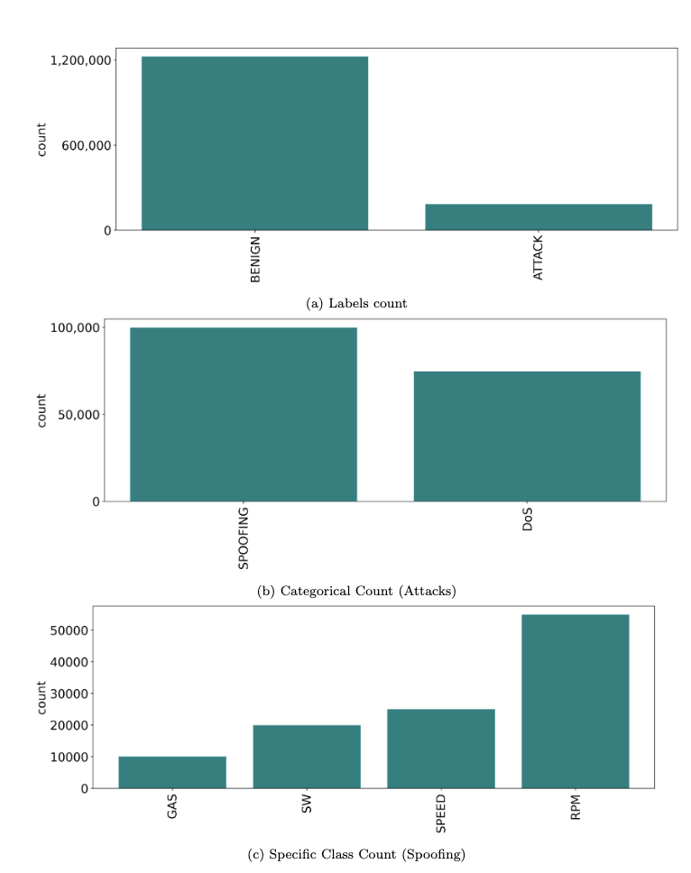

Dataset Directories

The main dataset directory (CICIoV2024) contains four subdirectories related to different files, namely:
Hexadecimal: Data collected represented in hexadecimal format (benign, DoS, spoofing-GAS, spoofing-RPM, spoofing-SPEED, and spoofing-STEERING_WHEEL).

Decimal: Data collected represented in decimal format (benign, DoS, spoofing-GAS, spoofing-RPM, spoofing-SPEED, and spoofing-STEERING_WHEEL).

Binary: Data collected represented in binary format (benign, DoS, spoofing-GAS, spoofing-RPM, spoofing-SPEED, and spoofing-STEERING_WHEEL).

Acknowledgments
The authors graciously acknowledge the support from the Canadian Institute for Cybersecurity (CIC), the funding support from the National Research Council of Canada (NRC) through the AI for Logistics collaborative program, the NSERC Discovery Grant (no. RGPIN 231074), and Tier 1 Canada Research Chair to Dr. Ghorbani.

Citation

-

