Collected Data

This directory presents the data collected in the experiments. Three subdirectories are available:

Hexadecimal: Data collected represented in hexadecimal format (benign, DoS, spoofing-GAS, spoofing-RPM, spoofing-SPEED, and spoofing-STEERING_WHEEL)

Decimal: Data collected represented in decimal format (benign, DoS, spoofing-GAS, spoofing-RPM, spoofing-SPEED, and spoofing-STEERING_WHEEL)

Binary: Data collected represented in binary format (benign, DoS, spoofing-GAS, spoofing-RPM, spoofing-SPEED, and spoofing-STEERING_WHEEL)

Testbed

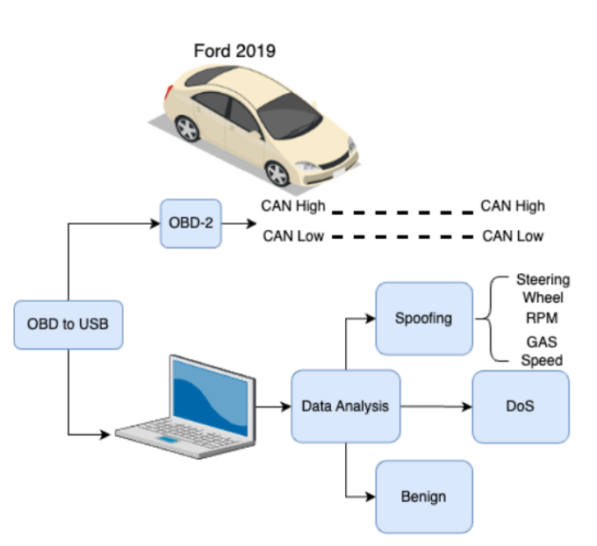
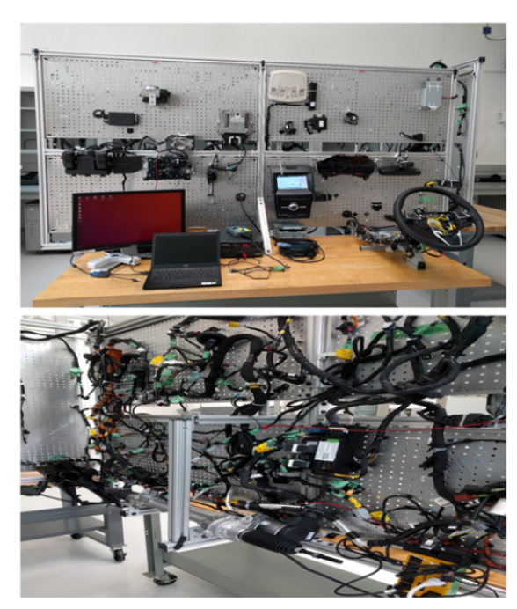

Features

