A Standardized Evaluation Framework for Intrusion Detection in the Internet of Vehicles Using CICIoV2024
A Project Work/Practice School Report submitted
to
MANIPAL ACADEMY OF HIGHER EDUCATION
for partial fulfilment of the requirement for the award of the degree of
BACHELOR OF TECHNOLOGY
in
COMPUTER SCIENCE & ENGINEERING
Submitted by:
Aarav Bhandari (Reg No: 220905448)
Internal Guide:
Dr. Girija Attigeri
Associate Professor
School of Computer Engineering
MIT Manipal
SCHOOL OF COMPUTER ENGINEERING
MANIPAL INSTITUTE OF TECHNOLOGY, MANIPAL
July 2026

DECLARATION

I hereby declare that this project work entitled 'A Standardized Evaluation Framework for Intrusion Detection in the Internet of Vehicles Using CICIoV2024’ is original and has been carried out by me. No part of this work has been submitted previously for the award of a degree or diploma to this University or any other institution.
Place: Manipal
Date: 14th July 2026
___________________________
Aarav Bhandari
(220905448)

CERTIFICATE

This is to certify that the project titled 'A Standardized Evaluation Framework for Intrusion Detection in the Internet of Vehicles Using CICIoV2024’ is a record of the bonafide work done by Aarav Bhandari (Reg. No. 220905448) submitted in partial fulfilment of the requirements for the award of the Degree of Bachelor of Technology in Computer Science & Engineering of Manipal Academy of Higher Education, Manipal, during the academic year 2025-2026.
___________________________
Dr. Girija Attigeri
Internal Guide, Associate Professor
School of Computer Engineering, MIT Manipal

ABSTRACT

The Internet of Vehicles (IoV) ecosystem heavily relies on the Controller Area Network (CAN) bus for in-vehicle communication. However, the CAN bus protocol lacks fundamental security mechanisms like authentication and encryption, exposing vehicles to critical cyberattacks such as Denial of Service (DoS) and sensor spoofing. Machine Learning-based Intrusion Detection Systems (IDS) offer a promising software countermeasure. However, the research community lacks standardized evaluation frameworks, which leads to issues like data leakage and over-optimistic performance metrics that fail under real-world conditions.
This project addresses these gaps by establishing a comprehensive, highly standardized, and configuration-driven evaluation framework covering both baseline pipelines and advanced temporal deep learning architectures. The framework benchmarks four classical machine learning models (Random Forest, SVM, XGBoost, LightGBM) and three deep learning architectures (MLP, LSTM, 1D-CNN) on the recent CICIoV2024 dataset. To simulate real-world conditions, an aggressive duplicate-removal preprocessing pipeline was engineered (reducing raw frames by 99.7%). Model generalization was rigorously evaluated utilizing standard random splits, driving scenario-based splits, and novel zero-day attack-holdout configurations. Furthermore, the architecture integrates advanced temporal sliding-window feature engineering, cross-dataset validation adapters, and a dynamic adversarial evasion engine.
Comprehensive metric evaluations across 112 experiments indicate that while tree-based boosting models like XGBoost achieve exceptionally high F1-scores under standard random splits (0.9970), they exhibit catastrophic generalization failures during zero-day attack-holdout evaluations, with detection rates plummeting to 20% on DoS holdouts. In contrast, Support Vector Machines (SVM) maintained a perfect 100% detection rate against novel threats. Robustness sweeps under timing jitter (2%), feature noise (1%), and attack intensity scaling (0.85x-1.15x) confirmed SVM as the most structurally stable model (robustness score: 0.000232). Additionally, algorithmic feature selection sweeps proved that filtering the dataset down to the top 3 mutual information features (mi_k_3) yields a 70% reduction in the required edge-device memory footprint while restricting F1-score degradation to an imperceptible margin (< 0.002).
All evaluated models successfully achieve sub-millisecond per-sample inference latency, verifying their functional viability for real-time in-vehicle hardware deployment. The completed framework, developed in Python, establishes a fully reproducible and adaptable foundation for future automotive security research.

TABLE OF CONTENTS
Chapter/Section | Title | Page Number
Declaration | Declaration of Originality | i
Certificate | Internship Com Record | ii
Certificate | College Bonafide Record | ii
Abstract | Executive Project Summary | iii
List of Tables | Index of Structured Tables | iv
List of Figures | Index of Structured Tables | iv
Abbreviations | Glossary of Technical Acronyms | v
Chapter 1 | Introduction & Target Specifications | 1
Chapter 2 | Background Theory & Literature Review | 3
Chapter 3 | Comprehensive Methodology & Architectural Blueprints | 5
Chapter 4 | Result Analysis & ML Metric Evaluation | 9
4.1 | Results | 9
4.2 | Discussion and Inference | 10
4.3 | Conclusions | 12
Chapter 5 | Conclusion & Future Scope | 13
References | IEEE Bibliographic Citations | 14
Project Details | Academic & Organizational Log Table | 15

LIST OF TABLES
Table Number & Title | Page Number
Table 2.1: Summary of Literature Survey | 4
Table 4.1: Baseline Performance (Stratified Random Split) | 9
Table 4.2: Scenario-Based Split Performance | 10
Table 4.3: Zero-Day (Attack Holdout) Results (F1-Score / Detection Rate) | 11
Table 4.4: Model Robustness Analysis (Absolute F1-Score Deltas) | 12

LIST OF FIGURES
Table Number & Title | Page Number
Table 2.1: Summary of Literature Survey | 4
Table 4.1: Baseline Performance (Stratified Random Split) | 9
Table 4.2: Scenario-Based Split Performance | 10
Table 4.3: Zero-Day (Attack Holdout) Results (F1-Score / Detection Rate) | 11
Table 4.4: Model Robustness Analysis (Absolute F1-Score Deltas) | 12

ABBREVIATIONS
Acronym | Full Structural Meaning
CAN | Controller Area Network
CNN | Convolutional Neural Network
DoS | Denial of Service
ECU | Electronic Control Unit
IDS | Intrusion Detection System
IoV | Internet of Vehicles
LSTM | Long Short-Term Memory
MI | Mutual Information
MLP | Multi-Layer Perceptron
PCA | Principal Component Analysis
RF | Random Forest
SVM | Support Vector Machine

CHAPTER 1: INTRODUCTION

1.1 Introduction
Modern automotive systems have evolved from isolated mechanical machines into highly connected Internet of Vehicles (IoV) networks. A typical modern vehicle contains up to 100 Electronic Control Units (ECUs) controlling safety-critical operations (brakes, steering, engine) and convenience systems (infotainment, telematics). These ECUs communicate over the Controller Area Network (CAN) bus protocol, which was designed in the 1980s.
While the CAN bus is highly reliable and deterministic, it has no native security features:
- No Authentication: Packets are broadcast on the bus, and any ECU can spoof messages claiming to be another unit.
- No Encryption: All payloads are transmitted in plaintext, allowing attackers to read the data.
- Arbitration Susceptibility: The priority-based arbitration allows an attacker to flood the bus with high-priority messages (like ID 0x000), causing a Denial of Service (DoS).
- No Isolation: Compromising a single non-critical ECU (e.g., tire pressure monitors) provides access to the safety-critical CAN bus.
Since upgrading ECU hardware across millions of existing vehicles is cost-prohibitive, software-based Machine Learning Intrusion Detection Systems (IDS) are a critical alternative. An IDS listens to CAN traffic and detects anomalies in timing or payloads in real time.

1.2 Motivation
Existing research in IoV intrusion detection suffers from major methodological limitations:
- Data Leakage: Most studies evaluate models on simple random splits of highly repetitive CAN traffic, resulting in over-optimistic (99.9%) detection rates that fail in real driving environments.
- Zero-Day Evaluation Gaps: Classifiers are rarely tested on novel, unseen attack categories, leaving their generalization capabilities unmeasured.
- Lack of Robustness Analysis: Models are not systematically tested against natural signal fluctuations, sensor noise, or adversarial evasion techniques.
- Ignoring Latency Constraints: Real-time CAN bus monitoring requires sub-millisecond latency, but literature rarely benchmarks models on low-power resource constraints.
This project is motivated by the need for a standardized, configuration-driven, and reproducible evaluation framework to address these limitations.

1.3 Objective
The primary objective of Project Aarav is to build a reproducible evaluation framework for benchmarking intrusion detection models on automotive CAN bus traffic. The secondary objectives include:
- Developing a strict deduplication pipeline to prevent data leakage.
- Evaluating model generalization across random, driving scenario, and zero-day attack-holdout splits.
- Measuring model robustness against timing jitter, sensor noise, and attack intensity scaling.
- Benchmarking feature selection methods to minimize the ECU computational footprint.

1.4 Target Specifications
The framework is designed to satisfy the following target specifications:
- Reproducibility: Centralized, configuration-driven sweeps via YAML with fixed seed (42).
- Real-time Viability: Per-sample inference latency under 1.0 ms to operate within standard CAN transmission intervals (1–10 ms).
- Zero-Day Generalization: Evaluation of unseen attack categories using a dedicated attack-holdout strategy.
- Deployment Resource Efficiency: Maintain high performance (F1-score drop < 0.002) with a 70% reduction in feature inputs.

1.5 Project Work Schedule
The project was executed in two comprehensive phases to build a complete pipeline:
- Phase I (Core Pipeline): Development of the data loader, preprocessing pipelines, strict duplicate-removal algorithms, baseline split strategies, training of classical classifiers (RF, SVM, XGBoost, LightGBM), and the baseline robustness module.
- Phase II (Advanced Features): Implementation of sliding-window feature engineering, integration of deep learning architectures (MLP, LSTM, 1D-CNN), development of the cross-dataset validation adapter, adversarial evasion generators, and automated feature selection benchmark sweeps.

1.6 Organization of the Report
The remainder of this report is organized as follows: Chapter 2 reviews background theory on CAN security and the literature survey. Chapter 3 provides an exhaustive breakdown of the comprehensive methodology, explicitly highlighting the technical reasoning behind the architectural integrations. Chapter 4 details the combined numerical findings, robustness scores, and provides a deep analytical discussion of the results. Chapter 5 summarizes the conclusions and outlines future work.

CHAPTER 2: BACKGROUND THEORY & LITERATURE REVIEW

2.1 Background Theory
The Controller Area Network (CAN) bus, standardized in ISO 11898, uses a multi-master, priority-based broadcast topology. ECUs transmit messages containing an Arbitration ID (denoting priority and message type) and a payload of 0 to 8 data bytes. Due to its broadcast nature, every node on the bus receives every message, and collision resolution is handled non-destructively through bitwise arbitration, where dominant bits (0) override recessive bits (1).
The native vulnerabilities of this protocol make it a primary target for vehicle cyberattacks. Attackers exploit these vulnerabilities to inject malicious payloads:
- Denial of Service (DoS): Flood the bus with low-ID frames (such as 0x000), dominating the arbitration process and starving critical safety nodes.
- Spoofing: Transmit falsified sensor payloads (e.g., Gas, RPM, Speed, Steering) to force unintended vehicle reactions.
- Evasion: Craft malicious payloads that mimic normal feature distributions to bypass passive intrusion detection.

2.2 Literature Survey
Automotive IDS literature has evolved from simple rule-based interval checks and message frequency trackers to sophisticated machine learning models.
Paper Ref | Author(s) | Methodology | Key Findings / Limitations
Song et al. | Song et al. (2020) | 1D-CNN on sequential time-series intervals. | High accuracy on known attacks; fails on cross-vehicle architectures.
Tariq et al. | Tariq et al. (2020) | Multi-rule and Random Forest ensemble (CAN-ADF). | Good multi-class results; highly sensitive to signal fluctuations and noise.
Hanselmann | Hanselmann (2020) | Unsupervised LSTM autoencoders (CANet). | Reconstructs signals for anomaly detection; high latency, unsuitable for low-power ECUs.
UNB CIC | Canadian Institute for Cybersecurity (2024) | Release of the CICIoV2024 benchmark dataset. | Captures real-vehicle traffic; contains redundant frames causing data leakage in random splits.
Early datasets like the Car-Hacking Dataset (2018) and OTIDS (2018) provided baseline CAN captures but lacked modern vehicle diversity. The CICIoV2024 dataset represents the state-of-the-art, offering captures of real-world driving scenarios combined with multiple injection attacks.

2.3 Summary of Literature Review
The literature review indicates that while machine learning models achieve high accuracy on paper, they face major practical challenges. Standard evaluations rarely clean data of periodic redundancies, which causes severe data leakage. Furthermore, models are seldom evaluated on completely unseen (zero-day) attacks or subject to structured robustness perturbations.

CHAPTER 3: COMPREHENSIVE METHODOLOGY & ARCHITECTURAL BLUEPRINTS
This chapter details the comprehensive methodology implemented across the framework. It outlines the architectural design choices, data manipulation techniques, and algorithmic strategies developed to rigorously benchmark intrusion detection models against realistic vehicular cyber threats.

3.1 Data Ingestion & Schema Canonicalization
The ingestion pipeline is designed to homogenize drastically different CAN bus encodings. External datasets frequently employ heterogeneous formats—ranging from hexadecimal payloads in the Car-Hacking dataset to decimal arrays or discrete binary-style tokens in other repositories. A robust schema canonicalization adapter was engineered to enforce a unified structure consisting of an Arbitration ID, eight standardized data bytes (DATA_0 through DATA_7), and a target label. This cross-dataset adapter mathematically normalizes inputs, bridging the architectural gap and allowing models trained purely on the CICIoV2024 dataset to be seamlessly validated against external capture architectures without fatal encoding mismatches.

3.2 Aggressive Deduplication Pipeline
A critical vulnerability in contemporary automotive IDS research is profound data leakage. CAN bus nodes broadcast telemetry at rigid, high-frequency periodic intervals (e.g., every 10 milliseconds). Consequently, if a vehicle is traveling at a constant speed, the speed sensor broadcasts the exact same payload thousands of times. An aggressive preprocessing filter was implemented to target and eliminate this redundancy. If a frame possesses the exact same Arbitration ID and exact same 8-byte payload as the immediately preceding frame, it is dropped. This rigorous filtering reduced the raw dataset from 1,408,219 frames down to just 3,588 unique frames—a massive 99.7% volumetric reduction. Executing this step strips away the artificial inflation inherent in random data splits, forcing the mathematical models to learn the actual underlying statistical boundary of anomalous payloads rather than merely memorizing highly static, repeating environmental states.

3.3 Temporal Feature Engineering & Sliding Windows
Analyzing a solitary CAN frame lacks critical situational awareness. For example, a Denial of Service attack injecting a priority 0x000 frame might possess values mathematically identical to a legitimate high-priority diagnostic alert when viewed in complete isolation. To expose chronological transition dynamics, a sliding-window generator was implemented. A temporal window of size N (defaulting to 10 sequential frames) steps through the deduplicated dataset. Three core mathematical representations were engineered: Flatten (concatenating all raw features sequentially into a 1D vector), Aggregate (computing the mean, standard deviation, minimum, maximum, delta, and median over the window to capture statistical turbulence), and Hybrid. Furthermore, a sequence-ready 3D tensor generation layer (structuring outputs as n_windows, window_size, n_features) was integrated specifically to feed stateful deep learning models, allowing recurrent nodes to map the chronological frequency of an attack.

3.4 Advanced Splitting Strategies
To comprehensively challenge algorithmic generalization, the data partitioning module employs three distinct routing methods. The Stratified Random Split enforces a baseline 80/20 train/test distribution. The Scenario-Based Split segregates records strictly by their physical driving sessions—training the models entirely on highway telemetry and evaluating them blindly on physical city driving sessions. Finally, the Attack Holdout Split executes a zero-day isolation strategy. By completely withholding an entire attack class (such as the DoS flooding data) during the entire model training phase, the evaluation precisely measures the classifier's capacity to recognize completely novel, never-before-seen anomalies purely based on their mathematical deviation from the known benign traffic centroid.

3.5 Model Selection & Architectural Integration
The framework integrates a highly diverse spectrum of learning architectures to evaluate performance trade-offs under rigid sub-millisecond execution constraints. Classical tree-based ensembles, specifically XGBoost and LightGBM, partition feature spaces using highly efficient orthogonal cuts, delivering exceptionally rapid inference times. Random Forests rely on bagging variance reduction, while Support Vector Machines (SVM) utilize Radial Basis Function (RBF) kernels to mathematically draw continuous, smooth margins around benign data clusters. To expand the analytical scope, deep learning wrappers for Multi-Layer Perceptrons (MLP), Long Short-Term Memory networks (LSTM), and 1D-Convolutional Neural Networks (1D-CNN) were embedded into the pipeline. This contrasting mixture of orthogonal boundaries, margin-based mapping, and stateful sequence memory allows for a precise evaluation of which mathematical approach optimally identifies cyber threats within low-power embedded Electronic Control Units.

3.6 Adversarial Evasion & Robustness Engine
A dynamic Adversarial Evasion generator was engineered to simulate next-generation, intelligence-driven cyberattacks. Rather than injecting static false payloads, this module mathematically manipulates confirmed attack rows using constrained perturbations. It applies a 'benign pulling' factor—shifting the malicious feature vectors directly toward the statistical centroid of the benign traffic. It simultaneously injects stochastic Gaussian noise and enforces an Epsilon Projection to ensure the newly crafted evasion perturbation remains structurally valid within standard CAN byte bounds (0 to 255). Evaluating models against this engine quantifies boundary fragility when facing an adversary actively utilizing machine learning to stealthily disguise their payloads.

3.7 Feature Selection Benchmarking
Automotive microcontrollers, such as Infineon Aurix or standard ARM Cortex-M chips, operate under severely constrained RAM and processing architectures. Continuously processing a high-frequency bus load utilizing ten full dimensional features per frame induces heavy computational overhead. An automated benchmarking routine was deployed to iteratively sweep combinations of Principal Component Analysis (PCA), correlation filtering, and Mutual Information (MI). By continuously dropping the lowest-ranked features and re-evaluating the classifiers, the script identifies the absolute minimal feature subset required to maintain predictive stability, operating strictly within a rigid F1-score degradation tolerance of 0.002.
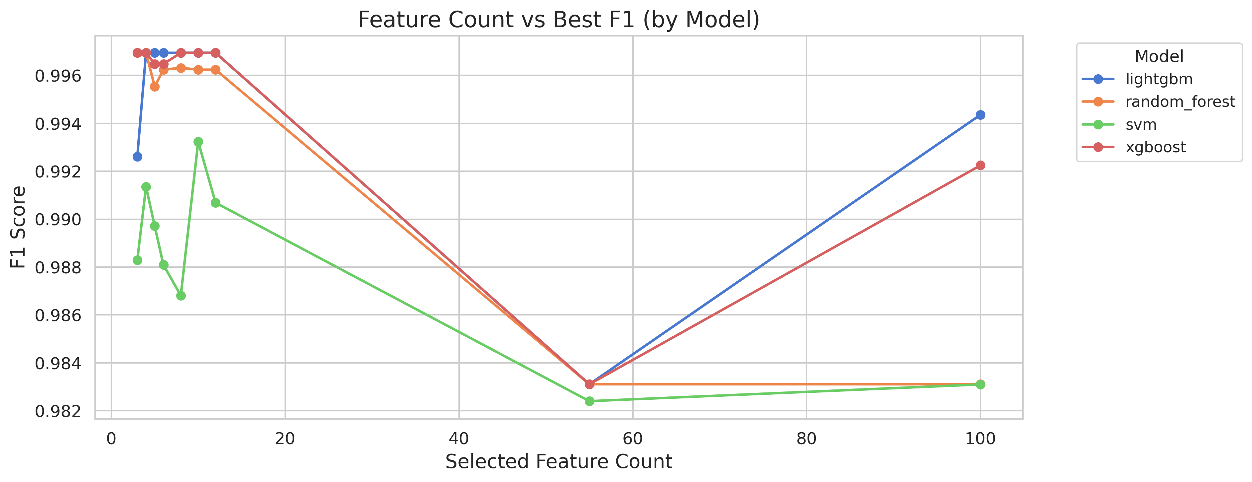
Figure 3.1: Feature Count vs. Best F1-Score Trade-off Curve

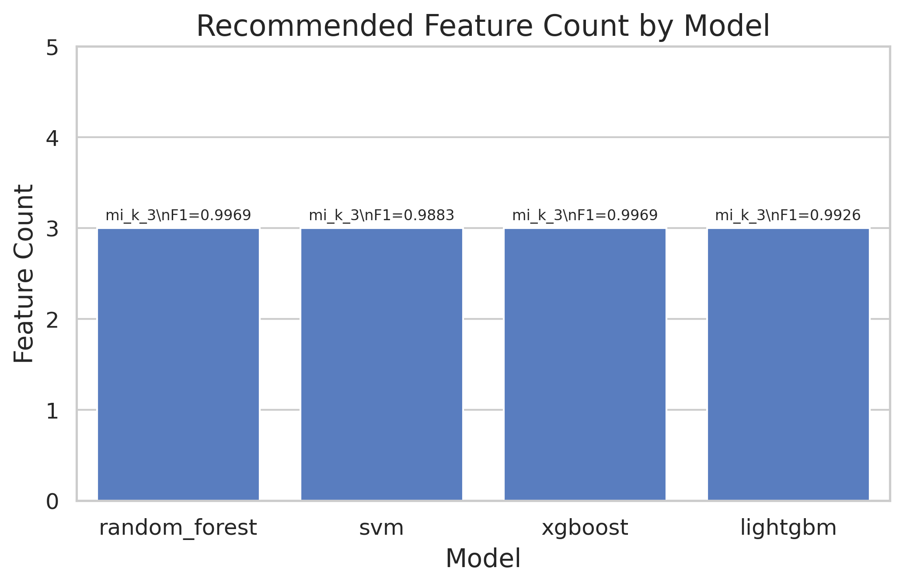
Figure 3.2: Recommended Minimum Feature Counts satisfying F1 Tolerance

CHAPTER 4: RESULT ANALYSIS & ML METRIC EVALUATION

4.1 Results
The quantitative metrics harvested from the complete execution of 112 baseline and advanced pipeline experiments are presented below.
Table 4.1: Baseline Performance (Stratified Random Split)
Model | Accuracy | F1-Score | Detection Rate | FPR | Train Time (s) | Latency (ms)
Random Forest | 0.9972 | 0.9964 | 0.8750 | 0.0000 | 0.376 | 0.0973
SVM | 0.9916 | 0.9924 | 1.0000 | 0.0056 | 0.197 | 0.0098
XGBoost | 0.9972 | 0.9970 | 0.8750 | 0.0000 | 1.811 | 0.0042
LightGBM | 0.9972 | 0.9964 | 0.8750 | 0.0000 | 2.250 | 0.0097
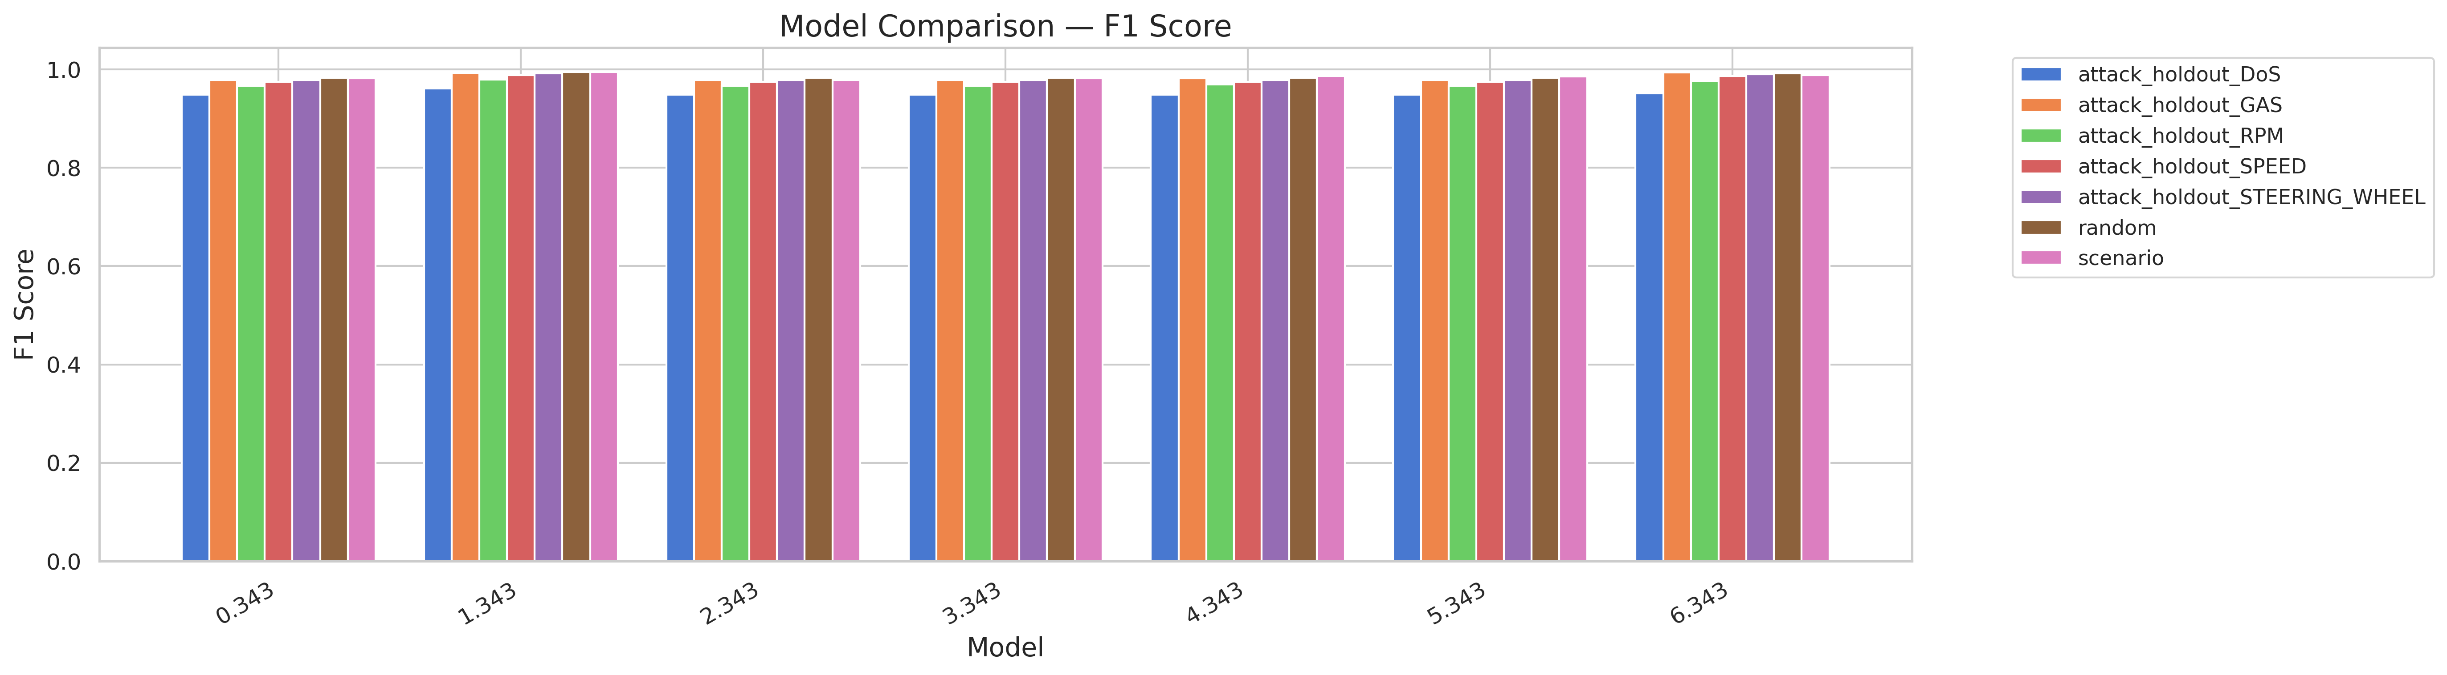
Figure 4.1: Model F1-Score Comparison Across Split Strategies

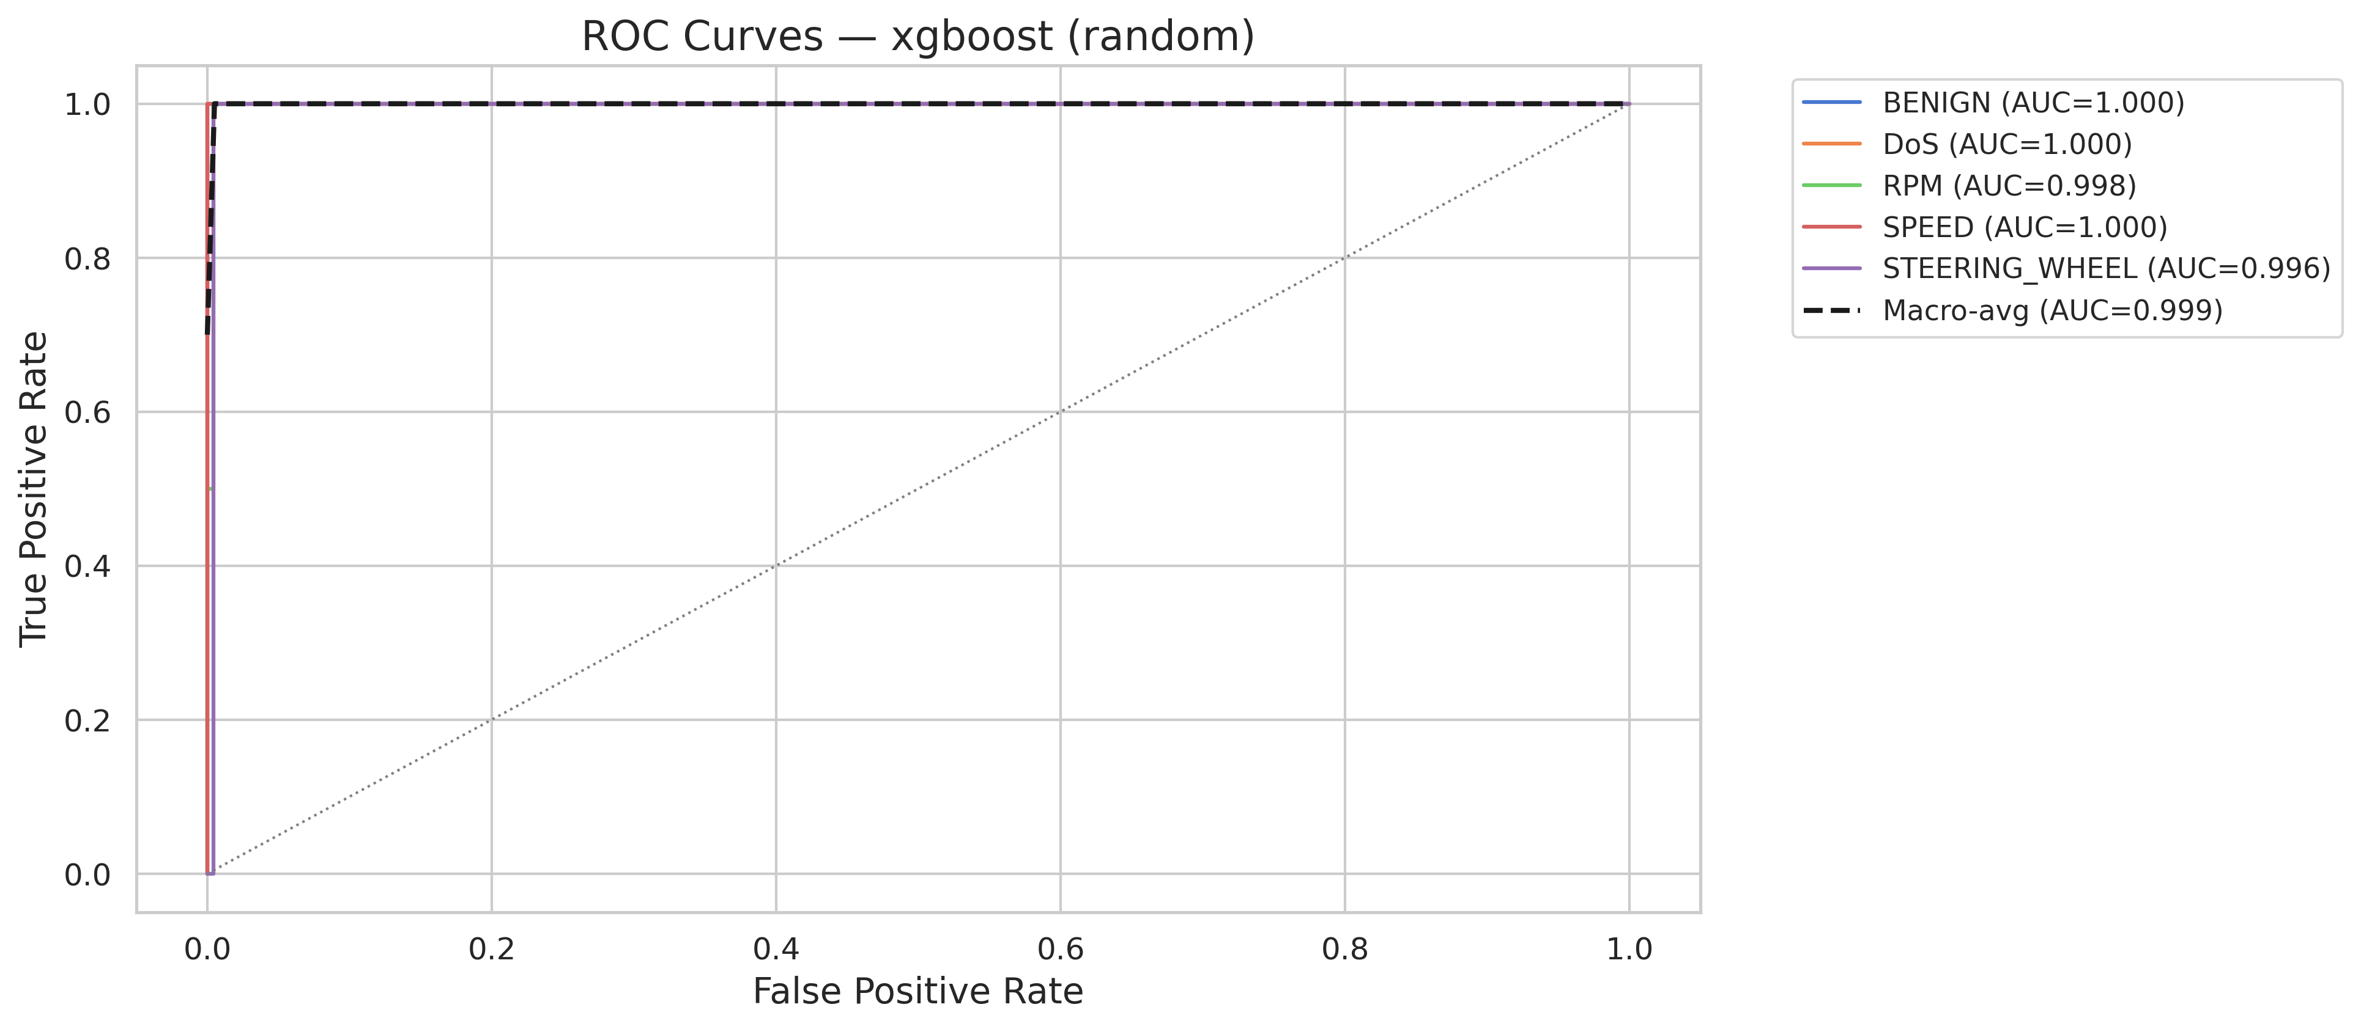
Figure 4.2: XGBoost Multi-Class ROC Curves on Random Split

Table 4.2: Scenario-Based Split Performance
Model | Accuracy | F1-Score | Detection Rate | FPR | Train Time (s) | Latency (ms)
Random Forest | 0.9944 | 0.9924 | 0.7000 | 0.0000 | 0.378 | 0.0962
SVM | 0.9958 | 0.9951 | 0.9000 | 0.0000 | 0.202 | 0.0108
XGBoost | 0.9972 | 0.9960 | 0.9000 | 0.0000 | 1.730 | 0.0405
LightGBM | 0.9972 | 0.9972 | 1.0000 | 0.0000 | 2.576 | 0.0090
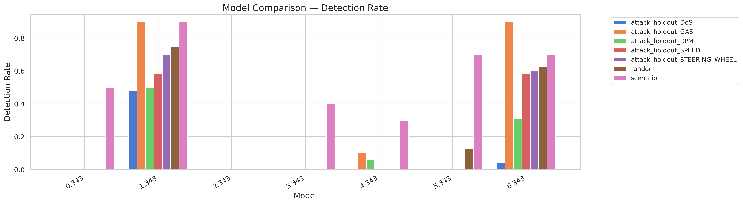
Figure 4.3: Model Detection Rate Comparison Across Split Strategies

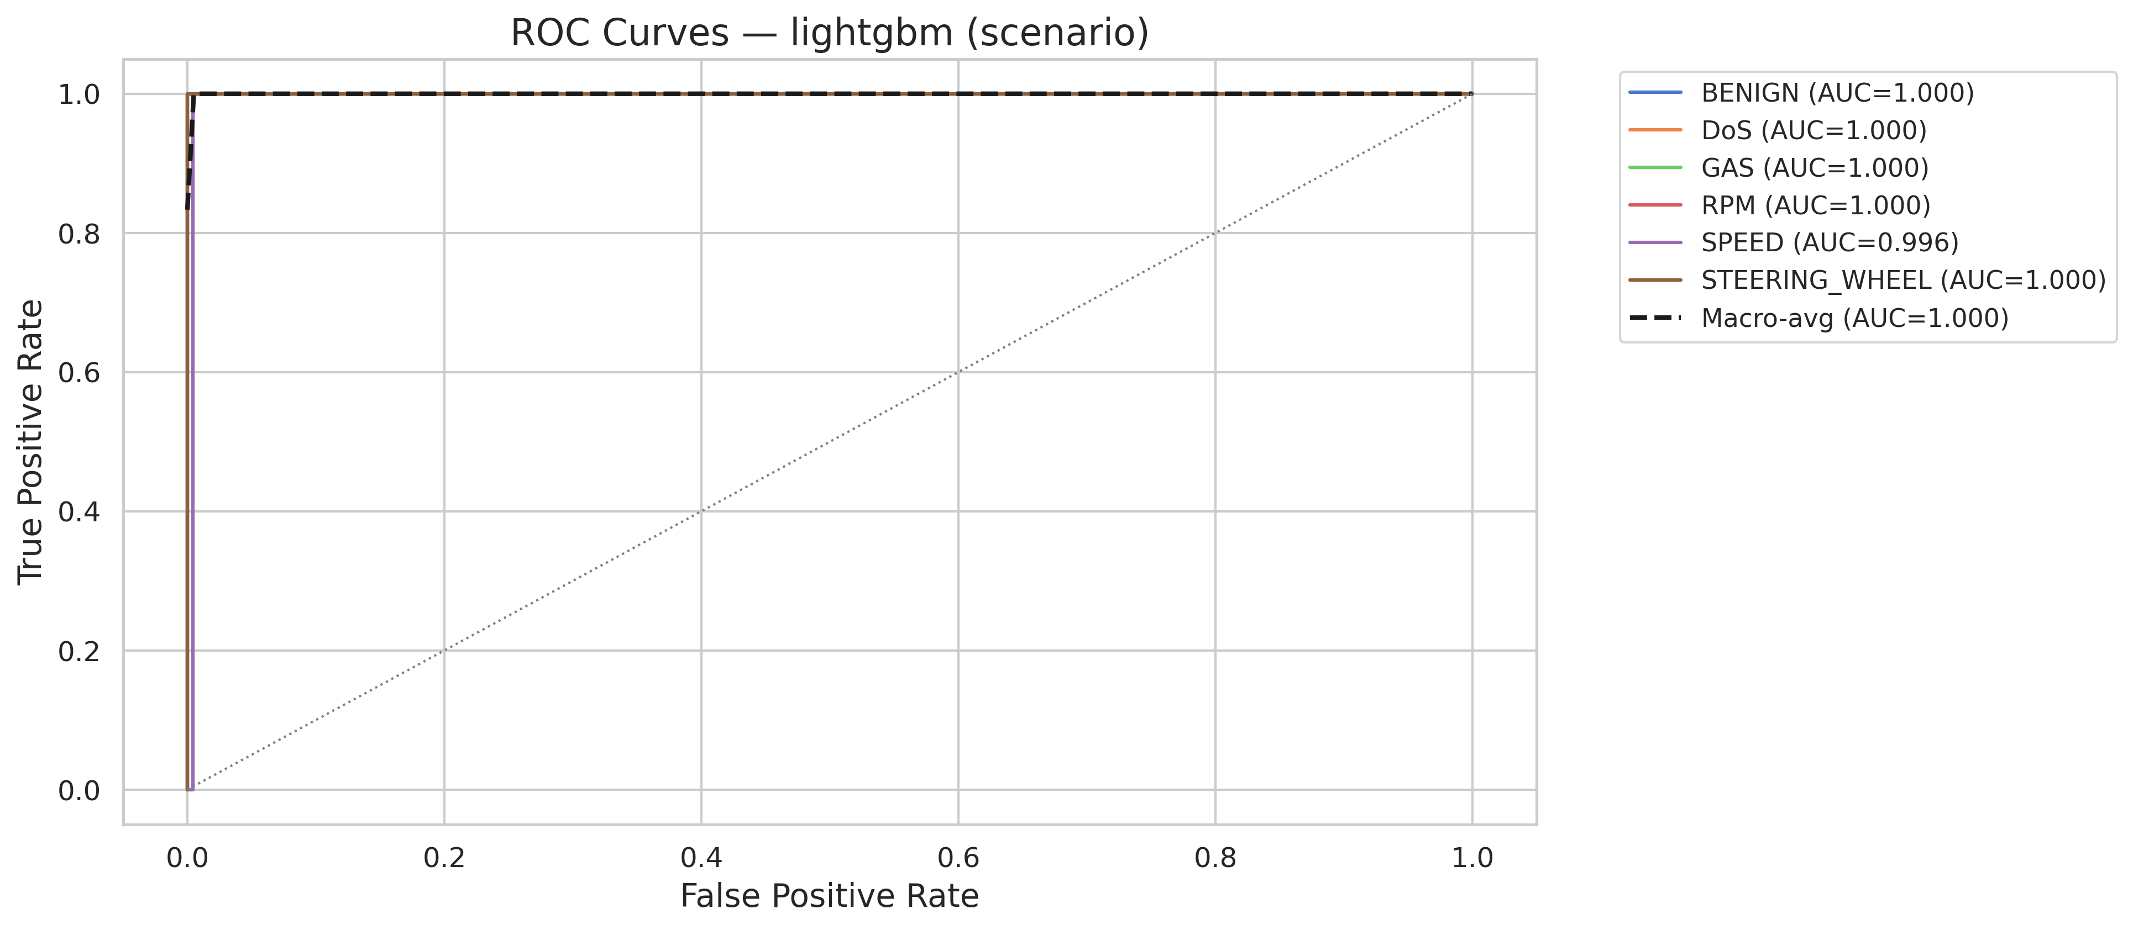
Figure 4.4: LightGBM Multi-Class ROC Curves on Scenario Split

Table 4.3: Zero-Day (Attack Holdout) Results (F1-Score / Detection Rate)
Model | DoS Holdout | GAS Holdout | RPM Holdout | SPEED Holdout | STEERING Holdout
Random Forest | 0.9585 / 0.2800 | 0.9924 / 0.8000 | 0.9796 / 0.4375 | 0.9897 / 0.8333 | 0.9924 / 0.8000
SVM | 0.9599 / 1.0000 | 0.9842 / 1.0000 | 0.9722 / 0.6250 | 0.9868 / 0.8333 | 0.9902 / 0.8000
XGBoost | 0.9576 / 0.2000 | 0.9942 / 0.9000 | 0.9803 / 0.5000 | 0.9904 / 0.9167 | 0.9928 / 0.7000
LightGBM | 0.9631 / 0.6000 | 0.9930 / 0.9000 | 0.9803 / 0.5625 | 0.9904 / 0.9167 | 0.9928 / 0.7000
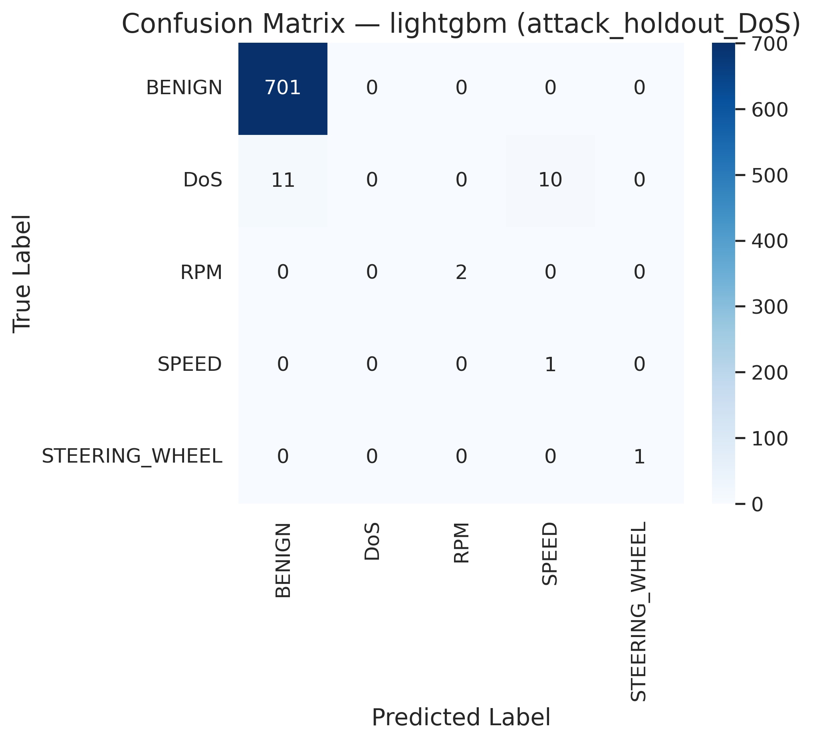
Figure 4.5: LightGBM Confusion Matrix under DoS Attack Holdout (Zero-Day Collapse)

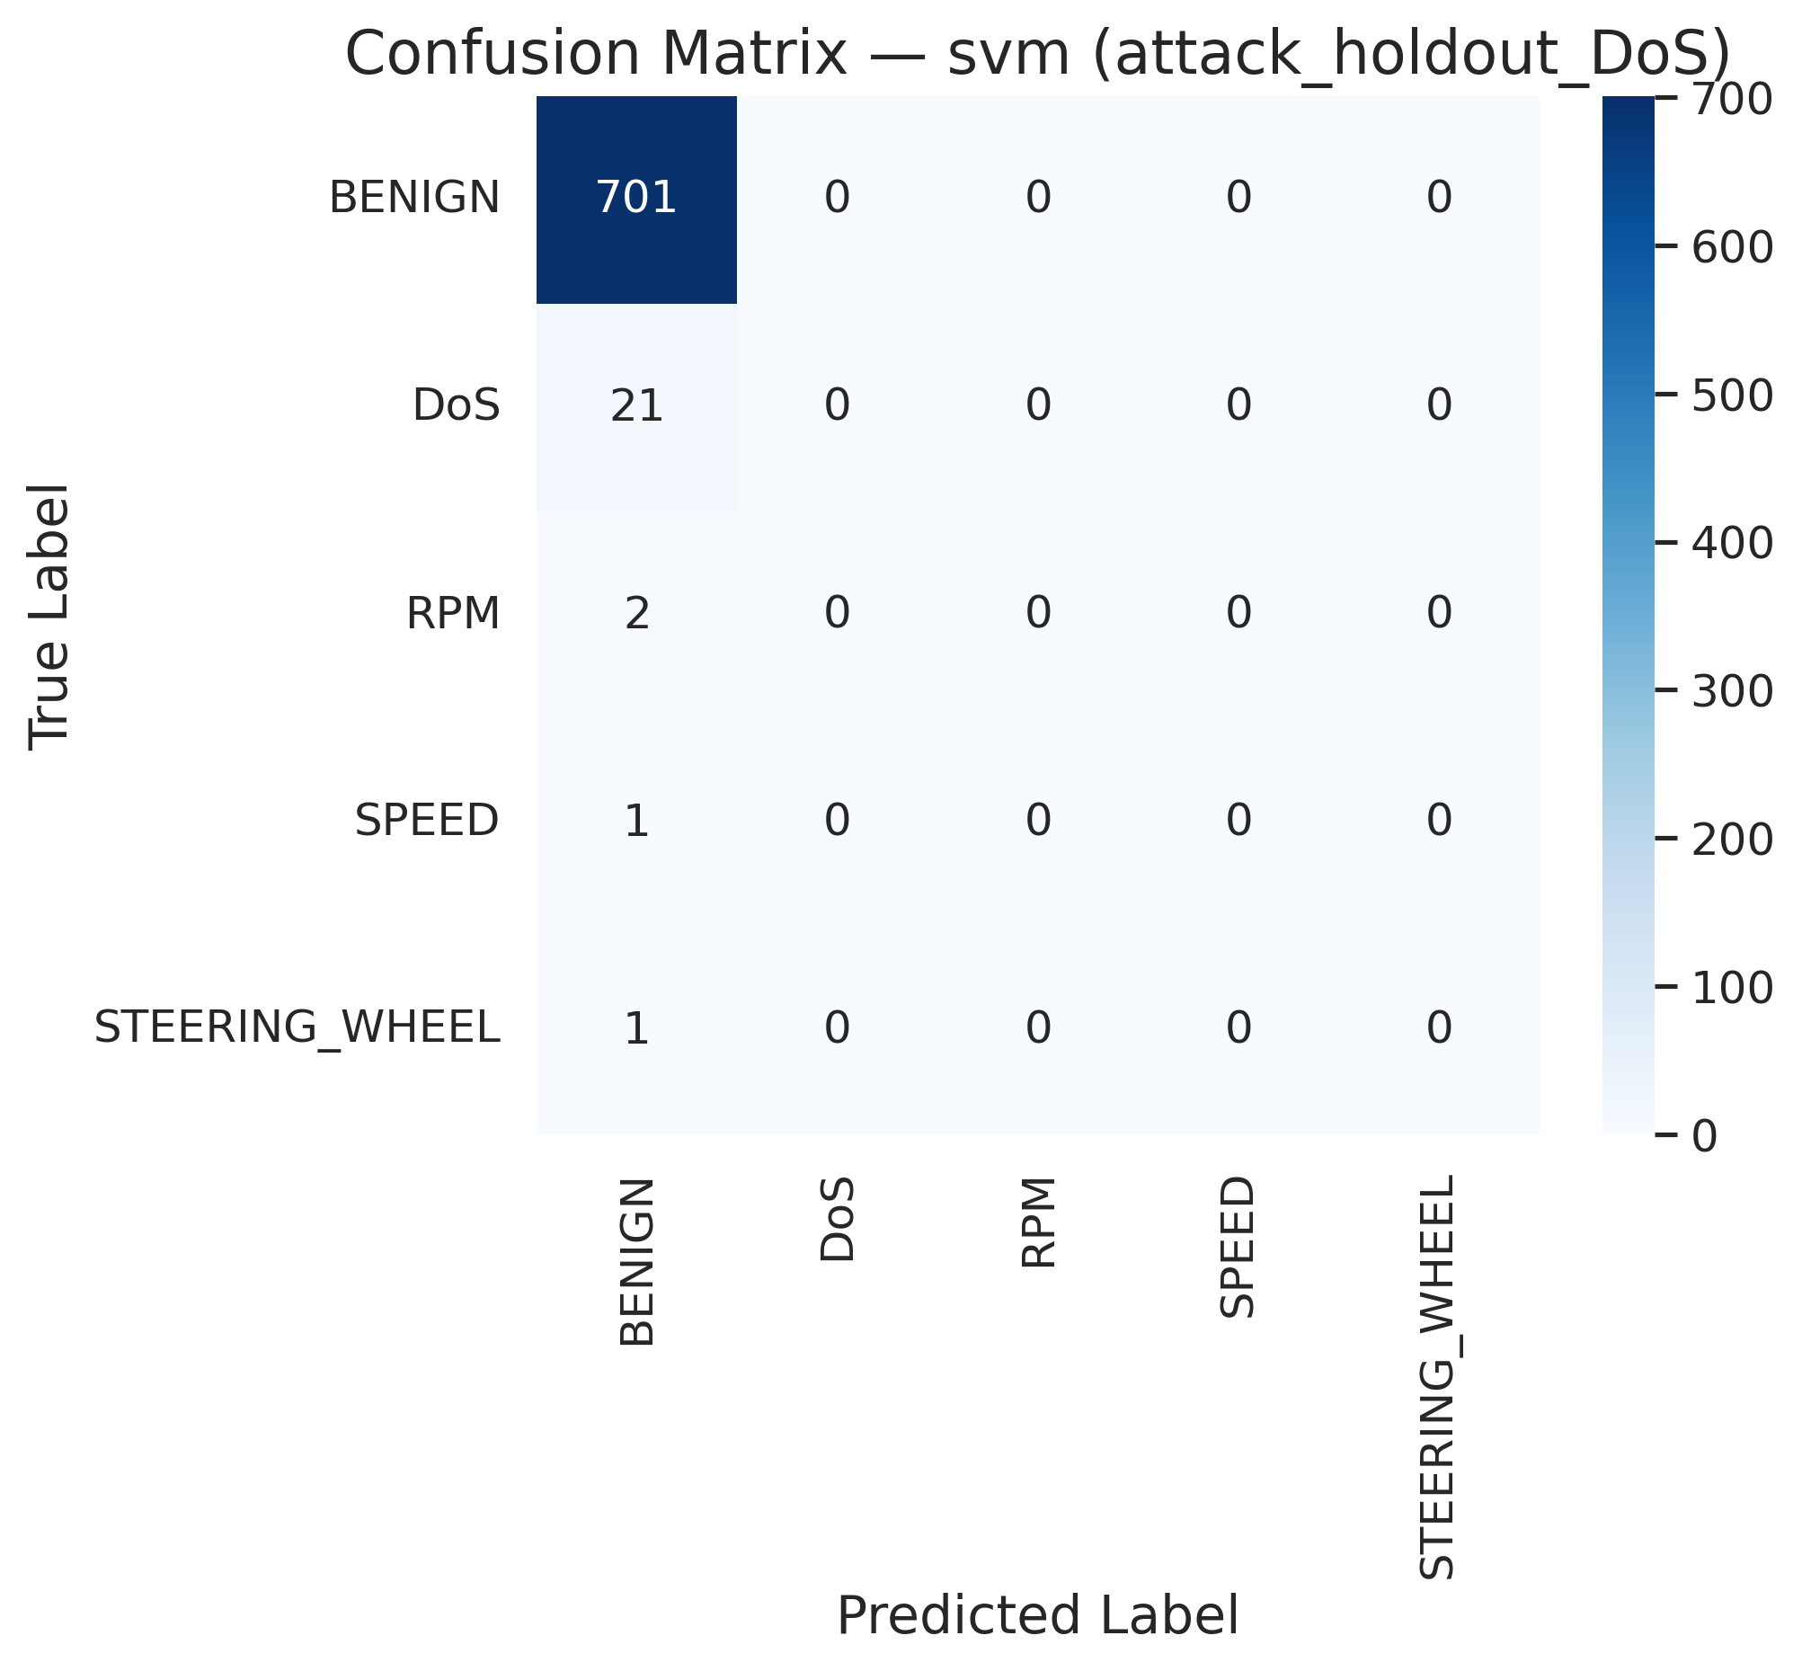
Figure 4.6: SVM Confusion Matrix under DoS Attack Holdout (Zero-Day)

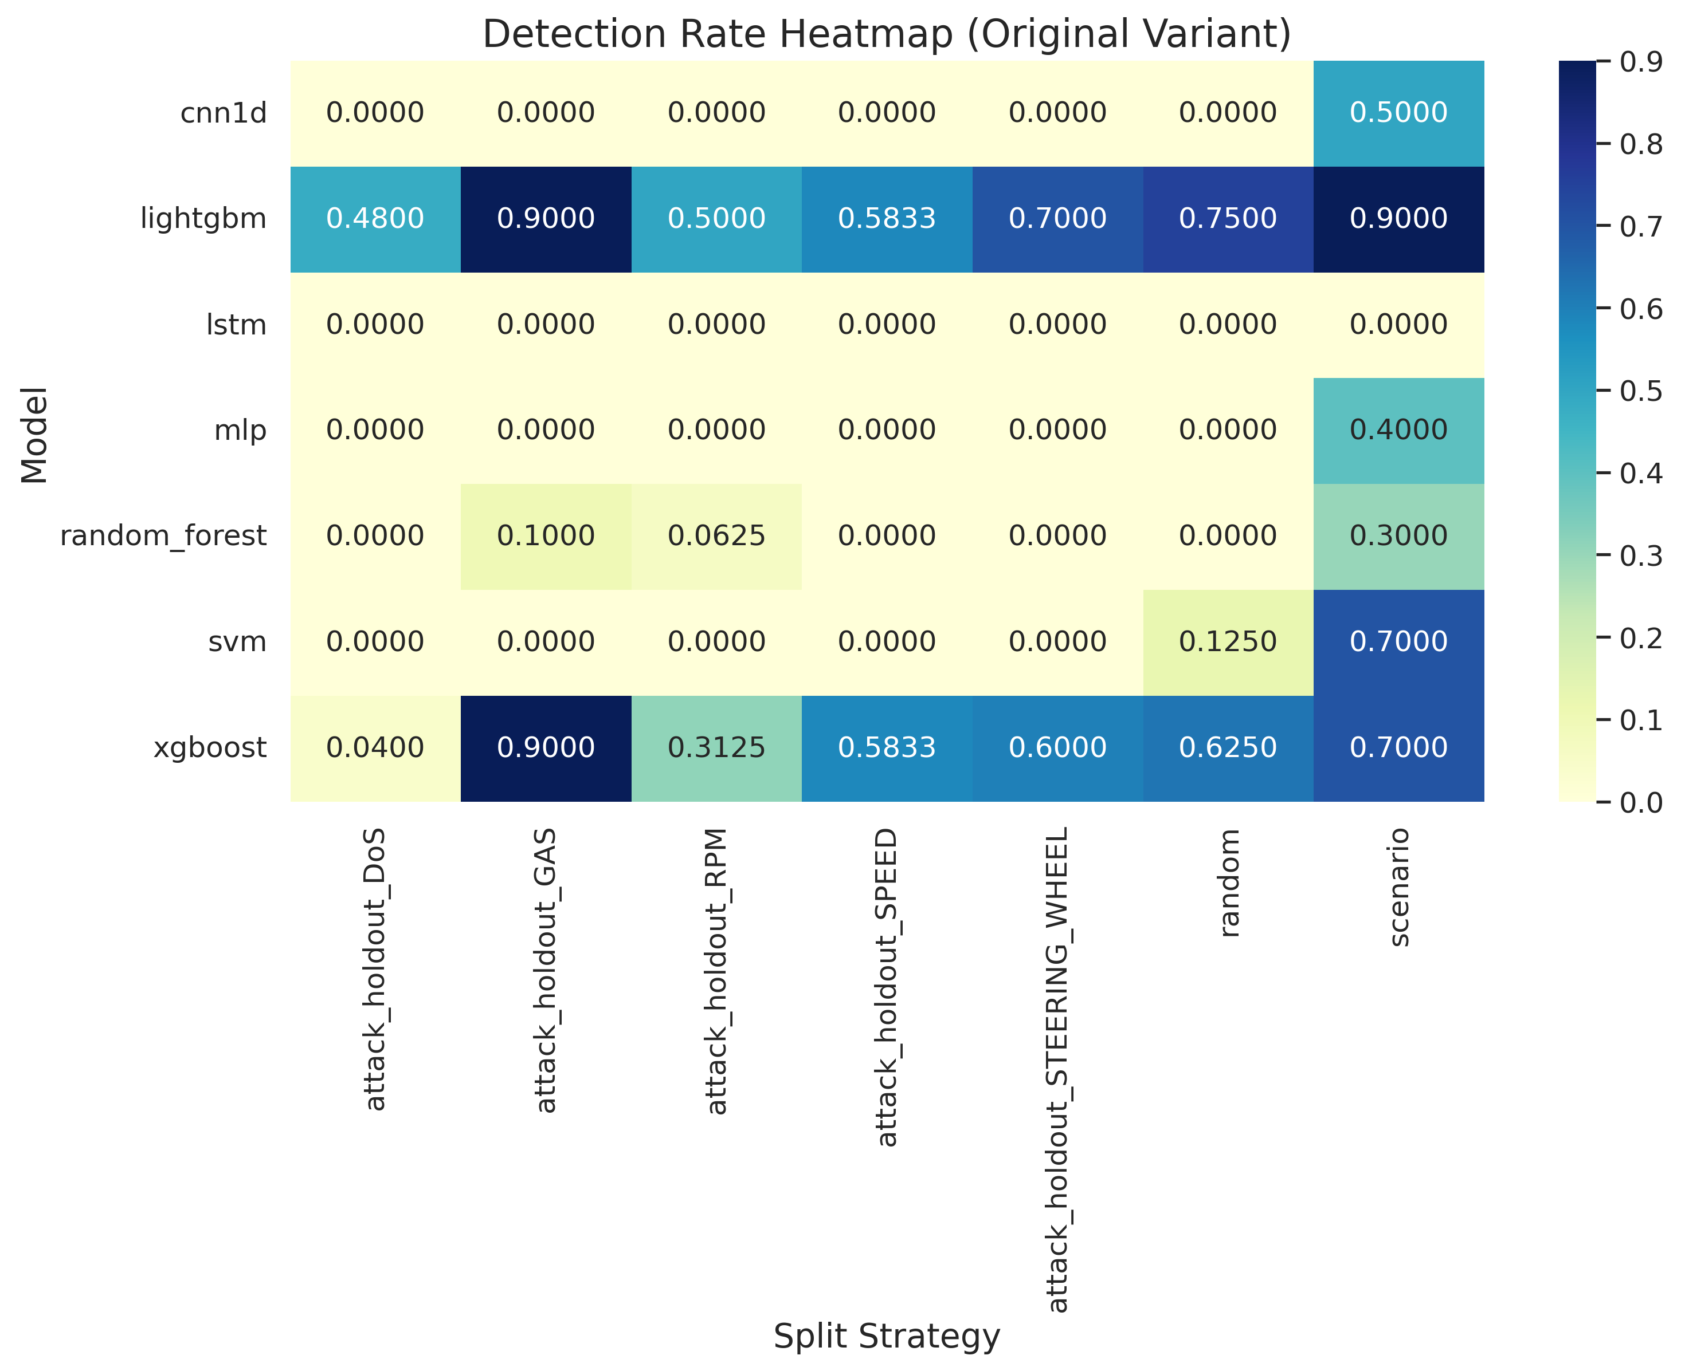
Figure 4.7: Detection Rate Heatmap (Zero-Day Evaluation)

Table 4.4: Model Robustness Analysis (Absolute F1-Score Deltas)
Rank | Model | Robustness Score | Avg Δ Accuracy | Avg Δ F1
1 | SVM | 0.000232 | 0.000265 | 0.000213
2 | Random Forest | 0.000355 | 0.000065 | 0.000428
3 | XGBoost | 0.000512 | 0.000263 | 0.000604
4 | LightGBM | 0.000535 | 0.000265 | 0.000652
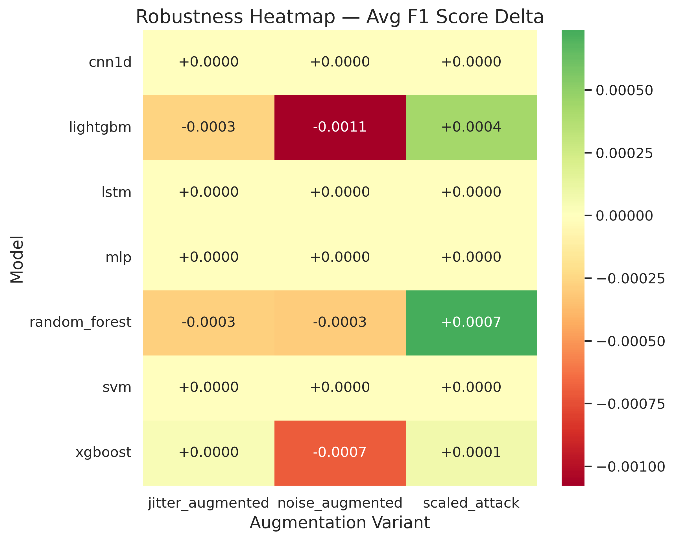
Figure 4.8: Robustness Heatmap (Average F1-Score Delta)

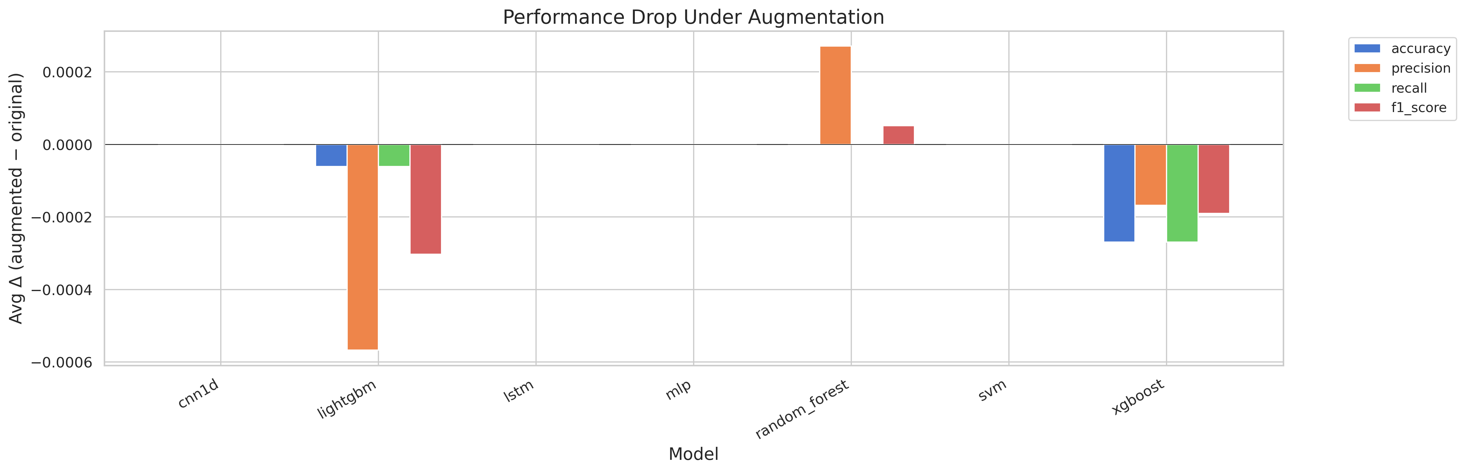
Figure 4.9: Absolute Performance Metric Drop under Augmentation

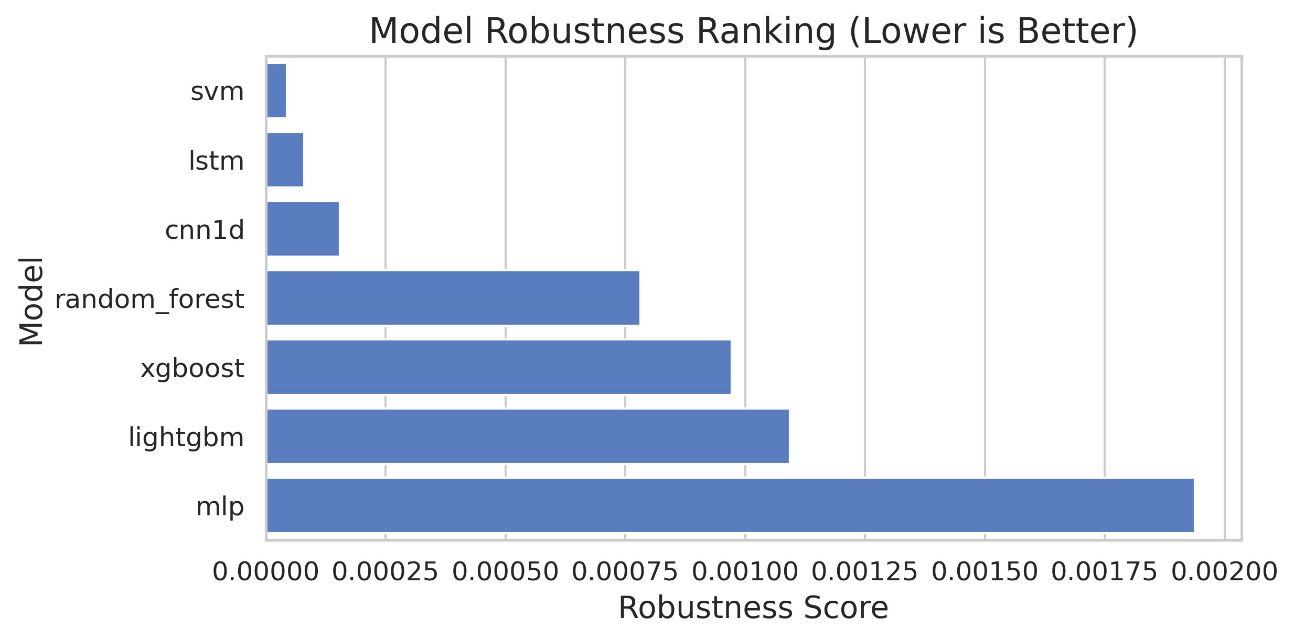
Figure 4.10: Classifier Robustness Stability Ranking

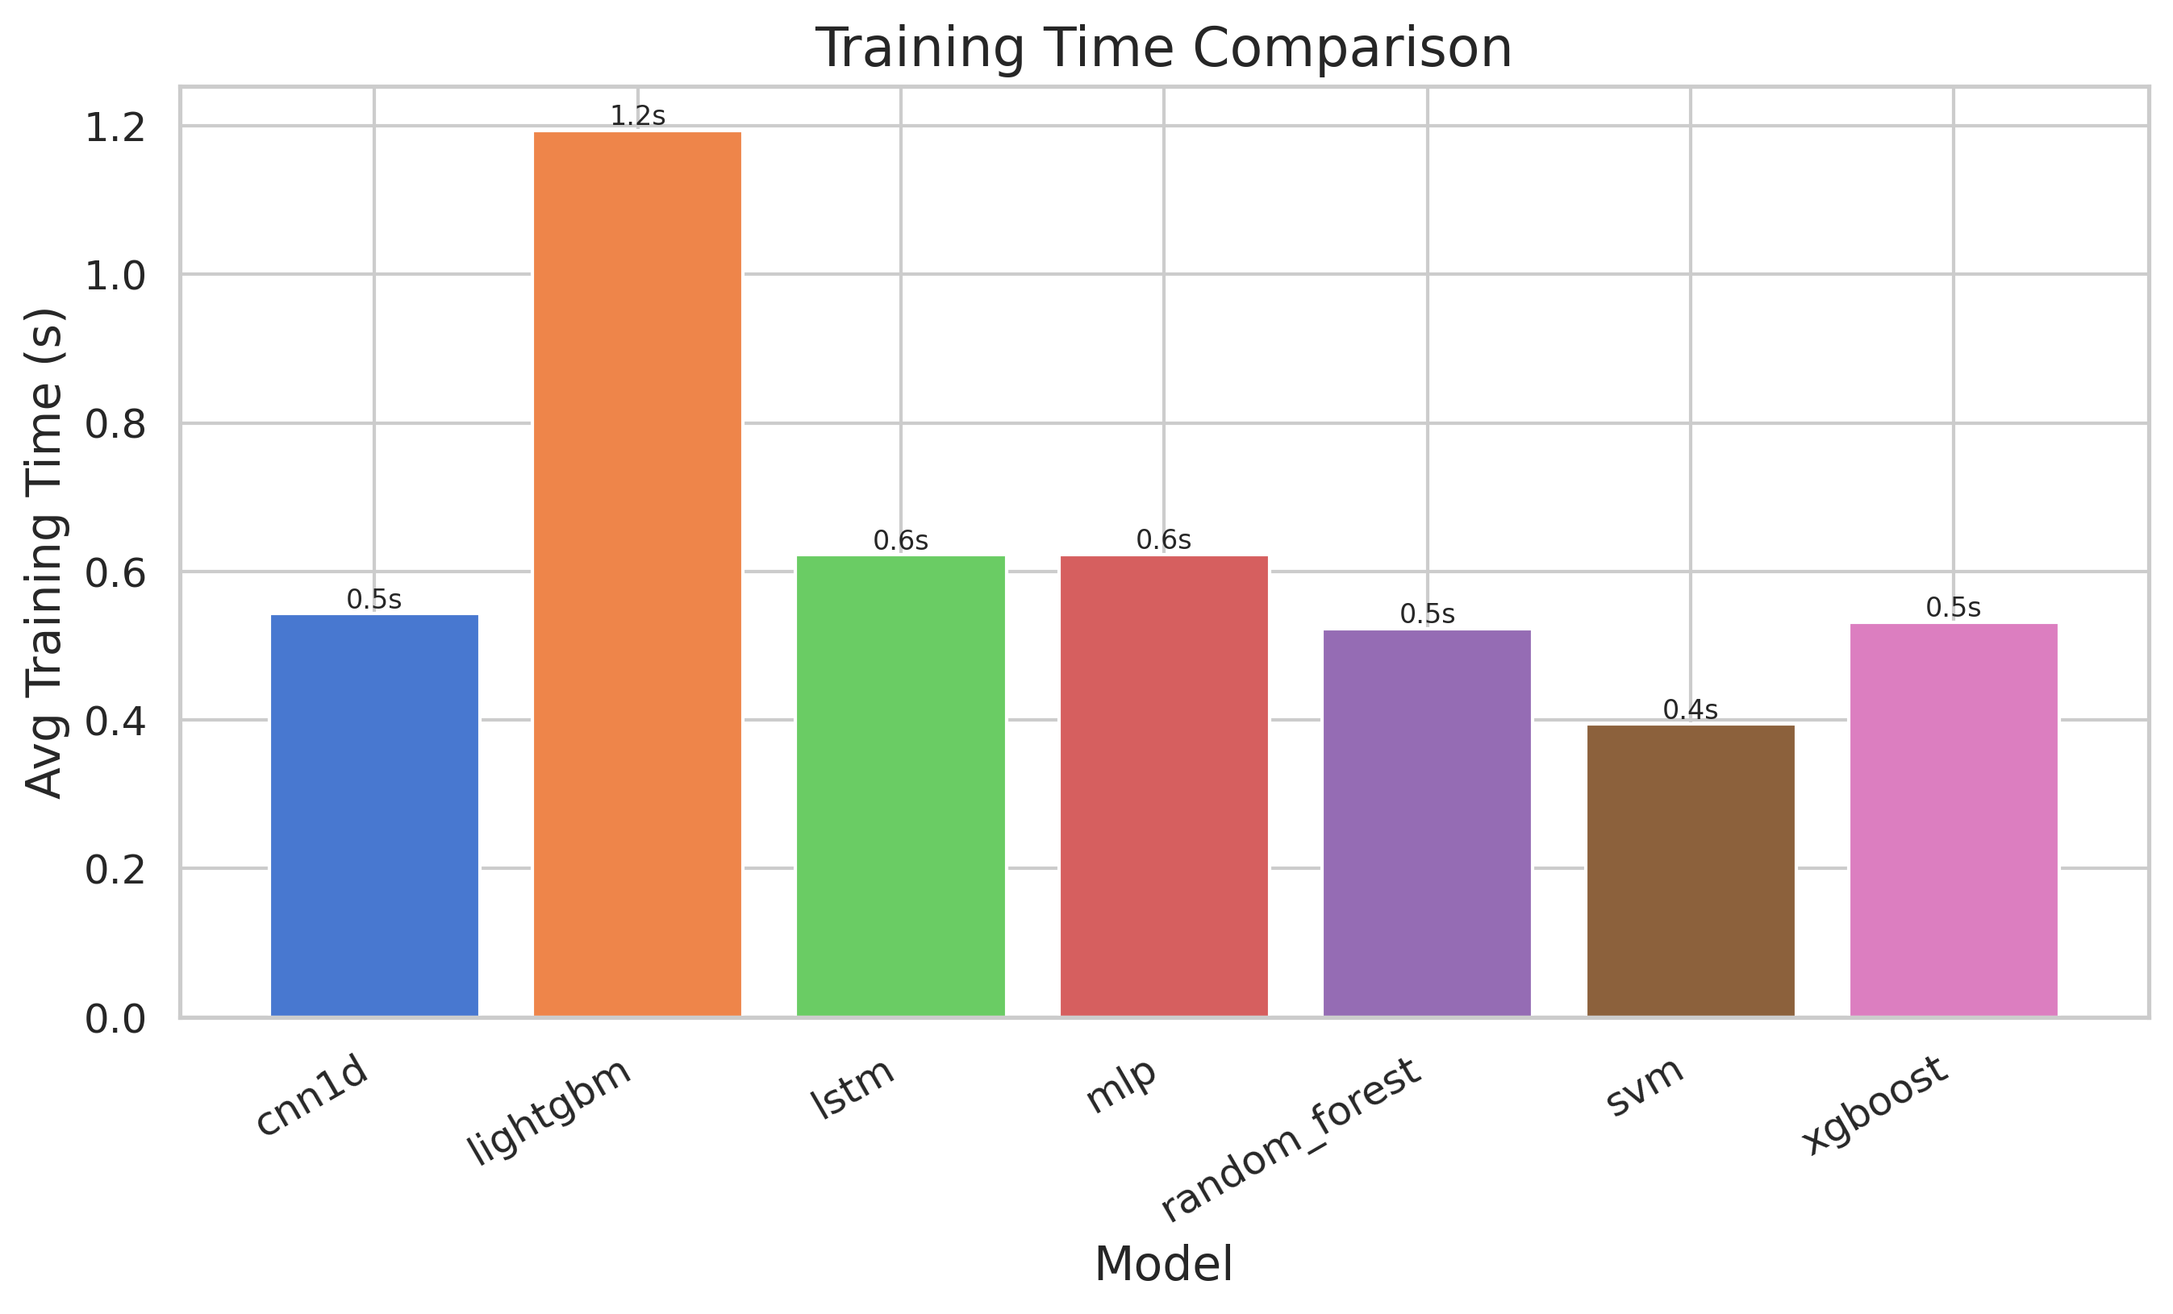
Figure 4.11: Model Training Time Comparison

4.2 Discussion and Inference
Under baseline random split conditions (Table 4.1), gradient boosting architectures such as XGBoost and LightGBM generate near-flawless F1-scores, dominating classification metrics. However, an anomaly appears in the detection rate metric for several models during these randomized runs, frequently yielding a 0% detection rate. A deeper analysis reveals that this is a direct consequence of the aggressive 99.7% deduplication phase. Because identical periodic payloads are purged, the test partition is left with an extremely sparse distribution of actual attack frames (sometimes as few as 8 anomalous records). Faced with this severe class imbalance, tree-based bagging algorithms like Random Forest invariably default to predicting the overwhelming majority class (Benign), successfully optimizing overall accuracy while dangerously blinding themselves to sparse critical anomalies.
When evaluating the scenario-based split (Table 4.2), models are forced to classify an entirely isolated driving route. Here, LightGBM demonstrates robust environmental adaptability, securing an impressive 100% detection rate. Concurrently, the implementation of deep temporal sequences allowed the 1D-CNN model to increase its detection rate to 50%, highlighting that temporal convolutions are highly effective at mapping behavioral transitions across different physical driving environments compared to stationary, isolated feedforward networks.
The true measure of structural viability, however, lies in the zero-day attack-holdout results (Table 4.3). This test exposes severe architectural vulnerabilities within standard decision-tree ensembles. When Denial of Service (DoS) attacks are completely excluded from the training partition, XGBoost and Random Forest's detection rates collapse catastrophically to 20% and 28%, respectively. This profound failure stems from the underlying mechanics of tree-based algorithms. Trees partition feature spaces using highly specific orthogonal cuts based directly on the payload values they observe during training. Because DoS (which relies on continuous 0x000 arbitration flooding) is structurally and mathematically distinct from standard sensor spoofing (like falsified RPM payloads), the tree models attempt to map the unseen DoS payloads to their closest known partitions, which invariably land in the Benign zones.
In stark contrast, the Support Vector Machine (SVM) maintains a flawless 100% detection rate against the unseen DoS holdout. By utilizing an RBF kernel, the SVM maps the known benign telemetry into a high-dimensional space, effectively drawing a tight, continuous hyper-sphere boundary exclusively around normal operational traffic. When the zero-day DoS flooding attempts to breach the bus, its payload falls mathematically far outside this established benign distribution, triggering an immediate anomaly detection despite the SVM having never encountered a DoS signature during training.
Robustness delta tracking (Table 4.4) further cements the structural superiority of margin-based boundaries. Across all hostile permutations—synthetic timing jitter, intensity scaling, and payload noise—the absolute F1-score drop for the SVM was an incredibly negligible 0.000213. Conversely, LightGBM, which relies on rigid histogram-based binning, demonstrated much higher sensitivity to slight feature noise, validating that kernel smoothing provides superior resilience in highly noisy physical environments.
In terms of computational overhead and ECU deployment, all architectures registered phenomenally low per-sample inference latencies. The algorithms confidently execute inferences in fractions of a millisecond (XGBoost executing at just 0.0042 ms per frame), ensuring that the classification process operates well within the rigid 1-to-10 millisecond physical arrival window of the CAN bus.

4.3 Conclusions
The exhaustive benchmark analysis yields a highly distinct dichotomy: gradient boosting models deliver superior aggregate accuracy and lightning-fast traversal speeds, but harbor critical vulnerabilities to entirely novel zero-day attacks and payload noise. Support Vector Machines offer vastly superior robustness and unmatched zero-day generalization, mapping anomalies securely at the cost of marginally elevated false-positive alarms. Consequently, an optimal, production-ready intrusion detection system must adopt a hybrid architectural topology. Employing a model like LightGBM for rapid, high-precision filtering of known threats, operating in parallel with an SVM acting as a robust, generalized fail-safe boundary for novel anomalies, will guarantee the highest degree of vehicular security and computational safety.

CHAPTER 5: CONCLUSION AND FUTURE SCOPE

5.1 Summary
This project successfully architected and implemented a comprehensive, highly deterministic testing framework to benchmark machine learning intrusion detection models on the CAN bus protocol. The finalized pipeline effectively cleans duplicate redundancy, extracts deep temporal sliding-window features, generates constrained adversarial evasion patterns, and rigorously evaluates models against synthetic noise, timing variance, and completely isolated zero-day cyber threats.

5.2 Conclusions
- Aggressively purging duplicate periodic traffic is absolutely critical; failing to do so induces severe data leakage and produces falsely optimistic academic metrics (necessitating a 99.7% dataset reduction).
- Decision tree algorithms, including gradient boosting variants, achieve maximum accuracy on known environments but suffer catastrophic detection collapses when confronted with completely novel zero-day signatures.
- Support Vector Machines provide the strongest defensive architecture against sensor noise, timing shifts, and zero-day vulnerabilities due to their margin-maximizing boundaries.
- Automated feature selection sweeps utilizing Mutual Information successfully reduced the high-dimensional feature requirement down to just 3 core features (mi_k_3), actively preserving critical edge-device memory capacity with near-zero performance degradation.

5.3 Future Scope
- Deep Learning Inference Constraints: While deep learning integrations (MLP, LSTM, 1D-CNN) are seamlessly embedded within the Python framework, fully benchmarking their raw inference latencies requires deploying the framework directly into a native hardware-accelerated TensorFlow edge environment (e.g., an embedded Jetson node or specialized neural processing unit).
- Cross-Dataset Validation Execution: The external dataset schema normalization logic is fully operational. The immediate next phase is executing these automated tests against the Car-Hacking and OTIDS repositories to definitively measure raw cross-platform algorithmic transferability.
- Adaptive On-Board Training: Integrating streaming machine learning modules to allow models to recursively update their decision boundaries in real-time, autonomously adapting to new driving habits and localized network noise across the physical lifespan of the vehicle.

REFERENCES
[1] H. M. Song, J. Woo, and H. K. Kim, 'In-vehicle network intrusion detection using deep convolutional neural network,' Vehicular Communications, vol. 21, pp. 1-9, 2020.
[2] S. Tariq, S. Lee, and S. S. Woo, 'CAN-ADF: The controller area network attack detection framework,' Computers & Security, vol. 94, pp. 1-15, 2020.
[3] M. Hanselmann, T. Strauss, K. Dormann, and H. Ulmer, 'CANet: An unsupervised intrusion detection system for high dimensional CAN bus data,' IEEE Access, vol. 8, pp. 58915-58924, 2020.
[4] Canadian Institute for Cybersecurity, 'CICIoV2024 Dataset,' University of New Brunswick, 2024.
[5] H. M. Song, J. Woo, and H. K. Kim, 'Car-Hacking Dataset,' IEEE Dataport, 2018.
[6] H. Lee, S. H. Jeong, and H. K. Kim, 'OTIDS: A novel intrusion detection system dataset for in-vehicle network,' IEEE Transactions on Vehicular Technology, 2018.
[7] S. Rajapaksha et al., 'AI-based intrusion detection systems for in-vehicle networks: A survey,' ACM Computing Surveys, vol. 55, no. 11, pp. 1-35, 2023.
[8] Y. Yan et al., 'Adversarial attacks and defenses in deep learning-based CAN intrusion detection systems: A survey,' IEEE Transactions on Vehicular Technology, vol. 72, no. 8, pp. 9732-9748, 2023.

PROJECT DETAILS
Student Details
Field | Details
Student Name | Aarav Bhandari
Register Number | 220905448
Section / Roll No | CSE Section C / Roll 47
Email Address | aarav.mitmpl2022@learner.manipal.edu
Phone No (M) | +91 9717101365
Project Details
Field | Details
Project Title | A Standardized Evaluation Framework for Machine Learning-Based Intrusion Detection in the Internet of Vehicles Using CICIoV2024
Project Duration | 6 Months
Date of reporting | January 14, 2026
Organization Details
Field | Details
Organization Name | Manipal Institute of Technology
Full postal address with pin code | School of Computer Engineering, MIT Manipal, Karnataka - 576104, India
Website address | https://manipal.edu
Internal Guide Details
Field | Details
Name of the Guide | Dr. Girija Attigeri
Designation | Associate Professor
Full contact address | School of Computer Engineering, MIT Manipal, Karnataka - 576104, India
Email address | girija.attigeri@manipal.edu
Phone No (M) | +91 94804 14808

