GDG ON CAMPUS MPSTME · APP DEVELOPMENT DEPARTMENT
Spider-Man Game
GDG
Product Requirements Document · v1.0 · Event build
A native Windows arcade installation where one player uses a webcam, body movement and hand gestures to survive a continuous city chase, fight the Green Goblin and complete a two-hand web finisher. Built in Godot 4 with a local Python/MediaPipe vision service.
Field | Value
Owner | App Development Department, GDG on Campus MPSTME
Platform | Windows 11; Godot 4.7.x; Python 3.11; one webcam
Milestone | Playable supervised event build and source repository
Audience | Event participants, booth operators, developers and reviewers
Status | Production rehearsal build; physical venue acceptance still required
Table of Contents
# | Section | # | Section
1 | Problem & goal | 5 | Evaluation
2 | Users & workflow | 6 | Tech stack
3 | Architecture & runtime | 7 | Out of scope & future
4 | Key product decisions
1. Problem & Goal
Most event games ask the participant to learn a controller, wait through menus, or watch a demo. That wastes the only scarce resource at a booth: attention. This project turns the participant's own movement into the controller and gets to a readable action sequence quickly.
The hard part is not drawing a superhero scene. It is making camera input dependable enough that a first-time player can understand what happened, recover when tracking drops, and still reach a satisfying ending inside a fixed public-event slot.
1.1 The product
The player steps into frame and holds both open palms for three seconds. The game then runs one uninterrupted 90-second mission: calibration, web verification, a ten-beat city chase, the Green Goblin fight, an assisted finisher, results and automatic reset. There is no account, character select or name entry.
1.2 Goals
PRIMARY GOAL
Deliver a short, legible and replayable body-controlled game that a participant can start without an operator explaining the controls.
Secondary goals: demonstrate local computer vision in a form that is visible to non-specialists; give the team a production-quality Godot/Python codebase; keep camera data private; and make failures recoverable rather than embarrassing at the booth.

1.3 Success criteria
# | Criterion | Measurement | Target
SC-1 | Time to start | Cold launch to camera-ready attract screen | Under 20 s
SC-2 | Hands recognised | Two open palms held in final venue lighting | 3 s lock
SC-3 | Mission duration | Authoritative Godot session clock | 90.0 s
SC-4 | Readable controls | First-time player completes prompted actions | No operator coaching
SC-5 | Tracking recovery | Remove player/camera during an active run | No home-screen reset
SC-6 | Repeated sessions | Consecutive accelerated full missions | 3/3 clean resets
SC-7 | Performance | 1280x720 authored capture | 60 FPS 5th percentile
SC-8 | Privacy | Storage and network inspection | No frames/landmarks saved
1.4 MVP
The MVP is the smallest build that can run as a supervised event installation, not a prototype clip.
Area | In the MVP
Entry | Camera readiness, player tracking and explicit three-second two-palm lock.
Movement | Lane movement, jump, crouch, dodge and shield from pose features.
Webs | Both-hand averaged aim, web pose/pinch/fist fire and attached-web pull.
Mission | Calibration, verification, ten chase beats, boss combat, finisher and results.
Fallback | Keyboard/mouse mode, deterministic simulated vision and assisted completion.
Operations | Diagnostics, camera switching, reset, fullscreen, mute and clean shutdown.
Release | Windows export, setup scripts, tests, logs and replaceable branding assets.
MVP ACCEPTANCE
A participant can enter, hold both palms, finish the complete mission and return to the attract screen without a crash, manual reset or cloud connection.
2. Users & Workflow
User group | What they need
Participant | Immediate feedback, large prompts, forgiving recognition and a clear result.
Booth operator | One launch command, camera health, keyboard fallback and safe reset controls.
Event lead | Predictable throughput, privacy clarity, replaceable branding and honest evidence.
Developer | Deterministic simulation, bounded interfaces, logs and focused regression tests.
2.1 The journey
Launch with `python main.py`. The supervisor starts vision, waits for a real frame and UDP packet, then opens Godot. The participant sees camera status and the complete control guide. Both open palms held for three seconds start the mission. Prompts teach each action in context; results remain briefly visible before the installation resets for the next player.
2.2 Failure workflows
Scenario | Required behaviour
Camera unavailable | Stay on attract; show launch/reconnect guidance; offer F4 keyboard mode.
Tracking lost | Keep the 90-second clock running; show reconnect overlay and keyboard backup.
Vision process exits | Supervisor restarts it once and gives the new process a fresh session identity.
Bad UDP packet | Reject malformed, oversized, duplicated, stale or retired-session input.
Energy reaches zero | Enter Last Chance Mode, restore limited energy and continue the mission.
Three collisions | Disqualify the score but complete the boss and assisted ending on schedule.

3. Architecture: The Runtime System
Read the system from left to right: the participant produces movement, Python turns the newest camera frame into normalized actions, and Godot consumes only bounded snapshots. The red process boundary is the only runtime connection.
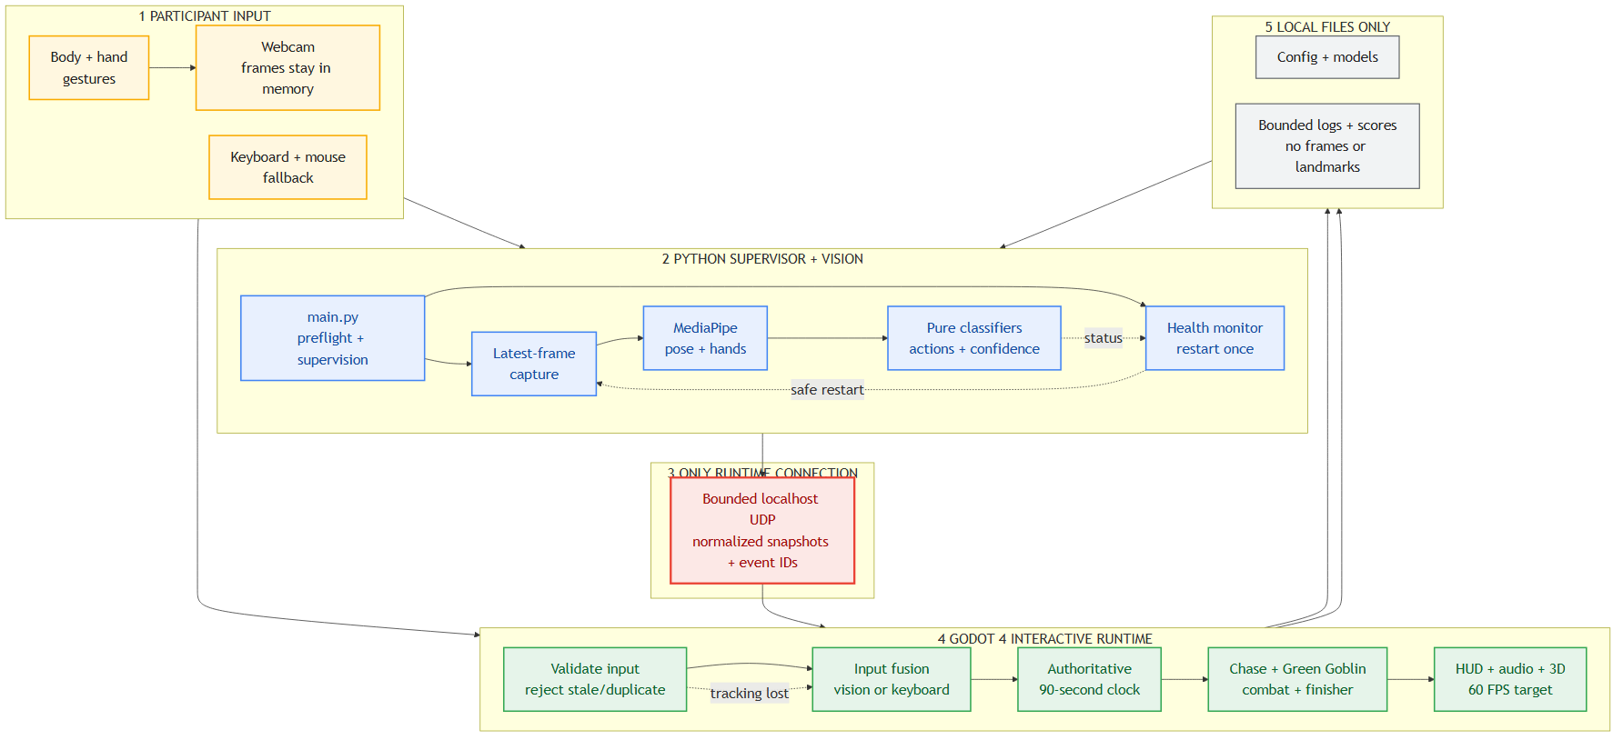
Figure 1. Runtime architecture and failure-safe data path
Colour | Meaning | Owner
Yellow | Participant input | Camera, body gestures and keyboard fallback
Blue | Vision pipeline | Python supervisor, capture, inference and classifiers
Red | Process boundary | Bounded UDP snapshots on 127.0.0.1
Green | Interactive runtime | Godot input fusion, session, gameplay and presentation
Grey | Local persistence | Configuration, models, bounded logs and scores
CRITICAL RULE
Camera inference never blocks Godot. A slow, missing or restarted vision service changes the input source, not the render loop or the 90-second mission clock.
3.1 How a gesture becomes gameplay
Capture keeps one mirrored frame, MediaPipe extracts pose and hands, and pure classifiers apply normalized thresholds, hysteresis and cooldowns. Each packet carries sequence, session and event identifiers. Godot rejects stale, oversized, duplicated or retired-session data before combining it with keyboard input.
3.2 Controls carried by the contract
Torso position drives lanes; hip and shoulder movement drive jump and crouch; fast lateral movement drives dodge; raised close wrists drive shield; the average of both hands drives aim; web pose, pinch or a newly closed fist fires; and a closed hand moving inward drives pull.

3.3 The fixed mission lifecycle
Every participant receives the same complete arc. Skill changes score and health, but neither mistakes nor tracking loss can strand the player before the ending.
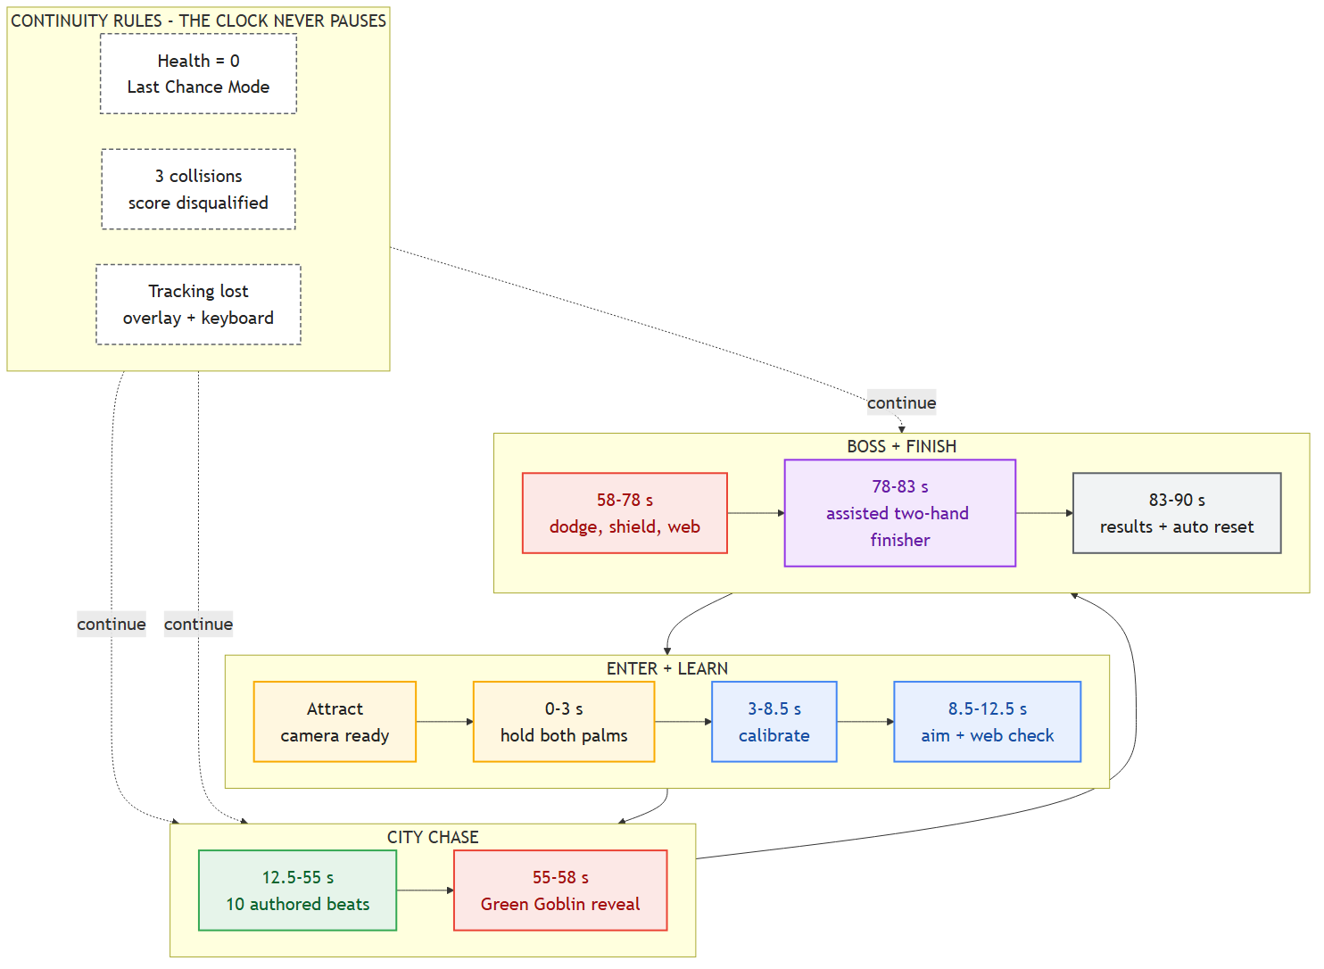
Figure 2. Complete participant journey and continuity rules
TIMELINE GUARANTEE
Health reaching zero activates Last Chance Mode. Three collisions disqualify the score. In both cases the chase, Green Goblin encounter and assisted finisher still complete by 90 seconds.
3.4 Chase and boss systems
ChaseDirector schedules ten non-overlapping beats with prompts, warnings and response windows. BossController drives Green Goblin's glider movement, readable attacks, hit reactions, target-locked web shots, debris interactions and the final web cage. Both health bars remain visible throughout combat.
3.5 Recovery and reset
Failure or reset event | Visible system response
Stale or repeated packet | Reject it; clear shot edges; keep the latest safe continuous input.
Tracking dropout | Show reconnect overlay; keep keyboard active; continue the mission clock.
Vision process exit | Supervisor restarts it once with a fresh session identity.
Fresh mission | Godot sends bounded sync packets; all gameplay and calibration state resets.
Low frame rate | Reduce VFX before changing input behaviour or authored timing.
3.6 Privacy and persistence
The runtime uses no cloud service. Camera frames and raw landmarks stay in process memory and are never written to disk. Godot receives normalized actions and confidence values only. Persistent data is limited to configuration, bounded logs, optional score metrics and timestamps. No account or participant name is collected.
3.7 Non-functional requirements
Priority | Requirement
Performance | Newest-frame capture at requested 30 FPS; 60 FPS render target; no frame backlog.
Reliability | Three consecutive simulated missions with complete reset and clean launcher exit.
Latency | Packets older than 600 ms are stale and cannot trigger edge actions.
Accessibility | Large prompts, high contrast, keyboard parity and timed assistance.
Privacy | No cloud, saved camera frames, raw landmarks or biometric templates.
Release | One root launch command and a reproducible Windows export through build.ps1.
4. Key Product Decisions
These choices are recorded because changing any one of them changes the event experience, not just the implementation.
4.1 A fixed mission, not an endless score loop
A booth needs predictable throughput. The mission always reaches the boss and finisher, and always resets at 90 seconds. Skill changes the score, accuracy and rank; it does not decide whether the participant sees the ending.
4.2 Local vision in a separate process
MediaPipe and OpenCV belong outside the render process. This isolates camera failures, keeps the Godot loop simple and lets simulated vision exercise the exact same UDP contract. The cost is a supervised launcher, which is why the EXE alone is not the supported camera-mode entry point.
4.3 Both hands define aim
The reticle uses the exact average of both visible hand points. It is steadier than a single fingertip and makes the superhero pose legible from a distance. Boss target-lock radii and aim assistance absorb normal camera noise without turning shots into automatic hits.
4.4 Failure changes score, not access
Health reaching zero triggers Last Chance Mode. Three obstacle strikes disqualify the leaderboard run. Both cases preserve the authored timeline. A public installation should not strand a first-time player because one classifier or gesture was missed.
4.5 Decision log
Decision | Selected | Reason
Engine | Godot 4 Forward+ | Native Windows export, strong 3D/VFX workflow and typed GDScript.
Vision | Python + MediaPipe Tasks | Reliable local pose/hands with testable pure classifiers.
Transport | Bounded localhost UDP | Latest input matters; dropped snapshots are safer than a latency queue.
Aim | Average of two hands | Stable, visible pose; still supports independent left/right web events.
Start | Two open palms for 3 s | Deliberate gesture prevents accidental starts and proves both hands are tracked.
Mission | One continuous 90 s run | Predictable event throughput and no mid-game navigation.
Failure | Fail-soft with score consequences | Every participant reaches the showcase ending.
Boss | Team-authored Green Goblin GLB | A shareable original model provides the glider silhouette, movement and hit reactions.
Identity | No name or account | Removes friction and avoids collecting unnecessary participant data.
Fallback | Keyboard + deterministic simulation | Keeps demos and testing possible when camera conditions fail.
5. Evaluation
The build is accepted on observed behaviour, not on the existence of feature code. Automated proof and physical booth acceptance are kept separate.
5.1 Functional testing
Area | Method | Current evidence
Python | Unit tests for protocol, health, classifier and simulation | 35 tests passing
Godot | Headless state, chase, boss, UDP, save and policy assertions | 117 assertions passing
Build | Import, parser, lint, tests and Windows export | All gates passing
Mission | Accelerated authored capture | All states, results and reset reached
Recovery | Forced tracking loss and service restart | Timeline and results preserved
Repeatability | Three consecutive accelerated sessions | 3/3 clean launcher exits
5.2 Gesture and gameplay evaluation
A physical acceptance run must use the final laptop, camera position, lighting and participant distance. Observe whether open palms lock in three seconds; both-hand aim reaches the target without jitter; fist/web/pinch fire produces visible confirmation; pull begins only after attachment; and jump, crouch, dodge and shield prompts are understood without coaching.
STOP AND RETUNE
Do not run the booth if palm lock is unreliable, ordinary movement fires webs, the reticle cannot reach the boss, camera loss returns to attract, or prompts require an operator to translate them.
5.3 Release criteria
Ship the supervised event build only when setup check, Python tests, GDScript tests, simulated capture and Windows export all pass from a clean checkout; the camera indicator activates; one participant completes a physical run; projector framing and audio are checked; and the event QR and branding are approved. The executable may remain unsigned for internal rehearsal, but public distribution requires an explicit owner decision.
6. Tech Stack
Layer | Technology | Purpose
Game | Godot 4.7.x Forward+ | Rendering, state clock, gameplay, UI, audio and Windows export.
Game code | Typed GDScript | Small explicit components and deterministic state transitions.
Vision | Python 3.11 | Camera supervision, inference, health and simulation.
Capture | OpenCV | Media Foundation/DirectShow camera backends and latest-frame exchange.
Inference | MediaPipe Tasks | Local pose and two-hand landmarks using bundled model files.
Transport | UDP on 127.0.0.1 | Bounded snapshots, events, health and operator commands.
Configuration | YAML / JSON | Shared tuning, ports, thresholds and machine-local overrides.
Testing | pytest + Godot headless | Pure classifiers, protocol, game policies and state-machine regression.
Build | PowerShell + Godot export | Repeatable setup, validation and Windows executable.
Repository | GitHub | Source review and team collaboration.
6.1 Development and release process
Changes start with the narrowest relevant unit or headless test. Camera-independent behaviour must be reproducible through simulated vision. Before a release candidate, run `python -m pytest`, `python main.py --setup-check`, the simulated capture, repeated runtime smoke and `build.ps1`. Review the authored screenshots, then perform one live-camera acceptance run. Evidence from simulation is never reported as webcam proof.
7. Out of Scope & Future
The event build is intentionally narrow. These items are excluded because they add operational or legal surface without improving the 90-second booth experience.
Excluded | Why
Online multiplayer | Changes the product into a network service and introduces matchmaking/moderation.
Cloud vision or analytics | Unnecessary for the experience and conflicts with the local privacy boundary.
Accounts or participant names | Adds onboarding friction and stores personal data the game does not need.
Open-world traversal | Conflicts with fixed throughput and the authored chase schedule.
Multiple bosses or levels | Quality and clarity matter more than content count for the event build.
Unassisted hard fail | Would prevent inexperienced players from reaching the showcase ending.
Mobile/web builds | Camera, performance and export assumptions are Windows-specific.
Cloud leaderboard | Requires identity, abuse handling and internet reliability.
Licensed film assets | The project uses an original boss and replaceable original artwork.
7.1 Future expansion
After the event build is stable, useful additions are a guided operator calibration screen, additional original chase variants, per-venue tuning profiles, richer accessibility modes, signed installers and automated camera/lighting diagnostics. New content should plug into the existing authored schedule rather than bypass its timing and reset rules.
DEPENDENCIES WORTH STATING NOW
Public event release still depends on final venue lighting, projector/audio checks, approved branding and QR content, and a decision on code signing. These are operational gates, not missing gameplay features.

7.2 Roadmap
Phase | Deliverable | Exit criteria
1 Foundation | Launcher, configuration, Godot shell, UDP contract and test harness. | Root launch works; setup check identifies every dependency.
2 Vision | Camera capture, MediaPipe pose/hands, calibration and gesture classifiers. | Fresh bounded packets; deterministic simulation; no frame backlog.
3 Core mission | State clock, movement, webs, scoring, HUD and full reset. | All boundaries reached at authored times; keyboard parity works.
4 Chase and boss | Ten chase beats, Green Goblin, counters, debris and assisted finisher. | Every prompt has success/failure handling; ending completes on time.
5 Production hardening | Recovery, collision loss, operator tools, performance mode and save safety. | Tracking loss and repeated sessions complete without reset/crash.
6 Event release | Windows export, branding, QR, venue calibration and participant acceptance. | All automated gates green plus one final physical run.
7 Post-event | Metrics review, tuning notes and prioritised follow-up backlog. | Evidence and operator feedback converted into owned issues.
One closing note on sequencing.
The camera and input contract are the foundation, not a layer to patch after the visuals. A polished boss scene cannot rescue uncertain input, and more effects cannot repair an unclear prompt. Keep the three-second start, the fixed clock, the fallback path and the reset contract stable; build new content inside those boundaries.

