**Question A: Set up the Simple Personal Organizer Project**

Set up the Simple Personal Organizer project in Android Studio.

➢Create a new Android project in Android Studio and name it SimplePersonalOrganizer.

➢Select an Empty Activity template and ensure the project targets API level 24 (Nougat) or higher.

➢Configure the package name and app settings as required.

➢Create a database helper class named DatabaseHelper to manage the SQLite database.

➢Define a table Users with the following columns:

Oid (INTEGER, primary key, auto-increment)

oname (TEXT, stores the user’s name)

oemail (TEXT, stores the user’s email address)

**Deliverable: Submit the project setup screenshot showing the project structure, configuration, and the DatabaseHelper class code.**

**DatabaseHelper.kt + project structure + configuration**

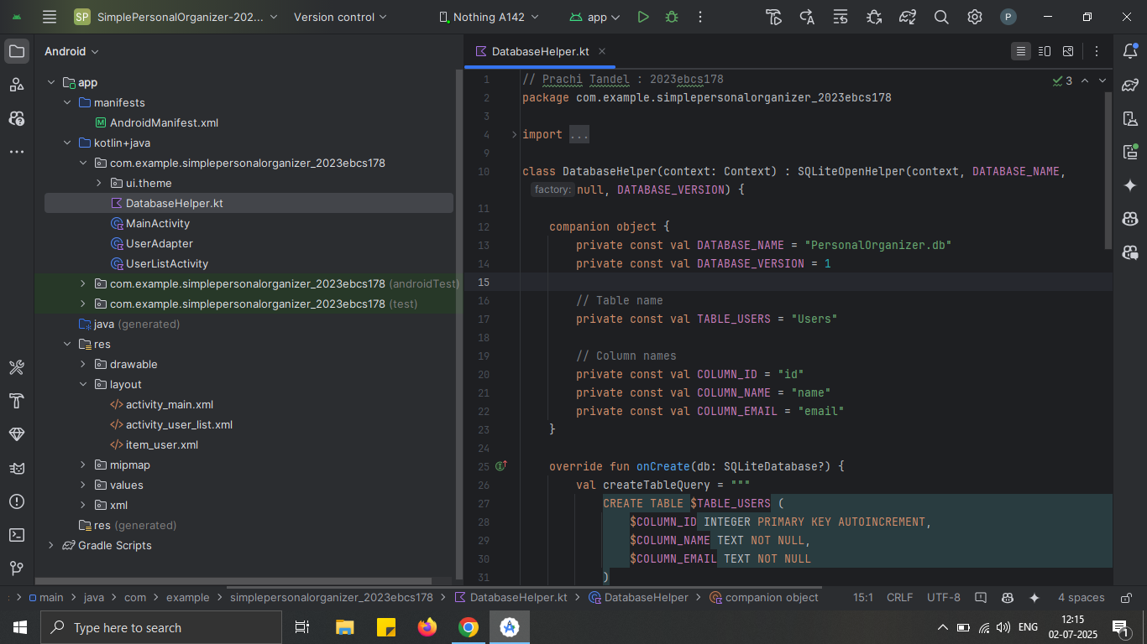

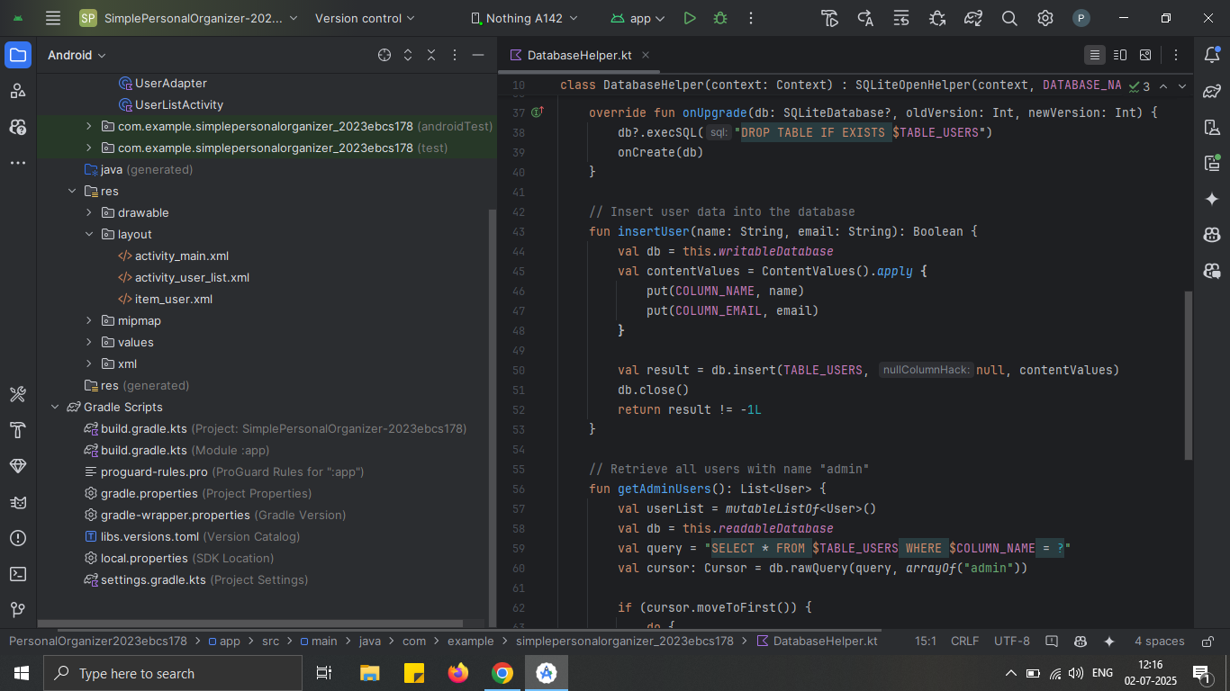

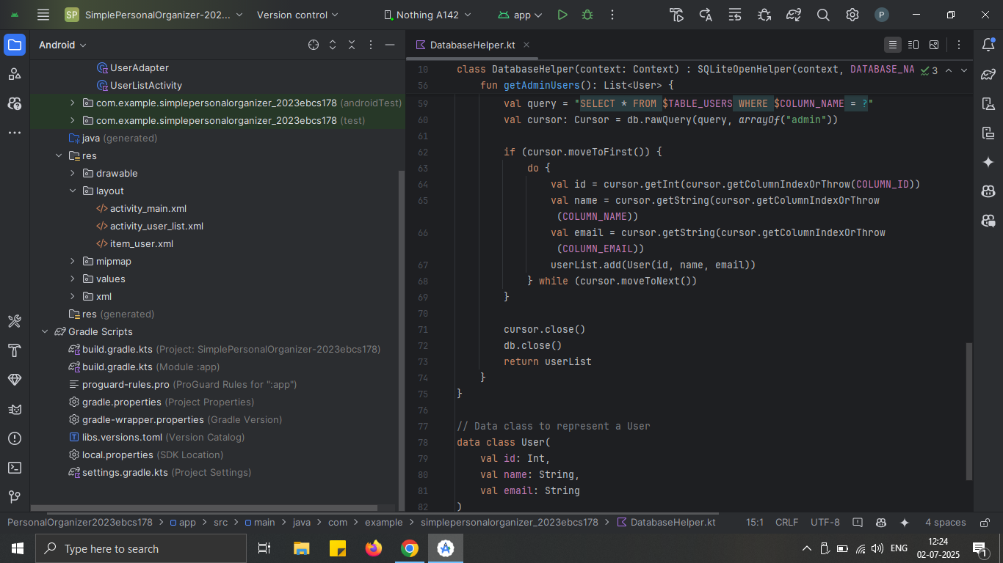

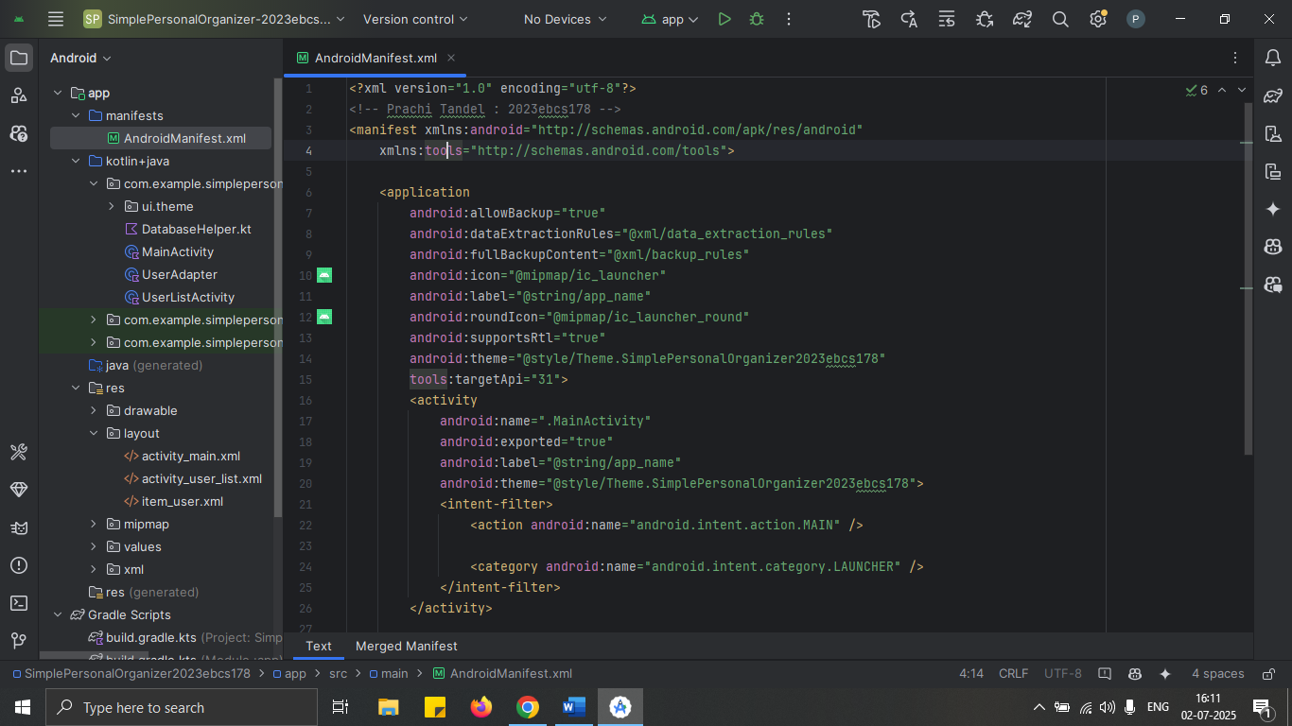

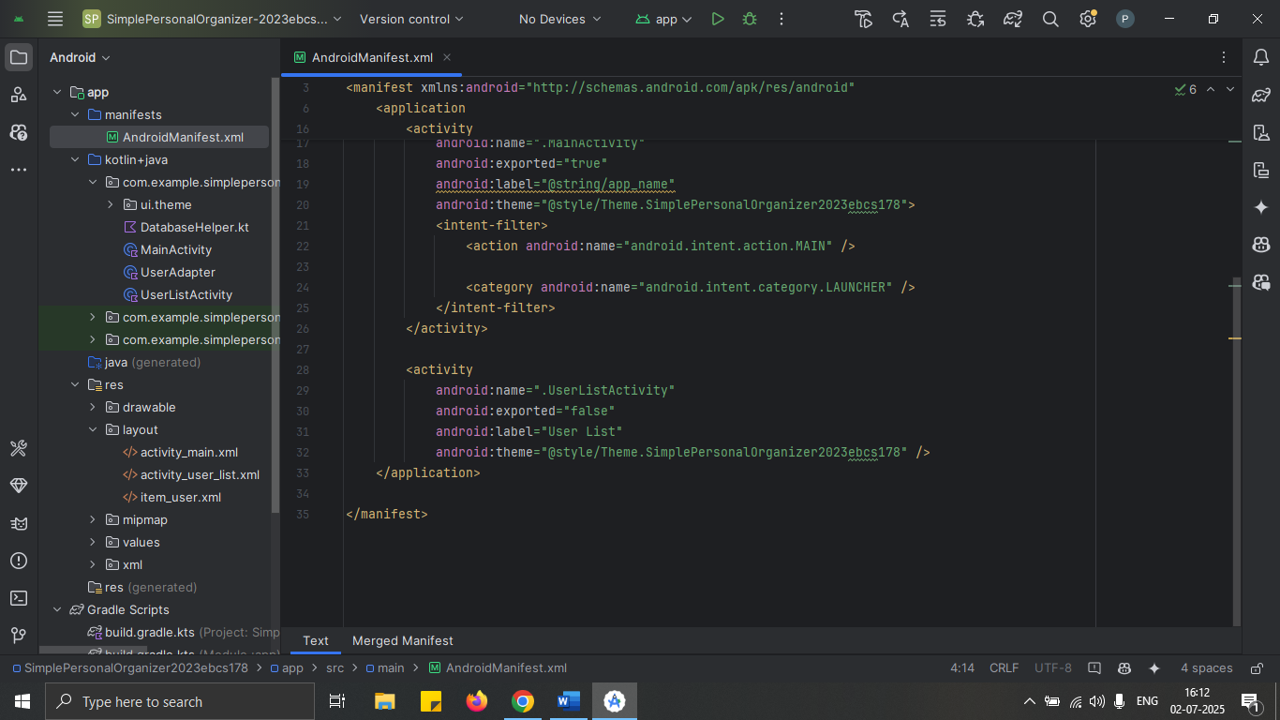

**Question B: Design the Information Form**

Design a basic information form in activity_main.xml to collect user details and store them in the database.

➢Add EditText elements in activity_main.xml for Name and Email, with TextView labels for each field.

➢Add a "Save" button to store the entered data in the Users table using the DatabaseHelper class.

➢Add basic styling (e.g., padding, margins) to make the form visually readable.

➢Display a success message upon saving the data.

**Deliverable: Submit the XML layout file (activity_main.xml) and MainActivity.kt file, and a screenshot of the form showing sample data saved in the database**

**activity_main.xml**

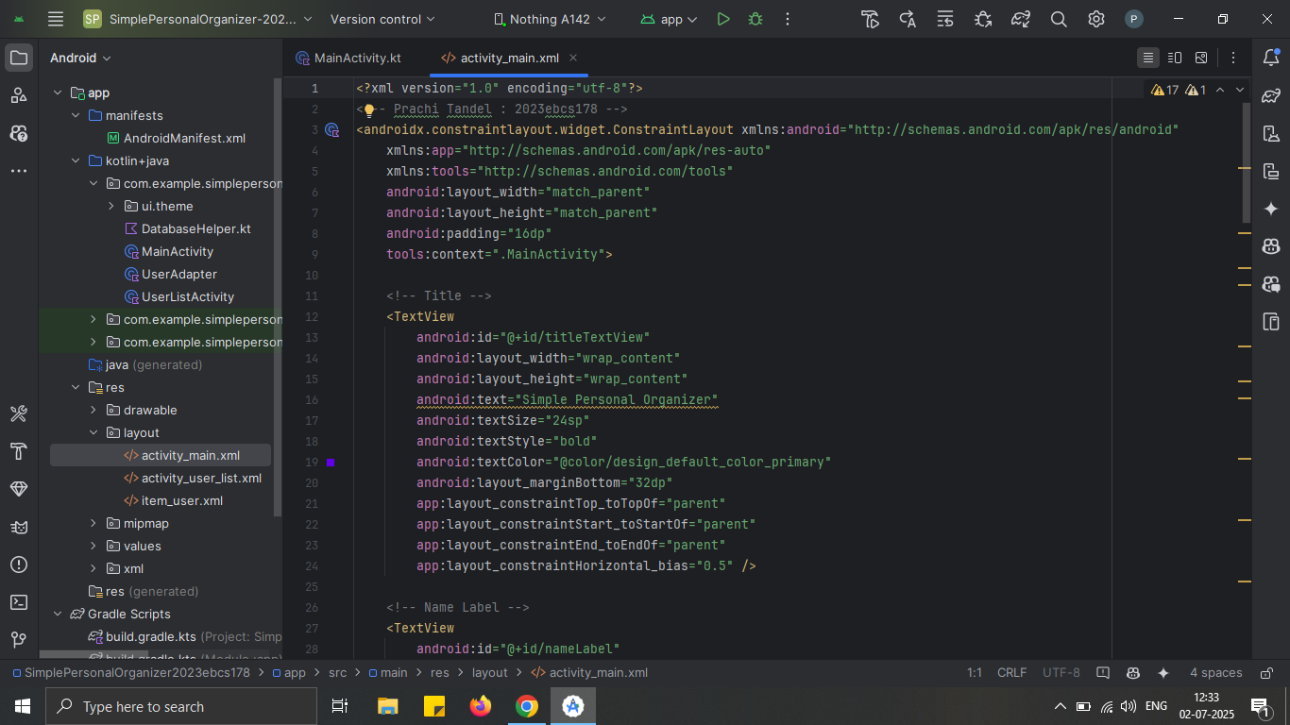

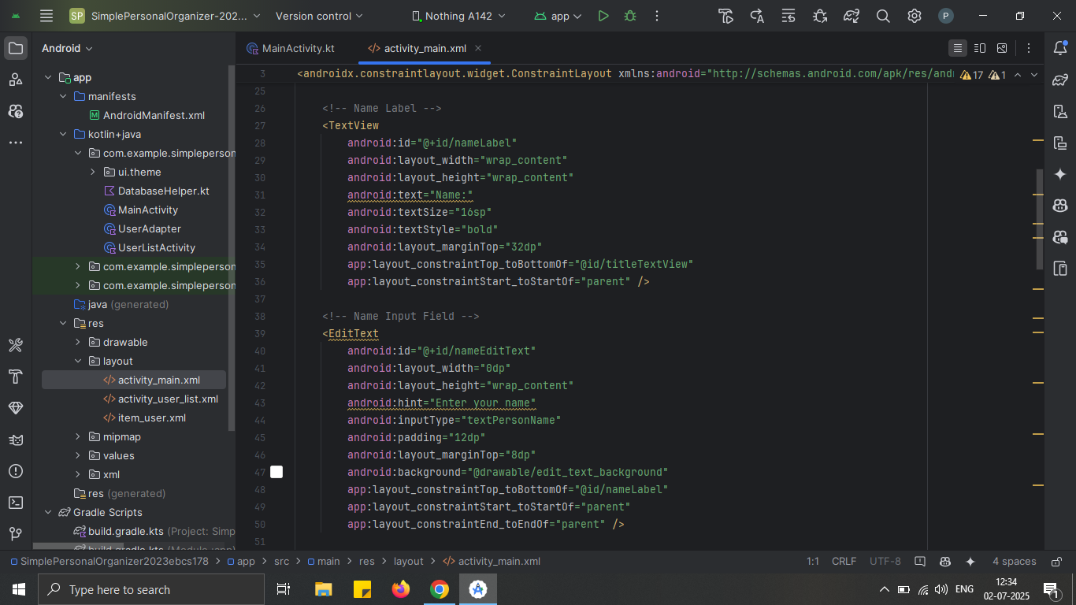

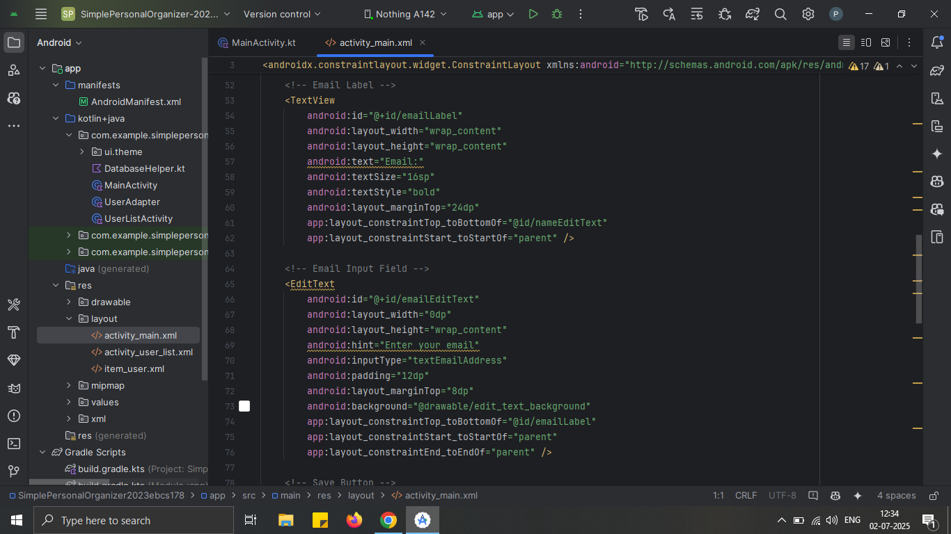





**MainActivity.kt**

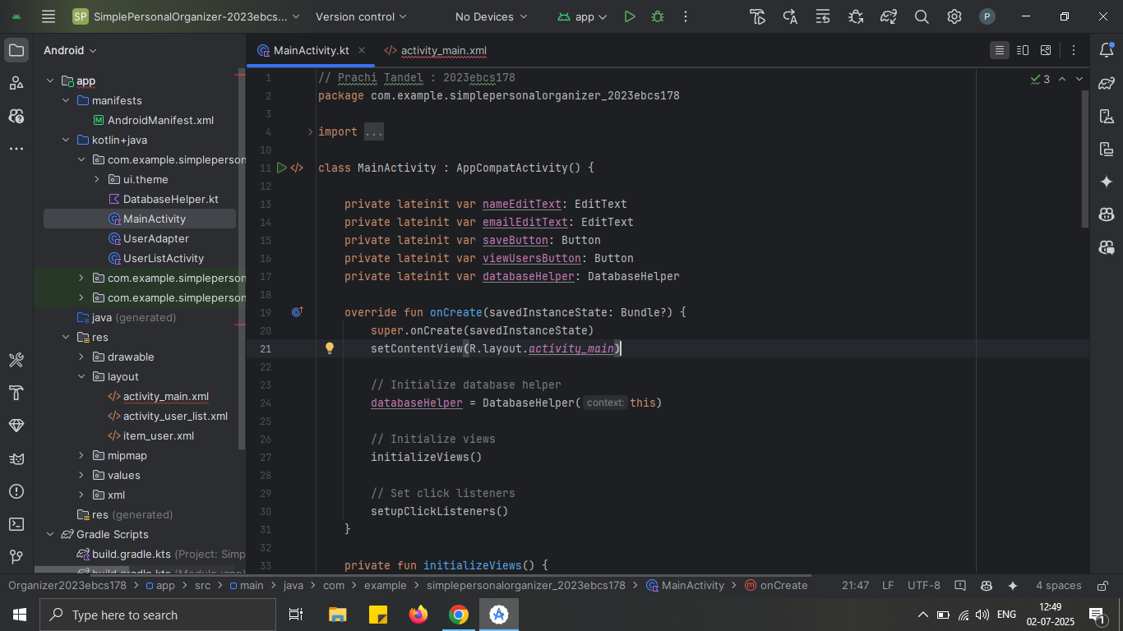

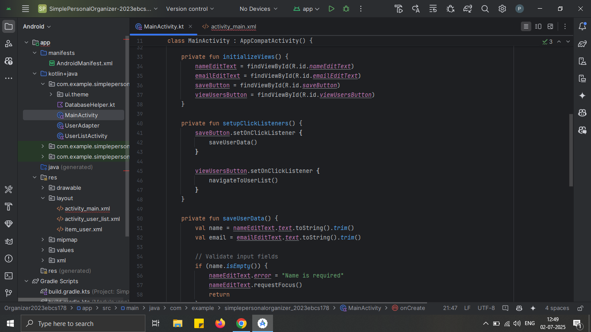

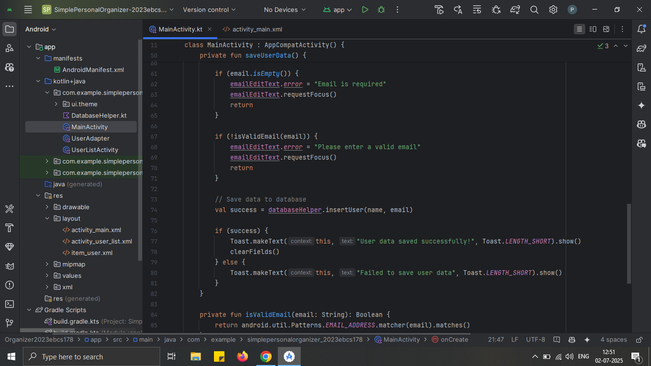

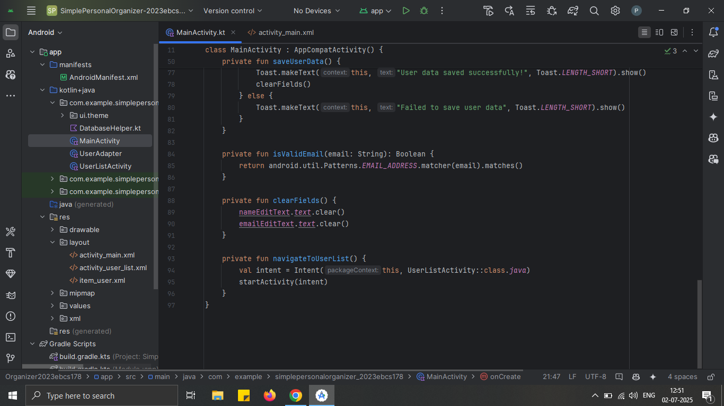

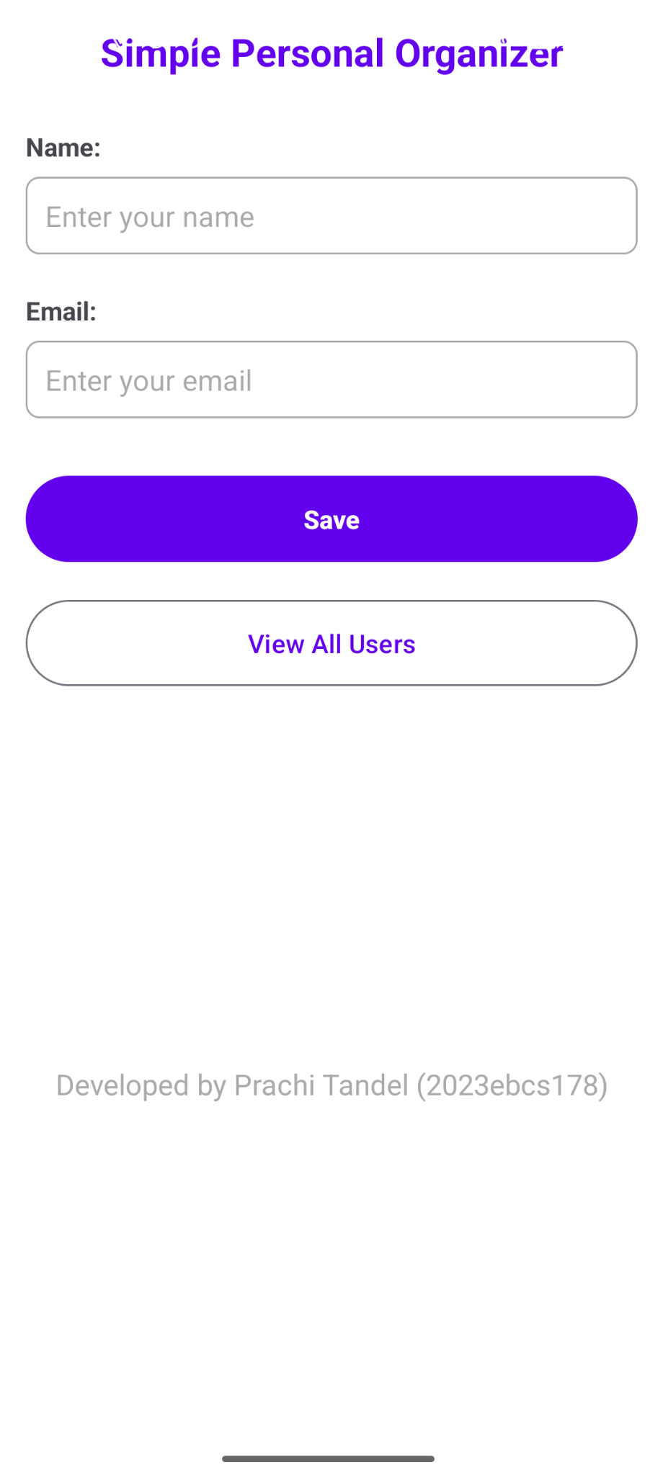

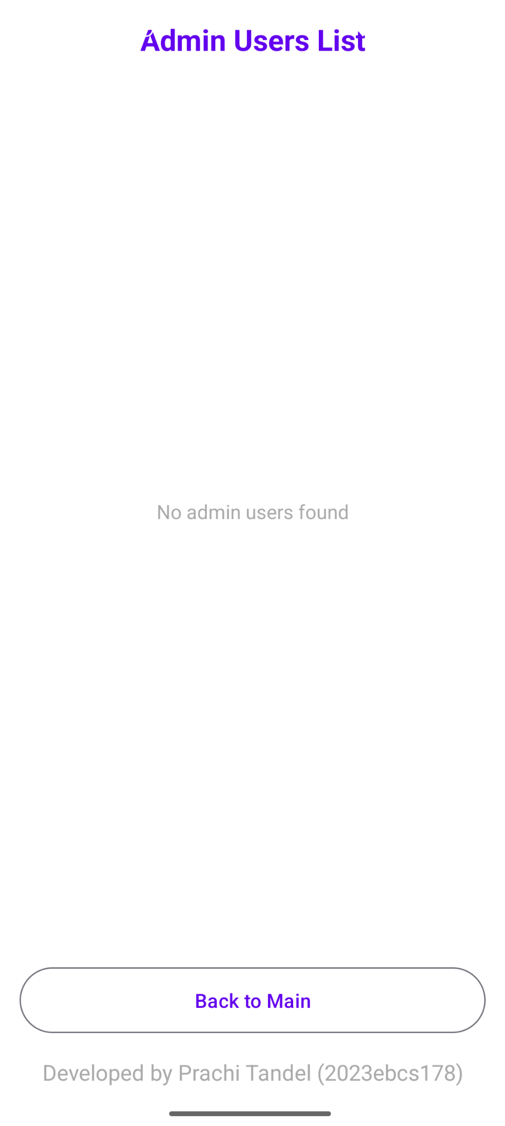

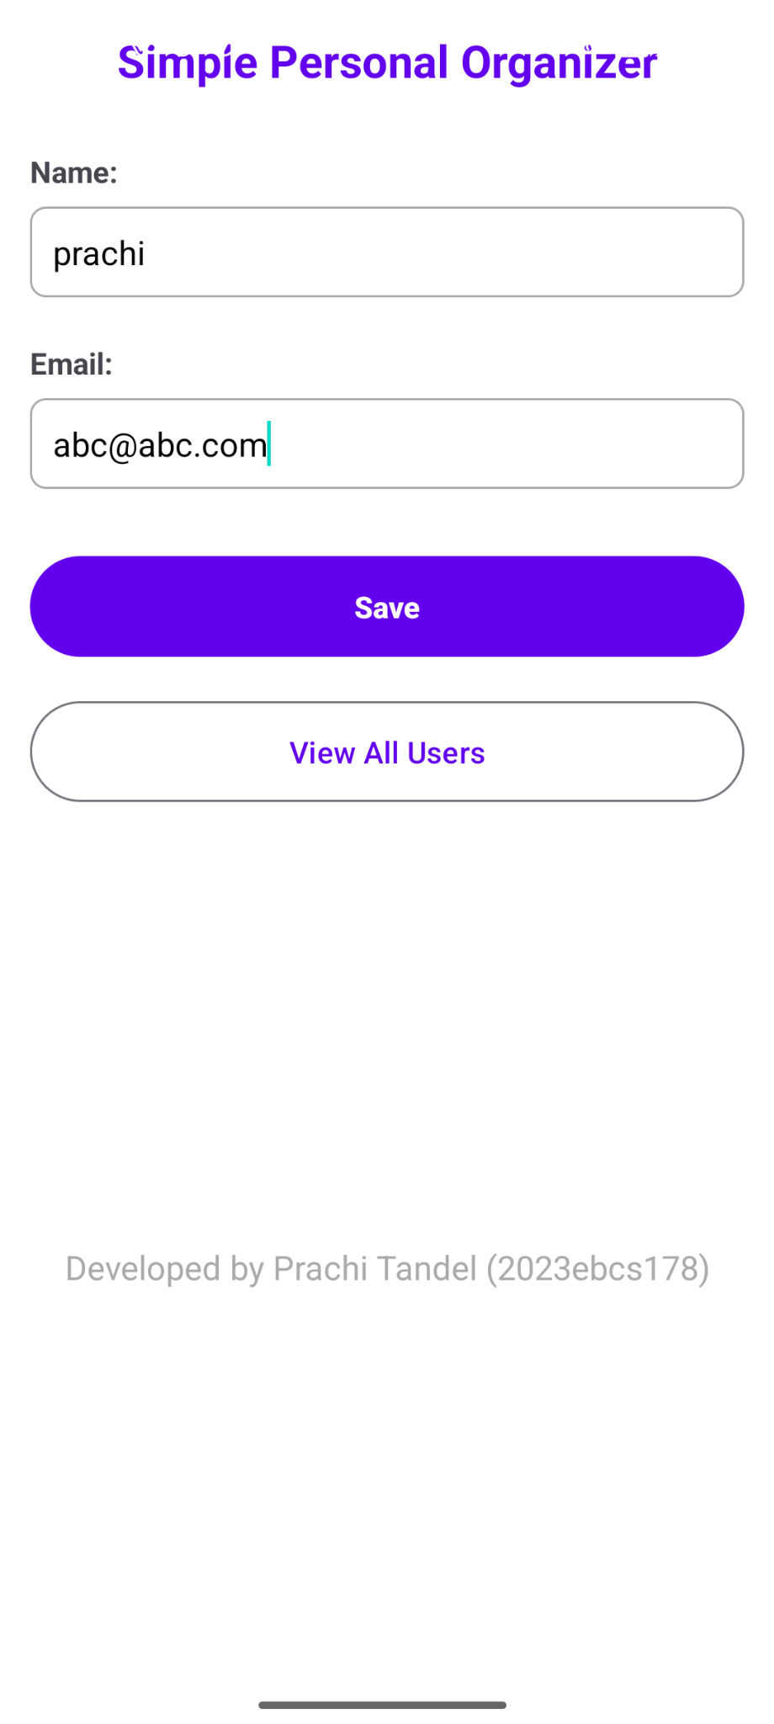

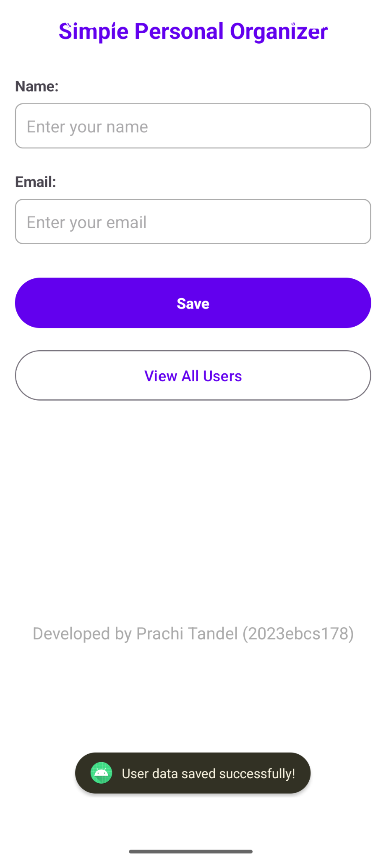

**Question C: Implement Navigation and Data Retrieval**

Create a second screen to display the stored user information.

➢Add a new activity named UserListActivity.

➢Use the DatabaseHelper class to retrieve all user records from the Users table only for user named “admin”.

➢Display the retrieved data in a RecyclerView or ListView, showing Name and Email.

➢Add a "View All Users" button in the main form to navigate to the UserListActivity.

**Deliverable: Submit the UserListActivity.kt file and a screenshot showing the list of users displayed on the screen.**

**UserListActivity.kt**

