**Tandel Prachi Raghunath 2023EBCS178**

**Question 1: IDCard.html and IDCard_styles.css**

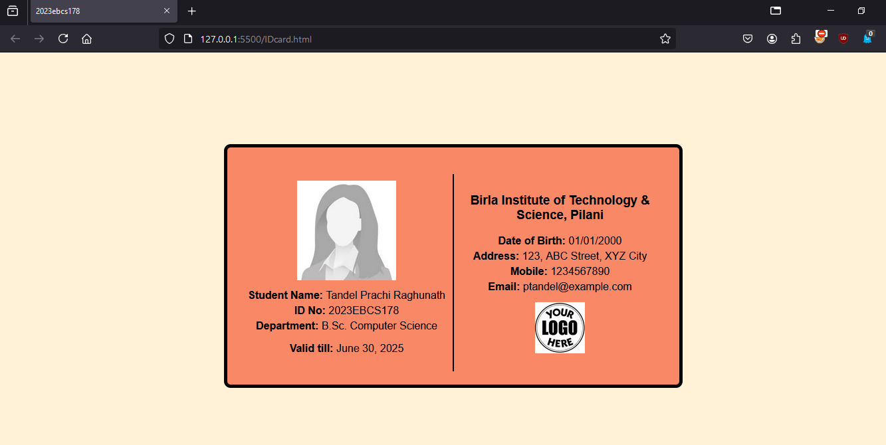

**Question 2: StudentApp.html and StudentApp.js**

