**Tandel Prachi Raghunath - 2023ebcs178**

## **Staff Graded Assignment: Building a Student Management System Using PHP**

**Q.1:** covered in student_form.html

**Q.2 to Q.4:** covered in process_form.php

**Q.5:** Implement CRUD operations for the student details. Provide the ability to add, view, update, and delete student records from the database.

Add Details:

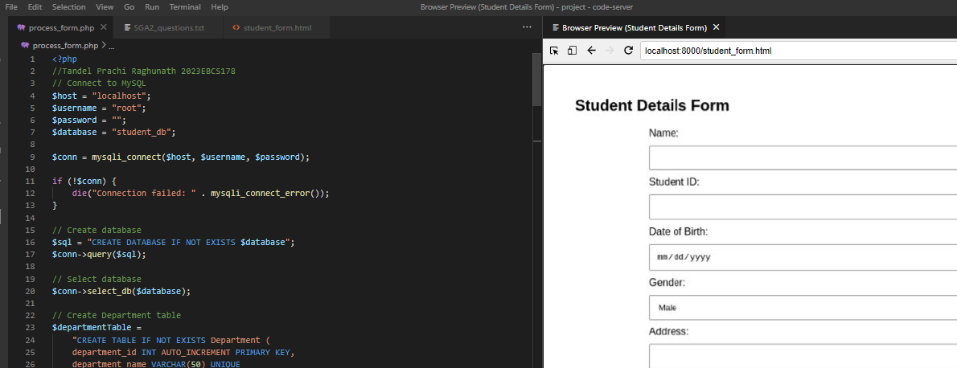

View & Update Details:

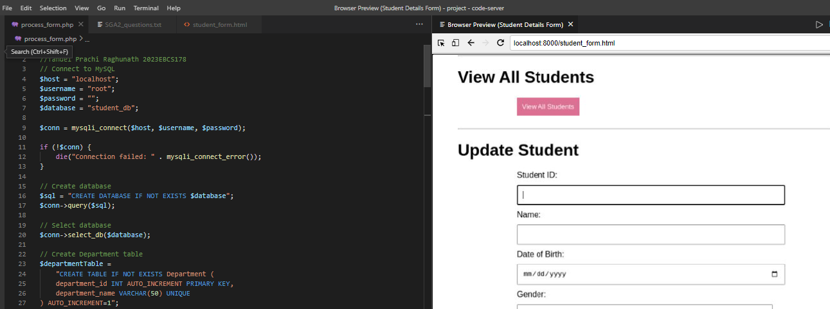

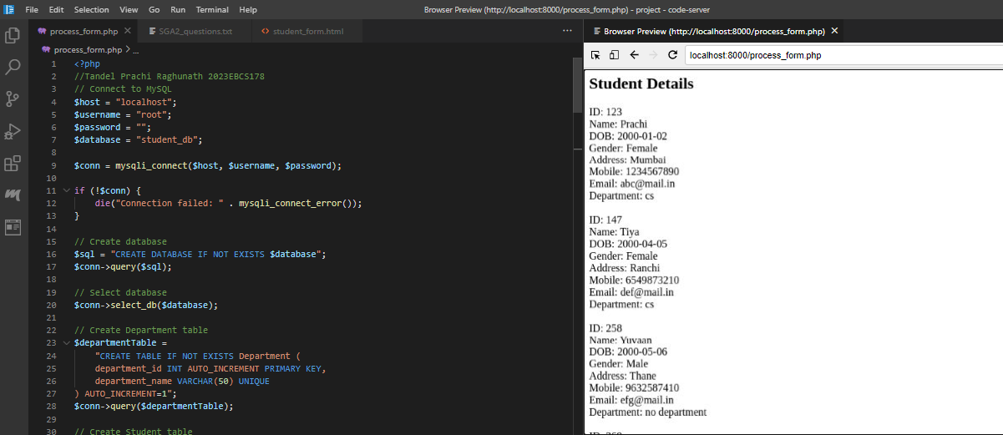

Delete details:

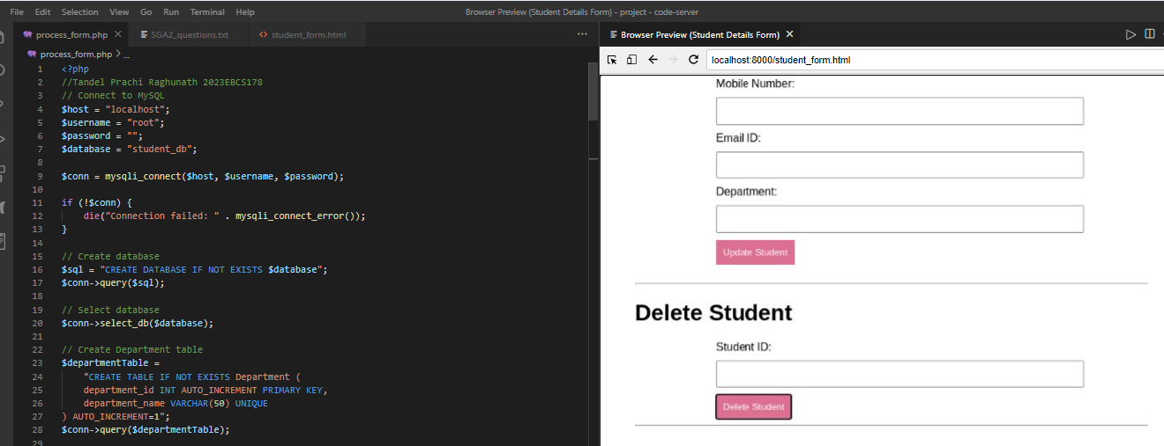

**Q.6:** Explain how the foreign key relationships are established.

Foreign keys enforce referential integrity by ensuring that each student’s department ID exists in the Department table, establishing a relationship between Student and Department.

**Q.7:** Write SQL queries to:

**a)** Fetch student details along with their corresponding department information.

**SELECT Student.student_id, Student.name, Department.department_name FROM Student LEFT JOIN Mapping ON Student.student_id = Mapping.student_id LEFT JOIN Department ON Mapping.department_id = Department.department_id;**

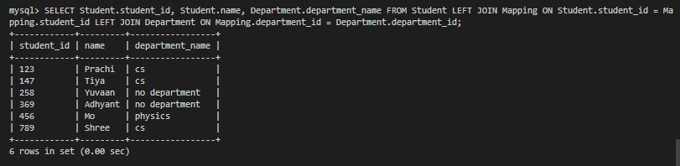

**b)** Fetch all student details, including those who may not have a corresponding department entry.

**SELECT Student.* FROM Student LEFT JOIN Mapping ON Student.student_id = Mapping.student_id;**

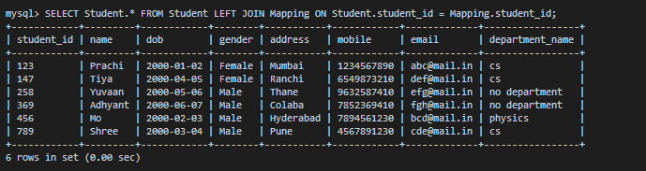

**c)** Obtain department name and count of associated students.

**SELECT Department.department_name, COUNT(Mapping.student_id) AS student_count FROM Department LEFT JOIN Mapping ON Department.department_id = Mapping.department_id GROUP BY Department.department_name;**

