**Project Title: Machine Learning Model Deployment for Student Dropout**

**Analysis with IBM Cloud Watson Studio Problem Definition:**

Student dropout rates in educational institutions have become a significant concern. Institutions invest substantial resources in nurturing students' potential, and when students drop out, it not only affects their futures but also leads to the underutilization of educational resources.

**Phase 2: Innovation - Transforming Design into Solution**

In Phase 1, we laid the foundation for addressing the critical issue of high student dropout rates through predictive analytics. Now, in Phase 2, we embark on the transformative journey of turning our design into a practical, effective, and data-driven solution, leveraging the capabilities of IBM Cloud Watson Studio.

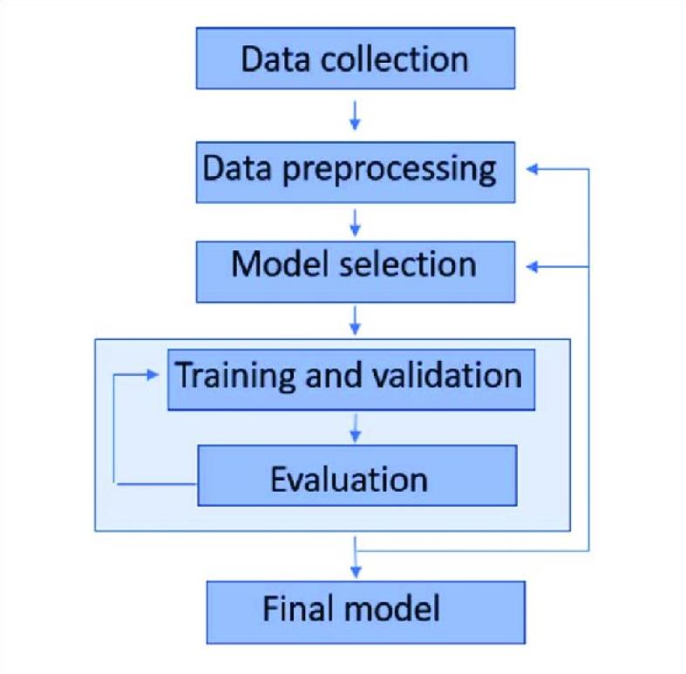

**Proposed Methodology:**

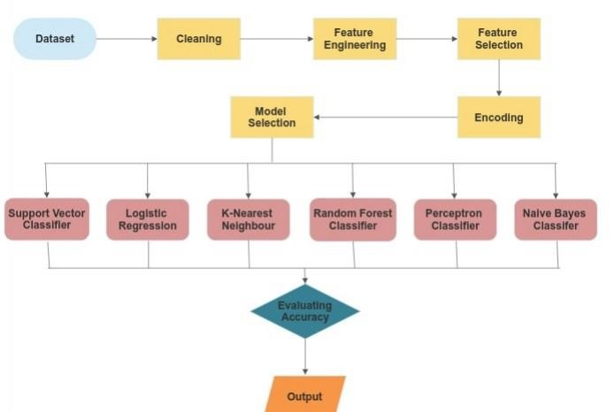

# Step 1: Comprehensive Data Collection and Integration

Our journey begins with a deep dive into data collection and integration. The comprehensive dataset may include:

* **Academic Records:** Historical grades, course enrollments, and academic performance metrics.
* **Attendance Data:** Records of students' attendance and patterns of attendance.
* **Demographic Information:** Socio-economic background, gender, age, and residential details. **- Behavioral Data:** Any available records of behavioral incidents, helping us identify potential patterns.
* **Extracurricular Activities:** Information on students' participation in sports, clubs, volunteer work, and other activities.

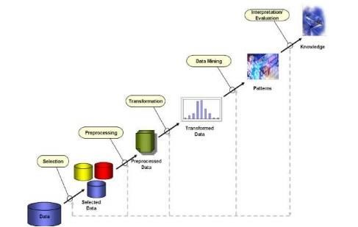

The collected data undergoes meticulous cleaning, transformation, and integration to ensure that it forms a unified and coherent dataset. This step is essential to empower our predictive model with diverse features for accurate analysis.

**SAMPLE DATASETS AVAILABLE ON KAGGLE:**

[**Student Dropout Prediction | Kaggle - Sample Datasets**](https://www.kaggle.com/competitions/dropout-prediction/data)

[**"DONATED DATASETS ON UC IRVINE MACHINE LEARNING REPOSITIORY."**](https://archive-beta.ics.uci.edu/dataset/697/predict+students+dropout+and+academic+success)

# Step 2: Algorithm Selection and Model Training

Having prepared our dataset, we venture into the realm of machine learning by selecting an appropriate algorithm for our predictive model. IBM Cloud Watson Studio offers a rich palette of options, and our choice will be guided by the unique characteristics of the data and the complexity of the problem at hand.

Once the algorithm is selected, we initiate the model training process. This involves feeding the historical data into the model, allowing it to learn from the patterns and nuances present in the dataset. Within this process, we undertake:

* **Data Cleaning:** Identifying and handling missing values and outliers to ensure data quality.
* **Feature Engineering:** Selecting relevant features and transforming the data to be fed into the model.
* **Data Splitting:** Dividing the dataset into training and testing sets to evaluate the model's performance.
* **Model Selection:** Making the critical decision of choosing the most suitable machine learning algorithm for our predictive task.
* **Model Training:** Teaching the model to recognize patterns and make accurate predictions.

# Step 3: Rigorous Model Evaluation and Refinement

Following the initial model training, we embark on a rigorous evaluation process to gauge its performance. We employ a range of metrics, including accuracy, precision, recall, and F1-score, to assess the model's predictive power. If deemed necessary, we enter the phase of model refinement. Here, we fine-tune hyperparameters, experiment with different algorithms, and optimize the model to enhance its effectiveness.

## Step 4: Seamless Web Service Deployment

IBM Cloud Watson Studio offers a streamlined process for deploying machine learning models as web services. We harness this capability to host our predictive model in the cloud. The benefits of this deployment strategy are numerous:

* **Scalability:** Our model becomes capable of handling predictions for a large number of students.
* **Accessibility:** Educators and administrators gain easy access to the model through a userfriendly interface.
* **Real-time Predictions:** Continuous monitoring of student risk factors enables timely intervention.

## Step 5: Integration and User Interface Development

To seamlessly integrate our solution into existing educational systems, we embark on the development of APIs. These APIs serve as gateways to access the model's predictive capabilities.

Additionally, we create an intuitive user-friendly dashboard that empowers educators and administrators to effortlessly view predictions and take timely actions. The dashboard offers valuable insights into individual students' risk factors, enabling personalized interventions.

## Step 6: Automated Alert Mechanisms and Continuous Monitoring

To bolster the effectiveness of our solution, we implement automated alert mechanisms. These alerts notify educators and administrators about students at high risk of dropping out. The realtime nature of these alerts allows for rapid response and intervention, thereby preventing potential dropouts. We also establish a system for continuous monitoring of student risk factors, ensuring that the solution remains adaptive and responsive to changing circumstances.

## Step 7: Comprehensive Documentation and Knowledge Transfer

Throughout the innovation phase, we maintain meticulous documentation of our progress, methodologies, and implementation steps. This documentation serves as a valuable resource for knowledge transfer, ensuring that the solution can be seamlessly adopted by educational institutions. It also lays the foundation for future enhancements and refinements.

In essence, Phase 2 represents the transformative journey from design to innovation. We are committed to converting our vision into a tangible, data-driven solution that addresses the pressing challenge of high student dropout rates. Through the strategic use of IBM Cloud Watson Studio, comprehensive data analysis, predictive modeling, and user-friendly interfaces, we empower educational institutions to support students effectively, enhance retention rates, and efficiently allocate resources. This holistic approach enables institutions to make data-driven decisions that foster student success, ultimately benefiting individuals and the educational ecosystem as a whole.