Implement Client Script & UI Policy (Incident)
Phase 5 – Project Development

1. Development Environment
- ServiceNow instance
- Incident table
- System UI → UI Policies
- System UI → Client Scripts

2. UI Policy – High Impact Control
- Log in to the ServiceNow instance with administrative or configuration access.
- Navigate to System UI → UI Policies.
- Click New.
- Enter Name: High Impact Control.
- Select Table: Incident.
- Set Active to true.
- Set the condition to Impact is 1 – High.
- Configure the UI Policy Action for Assignment group as mandatory.
- Set Reverse if false to true.
- Click Submit.

3. UI Policy Action – Urgency
- Open the High Impact Control UI Policy.
- Scroll to the UI Policy Actions related list.
- Click New.
- Select Field name: Urgency.
- Set Read-only to true.
- Leave Visible unchanged.
- Click Submit.

4. onChange Client Script
Name: Auto set urgency for high impact
Table: Incident | Type: onChange | Field name: Impact | Active: true
Script:
function onChange(control, oldValue, newValue, isLoading) {
if (isLoading || newValue == '') {
return;
}
if (newValue == '1') {
g_form.setValue('urgency', '1');
g_form.addInfoMessage('Urgency set to High for High impact incident.');
}
}

5. onSubmit Client Script
Name: Prevent save if Assigned To missing
Table: Incident | Type: onSubmit | Active: true
Script:
function onSubmit() {
if (g_form.getValue('impact') == '1' &&
g_form.getValue('assigned_to') == '') {
g_form.showErrorBox(
'assigned_to',
'Assigned To is mandatory for High impact incidents.'
);
return false;
}
return true;
}

6. onCellEdit Client Script
Name: Prevent state change via list edit
Table: Incident | Type: onCellEdit | Field name: State | Active: true
Script:
function onCellEdit(sysIDs, table, oldValues, newValue, callback) {
alert('State cannot be updated using list editing. Please open the Incident.');
callback(false);
}

7. Development Result
The Incident configuration now contains the planned UI Policy, UI Policy Action, onChange Client Script, onSubmit Client Script, and onCellEdit Client Script.

8. Screenshot Placeholders
High Impact Control UI Policy

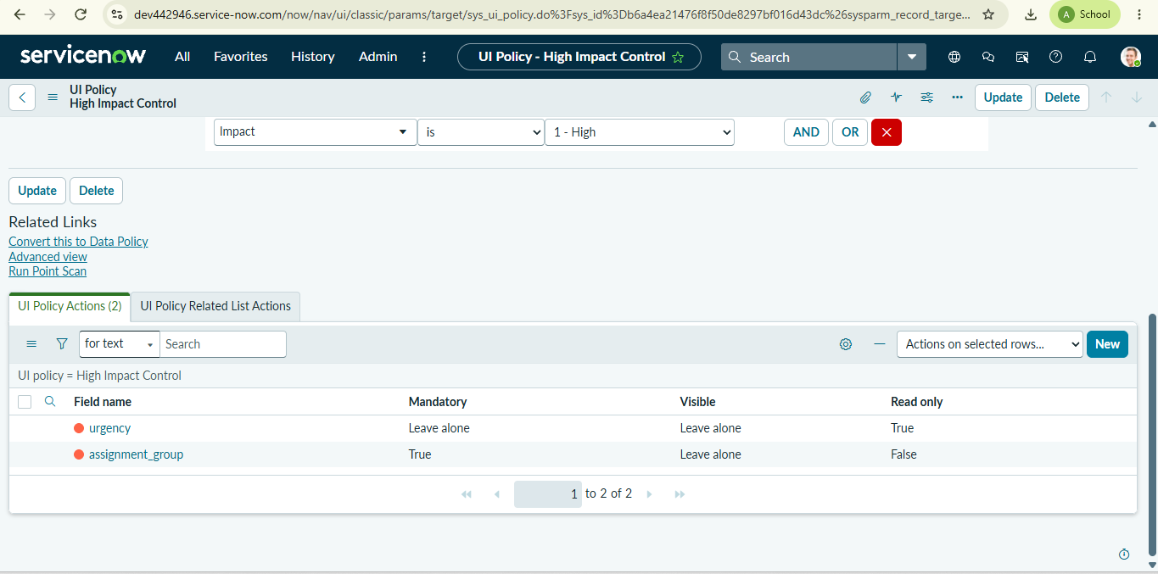

Urgency UI Policy Action

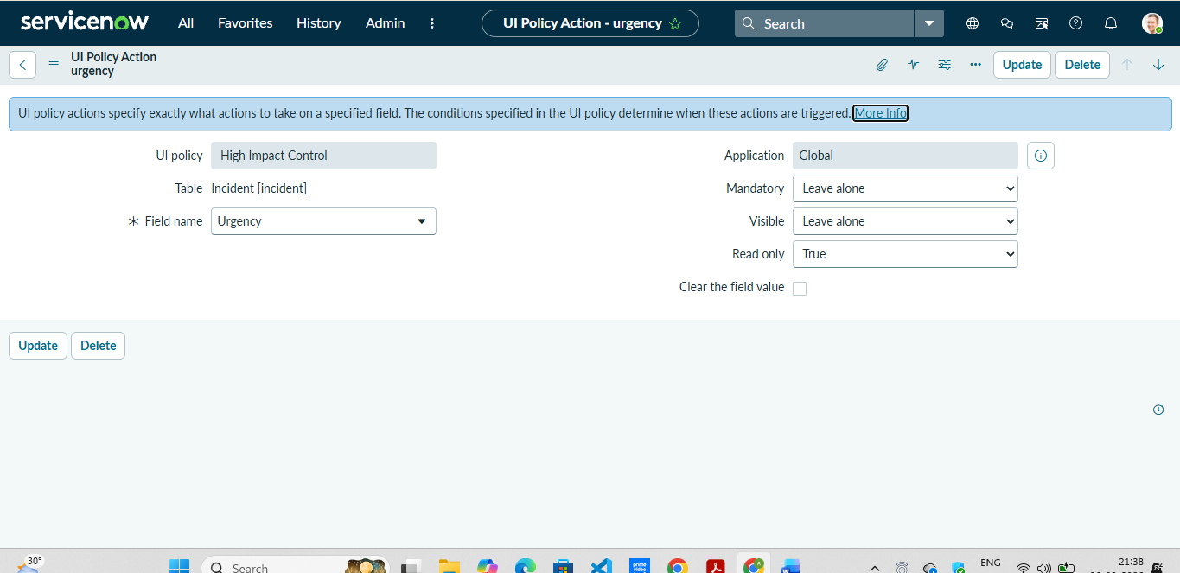

OnChange Client Script

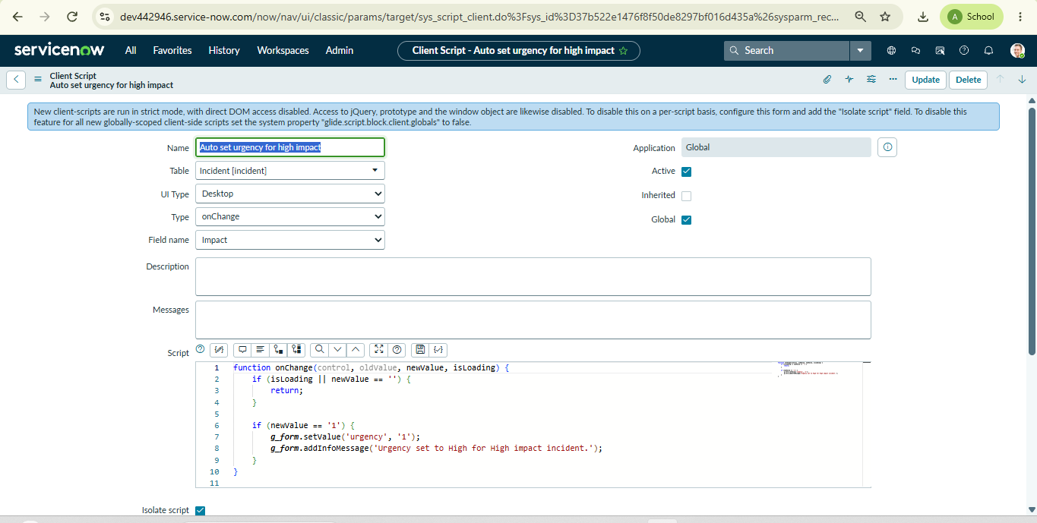

onSubmit Client Script

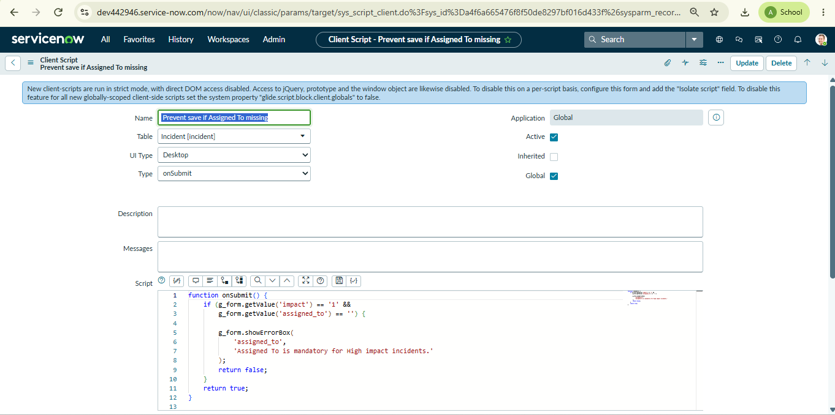

onCellEdit Client Script

