**Project Title: Design and Simulation of a 3D Antenna Structure in HFSS**

By Aaren Jain

**Overview**

This project involves the design and simulation of a 3D antenna structure using ANSYS HFSS (High-Frequency Structure Simulator). The objective is to analyze the antenna's performance parameters, including S-parameters, Z-parameters, and realized gain. The project aims to demonstrate the effectiveness of HFSS in designing antennas suitable for high-frequency applications.

**Tools and Software**

* **ANSYS HFSS:** A 3D electromagnetic simulation software for designing and simulating high-frequency electronic components.
* **3D Modeler:** Used to create the physical structure of the antenna.
* **Simulation Tools:** Used to configure and run the simulations to analyze the antenna's performance.

**Project Components**

1. **Substrate and Material**
   * **Substrate Material:** Rogers RT/duroid 5880, known for its low dielectric constant and loss, which makes it suitable for high-frequency applications.
   * **Substrate Thickness:** Defined according to the design requirements, as seen in the properties panel.
   * **Material Properties:** The surrounding environment is defined as vacuum to simulate free-space conditions.
2. **Antenna Design**
   * **Feedc:** The feed component for the antenna, created using cylindrical shapes to represent the feeding mechanism.
   * **Inner1 and Inner2:** Cylindrical structures subtracted from the main design to create the desired antenna structure, ensuring proper impedance matching and radiation characteristics.
   * **Ground and Radiator:** Perfect E and Radiator sheets are used to define the ground plane and radiating elements, ensuring efficient radiation and proper return loss characteristics.
3. **Simulation Setup**
   * **Setup1:** The primary analysis setup, including boundary conditions, excitation sources, and frequency sweep parameters to simulate the antenna's performance accurately.
   * **Analysis Parameters:** Various dimensions and properties of the antenna elements are specified in the properties panel, allowing for precise control over the design and simulation process.

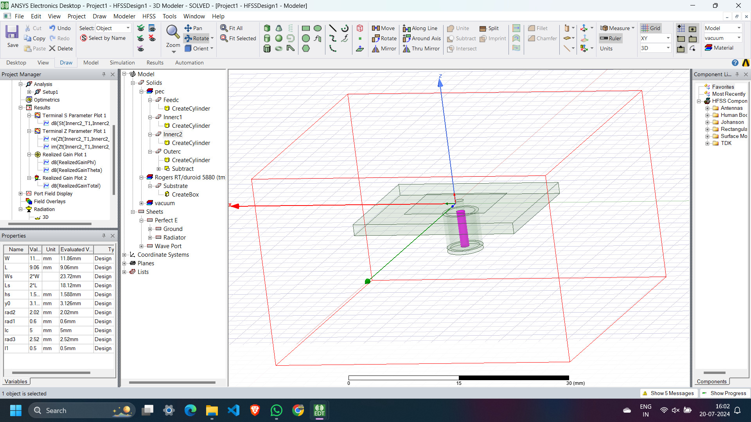

**Simulation Results**

1. **Terminal S Parameter Plot 1**
   * **Description:** This plot shows the S-parameter (S11) of the antenna, indicating the reflection coefficient across a frequency range.
   * **Graph Analysis:** The plot displays a significant dip at the resonant frequency, indicating good matching at that point. This is crucial for ensuring minimal reflection and maximum power transfer.
   * **Frequency Range:** 4 GHz to 10 GHz.
   * **Observations:** Minimum S11 value is approximately -16.997 dB at around 6.6467 GHz, indicating excellent impedance matching at this frequency.

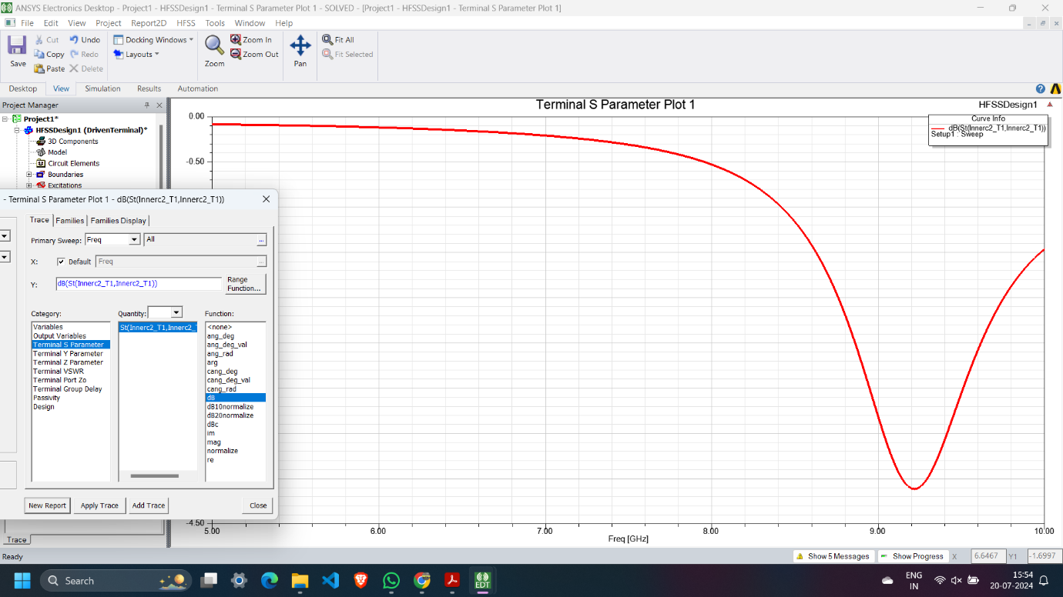

1. **Terminal Z Parameter Plot 1**
   * **Description:** This plot shows the real and imaginary parts of the Z-parameter (impedance) of the antenna, providing insight into its impedance characteristics over the frequency range.
   * **Graph Analysis:** The plot indicates the impedance characteristics of the antenna over the specified frequency range, showing both the resistive and reactive components.
   * **Frequency Range:** 4 GHz to 10 GHz.
   * **Observations:** The real part of the impedance peaks at certain frequencies, while the imaginary part shows reactive characteristics, which is typical for resonant structures.

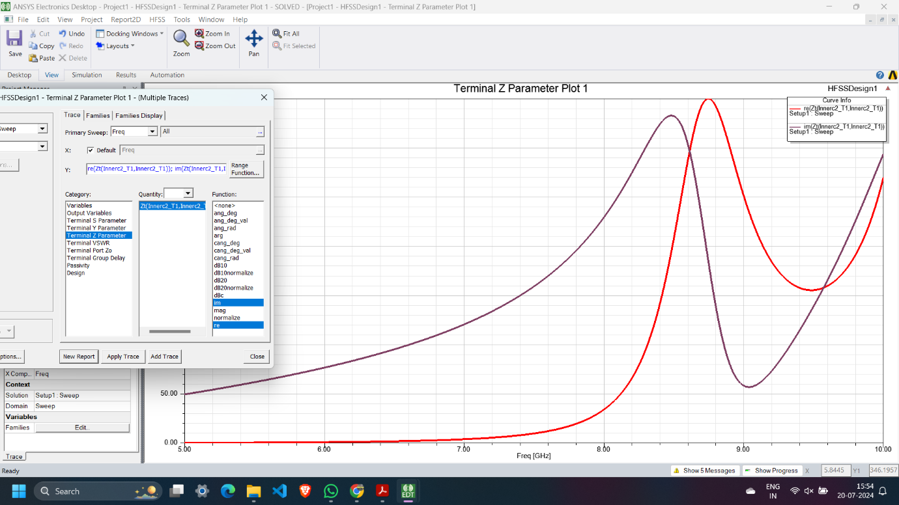

1. **Realized Gain Plot 1**
   * **Description:** This plot shows the realized gain of the antenna, indicating how effectively it radiates energy.
   * **Graph Analysis:** The gain plot provides insight into the directional characteristics and efficiency of the antenna.
   * **Frequency Range:** 4 GHz to 10 GHz.
   * **Observations:** Peaks in the gain plot indicate the frequencies at which the antenna performs best, with high gain values indicating efficient radiation.

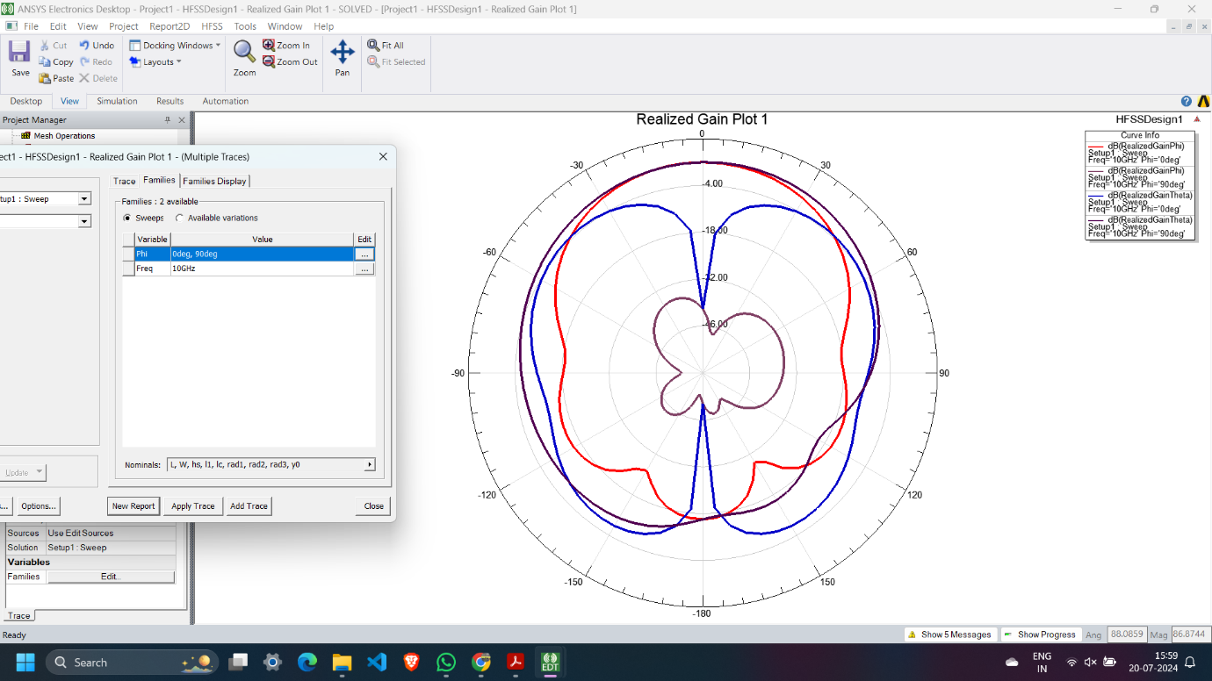

1. **Realized Gain Plot 2**
   * **Description:** An additional realized gain plot providing further insight into the antenna's performance.
   * **Graph Analysis:** Helps in understanding the gain characteristics over a wider range or under different configurations.
   * **Frequency Range:** 4 GHz to 10 GHz.
   * **Observations:** This plot supplements the first realized gain plot by offering a different perspective or validation of the antenna's performance.

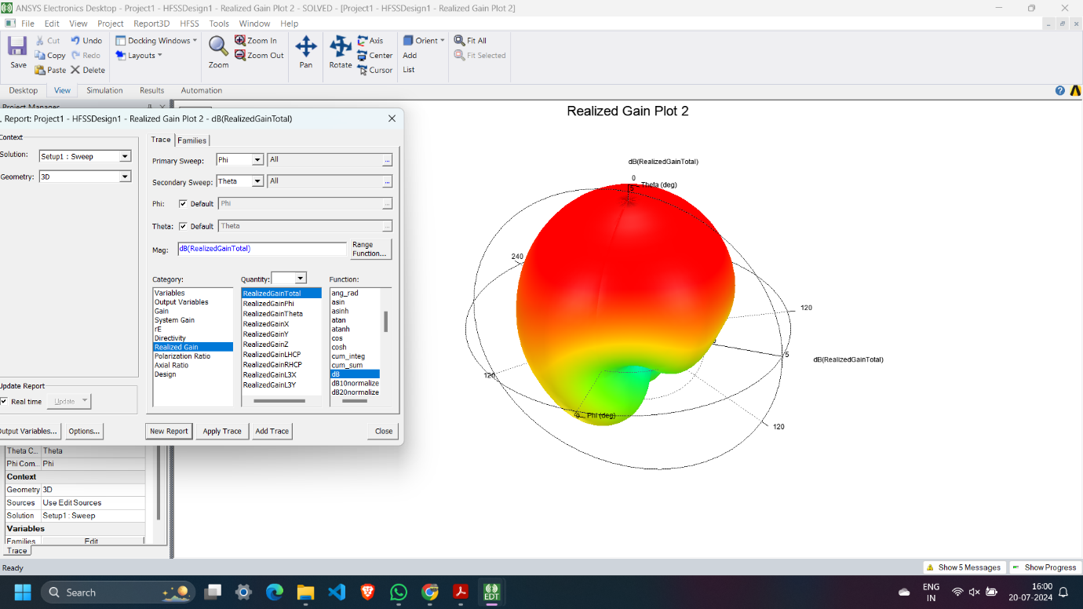

**Performance Metrics**

* **W (Width):** 11.86 mm
* **L (Length):** 9.06 mm
* **Ws and Ls (Substrate Width and Length):** 22 mm and 18.12 mm respectively.
* **y0, rad1, rad2, rad3:** Various radii and positional parameters for the antenna design elements, crucial for fine-tuning the antenna's performance.

**Design Methodology**

1. **Modeling:** The antenna structure is created using basic shapes like cylinders and boxes. These shapes are then manipulated using operations like subtraction and union to achieve the desired design. This step involves careful planning and iterative adjustments to ensure optimal performance.
2. **Material Assignment:** The materials are assigned to different components of the antenna, including the substrate and feed, to accurately simulate real-world conditions.
3. **Simulation:** The simulation setup is configured with appropriate boundaries and excitation. The analysis is run to gather performance data, which is then used to refine the design further.

**Summary**

The project demonstrates the use of HFSS for designing and simulating a complex 3D antenna structure. The detailed setup and simulation results provide insights into the antenna's performance, making it suitable for various high-frequency applications. The process involves meticulous design, accurate material assignment, and comprehensive simulation to ensure the antenna meets the desired specifications.