Not Quit Paradise

Game design document

# Overview

Island rises from the ocean every few decades, attracting treasure-seekers and the adventure-bound from around the world. Little do they know that the island, and the rumours around it, are created by the gods who watch on for their own amusement.

A game about the failures, the down and outs, the folk so desperate that they've decided to take on the temptation of the Old God's Isle. Humour inspired by venture brothers and arrested development.

# Player Objectives and Progression

# Game World and Background

## Races

Herraculen - hercules beetle inspired, wings can be hidden, brittle shell

- stat growth; speed, strength

- negative passive; (brittle shell) if take more than x% in a single turn then apply status effect

- positive passive;

Goblinn -

??? - yeti type creature with a small frog on its head

- positive passive; (two heads better than one) all stat gain to mental is doubled

## Peoples

Mushroom Kingdom(?) – feuding lords competing to grab land as the great maw(?) (whirlpool) slowly devours their land. They make castles from giant fungi.

Refugees(?) – escaping the violence of the Mushroom Kingdom and the inhospitable northern mountains they now reside in the dank bogs.

Aristo-Pirates(?) – living along the 1000 isle range they consider themselves kings of their little domain and have an ego to match, ruling over each tiny island with ineffectual largesse.

(?) – living in far flung, glass domes surrounded by desert these small groups scheme and plot to further their own position.

# User Interface

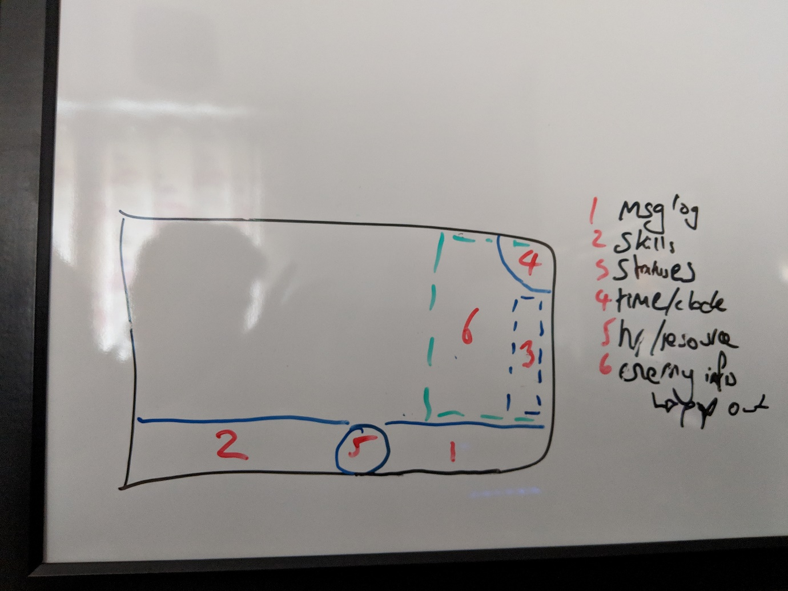

Side bar with main elements (e.g. skills, monster compendium) and pop out options

button press pops out options and moves focus

hover over info for all key elements

slide in "main" screen, such as inventory, skill select

section showing info for entity under the mouse; left click to maintain selection

section for selected skills

section to show resource. Will always have health. Possibly have more than one alternate resource - split second bar/circle in half, one for each? Should never have more than 2 resource types (not including health)

area for status effects, including passives

# Art and Sound Style

# Initial Systems and Features

For the first playable build (v0.0.1)

* ~~Time-based queue~~
* ~~Grid based movement~~
* ~~Actor stats derived from class, race etc.~~
* Item generation
* Map procedural generation
* Win condition; retrieve McGuffin from end point and then race the rising water (and sinking island) back to the entrance.
* Time limit upon which time the island begins to sink
* Player experience created from sacrificing items to the gods
  + On item pickup choose to keep or sacrifice for exp
* Skill tree
* Limited selected active and passive skills; can only select at certain locations
* Save and load
* Environment system
  + Dynamic creation of environmentals (rain, gas etc.)
  + Environmental interactions (fire + rain = steam)
* Gods system
  + Gods judge actions and gain like and dislike
  + Gods take actions on the map; summon new monsters, cast spells, change terrain, comment
  + Gods apply rules to their areas so that actions (e.g. putting out a fire) cause a god related response (e.g. causing a fire on the location of the entity that put out the fire). Announce rules of the area on entry. Rules apply to everyone.
  + Increased favour/positive gains the longer without resting at camp
* Unique health system
  + Current hp can go below 0. Doing so reduces max hp instead. Only heal between combat up to max hp. If max hp =0 then dead. Max hp only restored at camp.
  + OR 10% of damage taken goes onto max hp?
* Ambient sound
  + Use emitters and calc distance from source to player and use that to set volume.

# Desired Systems and Features

* Online high scores
* Network chat
* Replay system
* Unique enemies
* Key rebinding
* Proc gen enemies
* Actor name generation
* Controller support
* External language file
* NPC experience growth based on time
* story elements (gods talking? scenes on the main land?) after each death
* tile type (terrain) affects the entity; movement/action cost, trigger effects etc.
* Tutorial:
  + Tutorial god that explains concepts
  + Tutorial location of beachhead and another adventurer wanting to take out the competition. Kill and give a random item.
* Extended gods system
  + like and dislike is increased in their realm and their chance of interaction with player is also increased.
  + Random selection of gods, and therefore the realms, per run.
* Extended map gen
  + Themed map generation
    - Each area of the map is a god’s realm; only some areas generated per world
    - Enemies generated in line with theme
  + Camps
    - Some sections between realms have camps,
* Item trading
  + Player can trade items at camps. As no inventory can only trade directly from equipment.
* Item generation
  + Items have levels 1-4, each level has expected amount of stats and general strength, and corresponds to a certain amount of devotion points (xp from gods)
* In game wiki/access to the wiki
* Health bars show section for every X hp (like in LoL)
* Different encounter types e.g. a tough enemy that runs away and must be killed before escapes
* Light sources generate their own field of light, player can only see the light if it is within their sight range

# Systems (in depth)

## Gods

Varied pantheon of gods

they judge actions as they happen

gods take actions around the player based on their disposition and feelings towards entities

each god has its own personality dictating what they build/ruins an entities relationship with them and what actions they take

gods can interfere with one another

gods interact with other entities as well as player

god interactions; things like: summon creature, heal, elemental damage, environmental distortion, status effects, item generation, amend time limit (within hard limits)

CONSIDERATIONS

will need enough variety and differentiation of actions to allow this to work

repetition of an action should reduce positive gains and increase negative gains to prevent grinding

NPC will need relationships with the gods to trigger actions

## Combat

Players rapidly heal after each combat.

Some skills are per combat, some are per rest/camp, some are just cool down. Learnt skill should only be cooldown or per combat. (Maybe just start with cooldown and extend from there)

## World Generation

Monsters

monsters spawn from a central point in each themed area and wander out to fill the rooms (each room will need an "ideal monsters in room" stat)

Fill one room then spill into the next

Monster density higher closer to spawn room

Spawn point can be destroyed, preventing future spawns.

Spawn rate is 0 when player is in spawn room

## Items

all items should add value and allow for different play styles

barring from use of an item should be the exception (classA can't use axes)

items within a class/grouping should be clearly differentiated e.g. weaponTypeA can have X,Y,Z affixes, weaponTypeB can have A,B,X

items generated with affixes based on level of rarity

Unique (i.e. preset) items exist and should be distinct combos that break the usual rules, but are not inherently more powerful

## Player Character

Char creation

background (early life, later life), each one offers a skill tree/selection and amends starting stats

race provide core stats and 2 passives, one positive and one negative

Char development

Can only have access to X skills at a time

Can swap skills at a "town" type location

No stat growth

Xp ("Favour"?) growth through item donation

new levels award a selection of skills, of which the player can pick one.

## Tutorial

Start with a neutral blocking the way . Bump triggers talk. Bump again triggers talk then change to enemy. Last bump triggers damage and kills. Gods award a crap item and player can discard for first level and skill choice.

# Tools

# Technical Documentation

# Detailed Asset Lists

# Prototypes and Playtesting

# General notes and thoughts