# Wireframe

Wireframe

# BIKE SHARE PREDICTION

Revision Number – 3.0

Last Date of Revision – 28/03/2022

Biswajit Rajaguru Mohapatra

Document Version Control

Wireframe

|  |  |  |  |
| --- | --- | --- | --- |
| Data Issued | Version | Description | Author |
| 10/03/2022 | 01 | Abstract, User interface | Biswajit |
| 10/03/2022 | 03 | User input | Biswajit |
| 10/03/2022 | 03 | Result Page | Biswajit |

**Contents**

Wireframe

[**Abstract** 4](https://docs.google.com/document/d/1ZLlZEVdMuxYl3o0PziQjZcUbNmAcz-PR/edit#heading=h.gjdgxs)

**Web Interface 5**

**User Input and result 5**

**Abstract**

Wireframe

Bike sharing systems are new generation of traditional bike rentals where whole process from membership, rental and return back has become automatic. Through these systems, user is able to easily rent a bike from a particular position and return back at another position. Currently, there are about over 500 bike-sharing programs around the world which is composed of over 500 thousand bicycles. Today, there exists great interest in these systems due to their important role in traffic, environmental and health issues. Apart from interesting real-world applications of bike sharing systems, the characteristics of data being generated by these systems make them attractive for the research. The work discusses the implementation a Machine learning backend to predict the availability of bikes for sharing, that can be best picked by the users to save time for their usual works and make them likely to choose this mode of transportation for helping the greater benefits of health, fuel consumption and many more.

**Goal**

The goal here is to build an end-to-end regression task. Here the user will provide the data and the result will be given by the best performing hyper tuned Machine Learning model.

This documentation is all about the user interface wireframe; here the home page of our flight fare prediction project is explained.

**1. Web Interface**

Wireframe

Our web page is one single interface where both input from the user and the prediction is displayed. Input form is a file type, where user will provide a .csv type dataset and a pre-trained model will be used to predict the outcomes.

Else, the user can also train a model by their own.

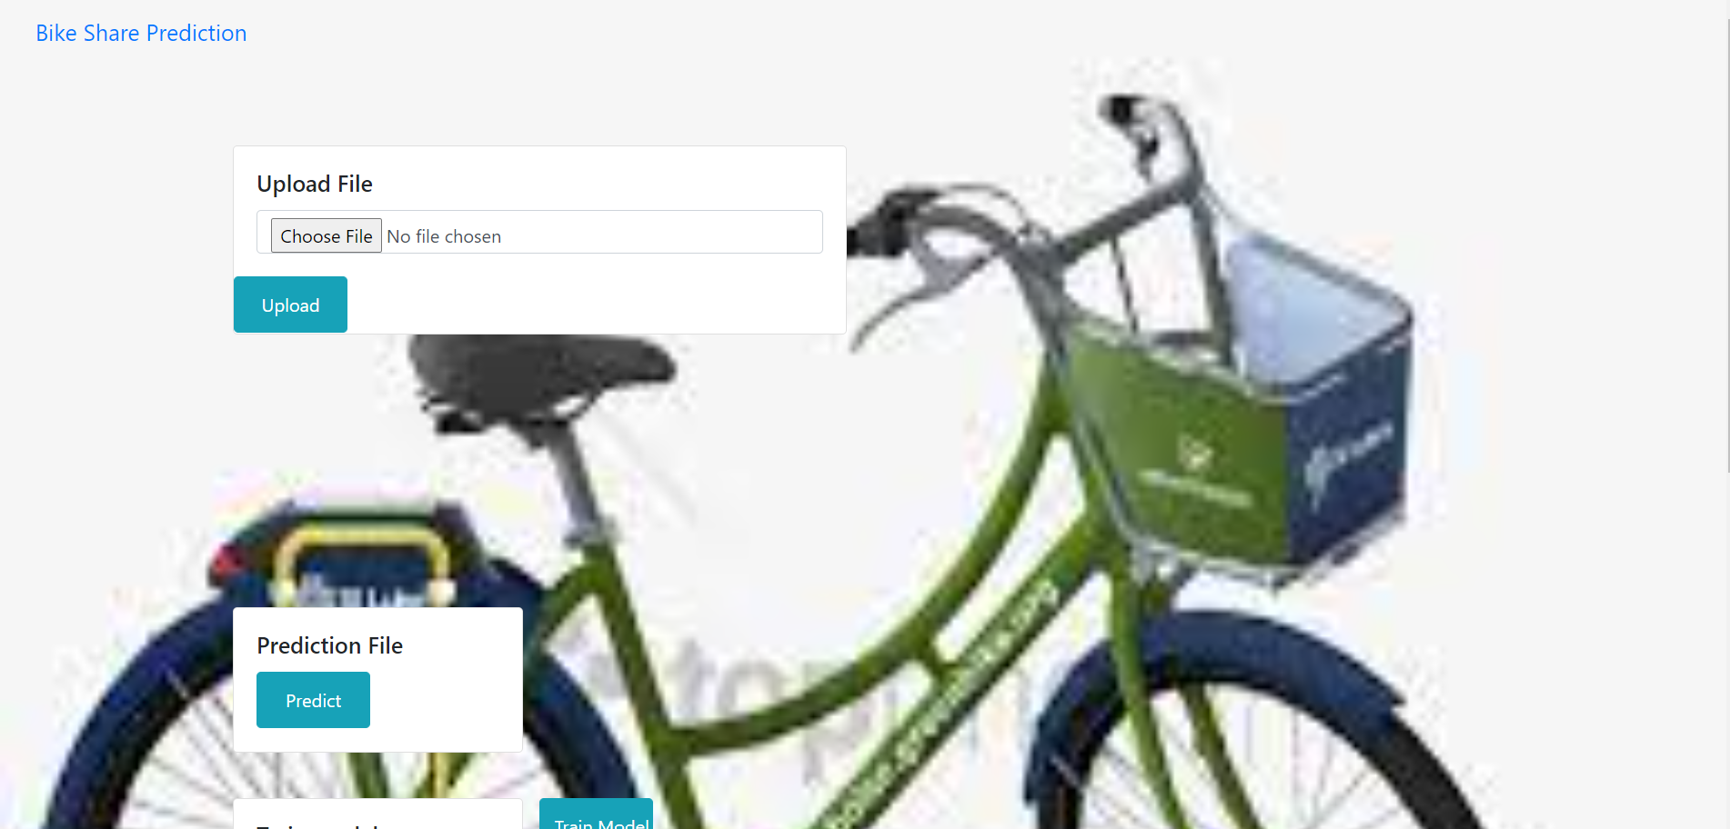

**2. Result Page**

After the user hits the submit button the page gets refreshed and the results are being displayed in the highlighted area in the above frame.

The user can refill all the inputs in same page and get the results in the same way.

