GUJARAT TECHNOLOGICAL UNIVERSITY Academic Year (2022-23)




Government Engineering College , Modasa

Internship Report Under
Subject of
6 Months INTERSHIP
B.E SEMESTER – VIII

BRANCH – Information Technology
Submitted By : -
Aarika M. Jain
190160116128

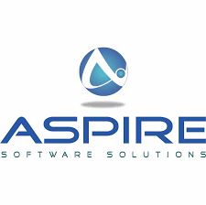

Aspire Softserv Pvt. Ltd.

(Internal Guide) (External Guide)

Company Profile

Company Name : AspireSoftServ Pvt.ltd
Address :402,Vishvacomplex,Navrangpura,Ahmedabad
Website : https://aspiresoftware.in

About Us

Aspire is a leading Java EE, Liferay, Mobility BigData and Customized Software Development Services providing company with development center in Ahmedabad, Gujarat, India. We have been providing high-quality, high-value software development services to the Independent Software Vendors and the enterprises since 2010 by leveraging best-in-class people, processes and technologies.
Aspire is dedicated to developing effective outsourcing partnerships with clients in order to accelerate time to market, reduce operational cost, and empower them to devote more time to their core business.
Since our founding, Aspire has built a successful business by focusing on a simple yet compelling mission: clients' success is our success. We do so through careful, strategic investments in technology, process, and—most significantly—people. Indeed, Aspire’s people are our greatest strength for high-quality, custom software development and business process outsourcing support.

Joining Letter
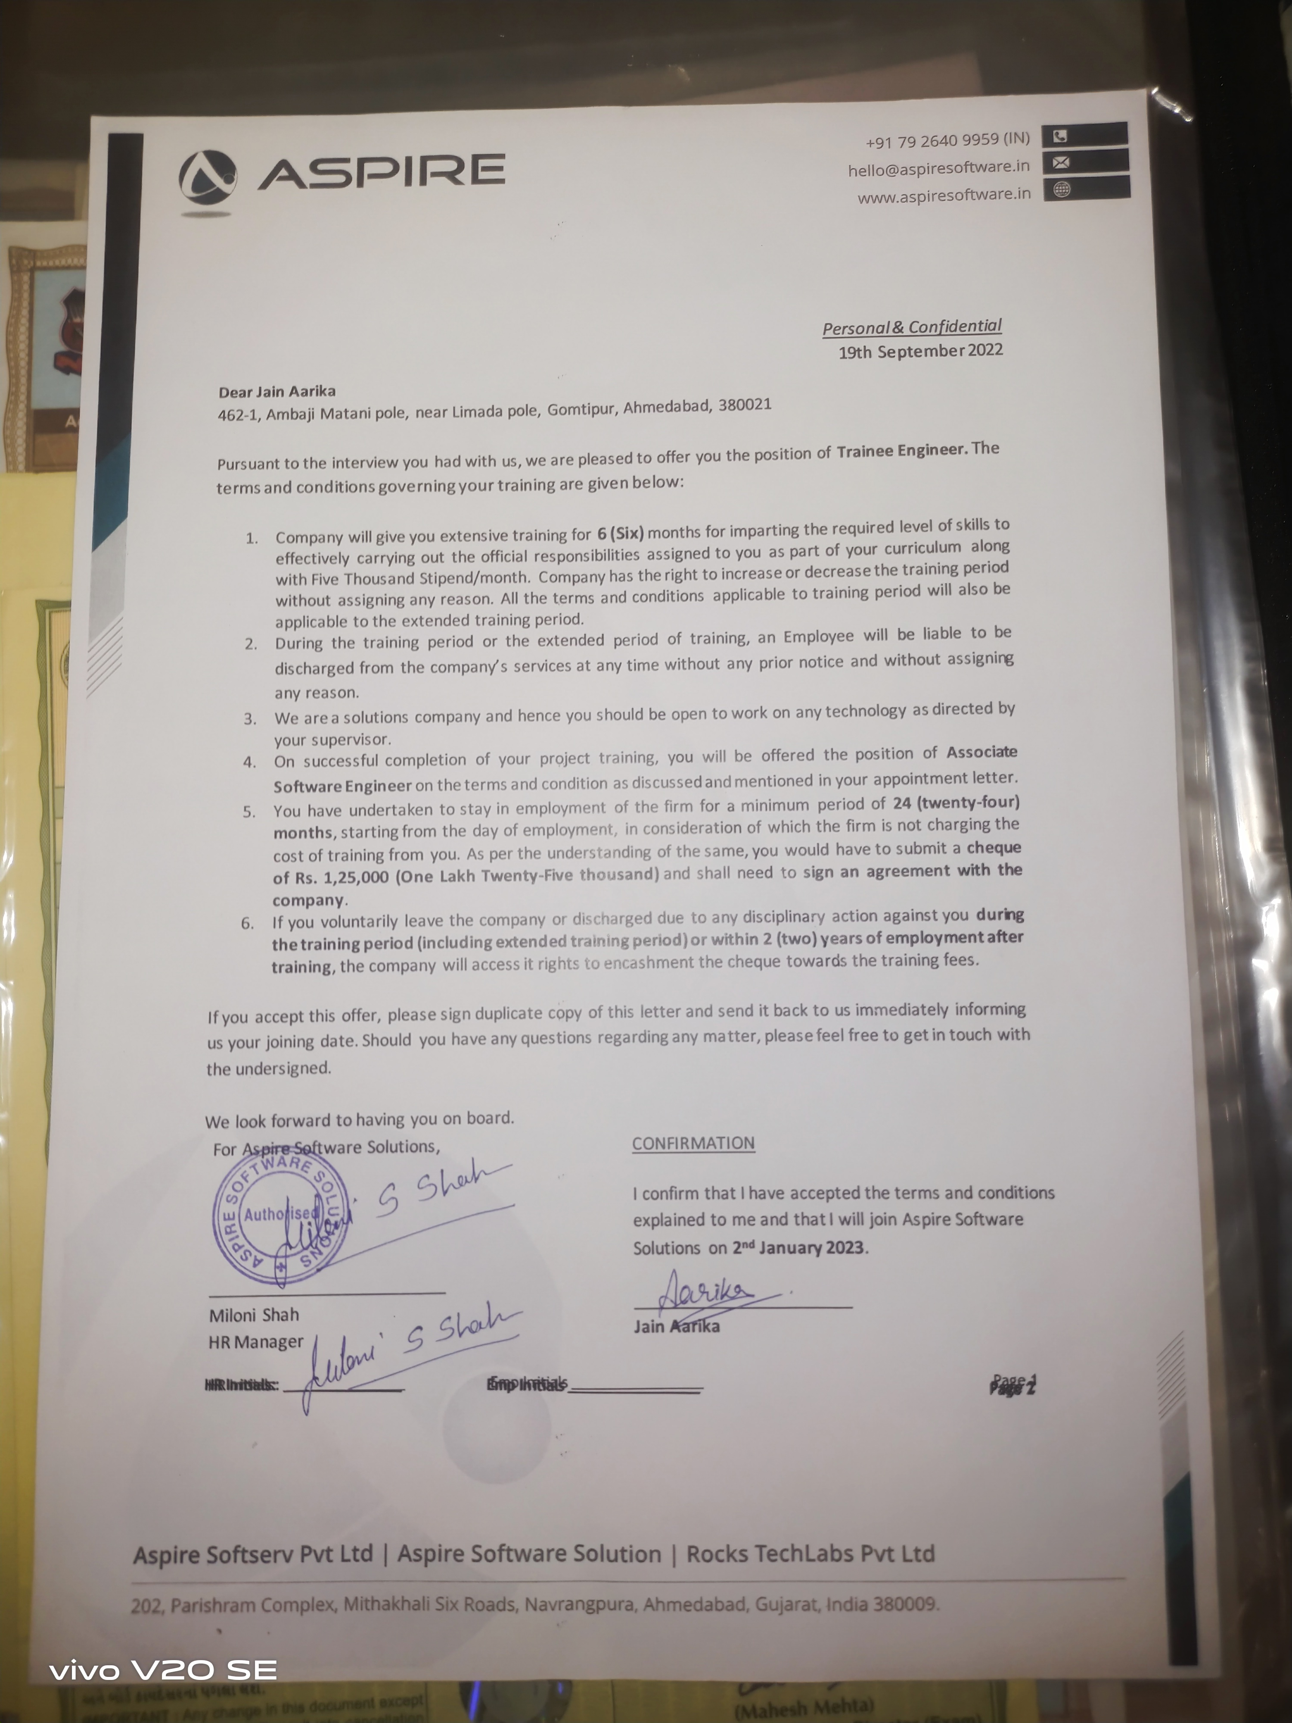

Acknowledgement

I would like to express my gratitude and appreciation to all those whogave me the possibility to complete this report. Special thanks is due to mysupervisor Mr. Hazami bin Che Hussain whose help, stimulating suggestionsand encouragement helped me in all time of fabrication process and in writingthis report. I also sincerely thanks for the time spent proofreading and correcting my many mistakes.

I would also like to acknowledge with much appreciation the crucial role of the staff in Mechanical Laboratory, who gave me a permission to use the lab equipment and also the machine and to design the drawing and giving a permission to use all the necessary tools in the laboratory.

Many thanks go to the all lecturer and supervisors who have given their full effort in guiding the team in achieving the goal as well as their encouragement to maintain our progress in track. My profound thanks go to all classmates, especially to my friends for spending their time in helping and giving support whenever I need it in fabricating my project.

Chapter 1 : HTML

What is HTML?

- HTML stands for Hyper Text Markup Language
- HTML is the standard markup language for creating Web pages
- HTML describes the structure of a Web page
- HTML consists of a series of elements
- HTML elements tell the browser how to display the content
- HTML elements label pieces of content such as "this is a heading", "this is a paragraph", "this is a link", etc.

HTML tags are keywords used in HTML to display web-pages with certain properties. They are further used for defining HTML elements. An HTML element consists of a starting tag, some content, and an ending tag. The web browser reads the HTML document from top to bottom, left to right. Each HTML tag defines a new property that helps in rendering the website.

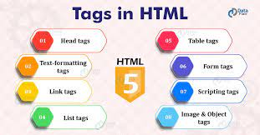

Chapter 2: CSS

CSS Introduction:

Cascading Style Sheets, fondly referred to as CSS, is a simply designed language intended to simplify the process of making web pages presentable. CSS allows you to apply styles to web pages. More importantly, CSS enables you to do this independent of the HTML that makes up each web page. It describes how a webpage should look: it prescribes colors, fonts, spacing, and much more. In short, you can make your website look however you want. CSS lets developers and designers define how it behaves, including how elements are positioned in the browser.
While html uses tags, css uses rulesets. CSS is easy to learn and understand, but it provides powerful control over the presentation of an HTML document.

Advance CSS:
Advanced CSS is a set of tools and techniques that help you create the modern websites that employers and clients are looking for. These skills help you make websites more responsive more easily so, whatever kind or size of device someone is using to view your site, it looks fantastic and works well.

Because it plays such an important role in building the web, CSS is a fundamental skill you simply have to get right to get started in tech. But what if you’ve already mastered the basics of CSS? Is your styling fun done? Not hardly! It’s the perfect time to take your skills—and your chance of landing a high-paying job—to the next level with more advanced CSS.
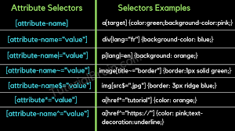
Chapter 3 :JavaScript

Introduction Javascript:

JavaScript Tutorial is designed for beginners and professionals both. JavaScript is used to create client-side dynamic pages.
JavaScript is an object-based scripting language which is lightweight and cross-platform.
JavaScript is not a compiled language, but it is a translated language. The JavaScript Translator (embedded in the browser) is responsible for translating the JavaScript code for the web browser.
Client-side: It supplies objects to control a browser and its Document object Model(DOM) Like if client-side extensions allow an application to place elements on an HTML form and respond to user events such as mouse clicks, form input, and page navigation. Useful libraries for the client-side are AngularJS, ReactJS, Vieu and so many others.
Server-side: It supplies objects relevant to running JavaScript on a server. Like if the server-side extensions allow an application to communicate with a database, and provide continuity of information from one invocation to another of the application, or perform file manipulations on a server. The useful framework which is the most famous these days is node.js.
Imperative language – In this type of language we are mostly concern about how it is to be done . It simply control the flow of computation . The procedural programming approach , object, oriented approach comes under this like async await we are thinking what it is to be done further after async call.
Declarative programming – In this type of language we are concern about how it is to be done , basically here logical computation require . Here main goal is to describe the desired result without direct dictation on how to get it like arrow function do .
JavaScript can be added to your HTML file in two ways:
Internal JS: We can add JavaScript directly to our HTML file by writing the code inside the <script> tag. The <script> tag can either be placed inside the <head> or the <body> tag according to the requirement.
External JS: We can write JavaScript code in other file having an extension.js and then link this file inside the <head> tag of the HTML file in which we want to add this code.
Advanced JavaScript Backend Basics
Getting Started with javascript Backend Basics The following article is a continuation to my previous article. In this article, we will dive deep into some of the advanced JavaScript concepts that are being used widely in the industry.
“==” vs “===”
- The “==” coerces the types of the input that is it forces the variable to be the same and then checks their equality.
- The “===” actually requires equivalent types to give a true output. Basically, the “===” is more widely used and the “==” should only be used when we really know the type equivalence of the inputs. Below is the table that clearly defines for what values they both will send TRUE or FALSE.

