Game Design Document

Fill up the following document

1. Write the title of your project.

Doodle Jump

1. What is the goal of the game?

To get the highest possible score or to beat you previous high score

1. Write a brief story of your game.

The doodler jumping ever upwards avoiding traps that will crash him back down to earth.

Which are the playing characters of this game?

* Playing characters are the ones who respond to the user based on the input from the user.
* Cars, monkeys, dinos, wizards, etc., are the playing characters in the game.

|  |  |  |
| --- | --- | --- |
| Number | Character Name | What can this character do? |
| 1 | The doodler | Jump and move right to left |
| 2 |  |  |
| 3 |  |  |
| 4 |  |  |
| 5 |  |  |
| 6 |  |  |
| 7 |  |  |
| 8 |  |  |

1. Which are the Non-Playing Characters of this game?

* Non-Playing characters are the ones that don't have an action or behavior when the user interacts with the game.
* Hurdles, stones, bananas, coins, etc., are non-playing characters in the game.

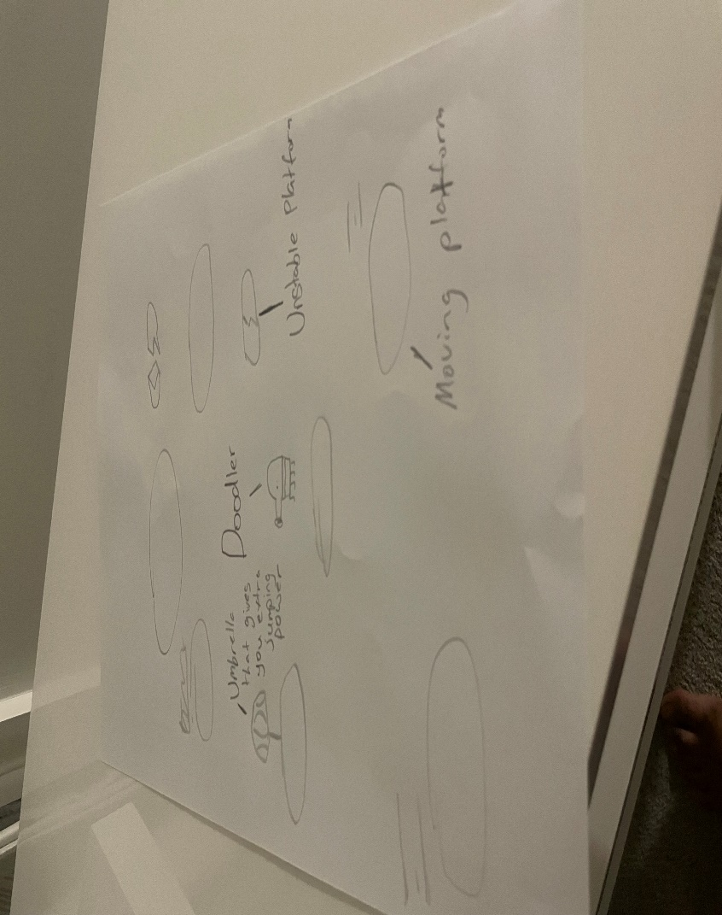

|  |  |  |
| --- | --- | --- |
| Number | Character Name | What can this character do? |
| 1 | Platform | Your able to jump on it |
| 2 | Moving platform | Your able to jump on it but it is moving right to left |
| 3 | Unstable platform | A platform which is basically a trap it is unstable so if you jump on it you fall. |
| 4 |  |  |
| 5 |  |  |
| 6 |  |  |
| 7 |  |  |
| 8 |  |  |

Draw your imagination of this game. What does this game look like?

* Draw the game either on your computer or on paper.
* Add images of the game scenes to show each of the playing and non-playing characters at least once.

How do you plan to make your game engaging?

To make the game colour full and unique and add a lot of interesting stuff so they player don’t get bored fast.