MS Word

This is a Quarto document. To learn more about Quarto visit <https://quarto.org>.

## Plots

See fig. 1 for an example of rendering plots as figures:

import numpy as np  
import matplotlib.pyplot as plt  
  
r = np.arange(0, 2, 0.01)  
theta = 2 * np.pi * r  
fig, ax = plt.subplots(subplot_kw={'projection': 'polar'})  
ax.plot(theta, r)  
ax.set_rticks([0.5, 1, 1.5, 2])  
ax.grid(True)  
plt.show()

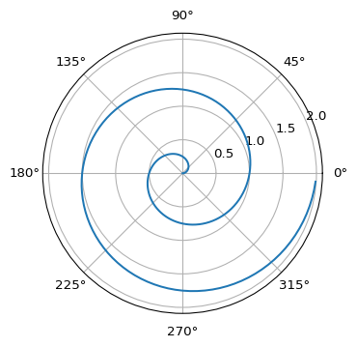

Figure 1: A line plot on a polar axis

## Data Frames

Render data frames with:

import pandas as pd  
  
d = {'one' : [1., 2., 3., 4.],  
 'two' : [4., 3., 2., 1.]}  
df = pd.DataFrame(d)  
df.to_html(index = False)

one

two

1.0

4.0

2.0

3.0

3.0

2.0

4.0

1.0