Water Body (Rivers, Lakes, Reservoirs) Detection & Mapping

Muhammad Aarish Mughal  
Reg Id. **223570**Department of Computer Science  
Multan, Punjab, Pakistan.  
[aarishmughal21@gmail.com](mailto:aarishmughal21@gmail.com)

Aymen Majid  
Reg Id. **223574**Department of Computer Science  
Multan, Punjab, Pakistan.  
[aymenmajid440@gmail.com](mailto:aymenmajid440@gmail.com)

# Introduction

Detecting and mapping water bodies helps in monitoring floods, managing resources, and planning cities. Using satellite images and remote sensing makes this faster and more accurate.

# Problem Statement

Traditional water body mapping relies heavily on manual efforts and field surveys, which are time-consuming and limited in scope. Moreover, environmental challenges such as seasonal changes, cloud cover, and sediment interference further complicate manual analysis. With the increasing availability of satellite imagery, there is a pressing need to develop automated, accurate, and scalable solutions for detecting and mapping water bodies in various terrains and climatic conditions.

# Objectives

* To apply filtering concepts learned in our course Digital Image Processing.
* To automate the detection of water bodies using satellite/aerial imagery.
* To compute the area of water bodies via computers.

# Related Work

Researchers use methods like NDWI and machine learning to find water bodies in satellite images. Deep learning (e.g., U-Net) gives better results in many cases.

# Theory

* **NDWI Formula:**
$$NDWI=\frac{Green- NIR}{Green+NIR}$$

* **Basic Concepts:**
  + NDWI highlights water in images.
  + U-Net is a deep learning model used for image segmentation.
  + Accuracy is checked using Precision, Recall, and IoU.

# Design

## Flowchart

This is a very abstract flow of our intended design:

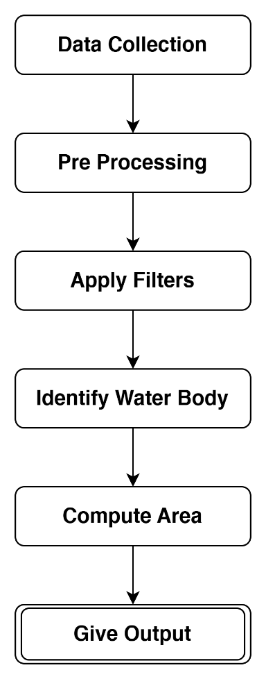

## Method Used:

Filtering & Geometry.

## Tools:

Python, OpenCV, TensorFlow/Keras.

*Some of these tools may not be used in the final implementation.*

## Evaluation:

Detect water bodies via Satellite Images and Computing the area of these water bodies via filtering.