COLLEGE OF ENGINEERING TRIVANDRUM
Department of Computer Applications
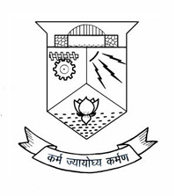

20MCA135
DATA STRUCTURES LAB

Name: {Name}
University Register No: {ktu}
Class: First Semester MCA(2 year)
Year: 2025-2026 November 2025

Certified Bonafide Record of Work Done By {Name}

External Examiner Faculty In-Charge
Prof. Sunitha D.

