

On Kinship Structure, Female Autonomy, and Demographic Behavior in India Author(s): Tim Dyson and Mick Moore
Source: Population and Development Review , Mar., 1983, Vol. 9, No. 1 (Mar., 1983), pp. 35-60
Published by: Population Council
Stable URL: https://www.jstor.org/stable/1972894

JSTOR is a not-for-profit service that helps scholars, researchers, and students discover, use, and build upon a wide range of content in a trusted digital archive. We use information technology and tools to increase productivity and facilitate new forms of scholarship. For more information about JSTOR, please contact support@jstor.org.
Your use of the JSTOR archive indicates your acceptance of the Terms & Conditions of Use, available at https://about.jstor.org/terms


Population Council is collaborating with JSTOR to digitize, preserve and extend access to
Population and Development Review

This content downloaded from
223.235.163.95 on Mon, 06 Dec 2021 23:52:58 UTC
All use subject to https://about.jstor.org/terms

On Kinship Structure, Female Autonomy, and Demographic Behavior in India

Tim Dyson Micl< Moore

This paper stands at the confluence of three streams of social science analysis: the sociological study of gender relations; the regional demography of India; and the study of geographic variations in Indian culture. As the volume and sophistication of research in these areas have grown, it has become increasingly clear that each is in some sense pointing to the same consistent and important, if not very clearly defined, pattern of regional variation in Indian demography and culture. The salient features of this pattern are a broad north—south (or northwest—southeast) contrast within India between areas of low female autonomy and unfavorable demographic performance (high birth and death rates), on the one hand, and comparatively high female autonomy and relatively favorable demographic performance, on the other.'
The purpose of this paper is twofold. The first is to elaborate on and confirm the relative clarity and long-term historical consistency of the dichotomous regional pattern of demographic performance. The second is to develop a sociological model of the different gender relations inherent in north and south Indian culture and to describe how this model may help explain some of the differences in demographic performance.
At the outset we should note that, because of certain doubts about the sharpness and location of the demarcation between areas of northern and south- ern culture in the eastern states of India, much of the empirical data is grouped into three regional clusters of states: the north (Gujarat, Rajasthan, Uttar Pra- desh, Madhya Pradesh, Punjab, Haryana); the south (Kerala, Tamil Nadu, Andhra Pradesh, Karnataka, Maharashtra); and the east (Bihar, West Bengal, Orissa). ²
India’s regional demography
India’s regional demography is a relatively new subject and is still much constrained by the data sources. In most cases the unit of analysis used here
POPULAR ION AND DEVELOPMENT REVIEW 9. NO . 1 {MARCH 19B33 35

India: selected states and Union Territories
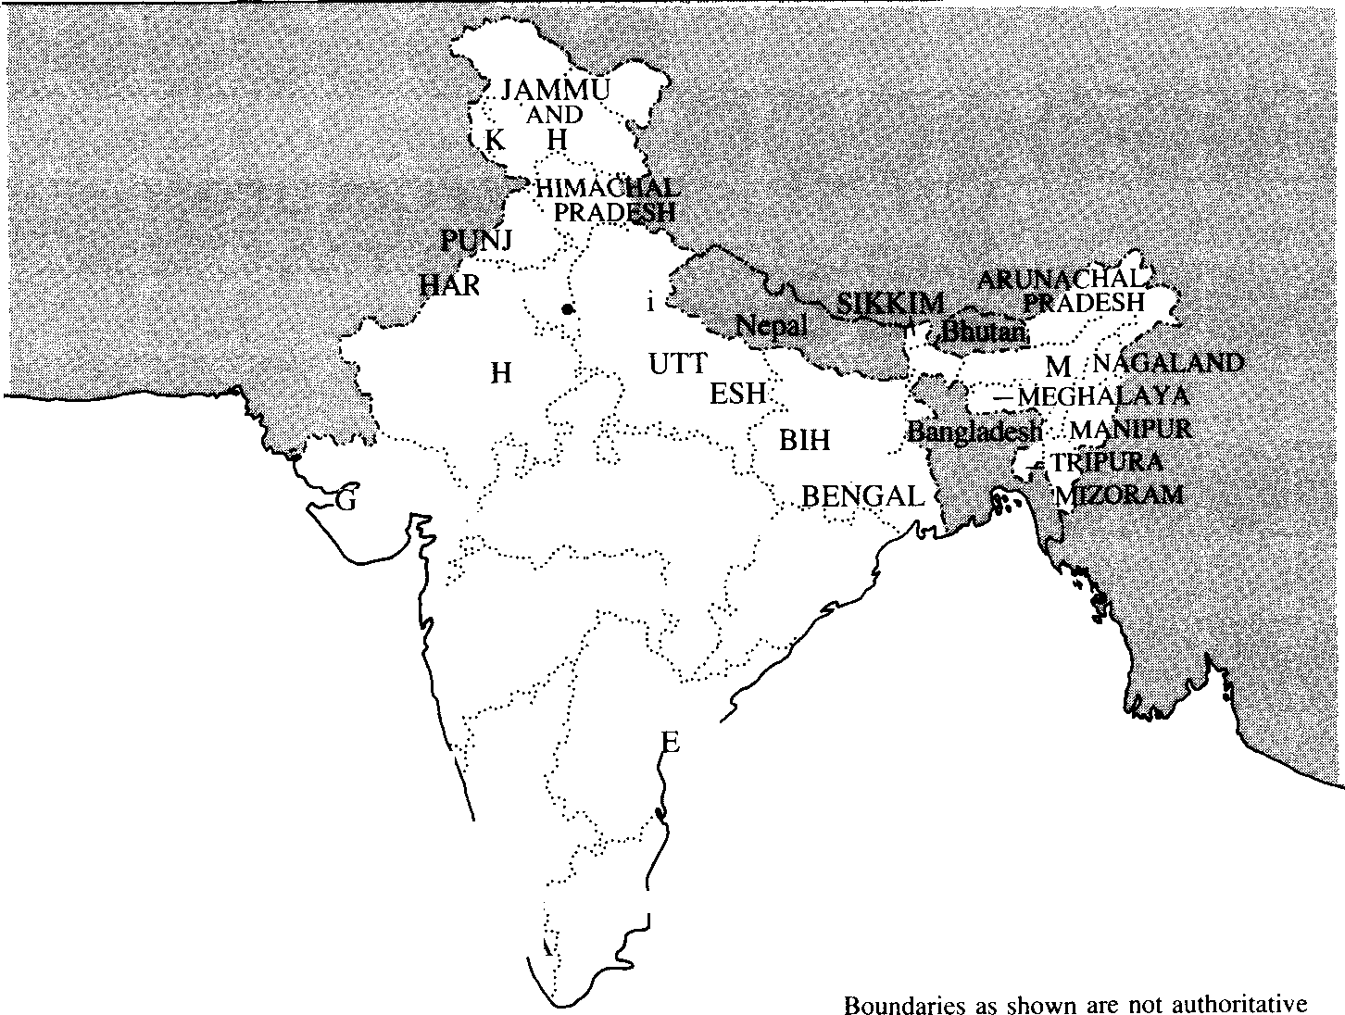
AS MIR
AB
Y“A
Delh
RAJAST AN
AR
PRAD
ASSA
AR WEST
UJARAT
MADHYA PRADESU
°MAHARASHTRA
ORISSA
GOA'
ANDHRA PRAD SH
KARNATAKA

“' :TAMILINADU
KEl . /

FIGURE 1 Sex ratios by district, for children aged 0—9, 1961

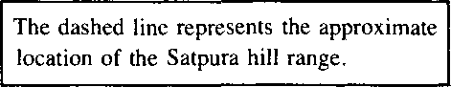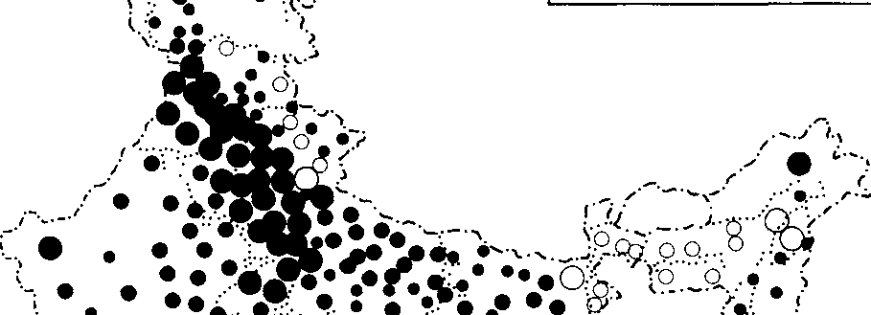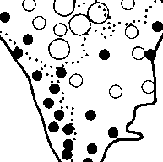SOURCE: Derived from D.E. Sopher, cited in note 5, by permission of Cornell University Press.
The dashed I inc represents the approximate
location of the Satpura hill range.
o .
O'..i
Males per I ,000 females I , 100 and over @ 1,040 to I ,099 o
I ,000 to I ,039 •

973 to 999 a
230 miles
less than 975 O

Tim Ovson / M ici< Moore 37

is the individual state. Although for some purposes this is too high a level of aggregation, the lack of satisfactory demographic material at, for example, the district level leaves one with little alternative. In the early 1960s the census was virtually the only source of state-level demographic estimates. Today, however, there are several sources. These include the dual survey Sample Registration System (SRS), which furnishes annual estimates of vital rates and appears to perform fairly well in most states. Also, in 1972 the Registrar General conducted a nationwide survey that included so-called indirect questions designed to give estimates of fertility and child mortality. These and other data sources have been extensively studied using modern analytic techniques.
Nevertheless our concern here is not with the difficult task of producing a single best set of demographic estimates for the Indian states. Nor do we wish to obscure the discussion with explanations of assumptions and techniques employed, and with reconciliations of different sets of competing estimates. For present purposes suffice it to say that the relative picture of regional demographic variation that has emerged from various sources and analyses has been much the same.'

FIGURE 2 Child/woman ratios, by administrative division, 1951
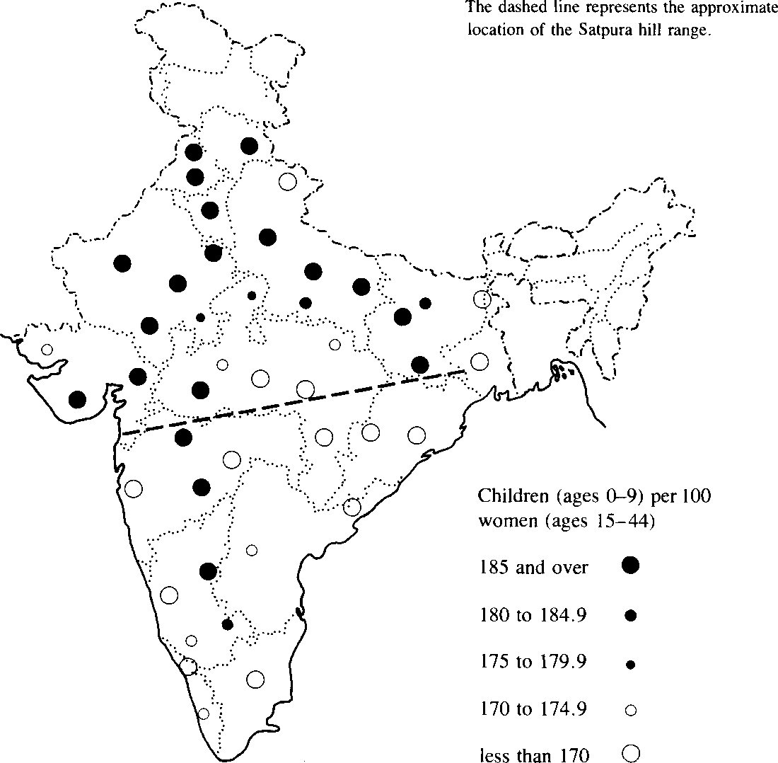

3B On Kinship Structure, Female Autonomy, and Delnographic Behavior 1n India

Sex radios
One of the earliest essays into India’s regional demography was Visaria’s study of interstate differences in sex ratios between 1901 and 1961 . This revealed that, throughout the period, sex ratios were persistently higher (i.e. , more masculine) in the northern states, and lower in the south. Visaria argued convincingly, though in the absence of adequate direct evidence, that mortality differentials by sex were chiefly responsible.‘ He also demonstrated that, for the most part, the high sex ratios in the north were not directly attributable to a Muslim presence. 5
Table 1, which contains state-level population sex ratios for the censuses of 1901, 1961, and 1981, shows the continuation of this regional pattern to the present. More interestingly, Figure 1 presents district-level sex ratios of the population below age ten, in order to minimize the sex-selective influence of migration. We agree with Sopher’s opinion of the impressive completeness of the regional dichotomy, 6 and add that the country can be roughly divided in two by a line that approximates the contours of the Satpura hill range, extending eastward to join the Chota Nagpur hills of southern Bihar (see Figure

TABLE 1 State-level populations enumerated in 1981 and see ratios for selected censuses,
19Ot —B1

Region/state
Sex ratio (males per 100 Population enumerated females)
in 1981 (000s) 1901 1961 1981

South
Kerala | 25,403 | 99 | 98 | 97
Tamil Nadu | 48,297 | 96 | 101 | 102
Andhra Pradesh | 53,404 | 101 | 102 | 103
Karnataka | 37,043 | 102 | 104 | 104
Maharashtra | 62,694 | 102 | 107 | 107
North
Gujarat | 33,961 | 105 | 106 | 106
Rajasthan | 34,103 | 110 | 110 | 109
Uttar Pradesh | 110,858 | 107 | 110 | 113
Madhya Pradesh | 52,132 | 101 | 105 | 106
Punjab | 16,670 | 120 | 117 | 113
Haryana | 12,851 | 116 | 116 | 114
East
Bihar | 69,823 | 95 | 101 | 106
West Bengal | 54,486 | 106 | 114 | 110
Orissa | 26,272 | 96 | 100 | 102
All India | 683,810 | 103 | 106 | 107
NOTE: As noted in the text, we have allocated states to three rough regional subgroup- ings, although certain states (e.g. , Maharashtra) fit somewhat ambiguously into such a simplified schema.
SOURCES: Statistics for 1981 have been derived from P. Padmanabha, Provisional Population Totals, Census of India, 1981, Series I, Paper 1 of 1981 (New Delhi: Office of the Registrar General, March 1981). Those for 1901 and 1961 have been derived from statistics in S. B. Mukherjee, The Age Distribution of the Indian Population (Honolulu: East-West Center, 1976).

Tim Dyson / Micl< Moore 39
1).7 To the north of this line sex ratios are high, especially in Punjab and Haryana and areas of western Uttar Pradesh. To the south sex ratios are comparatively low. In the east the demarcation of West Bengal—which clearly has to be grouped with the southern states—from Bihar is also fairly unam- biguous, and can be roughly represented by the state border running northward from the region of the Chota Nagpur hills.8
The cause of this marked regional variation in sex ratios is clearly crucial to any attempt to link it to sociological variables. In this context SRS and other statistics support Visaria’s conclusion that the prime reason lies in sex differ- entials in mortality (discussed further below).
Fertility
Regional variations in Indian fertility are consistent over time and exhibit much the same regional pattern as sex ratios. To illustrate this we consider child/ woman ratios (the ratio of the population aged 0-9 to the female population aged 15—44) based on census returns. Although these are crude measures, they have the advantage of being available over the long run and can be computed at the (lower) level of the administrative division as well as at the state level. Table 2 presents state-level ratios and the rank orders for selected censuses between 1921 and 1971. In spite of absolute changes in ratios, the overall impression is one of stability over time in the relative positions of the states. Ratios in northern states have been consistently higher than those of the south

TABLE 2 State-level child/Women ratio CWR and associated rank orders, 1921-7 1
CWR Rank order (highest to lowest)
Region/state | 1921 | 1941 | 1961 | 1971 |  | 1921 | 1941 | 1961 | 1971
South
Kerala 1.12 |  | 1.26 | 1.38 | 1.21 | 11 |  | 8 | II | 13
Tamil Nadu 1.10 |  | 1.23 | 1.16 | 1.18 | 13 |  | 11 | 14 | 14
Andhra Pradesh 1.12 |  | 1.23 | 1.29 | 1.35 | 10 |  | 12 | 13 | 12
Karnataka 1.21 |  | 1.25 | 1.46 | 1.44 | 8 |  | 9 | 7 | 9
Maharashtra 1.24 |  | 1.25 | 1.40 | 1.42 | 6 |  | 10 | 10 | 10
North
Gujarat 1.34 |  | 1.29 | 1.50 | 1.47 | 3 |  | 7 | 5 | 6
Rajasthan 1.30 |  | 1.45 | 1.52 | 1.60 | 4 |  | 2 | 4 | 3
Uttar Pradesh 1.18 |  | 1.30 | 1.43 | 1.51 | 9 |  | 5 | 9 | 5
Madhya Pradesh 1.29 |  | 1.30 | 1.44 | 1.62 | 5 |  | 6 | 8 | 2
Punjab 1.50 |  | 1.51 | 1.60 | 1 .40 | 1 |  | 1 | 2 | l 1
Haryana 1.45 |  | 1 .41 | 1.73 | 1.71 | 2 |  | 3 | 1 | 1
East
Bihar 1.21 |  | 1.32 | 1.48 | 1.47 | 7 |  | 4 | 6 | 7
West Bengal 1 .06 |  | 1. 18 | 1.53 | 1.55 | 14 |  | 13 | 3 | 4
Orissa 1.10 |  | 1.09 | 1 . 30 | 1 .44 | 12 |  | 14 | 12 | 8
All India 1.20 |  | 1.28 | 1.42 | 1.45 |  |  |  |  | —
SOURCES: The CWRs for 1921 to 1961 have been computed on the basis of age/sex distributions contained in Mukherjee, cited in Table 1. Those for 1971 have been computed on the basis of distributions taken from Census of India, 1971, Social and Cultural Tables, Part II-C(ii) (New Delhi: Office of the Registrar General, 1976).

40 On Kinship Structure, Female Autonomy, and Demographic Behavior in India

and east. Perhaps the main exceptions are Punjab and West Bengal, although, as Table 2 indicates, these states have only fairly recently broken ranks. And in the case of Punjab there is evidence that the change can be attributed to fertility decline.’ In order to get a better idea of fertility variation prior to these changes, Figure 2 maps child/woman ratios for the main administrative divi- sions of India in 1951. Although the line of demarcation between north and south is not as precise, a general correspondence to the regional pattern of sex- ratio variation depicted in Figure 1 certainly exists. Again, West Bengal is contrasted with Bihar, the former clearly falling within the southern cluster.
Confirmation of this regional pattern of fertility variation is provided by estimates of total fertility obtained from the 1972 Sample Registration Survey (see Table 3). The northern states all exhibit total fertility rates from six to nearly seven live births per woman, while the rates are lower—generally around five—in the remaining states of the south and east. Comparable estimates for four states in the south and east—Kerala, Orissa, Andhra Pradesh, and Tamil Nadu—are also available from surveys conducted in 1962 (not shown), which support a picture of relatively low southern fertility at that time.'°

TABLE 3 State-level measures of fertility and age at marriage

Total fertility
Region/state | rate (TFR)• | (TMFR)• | 1961 | 1971
South
Kerala | 5.43 | 8.24 | 20.1 | 20.9
Tamil Nadu | 4.97 | 6.70 | 18.4 | 19.6
Andhra Pradesh | 4.88 | 5.68 | 15. 4 | 16.4
Karnataka | 5.68 | 7.36 | 16.5 | 17.9
Maharashtra | 5. 16 | 6.34 | 15.9 | 17.5
North
Gujarat | 6.19 | 7.55 | 17.2 | 18.3
Rajasthan | 6.32 | 7.04 | 14.6 | 15.4
Uttar Pradesh | 6.85 | 7.53 | 14.8 | 15.6
Madhya Pradesh | 6.38 | 7.00 | 14.3 | 15. 2
Punjab Haryana | 6. 32  6.68 | 8.19  7.53 | 17. 6 | 20.1 16.6
East
Bihar | 5.01 | 5.63 | 14.7 | 15.5
West Bengal | 4.42 | n.a. | 16.1 | 17.8
Orissa | 5.65 | 6.8 I | 16.5 | 17. 2
All India | 5.78 | 7.07 | 16.1 | 17.2

Total marital fertility rate
Female age at first marriage•

- Fertility estimates are derived from Fertility Differentials in India, 1972 (New Delhi: Ministry of Planning 1974). The analysis is contained in Dyson, cited in note 3. The estimated TFRs and TMFRs for Punjab and Kerala may well be rather high. Figures for West Bengal from the 1972 survey are unavailable; therefore the TFR presented is an average of SRS estimates for 1970—72. For different fertility estimates that illustrate the same general regional pattern, see Preston et al., cited in note 3, and various issues of the Sample Registration Bulletin, published biannually by the Ministry of Home Affairs, New Delhi.
For these statistics see Goyal, cited in note 12. Estimates for Punjab and Haryana in 1971 have been computed separately from 1971 census data, whereas Goyal produces figures only for the old composite Punjab state (i.e. , contemporary Punjab and Haryana combined).

Tim Dyson / Mick Moore 41

The estimates of total marital fertility presented in Table 3 help clarify the regional pattern of total fertility around 1970: generally the estimated levels of marital fertility are lower in the southern and eastern states. However, in one or two of these states, especially in Kerala, higher female age at first marriage clearly plays an important role in keeping total fertility rates comparatively low.

Marriage
Regional differences in marriage patterns have been studied for the period 1891—1951 by Agarwala, applying Hajnal’s method of estimation to census data. I ' Agarwala concluded that the states that consistently had the highest mean age at marriage were Travancore-Cochin, Madras, Mysore, and Punjab. Goyal made the same estimates for 1961 and 1971. Goyal’s estimates are also presented in Table 3. Despite across-the-board increases in marriage age, the figures illustrate much the same regional pattern uncovered by Agarwala. With the main exception of Punjab (and to a lesser degree Gujarat), the female age of marriage in the northern states tends to be particularly low.'2 There is also evidence of slightly higher rates of both nonmarriage and marital dissolution in the south and east.13 Analysis suggests that differences in age at marriage and in marital fertility were about equally responsible for the differences in total fertility existing in the early 1970s between the north on the one hand and the south and east on the other.' 4 But this may not have been true in earlier decades, when the age of female marriage was generally much lower throughout the country.' 5

Infant and child Mortality
Several sets of fairly recent state-level infant and child mortality estimates exhibit a similar regional pattern.' 6 For present purposes infant and child (0—4) mortality rates taken directly from the Sample Registration Survey for 1968—71 will suffice" (see Table 4). With the exceptions of Punjab/Haryana and Orissa, the rough division of the country into two regions is again apparent: mortality in the early 1970s was higher in the main northern states than in those of the south and east. Direct evidence on levels of infant and child mortality for previous periods is scant and of poor quality. Nevertheless, infant and child death rates for rural areas obtained by the National Sample Survey (NSS) around 1960 are fairly consistent with the basic north—south dichotomy— although they are less reassuring as regards Orissa and Bihar in the east (see Table 4).
Finally, as we have already noted, the difference between north and south is not simply one of mortality level; there is also a distinctive regional pattern to the sex differential in mortality.' 8 In this context Table 4 illustrates the significant mortality disadvantage suffered by females aged 0-4 years throughout the northern states.

On Kinship Structure. Female Autonomy. and Demographic Behavior in India

TABLE 4 State-level measures of infant and child mortality- 1968-71 (SRS) and 1958-60 (NSS)

 | SRS infant
 | and child
 | mortality | NSS rural
 | rates per | infant
 | 1,000 | mortality | NSS rural child | Ratio of male to
 | population | rates (aged | mortality rates | female infant and
 | (aged 0-4), | 0-1), | (aged 1—4), | child mortality
Region/state | 1968-71‘ | 1958-59‘ | 1959—60* | rates, 1968-71*
South
Kerala | 22.6 | 89 | 11.98 | 0.95
Tamil Nadu | 46.6 | 119 | 15.60 | 0.95
Andhra Pradesh | 43.9 | 112 | 14.95 | 0.90
Karnataka | 42. 2 | 103 | 26.96 | 0.93
Maharashtra | 41.9 | 135 | 29. 33 | 1.02
North
Gujarat | 67.5 | 134 | 24.55 | 1.10
Rajasthan | 70.9 | 114 | 28.19 | 1 15
Uttar Pradesh | 81.2 | 221 | 31.35 | 1.36
Madhya Pradesh | 61 . 1 | 163 | 30.00 | 1.03
Punjab | 35.6 | 122 | 22.01 | 1.38
Haryana | 31 .8 |  |  | 1.24
East
Bihar | 35.6 | 161 | 20.77 | 1.06
West Bengal | 32. 4 | 83 | 6.51 | 1.01
Orissa | 57.8 | 154 | 16.99 | 0.87
All India | 51.6 | 143 | 22.09 | 1 .09
" These figures are averages of SRS infant and child mortality rates for 1968—7 1 . They are based on annual rates presented in various issues of the SRS Bulletin, cited in Table 3.
^{b} These NSS IMRs are taken from K. S. Natarajan, “Child mortality: Rural, urban and sex differentials—further analysis of 1972 fertility survey,” paper presented to a Conference on Population Dynamics and Rural Development, meeting of the Indian Association for the Study of Population, Bombay, mimeo, 1979.
Rates are taken from National Sample Survey, Differential Death and Infant Mortality Rates in Rural Households, The Fifteenth Round, Number 153, Cabinet Secretariat, Government of India, 1969. These rates substantially understate mortality around 1958—60; however, here we are concerned with their relative pattern by state.
d These ratios are based on sex-specific rates derived as in note a above. Note how great the sex differentials are; for example, in Uttar Pradesh the rates are 69. 1 and 94. 1 for males and females respectively. Such a differential is sufficient
to account for the high sex ratio depicted in Figure 1 . Analysis of retrospective 1972 SRS child mortality data gives a very similar regional pattern; see Natarajan, cited in note b above.

The two demographic regimes
In summary, the main states of India can be broadly grouped into two basic demographic regimes. In contrast to the north, states in the south and east are characterized by the following: relatively low overall fertility; lower marital fertility; later age at first marriage; lower infant and child mortality; comparatively low ratios of female to male infant and child mortality, and, largely as a consequence, relatively low sex ratios."
Of course our division of states into two regimes by no means captures all significant features of the country’s aggregate demographic variation. For example, Kerala is often the most “southern” of states in the south. And in

Tinn Dyson / lWick hñoore
the north Punjab in particular deviates in important respects from the northern demographic regime: for instance, it experiences somewhat later marriage and comparatively low rates of infant and child mortality. Yet in respect to the sex differential in mortality, Punjab appears to conform to the northern demo- graphic pattern. In addition, questions remain concerning the location and clarity of the frontier between the two regimes. The relatively high level of data aggregation appears to be part of the problem. But when, as in Figures l and 2, data are presented at the divisional or district rather than at the state level, the Satpura hill range appears to be a tolerable approximation. Within the eastern states, however, there is some ambiguity about the location, and indeed existence, of any distinct frontier.°°
Finally, we should stress that virtually all available data for earlier periods support the view that the basic regional demographic dichotomy sketched above has existed for several decades and possibly for much longer. What we have to explain, then, appears to be a sociocultural variation deeply rooted in Indian society. We now turn to a consideration of this variation between north and south India.

Regional sociocultural variation
In the search for a pattern of regional sociocultural variation that might shed light on these demographic patterns, we begin with the contrast between north and south India contained in the work of several social anthropologists, and usually conceptualized in terms of kinship. Such a presentation must be pre- ceded by two qualifications. The first is that even today surprisingly little is known about family and kinship structure in many areas of India.°' The second is that, just as with the demographic regimes, kinship systems are not conceived of here as being homogeneous either across all social strata or within a given region. In the present context, for example, there is often considerable vertical differentiation according to caste. 22
Our point of departure is the so-called north India—south India dichotomy that has generally been viewed as fundamental to the study of Indian kinship.°³ We shall briefly summarize the northern and southern kinship systems in ideal- typical form—as if each were internally fully consistent while differing from each other in ways that might be inferred from a few basic postulates. The untidiness of reality cannot concern us too much here.
The NorthIndian system
There are three key principles of north Indian kinship. First, spouses must be unrelated in kinship reckoning, and often too by place of birth and/or residence. In other words, marriage rules are exogamic. Second, males tend to cooperate with and receive help from other males to whom they are related by blood, frequently their adult brothers. Third, women generally do not inherit property for their own use, nor do they act as links through which major property rights are transferred to offspring.

On Kinship Structure, Female Autonomy, and Demographic Behavior in India

Some important sociocultural consequences derive from these principles. A characteristic feature of social relations is tension between patrilineally related groups of males. Marriage is often dominated by the search for inter- group alliances, and women usually have no choice in the matter. The “wife- givers” are socially and ritually inferior to the “wife-takers,” and dowry is the main marriage transaction; at the extreme, marriage transactions may resemble trafficking in females. The fact that the in-marrying female comes from another group means that in some ways she is viewed as a threat: her behavior must be closely watched; she must be resocialized so that she comes to identify her own interests with those of her husband’s kin; senior family wives tend to dominate young in-marrying wives. ²⁴ Because women are out-marriers, parents can expect little help from their daughters after marriage, whereas sons will remain at home. Since marriage represents a major rearrangement of the bride’s social position, as well as a social statement of relationship between groups, it is an important ceremony. The size of the bride’s dowry may be a matter of particular concern.
Groups of patrilineally related males would have their honor, reputation, and consequently their power undermined should the chastity of their females— so crucial to the formation of alliances and the production of heirs—be sub- verted. Thus, the sexuality of females is very rigidly controlled. Restriction on female personal movements and “protection” from other males may take the form of seclusion (i.e. , purdah). Additionally, emotional ties between husband and wife constitute a potential threat to the solidarity of the patrilineal group. Hence the northern system is associated with the segregation of the sexes in general, and with conjugal reserve in particular. There often exists a distinct female-specific communication network that is inaccessible to adult males. Women exercise social influence largely through “gossip” and similar strategies. 2’ And socially approved female formal employment involves inter- action only with other women—for example, as a teacher in a girls’ school or a nurse in a female ward.
The south Indian system
The southern system can be contrasted with that of the north with respect to most of these principles and their consequences. Under the southern model there exist “preferred’ forms of marriage. Often the ideal marriage is between cross-cousins. If marriage partners are not cross-cousins, their respective groups of relatives may nevertheless address and refer to one another using the same kinship terms as would have applied had the partners indeed been cross-cousins. The descent group is endogamous. Males are at least as likely to enter into social, economic, and political relations with other males with whom they are related by marriage (i.e. , affines) as they are with males with whom they are related by blood (i.e. , by descent). Women may sometimes inherit and/or transfer property rights.
The consequences of the south Indian kinship system for female social interaction are thus quite different. Females are much more likely to be married

Tirri Dvson / Mick Moore 45
to known persons in familiar households near to their natal home. Social and ritual equality exists between affinally related kin. Neither marriage nor dowry is necessarily very important, for marriage does not inevitably effect any immediate major rearrangement of social relationships; indeed, if spouses are closely related the ceremony may be dispensed with entirely. Bridewealth is more common, and contributions to the expenses of the marriage ceremony are likely to be more equally shared by the kin groups of the bride and the grooms 26
Under southern kinship, affinity is as important to social organization as descent. Female chastity is less important, and both the woman’s sexuality and her personal movements are less rigidly controlled. Women interact with their natal kin more regularly than their counterparts in the northern system, and there is less need to repress and resocialize females in their affinal home. Indeed, nuclear families are often established at marriage. 27 Affective ties between husband and wife represent no social threat to the descent group. And daughters are much more likely—along with sons—to be on hand to render parents help and support in later years. Finally, communication networks are less sex specific, and there is less social restriction on female occupational choice.

Culture and female autonomy
In stating that “the south represents ... greater freedom for women in society” Karve was expressing the widespread perception that south Indian women enjoy a higher social status. 28 While this perception is both accurate and important, the term “social status” may not be helpful. For it cannot be used without evoking the idea of esteem, an idea that is in no sense intrinsic to the differing social positions of north and south Indian women. Attitudes toward women on the part of men (esteem) should be clearly separated from the concept we wish to discuss here: female autonomy, the capacity to manipulate one’s personal environment. Autonomy indicates the ability—technical, social, and psychological—to obtain information and to use it as the basis for making decisions about one’s private concerns and those of one’s intimates. Thus, equality of autonomy between the sexes in the present sense implies equal decision-making ability with regard to personal affairs. 2
In agrarian societies most major personal decisions are strongly influ- enced and constrained by kinship, family, and marriage relationships. Societies in which females have high personal autonomy relative to males are typically characterized by several of the following features: freedom of movement and association of adolescent and adult females; postmarital residence patterns and behavioral norms that do not rupture or severely constrain social intercourse between the bride and her natal kin; the ability of females to inherit or otherwise acquire, retain, and dispose of property; and some independent control by females of their own sexuality—for example, in the form of choice of marriage partners. We emphasize that these features are simply tests of relative female

46 On Kinship Strum:ture, Female Autonomy, and Demographic Behavior in India

autonomy. High autonomy in the present sense implies an ability to influence and make decisions covering the full range of personal and household affairs. 30Two further explanatory points are required. The first is that the emphasis placed on sexual and marital relationships reflects the centrality of these re- lationships for females, to a greater extent than for males, in almost all societies, in determining patterns of life. The second point is the importance in our schema of postmarital relationships between females and their two sets of kin (i.e. , those of their natal home and those into which they marry). In India, as in most other developing agrarian societies, kin relationships still constitute for the great majority of people the prime avenue of access to such scarce social resources as information, economic assistance, and political support. An individual’s power, influence, and social ranking are often closely related to his or her ability to exploit kin linkages. Thus cultural practices—such as those of the north Indian system—that tend to constrain or erode the personal links between a married woman and her natal kin directly diminish the woman’s autonomy. If, at the same time, norms of avoidance make it difhcult for the woman to establish affective links within the household into which she marries,
she is left socially almost powerless.
Lastly we should emphasize that in global perspective India is on the whole an area of comparatively low female autonomy. When below we refer to the concept of high female autonomy, its use is therefore purely relative; even within those areas of India characterized by southern kinship, women may be noticeably repressed in relation to their counterparts in other areas of the world.3’
Regional variation in female autonomy
Having established the concept of female autonomy and the fact that it is more consistent with southern than with northern kinship, we now consider the spatial distribution of these kinship systems. For, in common with most of the sources from which it is derived, our schema of north—south kinship differences is presented in abstract terms and therefore not precisely mapped.
The task is complicated by the fact that one can only map kinship variables rather than the degree of female autonomy, the variable for which kinship is here taken as a close proxy. Exactly how close a proxy it is one cannot at present say. A further problem has already been indicated above: continuing ignorance about kinship practices in parts of India.
Nevertheless, it is clear that southern kinship predominates in the states of Kerala, Tamil Nadu, Karnataka, and Andhra Pradesh; the northern system prevails in the northwestern states of India, that is, Rajasthan, Gujarat, Uttar Pradesh, Haryana, and Punjab. Lastly, as Karve pointed out, Madhya Pradesh and Maharashtra are undoubtedly intermediate between the two."²
In mapping kinship systems the main problem lies in the eastern states of West Bengal, Orissa, and Bihar. Cross-cousin marriage, which we have found to be a prima facie indicator of the southern system, is fairly common in Orissa."3 In West Bengal relatively little is known about the practices of

Tim Ovson / M icl< Mooce 47

members of the rural population not following high-caste models. 34 Instead of attempting to pick up clues from inadequate data, we turn to some other variables that, as indirect indicators of kinship practices, may be considered useful pointers to relative female autonomy: the spatial dimensions of the marriage alliance. Both the median distance between females’ natal and marital homes and the proportions of marriages occurring within females’ villages of birth have been variously estimated by Libbee and Sopher, controlling for a variety of factors including population density."5 Various mappings of these parameters confirm the broad spatial dimensions of the northern and southern systems of kinship as sketched above. They also enable us to tentatively assign West Bengal to the latter system, due to the predominance there of short distances between natal and marital homes and high rates of village endogamy. However, categorizing Orissa, and especially Bihar, remains difficult because on both parameters their status can best be described as intermediate.
In concluding this section we note the general view of scholars that both the essential features of the regional differences in kinship outlined above, and their broad geographical distribution, are of very long standing. It is widely held that they mostly predate the Muslim presence, reflecting instead basic differences between northern “Aryan’ and southern “Dravidian” culture
areas p36

Kinship, autonomy, and demographic behavior
We have established that the division between the areas of northern (unfavorable) and southern (favorable) demographic regimes broadly coincides with the division between areas of northern kinship/low female autonomy and south- ern kinship/high female autonomy. Before we elaborate on the connections between these two sets of variables, however, an important qualification is required. That is, while our point of departure is the difference between northern and southern kinship systems, this does not necessarily commit us to the broadly structuralist view that the difference in kinship systems is in itself an adequate and ultimate explanation of sociocultural differences between north and south. Thus it has been argued elsewhere that the ultimate historical “cause” of differences between north and south may lie in agrarian ecology: in particular, in the far greater value of female labor in the rice-based agrarian systems of the south. 3’ Some of the (deductive) argument presented below could be reformulated by making the relative scarcity and value of female labor the critical determining variable."8 However, such an approach raises problems: for example, that of reconciling the notion of economically deter- mined “culture areas” with the fact of enormous socioeconomic differentiation and widely differing material conditions among the populations of each culture area. Contemporarily at least, there simply is no clear spatial correspondence between cultural variation on the one hand and differences in agrarian ecology on the other." So whatever the ultimate economic and historical factors shaping

4B On Kinship Structure, Female Autonomy, and Demographic Behavior in India

culture, it seems safer and more realistic to take culture as the primary deter- mining factor for purposes of the present analysis.
The deterrriinarrts of fertility
The earlier elaboration of the northern kinship system provides strong a priori arguments as to why the age at female marriage should be relatively low in the north. In a system where marriages create alliances for patrilineal groups, where chastity is particularly prized, and where women are virtually powerless in their choice of partner, there are clear advantages to arranged early marriages. To begin with, they facilitate the maintenance within the family of the authority of senior generations, and discourage the establishment of a strong husband—wife bond. Further, such marriages help to reinforce the “value” of daughters who retain their virginity until they wed. Early arranged marriages also reduce the economic burdens involved in supporting females who will marry out and away, and whose children will contribute neither income nor offspring to their mother’s natal group. Since unmarried women are social liabilities, their marriage costs (i.e. , dowry requirements) may increase with age, providing another reason to ensure early marriage. Finally, early marriage increases the period over which females can produce male heirs for the groups into which they marry. This consideration is much more important under the northern system than in the south, where rules governing the transmission of property and other rights are more flexible.‘°
Turning to fertility within marriage, it is evident that under northern kinship women are subjected to relatively strong pronatalist pressures, and that they are faced with particularly severe restrictions on their ability to control their fertility. 4 ' A married woman’s prime task is to produce male heirs for the descent group, and, other things being equal, this sex preference in itself will tend to engender higher fertility. 42 Females are socialized to believe that their own wishes and interests are subordinate to those of the family group. They are therefore more likely to sacrifice their own health in repeated child- bearing than are females reared in cultures that give greater weight to personal interests. From the male standpoint, the continual involvement of women in pregnancy and childcare activities can be seen as a way of reducing the risk of sexual violation of wives. ⁴" Given the situation facing a newlywed woman in the north, there are undoubted advantages to high fertility: her relative social isolation may encourage her to create her own affective social group by pro- ducing children; confronted with an insecure future that will probably become more unstable when her husband dies, a woman undoubtedly sees children, especially sons, as a potential source of security.^ Finally, a woman’s standing among her husband’s kin is undeniably improved with the production of sons. As Karve wrote of northern women, “Only when she becomes a mother can she be a little freer ... she rarely makes a positive impression except as a mother.” ^⁵
Nevertheless, pronatalist pressures within marriage under the northern model probably constitute only part of the explanation for generally higher

Tim Dyson / Mick Moore 49

fertility there than in the south, especially in the light of nationally organized efforts to promote family planning. Another part of the explanation is likely to lie in the differing degrees to which the two sociocultural systems permit innovative action, which in this context means fertility control of some kind within marriage. Certainly official family planning indexes related to the adop- tion of contraception (Table 5) broadly indicate poorer acceptance in the north (again excepting particularly Punjab and Haryana) than in the south and east (again excepting Bihar). ⁴⁶
Greater acceptance of family planning in areas of southern kinship may well be due in part to the fact that women there are less likely to be constrained by the influence of senior wives in a joint family situation, and that interspouse communication, which is clearly important in the adoption of methods of fenility control, is easier. The fact that southern women tend to be more active

TABLE 5: Selected standardized indices related to women’s status and
acceptance of family planning

 | Percent of
 | couples | Female labor | Percent of |  | Percent of
 | protected by | force | women | Percent of | births
 | family | participation | practicing | females | medically | Index of son
Region/state | planning° | rate, 1971 | purdah* | literate, 1971‘ | attendede | preference
South
Kerala | 28.8 | 13 | 4.3 | 54.3 | 25.7 | 17.2
Tamil Nadu | 28. 4 | 15 | 4.9 | 26.9 | 21.9 | 11.5
Andhra Pradesh | 26.5 | 24 | 9.4 | 15.7 | 12.2 | 8.9
Karnataka | 22. 4 | 14 | 5.4 | 20.9 | 15.9 | ll.2
Maharashtra | 34.7 | 20 | 16.7 | 26.4 | 7.5 | 18.4
North
Gujarat | 20. 1 | *0 | 41 . 8 | 24.7 | 9.7 | 20.8
Rajasthan | 13.0 | 8 | 62.2 | 8.5 | 4.1 | n.a.
Uttar Pradesh | 11. 5 |  | 46. 4 | 10.7 | 2.5 | 25.0
Madhya Pradesh | 20.9 | 19 | 42.9 | 10.9 | 5.1 | 21.9
Punjab 25.0 |  | 1 | 44.6 | 25.9 | 11 . 3 | 31. 3
Haryana 30.1 |  |  | 72.6 | 14.9 | 15.3 | 20.7

East
Bihar | 12.2 | 9 | 29.6 | 8.7 | 2. 8 | 24. 3
West Bengal | 21 . 2 | 4 | n. a. | 22. 4 | n.a. | 18. 4
Orissa | 24. 4 | 7 | 27.7 | 13.9 | 6.8 | 15.7
All lndia | 22. 1 | 12 | n.a. | 18.7 | n.a. | 20. 2
Statistics are cumulative to 1979; source: The Monthl y Bulletin of Famil y Welfare Statistics, Evaluation and Intelligence Division, Department of Family Welfare, New Delhi, September 1979.
Source: Census of lndia, 1971 , Series I—lndia, Part HA (ii), Union Primary Census Abstract, New Delhi, 1976.
* Source: Committee on the Status of Women in lndia, Tocards EQuality.’ Report of the Committee on the Status of Women in lndia (New Delhi: Government of lndia, 1974).
d Statistics include the population aged Œ4; source: Government of lndia, Pocket Book of Population Statistics (New
Delhi, 1972). Although the statistics relate to the absolute level of female literacy, it is worth stressing that their relative literacy (i.e. , vis-à-vis males) also tends to be substantially lower in the main northern states. The same point is applicable to labor force participation.
Source: Govemment of lndia, Pocket Book of Health Statistics (New Delhi, 1975).
' Source: J. C. Bhatia, “Ideal number and sex preference of children in lndia,” Journal of Famil y Welfare (Bombay) 24, no. 4 (1978). An index of zero would imply equal preference for sons and daughters.

50 On Kinship Structure. Female Autonomy, and Demographic Behavior in India
in the labor force (see Table 5) may also provide them with greater reason to control fertility .^7
In contrast, under northern kinship, women—especially those in the peak
childbearing years—usually have strict limits placed on their personal movements and contacts with strangers (note the statistics on purdah presented in Table 5). Therefore they are more restricted in their ability to visit family planning clinics. Insofar as they are socialized to depend on others to make decisions for them, northern women may be less mentally prepared to innovate. They receive relatively little education—parents consider the education of sons a better investment—and are thus not habituated to search for information that is not readily available. To the extent that a modern family planning program is in operation, northern females thus have more limited access to any message disseminated in print (see the literacy rates presented in Table 5).4'
In the north, females are constrained from joining the staff of family planning services. Hence the development of these services is hindered by lack of female staff, while those who do serve tend to originate from areas where the position of women is better (i.e. , the south); these women are less effective because they find it difficult to establish rapport with their potential clients.^ Finally, under the northern system female interests weigh less heavily in the political process, and female-specific services, such as family planning, are more likely to be neglected or, as in the Emergency period, abused. 50

The determinants of child mortality
The relationship between female status and the level of child mortality appears to have received less attention than the corresponding link between status and fertility." Yet similar arguments can be invoked with respect to child care practices as can be summoned in connection with the adoption of methods of fertility control. In brief, women living under northern familial institutions may be less prepared and able to innovate, have less access to new information regarding child care, and be more restricted in their ability to utilize health services, either for themselves or for their children. Likewise, problems of obtaining female medical staff and the gender bias of political leaders are likely to be of relevance here too.’2
More tentatively, we hypothesize that even in “traditional” circum- stances—that is, in the absence of modern health education and services—
differences in kinship structure and female autonomy between north and south may influence patterns of child care, and hence child mortality. This may be the case inasmuch as the structure of family authority under southern kinship permits women to exercise greater indulgence toward their children: for ex- ample, in intrafamilial food distribution and in the provision of ayurvedic (traditional) medical treatment. The broad regional differences in female em- ployment patterns may also be significant. For it may well be that earned income accruing to mothers is more likely to benefit children than that accruing to fathers. And we have already noted that southern women are more eco- nomically active outside the household than their counterparts in the north.'3

Tim Dyson / Mick Moore BI

Sex differentials in child mor-tality
This brings us finally to the contrasting direction of sex differentials in child monality between the northern and southern systems. It has been firmly es- tablished that the main reason for the relatively high sex ratios in the north is higher female mortality. This in turn is probably strongly influenced by age- old practices of discrimination against females in access to food and medical care. Interestingly, a disproportionately large number of historical references to adverse treatment of females in general—and to female infanticide in par- ticular—refer to northwestern India."
Many of the reasons for this gender discrimination are directly related to the northern kinship model. The fact of group exogamy means that women move away at marriage, whereas sons remain at home to provide a variety of economic, social, and psychological supports. Since patrilineal descent is cen- tral to social organization, so too is the production of sons. Moreover, under the northern system, dowry (as opposed to bridewealth) is much more likely to be required, and the size of a bride’s dowry may well be an issue of concern (marriage costs in the nonh tend to be greater).” Additionally, the low status of the woman in her husband’s home puts her in a poorer position to care for her children, especially her daughters. As noted above, under northern kinship women must see sons in panicular as a promising source of future security. In any event, women’s entire socialization experience tends to internalize this sex preference: “The men of the family wanted sons, therefore so did the
women.’ ’56
All this is not to deny the existence of a sex preference, and possibly differential child care as well, throughout much of the rest of the country.’7 Nor is it to discount the possible explanatory importance of sex differences in contributions to household production between different agricultural systems. What we wish to emphasize is that in areas of southern kinship the sex bias is not buttressed to the same extent by considerations of descent, postmarital residential arrangements, marriage costs, and reduced contributions to the natal home. Attitudinal studies do in fact suggest the existence of a preference for sons throughout India.’8 But as the index of son preference recorded in Table 5 shows, this preference is altogether stronger in the north, and is especially pronounced in Punjab, Uttar Pradesh, and, in this case, Bihar as well.

The vviBer Asian context
The arena for our analysis has so far been India. But the discussion would be incomplete without at least some mention of the broader geographic context. For what we have termed the north Indian kinship system can be viewed as part of a far wider “West Asian” system, whereas the southern model is related to the “South and East Asian” kinship constellation. In other words, India stands at a point where two larger sociocultural areas meet.” While detailed exploration of this broader context is beyond the scope of this paper,

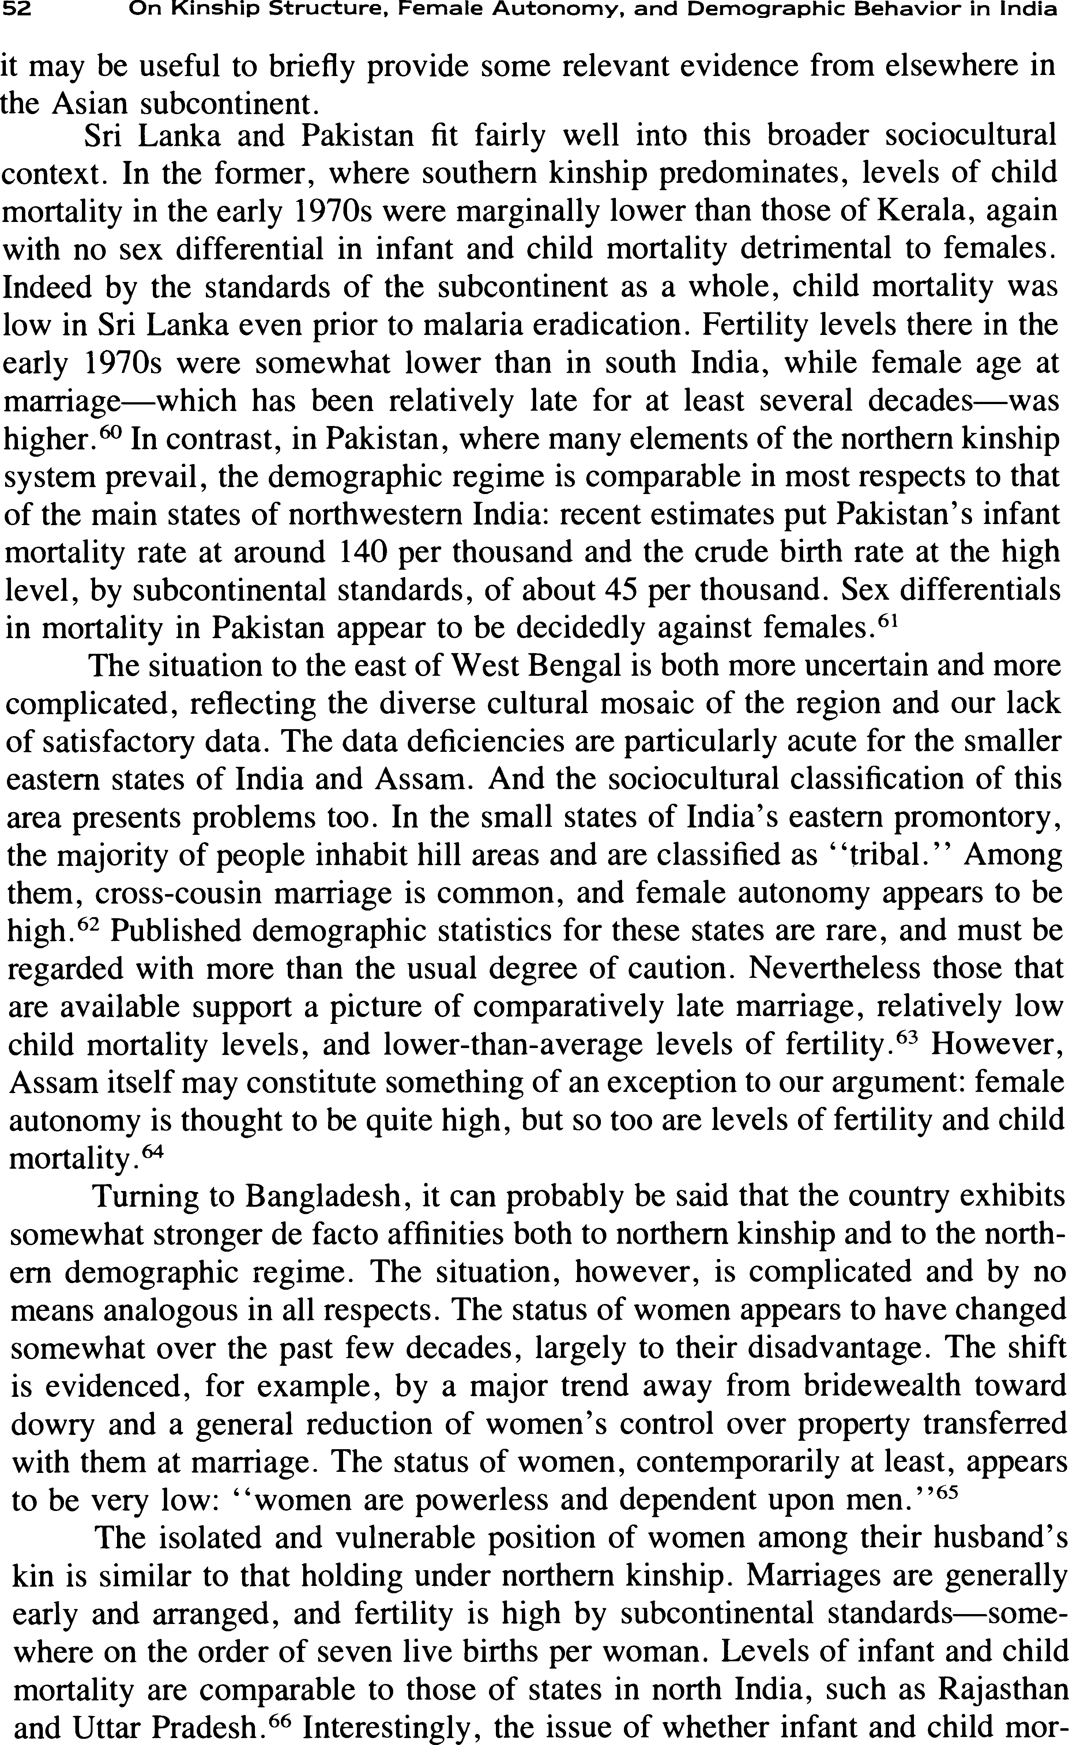

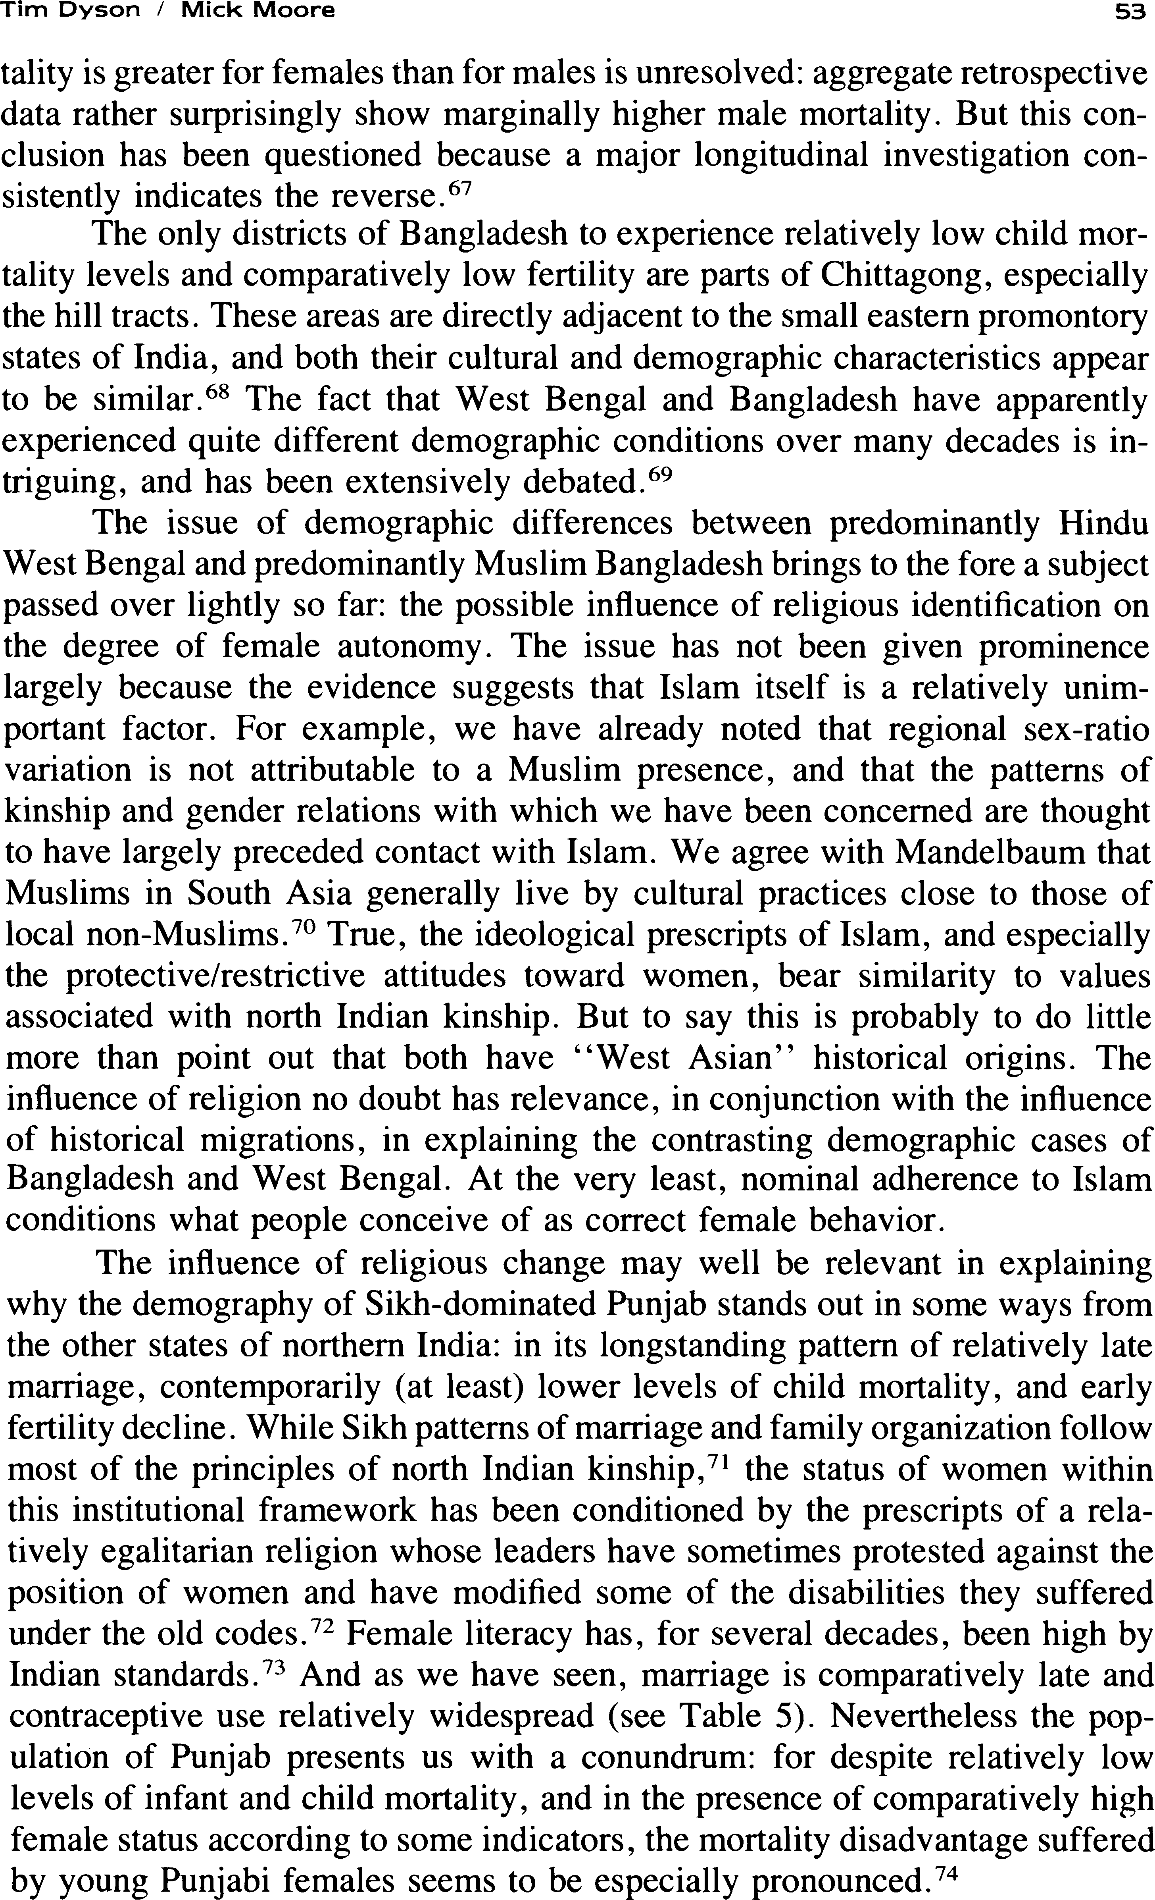

s•t On Kinship St:ructure. Female Autonomy, and Demographic Behavior in India

All of this only serves to underscore the fact that by no means all regional differences in India’s (or South and East Asia’s) aggregate demography can be explained simply by reference to the two dominant cultural regimes, im- portant though they undoubtedly are. As we have stressed above, there is considerable variation—both demographic and sociocultural—within north and south India. And in any event, the sociocultural explanation for regional de- mographic variation forwarded here is in no way intended as complete.”
Conclusion
Our analysis chimes in neatly with Mitra’s suggestion that female social status is probably the single most important element in comprehending India’s de- mographic situation.’⁶ In the present view the particularly high birth and death rates that continue to prevail throughout most of northern India must be seen within the context of local-level kinship arrangements. These arrangements not only have demographic implications of their own, but also condition the degree to which women can pursue their self-interest and that of their children. In this context we have seen that the spatial and social dimensions of the marriage alliance are particularly important.
Given the differences in female autonomy between northern and southern cultural areas, we expect, and find, a generally greater degree of health service and family planning utilization by women living in the south. It is probably too early to assess the extent to which these differences have influenced vari- ations in the timing and pace of demographic change. But, on balance, the available evidence is consistent with earlier and more pronounced fertility declines in southern areas of the subcontinent. And those states for which one can be fairly confident of little fertility change—for example, Uttar Pradesh and Rajasthan—contain populations among which northern kinship prevails and female autonomy is low. 7’
From a policy point of view this paper offers no direct lessons that could be accepted and adopted without further elaboration. But it certainly creates a strong presumption in favor of a broadly feminist mode of social action— specifically, to increase the autonomous social and political capacity of groups of females—both as an end in itself and as a means to facilitate reduced birth and death rates. It would clearly be unwise, however, to assume that future demographic progress in northern India must await a wholesale revision of gender relations. Many relevant socioeconomic changes are occurring in north- ern India, and fertility declines are under way in one or two of the smaller states.78 It is probably to these that we should look most closely for clues as to how to encourage such trends in the larger states of north India.’

Notes
We wish to thank John Caldwell, Ron Dore, Kamla Gupta, John Harriss, Malini Karkal, and K. Srinivasan for valuable comments on earlier versions of this paper.

1 Among the publications that fore- shadow our analysis are D. E. Sopher (ed.), An Exploration of India (London: Longman, 1950); B. Miller, The Endangered Sex (Ithaca:

Tim Dyson / Micl< Moore

Cornell University Press, 1981); and M. P. Moore, ‘‘Cross-cultural surveys of peasant family structures: Some comments,’ ’ Ameri- can Anthropologist 75, no. 3 (1973).
- When referring in the text to these re- gional clusters, the terms north, south, and east will be used without quotation marks. At the outset we should underline the abstract nature of the argument. Here we will be primarily concerned with the basic north—south contrast. But of course there is considerable subvaria- tion—both demographic and sociocultural— within these macro-regions, only a small part of which can be alluded to in the text.
- Justification for these points on the de- mographic sources is to be found in S. H. Preston, N. Chen, and J. Hobcraft “Prelimi- nary report on application of techniques for estimating death registration completeness to data from the Indian Sample Registration Sys- tem”; see also T. Dyson, “A working paper on fertility and mortality estimates for the states of India”; both papers are mimeo and were presented at a meeting of the India Panel, Committee on Population and Demography, United States National Academy of Sciences, Washington, D.C. , 1979.
- An exception was West Bengal, where Visaria attributed the high sex ratio to male inmigration; see P. M. Visaria, “The sex ratio of the population of India and Pakistan and regional variations during 1901-61,” in Pat- terns of Population Change in India, 1951—6I, ed. A. Bose (Bombay: Allied Publishers, 1967).
- State-level analysis shows no signifi-
cant correlation between the proportion of Muslims in the population and the population’s masculinity. See Visaria, cited in note 4, and
D. E. Sopher, “The geographic patterning of culture in India,” in D. E. Sopher (ed.), cited in note 1.
- Sopher, cited in note 5, p. 296.
- For the importance of the Satpura range we are indebted to Kamla Gupta (personal communication).
- Note that the low child sex ratios for West Bengal in Figure 1 are consistent with Visaria’s contention that migration largely ac- counts for the state’s masculinity (see note 4).
- On fertility decline in Punjab over 1961-71 see P. Visaria and A. K. Jain, India,
55

Country Profiles (New York: The Population Council, May 1976). The marked rise in the CWR for West Bengal between 1951 and 1961 may partly reflect malaria eradication. There is no doubt that previously West Bengal was particularly affected by malaria, and to a greater extent than East Bengal. See A. Geddes, “The social and psychological significance of variability in population change,” in ffuman Relations, vol. 1 (1947—48).
- See Dyson, cited in note 3.
- See J. Hajnal, “Age at marriage and proportions marrying,” Population Studies 7 (November 1951).
- See S. N. Agarwala, “The age of mar- riage in India,” Population Index 23, no. 2 (1957) and R. P. Goyal, “Shifts in age at marriage in India and different states during 1961—1971,” Demographic Research Centre, Institute of Economic Growth, Delhi-7, mim- eo, 1975. Both state names and jurisdictions have changed since Agar wala wrote: Madras and Mysore are present-day Tamil Nadu and Karnataka; Travancore-Cochin corresponded roughly to parts of contemporary Kerala; and Punjab constituted present-day Punjab plus Haryana. For further confirmation of this re- gional marriage pattern—which is similar for males—see Census of India, 1971, paper 4 of 1977, Female Age at Marriage (New Delhi: Demography Division, Ministry of Home Af- fairs, June 1977).
- For example, census data for these states classify marginally higher proportions of women aged 40—49 as “never married’’ and “divorced and separated.”
- See T. Dyson, “India’s regional de- mography,” mimeo, 198 I .
- In interpreting Indian marriage statis- tics, however, it has to be borne in mind that the age of onset of cohabitation is often a year or two after the formal marriage.
- We concentrate on infant and child mortality both because less is known about regional variation in overall mortality, and because variation in the former is undoubtedly important in explaining both regional and sex- specific variation in overall mortality.
- For alternative estimates based on ret- rospective questions from the 1972 survey see Dyson, cited in note 3. For state-level esti- mates of the infant death rate see various issues

56 On Kinship Structure, Female Autonomy, and Demographic Behavior in India

of the Sample Registration Bulletin, published biannually by the Ministry of Home Affairs, New Delhi.
  - We should emphasize that the regional pattern of variation in mortality level is found for males as well as females—i.e. , it can be detected independently of specifically higher female mortality in the north.
  - There are other regional demographic differences (e.g. , see note 13). Also, as re- gards the age pattern of mortality, child mor- tality is particularly high, relative to adult mortality, throughout the north; see Dyson, cited in note 3.
  - Bihar is especially difficult to classify
demographically. There are increasing signs that it may be better grouped with the states of the north. For example, recent work by P.N. Marr Bhat (unpublished) indicates that child mortality levels in Bihar may be closer to those of Uttar Pradesh than the figures in Table 4 imply.
  - This point is made by Dumont and Po- cock in a review of Karve’s standard text on Indian kinship; I. Karve, Kinship Organisation in India, Deccan College Monograph Series no. 11 (Madras: G. S. Press, 1953). See L. Dumont and D. Pocock, “Kinship,” in Con- tributions to Indian Sociolog y, 1957. A sim- ilar sentiment is echoed by Miller, cited in note 1.
  - In general, and to an extent anticipating arguments in the text below, the higher the caste, the more closely does the position of females resemble that accorded them under the north Indian kinship model. Higher castes gen- erally own more property and are more con- cerned with extravillage alliances—a key aspect of the northern system. Among lower castes, particularly in the south, kinship is more a matter of proximity and cooperation, and less one of ritual and blood relationships. However, even in the south higher caste groups may fol- low north Indian familial norms. Also there are increasing signs of the encroachment of the north Indian model among large sections— particularly upwardly mobile sections—of south Indian society. This is evidenced, for example, by a trend toward dowry. Lower caste females have much to lose if their caste is upwardly mobile; in the telling words of Srinivas, “San- skritisation results in harshness towards women.” For more on these issues see M. N.

Srinivas, Caste in Modern India and Other Essays (Bombay: Asia Publishing House, 1962).
  - One of the best known social anthro- pologists explicating the north—south schema is L. Dumont; see, for example, Dumont and Pocock, cited in note 21. The form in which this schema is presented here, however, de- rives most directly from the work of Yalman; see N. Yalman, Under the Bo Tree, Studies in Caste, Kinship and Marriage in the Interior of Ce ylon (Berkeley: University of California Press, 1967), supplemented by the scientific feminist analysis of B. S. Denich, “Sex and power in the Balkans,” in homes, Culture and Society, ed. M. Z. Rosaldo and L. Lam- phere (Stanford: Stanford University Press, 1974). Differences between the northern and southern models do not necessarily correspond closely to the common anthropological descent categories. While the northern system is usu- ally expressed firmly within a framework of patrilineal descent, the southern variant may be expressed within any of the three main de- scent categories.
  - An interesting correlate of north Indian kinship is that movements to modernize the family tend to ally both feminist and antige- rontocratic sentiments. Greater social differ- entiation across age groups in the north may help explain the regional differences in mor- tality cited in note 19 above.
  - On female gossip under northern kin- ship see L. Lamphere, “Strategies, co-oper- ation and conflict among women in domestic groups,” in Women, Culture and Society, cited in note 23.
  - A useful ethnographic documentation of the geographical distribution of these basic differences in marriage transactions is con- tained in Miller, cited in note 1.
  - Under the northern system, patrilineal descent and the need to control and resocialize in-marrying females promote joint families. For arguments that strict segregation of male and female spheres of activity is more difficult in nuclear as opposed to joint households, see
M. S. Luschinsky, The Life of Women in a Village of North India: A Study of Role and Status, Ph. D. Thesis, Cornell University (Ann Arbor: University Microfilms, 1962).
  - Karve, cited in note 21, p. 229.

/ Micl< Moore

  - We use the term “autonomy’ ’ rela- tively, i.e. , to describe the position of females vis-à-vis males within a given socioeconomic strata in a particular society; the absolute level depends upon other factors. For a recent at- tempt to conceptualize the components of fe- male autonomy, see C. Safilios-Rothschild, “Female power, autonomy and demographic change in the Third World,” in Women’s Roles and Population Trends in the Third World, ed.
R. Anker et al. (London: Croom Helm, 1982). 30 There is clearly scope for valid dispute about the operational criteria to be used in gauging autonomy. Also, as the text implies,
autonomy may vary with age.
- Likewise, the contrast in practice between certain features of northern and south- er kinship may not always be quite as marked as the ideal-typical descriptions imply. Of course, choice of marriage partner for southern females is often nonexistent, and chastity is prized in the south as well as the north. Thus, as we stress in the text below with reference to son preference, the difference between northern and souther systems is often a subtle one of degree. The situation is further com- plicated by considerations of encroachment referred to in note 22 above.
- The main source of information on the spatial patterning of kinship is Karve, cited in note 21. But see also A. K. Roychoudhury, “Incidence of inbreeding in different states in India,” Demography India S (December 1976).
- See Karve, cited in note 21.
- See Karve, cited in note 21; see also note 22 above.
- See, for example, M. J. Libbee and D.
E. Sopher, “Marriage migration in rural In- dia,” in People on the Move. Studies on In- ternal ñfigrafion, ed. Leszek A. Kosinski and
R. Mansell Prothero (London: Methuen, 1975).
- Interestingly, the Narmada river— closely aligned to the Satpura hill range—rep- resents the boundary between north and south India in classical Brahmanic writings. And extant scripts from before the time of Christ remark on the greater social freedom enjoyed by women in the south. See D. E. Sopher, “Indian civilization and the tropical savanna environment,” in Human Ecolog y in Savanna Environments, ed. 0. R. Harris (London: Ac- ademic Press, 1980).
57

- See for example Moore, cited in note 1.
- Indeed, with reference to regional vari- ation in the sex differential in mortality, this is what Miller has attempted in a recent book; see Miller, cited in note 1.
- Even linguistic maps are by no means perfect representations of the cultural variation with which we are concerned here. See So- pher, cited in notes 5 and 36.
- Under the southern system later mar- riage may both reflect and promote a greater measure of female autonomy (see also note 48 below). We should add that the considerations of this paragraph may be relevant in explaining apparently more widespread marriage and lower levels of divorce and separation in the north (see note 13).
- Note the need to consider the demo graphic consequences of various kinship sys- tems separately from the demographic implications of various degrees of female au- tonomy. In explaining particularly the past re- gional demography of India, we believe that the different logics of northern and southern kinship deserve somewhat greater weight. A related theoretical point is that a high measure of female autonomy need not preclude high fertility (for example), if women perceive this to be in their own interest. This may be ap- propriate in the context of matrilineal popu- lations in Kerala (see note 60 below). Conversely, in some circumstances, a low de- gree of female autonomy could accompany low fertility, or even a fertility decline. As we note in the text below, it is especially in the light of an organized family planning program that the degree of female autonomy may be im- portant in understanding the timing and speed of the demographic response.
- Of course, the demographic effect will be small, given generally uncontrolled fertility in the north.
- On this point, see J. C. Caldwell, “The mechanisms of demographic change in histor- ical perspective,” Population Studies 35, no. 1 (March 1981).
- The pronounced vulnerability of north- ern widows without surviving sons may con- tribute to excess adult female mortality, and hence the high northern sex ratios in Table 1. So too may higher northern fertility, through the mechanism of increased maternal mortality.

58 On Kinship Structure, Female Autonomy, and Demographic Behavior in India

  - Karve notes that in the south a woman’s status is relatively independent of her repro- ductive performance; see Karve, cited in note 21, pp. 134—135.
  - The considerations raised in note 20 are also relevant here.
  - We speculate that any past regional fer- tility differences implied, for example, by the CWRs in Table 2 were due more to differences in marital fertility than to differences in mar- riage patterns (see also text above). Unfortu- nately, statistics on breastfeeding for India are scarce, and insufficient to ascertain whether there is substantial regional variation. But for an argument that induced abortion was prom- inent in explaining low fertility among Indian Tamils in Sri Lanka, see C. M. Langford, “The fertility of Tamil estate workers in Sri Lanka,” forthcoming Scientific Report of the World Fertility Survey; and for a small study that found an astonishingly high rate of abor- tion in Tamil Nadu, see D. G. Mandelbaum, Human Fertility in India (Berkeley: University of California Press, 1974). The sources cited by Mandelbaum are: “A report on the study of the incidence of abortion in a weaver com- munity in the project area” and “A brief report on the base line survey on attitude, knowledge and practice of family planning in a few se- lected villages in the project area,” both in the Bulletin of the Pilot Health Project (Gandhi- gram) 4, no. 3 (1963).
  - The demographic implications of dif- ferent levels of female education between north and south are probably much more substantial and complex than we allow for in the text. In our view, however, higher levels of female literacy in the south mainly reflect the more favorable social position of southern women. For a state-level multivariate analysis of re- gional variations in Indian fertility which con- cluded that cultural variables relating to the status of women (e.g. , the proportion of women in purdah) were more important than socioeconomic measures (e.g. , the proportion of females literate), see S. J. Jejeebhoy, “Sta- tus of women and fertility: A socio-cultural analysis of regional variations in fertility in India,” in Dynamics of Population and Family Welfare, ed. K. Srinivasan and S. Mukerji (Bombay: Himalaya Publishing House, 1981).
  - This complaint is expressed repeatedly by administrators in north India.
  - For evidence on this, see P. K. Bard- han, “On life and death questions,” Economic and Political Weekly, special number, 9, nos. 32-34 (1974); for observations on the regional distribution of Emergency excesses in steril- ization see D. R. Gwatkin, “Political will and family planning: The implications of India’s Emergency experience,” Population and De- velopment Review 5, no. I (March 1979).
  - We draw on J. C. Caldwell, “Maternal education as a factor in child mortality,” in World Health Forum (Geneva) 2, no. 1 (198 l).
  - Note in Table 5 that significantly higher proportions of births are medically attended in the south.
  - Wider female work opportunities may also help explain the generally later marriage age of southern women.
  - For sex differences in the regional dis- tribution of food and childcare see Miller, cited in note I . On female infanticide see L. Pani- grahi, British Social Polic y and Female Infan- ticide in India (New Delhi: Munshiram Manoharlal Press, 1973). The considerations of note 44 are also relevant here.
  - See Miller, cited in note 1.
  - See J. B. Wyon and J. E. Gordon, The Khanna Study (Cambridge: Harvard Univer- sity Press, 1971), p. 235.
  - Although recent data indicate no mor- tality differential against females in the south and east, we would not be surprised if histor- ically such a differential existed in these areas, although we would expect it to have been less pronounced than in the north. Certainly Sri Lanka experienced such a trend away from higher female mortality in the late 1950s; see A Meegama, Sri Lanka, First Report, World Fertility Survey, Department of Census and Statistics, Ministry of Plan Implementation, Colombo, March 1978.
  - This is a good illustration of the rela- tivity of north—south differences; see note 31 above.
  - The northern constellation extends in part to the Mediterranean, while the South and East Asian system is bounded by the Confucian cultures of China, Vietnam, Korea, Taiwan, and Japan. For more on this see Moore, cited in note I . On the greater autonomy of women under South and East Asian kinship, see R.

Tim Dyson / Mick Moore

Whyte and P. Whyte, Rural Asian Women (Singapore: Institute of South East Asian Stud- ies, 1978).
  - The IMR in Sri Lanka was approxi- mately 140 and 50 in 1946 and 1974 respec- tively. The singulate mean age of first marriage for females was estimated at 20.7 and 23.5 years for 1946 and 1971 respectively (see Meegama, cited in note 57). In terms of both their demographic and their sociocultural fea- tures, Kerala and Sri Lanka are fairly similar (at least at the level of abstraction adopted here), and can be grouped somewhat apart from the remainder of the south. The fact that marital fertility in both areas in the past has been fairly high serves to underline the point, made in note 41, that a high degree of female autonomy need not preclude high fertility. However, marriage patterns in both areas have operated to keep levels of total fertility rela- tively low.
  - For these estimates see US Bureau of the Census, World Population 1979 (US De- partment of Commerce, October 1980). For an analysis of mortality by sex see A. R. Ru- kanuddin, “A study of the sex ratio in Paki- stan,” in Studies in the Demography of Pakistan, ed. Warren C. Robinson (Karachi: Pakistan Institute of Development Economics, Decem- ber 1967).
  - See Karve, cited in note 21, and C. Nakan, Garo and Khasi (The Hague: Mouton, 1967).
  - On age at marriage, see Census of In- dia, cited in note 12; for measures of fertility and child mortality see Fertility Differentials in India, ? 972 (New Delhi: Ministry of Home Affairs, 1974). The “tribal” people who live in these small eastern states, and in contiguous areas of Bangladesh, undoubtedly fall within the South and East Asian kinship constellation, and, as we note in the text, seem to enjoy relatively low rates of fertility and child mor- tality. But they probably differ sufficiently in both respects from most of south India to be identified as a major subvariation.
  - For demographic estimates for Assam see Preston et al., and Dyson, both cited in note 3. Satisfactory demographic measures for this state have been hard to obtain; but it seems to experience high fertility and, less certainly, fairly high infant and child mortality. How-
5g

ever, the prevailing view that female status is high in Assam may be questioned. The modern state excludes most of the hill areas where female status is known to be favorable (see notes 62 and 63); and many Assamese plains people are the descendants of migrants from north India.
  - M. Cain, S. Rokeya Khanam, and S. Nahar, “Class, patriarchy, and women’s work in Bangladesh,” Population and Development Review 5, no. 3 (September 1979): 406. As the text implies, traditional kinship principles in Bangladesh were in some respects different from those of north India—e. g., women could inherit property, although today its de facto control usually resides in male hands. How- ever, cross-cousin marriage in Bangladesh is comparatively rare, and the basic northern principles of descent based on patrilineality apply.
  - See Committee on Population and De- mography, Estimation of Recent Trends in Fertility and Mortality in Bangladesh, Report no. 5 (Washington, D.C.: National Academy Press, 1981).
  - See L. C. Chen, E. Huq, and S. D’Souza, “Sex bias in the family allocation of food and health care in rural Bangladesh,” Population and Development Review 7, no. 1 (March 1981).
  - For demographic measures see J. G.
C. Blacker et al. , Report on the 1974 Ban- gladesh Retrospective Survey of Fertility and Martality (London: Overseas Development Administration, 1977); see also note 63.
  - See Geddes, cited in note 9. Most of the debate has focused on mortality. But mark- edly higher contemporary fertility in Bangla- desh suggests that different fertility levels may account for much of the difference in past pop- ulation growth.
  - See D. G. Mandelbaum, Society In In- dia, 2 vols. (Berkeley: University of California Press, 1970).
  - See Karve, cited in note 21, p. 94. Approximately 60 percent of Punjab’s popu- lation is Sikh.
  - Correlates of the low status of women have been concerns of Sikh leaders form Guru Nanak onward; see B. J. Singh, “The structure and character of Sikh society,” in Sikhism and Indian Society (Simla: Rashtrapati Nivas, 1967).

60 On Kinship Structure, Female Autonomy, and Demographic Behavior in In¢lia

    - See Table 5 and D. E. Sopher, “Sex in Sri Lanka and Kerala. The 1981 census re- disparity in Indian literacy,” in An Exploration sults indicate particularly sizable growth-rate of india, cited in note 1. declines in Orissa and Tamil Nadu. For an

    - Note the very high child sex ratios for Punjab in Figure 1 and the indicated sex dif- ferential in mortality and very strong son pref- erence shown in Table S. Also on the conundnim see D. Seckler, “The mystery of the sex ratio in the Punjab,” the Ford Foundation, New Delhi, mimeo, 1982.
    - For example, there is almost certainly a direct two-way causal relationship between levels of fertility and mortality, and this is certainly relevant in explaining the overall pat- tern of regional demographic variation in India.
    - See A. Mitra, India’s Population. As- pects of Quality and Control (New Delhi. Abhinar Publications, 1978), especially the introduction. While we have arrived at this conclusion from a regional analysis, Mitra’s approach involved an examination of sex ratio, mortality, marriage, and employment patterns over time.
    - Probably the most pronounced and ear- liest fertility declines in the region occurred
analysis of the likelihood of fertility decline by state, see T. Dyson, “Preliminary demog- raphy of the 1981 census,” Economic and Political Weekly, no. 33, August 1981 . On a broader canvas the comparatively early and rapid fertility declines in South and East Asia should be seen within the context of South and East Asian kinship and the position it affords women.
    - Indeed, in such states fertility and mor- tality may have sometimes fallen first among high caste groups despite the fact that corre- sponding levels of female autonomy may be (or may have been) very low. Of course, high castes also tend to be economically better off. And the considerations of note 41 may also be relevant to this issue.
    - Thus, in addressing the problem of continuing very high birth and death rates in Uttar Pradesh, we may have more to learn from the experiences of Punjab and Gujarat than from the so-called Kerala model of demo- graphic transition.

