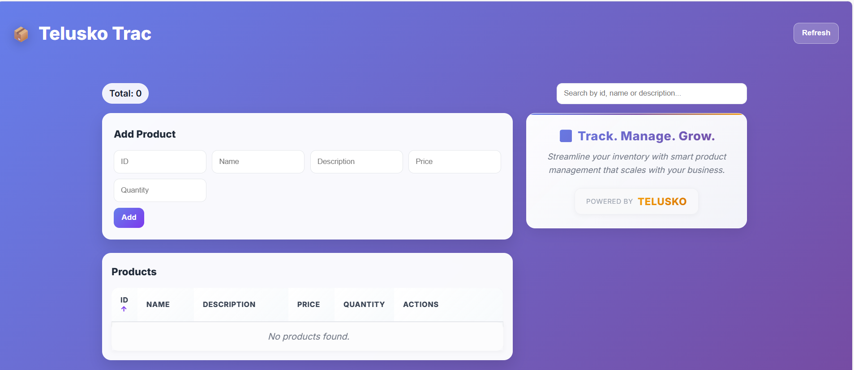
This is how initial frontend look like without backend database.
With the help of decorator and http method get for performing CRUD operation , you can see the function requested by client on the home screen.
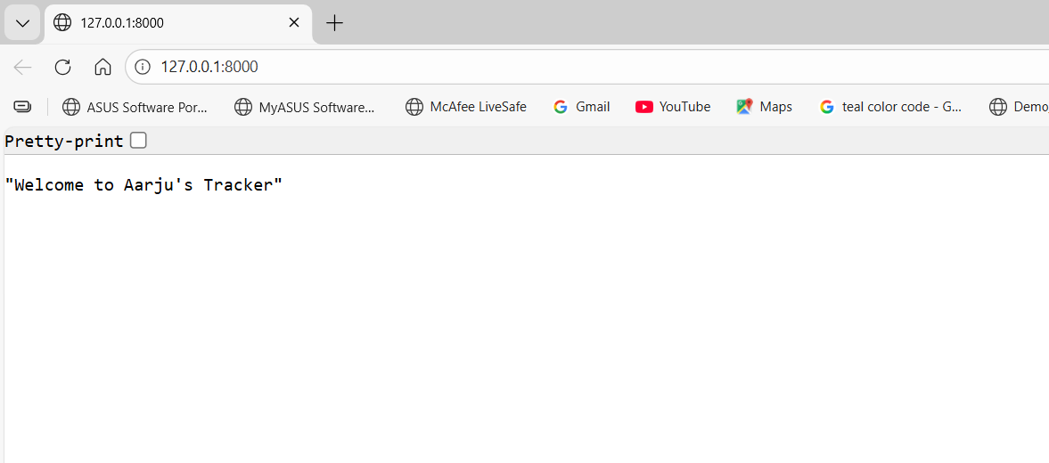

So for fastAPI we will use pydantic, t help for Data Visualization and server centric JSON format convertion of data
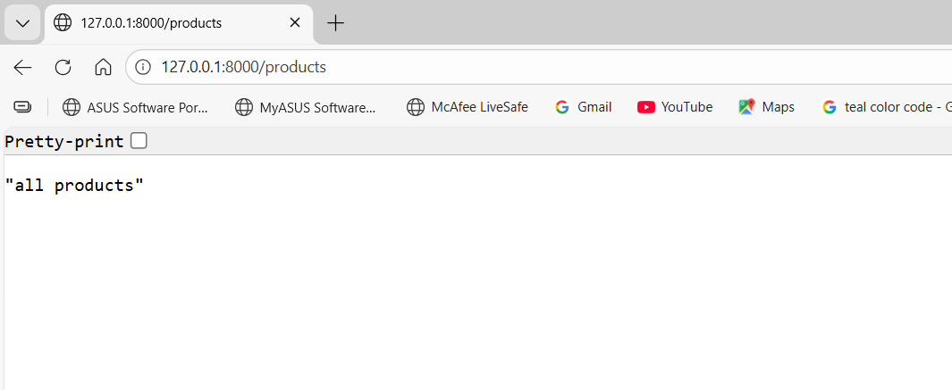
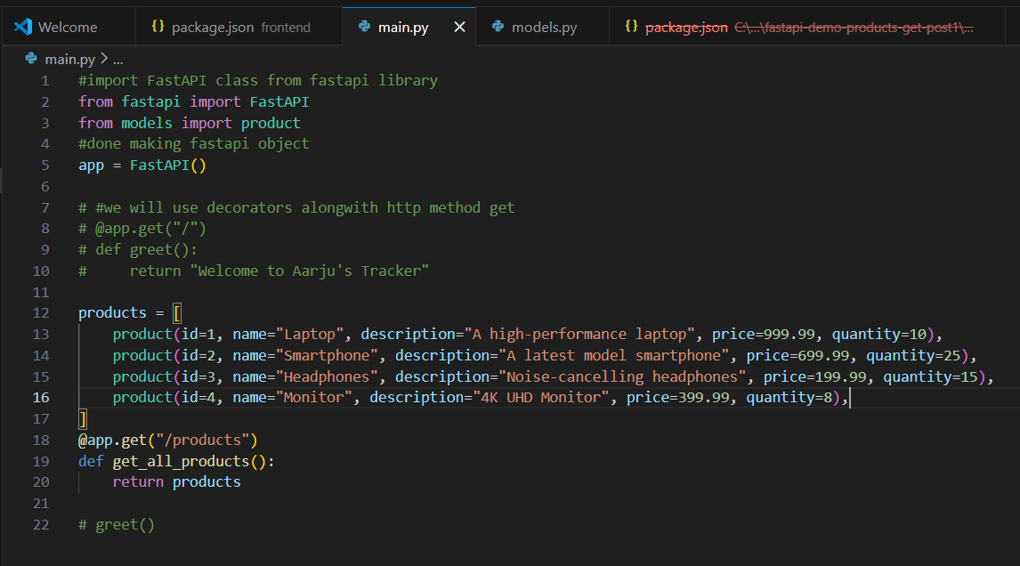
This is swagger, imbuild with fastAPI,
