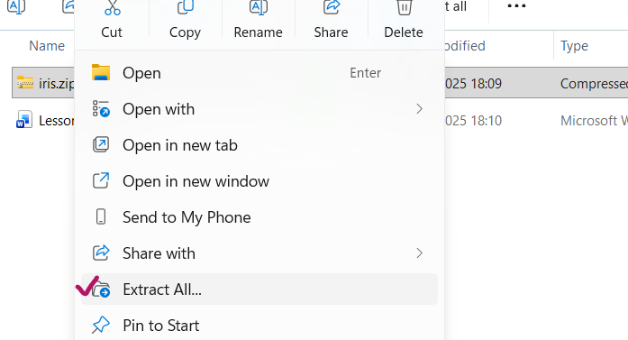

Open with vs code
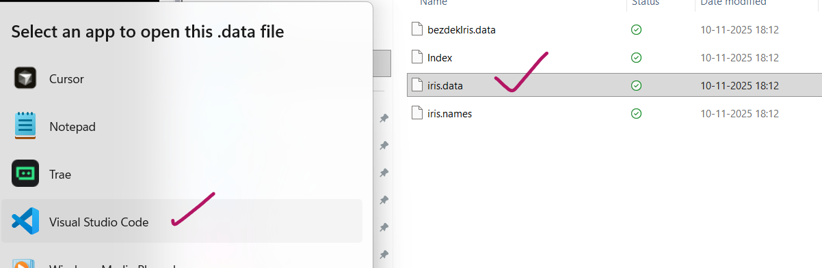
You can see comma separated values
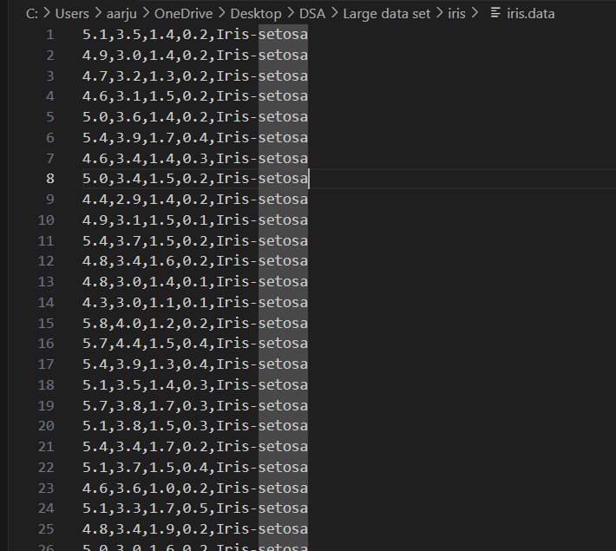
You can read it with python and can create csv.
This is small data set. We can make csv with different way as well.
Open excel and paste all rows of data.
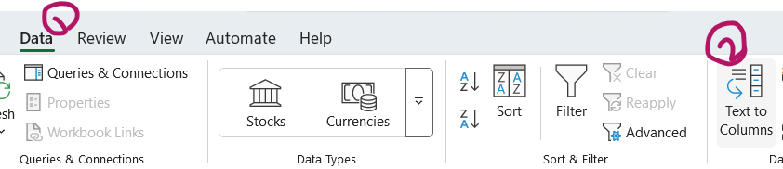
Because all data in the same column , so click on data then Text to Column.
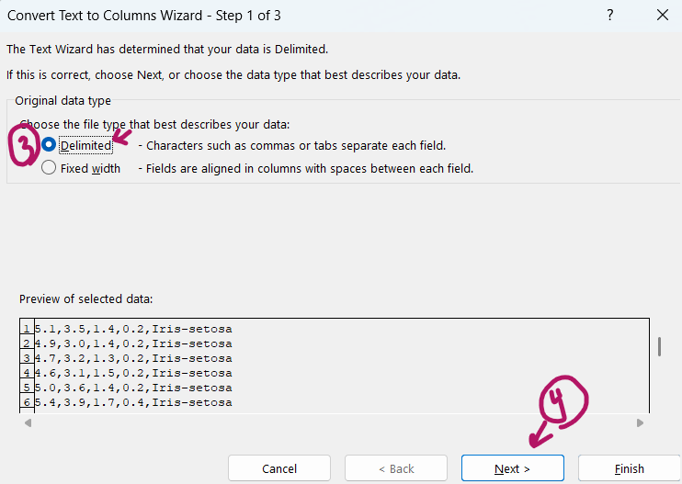
We know our data separated with comma,
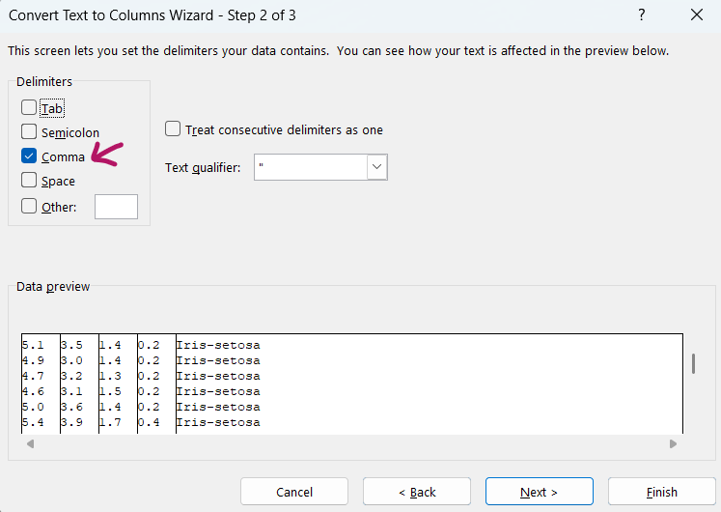
Click on Finish

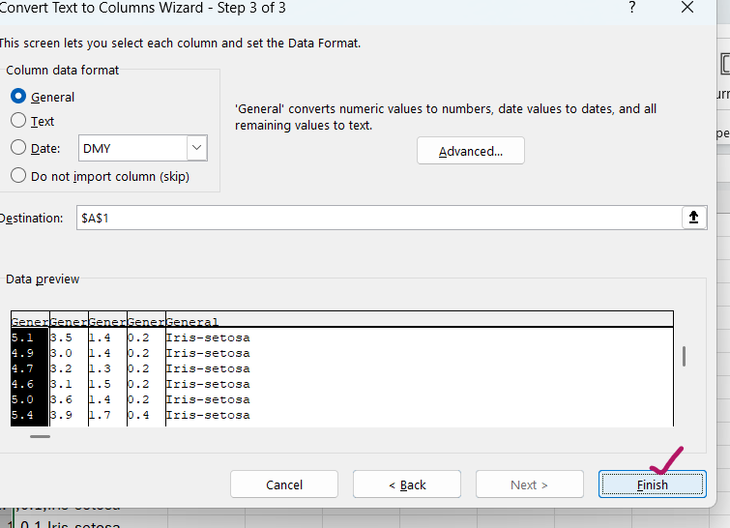
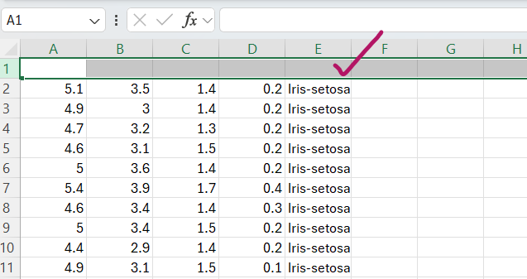
Press ‘ctrl +’ to create a row above for writing Lables.
For getting the index or labels , we need to look for index file.
Open index file inside vs code.
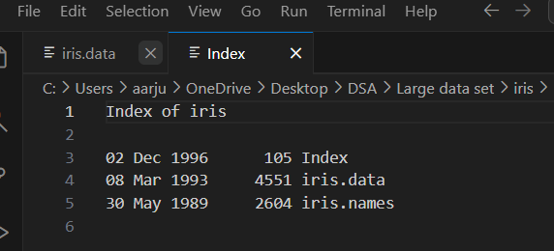
Iris data set is based on flower, you can show student to open Wikipedia.
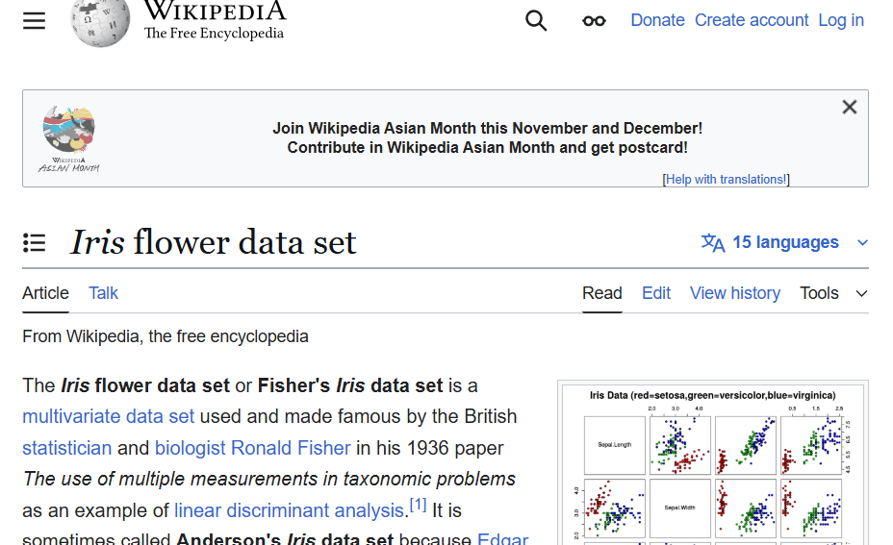
On the bases of leave width and length, we will tell which flower is what type.
We need to find the class of flower on the bases of lengths given.
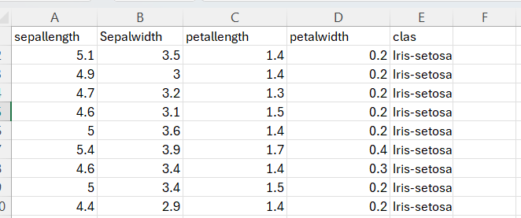
It has 3 types of classes.
Now we need to do train test split. Total number of classes we have is 150.
120 class we will take for Training, and 30 class we will take for Testing.
Open Anaconda prompt and open folder with cd command
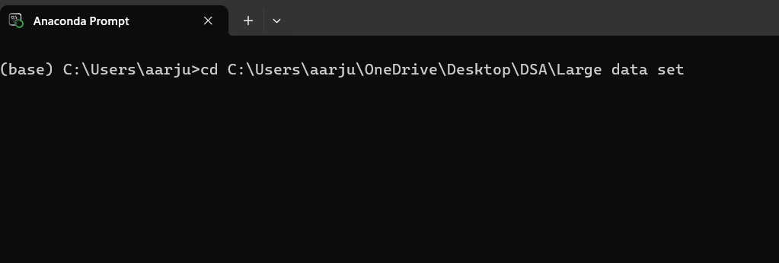
Open Jupyter Notebook
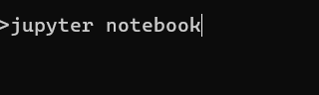
Create one Notebook,
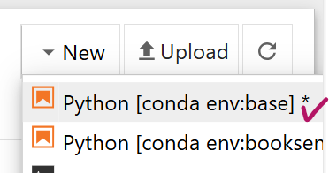
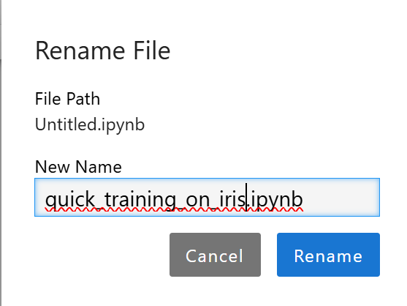
We are going to use RandomForestClassifier.
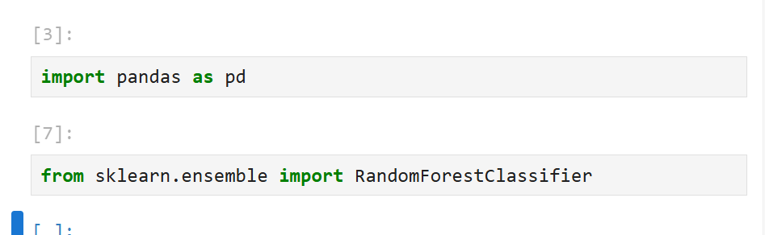
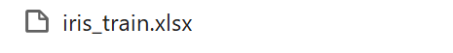

Now we will read our csv file.
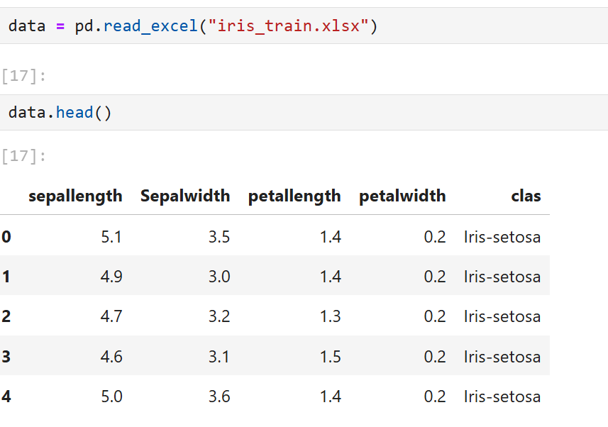
Now we will train out complete data then on the bases of some features we will test it.
We will be making Train Test split.

