ADAPTIVE NETWORK TROUBLESHOOTING AGENT
A PROJECT REPORT

Submitted by
ATHIRA M A 241901011
AARJUN G 241901001
in partial fulfillment for the award of the degree
of

BACHELOR OF ENGINEERING
in
COMPUTER SCIENCE AND ENGINEERING (CYBER SECURITY)


RAJALAKSHMI ENGINEERING COLLEGE
An Autonomous Institute

CHENNAI

NOVEMBER 2026

RAJALAKSHMI ENGINEERING COLLEGE
CHENNAI

BONAFIDE CERTIFICATE

Certified that this project report “ADAPTIVE NETWORK TROUBLESHOOTING AGENT” is the bonafide work of “ATHIRA M A (241901011)” who carried out the project work under my supervision.

SIGNATURE
Dr. Bhuvana S, Ph.D.,
ASSISTANT PROFESSOR(SG)
Department of Computer Science
And Engineering (Cyber Security)
Rajalakshmi Engineering College
Chennai – 602 105

Submitted to Project Viva-Voce Examination held on ______________

SIGNATURE OF THE INTERNAL EXAMINER
ABSTRACT

Modern computer networks require reliable connectivity and consistent performance. However, problems such as packet loss, DNS failure and loss of connectivity are still diagnosed mainly through manual procedures, fixed checklists. These approaches involve repeated tests, lack path optimization. This project proposes an Adaptive Network Troubleshooting Agent, an Artificial Intelligence-based decision-support system that selects an efficient sequence of diagnostic actions from the symptoms and results observed during troubleshooting. It combines Forward Chaining, a rule-based reasoning technique that infers possible faults from known symptoms, with the A* Search algorithm, which evaluates alternative diagnostic paths using cost, time and effectiveness. Case-based retrieval reuses the strategy of previously solved problems when the symptoms match. Unlike a fixed checklist, the agent adapts its next action to intermediate test results, aiming to remove redundant steps and to explain the reasoning behind every recommendation in plain language. The system is implemented in Python with a Flask web interface, JSON-based knowledge and case bases, an SQLite diagnosis history and standard network diagnostic utilities. A first prototype demonstrates symptom-to-cause inference, case retrieval, A* path generation, explanation, diagnosis history and a dashboard. The project shows how classical AI techniques can support network management without machine-learning models or historical training datasets.
ACKNOWLEDGEMENT

First and foremost, we thank Almighty God for enabling us to complete this project successfully. We express our sincere gratitude to our Chairman, Mr. S. Meganathan, B.E., F.I.E., for his dedicated efforts in providing quality education at this esteemed institution. We are deeply grateful to our beloved Chairperson, Dr. Thangam Meganathan, Ph.D., for her constant motivation and encouragement, which inspired us throughout the completion of this project. We also thank our Vice Chairman, Mr. Abhay Shankar Meganathan, B.E., M.S., for providing the necessary infrastructure and facilities.
We express our sincere gratitude to our College Principal, Dr. S. N. Murugesan, M.E., Ph.D., and Dr. P. Tamilselvi, Ph.D., Professor and Head, Department of Computer Science and Engineering (Cyber Security), for their support and encouragement.
We are especially thankful to our project guide, Dr. Bhuvana S., Ph.D., Assistant Professor(SG), for her valuable guidance, continuous encouragement, and support throughout the project. Finally, we thank our parents and friends for their direct and indirect contributions, encouragement, and support in the successful completion of this project.
AARJUN G (241901001)
ATHIRA M A (241901011)
TABLE OF CONTENTS
CHAPTER NO. | TITLE | PAGE NO.
 | ABSTRACT | iii
 | LIST OF TABLES | vii
 | LIST OF FIGURES | viii
1 | INTRODUCTION | 1
 | 1.1 BACKGROUND | 1
 | 1.2 PROBLEM STATEMENT | 1
 | 1.3 OBJECTIVES | 2
 | 1.4 SCOPE  1.4.1 IN SCOPE  1.4.2 OUT OF SCOPE | 3  3  3
 | 1.5 SECURITY REQUIREMENTS / SECURITY CONSIDERATIONS | 3
 | 1.6 SDG ALIGNMENT | 4
2 | LITERATURE REVIEW | 5
 | 2.1 EXISTING SYSTEM WITH SECURITY APPROACHES | 5
 | 2.2 RESEARCH GAPS | 8
 | 2.3 PROPOSED SYSTEM | 9
 | 2.3.1 OVERVIEW OF THE PROPOSED SYSTEM | 9
 | 2.3.2 OBJECTIVES OF THE PROPOSED SYSTEM | 9
 | 2.3.3 ADVANTAGES OF THE PROPOSED SYSTEM | 10
 | 2.3.4 NOVELTY OF THE PROPOSED SYSTEM | 10
 | 2.4 SUMMARY OF LITERATURE | 11
3 | SYSTEM DESIGN | 13
 | 3.1 SYSTEM ARCHITECTURE | 13
 | 3.2 MODULE DESIGN | 14
 | 3.3 DATA FLOW / UML DIAGRAMS | 15
 | 3.4 THREAT MODEL AND ATTACK SURFACE | 18
 | 3.5 SECURITY CONTROLS | 18
4 | SYSTEM DESCRIPTION | 20
 | 4.1 DATA COLLECTION | 20
 | 4.2 DATA PREPROCESSING | 20
 | 4.2.1 ALGORITHMS / METHODOLOGY | 21
 | 4.2.2 RESULTS AND DISCUSSION | 23
 | 4.3 PROJECT SCHEDULE AND CURRENT PROGRESS | 27
5 | CONCLUSION | 28
 | 5.1 CONCLUSION | 28
 | 5.2 FUTURE WORK | 28
 | REFERENCES | 30
 | APPENDIX | 31
 | Appendix A: Diagnostic Scenario | 31
 | Appendix B: Knowledge-Base Records | 31
 | Appendix C: Hardware and Software Requirements | 32
 | Appendix D: Abbreviations | 33
LIST OF TABLES
TABLE NO. | TITLE | PAGE NO.
1.1 | SDG ALIGNMENT OF THE PROPOSED PROJECT | 4
2.1 | COMPARISON OF EXISTING AND PROPOSED SYSTEMS | 11
2.2 | SUMMARY OF LITERATURE REVIEWED | 11
3.1 | MODULE DESCRIPTIONS | 15
3.2 | THREATS AND MITIGATIONS | 18
4.1 | ILLUSTRATIVE SYMPTOM-TO-FACT MAPPING | 21
4.2 | ILLUSTRATIVE A* RANKING OF CANDIDATE ACTIONS FOR A DNS FAILURE | 22
4.3 | SAMPLE ENTRIES FROM THE DIAGNOSIS HISTORY (5 OCTOBER 2026) | 25
4.4 | DASHBOARD SUMMARY AT THE TIME OF THE FIRST REVIEW | 26
4.5 | PROJECT SCHEDULE | 27
4.6 | CURRENT PROGRESS (PHASE I) | 27
C.1 | HARDWARE REQUIREMENTS | 32
C.2 | SOFTWARE REQUIREMENTS | 32
LIST OF FIGURES
FIGURE | TITLE | PAGE NO.
3.1 | PROPOSED SYSTEM ARCHITECTURE | 13
3.2 | DATA FLOW OF THE TROUBLESHOOTING AGENT | 16
3.3 | HIGH-LEVEL ACTIVITY FLOW (BLOCK DIAGRAM OF THE PROPOSED SYSTEM) | 17
4.1 | PROTOTYPE OUTPUT FOR A DNS-ERROR DIAGNOSIS (FORWARD CHAINING, CASE RETRIEVAL, A* PATH AND EXPLANATION) | 24
4.2 | DIAGNOSIS HISTORY PAGE OF THE PROTOTYPE | 24
4.3 | INTELLIGENCE DASHBOARD OF THE PROTOTYPE | 25

CHAPTER 1
INTRODUCTION
Computer networks underpin communication, information sharing and access to online services. Their reliability depends on correct configuration and on the timely detection and correction of faults. Common problems include packet loss, high latency, Domain Name System (DNS) resolution failures and complete loss of connectivity. When such a problem occurs, an administrator typically runs several commands, interprets their output and decides which test to perform next.
This project, the Adaptive Network Troubleshooting Agent, applies two classical Artificial Intelligence (AI) techniques to this problem: Forward Chaining, a rule-based inference method that derives probable causes from observed symptoms, and A* Search, a heuristic search algorithm that selects an efficient sequence of diagnostic actions. A case-based retrieval step reuses previously solved situations where they match the current symptoms.
The agent updates its plan after every diagnostic result instead of following a fixed checklist. It is intended to cut total troubleshooting time, reduce redundant tests, lower the dependence on senior network engineers, and give beginner administrators a clear, step-by-step explanation of why each action is recommended.
1.1 BACKGROUND
Standard diagnostic utilities such as ping, traceroute or tracert, nslookup, netstat and ipconfig or ifconfig report useful measurements, but none of them decides which test is the most worthwhile to run next. Protocols such as the Dynamic Host Configuration Protocol (DHCP) automate the initial assignment of an IP address, default gateway and DNS server; however, DHCP is strictly a configuration protocol. It cannot diagnose a faulty link, repair a failed service or evaluate network performance once the configuration has been applied.
Network outages and performance degradation can cause significant operational downtime, which makes network diagnosis a high-impact application area for AI. The industry is also moving towards AI for IT Operations (AIOps) and self-healing, autonomous monitoring, which creates demand for systems that can reason about faults rather than merely report them.
1.2 PROBLEM STATEMENT
Manual and conventional network troubleshooting relies on fixed, step-by-step checklists or on the experience of the administrator. Diagnostic actions are usually executed one after another, even when some of them are unnecessary for the symptoms observed. Existing command-line utilities provide raw performance data about connectivity, routing, DNS resolution and interface configuration, but they lack intelligent decision-making: a human must interpret the output, infer the probable root cause and choose the next action.
Rigid troubleshooting sequences lengthen the time needed to isolate faults, introduce redundant diagnostic steps, increase operating cost and place a heavy burden on skilled network engineers. They also adapt poorly when an intermediate test returns an unexpected result, and multi-layer symptoms (for example DNS errors occurring together with high latency) are difficult to handle with a static procedure.
There is therefore a need for an intelligent decision-support system that analyses the observed symptoms, infers possible causes, and recommends an efficient, explainable sequence of troubleshooting actions that can change as new results arrive. This project addresses that need by combining Forward Chaining for symptom-to-cause inference with A* Search for diagnostic path optimization.
1.3 OBJECTIVES
The main objectives of the Adaptive Network Troubleshooting Agent are:
- Automate network diagnostic reasoning: develop an intelligent decision-support system that analyses multi-layer network symptoms such as packet loss, high latency, DNS failure and connectivity loss.
- Implement rule-based root-cause inference: use Forward Chaining to map observed symptoms to potential network faults and system conditions.
- Optimize diagnostic path selection: apply A* Search with a custom heuristic that considers time, cost and effectiveness to select the fastest, lowest-cost sequence of diagnostic actions.
- Eliminate redundant diagnostic steps: reduce manual, static and linear checks by adapting the path to intermediate test results.
- Enhance explainability and decision support: provide clear, step-by-step explanations of the inferred fault and the recommended actions to assist novice network administrators.
- Demonstrate classical AI in network management: show that rule-based reasoning and heuristic search can support troubleshooting without machine-learning models or training datasets.
1.4 SCOPE
The project develops an AI-based decision-support agent for common network connectivity and performance problems.
1.4.1 In scope
- Diagnosis of four symptoms: packet loss, high latency, DNS failure (DNS error / DNS drop-outs) and connectivity loss.
- Converting network symptoms or diagnostic observations into structured facts and applying Forward Chaining rules to infer possible causes.
- Retrieving similar solved cases where available, and using A* Search to rank diagnostic actions by estimated cost, time and effectiveness.
- Presenting the recommendations, the selected path and a human-readable explanation through a web interface, and storing each diagnosis in a history database.
1.4.2 Out of scope
- Automatic repair. The agent is a guidance tool, and any action that changes network configuration must be carried out by an authorized user.
- A claim that every network fault can be diagnosed or repaired automatically.
- Machine-learning models and historical training datasets.
- Testing on production or unauthorized networks. Testing is planned on controlled, simulated or authorized networks only.
1.5 SECURITY REQUIREMENTS / SECURITY CONSIDERATIONS
Because the system interacts with operating-system diagnostic utilities and handles network-related information, security has to be considered from the start. The following requirements apply to the development and testing of the agent.
- Authorization: diagnostic commands and any configuration changes must be run only on systems and networks for which the user has permission.
- Input validation: user-supplied hostnames, IP addresses and parameters must be validated before they are used in any diagnostic operation.
- Command safety: operating-system commands must not be assembled directly from untrusted input; a controlled, allow-listed set of diagnostic commands and safe process invocation should be used.
- Least privilege: the application should run with only the permissions needed for the selected diagnostic tasks.
- Privacy: the system should not collect unnecessary personal data, credentials or unrelated network traffic.
- Log protection: diagnosis history should be stored carefully, with access restricted and secrets or sensitive identifiers excluded.
- Explainability: the system should show the facts observed, the causes inferred and the reason for every recommended step.
- Controlled testing: tests must be carried out on isolated or authorized networks so that other systems are not disrupted.
1.6 SDG ALIGNMENT
The project aligns with United Nations Sustainable Development Goal 9: Industry, Innovation and Infrastructure. SDG 9 calls for resilient infrastructure, inclusive and sustainable industrialization, and the encouragement of innovation. Reliable computer networks are a core part of modern digital infrastructure, and the agent supports their reliability by giving intelligent assistance in diagnosing connectivity and performance problems.
S.No | SDG No. & Goal | Relevant SDG Target | Project Contribution / Alignment
1 | SDG 9: Industry, Innovation and Infrastructure | Target 9.1: reliable and resilient infrastructure | Supports the reliability of network infrastructure by giving intelligent assistance in diagnosing connectivity and performance problems.
2 | SDG 9: Industry, Innovation and Infrastructure | Target 9.5: upgrading technological capabilities and encouraging innovation | Explores an innovative way of improving troubleshooting efficiency by combining rule-based reasoning with heuristic search, supporting more systematic network maintenance with reduced diagnostic effort.
Table 1.1 SDG alignment of the proposed project
This is a proposed contribution; the actual effect on troubleshooting time and network reliability has to be established through implementation and testing.
CHAPTER 2
LITERATURE REVIEW
This chapter reviews existing approaches to network troubleshooting and the research on network fault detection and diagnosis, expert systems using fault-tree reasoning and knowledge-based rule reasoning. It then identifies the gaps in these approaches and describes how the proposed Adaptive Network Troubleshooting Agent addresses them.
2.1 EXISTING SYSTEM WITH SECURITY APPROACHES
2.1.1 Conventional troubleshooting
Traditional network troubleshooting is performed with static checklists and Standard Operating Procedures (SOPs), in which an administrator follows fixed diagnostic steps in a linear order. Command-line diagnostic utilities such as ping, traceroute, nslookup and netstat are executed by hand and their output is interpreted by the administrator. DHCP and other auto-configuration protocols allocate IP addresses, default gateways and DNS settings when a device connects, but DHCP is a configuration protocol and not a fault-diagnosis engine. Basic scripting and decision trees, in the form of simple if-else automation scripts and static flowcharts, are also common.
These approaches are simple, predictable and standardized for routine network set-up and basic configuration, and they are natively available on all operating systems without any advanced AI infrastructure. Their limitations are the gaps that this project addresses. Tests are executed sequentially without considering execution time, cost or likelihood of success; static scripts cannot re-route the diagnostic logic when an unexpected error or intermediate failure occurs; tools report raw performance metrics but depend on skilled engineers to interpret the root cause; and the same set of tests is often applied to different types of fault, which makes troubleshooting harder in large, complex networks.
2.1.2 Reviewed studies
One of the most important problems in the operation of computer networks is locating the root cause of a fault quickly and with as little effort as possible. Won et al. [1] presented a fault detection and diagnosis technique for IP-based mission-critical industrial process control networks, in which the weakness of traditional monitoring tools was the starting point. According to this work, conventional monitoring is inadequate for such networks, early detection of symptoms is crucial, and data mining combined with fine-grained feature extraction is preferable to static rules for recognizing abnormal network behaviour. As a result, abnormal conditions could be recognized earlier than with threshold-based monitoring alone. However, the approach relies heavily on labelled training data, its diagnostic logic is comparatively primitive, and it does not plan the order in which further diagnostic tests should be carried out. A network administrator who needs to decide which test to run next therefore receives little help from it.
Wang [2] introduced a fault diagnosis expert system based on the integration of a neural network and a fault tree. Here, the rule-explosion bottleneck that limits purely rule-based expert systems was addressed by combining shallow knowledge, which captures the experience of human experts, with deep knowledge, which captures the structure of the system and its faults, in a single hybrid knowledge base. The integration also improved the inference process by allowing reasoning in two directions, from symptoms towards causes and from suspected causes back towards the symptoms that should be observed. Nevertheless, the failure structure of the fault tree is fixed in advance. The system does not optimize the path or the cost of the diagnostic steps, it does not reason sequentially as new results arrive, and it cannot handle novel or compound failures, which are common in modern multi-layer networks where, for example, a DNS error and high latency may appear together.
Yang and Wang [3] surveyed modern fault diagnosis methods in networks and gave particular attention to knowledge-based fault diagnosis and rule-based reasoning. The survey indicates that knowledge-based approaches isolate failures efficiently, separate the knowledge about faults from the control strategy that uses it, and deal effectively with deterministic faults whose symptoms and causes are well understood. These properties are exactly what a troubleshooting assistant needs, because the rules can be read, checked and extended by a network engineer without changing the inference procedure. At the same time, the survey points out the limitations of the approach: rule matching introduces overhead and performance bottlenecks as the rule base grows, the knowledge base is brittle when a situation was not anticipated by its authors, and there is no optimal execution planning or dynamic adaptation of the diagnostic path. These limitations motivate the use of a separate search component, in addition to rule-based inference, in the proposed agent.
The use of recorded observations as the input of automated troubleshooting has also been studied. Thornadtsson et al. [4] presented a systematic mapping study of log-file analysis for smart troubleshooting in Industry 4.0. Their study organizes the existing research on analysing the logs produced by systems and devices so that faults can be found and explained with less manual effort, and it shows that collected logs and observations can serve as a structured input to an automated troubleshooting process. This supports the design decision made in the proposed agent to convert raw diagnostic output and user-reported symptoms into structured facts before any reasoning is performed. Kreutz et al. [5] introduced a comprehensive survey of Software-Defined Networking (SDN), in which the separation of the control plane from the data plane makes a network programmable and centrally managed. Although the proposed agent does not depend on SDN, this work provides context for the future extension of the agent from recommending actions towards carrying out automated and authorized remediation in programmable networks.
For the practical side of the problem, Bigelow [6] provides a reference on troubleshooting, maintaining and repairing PCs, which describes the conventional procedures that administrators follow when a computer or its network connection fails. Such procedures are a useful record of the diagnostic steps that are available, but they are written as fixed sequences and leave the choice and the order of the steps to the experience of the technician. The algorithmic foundations of the proposed system come from two classical sources. Hart, Nilsson and Raphael [7] described a formal basis for the heuristic determination of minimum-cost paths, which is now known as the A* algorithm. It evaluates every candidate path with the function f(n) = g(n) + h(n), where g(n) is the cost already incurred and h(n) is an estimate of the remaining cost, and it returns a least-cost path when the heuristic never overestimates the true remaining cost. Russell and Norvig [8] described forward chaining as a data-driven inference method in which rules whose conditions are satisfied by the known facts are fired repeatedly until no further conclusion can be drawn, and they present A* among the informed search strategies. Together, these two techniques make it possible to separate the question of what is wrong with the network from the question of which test should be run next.
A further idea that is relevant to troubleshooting is the reuse of earlier experience. Faults in real networks tend to recur, and the strategy that solved a previous problem with the same symptoms is often the quickest way to solve the present one. For this reason, the proposed agent keeps a base of solved cases and compares the current symptoms with them. When the similarity is high the strategy of the matching case is reused, and when it is only partial the case is reported as supporting evidence while the search continues. The core reasoning, however, remains the predefined rules and the search algorithm, and the cases act only as supporting experience.
In summary, the studies reviewed above show the value of early symptom detection, structured reasoning and knowledge-based isolation of faults. They also share a common weakness: none of them plans the order in which diagnostic actions should be carried out, none weighs the cost of an action against its expected usefulness, and none adapts the sequence of actions as new results arrive. Several of the approaches also depend on labelled training data or on complex models that are difficult to inspect. The proposed system fills this gap by adding A* Search on top of Forward Chaining, so that diagnosis (what is wrong) and planning (what to test next) are handled in one lightweight and explainable framework.
2.1.3 Security approaches
From a security perspective, diagnostic utilities must be used only with proper authorization, user-supplied inputs must be validated before they reach system commands, and stored diagnostic logs must be protected so that network details such as hostnames and IP addresses are not exposed unnecessarily. These considerations are carried into the design of the proposed agent in Sections 3.4 and 3.5.
2.2 RESEARCH GAPS
The reviewed literature and the existing approaches point to the following gaps.
- Lack of dynamic path optimization. Traditional methods use predefined sequences and do not choose the most efficient path for the current symptoms and the estimated cost of each test.
- Dependence on manual interpretation. Diagnostic utilities provide measurements, but an administrator must interpret them and identify the likely root cause.
- Redundant diagnostic steps. Fixed procedures may run unnecessary tests, increasing the time needed to isolate a fault.
- Limited adaptability. Basic scripts, static rule sets and fixed decision trees have little ability to change their sequence when an intermediate result differs from what was expected.
- Limited explainable decision support. There is a need for a system that not only recommends actions but also explains the facts and rules behind each recommendation.
- Need for a lightweight classical AI approach. Several existing approaches depend on labelled training data or complex models. Rule-based reasoning combined with heuristic search offers intelligent support without a training dataset.
2.3 PROPOSED SYSTEM
2.3.1 OVERVIEW OF THE PROPOSED SYSTEM
The proposed Adaptive Network Troubleshooting Agent is an AI-based decision-support system that identifies possible network faults and recommends an efficient sequence of diagnostic actions. It is a hybrid AI engine built from three cooperating techniques:
- Forward Chaining analyses the known symptoms and fires predefined rules to infer possible causes. For example, a DNS error can fire a rule that points to a DNS server failure and raises its priority.
- Case-based retrieval compares the current symptoms with previously solved cases and reuses the successful strategy of a close match.
- A* Search explores the available diagnostic actions and selects a path using the accumulated cost g(n) and an estimate of the remaining effort h(n).
The agent works adaptively. After a diagnostic action is evaluated, its result is added to the current state, the diagnosis is reconsidered and the next action is selected. The major stages are:
- Collect network symptoms and diagnostic observations.
- Convert the observations into structured facts.
- Apply Forward Chaining to infer possible fault causes.
- Generate the candidate diagnostic actions.
- Use A* Search to select a suitable diagnostic path.
- Execute or evaluate the selected action.
- Update the facts and adapt the next step if necessary.
- Generate a report containing the likely cause, the recommended actions and the reasoning.
2.3.2 OBJECTIVES OF THE PROPOSED SYSTEM
- Represent common network symptoms and diagnostic knowledge in a structured knowledge base.
- Apply Forward Chaining to infer possible network fault conditions.
- Use A* Search to prioritize diagnostic actions by estimated cost and effectiveness.
- Adapt the troubleshooting sequence according to intermediate diagnostic results.
- Minimize redundant tests and improve troubleshooting efficiency.
- Provide understandable explanations of the reasoning process.
- Build a lightweight, accessible system with Python and common web technologies.
2.3.3 ADVANTAGES OF THE PROPOSED SYSTEM
- Adaptive troubleshooting: the next action can change according to the results of previous tests.
- Reduced redundancy: unnecessary diagnostic steps are avoided, which is expected to reduce Mean Time to Resolution (MTTR).
- Rule-based diagnosis: Forward Chaining gives a structured way to derive causes from symptoms.
- Optimized path selection: A* Search prioritizes sequences using configured costs and heuristic estimates.
- Explainable reasoning: the observed facts, the inferred conditions and the recommended actions are all explained in plain language.
- Lightweight implementation: classical AI techniques need no machine-learning training dataset or heavy infrastructure.
- Beginner-friendly support: the output helps novice administrators understand the troubleshooting process.
2.3.4 NOVELTY OF THE PROPOSED SYSTEM
The novelty of the project lies in integrating rule-based fault diagnosis and heuristic path optimization within a single troubleshooting framework. Conventional systems rely on fixed checklists, manual diagnosis or static procedures, whereas here each diagnostic result influences the next action and the troubleshooting path is continuously updated from intermediate observations. Prioritizing actions by cost, time and effectiveness, which is generally absent from traditional approaches, is made possible by A* Search.
The system also provides transparent reasoning by showing how every inferred fault and recommended action follows from the rule base. The primary contribution is a lightweight, explainable AI-based troubleshooting agent that does not depend on machine learning or historical training data, and that can serve as a foundation for future autonomous network management and fault-diagnosis systems.
Point | Conventional troubleshooting | Proposed agent
Order of tests | Fixed checklist, executed one after another | A* Search ranks actions by cost, time and effectiveness
Adaptation | Static scripts and decision trees cannot change course | The next action is re-selected after every result
Interpretation | Administrator interprets raw output | Forward Chaining infers the likely cause and priority
Redundant tests | Often executed regardless of the symptoms | Expected to be reduced by path optimization
Explanation | None, or only the experience of the engineer | Plain-language reasoning for each recommendation
Training data | Not applicable (manual) or needed by learning-based tools | Not needed: rules and heuristic search
Table 2.1 Comparison of existing and proposed systems
This comparison describes what the system is designed to provide; the efficiency gain itself is to be measured in Phase II.
2.4 SUMMARY OF LITERATURE
Table 2.2 summarizes the three primary studies together with their key findings and the limitations that the proposed system sets out to address.
Study | Technique / Focus | Key Findings | Limitations
Won et al. (2008) [1] | Fault detection and diagnosis in IP-based mission-critical industrial process control networks | Traditional monitoring tools are inadequate; early symptom detection is crucial; data mining preferred over static rules; fine-grained feature extraction. | Primitive diagnostic logic; heavy reliance on labelled training data; no dynamic path planning; static rule sets.
Wang (2009) [2] | Fault diagnosis expert system based on integration of neural network and fault tree | Resolves the rule-explosion bottleneck; hybrid shallow and deep knowledge base; improved two-way inference. | Static failure structure; no path or cost optimization; no sequential adaptive reasoning; cannot handle novel or compound failures.
Yang and Wang (2017) [3] | Survey of modern fault diagnosis methods in networks; knowledge-based, rule-based reasoning | Efficient failure isolation; separation of knowledge and control; effective handling of deterministic faults. | Rule-matching overhead and performance bottlenecks; no optimal execution planning; brittle knowledge base; no dynamic path adaptation.
Table 2.2 Summary of literature reviewed
Three further sources provide supporting background: Thornadtsson et al. [4] on log-file analysis for smart troubleshooting in Industry 4.0, Kreutz et al. [5] on Software-Defined Networking and Bigelow [6] on conventional PC troubleshooting. The algorithmic foundations used in this work are described by Hart, Nilsson and Raphael [7] for A* Search and by Russell and Norvig [8] for rule-based inference and search.
CHAPTER 3
SYSTEM DESIGN
3.1 SYSTEM ARCHITECTURE
The system follows a modular architecture in which network symptoms pass through normalization, reasoning, search, action evaluation and reporting stages. Each stage hands structured information to the next, and the result of every evaluated action is fed back so that the plan can be revised. Figure 3.1 shows the proposed architecture.
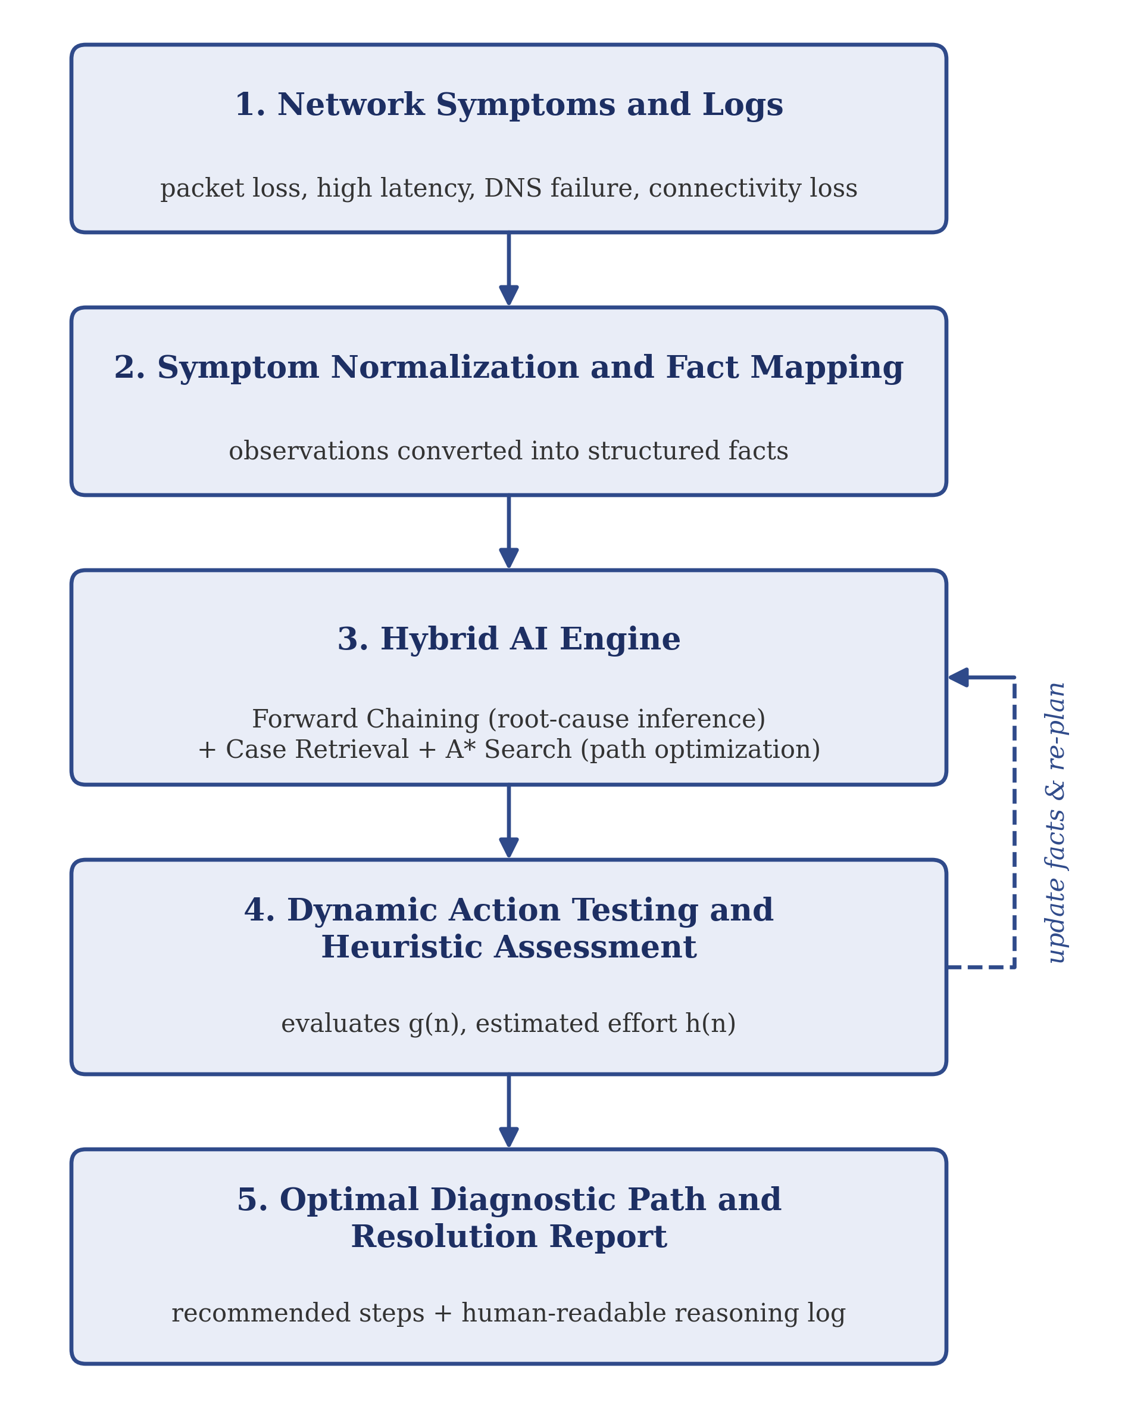
Fig 3.1: Proposed System Architecture
The five components of the architecture are described below.
- Network Symptoms and Logs. The input stage receives symptoms and available diagnostic observations: packet loss, high latency, DNS dropouts and connectivity loss.
- Symptom Normalization and Fact Mapping. The raw conditions are extracted and mapped to initial facts in the knowledge base, so that the inference engine can process them consistently.
- Hybrid AI Engine. Forward Chaining performs root-cause inference, case retrieval looks for similar solved cases, and A* Search performs diagnostic path optimization.
- Dynamic Action Testing and Heuristic Assessment. The candidate actions are evaluated using the actual accumulated cost g(n) and the estimated remaining effort h(n). The outcome of each action updates the facts and returns control to the AI engine (the dashed feedback loop in Figure 3.1), which is what makes the process adaptive.
- Optimal Diagnostic Path and Resolution Report. The final stage produces the recommended repair steps and a human-readable reasoning log, and stores the diagnosis in the history database.
3.2 MODULE DESIGN
The system is divided into five modules, summarized in Table 3.1.
MODULE 1: SYSTEM SETUP AND KNOWLEDGE REPRESENTATION
Defines the structure of the knowledge base: network symptoms, possible causes, diagnostic actions, rules and the cost of each action. The knowledge base and the case base are stored as JSON files that the inference engine and search algorithm read. Expected output: structured diagnostic facts, rules, actions and costs.
MODULE 2: AI-BASED NETWORK DIAGNOSIS
Applies Forward Chaining to the facts derived from the observed symptoms. Each rule has a condition and a conclusion; when the facts satisfy the condition, the cause is added with a priority (for example High or Medium). Expected output: a set of possible network fault hypotheses.
MODULE 3: ADAPTIVE AND CASE-BASED INTELLIGENCE
Manages the adaptive process. It compares the current symptoms with stored cases, computes a similarity score, and reuses the strategy of a matching case when the similarity is high. It also updates the state with the result of each executed action so that the path can be re-planned. The core reasoning remains the predefined rules and the search algorithm; cases act as supporting experience. Expected output: updated facts and an adapted troubleshooting path.
MODULE 4: DATA MANAGEMENT AND REPORTING
Manages the structured diagnostic information and prepares the report. Every diagnosis (symptoms, cause, priority, method, action, matched case, similarity and timestamp) is stored in an SQLite database to support review and comparison of sessions. Expected output: diagnosis history and a human-readable troubleshooting report.
MODULE 5: ANALYTICS, TESTING AND FINALIZATION
Supports testing and evaluation: it provides dashboard statistics and is used to assess the diagnostic sequence, the number of steps, the resolution time and the suitability of the recommendations over scenarios such as packet loss, high latency, DNS failure and connectivity loss. Expected output: test observations and an evaluation summary.
Module | Main Responsibility | Expected Output
1. System Setup and Knowledge Representation | Define diagnostic facts, rules, actions, costs and goals. | Structured knowledge base
2. AI-Based Network Diagnosis | Apply Forward Chaining to infer possible causes. | Possible fault hypotheses
3. Adaptive and Case-Based Intelligence | Retrieve similar cases; update the state and guide the next diagnostic step. | Adapted diagnostic path
4. Data Management and Reporting | Maintain diagnosis history and generate explanations. | History and report
5. Analytics, Testing and Finalization | Test scenarios and evaluate diagnostic performance. | Test observations and evaluation summary
Table 3.1 Module descriptions
3.3 DATA FLOW / UML DIAGRAMS
The data flow begins when the user enters symptoms or starts a diagnostic check. Symptom processing validates and normalizes the input and builds structured facts. Forward Chaining evaluates the facts against the knowledge base (data store D1) to infer possible causes, case retrieval consults the case base (D2), and A* Search then ranks the diagnostic actions using the configured costs and heuristic estimates. After the selected action is evaluated, its result updates the current state and, if more information is required, inference and search are repeated. When the stopping condition is reached, the report generator produces the explanation and writes the diagnosis to the history database (D3). Figure 3.2 shows the data flow.
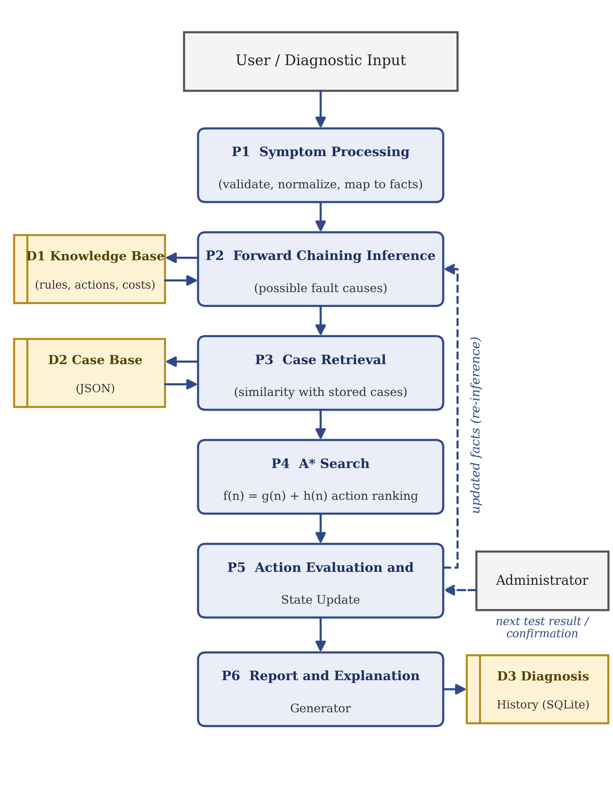
Fig 3.2: Data Flow of the Troubleshooting Agent
The overall activity flow of the proposed system, from detection of a network issue to restoration of the network, is shown in Figure 3.3. The decision "Problem solved?" implements the adaptive loop: when the answer is No, the network condition is updated and control returns to Forward Chaining.
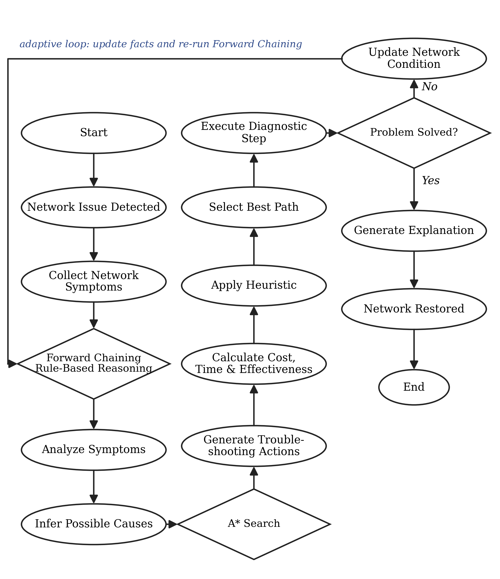
Fig 3.3: High-Level Activity Flow (Block Diagram of the Proposed System)
The main actor is the network administrator or student user, whose use cases are: enter or select the observed symptoms; view the inferred cause and its priority; view the recommended troubleshooting path with cost, heuristic and score values; read the explanation; browse the diagnosis history; and view the dashboard statistics. Detailed UML use-case and sequence diagrams will be finalized once the interface interactions are confirmed during implementation.
3.4 THREAT MODEL AND ATTACK SURFACE
The attack surface of the application consists of user inputs, calls to operating-system diagnostic utilities, stored diagnosis history, the local web interface and any network-connected features added in the future. Table 3.2 lists the main threats, their implications and the planned mitigations.
Threat | Possible Impact | Planned Mitigation
Command injection through unvalidated input | Unintended command execution on the host. | Input validation, allow-listed commands, safe process invocation (no shell-string construction).
Unauthorized diagnostic activity | Legal, operational or security problems if systems are probed without permission. | Restrict use to authorized systems; require confirmation for configuration-changing actions.
Exposure of network information in history | Disclosure of hostnames, IP addresses or other network details. | Store only necessary data; restrict access to local records; never save credentials.
Excessive application permissions | Larger impact of a software error or misuse. | Run with least privilege; avoid administrator rights unless essential.
Incorrect diagnosis from incomplete observations | A wrong cause or action is recommended. | Label results as likely causes with priority; show evidence and limitations; allow re-evaluation after each step.
Table 3.2 Threats and mitigations
3.5 SECURITY CONTROLS
The following controls are proposed to improve the security and reliability of the system:
- Input validation: validate and normalize hostnames, IP addresses and other parameters before processing.
- Safe command execution: use a controlled set of diagnostic commands and avoid unsafe shell-command construction.
- Access restrictions: run diagnostics only on authorized systems and networks.
- Least privilege: avoid running the application with unnecessary administrative privileges.
- Log protection: restrict access to diagnosis records and avoid recording credentials or unrelated sensitive information.
- Safe remediation: clearly separate diagnostic recommendations from configuration-changing actions.
- Error handling: show meaningful messages when a diagnostic command fails or evidence is insufficient.
- Controlled testing: use isolated or authorized networks during testing.
CHAPTER 4
SYSTEM DESCRIPTION
4.1 DATA COLLECTION
The agent uses network symptoms and diagnostic observations as the input to its reasoning. It does not need a machine-learning dataset for training because the core approach is based on predefined rules and heuristic search. The information considered includes:
- User-reported connectivity problems, packet-loss observations, high-latency observations and DNS resolution failures;
- Results from ping and traceroute / tracert;
- DNS information obtained with nslookup;
- Network interface and configuration details from ipconfig / ifconfig.
During development, controlled test cases are prepared to represent the supported problems. The observations populate facts in the knowledge base, which the inference engine and the search algorithm use to select actions. Only information necessary for the troubleshooting task is collected, and all tests are to be performed on authorized networks or controlled test environments.
4.2 DATA PREPROCESSING
Raw diagnostic output arrives in different formats, so a preprocessing stage converts the relevant observations into a consistent representation (unstructured logs are turned into structured Boolean facts). The stage consists of five steps:
- Symptom identification: identify the relevant condition in the user input or the diagnostic output.
- Fact mapping: represent each condition as a named fact that the knowledge base can evaluate.
- Data normalization: convert observations to a consistent format; each fact is recorded as present, absent or unknown.
- State preparation: organize the current facts and the earlier diagnostic results for Forward Chaining and A* Search.
- Result updating: after every action, update the facts so that the next action is chosen from the current state.
Observed Symptom | Example Fact | Possible Diagnostic Direction
Packet loss is reported | packet_loss = true | Check reachability and path quality.
Response time is high | high_latency = true | Compare response times and inspect the route.
Hostname does not resolve | dns_failure = true | Check DNS resolution and DNS configuration.
Host is unreachable | connectivity_loss = true | Check interface status, gateway and reachability.
Table 4.1 Illustrative symptom-to-fact mapping
The table gives illustrative mappings. The actual fact definitions, detection thresholds and rules are to be finalized and tested during implementation and should not be taken as universal network standards.
4.2.1 ALGORITHMS / METHODOLOGY
The agent integrates Forward Chaining, case-based retrieval, A* Search and an adaptive diagnostic loop.
A. Forward Chaining
Forward Chaining is a data-driven inference technique used in rule-based AI systems. It starts from the known facts and checks which rules have all their conditions satisfied. When a rule fires, its conclusion is added to the knowledge base as a new fact, and the process repeats until no further rule applies or a stopping condition is reached. Here it infers possible fault causes from observed symptoms.
Example (as in the prototype): the observed symptom is DNS Error. Rule R01 states that a DNS error indicates a DNS Server Failure, with priority High. The engine fires R01 and records the cause. This shows the intended reasoning; it does not imply that every DNS error has the same cause.
B. Case-Based Retrieval
A case records the symptoms of an earlier problem, its cause and the strategy that solved it. For a new problem the agent computes a similarity score between the current symptoms and each stored case. If the match is exact (100% similarity), the successful strategy of that case is reused directly; for a partial match the case is reported as supporting evidence while the search continues. In the prototype the case base currently contains one case, C001 (cause: DNS Server Failure).
C. A* Search
A* Search is a heuristic search algorithm that evaluates paths by combining the cost already incurred with an estimate of the remaining cost: f(n) = g(n) + h(n), where f(n) is the estimated total cost of a path through node n, g(n) is the actual accumulated cost from the start state to node n (for example the diagnostic time or resource cost of the actions executed), and h(n) is the estimated remaining effort from node n to a diagnostic goal.
In the agent a node is a diagnostic state (the current facts and the actions already performed) and an action is an edge to the next state. A priority queue, implemented with Python's heapq module, always expands the node with the lowest f(n). Because the search ranks the actions by combined cost and estimated effort, a cheap and highly relevant test is performed before an expensive one. Table 4.2 gives a worked illustration for a DNS-failure scenario; its numbers are chosen only to explain the mechanism and are not measured values.
Candidate Action | g(n) cost | h(n) estimate | f(n) = g + h | Rank
Check DNS Settings | 1 | 2 | 3 | 1
Flush DNS Cache | 1 | 3 | 4 | 2
Test Reachability by IP Address | 2 | 3 | 5 | 3
Check Router Logs | 4 | 3 | 7 | 4
Table 4.2 Illustrative A* ranking of candidate actions for a DNS failure
How closely the search matches the real troubleshooting effort depends on how the action costs and the heuristic are defined, so calibrating them is a key task of the next phase.
D. Adaptive Diagnostic Loop
The adaptive loop lets the agent reconsider its next action whenever new results become available:
- Collect the symptoms and diagnostic observations.
- Convert them into structured facts.
- Apply Forward Chaining to infer possible causes; consult the case base.
- Identify the available actions and estimate cost and remaining effort for the candidate paths.
- Use A* Search to select the next action.
- Evaluate the result of the action and update the facts.
- If the result changes the diagnosis, repeat from step 3 (adaptive re-routing); otherwise stop.
- Generate the final recommendation and explanation, and store the diagnosis.
E. Overall Methodology
The methodology therefore has six stages: (1) data collection of raw logs and performance metrics; (2) preprocessing into structured Boolean facts; (3) rule-based inference with Forward Chaining; (4) optimal path search with A*; (5) dynamic step execution and adaptive re-routing; and (6) the decision-support and remediation report.
4.2.2 RESULTS AND DISCUSSION
At the Phase I stage the problem definition, objectives, literature review, architecture, module design, methodology and technology plan have been completed, and a working prototype of the web application (named NetAdapt AI in the interface) has been demonstrated at the first review. The prototype implements symptom entry, Forward Chaining, case retrieval, A* path generation, an explanation panel, a diagnosis history and an analytics dashboard. This section reports what the prototype shows. These are development-stage observations and not a performance evaluation of the system.
Diagnosis Output
Figure 4.1 shows the result screen for a DNS-error diagnosis. The output is organized in numbered stages: (02) the Forward Chaining result, where rule R01 fired for the symptom DNS Error and the cause DNS Server Failure was identified with High priority; (03) case-based reasoning, where the previous case C001 matched with 100% similarity (an exact match) and its successful strategy was reused; (04) the A* path generated, listing the ranked actions Check DNS Settings and Flush DNS Cache with their cost, heuristic and score; and (05) a plain-language explanation of why the rule fired and why the case was reused.
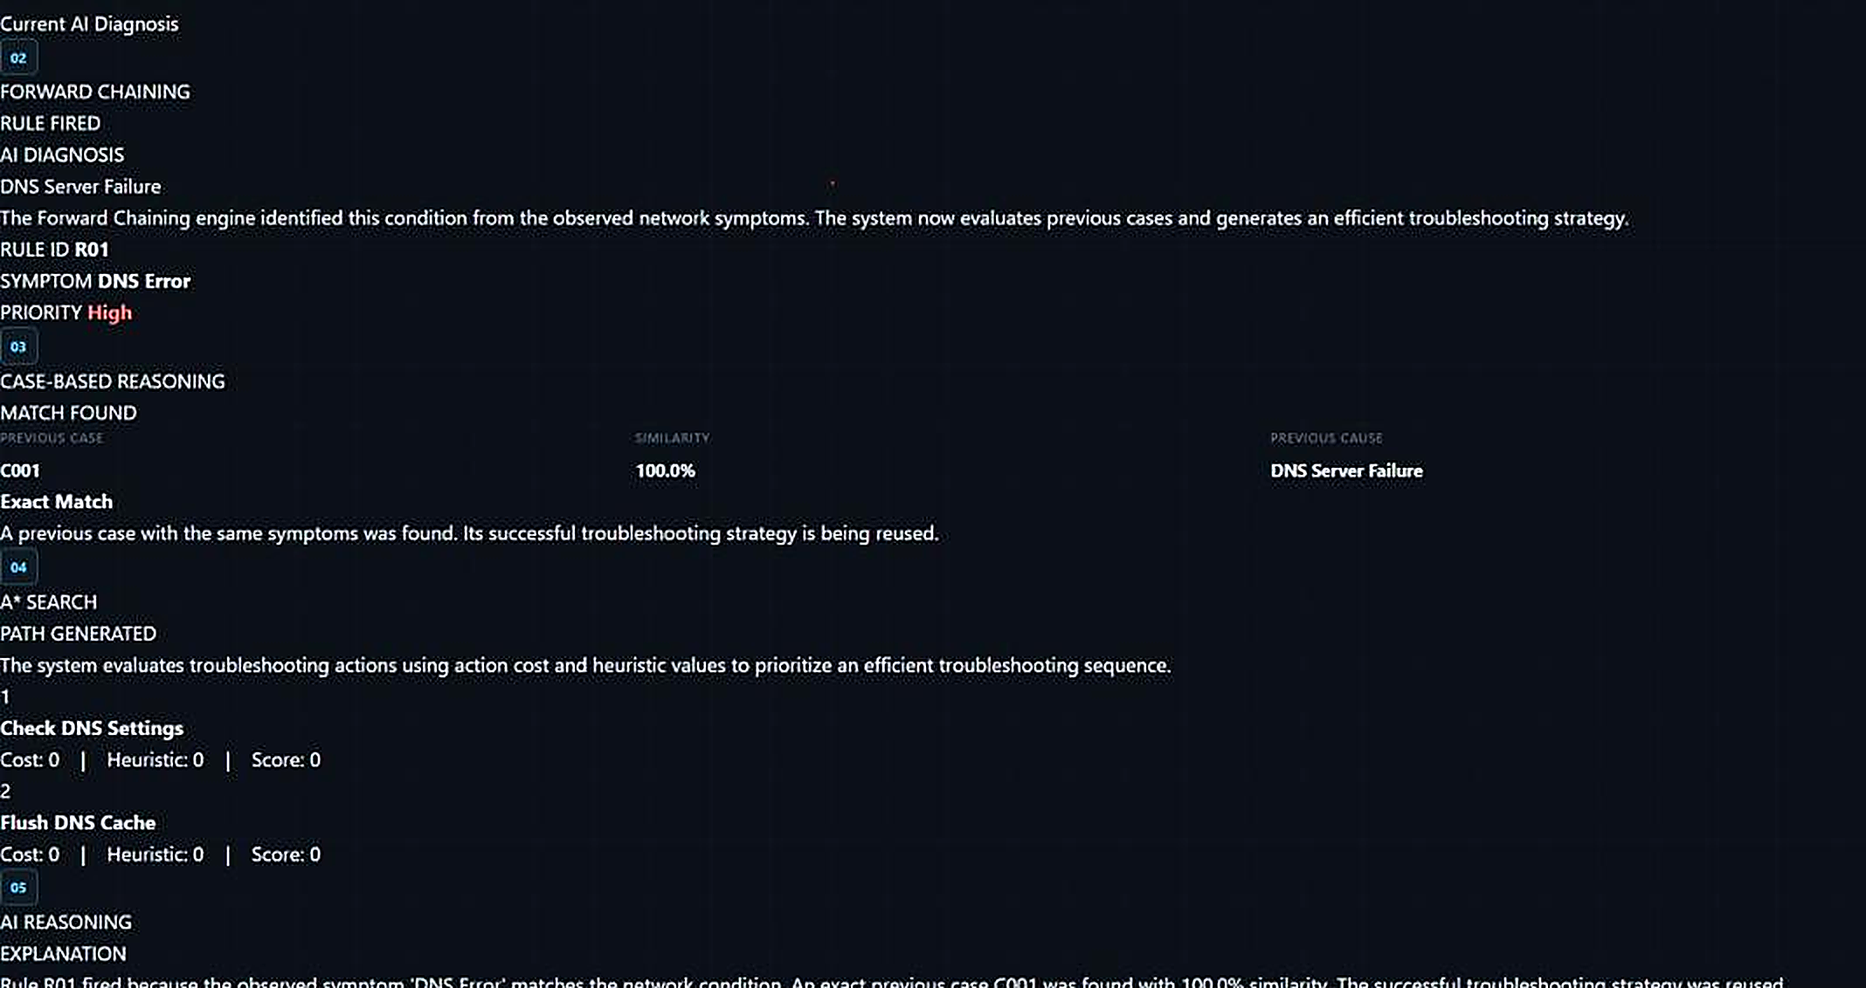
Fig 4.1: Prototype Output for a DNS-Error Diagnosis (Forward Chaining, Case Retrieval, A* Path and Explanation)
Diagnosis History
Each diagnosis is stored in SQLite and listed on the history page (Figure 4.2) with its symptoms, inferred cause, priority, method, recommended action, matched case, similarity and timestamp. Table 4.3 reproduces five of the recorded entries.
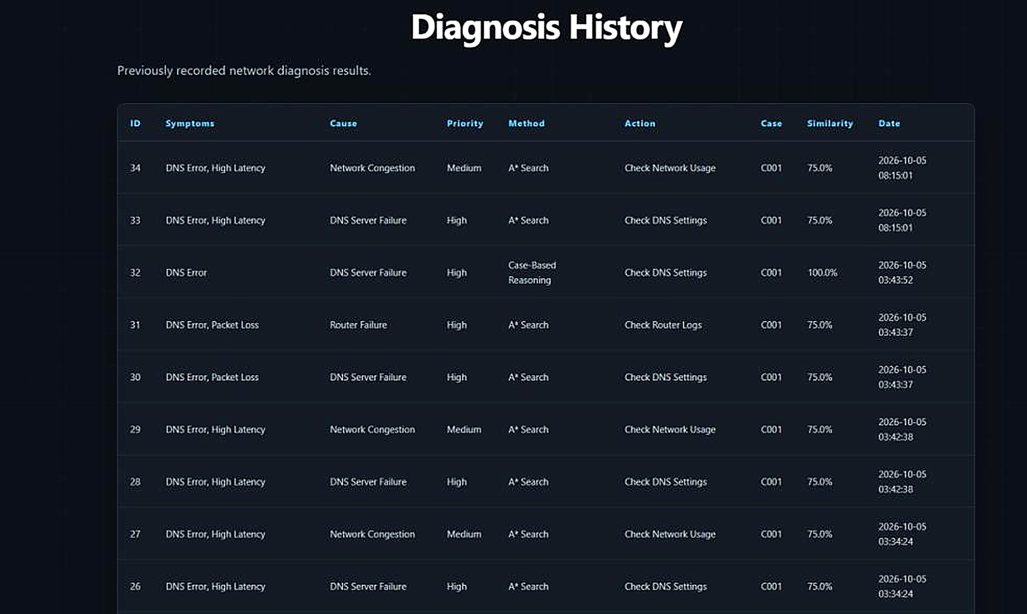
Fig 4.2: Diagnosis History Page of the Prototype
ID | Symptoms | Cause | Priority | Method | Action | Similarity
34 | DNS Error, High Latency | Network Congestion | Medium | A* Search | Check Network Usage | 75.0%
33 | DNS Error, High Latency | DNS Server Failure | High | A* Search | Check DNS Settings | 75.0%
32 | DNS Error | DNS Server Failure | High | Case-Based Reasoning | Check DNS Settings | 100.0%
31 | DNS Error, Packet Loss | Router Failure | High | A* Search | Check Router Logs | 75.0%
30 | DNS Error, Packet Loss | DNS Server Failure | High | A* Search | Check DNS Settings | 75.0%
Table 4.3 Sample entries from the diagnosis history (5 October 2026)
Intelligence Dashboard
The dashboard (Figure 4.3) summarizes the diagnoses stored in the history database. Table 4.4 lists the figures it displayed at the time of the review.
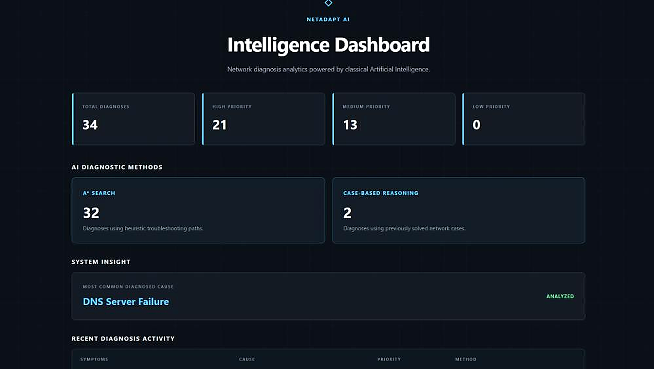
Fig 4.3: Intelligence Dashboard of the Prototype
Dashboard Item | Value
Total diagnoses recorded | 34
High-priority diagnoses | 21
Medium-priority diagnoses | 13
Low-priority diagnoses | 0
Diagnoses made with A* Search (heuristic troubleshooting paths) | 32
Diagnoses made with case-based reasoning (previously solved cases) | 2
Most common diagnosed cause | DNS Server Failure
Table 4.4 Dashboard summary at the time of the first review
Discussion
The prototype shows that the planned pipeline works end to end: symptoms are mapped to facts, rules fire to infer causes with priorities, similar cases are retrieved, actions are ranked, an explanation is generated and the result is stored. The history also shows that a combined symptom set can yield more than one candidate cause with different priorities; for example "DNS Error, High Latency" produced both DNS Server Failure (High) and Network Congestion (Medium) with different recommended actions, which fits the multi-layer symptom analysis described in the objectives.
Several limitations are recognised at this stage:
- The 34 recorded diagnoses come from repeated development runs on a small set of symptom combinations (mainly DNS-related), so the counts in Table 4.4 describe prototype use and not real-world fault frequency.
- In the captured output the cost, heuristic and score of the A* actions are displayed as 0, which indicates that the action-cost and heuristic model has not yet been calibrated. Defining and validating these values is a priority for the next phase.
- The case base contains a single case (C001), which is why every history entry matches it; it has to be extended with further solved cases.
- No measurements of troubleshooting time, number of steps or diagnostic accuracy have been made, so no efficiency claim is made in this report.
The system will be evaluated in Phase II using representative scenarios for packet loss, high latency, DNS failure and connectivity loss, with the following measures: number of diagnostic steps; total diagnostic time or MTTR; whether the likely fault is identified; number of redundant checks avoided; suitability of the recommended actions; clarity of the explanations; and a comparison against a traditional fixed troubleshooting sequence and sequential manual command-line diagnosis.
4.3 PROJECT SCHEDULE AND CURRENT PROGRESS
The project is planned over four months, as shown in Table 4.5, and its present status is given in Table 4.6.
Activity | Month 1 | Month 2 | Month 3 | Month 4
Literature Survey | ✓
Problem Identification | ✓
System Design |  | ✓
Implementation |  | ✓ | ✓
Testing & Evaluation |  |  |  | ✓
Table 4.5 Project schedule
Task | Status
Literature survey | Completed
Problem identification | Completed
Requirement analysis and methodology | Completed
Prototype: knowledge base, Forward Chaining, case retrieval, A* path generation, history and dashboard | Demonstrated; to be completed and calibrated
Full implementation | In progress
Experimental testing and comparison with fixed checklists | Pending (Phase II)
Final evaluation and documentation | Pending (Phase II)
Table 4.6 Current progress (Phase I)
CHAPTER 5
CONCLUSION
5.1 CONCLUSION
The Adaptive Network Troubleshooting Agent is proposed as a lightweight, AI-based decision-support system for diagnosing common network connectivity and performance problems such as packet loss, high latency, DNS dropouts and connectivity loss. Traditional troubleshooting depends on manual procedures, fixed checklists and administrator experience; the proposed system improves on this by combining Forward Chaining for rule-based fault inference with A* Search for diagnostic path optimization, supported by case-based retrieval of earlier solved problems.
Its key contributions are a dynamic and adaptive workflow in which each test result can change the next step, cost-optimized pathfinding that ranks tests by time, cost and diagnostic effectiveness, and transparent step-by-step reasoning logs that need no complex machine-learning models or heavy training data. Phase I has produced the problem statement, objectives, literature review, system architecture, module plan, methodology, security considerations and implementation requirements, together with a working prototype that demonstrates the intended pipeline.
The expected outcome is shorter troubleshooting time, fewer redundant checks and less dependence on senior engineers, and a foundation for autonomous network management. These benefits remain to be established through the experiments planned for Phase II.
5.2 FUTURE WORK
- Complete the implementation: develop the full Python-based core engine integrating Forward Chaining for symptom-to-cause inference and A* Search for dynamic diagnostic pathfinding, including a calibrated action-cost and heuristic model.
- Extend the knowledge and case bases: add rules, actions and solved cases covering packet loss, high latency, DNS drop-outs and connectivity loss.
- Conduct experiments and compare with existing methods: test the agent on varied network-failure scenarios and benchmark it against traditional checklists, sequential manual CLI diagnosis (ping, nslookup) and fixed decision trees.
- Perform performance evaluation: measure Mean Time to Resolution, diagnostic step reduction percentage and search efficiency.
- Prepare the final system and documentation: finalize the user interface, display real-time diagnostic logs, and compile the project documentation and code repository.
REFERENCES
[1] Y. J. Won, M.-J. Choi, J. W.-K. Hong, M.-S. Kim, H. Hwang, J.-H. Lee and S.-G. Lee, "Fault Detection and Diagnosis in IP-based Mission Critical Industrial Process Control Networks," 2008.
[2] Y. Wang, "Fault Diagnosis Expert System Based on Integration of Neural Network and Fault Tree," 2009.
[3] Z. J. Yang and Y. Wang, "Survey of Modern Fault Diagnosis Methods in Networks," 2017.
[4] J. Thornadtsson, S. Partovian and A. Bucaioni, "Analysis of Log Files to Enable Smart-Troubleshooting in Industry 4.0: A Systematic Mapping Study," 2023.
[5] D. Kreutz, F. M. V. Ramos, P. E. Verissimo, C. E. Rothenberg, S. Azodolmolky and S. Uhlig, "Software-Defined Networking: A Comprehensive Survey," Proceedings of the IEEE, vol. 103, no. 1, pp. 14–76, 2015.
[6] S. J. Bigelow, Troubleshooting, Maintaining and Repairing PCs.
[7] P. E. Hart, N. J. Nilsson and B. Raphael, "A Formal Basis for the Heuristic Determination of Minimum Cost Paths," IEEE Transactions on Systems Science and Cybernetics, vol. 4, no. 2, pp. 100–107, 1968.
[8] S. Russell and P. Norvig, Artificial Intelligence: A Modern Approach, 4th ed., Pearson, 2020.
[9] M. Holkovič and O. Ryšavý, “Using Rule-Based Decision Trees for Automatic Passive Diagnostics of the Network Problems,” International Journal on Advances in Networks and Services, vol. 2020, no. 1, pp. 1–10, 2020.
[10] R. Mathonet, H. Van Cotthem and L. Vanryckeghem, “DANTES: An Expert System for Real-Time Network Troubleshooting,” Proceedings of the Tenth International Joint Conference on Artificial Intelligence, 1987.

APPENDIX
Appendix A: Diagnostic Scenario
Scenario: DNS Resolution Failure. A user reports that a website cannot be accessed by its hostname. The agent records the symptom DNS Error and maps it to the fact dns_failure = true. Forward Chaining fires rule R01 and infers a DNS Server Failure with High priority. Case retrieval then compares the symptoms with the stored cases; if an exact match exists, its successful strategy is reused.
A* Search ranks the follow-up actions (for example Check DNS Settings, Flush DNS Cache, Test Reachability by IP Address) by f(n) = g(n) + h(n). The lowest-cost action is performed first and its result is added to the facts. If the problem persists, the agent reconsiders the diagnosis (for instance, a router failure or network congestion) and selects the next action; otherwise it stops. The final report contains:
- the initial symptom and the diagnostic observations;
- the possible fault inferred and its priority;
- the troubleshooting actions selected and the results of each step;
- the recommended corrective action;
- an explanation of the reasoning (the rule fired, the case matched and why the actions were ordered as they were).
This scenario illustrates the intended workflow of the system; it is not a claim of a completed experimental test.
Appendix B: Knowledge-Base Records
The records below sketch how a rule and a case may be represented in the JSON knowledge base. They are illustrative of the design; the exact field names are defined in the implementation.
{
"rule": {
"id": "R01",
"if": ["dns_failure"],
"then": { "cause": "DNS Server Failure", "priority": "High" }
},
"case": {
"id": "C001",
"symptoms": ["DNS Error"],
"cause": "DNS Server Failure",
"actions": ["Check DNS Settings", "Flush DNS Cache"]
}
}
Appendix C: Hardware and Software Requirements
The requirements below are based on the zeroth and first review documents and may be adjusted as implementation and testing proceed.
Hardware Component | Requirement
Processor | Intel Core i3 or higher (Intel Core i5 recommended)
RAM | Minimum 4 GB (8 GB recommended)
Storage | Minimum 20 GB of free disk space
Network | Wi-Fi or Ethernet connection for testing network diagnostics
Display | 1366 × 768 resolution or higher
Input devices | Keyboard and mouse
Table C.1 Hardware requirements
Software Component | Technology / Purpose
Operating system | Windows 10 / 11
Programming languages | Python 3.11 or later; HTML, CSS and JSON
Web framework | Flask, to handle routes, requests and responses; Jinja2 templates for dynamic HTML pages
Python libraries | json (knowledge base and case base in JSON files); heapq (priority queue for A* Search); os (file and knowledge-base management); sqlite3 (connection to SQLite); Flask modules render_template, request and session
Database | SQLite, a lightweight relational database that stores the diagnosis and troubleshooting history
Tools / IDE | Visual Studio Code, Git Bash, Python virtual environment, Git and GitHub, web browser (Chrome or Edge)
Diagnostic utilities | ping, traceroute / tracert, ipconfig / ifconfig, nslookup
Table C.2 Software requirements
The user interface was initially planned with Streamlit (zeroth review). The prototype built for the first review uses Flask with Jinja2 templates, so Flask is taken as the implementation framework in this report. The final list of Python dependencies will be fixed during implementation.
Appendix D: Abbreviations
Abbreviation | Meaning
AI | Artificial Intelligence
AIOps | Artificial Intelligence for IT Operations
CBR | Case-Based Reasoning
CLI | Command-Line Interface
DHCP | Dynamic Host Configuration Protocol
DNS | Domain Name System
IDE | Integrated Development Environment
IP | Internet Protocol
JSON | JavaScript Object Notation
MTTR | Mean Time to Resolution
SDG | Sustainable Development Goal
SDN | Software-Defined Networking
SOP | Standard Operating Procedure
UML | Unified Modelling Language
XAI | Explainable Artificial Intelligence

