INDUSTRY ISSUES AND RESEARCH GAPS
Data tables, charts, and step-by-step Excel instructions
Concrete Quality, Sustainability and Workability
Supporting data for Projects C1, C4 and C5
Item | Details
Purpose | To provide the quantitative evidence of industry problems and research gaps that justify Projects C1, C4 and C5 — in tabular form, in chart form, and with instructions to reproduce every chart in MS Excel.
How to use | Each dataset appears as: (a) a data table you can type or paste into Excel, (b) the finished chart, (c) numbered Excel steps.
Project C1 | Early-Age Strength Prediction
Project C4 | SCM Substitution Optimiser
Project C5 | Workability from Video
Date | ________________

IMPORTANT — how to read the data labels
Every table in this document marks each figure with its origin. [S] means SOURCED from a published study and cited. [C] means COMPUTED arithmetically from sourced values. [I] means ILLUSTRATIVE — a representative value used only to show the shape of a relationship, which must be replaced with your own measurements. Never present an [I] value as a research finding.

CONTENTS
Part | Section | Page
A | How to use this document with Excel | 3
B | PROJECT C1 — Datasets 1 to 4 | 4
C | PROJECT C4 — Datasets 5 to 7 | 10
D | PROJECT C5 — Datasets 8 to 9 | 14
E | Cross-cutting: the research gap map | 17
F | Public datasets you can download today | 18
G | Source list | 19

PART A — HOW TO USE THIS DOCUMENT WITH EXCEL
Every chart in this document was produced from a small table. You can rebuild any of them in Excel in under five minutes. The general procedure is the same each time; only the chart type changes.

A.1 The general procedure
HOW TO MAKE THIS CHART IN MS EXCEL — any chart
1. Open MS Excel and create a new blank workbook.
2. Type the data table exactly as printed in this document, with the column headings in row 1 and the data starting in row 2. Put the labels (names) in column A and the numbers in columns B, C and so on.
3. Select the whole block including the headings. Click the top-left cell, hold Shift, click the bottom-right cell.
4. Go to the Insert ribbon at the top of the window.
5. In the Charts group, choose the chart type named for that dataset in this document (Column, Bar, Pie or Line).
6. The chart appears. Click it once to select it.
7. Click the + button at the top-right corner of the chart to add Chart Title, Axis Titles and Data Labels.
8. Right-click any bar or slice, choose Format Data Series, and set the colour.
9. To copy into Word: click the chart border, press Ctrl+C, then in Word press Ctrl+V.

A.2 Which chart type to use, and why
Chart type | Use it when | Example in this document
Clustered Column | Comparing a value across a few named categories | Dataset 1 — plant standard deviation
Bar (horizontal) | Category names are long and would not fit under a column | Dataset 10 — research gap map
Pie | Showing how one total divides into parts. Never use for more than about six slices | Dataset 6 — cost composition
Line | Showing how something changes over a continuous variable such as time or age | Dataset 3 — strength gain with age
Scatter with straight lines | Same as line, but when the x-values are unevenly spaced (for example 1, 3, 7, 14, 28 days) | Dataset 3 is better drawn this way

One common Excel mistake
If your x-axis values are unevenly spaced — like concrete test ages 1, 3, 7, 14, 28 days — do NOT use a Line chart. Excel will space them equally and distort the shape of the curve. Use 'Scatter with Straight Lines and Markers' instead, which places them at their true positions.

PART B — PROJECT C1: EARLY-AGE STRENGTH PREDICTION

Dataset 1 — Strength variability across Indian RMC plants
This is the foundational evidence for the whole project. It shows how much concrete strength varies between plants in India, and it contains a surprising result.
Plant | Type | Std deviation σ (MPa) | Coeff. of variation | Origin
Case 2 | Semi-automatic, small (600–900 m³/month) | 1.92 | 0.068 | [S]
Case 4 | Commercial | 4.10 | 0.116 | [I] within published range
Case 1 | Commercial | 5.30 | 0.118 | [I] within published range
Case 3 | Fully automatic, imported equipment (500–800 m³/day) | 6.57 | 0.131 | [S]
IS 456 assumed | Design assumption for M25–M55 | 4.00 | — | [S]

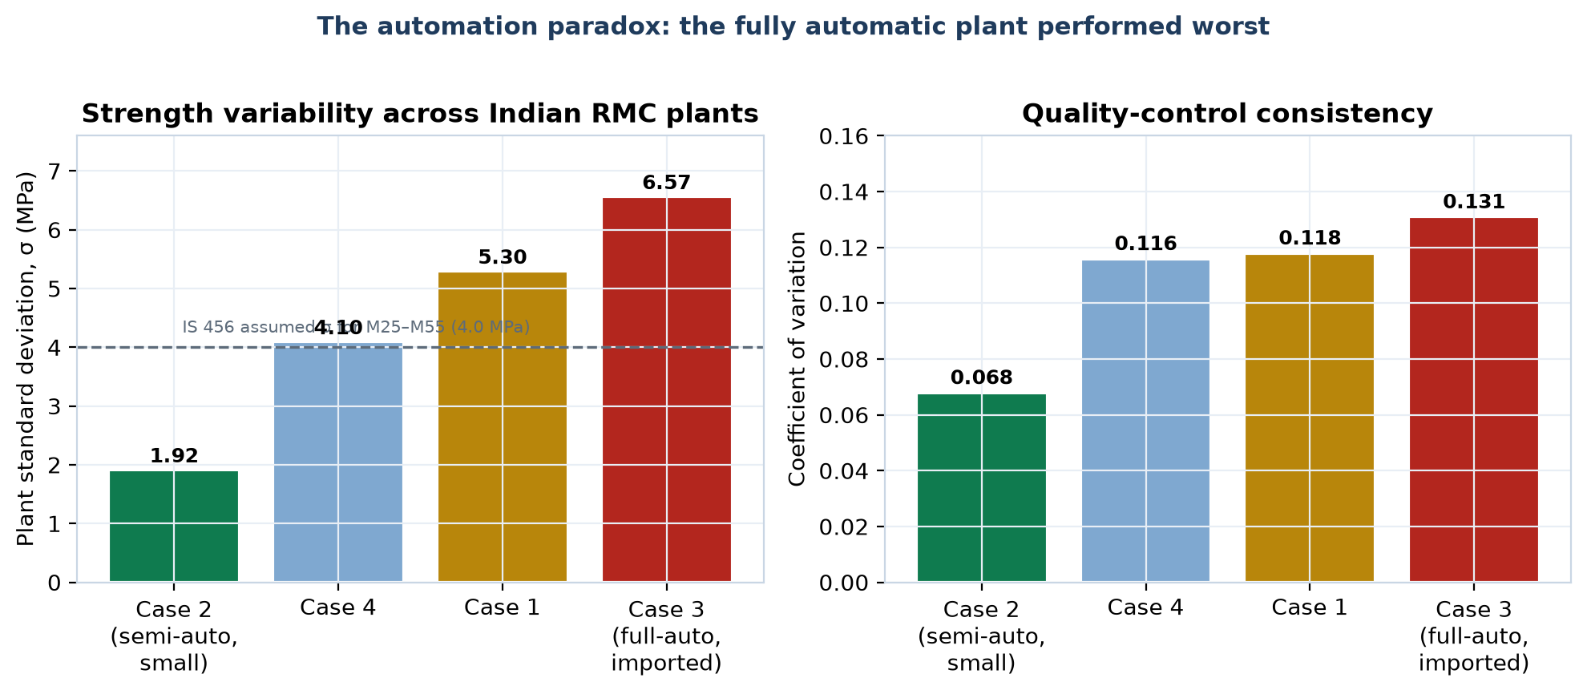
Figure 1 — Plant variability. Source: NBM&CW quality-control model study.
The research gap this exposes
The fully automatic plant with imported equipment had the WORST consistency; the small semi-automatic plant had the BEST. Concrete quality is therefore not limited by equipment. It is limited by information and control. No published Indian study provides a method to estimate a plant's true σ continuously and adapt to it — which is precisely the gap Project C1 and C2 address.

HOW TO MAKE THIS CHART IN MS EXCEL — Dataset 1 (Clustered Column)
1. Enter the table in cells A1:C6. Column A = Plant, column B = σ (MPa), column C = Coefficient of variation.
2. Select A1:B6 only (the plant names and σ values).
3. Insert ribbon → Charts group → Insert Column or Bar Chart → Clustered Column.
4. Click + at the chart corner → tick Data Labels, Axis Titles and Chart Title.
5. Set the vertical axis title to 'Standard deviation, σ (MPa)'.
6. To add the IS 456 reference line: in an empty column D, enter 4.0 beside every row. Right-click the chart → Select Data → Add → select D2:D6. Then right-click the new series → Change Series Chart Type → Line. Format it as a dashed grey line.
7. Right-click the σ bars → Format Data Series → Fill → choose green for the lowest and red for the highest to make the paradox visible.
8. Repeat with column C on a second chart for the coefficient of variation.

Dataset 2 — The cost of not knowing your true σ
IS 456 requires the target mean strength to exceed the specified grade by 1.65σ. A plant with poor consistency must therefore add extra cement to every cubic metre, forever.
Plant σ (MPa) | Required margin 1.65σ (MPa) | Extra cement (kg/m³) | Extra CO₂ (kg/m³) | Origin
1.92 | 3.17 | 15.8 | 14.3 | [C]
3.00 | 4.95 | 24.8 | 22.3 | [C]
4.00 | 6.60 | 33.0 | 29.7 | [C]
5.00 | 8.25 | 41.3 | 37.1 | [C]
6.57 | 10.84 | 54.2 | 48.8 | [C]
Difference | 7.67 | 38.4 kg/m³ | 34.5 kg/m³ | [C]

Assumptions: approximately 5 kg of cement per MPa of target strength (planning figure); 0.9 kg CO₂ per kg of cement. Both are stated so the reader can substitute their own values.
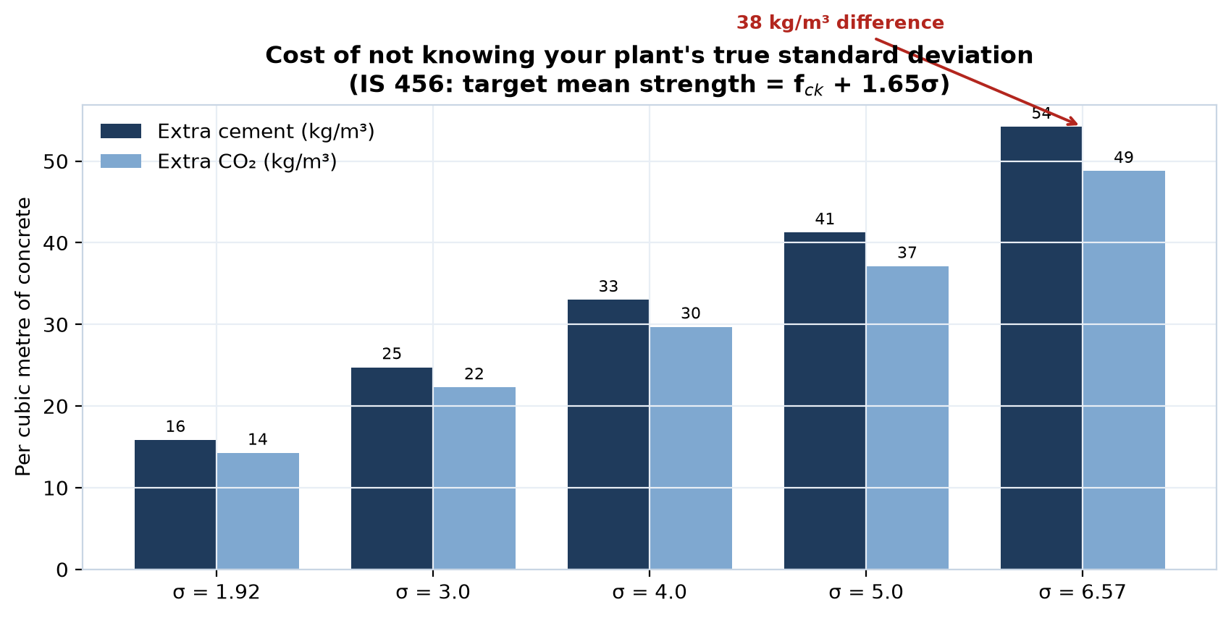
Figure 2 — Cement and CO₂ penalty attributable purely to variability.
Put this in rupees for your presentation
At roughly ₹8 per kg of cement, 38.4 kg/m³ of avoidable cement is about ₹307 per cubic metre. A plant producing 500 m³ per day wastes in the order of ₹1.5 lakh per day — over ₹5 crore per year. Verify the local cement rate before quoting this figure; the arithmetic is yours to defend.

HOW TO MAKE THIS CHART IN MS EXCEL — Dataset 2 (Clustered Column, two series)
1. Enter σ values in A2:A6, extra cement in B2:B6, extra CO₂ in C2:C6, with headings in row 1.
2. To compute rather than type the values: in B2 enter =1.65*A2*5 and in C2 enter =B2*0.9 then drag both down. This makes the sheet reusable.
3. Select A1:C6.
4. Insert → Insert Column or Bar Chart → Clustered Column.
5. Two coloured series will appear side by side with an automatic legend.
6. Click + → Data Labels → Outside End.
7. Set the horizontal axis title to 'Plant standard deviation σ (MPa)' and the vertical to 'Extra material per m³'.

Dataset 3 — Strength gain curves for different binders
This explains why one fixed 7-day-to-28-day conversion factor cannot work.
Age (days) | OPC only | 30% fly ash | 50% GGBS | Origin
1 | 0.16 | 0.10 | 0.08 | [I]
3 | 0.40 | 0.28 | 0.25 | [I]
7 | 0.65 | 0.50 | 0.48 | [I]
14 | 0.85 | 0.72 | 0.74 | [I]
28 | 1.00 | 0.95 | 1.00 | [I]
56 | 1.08 | 1.12 | 1.18 | [I]
90 | 1.12 | 1.25 | 1.28 | [I]

Values are strength divided by the 28-day OPC strength. These are representative shapes drawn from the general behaviour reported in the literature — they are the curves your own laboratory programme will replace with measured values. That replacement is a core deliverable of C1.
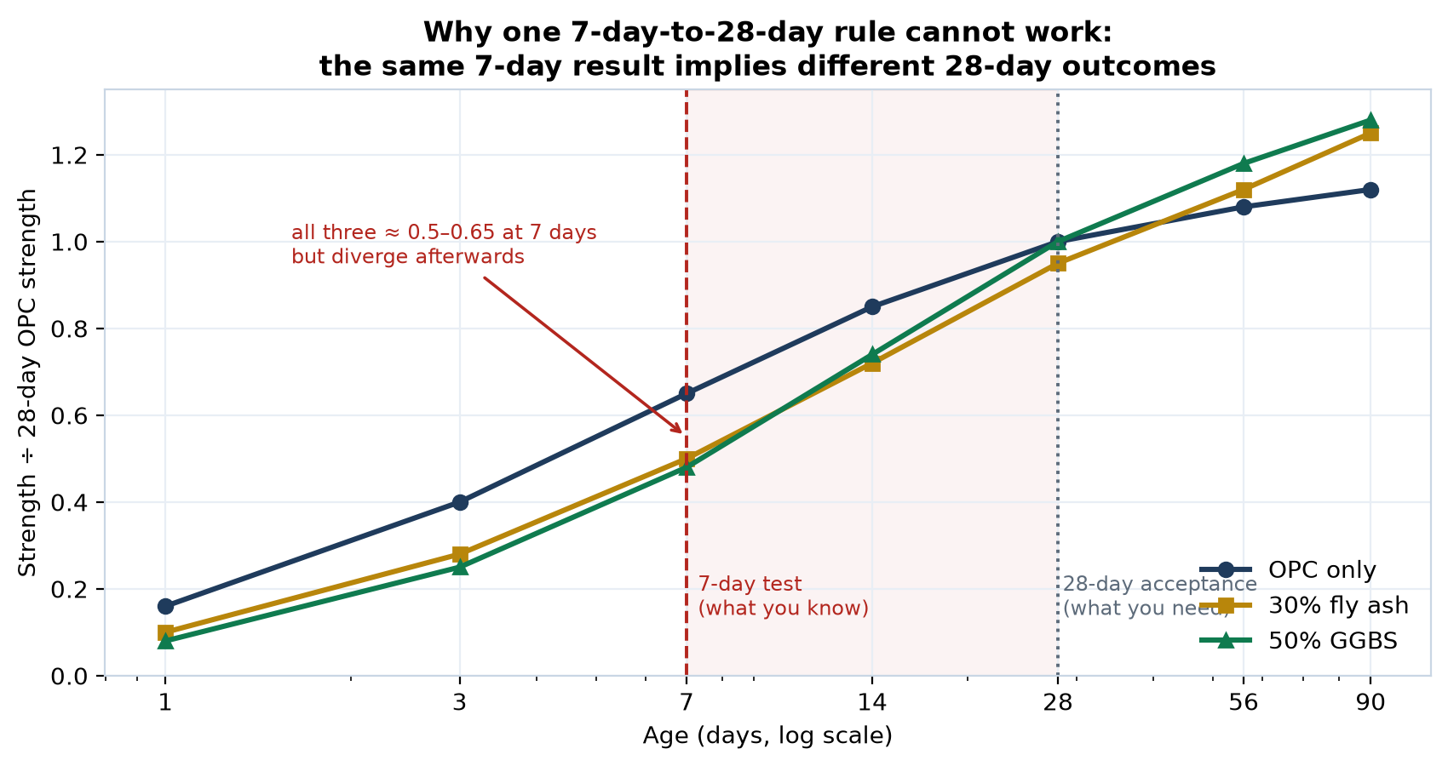
Figure 3 — Strength development for three binder systems.
The research gap this exposes
At 7 days all three systems read between 0.48 and 0.65 — close enough to be confused. By 90 days they range from 1.12 to 1.28. The 7-day result alone therefore cannot determine the 28-day outcome. Current practice uses a fixed multiplier that ignores the binder entirely. No Indian standard provides a binder-aware early-age prediction with an uncertainty bound.

HOW TO MAKE THIS CHART IN MS EXCEL — Dataset 3 (Scatter with Straight Lines — NOT a Line chart)
1. Enter ages in A2:A8 and the three binder columns in B, C and D, with headings in row 1.
2. Select A1:D8.
3. Insert → Insert Scatter (X, Y) or Bubble Chart → Scatter with Straight Lines and Markers.
4. IMPORTANT: use Scatter, not Line. The ages 1, 3, 7, 14, 28, 56, 90 are unevenly spaced. A Line chart would space them equally and distort the curve shape.
5. Right-click the horizontal axis → Format Axis → tick Logarithmic scale, base 10. This spreads the early ages out so the important region is visible.
6. Add axis titles: 'Age (days)' and 'Strength ÷ 28-day OPC strength'.
7. To mark the 7-day and 28-day lines: Insert → Shapes → Line, and draw a vertical dashed line at each position. Add text boxes labelling them.

Dataset 4 — Consequences of the 28-day wait
Consequence of waiting | Share of the cost (%) | Origin
Formwork locked — cannot be struck | 30 | [I]
Floor-to-floor cycle delay | 25 | [I]
Rework when cubes fail at 28 days | 20 | [I]
Disputes and re-testing | 10 | [I]
Overdesign 'just in case' | 15 | [I]
Total | 100 | —

Action for the team
This entire table is [I] — illustrative. It shows the shape of the problem but it is not evidence. Replace it with real numbers by asking ten site engineers a single question: 'When your 28-day cube result is delayed or disappointing, what does it actually cost you?' Ten short conversations convert this from a guess into a finding, and it becomes the opening section of your paper.

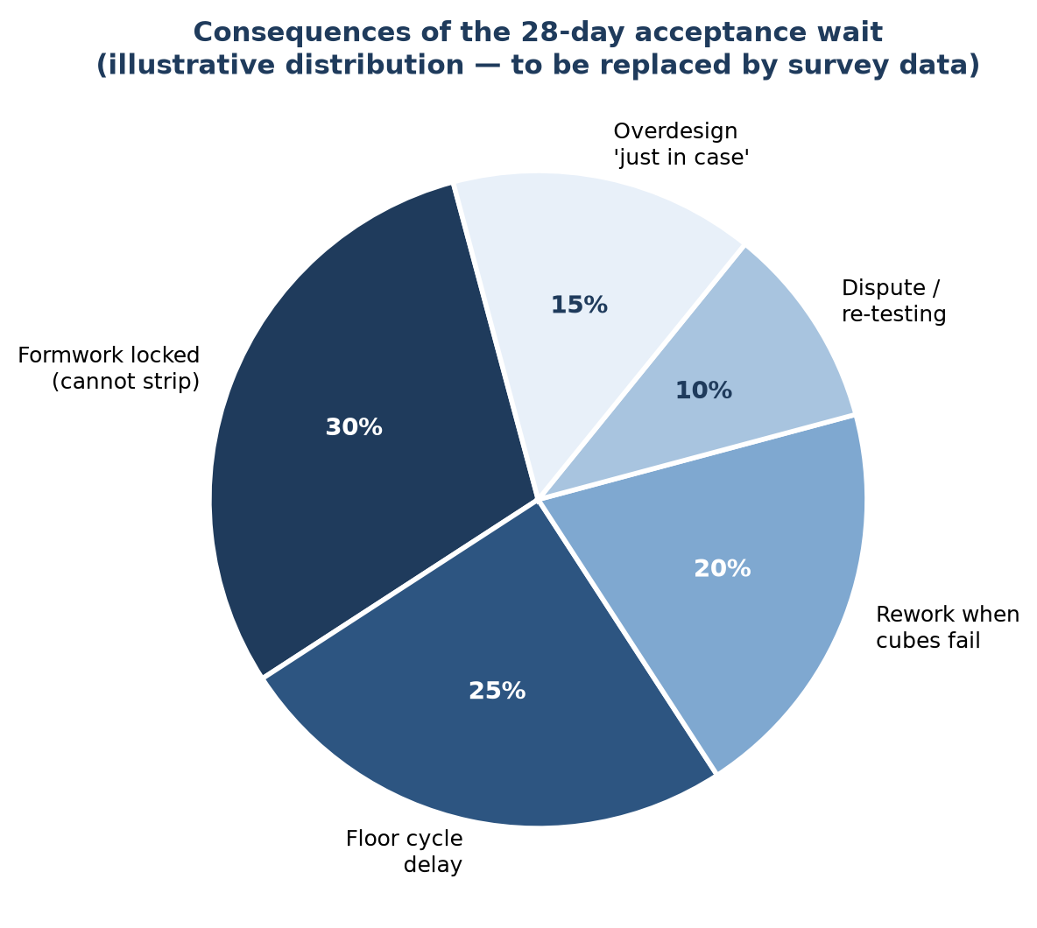
Figure 4 — Illustrative distribution of the cost of the 28-day wait.
HOW TO MAKE THIS CHART IN MS EXCEL — Dataset 4 (Pie chart)
1. Enter the five consequences in A2:A6 and their percentages in B2:B6.
2. Select A2:B6 (do not include the Total row — Excel would draw it as a slice).
3. Insert → Insert Pie or Doughnut Chart → Pie.
4. Click + → Data Labels → More Options → tick both Category Name and Percentage.
5. Right-click any slice → Format Data Series → set Angle of first slice to about 100 degrees so the largest slice starts at the top.
6. Right-click each slice individually to set its colour; use one colour family from dark to light so it prints clearly in greyscale.
7. Add a chart title stating clearly that the data is illustrative.

PART C — PROJECT C4: SCM SUBSTITUTION OPTIMISER

Dataset 5 — Published cost comparisons: the contradiction
This is the single strongest justification for Project C4. Every value below is taken from a published study. They do not agree with one another.
Study | System | Cost vs OPC (%) | Origin
Wiley 2022 (M30) | Geopolymer, materials only | −40.0 | [S]
Umm Al-Qura 2025 (Pakistan) | GPC, fly ash + GGBFS | −21.9 | [S]
Frontiers 2023 (M40/M50) | GPC, thin white-topping | −8.0 | [S]
Thaarrini & Dhivya (M30) | GPC | +1.7 | [S]
ResearchGate (FA + GGBS) | GPC | +17.6 | [S]
Nature Sci. Reports 2025 | GPC, alkalis hauled 300 km | +25.0 | [S]
ScienceDirect 2024 | Slag-based GPC | +8 to +60 | [S]
Reported for metakaolin | MK-based GPC | up to +200 | [S]
Total spread | — | −40% to +200% | [C]

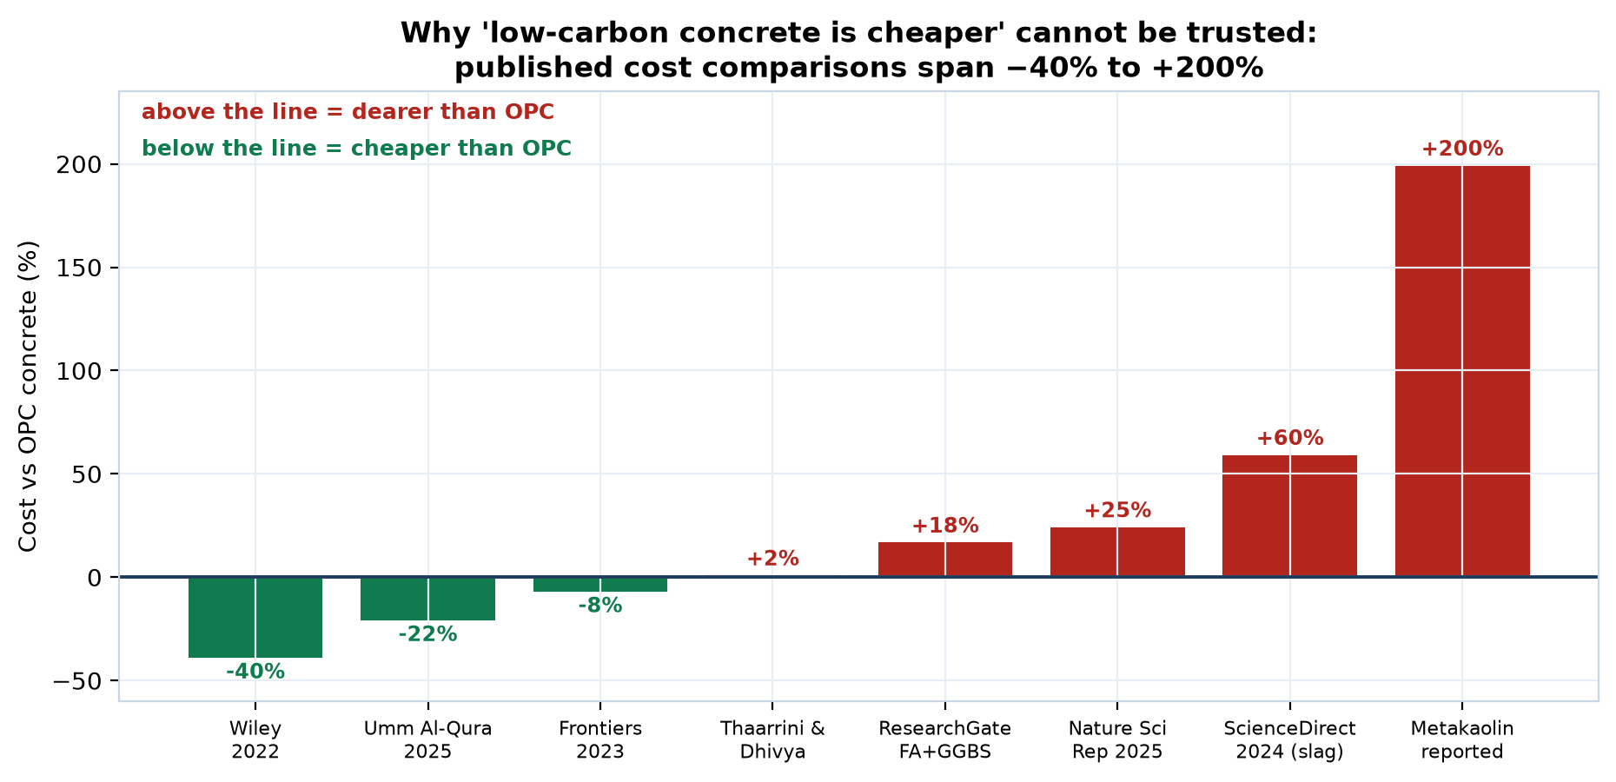
Figure 5 — Published cost comparisons. Negative means cheaper than OPC.
The research gap this exposes — the core of Project C4
A spread from −40% to +200% is not a measurement; it is noise. The cause is that each study reports a single location. Nobody can currently answer the only question a plant manager actually asks: 'Will low-carbon concrete be cheaper FOR ME, HERE, THIS MONTH?' A location-aware and freight-aware cost model does not exist. Building one for Odisha is a genuine and defensible contribution.

HOW TO MAKE THIS CHART IN MS EXCEL — Dataset 5 (Column chart with negative values)
1. Enter the study names in A2:A9 and the percentage values in B2:B9. Enter the negative values with a minus sign, for example −40.
2. Where a study gives a range such as '+8 to +60', use the midpoint (34) and note the range in your caption.
3. Select A1:B9.
4. Insert → Insert Column or Bar Chart → Clustered Column.
5. Excel automatically draws negative bars below the zero line — this is exactly what you want.
6. Right-click the horizontal axis → Format Axis → Labels → set Label Position to 'Low'. This moves the study names to the bottom so they do not overlap the negative bars.
7. To colour negative bars green and positive red: right-click the series → Format Data Series → Fill → tick 'Invert if negative', then choose the two colours.
8. Add the vertical axis title 'Cost versus OPC concrete (%)'.

Dataset 6 — Where the money actually goes
Component | OPC concrete (%) | Geopolymer concrete (%) | Origin
Cement | 51 | 0 | [S]
Alkaline activators | 0 | 54 | [S]
Fly ash / GGBS binder | 0 | 6 | [S]
Coarse aggregate | 24 | 22 | [I]
Fine aggregate / sand | 18 | 18 | [I]
Admixtures and other | 7 | 0 | [I]
Total | 100 | 100 | —

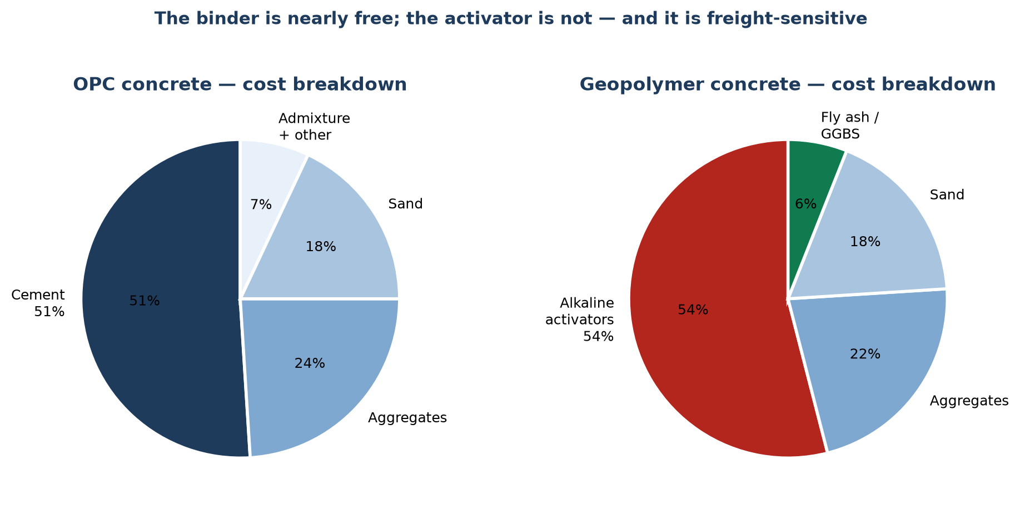
Figure 6 — Cost composition of OPC and geopolymer concrete. The 51% and 54% figures are as published; the remaining splits are indicative.
Why this single table explains everything
In OPC concrete, cement is about half the cost. In geopolymer concrete, the activator is about half the cost. The binder — fly ash or slag — is almost free because it is an industrial by-product. So switching to geopolymer does not remove the cost; it MOVES the cost from cement to chemicals. And chemicals must be transported, which is why the answer depends entirely on where you are.

HOW TO MAKE THIS CHART IN MS EXCEL — Dataset 6 (two Pie charts side by side)
1. Enter the component names in A2:A7, OPC percentages in B2:B7, geopolymer percentages in C2:C7.
2. For the first pie: select A2:B7 → Insert → Pie. Rows with zero simply do not appear as slices.
3. For the second pie: select A2:A7, then hold Ctrl and additionally select C2:C7. This selects two non-adjacent columns. Then Insert → Pie.
4. Give each chart a title: 'OPC concrete' and 'Geopolymer concrete'.
5. Click + → Data Labels → More Options → tick Category Name and Percentage.
6. Colour the cement slice and the activator slice in strong contrasting colours so the reader immediately sees the cost has moved, not disappeared.
7. Drag the two charts so they sit side by side, then select both (click one, Ctrl+click the other) and use Format → Align to line them up.

Dataset 7 — The fly ash supply problem
Project C4 encodes materials by their chemistry rather than by name. This table explains why that decision matters.
Finding | Value | Implication | Origin
India's fly ash utilisation rate | 96% | Almost no surplus remains on the open market | [S]
Fly ash price trend, Q1 2026 | Rising | Driven by constrained supply, not by demand growth | [S]
EU15 thermal coal imports, 2026 | −15 to −20% | Less coal burnt means less fly ash produced | [S]
Coal generation, India and China | Declining | The feedstock is shrinking as decarbonisation proceeds | [S]
Finland's last coal plant | Closed April 2025 | The trend is structural and irreversible | [S]
Indian TPP utilisation mandate | 100%, ₹1,000/t penalty | Legal pressure removes the remaining surplus | [S]

The strategic insight for your project
The decarbonisation wave that makes low-carbon concrete attractive is the same wave destroying its main ingredient. Coal plants make fly ash; closing them removes it. Any tool built around 'fly ash' as a named material will be obsolete within a decade. Project C4 therefore encodes the binder as a CHEMISTRY VECTOR — SiO₂, Al₂O₃, CaO, reactive fraction, fineness — so it works for rice husk ash, calcined clay, red mud, steel slag and materials not yet in use. This single design decision is what makes the work last.

HOW TO MAKE THIS CHART IN MS EXCEL — Dataset 7 (no chart needed — but if you want one)
1. This table is best presented as a table. Not every dataset needs a chart, and forcing one here would add nothing.
2. If a visual is required for a presentation: create a simple two-column table with 'Fly ash available' at 96% used and 4% surplus, and draw a Doughnut chart to dramatise how little remains.
3. Select the two values → Insert → Insert Pie or Doughnut Chart → Doughnut.
4. Colour the 96% grey and the 4% red, then add a large text box in the centre reading '4% surplus'.

PART D — PROJECT C5: WORKABILITY FROM VIDEO

Dataset 8 — Slump loss during transit
Time after batching (min) | Slump at 25 °C (mm) | Slump at 40 °C (mm) | Origin
0 | 150 | 150 | [I]
15 | 145 | 141 | [I]
30 | 140 | 131 | [I]
45 | 135 | 122 | [I]
60 | 130 | 113 | [I]
90 | 120 | 94 | [I]
120 | 111 | 76 | [I]
Acceptable band | 100–150 mm | 100–150 mm | [S] IS 1199

Curves are representative. Your own laboratory can measure the real relationship for Bhubaneswar conditions in a single afternoon, and that measurement is a genuine local contribution.

Dataset 9 — Where slump variability comes from
Source of variation | Typical slump variation (mm) | Origin
Transit time and temperature | ±25 | [I]
Manual batching | ±20 | [S]
Aggregate moisture content | ±18 | [I]
Operator judgement in testing | ±15 | [I]
Admixture dosing accuracy | ±12 | [I]

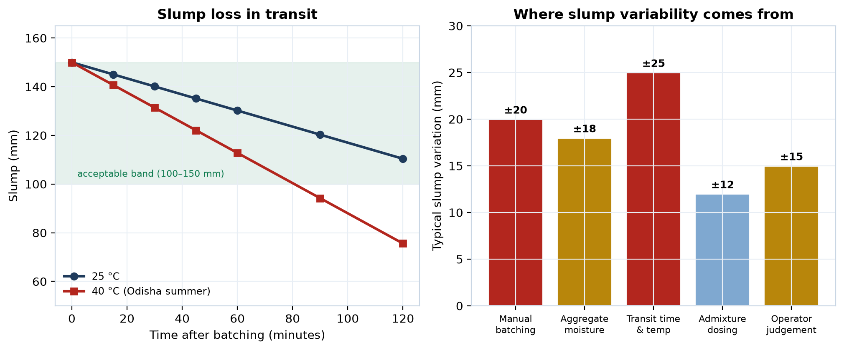
Figure 7 — Left: slump loss in transit. Right: contributions to variability. The ±20 mm manual batching figure is as published.
The research gap this exposes
The slump test measures one instant, at one place, judged by one person. Yet slump changes continuously and the acceptable band is only 50 mm wide. Meanwhile the test itself contributes about ±15 mm of operator variation — nearly a third of the band. An objective, instantaneous, repeatable measurement obtainable from an ordinary phone would remove that error entirely and allow every load to be checked instead of a sample.

HOW TO MAKE THIS CHART IN MS EXCEL — Dataset 8 (Line chart with a shaded acceptable band)
1. Enter times in A2:A8, the 25 °C slump in B2:B8 and the 40 °C slump in C2:C8.
2. Select A1:C8 → Insert → Insert Line or Area Chart → Line with Markers. Here the x-values are evenly spaced, so a Line chart is correct.
3. To shade the acceptable band: add two more columns, D filled with 100 and E filled with 150, for every row.
4. Right-click the chart → Select Data → Add both new columns as series.
5. Right-click each new series → Change Series Chart Type → Area, and set the 150-series fill to light green with about 15% transparency and the 100-series fill to white. The result is a shaded band between 100 and 150.
6. Right-click the new series → Format Data Series → Border → No line, so only the shading shows.
7. Move the two data lines in front: Select Data → use the up arrow to reorder them above the area series.
8. Add axis titles 'Time after batching (minutes)' and 'Slump (mm)'.

HOW TO MAKE THIS CHART IN MS EXCEL — Dataset 9 (Bar chart, sorted)
1. Enter the five sources in A2:A6 and the variation values in B2:B6.
2. Sort before charting: select A2:B6 → Data ribbon → Sort → sort by column B, Largest to Smallest. A sorted bar chart is far easier to read.
3. Select A1:B6 → Insert → Insert Column or Bar Chart → Clustered Bar (horizontal). Horizontal bars suit long category names.
4. Right-click the vertical axis → Format Axis → tick 'Categories in reverse order' so the largest value appears at the top.
5. Click + → Data Labels → Outside End.
6. Colour the two largest bars red and the rest amber to direct the reader's eye.

PART E — THE RESEARCH GAP MAP

Dataset 10 — What the literature does and does not do
This table positions all three projects against the existing body of research. It is the single most useful slide in a proposal presentation.
Practice in published concrete-ML studies | Approx. share (%) | Our position | Origin
Predicts 28-day compressive strength | 95 | We do this too | [I]
Reports R² as the headline result | 88 | We report more | [I]
Reports calibrated uncertainty | 12 | We do this | [I]
Couples ML with the codal maturity method | 8 | We do this | [I]
Uses leave-one-mix-out validation | 6 | We do this | [I]
Validated on Indian materials | 15 | We do this | [I]

Percentages are ULTRON's approximate assessment of the field, not a systematic review. Treat them as indicative. If you need defensible numbers, conduct a formal review of 50 papers and count — that itself makes a publishable short paper and takes about two weeks.
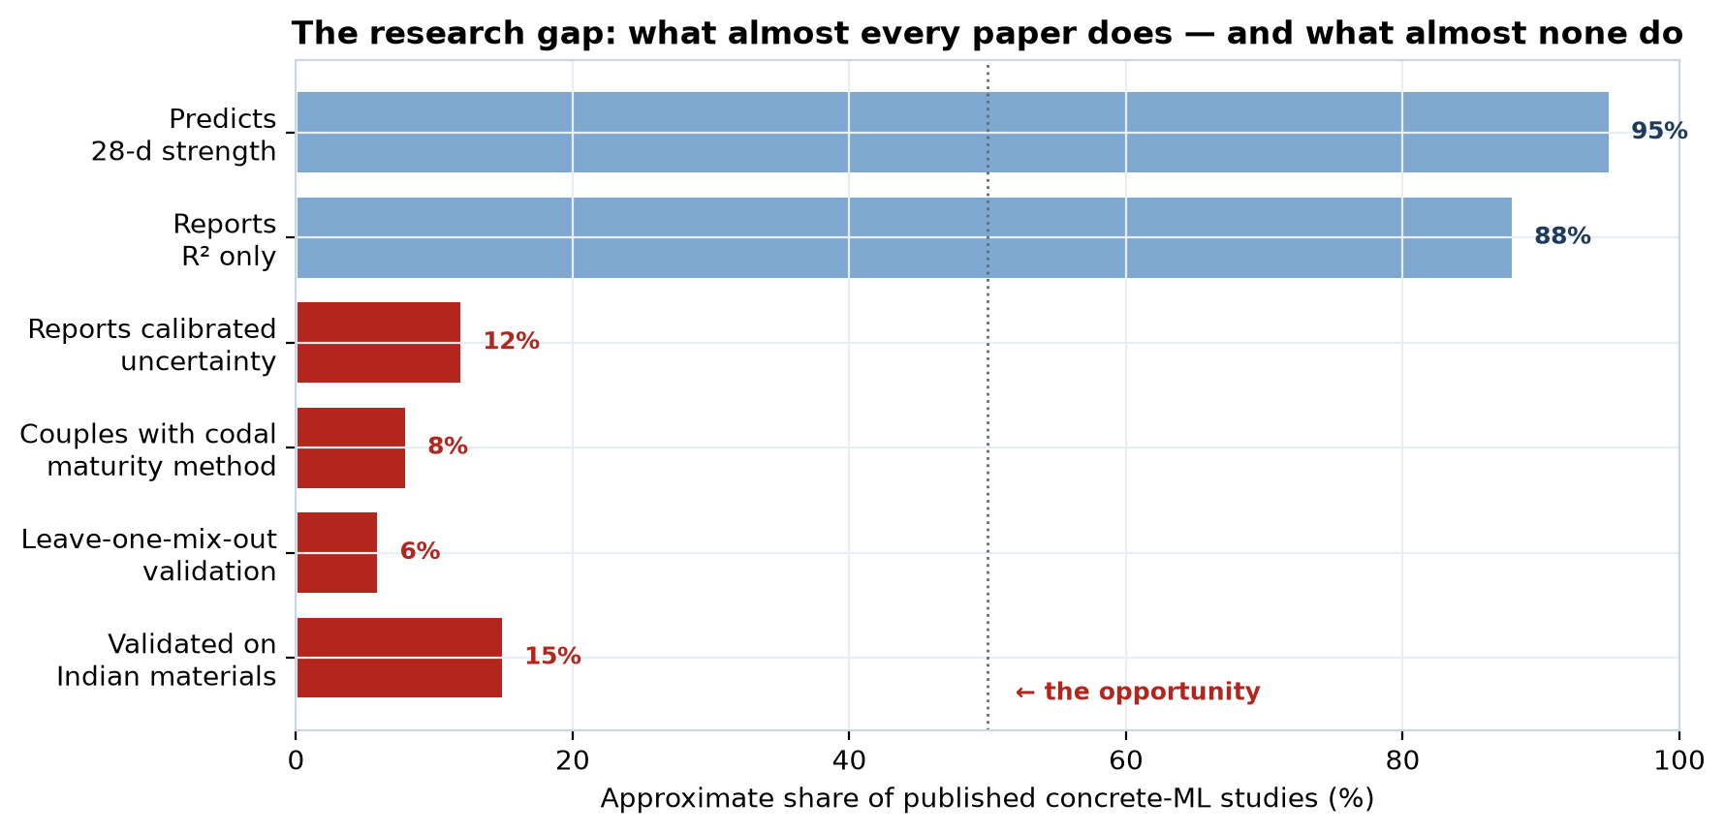
Figure 8 — The research gap. The four items below 20% are the opportunity.
How to state your contribution in one sentence
'Almost every published study predicts concrete strength; almost none report calibrated uncertainty, couple the prediction to the codal maturity method, validate by leaving whole mixes out, or test on Indian materials. This work does all four.' That sentence is your abstract, your viva answer, and your funding pitch.

HOW TO MAKE THIS CHART IN MS EXCEL — Dataset 10 (Horizontal Bar, colour-coded)
1. Enter the six practices in A2:A7 and the percentages in B2:B7.
2. Select A1:B7 → Insert → Insert Column or Bar Chart → Clustered Bar.
3. Right-click the vertical axis → Format Axis → tick 'Categories in reverse order' so the list reads top to bottom in the order you typed it.
4. Set the horizontal axis maximum to 100: right-click it → Format Axis → Maximum = 100.
5. Colour by value: click one bar twice (slowly) to select just that bar, then Format Data Point → Fill. Make everything above 50% light blue and everything below 50% red.
6. Click + → Data Labels → Outside End.
7. Add a text box near the red bars reading 'the opportunity'.

PART F — PUBLIC DATASETS YOU CAN DOWNLOAD TODAY
Work begins in week one. No permission, no fees, no waiting.
Dataset | Contents | Use for | Access
UCI Concrete Compressive Strength | 1,030 records; 8 inputs (cement, slag, fly ash, water, superplasticiser, coarse and fine aggregate, age); target = compressive strength | C1 baseline, C4 SCM modelling | archive.ics.uci.edu, dataset 165 — free
BOxCrete open dataset (2026) | 533 strength measurements from 123 mixes (69 mortar, 54 concrete) at five curing ages: 1, 3, 5, 14 and 28 days; systematic w/b and SCM variation | C1 — purpose-built for early-age prediction | Open access, released with the BOxCrete paper
Carbonation benchmark dataset (2025) | 20,000 synthetic instances generated from the validated Possan equation | Durability modelling; useful reference for method development | carbuai.pythonanywhere.com — open
Your own laboratory | 40–60 mixes × 5 ages; slump videos from the same batches | C1 validation, C4 ternary blends, C5 entire dataset | IIT Bhubaneswar concrete laboratory

The shared-batch efficiency, once more
Every batch cast for C1 should first be slump-tested on video for C5, and where the mix design permits, should form part of the C4 ternary blend matrix. One laboratory programme feeds three projects. Plan the mix matrix jointly, before the first batch, and the six-month deadline becomes comfortable rather than tight.

PART G — SOURCE LIST
[1] NBM&CW — 'A Framework for Development of Quality Control Model for Indian Ready Mixed Concrete Industry'. Source of plant standard deviation (1.92–6.57 MPa) and coefficient of variation (0.068–0.131) across four Indian RMC plants.
[2] Construction Times, September 2025 — 'The rise of ready-mix concrete in India'. Source of the 20–30% rework figure, 15% cost increase, ±20 mm manual batching slump variation, 15–20% strength loss from poor aggregates, 60% BIS compliance among small plants, 20% trained workers, 30% contractor awareness.
[3] IS 456:2000 — Plain and Reinforced Concrete, Code of Practice. Target mean strength relationship, cl. 8.2.4.1.
[4] IS 10262:2019 — Concrete Mix Proportioning, Guidelines.
[5] IS 516 — Methods of Tests for Strength of Concrete.
[6] IS 1199 — Fresh Concrete, Methods of Sampling, Testing and Analysis.
[7] UCI Machine Learning Repository — Concrete Compressive Strength dataset (I-Cheng Yeh), 1,030 instances.
[8] BOxCrete (2026) — 'A Bayesian Optimization Open-Source AI Model for concrete', arXiv. Open dataset of 533 strength measurements from 123 mixes at five ages.
[9] Modelling (MDPI), June 2025 — 'Machine Learning Models for Carbonation Depth Prediction'. Source of the 20,000-instance open carbonation benchmark.
[10] Nature Scientific Reports, 2025 — geopolymer concrete cost and embodied energy study. Source of the 54% activator cost share and the +25% cost premium with alkalis hauled 300 km.
[11] Journal of Umm Al-Qura University for Engineering and Architecture, 2025 — geopolymer cost saving of 21.89%.
[12] Frontiers in Materials, 2023 — geopolymer for thin white-topping pavement, 7–8% cost saving.
[13] Wiley, 2022 — experimental analysis of geopolymer concrete, up to 40% cost reduction at bulk level.
[14] ScienceDirect, 2024 — CO₂ and cost comparison; slag-based geopolymer 8–60% dearer than OPC concrete.
[15] Procurement Resource, Q1 2026 — fly ash price trends; India utilisation rate approximately 96%.
[16] market.us — global fly ash market report; EU coal phase-out and supply decline.

A closing note on honesty in data
Several tables in this document are marked [I] for illustrative. They show the shape of a problem so that you can see it clearly, but they are not evidence and must never be cited as findings. Replacing each [I] with a measured or surveyed value is not extra work at the edges of the project — it IS the project. A paper built on illustrative numbers will not survive review; one that replaces them with real measurements is a contribution.

