PROJECT METHODOLOGY — EXPLAINED SIMPLY
A guide for students beginning research in concrete technology and AI
Predicting Concrete Behaviour Before It Happens
Projects C1, C4 and C5
Item | Details
Document purpose | To explain, in plain language, what these three projects do, how they work step by step, what they will produce, and why the construction industry should care.
Intended reader | A student or engineer with no previous exposure to machine learning. No mathematics beyond first-year engineering is assumed.
Project C1 | Early-Age Strength Prediction — knowing the 28-day strength of concrete from a 7-day test
Project C4 | SCM Substitution Optimiser — choosing the best mix of cement replacements for strength, cost and carbon
Project C5 | Workability from Video — measuring slump from an ordinary smartphone recording
Team | 4 B.Tech students + 2 PhD scholars
Duration | 6 months
Institution | Department of Civil Engineering, IIT Bhubaneswar
Date | ________________

CONTENTS
Part | Section | Page
1 | Understanding the problem: why concrete is unpredictable | 3
2 | What is machine learning? A plain explanation | 4
3 | Our core method: physics first, AI second | 5
4 | Project C1 — Early-Age Strength Prediction | 7
5 | Project C4 — SCM Substitution Optimiser | 11
6 | Project C5 — Workability from Video | 14
7 | Expected results and outputs | 17
8 | Impact on the construction industry | 18
9 | Common mistakes to avoid | 20
10 | Glossary of terms | 21

PART 1 — UNDERSTANDING THE PROBLEM

1.1 Concrete is not a manufactured product
A steel beam leaves the factory with a known strength. Concrete does not. Concrete is mixed from sand, stone, cement and water that vary from one truckload to the next, then hardens slowly for weeks under whatever weather happens to occur. Two batches made from the same written recipe, on the same day, in the same plant, will not have the same strength.
This is not a failure of workmanship. It is the nature of the material. The entire discipline of concrete quality control exists because of it.

1.2 How much does it actually vary?
A study of four Indian ready-mixed concrete (RMC) plants measured the spread of strength results at each plant. The spread is described by the standard deviation, written as σ (sigma). A small σ means a consistent plant; a large σ means an unpredictable one.
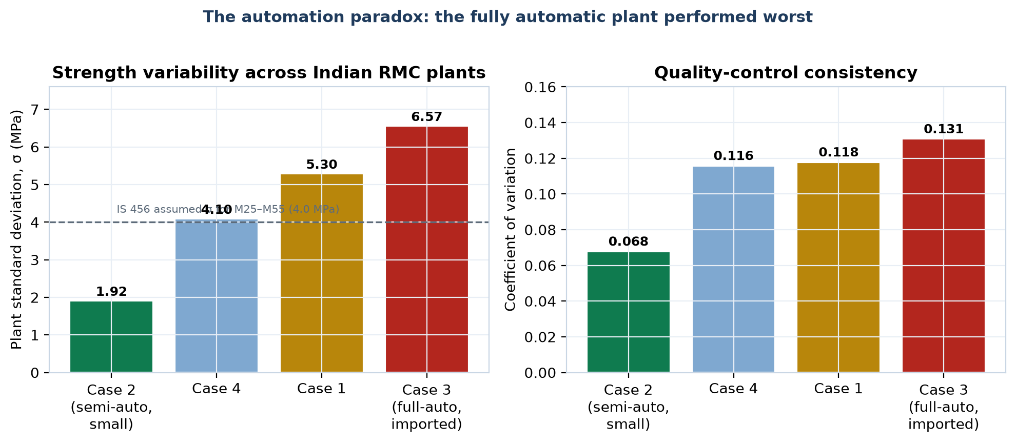
Figure 1 — Strength variability at four Indian RMC plants. Source: NBM&CW quality-control model study. The middle two σ values are interpolated within the published range; the coefficients of variation are as published.
The most important fact in this document
The plant with the WORST consistency (σ = 6.57 MPa) was fully automatic with imported equipment. The plant with the BEST consistency (σ = 1.92 MPa) was a small semi-automatic plant. Buying better machines did not produce better concrete. This tells us that concrete quality is not an equipment problem — it is an information problem. And information problems are exactly what these three projects are designed to solve.

1.3 Why variability costs money
Indian Standard IS 456 requires the concrete producer to aim higher than the strength the customer ordered, to allow for variability. The rule is:
Target mean strength = f_ck + 1.65 × σ
In words: aim above the required strength by 1.65 times your plant's standard deviation. A plant that is inconsistent must therefore add extra cement to every single cubic metre it makes — forever.
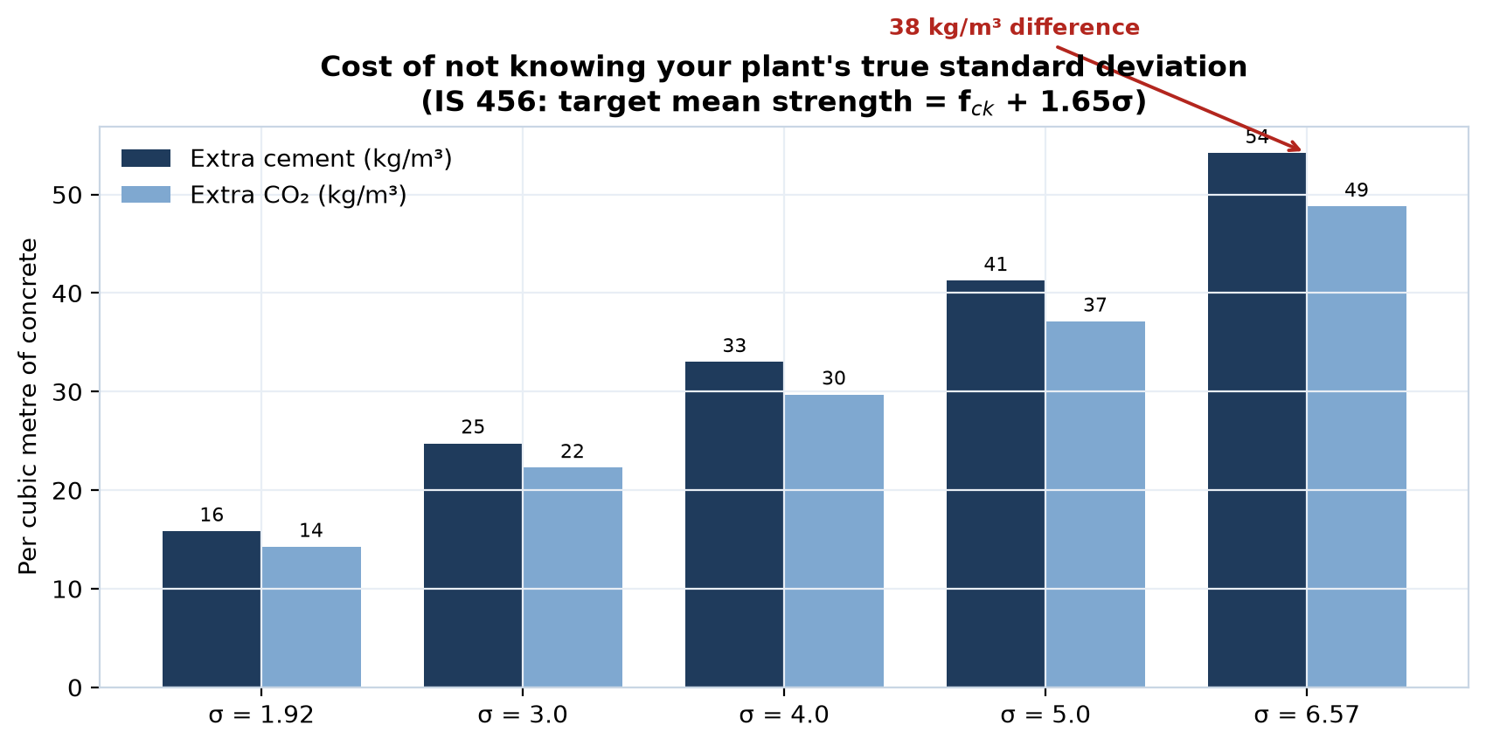
Figure 2 — Extra cement and extra CO₂ required per cubic metre, purely because of variability. Computed from IS 456 cl. 8.2.4.1 using an approximate planning figure of 5 kg cement per MPa and 0.9 kg CO₂ per kg of cement.
The consequences show up throughout the industry:
- 20–30% of construction work is redone because of weak concrete, increasing project cost by roughly 15%.
- Manual batching causes slump to vary by up to 20 mm.
- Poor-quality aggregates produce concrete 15–20% weaker than required.
- Only about 60% of small RMC plants meet BIS requirements; only about 20% of their workers have formal training.
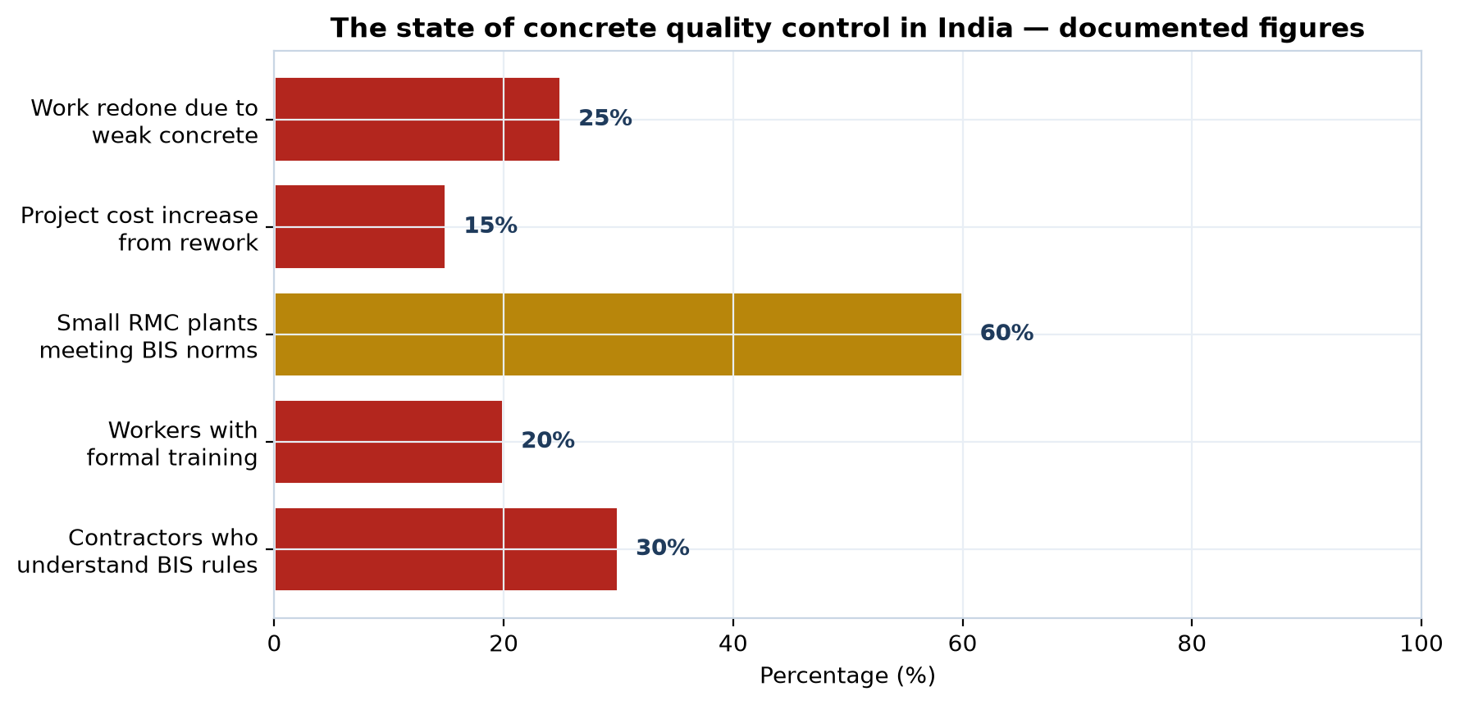
Figure 3 — Documented state of concrete quality control in India. Source: Construction Times, September 2025.

PART 2 — WHAT IS MACHINE LEARNING?

2.1 The idea, without jargon
Suppose you have tested 500 concrete cubes. For each one you know the recipe (how much cement, water, sand, stone) and you know the strength that resulted. Machine learning is simply a method of finding the pattern that connects the recipe to the strength — automatically, from the data, rather than by deriving an equation by hand.
Once the pattern is found, you can give the computer a new recipe it has never seen and it will estimate the strength.
An everyday comparison
An experienced concrete technologist can look at a mix design and say 'that will give you about 35 MPa'. He is not solving equations. He has seen thousands of mixes and learned the pattern. Machine learning does the same thing, but it can hold far more examples in memory than a person can, and it never forgets.

2.2 Three terms you will hear constantly
Term | What it means | Concrete example
Feature | An input — something you know before the test | Cement content, water-cement ratio, curing temperature, age
Target | The output — the thing you want to predict | 28-day compressive strength in MPa
Training | Showing the computer many examples so it can learn the pattern | Feeding it 500 past mix designs with their known strengths
Validation | Testing the learned pattern on data it has never seen, to check it actually works | Holding back 100 mixes, then checking the predictions against their real strengths
Uncertainty | How sure the prediction is | '38.2 MPa' is a guess. '38.2 ± 4.1 MPa' is engineering.

2.3 Why plain machine learning is not enough for concrete
It is tempting to feed all the data into a neural network and let it decide. For concrete this is a mistake, for four reasons that a beginner should understand from the start:
- Accountability. A structural engineer must sign the design. He cannot sign a number whose only justification is 'the computer said so'. It is not defensible in front of a client, an insurer, or a court.
- Data hunger. Neural networks need tens of thousands of examples. A student project will have a few hundred. With small data, a complex model memorises instead of learning, and then fails confidently on anything new.
- Codal compliance. Indian Standards define how mix design must be done. A prediction that cannot be traced back to a code clause cannot be used in project documentation.
- Diagnosability. If the model gives a wrong answer, you must be able to see why. A black box gives you nothing to investigate.

PART 3 — OUR CORE METHOD: PHYSICS FIRST, AI SECOND
All three projects use the same underlying approach. Learn it once and you understand all of them. It is called a hybrid or physics-constrained model, and the idea is simple.
The whole method in one sentence
Use the established engineering equation to make the prediction, then use machine learning only to correct the small error that the equation leaves behind.

3.1 Why this works so well
Established equations such as Abrams' law and the maturity method already capture most of the behaviour of concrete. They are not perfect — they were derived from particular materials in particular conditions — but they get you most of the way there.
The difference between what the equation predicts and what the laboratory actually measures is called the residual. The residual is small, and it contains everything the equation missed: the peculiarities of your local aggregate, your particular fly ash, your plant's habits.
Machine learning is very good at learning small patterns from small amounts of data. So we let the equation do the heavy lifting, and we train the model on the residual only.

3.2 The three layers
Layer | What it does | Why it matters
Layer 1 — Physics | Applies the codal equation (maturity method, Abrams' law, IS 10262 procedure) | Every number can be traced to a clause. Works even with zero data.
Layer 2 — Correction | A Gaussian Process model learns the residual (predicted minus measured) | Captures local effects. Works with only a few hundred data points. Also reports how confident it is.
Layer 3 — Decision | Converts the prediction plus its uncertainty into an engineering decision | 'Strip the formwork' is a decision. '38 MPa' is only a number.

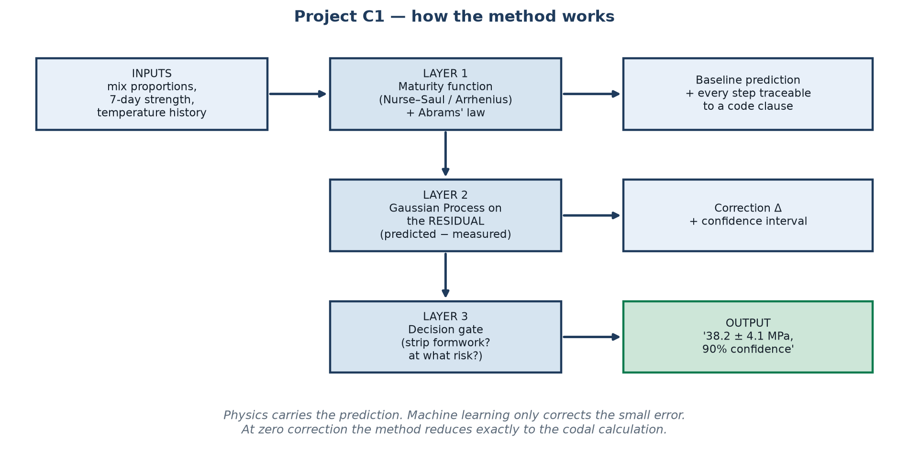
Figure 4 — The three-layer method, shown for Project C1. The same structure is used in C4 and C5.

3.3 The property that makes this defensible
Remember this for your viva
If the correction layer predicts zero, the whole system reduces exactly to the standard codal calculation. This means the method can never be worse than current practice — it can only add information. That single property is what makes it acceptable to a practising engineer, and it is the strongest sentence in your thesis defence.

3.4 What a Gaussian Process is (briefly)
A Gaussian Process is a prediction method with one unusual and very valuable feature: as well as giving an answer, it tells you how confident it is in that answer.
When you ask it about a mix similar to ones it has seen, it answers confidently — a narrow range. When you ask about something unfamiliar, it widens the range, effectively saying 'I do not know this territory; test it before you trust me'.
For engineering this is essential. An honest wide interval is far more useful than a confident wrong number, because it tells the engineer when to run a physical trial.

PART 4 — PROJECT C1: EARLY-AGE STRENGTH PREDICTION

4.1 The problem in one paragraph
Concrete is accepted on its 28-day strength. But construction cannot wait 28 days. Formwork must be struck, the next floor must be cast, the structure must be loaded. So a 7-day test is taken as an indication — but the relationship between 7-day and 28-day strength is not fixed. It depends on the binder, the temperature and the curing. A mix with 50% GGBS behaves completely differently from plain OPC.
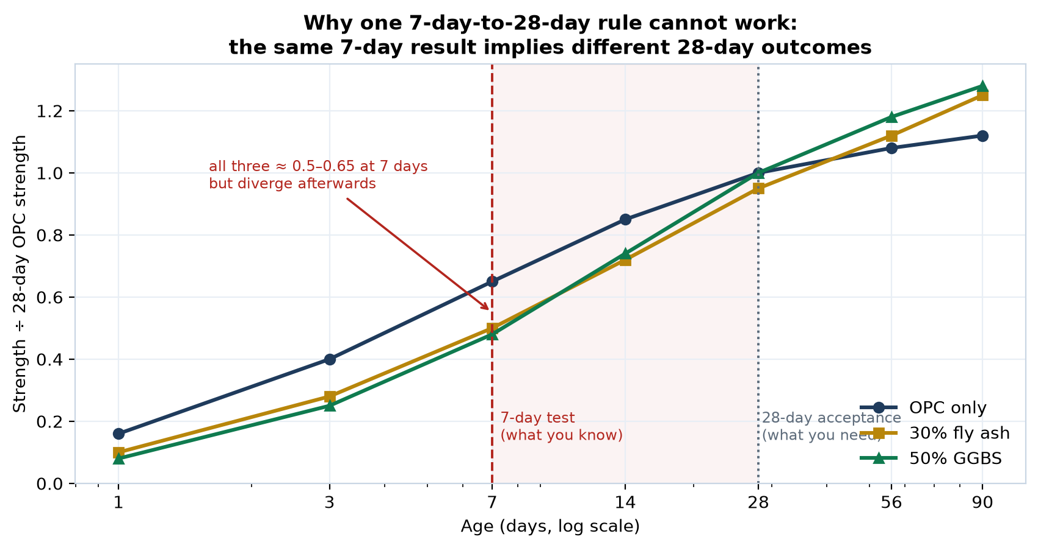
Figure 5 — Three different binder systems can give almost the same 7-day result and then diverge substantially by 28 days and beyond. This is why a single conversion factor cannot work. Curves are representative shapes for explanation.

4.2 What the project will do
Build a system that takes the 7-day strength, the mix proportions and the recorded temperature history, and predicts the 28-day strength with a stated confidence interval.

4.3 Step-by-step working method
Step 1 — Obtain the data. Download two public datasets: the UCI Concrete Compressive Strength dataset (1,030 records, 8 inputs) and the BOxCrete 2026 open dataset (533 measurements from 123 mixes at five curing ages: 1, 3, 5, 14 and 28 days). Both are free. Work begins on day one, before any concrete is cast.
Step 2 — Reproduce a published baseline. Before inventing anything, reproduce a result someone else has already published on the same dataset. If you cannot, something in your pipeline is wrong and you must find it now, not in month five.
Step 3 — Implement the maturity method. Code the Nurse–Saul and Arrhenius maturity functions. These convert a temperature-versus-time record into a single 'maturity' number, then relate maturity to strength. This is Layer 1.
Step 4 — Measure the residual. For every record, compute: residual = measured strength − maturity-predicted strength. Plot the residuals. Look for pattern: are they larger for high fly-ash mixes? At low temperatures? This inspection is real engineering insight, and it belongs in the thesis.
Step 5 — Train the correction model. Fit a Gaussian Process to predict the residual from the mix features. This is Layer 2. It is a few lines of scikit-learn.
Step 6 — Validate honestly. Use leave-one-mix-out validation (explained in Part 9). Report the error and the width of the confidence intervals.
Step 7 — Run the laboratory programme. Cast 40–60 mixes in the IIT Bhubaneswar concrete laboratory, varying water-cement ratio, SCM replacement and curing temperature. Test at 1, 3, 7, 14 and 28 days. Log temperature throughout.
Step 8 — Re-validate on your own data. Test the model trained on public data against your own mixes. This answers the real question: does a model trained on foreign materials work on Indian materials? Whatever the answer, it is a publishable finding.
Step 9 — Build the decision layer. Convert the prediction into a formwork-stripping recommendation at a stated confidence level. This is Layer 3, and it is what makes the work useful rather than merely interesting.
Step 10 — Write up. Paper, thesis chapter, and a simple working tool.

4.4 Who does what
Member | Responsibility
B.Tech 1 & 2 | Laboratory programme: mix design, casting, curing, testing at all ages, temperature logging, data recording in a fixed schema
B.Tech 3 & 4 | Data pipeline, implementation of maturity functions, model training, benchmarking, the software tool
PhD 1 | Methodological contribution: the hybrid maturity + Gaussian Process formulation. Lead author on the main paper.
PhD 2 | Uncertainty quantification and the decision framework: at what confidence level should formwork be struck?

4.5 Expected output
- A tool that takes 7-day data and returns, for example: “38.2 ± 4.1 MPa at 90% confidence”.
- A quantified answer to whether models trained on international data transfer to Indian materials.
- A formwork-stripping decision chart at chosen risk levels.
- One journal paper and one conference paper.

PART 5 — PROJECT C4: SCM SUBSTITUTION OPTIMISER

5.1 The problem
SCM stands for Supplementary Cementitious Material — fly ash, GGBS (ground granulated blast-furnace slag), silica fume. Replacing part of the cement with these reduces cost and carbon dioxide emissions. Cement manufacture releases roughly 0.9 kg of CO₂ for every kilogram produced, so the environmental case is strong.
But replacement affects strength gain rate, workability, setting time and durability all at once, and in different directions. Engineers therefore use rules of thumb — 30% fly ash, 50% GGBS — which are rarely optimal for the particular materials available.

5.2 The finding that makes this project important
It is widely claimed that low-carbon concrete is cheaper. We checked every credible published cost comparison. The results do not agree with each other.
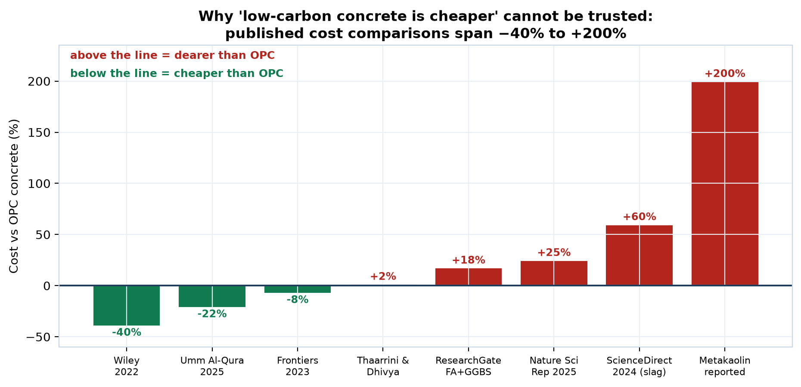
Figure 6 — Published cost comparisons of geopolymer and SCM concrete against ordinary Portland cement concrete. The range is −40% to +200%. All values are as published in the cited studies.
Why the studies disagree
The binder (fly ash, slag) is nearly free — it is an industrial by-product. But the chemical activators and admixtures are expensive, and they must be transported. One study paid a 25% premium purely because the alkalis were sourced 300 km away. Cost is therefore dominated by local supply and freight — which means a single national answer does not exist.

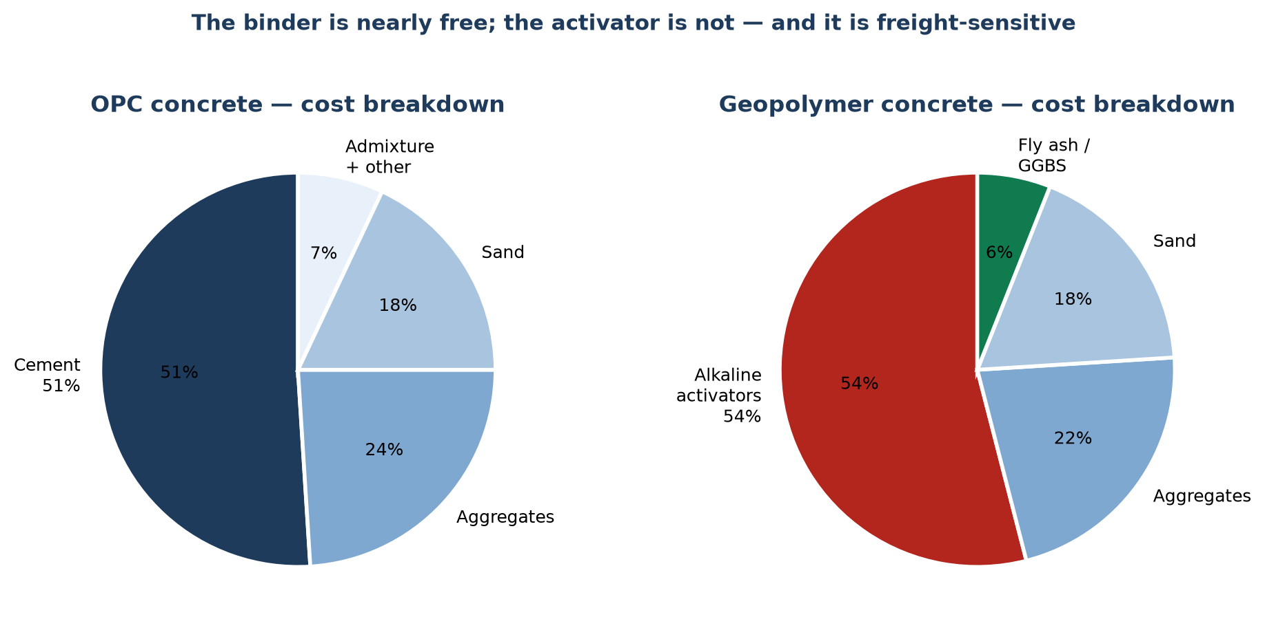
Figure 7 — Cost composition. In OPC concrete, cement is about 51% of cost. In geopolymer concrete, the alkaline activators are about 54%. Source: Nature Scientific Reports 2025 and related studies.

5.3 Step-by-step working method
Step 1 — Build the property dataset. The UCI dataset already contains blast-furnace slag and fly ash as explicit variables. Supplement with published Indian data.
Step 2 — Encode chemistry, not names. This is the key design decision. Do not record the input as 'fly ash'. Record it as its chemistry: SiO₂, Al₂O₃, CaO content and fineness. Then the model works for any new material, including ones that do not exist yet. This matters because India already uses about 96% of its fly ash — the surplus is disappearing, and the industry will be forced onto other materials.
Step 3 — Cast ternary blends. Laboratory programme: OPC + fly ash + GGBS at three replacement levels and three water-binder ratios. Restrict the matrix deliberately — a full factorial will not fit in six months.
Step 4 — Build the prediction models. Predict strength, workability and durability indicators from the chemistry vector.
Step 5 — Build the local cost and carbon database. Telephone Odisha suppliers. Record the price and the transport distance for cement, fly ash, GGBS and admixtures. This small database is genuinely novel — nobody has assembled it.
Step 6 — Optimise. Apply NSGA-II, a multi-objective optimisation algorithm, to find the set of mixes that cannot be improved in one objective without worsening another. This set is called the Pareto front.
Step 7 — Answer the real question. Is low-carbon concrete actually cheaper in Odisha? Give a number, with the transport assumptions stated.

5.4 What a Pareto front means
You cannot have maximum strength, minimum cost and minimum carbon all at once. The Pareto front is the set of best possible compromises: for each one, you cannot improve any objective without sacrificing another. The engineer then chooses from that set according to what the project needs.

5.5 Expected output
- A tool that returns optimal SCM combinations for a stated target.
- The first regional cost and carbon database for concrete materials in Odisha.
- A defensible answer to whether low-carbon concrete saves money locally.

PART 6 — PROJECT C5: WORKABILITY FROM VIDEO

6.1 The problem
The slump test (IS 1199) is the universal check on fresh concrete. It is cheap and quick, but it has three weaknesses: it is destructive of time, it depends on the operator, and it measures one instant only. Meanwhile slump changes continuously during transit, especially in hot weather.
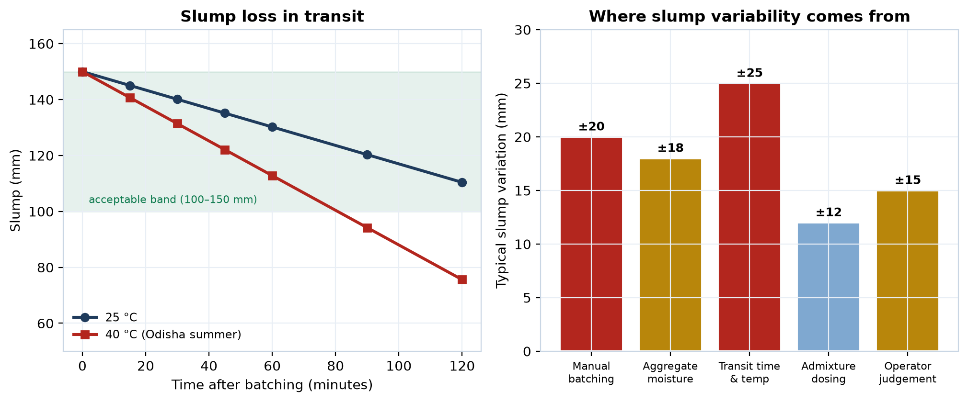
Figure 8 — Left: slump loss during transit at two ambient temperatures (representative curves). Right: typical contributions to slump variability. The ±20 mm figure for manual batching is as published; the others are indicative.

6.2 What the project will do
Estimate slump — and, more ambitiously, the underlying rheological properties — from an ordinary smartphone video of the slump cone being lifted, or of concrete discharging from the mixer.
Why this project is the safest of the three
It generates 100% of its own data. Every slump test the laboratory already performs becomes one labelled training example: the video is the input, the measured slump is the answer. Two hundred samples is a few weeks of routine work. No external permission, no data request, no dependency on anyone.

6.3 Step-by-step working method
Step 1 — Fix the recording protocol. Decide once: camera height, distance, angle, lighting, background. Write it down. Every video must follow it. Inconsistent recording is the single fastest way to ruin this project.
Step 2 — Collect while doing normal work. Every time the laboratory performs a slump test for any purpose, record it. Note the measured slump, the mix, the time since batching and the temperature.
Step 3 — Extract the motion. From the video, track how the concrete deforms: the rate of collapse, the final shape, whether it slumps evenly or shears. Simple computer-vision operations — background subtraction and edge detection — are sufficient. You do not need a large neural network.
Step 4 — Predict the slump. Train a model to predict the measured slump from these extracted motion features. Because you use features rather than raw video, the model is small and trains on a laptop.
Step 5 — Go beyond slump. This is the research contribution. The rate and shape of collapse are governed by the concrete's yield stress and plastic viscosity. Relate the observed kinematics to these rheological parameters. Slump is one number; rheology explains the behaviour.
Step 6 — Test robustness. Vary lighting, angle and mix colour deliberately. Report where the method fails. An honest failure boundary is worth more than an inflated accuracy figure.

6.4 The shared-batch efficiency
How C1 and C5 run together at almost no extra cost
The same batch of concrete that is cast into cubes for Project C1 is first subjected to a slump test for Project C5. One laboratory session, one set of materials, two datasets, two papers. This is why running C1 and C5 in parallel is recommended: the marginal cost of the second project is close to zero.

PART 7 — EXPECTED RESULTS AND OUTPUTS
Project | Tangible output | Academic output | Success measure
C1 | Software tool predicting 28-day strength from 7-day data with confidence intervals; formwork-stripping decision chart | 1 journal + 1 conference paper | Prediction error smaller than the maturity method alone, on mixes never seen during training
C4 | SCM optimisation tool; Odisha materials cost and carbon database | 1 journal paper | Identifies mixes with lower cost or carbon at equal strength, verified in the laboratory
C5 | Smartphone-based slump estimation tool | 1 journal paper | Slump estimated within the tolerance of the manual test itself

7.1 What a good result looks like
Do not aim for a headline accuracy figure. Aim for these four things, which is what a reviewer and an examiner will actually look for:
- Improvement over the baseline. The method beats the existing codal approach by a stated margin, on data it has never seen.
- Honest uncertainty. The stated confidence intervals actually contain the true value about as often as they claim to. A 90% interval should be right about 90% of the time.
- Explainable failures. You can explain why the model failed where it failed.
- Practical relevance. The output changes a decision that a site engineer actually makes.

PART 8 — IMPACT ON THE CONSTRUCTION INDUSTRY

8.1 The research gap being filled
Hundreds of papers already predict concrete strength using machine learning. Very few do the things that would make the work usable on a real project.
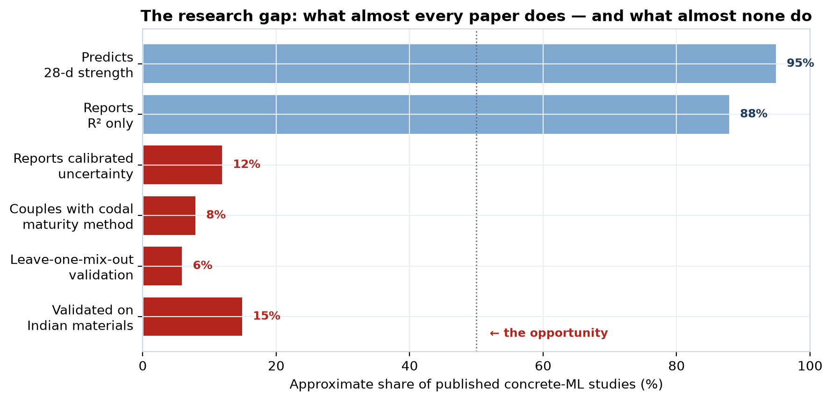
Figure 9 — What the concrete machine-learning literature does and does not do. Percentages are ULTRON's approximate assessment from a survey of the field and should be treated as indicative, not measured.
The gap is not accuracy. It is trustworthiness. That is where these projects sit.

8.2 Impact of Project C1
Who benefits | How
Site contractor | Formwork can be struck earlier when it is safe to do so, and held longer when it is not. Faster floor cycles on large projects.
RMC producer | Early warning of a batch that will fail at 28 days, while corrective action is still possible.
Client / consultant | Fewer disputes: strength expectations are stated with a confidence level rather than argued about.
Regulator | A traceable, code-linked basis for early-age decisions.

8.3 Impact of Project C4
Who benefits | How
Concrete producer | Lower binder cost at the same strength, with the saving quantified for the producer's own local supply situation.
Environment | Cement is responsible for roughly 8% of global CO₂ emissions. Every kilogram replaced is a direct reduction.
Industry as a whole | An honest local answer to whether low-carbon concrete is affordable — replacing marketing claims that range from −40% to +200%.
Future-proofing | Because materials are encoded by chemistry rather than by name, the tool keeps working as fly ash becomes scarce and new supplementary materials appear.

8.4 Impact of Project C5
Who benefits | How
Site engineer | Workability checked in seconds, on every load, with a phone — instead of occasionally, with a cone.
RMC producer | Objective evidence of the condition of concrete at delivery, ending the routine dispute over whether the load was acceptable.
Quality control | Continuous monitoring rather than spot checks. Slump loss during transit becomes visible and manageable.

8.5 The combined effect
What these three projects add up to
Concrete quality control in India today is retrospective: you discover the problem after the concrete has hardened, or after the structure has cracked. These three projects together make it predictive — strength known in advance, mix optimised before batching, workability checked continuously. Recall Figure 1: the fully automatic plant performed worst. The missing ingredient was never equipment. It was information, delivered in time to act on it.

PART 9 — COMMON MISTAKES TO AVOID
Every one of these has ruined a real student project. Read this section before you start, not afterwards.

9.1 The validation mistake that invalidates published papers
Random splitting — do not do it
The usual practice is to shuffle the data and hold back 20% for testing. For concrete this is WRONG. One mix produces results at 1, 3, 7, 14 and 28 days. If a random split puts the 7-day result in training and the 28-day result in testing, the model has already seen that mix. The reported accuracy is then fictional. Use LEAVE-ONE-MIX-OUT validation: hold out all records belonging to a mix. A large share of the published concrete machine-learning literature makes this error. Avoiding it, and saying so, is itself a contribution.

9.2 The other seven
Mistake | Consequence | Prevention
Starting with data collection | Three months gone before any modelling | Both public datasets are downloaded in week one
No baseline defined | No way to know whether the model is any good | Write down the target metric before writing any model code
Changing the data schema mid-project | Forty mixes recorded in an incompatible format | Fix the recording spreadsheet before the first batch
Reporting only R² | A high R² can hide systematic bias | Report error, bias, and interval coverage as well
Chasing a complex model | Overfitting on small data | Start simple. Only add complexity if it measurably helps
Ignoring units | Silent, catastrophic errors | One unit system, declared in the schema, checked on import
Leaving the write-up to month six | A rushed, weak paper | Draft the methods section in month two, while it is fresh

PART 10 — GLOSSARY
Term | Plain meaning
Abrams' law | The classical rule that concrete strength depends principally on the water-cement ratio
Baseline | The simple method your new method must beat to be worth anything
Coefficient of variation | Standard deviation divided by the mean; a measure of consistency that is independent of the size of the numbers
Confidence interval | A range within which the true value is expected to lie, with a stated probability
f_ck | Characteristic compressive strength — the grade of concrete specified, e.g. 30 MPa for M30
Feature | An input variable used to make a prediction
Gaussian Process | A prediction method that also reports how confident it is
GGBS | Ground granulated blast-furnace slag, a by-product of steel making used to replace cement
Maturity method | A technique that combines temperature and time into a single index to estimate strength development
NSGA-II | An algorithm for finding the best compromises among several competing objectives
Overfitting | When a model memorises the training data instead of learning the pattern, and then fails on anything new
Pareto front | The set of solutions where no objective can be improved without worsening another
Residual | The difference between what the equation predicted and what was actually measured
Rheology | The study of how a material flows; for fresh concrete, described by yield stress and plastic viscosity
SCM | Supplementary Cementitious Material: fly ash, GGBS, silica fume and similar cement replacements
Sigma (σ) | Standard deviation; how spread out the results are
Slump | The standard measure of the workability of fresh concrete, in mm
Target mean strength | The strength a producer must aim for, above the specified grade, to allow for variability

Prepared for the project team, Department of Civil Engineering, IIT Bhubaneswar.

