**Dynamic Form**

1. **Task Description**

Dynamic form that allows users to add multiple input fields dynamically. The dynamic form should also allow users to remove any input fields they have added.

1. **Task Output Screenshot**

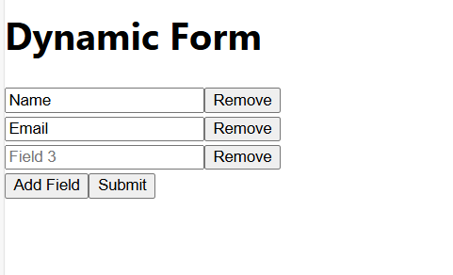

1. **Widget/Algorithm Used In Task**

* **Text Input**: Used for fields like name, email, and phone number, allowing users to input text data.
* **Button**: Used for adding new input fields and submitting the form.
* **useForm (React Hook Form)**: Manages form state, validation, and submission handling.
* **Array Mapping**: Used to render each input field dynamically based on the number of fields the user has added.
* **Local Storage**: Stores user preferences for themes (if applicable) or any persistent form data.
* **Dynamic Array State**: Manages the addition and removal of input fields, updating the form state accordingly.