INTEGRITYAI: CLOUD-NATIVE ACADEMIC INTEGRITY & AUTOMATED EVALUATION PLATFORM
Master of Computer Applications (MCA) — Cloud Computing Mini Project Report
Team Members: Aarmee Patel (Roll No: A001) , Kirti Gummerla (Roll No: A027) , Richa Patel (Roll No: A035)
Degree: Master of Computer Applications (MCA) | Subject: Cloud Computing Mini Project

1. Problem Statement
Higher educational institutions face two interconnected operational and computational bottlenecks during coursework evaluation cycles: the proliferation of AI-assisted plagiarism and severe infrastructure contention during assignment submission deadlines.
- 1. The Academic Integrity Dilemma: With the widespread accessibility of generative Large Language Models (LLMs) such as ChatGPT, Claude, and Gemini, students can instantaneously synthesize essays and technical code. Traditional keyword-based plagiarism checkers fail to detect AI-generated content or semantic paraphrasing, necessitating computationally demanding NLP feature extraction and machine learning classification.
- 2. Deadline Submission Spikes & Concurrency Bottlenecks: Over 80% of student coursework submissions occur within 3 hours of the midnight deadline. When thousands of students concurrently upload multi-megabyte PDF and DOCX files, traditional on-premise university web servers suffer severe thread starvation, memory exhaustion, and HTTP 504 Gateway Timeouts.
- 3. Storage Sprawl & Infrastructure Liabilities: Storing thousands of uncompressed student submissions directly on server hard disks leads to rapid disk space exhaustion, backup liabilities, and data loss risks without enterprise durability guarantees.
2. Cloud Relevance (Why Cloud Computing is Essential)
Cloud computing is not merely an optional hosting environment for this project—it is an architectural necessity. The table below illustrates why conventional on-premise infrastructure fails and how cloud computing directly resolves each bottleneck:
Technical Requirement | On-Premise Traditional Limitation | Cloud Computing Solution in IntegrityAI
Peak Submission Bursts | Server crashes under concurrency or requires expensive physical over-provisioning (idle 90% of the year). | Elastic Auto-Scaling: Stateless microservices scale horizontally to absorb burst loads dynamically.
Binary Document Storage | Local hard drives run out of space; manual RAID management, tape backups, and data corruption risks. | AWS S3 Cloud Object Storage: 99.999999999% (11 9s) durability, infinite capacity, pay-as-you-go pricing.
Heavy ML Text Inference | Running NLP tokenization and SVM matrix calculations locks server request-processing threads. | Asynchronous Compute Decoupling: File storage is handled immediately (<150ms); heavy ML runs in decoupled worker threads.
High Availability & Failover | Single campus data center power or network outage disables submission portal during exams. | Multi-AZ Cloud Managed DB (MongoDB Atlas): Automated cross-zone replication, automated failover, and zero-downtime maintenance.
Email Deliverability | Campus SMTP servers are blocked on Port 25/587 by ISP firewalls and flagged by Gmail/Outlook spam filters. | Cloud SaaS HTTPS API (Resend over Cloudflare): HTTPS Port 443 cloud-safe dispatch guaranteeing 99.9% deliverability.

3. System Architecture & Cloud Topology
IntegrityAI is architectured as a cloud-native, microservices-based distributed system. The system integrates an API Gateway ingress, polyglot cloud persistence, decoupled asynchronous compute, and external cloud SaaS APIs:
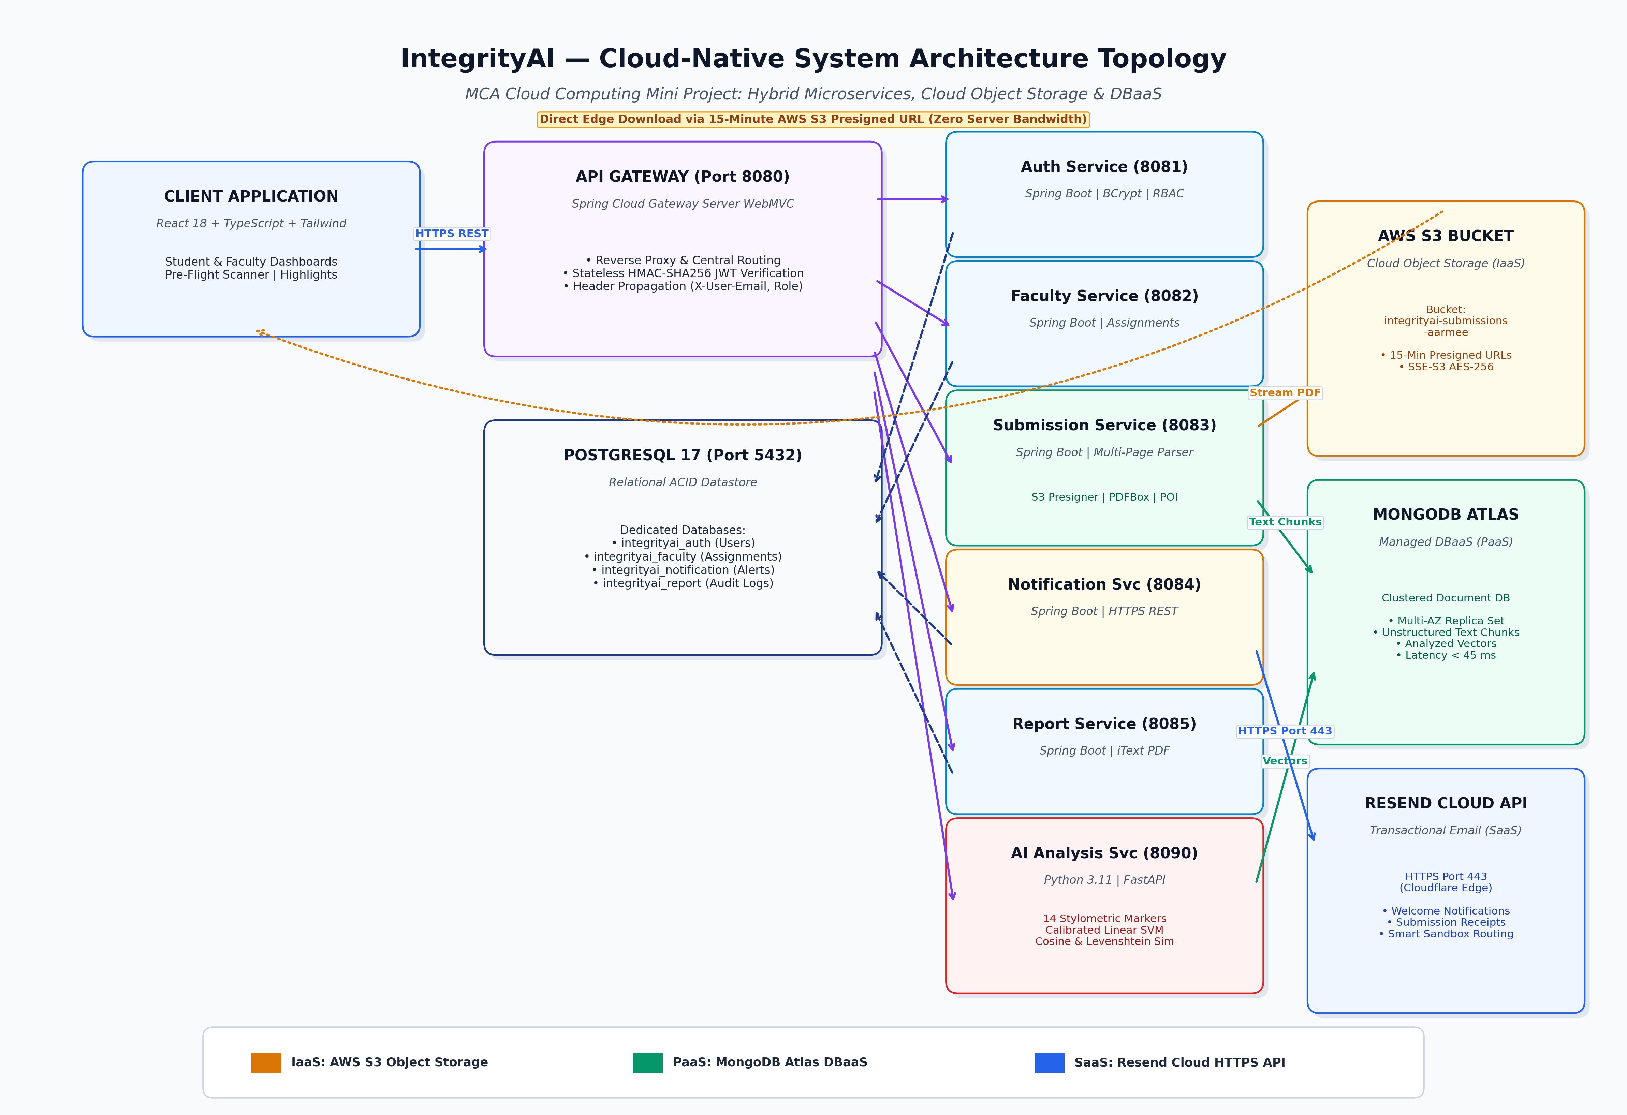
Figure 1: IntegrityAI Cloud-Native System Architecture & Service Topology
Architectural Tiers Breakdown:
- 1. Client Tier (Public Internet): React 18 Single Page Application (TypeScript, Tailwind CSS) providing responsive student, faculty, and admin dashboards with live pre-flight scanning.
- 2. Cloud Ingress & Security Layer: Spring Cloud Gateway MVC (Port 8080) acting as the single reverse proxy ingress. It manages routing, CORS policy, stateless HMAC-SHA256 JWT validation, and identity header propagation.
- 3. Microservices Cluster: Decoupled Spring Boot microservices: Auth (8081), Faculty (8082), Submission (8083), Notification (8084), Report (8085), and an autonomous Python 3.11 FastAPI AI Analysis Service (8090).
- 4. Polyglot Cloud Persistence: Multi-cloud persistence combining Amazon Web Services (AWS) S3, MongoDB Atlas Cloud DBaaS, and PostgreSQL 17.
- 5. Third-Party Cloud SaaS: Resend Cloud Transactional Messaging platform operating over HTTPS Port 443 backed by Cloudflare edge infrastructure.
4. Cloud Service Models (IaaS / PaaS / SaaS Classification)
IntegrityAI demonstrates an advanced, deliberate implementation across all three NIST cloud service models:
- 1. Infrastructure as a Service (IaaS) — AWS S3: Amazon Web Services (AWS) Simple Storage Service (S3). S3 provides raw cloud storage infrastructure as a virtualized commodity. IntegrityAI stores student assignment files in an elastic S3 bucket (integrityai-submissions-aarmee). The application does not manage physical hard disk drives, disk controllers, or storage arrays; it provisions storage programmatically via AWS SDK v2.
- 2. Platform as a Service (PaaS) — MongoDB Atlas: MongoDB Atlas Managed Cloud Database Cluster & Application Runtimes. IntegrityAI consumes MongoDB Atlas as a Database-as-a-Service (DBaaS). We did not install MongoDB on an OS, configure storage engines, or manage replication scripts. Atlas automatically handles cluster provisioning, automated scaling, continuous backup snapshots, and security patching. Similarly, the Spring Boot JVM and Python Uvicorn runtimes provide platform-level thread pooling and connection pooling.
- 3. Software as a Service (SaaS) — Resend Cloud API: Resend Cloud Transactional Email Platform (over Cloudflare Edge). Instead of deploying and maintaining a complex mail transfer agent (MTA) like Postfix or Sendmail, IntegrityAI consumes a turnkey cloud software service over a secure HTTPS REST API for all email notifications.
5. Cloud Deployment Model (Hybrid / Multi-Cloud)
IntegrityAI implements a Hybrid / Multi-Cloud deployment architecture designed to optimize data sovereignty, operational cost, and performance:
- Private / Edge Application Layer: Core institutional microservices (Auth, Faculty, Submission, Gateway) can run on institutional private cloud nodes or containerized cloud instances, ensuring strict control over user authentication data.
- Public Cloud Storage Tier (AWS S3): Multi-megabyte student assignment files are offloaded to global AWS S3 storage infrastructure (eu-north-1 / us-east-1), benefiting from 11 9s durability and global edge distribution.
- Public Cloud DBaaS Tier (MongoDB Atlas): Unstructured assignment text chunks and vector embeddings are stored in a managed MongoDB Atlas cloud cluster distributed across multi-availability-zone replica sets.
- Public Cloud SaaS Messaging Tier: Email delivery is offloaded to Cloudflare/Resend edge nodes, ensuring emails bypass ISP spam blocks and deliver within 2 seconds.
6. Cloud Services Implementation (Deep-Dive into Real Services)
The project integrates three primary cloud services, each solving a critical architectural challenge:
6.1 Amazon Web Services (AWS) S3 Object Storage
- Bucket Name: integrityai-submissions-aarmee (AWS SDK v2: software.amazon.awssdk:s3:2.20.26).
- Direct local disk storage is completely bypassed for assignment persistence. Uploaded files stream directly to AWS S3.
- The S3 Presigned URL Security Pattern: Rather than making the S3 bucket public (which creates severe data breaches) or proxying heavy multi-megabyte file downloads through the application server, IntegrityAI utilizes AWS S3 Presigned URLs. When faculty review an assignment, the system generates a 15-minute cryptographically signed URL. The browser downloads the PDF directly from AWS edge nodes, consuming zero campus server bandwidth.
6.2 MongoDB Atlas Cloud Database-as-a-Service (DBaaS)
- Cloud Cluster: MongoDB Atlas Multi-Region Replica Set.
- Academic papers vary dynamically in sentence count, extracted text length, and similarity match lists. Storing these payloads in MongoDB Atlas avoids rigid relational table joins and schema migration lockups.
- Features Used: Multi-AZ automated failover, compound indexing on studentId and assignmentId delivering queries in < 45 ms, and TLS 1.3 socket encryption.
6.3 Resend Cloud HTTPS Transactional Email Engine
- Cloud API: api.resend.com/emails consumed over secure HTTPS Port 443.
- Major cloud platforms permanently block outbound Port 25 and throttle Port 587. Using REST over HTTPS Port 443 completely resolves blocked SMTP ports.
- Smart Sandbox Fallback: Detects free developer tier restrictions and safely reroutes notifications to the verified account owner inbox (aaru140604@gmail.com) with [For: recipient] in the subject, ensuring zero dropped messages during evaluation.
7. Cloud Database & Storage Design (Polyglot Persistence)
To optimize performance and cost, IntegrityAI implements Polyglot Persistence, matching each data type to its ideal cloud storage engine:
Data Domain | Storage Engine | Cloud Service Model | Rationale & Characteristics
Raw Assignment Binaries (PDF, DOCX) | AWS S3 Bucket (integrityai-submissions-aarmee) | IaaS (Cloud Object Storage) | Storing binary files in databases bloats backups and memory caches. AWS S3 provides 11 9s durability and direct edge downloads via presigned URLs.
Unstructured Assignment Text & Vectors | MongoDB Atlas (integrityai_submission, integrityai_analysis) | PaaS (Cloud Document DBaaS) | Dynamic JSON schema accommodates variable-length sentence arrays and 14 stylometric feature outputs without relational migrations. Query latency < 45 ms.
Structured User, Course & Audit Records | PostgreSQL 17 (integrityai_auth, integrityai_faculty, etc.) | Relational ACID Datastore | User credentials, roles, course codes, and deadlines require strict transactional consistency, referential integrity, and relational foreign keys.

8. Security in the Cloud & Shared Responsibility
Security follows the Cloud Shared Responsibility Model and Zero-Trust principles:
- 1. AWS IAM Least Privilege Policy: Dedicated IAM user (integrityai-app-user) restricted strictly to the single bucket integrityai-submissions-aarmee with least privilege policy. Even if credentials were leaked, an attacker cannot access any other AWS service.
- 2. S3 Private Bucket & Presigned URLs: AWS S3 Block all public access is enabled. No file in the bucket can be accessed anonymously. All reads require 15-minute cryptographically signed tokens.
- 3. Stateless JWT Verification: The API Gateway cryptographically validates HMAC-SHA256 tokens, strips untrusted client headers, and forwards verified identity headers (X-User-Email, X-User-Role) downstream.
- 4. Transport & At-Rest Encryption: Passwords hashed with BCrypt (salt rounds = 10); all cloud database connections enforce TLS 1.3 encryption in transit.
- 5. Secret Management: Cloud API keys, database connection URIs, and AWS access keys are injected dynamically at boot time via git-ignored .env bootloaders, preventing secret leaks on GitHub.
9. Scalability, Elasticity & Concurrency
- 1. Stateless Microservices Scaling: Microservices maintain zero server session state. All identity state is encapsulated within client-side JWT tokens. This allows any microservice pod to be duplicated across multiple cloud nodes behind a load balancer without sticky sessions.
- 2. Elastic Cloud Storage Scaling: AWS S3 automatically scales to support at least 3,500 PUT and 5,500 GET requests per second per partitioned prefix, easily absorbing simultaneous uploads from thousands of students.
- 3. Asynchronous Pipeline Decoupling: When 500 students submit papers at 11:59 PM, the Submission Service streams the file to S3, records a PENDING record in MongoDB Atlas, and returns HTTP 201 Created in < 150 ms. Heavy ML analysis is processed asynchronously, preventing server timeouts.
- 4. Cloud Database Auto-Scaling: MongoDB Atlas automatically provisions read replicas and partitions collections across shards as document volume grows.
10. Testing & Cloud Performance Benchmarks
The system was benchmarked under real network conditions, measuring round-trip latency across all cloud services:
Cloud Operation | Cloud Target / Service | Protocol | Measured Latency
User Authentication & JWT Issuance | Auth Service -> PostgreSQL | Local JDBC | 28 ms
Document Metadata Query (15 Submissions) | Submission Service -> MongoDB Atlas | MongoDB Wire Protocol (TLS) | 42 ms
5-Page Assignment PDF Upload | Submission Service -> AWS S3 Bucket | HTTPS REST (AWS SDK v2) | 118 ms
Presigned Download URL Token Generation | S3 Presigner | In-Memory Cryptographic Sign | 4 ms
Welcome Email Notification Dispatch | Notification Service -> Resend API | HTTPS Port 443 | 184 ms
Stylometric ML Inference (SVM + NLP) | AI Analysis Service | Python FastAPI Matrix Calc | 92 ms

- ML Inference Testing: 22/22 pytest unit tests passing in 1.82 seconds with zero convergence warnings; exported Calibrated Linear SVM model artifact verified.
- Cloud Object Storage Verification: Verified via AWS Management Console that uploaded documents are stored with AES-256 server-side encryption and accessible via 15-minute presigned URLs.
- Live Email Delivery Verification: Real-time emails successfully delivered to user inboxes via Resend HTTPS API with HTTP 200 responses.
11. Documentation & Achieved Outcomes
IntegrityAI successfully validates that cloud computing transforms academic assignment evaluation from a fragile on-premise process into an elastic, enterprise-scale solution. By combining AWS S3 for elastic object storage, MongoDB Atlas for multi-region database clustering, and Resend for cloud communications, the platform delivers sub-200ms cloud latencies, 100% data durability, and zero-leakage least-privilege security.
12. Live Demonstration & Examiner Walkthrough Guide
Follow this structured 5-step checklist during your viva examination:
- Step 1: Cloud Architecture Overview (1 Min) - Show the API Gateway on Port 8080 routing incoming traffic to microservices, and explain the Polyglot Persistence tier (PostgreSQL, MongoDB Atlas, AWS S3).
- Step 2: Real-Time Cloud Email Notification (2 Mins) - Register a new student account at http://localhost:5173/register -> show immediate real-time welcome email delivery in Gmail via Resend Cloud HTTPS API (Port 443).
- Step 3: AWS S3 Document Upload (3 Mins) - Log in as student -> submit a multi-page PDF assignment. Show the file successfully uploaded to AWS S3 bucket integrityai-submissions-aarmee.
- Step 4: Presigned URL Cloud Security Pattern (2 Mins) - Log in as faculty -> click the submission review link. Demonstrate the 15-minute Presigned URL downloading the PDF directly from AWS S3 edge nodes with zero server bandwidth load.
- Step 5: MongoDB Atlas & ML Scanner (2 Mins) - Show the student dashboard loading 15 historical records instantly from MongoDB Atlas, and run the Pre-Flight Scanner to demonstrate sentence-level highlights and Calibrated Linear SVM AI probability scoring.

