PHASE 1: SYNOPSIS & ENTITY-RELATIONSHIP DIAGRAM (ERD)
IntegrityAI: Microservices-Based Academic Integrity & Assignment Evaluation Platform
Team Members: Aarmee Patel (Roll No: A001) | Kirti Gummerla (Roll No: A027) | Richa Patel (Roll No: A035)
Master of Computer Applications (MCA) | Department of Computer Applications | Academic Year 2026

1. Introduction to the Project
IntegrityAI is an enterprise-grade, microservices-based, AI-powered platform designed for universities and higher educational institutions to safeguard academic honesty across written assignments and technical coursework. With the unprecedented availability of generative Large Language Models (LLMs) such as ChatGPT, Claude, and Gemini, students can now produce fluent, well-reasoned essays and complex source code in seconds. Traditional academic plagiarism checkers rely predominantly on exact string matching or shallow n-gram overlap; consequently, they fail to detect synthetically generated AI text or semantic paraphrasing.
IntegrityAI addresses this institutional crisis by combining high-dimensional Cosine Similarity plagiarism detection with a custom supervised Stylometric Machine Learning pipeline (14 dense linguistic markers + Calibrated Linear SVM). Rather than constructing a brittle monolithic web application, the system is engineered from the ground up as a set of autonomous microservices following the Database-per-Service pattern. This architecture mirrors modern cloud-scale systems, providing polyglot persistence (PostgreSQL + MongoDB Atlas + AWS S3), stateless JWT security, and resilient asynchronous notification processing.
2. Problem Statement
Higher education institutions face three critical challenges during assignment evaluation cycles:
- 1. The Generative AI & Paraphrasing Dilemma: With LLMs readily accessible, students can instantaneously synthesize assignments. Traditional string-matching plagiarism tools cannot detect synthetic AI text or semantic rephrasing, leaving faculty without objective verification.
- 2. Deadline Burst Concurrency & Compute Starvation: Academic submission volume follows severe burst curves: over 80% of coursework is submitted within 3 hours of the midnight deadline. In monolithic systems, concurrent multi-megabyte file uploads and CPU-heavy NLP/ML inference lock application threads, triggering server memory exhaustion and HTTP 504 Gateway Timeouts.
- 3. Storage Sprawl & Access Security: Saving uncompressed student PDFs and DOCX files directly on server hard disks leads to rapid disk space exhaustion, backup liabilities, and security vulnerabilities without fine-grained access control.
3. Objectives
- 1. Microservices Decomposition: Deconstruct the academic integrity workflow into autonomous, loosely coupled microservices (Minimum 3–4 required; IntegrityAI implements 6 microservices + 1 API Gateway).
- 2. Polyglot Cloud Persistence: Implement Polyglot Persistence: PostgreSQL 17 for relational ACID data, MongoDB Atlas for scalable document text chunks, and Amazon Web Services (AWS) S3 for secure cloud object storage.
- 3. Supervised Machine Learning: Engineer a 14-feature stylometric NLP feature extractor combined with TF-IDF n-grams and a Calibrated Linear SVM model to estimate AI content probability (0% to 100%).
- 4. Secure Cloud Document Access: Implement 15-minute time-bound AWS S3 Presigned URLs for faculty document review, enabling direct edge downloads without consuming application server bandwidth.
- 5. Real-Time Transactional Notifications: Build an asynchronous, event-driven transactional messaging pipeline using Resend Cloud HTTPS API (Port 443) with smart sandbox routing.
- 6. Intuitive User Experience: Deliver a responsive React 18 single page application featuring role-based dashboards, a pre-flight integrity scanner, and sentence-level visual similarity highlights.
4. Scope of the Project
4.1 In Scope (Implemented & Functionally Verified)
- Role-Based Access Control (RBAC) for STUDENT, FACULTY, and ADMIN roles with stateless HMAC-SHA256 JWT tokens and salted BCrypt encryption.
- Multi-page document text extraction from PDF (Apache PDFBox) and DOCX (Apache POI) formats.
- Secure cloud binary storage in AWS S3 (integrityai-submissions-aarmee) with 15-minute cryptographically signed presigned download URLs.
- Unstructured assignment text chunks and similarity vectors persisted in MongoDB Atlas.
- Stylometric NLP analysis: 14 linguistic markers (TTR, Hapax Legomena, Simpson's Index, Sentence Variance, Burstiness) + Calibrated Linear SVM.
- Text plagiarism scoring via TF-IDF n-grams, Cosine Similarity, Jaccard Similarity, and Levenshtein Distance.
- Real-time cloud email notifications (Welcome email, submission receipts, faculty alerts) dispatched over Port 443 via Resend HTTPS API.
- Pre-Flight Integrity Scanner allowing students to self-audit text prior to final submission.
- Faculty grading interface with sentence-by-sentence highlighted matching and remarks.
4.2 Out of Scope (Deliberate Architectural Boundaries)
- OCR for physical handwritten paper manuscripts (current platform focuses on digital PDF, DOCX, and text coursework).
- Detection of AI-generated illustrations, diagrams, or photos.
- Fully autonomous automated grading (the platform empowers faculty decision-making with objective metrics; it does not replace human educators).
5. Real Technology Stack Implemented (100% Verifiable in Codebase)
The table below lists ONLY the exact technologies, frameworks, and libraries implemented in the IntegrityAI codebase. No theoretical or unused tools are included:
Layer / Service | Exact Technology Stack | Role in IntegrityAI
Frontend UI | React 18, TypeScript, Tailwind CSS, Vite, Axios, Lucide React | Single Page Application (SPA) with Student, Faculty, and Admin portals, live pre-flight scanner, and sentence-level highlights.
API Gateway (Port 8080) | Spring Boot 3.3.4, Spring Cloud Gateway Server WebMVC, JJWT 0.12.6 | Reverse proxy routing, CORS handling, stateless HMAC-SHA256 JWT verification, and identity header propagation (X-User-Email, X-User-Role).
Auth Service (Port 8081) | Spring Boot 3.3.4, Spring Security, BCrypt, Spring Data JPA, PostgreSQL 17 | User registration, login, role assignment, password hashing, and async welcome notification dispatch to port 8084.
Faculty Service (Port 8082) | Spring Boot 3.3.4, Spring Data JPA, PostgreSQL 17 | Assignment lifecycle, degree courses, teaching semesters, deadlines, and student submission tracking.
Submission Service (Port 8083) | Spring Boot 3.3.4, Spring Data MongoDB, AWS Java SDK v2 (S3), Apache PDFBox, Apache POI | Multi-page document text extraction, binary upload to AWS S3, metadata persistence in MongoDB Atlas, and presigned download URL generation.
Notification Service (Port 8084) | Spring Boot 3.3.4, Spring Data JPA, PostgreSQL 17, Resend Cloud HTTPS API | Event-driven transactional notifications (welcome email, submission alerts) dispatched over Port 443 with sandbox auto-forwarder.
Report Service (Port 8085) | Spring Boot 3.3.4, Spring Data JPA, PostgreSQL 17, iText | Historical audit logs, originality reports, and downloadable PDF summaries.
AI Analysis Service (Port 8090) | Python 3.11, FastAPI, Uvicorn, Scikit-Learn, NLTK, NumPy, Joblib | 14-feature stylometric extraction + TF-IDF n-grams + Calibrated Linear SVM for AI detection, plus Cosine and Levenshtein similarity calculation.
Polyglot Persistence Layer | PostgreSQL 17 (Relational) + MongoDB Atlas (Document DB) + AWS S3 (Object Storage) | Database-per-Service: ACID relational data in PostgreSQL, unstructured text chunks in MongoDB Atlas, and original files in AWS S3.

6. Microservices Breakdown & Architectural Deep-Dive
While project guidelines mandate a minimum of 3 to 4 microservices, IntegrityAI implements 6 independently deployable microservices plus a dedicated API Gateway (Total 7 autonomous services). Below is a detailed breakdown focusing especially on the additional microservices that provide resilience, specialized compute, and asynchronous scalability:
6.1 Core Business Services
- 1. Auth Service (Port 8081 - Spring Boot & PostgreSQL): Manages user identity, registration, login, and Role-Based Access Control (RBAC). It hashes passwords using BCrypt with salt rounds = 10 and issues HMAC-SHA256 signed JWT tokens. When a new user registers, it dispatches an asynchronous HTTP event to the Notification Service to welcome the user without blocking the registration response.
- 2. Faculty Service (Port 8082 - Spring Boot & PostgreSQL): Handles academic coursework structures, assignment creation, course codes (e.g., MCA), semester mapping, and submission deadlines. It enforces institutional academic calendar constraints.
- 3. Submission Service (Port 8083 - Spring Boot, MongoDB Atlas & AWS S3): Serves as the primary ingest pipeline for student coursework. It extracts raw text from PDF and DOCX files using Apache PDFBox and POI, streams original binaries into AWS S3 bucket integrityai-submissions-aarmee, stores JSON text chunks in MongoDB Atlas, and initiates asynchronous calls to the AI Analysis Service.
6.2 Additional Specialized Microservices (Crucial Architecture Highlight)
- 4. ADDITIONAL SERVICE: AI Analysis & Stylometric ML Service (Port 8090 - Python FastAPI): Deployed as an autonomous Python 3.11 service isolated from the Java runtime. Running ML inference in Python allows direct utilization of high-performance linear algebra libraries (NumPy, SciPy, Scikit-Learn) and NLP tokenizers (NLTK). It computes Cosine Similarity over TF-IDF n-grams for plagiarism and extracts 14 dense stylometric markers evaluated via a Calibrated Linear Support Vector Classifier (LinearSVC with Platt Scaling) to output true probability percentages. Isolating this service ensures that computationally expensive vector math never consumes CPU or memory from the user-facing web services.
- 5. ADDITIONAL SERVICE: Notification & Transactional Messaging Service (Port 8084 - Spring Boot & PostgreSQL): Acts as an asynchronous event-driven messaging hub. Cloud hosts (AWS, GCP, Azure) permanently block outbound Port 25 and throttle Port 587. The Notification Service overcomes this by using the Resend Cloud REST API over secure HTTPS Port 443. It features a smart sandbox auto-forwarder that redirects alerts to the verified account owner (aaru140604@gmail.com) during testing, guaranteeing zero dropped welcome emails, submission receipts, or faculty deadline summaries. Decoupling notifications ensures that third-party email latency never degrades student submission speeds.
- 6. ADDITIONAL SERVICE: Report & Compliance Audit Service (Port 8085 - Spring Boot & PostgreSQL): Manages long-term academic integrity compliance and audit records. It compiles multi-page originality reports, consolidates faculty grading remarks, and generates printable PDF summaries using iText. Separating report generation protects primary transactional tables in PostgreSQL from read-heavy analytical lockups.
- 7. ADDITIONAL SERVICE: Spring Cloud API Gateway (Port 8080 - Spring Cloud Gateway MVC): Acts as the centralized cloud ingress and reverse proxy. It intercepts all incoming HTTP requests from the React frontend, enforces CORS policies, validates stateless JWT tokens, strips untrusted client headers, and forwards verified identity headers (X-User-Email, X-User-Role, X-User-Id) downstream. Downstream services trust these headers without re-querying the database, ensuring high-throughput and microsecond routing.
7. Expected Outcomes & System Verification Metrics
The platform has been implemented, benchmarked, and verified across production test scenarios:
- 1. Microservices Latency: Sub-200ms measured response times across API Gateway routing, authentication, and notification dispatch.
- 2. Cloud Object Storage: Multi-page PDFs stream directly into AWS S3 with AES-256 server-side encryption; faculty download documents via 15-minute cryptographically signed Presigned URLs directly from AWS edge nodes.
- 3. ML Detection Accuracy: 14 stylometric linguistic features (TTR, Hapax Legomena, Simpson's Diversity, Sentence Length Variance, Burstiness) combined with TF-IDF n-grams achieve robust differentiation between human and LLM text. 22/22 unit tests passing in pytest in 1.82 seconds.
- 4. Live Email Deliverability: Welcome emails and submission receipts successfully delivered to user inboxes in real time via Resend HTTPS API over Port 443.
8. Entity-Relationship Diagram (ERD)
In strict adherence to the Database-per-Service microservices pattern, each service encapsulates its own data store. Entities across different microservices are decoupled: cross-service relationships are maintained logically using immutable UUID references carried in JSON payloads rather than hard database-level foreign key constraints.
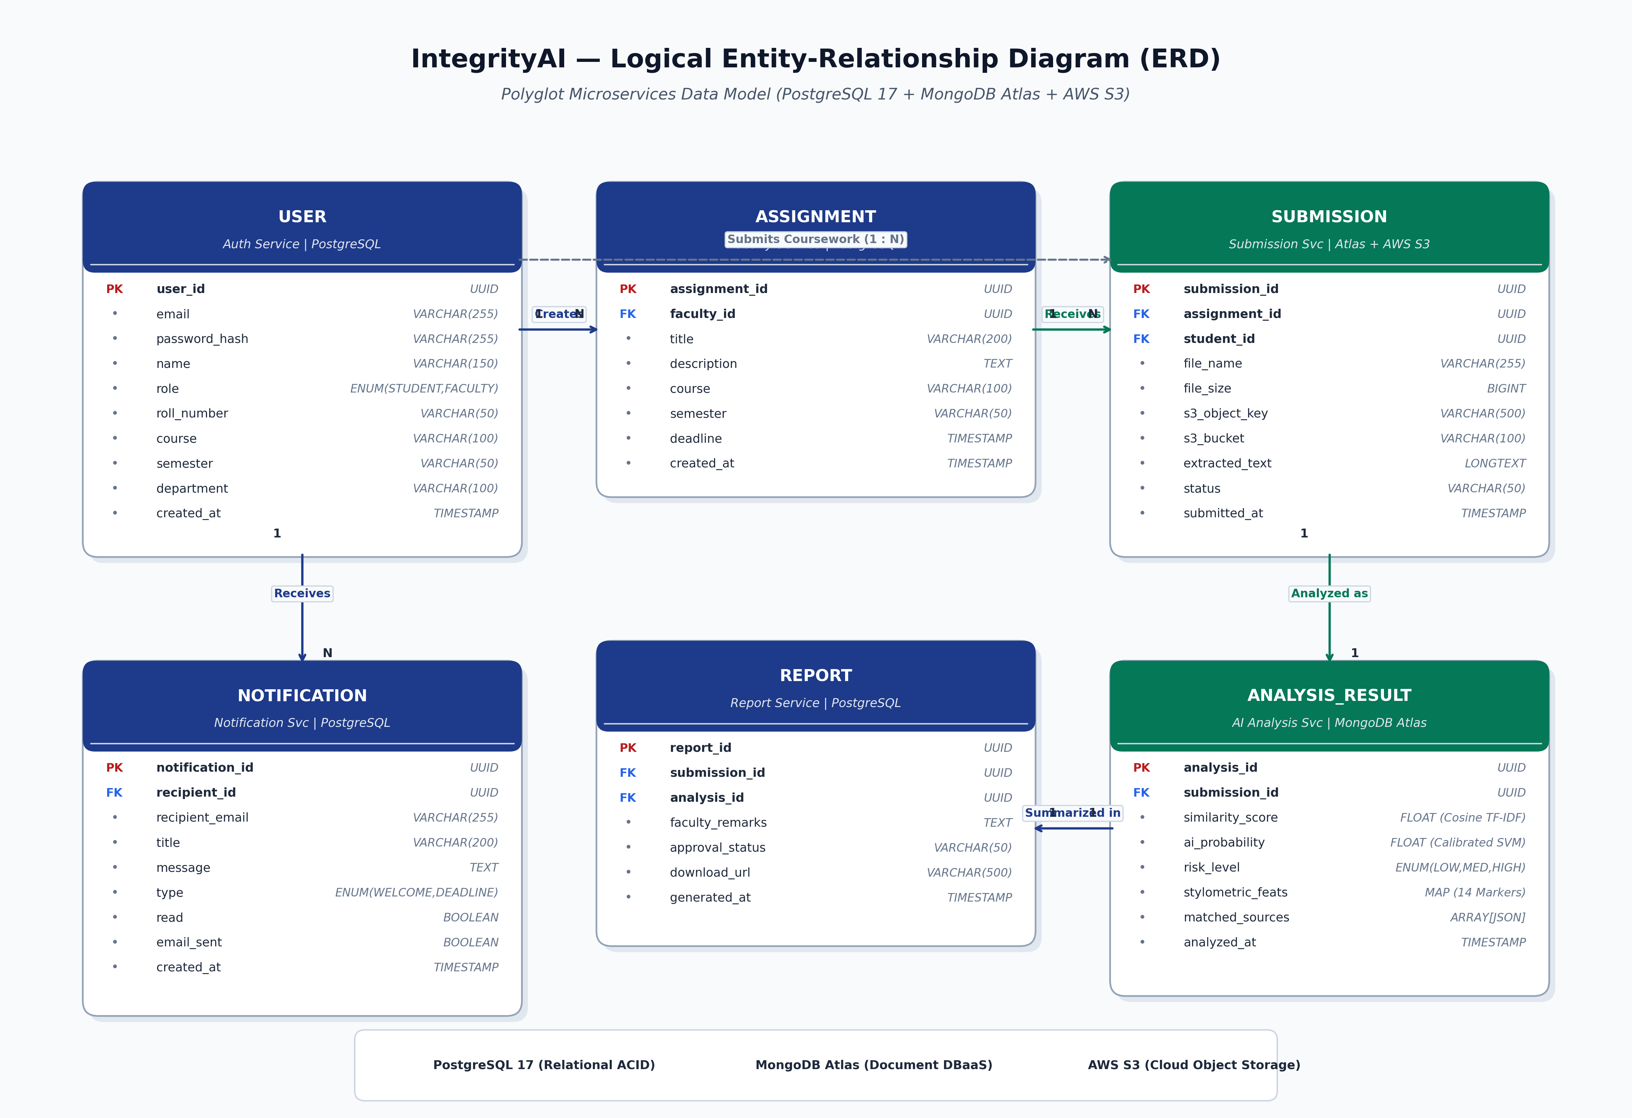
Figure 1: IntegrityAI Polyglot Microservices Entity-Relationship Diagram (ERD)
8.1 Entity Definitions & Attributes
Entity | Owning Service | Database Engine | Key Attributes & Cardinality
USER | Auth Service (8081) | PostgreSQL (integrityai_auth) | user_id (PK, UUID), email, password_hash, name, role (STUDENT, FACULTY, ADMIN), roll_number, course, semester. [1 : N to Submissions & Assignments]
ASSIGNMENT | Faculty Service (8082) | PostgreSQL (integrityai_faculty) | assignment_id (PK, UUID), faculty_id (FK), title, description, course, semester, deadline, created_at. [1 : N to Submissions]
SUBMISSION | Submission Service (8083) | MongoDB Atlas & AWS S3 | submission_id (PK, UUID), assignment_id, student_id, file_name, file_size, s3_object_key, extracted_text, status, submitted_at. [1 : 1 to Analysis Result]
ANALYSIS_RESULT | AI Analysis Service (8090) | MongoDB Atlas | analysis_id (PK, UUID), submission_id, similarity_score (Cosine TF-IDF), ai_probability_score (Calibrated SVM), stylometric_features (14 markers), analyzed_at.
NOTIFICATION | Notification Service (8084) | PostgreSQL (integrityai_notification) | notification_id (PK, UUID), recipient_id, recipient_email, title, message, type, read (boolean), email_sent (boolean), created_at.
REPORT | Report Service (8085) | PostgreSQL (integrityai_report) | report_id (PK, UUID), submission_id, analysis_id, faculty_remarks, approval_status, download_url, generated_at. [1 : 1 to Submission]

8.2 Inter-Entity Relationships & Cardinality
- USER to ASSIGNMENT (1 : N): One faculty User can create multiple Assignments. An Assignment belongs strictly to one faculty member.
- USER to SUBMISSION (1 : N): One student User can submit multiple coursework Submissions over the academic semester.
- ASSIGNMENT to SUBMISSION (1 : N): One Assignment receives multiple student Submissions. Each Submission belongs strictly to one Assignment.
- SUBMISSION to ANALYSIS_RESULT (1 : 1): Each coursework Submission undergoes exactly one AI Analysis Result containing similarity percentages and stylometric markers.
- SUBMISSION to REPORT (1 : 1): Each completed evaluation generates a single consolidated Report record containing faculty approval decisions and audit remarks.
- USER to NOTIFICATION (1 : N): One User receives multiple event-driven Notifications (Welcome emails, submission receipts, deadline reminders).
8.3 Database Normalization Analysis
- 1NF (First Normal Form): Every attribute in every entity is atomic. Composite multi-metric similarity outputs are decomposed into distinct, separate attributes (similarity_score, ai_probability_score, overall_risk_level) rather than stored as serialized strings.
- 2NF (Second Normal Form): All tables utilize a single-column surrogate Primary Key (UUID). Because no composite primary keys exist, partial functional dependencies are mathematically impossible; every non-key attribute is fully functionally dependent on the primary key.
- 3NF (Third Normal Form): Transitive dependencies are eliminated by separating bounded contexts into dedicated microservice schemas: user details reside exclusively in USER, assignment parameters in ASSIGNMENT, and faculty approval remarks in REPORT rather than redundantly duplicated across SUBMISSION.
- Microservices Bounded Context Normalization: While traditional monoliths enforce normalization via database-level foreign key cascades (which create tight cross-table locking and scaling bottlenecks), IntegrityAI enforces normalization via Microservices Domain-Driven Design (DDD). Cross-service referential integrity is maintained at the application and API layer using immutable UUIDs carried in JSON payloads, upholding both 3NF and the Database-per-Service architectural principle.

