PHASE 1
Synopsis & Entity-Relationship Diagram
IntegrityAI
AI-Powered Academic Integrity & Assignment Evaluation Platform
Team Members:-
Aarmee Patel (A001) , Kirti Gummerla (A027) , Richa Patel (A035)

1. Introduction
IntegrityAI is a microservices-based, AI-powered platform designed to help colleges and universities safeguard academic integrity across both written assignments and programming submissions. As generative AI tools such as ChatGPT, Claude, and Gemini become widely accessible, students can produce fluent, well-structured essays and functioning code in seconds — making traditional plagiarism checkers, which are built primarily around text-matching, increasingly insufficient. IntegrityAI addresses this gap by combining text-similarity detection, AI-generated-content estimation, and code-plagiarism analysis into a single explainable workflow that faculty can trust and act on.
The system is built as a set of independently deployable microservices, each responsible for a well-defined part of the workflow — authentication, submission handling, AI-based analysis, faculty review, notifications, and report generation. This architecture was chosen deliberately: it mirrors how real academic-integrity platforms are built at scale, allows each service to use the database and technology best suited to its job, and keeps the system resilient — for example, if the AI Analysis Service is temporarily unavailable, assignment submission itself does not fail.

2. Problem Statement
Educational institutions are increasingly unable to reliably verify the originality and authorship of student submissions. The core issues driving this problem are:
- AI-generated assignments — students can generate essays, reports, and even code using tools like ChatGPT, Claude, and Gemini, and current detection tools struggle to keep pace.
- Paraphrased plagiarism — reworded or lightly rephrased content evades traditional string- and n-gram-matching similarity checkers.
- Code plagiarism — students submit renamed-variable or logically restructured versions of the same solution, which simple text-diff tools fail to catch.
- Contract cheating — assignments completed by a third party are difficult to flag without deeper behavioural or stylistic signals.
- Faculty workload — manually cross-checking every submission for originality is time-consuming and does not scale with class sizes.
Existing tools only address fragments of this problem. Turnitin focuses on text similarity and offers limited support for AI-generated content; MOSS is effective for code similarity but has no text or AI-content capability; GPTZero flags AI-generated text but does not check plagiarism; Copyleaks lacks integrated code-plagiarism and academic-workflow features; and CodeGrade is oriented toward grading rather than integrity analysis as a whole. No existing solution unifies text plagiarism, code plagiarism, and AI-content detection into one explainable, risk-scored workflow — this is the gap IntegrityAI is designed to fill.

3. Objectives
- Design and build a single platform capable of analysing both text-based and code-based submissions for originality.
- Estimate the likelihood that a submission (text or code) was generated or substantially assisted by an AI tool, using multiple corroborating signals rather than a single classifier.
- Detect paraphrased plagiarism using semantic similarity (embeddings) rather than relying solely on surface-level text matching.
- Detect code plagiarism robustly, including cases involving variable renaming and logical restructuring, using AST-based comparison and token similarity.
- Generate a unified, explainable integrity risk score (Low / Medium / High) instead of a raw, hard-to-interpret similarity percentage.
- Provide faculty with a clear, actionable dashboard and downloadable report summarising findings for each submission.
- Build the system as independently deployable microservices to demonstrate scalable, production-style architecture, including asynchronous processing, service discovery, and fault tolerance.

4. Scope of the Project

4.1 In Scope
- Role-based access for Students, Faculty, and Admin users.
- Assignment creation and submission handling for PDF, DOCX, ZIP, and source-code files (Java, C++, Python).
- Automated text-similarity detection, semantic similarity checking, and stylometric writing-consistency analysis.
- Automated code-similarity detection using AST parsing, token comparison, and Levenshtein distance.
- AI-generated content estimation for both text and code, using multiple signals (perplexity, burstiness, stylometric consistency).
- Automatic, event-driven analysis pipeline triggered on submission, with asynchronous notifications.
- Faculty dashboard for reviewing reports, adding remarks, and approving or rejecting submissions.
- Downloadable PDF integrity reports per submission.

4.2 Out of Scope (Phase 1)
- Handwriting analysis for scanned, hand-written assignments (listed under Future Scope).
- Detection of AI-generated diagrams or images.
- Cross-university, privacy-preserving plagiarism detection across institutions.
- Fully autonomous grading — the platform assists faculty decision-making, it does not replace it.

5. Technologies Used
The table below summarises the technology stack, organised by architectural layer:
Layer | Technologies
Frontend | React (Student / Faculty / Admin web dashboard)
API Gateway | Spring Cloud Gateway — single entry point, routing, and auth filtering
Backend Microservices | Spring Boot (Auth, Submission, Faculty, Notification, Report Services)
AI Analysis Service | Python, FastAPI — hosts the ML/NLP pipeline as an independent service
AI / NLP Models | Sentence-Transformers (semantic similarity), Cosine Similarity, Stylometric analysis
Code Analysis | Tree-sitter (AST parsing), CodeBERT embeddings, Token similarity, Levenshtein distance, MOSS-style fingerprinting
AI-Text Detection | Perplexity & burstiness scoring, stylometric consistency, optional LLM classifier
Relational Database | PostgreSQL (Authentication Service — user accounts, roles)
Document Database | MongoDB (Submission Service — assignment metadata, files)
Messaging / Event Bus | Apache Kafka — asynchronous, event-driven communication between services
Caching | Redis — caches generated reports and frequently accessed dashboard data
Service Discovery | Netflix Eureka
Centralized Configuration | Spring Cloud Config Server
Fault Tolerance | Resilience4j Circuit Breaker — keeps submission flow working if AI service is down
Containerization | Docker (and Docker Compose for local orchestration)
Version Control | Git & GitHub

All tools above are free and open-source (or available on generous free tiers), which keeps the project fully buildable without licensing cost while still reflecting an industry-realistic microservices stack.

6. Expected Outcome
By the end of the project, IntegrityAI is expected to deliver a working, demo-ready platform where a student can submit a text or code assignment and, within a short processing window, receive an automated originality and AI-content analysis. Faculty will be able to log in to a dashboard, view a clear risk score (Low / Medium / High) with a breakdown of text similarity, code similarity, and AI-generation probability for each submission, add remarks, and approve or reject it. A downloadable PDF report will consolidate all findings for record-keeping.
Architecturally, the project is expected to demonstrate a realistic, decoupled microservices system: independent services communicating over an API Gateway and an event-driven Kafka backbone, backed by polyglot persistence (PostgreSQL + MongoDB), with resilience patterns (circuit breaker, service discovery, centralized config) in place — giving the project both academic and portfolio value.
7. Entity-Relationship Diagram (ERD)

The ERD below covers the core data entities owned across the platform's microservices — Authentication, Faculty, Submission, AI Analysis, Report, and Notification services (4 of the 6 microservices contribute the primary data model shown; Report and Notification are also represented). Each microservice owns its own entities and database, following the Database-per-Service pattern; relationships shown across service boundaries (e.g., Submission → Analysis Result) are maintained logically via foreign-key-style references carried in event payloads, not through direct cross-database joins.
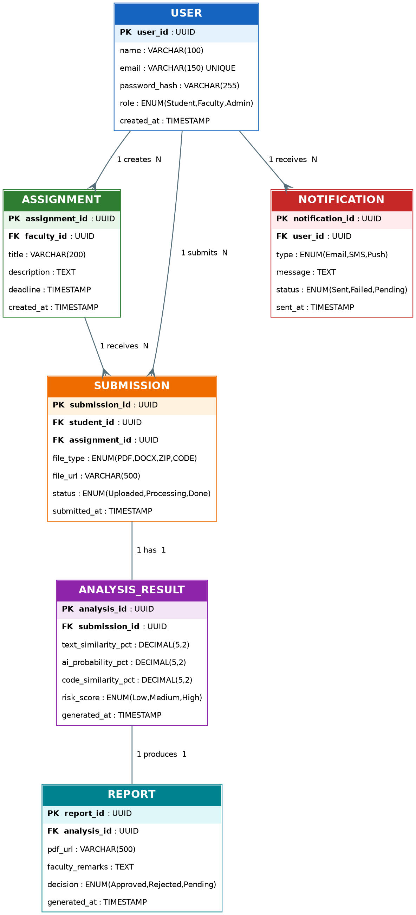
Figure 1: Entity-Relationship Diagram — IntegrityAI core data model

7.1 Entities and Relationships
Entity | Owning Service | Key Relationship | Cardinality
User | Authentication (PostgreSQL) | Creates Assignments; Submits Submissions; Receives Notifications | 1 : N
Assignment | Faculty Service  (PostgreSQL) | Belongs to a faculty User; Receives Submissions | 1 : N
Submission | Submission Service (MongoDB) | Belongs to a student User and an Assignment; has one Analysis Result | 1 : N / 1 : 1
Analysis Result | AI Analysis Service  (MongoDB) | Belongs to a Submission; produces one Report | 1 : 1
Report | Report Service  (PostgreSQL) | Generated from an Analysis Result | 1 : 1
Notification | Notification Service  (PostgreSQL) | Sent to a User (triggered by submission/analysis/feedback events) | 1 : N

7.2 Normalization Notes
- 1NF: every attribute in each entity is atomic — e.g., composite information such as multiple similarity metrics is split into separate columns (text_similarity_pct, code_similarity_pct, ai_probability_pct) rather than stored as one combined field.
- 2NF: every non-key attribute depends on the whole primary key. Since every table here uses a single-column surrogate key (UUID), partial dependency cannot occur.
- 3NF: transitive dependencies are removed by separating concerns into distinct services/entities — e.g., faculty remarks and decisions live in Report rather than being duplicated on Submission, and risk scoring lives in Analysis Result rather than being recalculated or stored redundantly elsewhere.
- Referential integrity across service boundaries (e.g., User.user_id referenced from Submission, Assignment, and Notification) is enforced at the application/event level rather than via database-level foreign keys, consistent with the Database-per-Service microservices pattern.

