PYTHON 3

## Tuple Unpacking: Using * as an Argument

By using *args in the argument section when calling function, we can unpack a Tuple/ List and treat each element in the Tuple/ List as individual argument.

Ex 1: Unpacking Tuple

Ex 2: Unpacking List

## Dictionary Unpacking: Using ** as an Argument

By using **args in the argument section when calling a function, we can unpack dictionary into keyword element.

Ex 1:

Ex 2:

Ex 3:

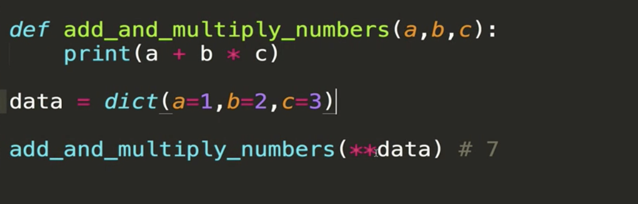

## Lambda:

- It’s a function with no name

**Syntax:**

lambda parameter: single expression

Note:

- The expression is automatically return. So, there’s no need t*o* use the return syntax.

- Lambda doesn’t need t*o* be assigned its value to any variable.



Why Lambda:

the most common use case is when you have some code that actually you need to pass the function into another function as a parameter and that function will never be used again.

## Map:

- A standard function that accepts at least 2 arguments, a function (which is usually a lambda) and an ‘iterable’.

- iterable: something that can be iterated over (lists, strings, dictionaries, sets, tuples).

- runs the lambda for each value in the iterable and returns a map object which can be converted into another data structure.

Ex:

doubles = map(lambda x: x*2, nums)

Explanation: map takes this lambda function and iterate it over every single element within nums

**Note:** Map object can only be iterated once.

## filter:

- There is a lambda for each value in the iterable.

- Returns filter object which can be converted into other iterables.

- The object contains only the values that return true to the lambda.

**Combining filter and map:**

Or we can use list comprehension:

