PYTHON 3
LINUX OS (UBUNTU)
Command Line:
1. Root /
2. Home ~
3. pwd (print working directory): will tell you the full absolute path of where you’re at.

4. cd (Change directory): followed by the absolute path of the folder will navigate you directly there.
Ex: From /User/Documents/Another_Folder, now if we want to go back to /User :
cd /User
- cd .. : back to previous directory
- cd / : back to root directory
- cd – : back to home directory
- cp: copy files
Ex: cp [Name of file that you want to copy] [New name for the new copied file]
cp Test Testcopy
- cp [Name of file that you want to copy] [Full path of the new directory that the new copied file will be located]
cp Test /home/Aaron/Documents

5. rm : remove a file (only can remove the file from the current working directory)
6. mkdir (make directory): followed by the name of the new directory will create a new child directory inside the current directory.
- mkdir [nameFolder1] [nameFolder2] : create more than 1 directory
- mkdir animals/salamanders : create a folder in different directory
7. rmdir : remove a folder (only can remove a folder in the current working directory, the folder has to be empty).
8. rm -r (recursive): remove a folder with all the content
Ex: rm -r [Folder name]
rm -r Folder
rm -f (force) : to prevent warning

rm -rf
9. man : stand for manual, use this command to get more information for other command
Ex: man [Command]
man ls
10. clear: clear command terminal
11. ls : list out content within the working directory
ls can be used to list out content from other directory
Ex: ls catPhotos/
- ls -a : used to list all files (including hidden ones)
- ls -l: for longer format
12. touch : followed by the filename and file-type extension will create a new file of that type.
Ex: touch favs.txt
13. mv (move) : files can be moved or renamed using this command, which takes two arguments: the source and the destination (where do you move the file or how do you want to rename it).
Ex 0: mv favs.txt GOAT.txt : This command will rename file favs.txt to GOAT.txt and the destination will remain the same.

Ex 1: mv GOAT.txt directory/ : move GOAT.txt to directory

Ex 2: mv Udemy_Python3/test.txt Documents/ : move test.txt file from folder Udemy_Python3 to Documents folder.

Ex 3: mv Documents/test.txt Udemy_Python3/test1.txt : move and rename test.txt file from Documents folder to Udemy_Python3 folder (Note: The current directory must be outside of both of these folders).

14. chmod: Change permission for a file
Ex 1: chmod -w : Change WRITE permission

WINDOWS OS (WINDOWS 10)
Command Line (Using PowerShell):
1. Root: \
On Windows, the home directory is the username
Ex: C: \Users\longk : this is my default home directory in my Dell laptop
2. pwd: print working directory

3. cd: change directory

4. mkdir: make directory

5. echo $null >> [file name]: Create new file in PowerShell
New-Item -ItemType file [File name] : Create new file in powerShell
Ex0: New-Item -ItemType file swing.py
Ex1: echo $null >> exp.py

6. rm -r -fo : permanently remove a folder and its content (you can’t retrieve it)

Python 2 vs Python 3
In Python 2.x print looks like this: print “hello”
In Python 3.x print looks like this: print (“hello”)
Note: it’s now a function, not a statement.
Python Interpreter
REPL: Read Evaluate Print Loop

Number and Math:
By default, division in Python returns a float value
1. ** : Exponentiation
Ex: 2 ** 3 = 8

2. % : Modulo (lay so du)
Ex: 3 % 2 = 1
6 % 4 = 2

3. // : Integer Division (integer division is floored in Python, meaning it chops off the decimal point and returns the integer remaining)
Ex: 6 // 7 = 0 (lay so nguyen)

Variable Assignment:
Variables can be:
- Assign to other variables
- Reassigned at any time
- Assigned at the same time as other variables
all, at, once = 5, 10, 15

Comment: Using the # sign

Naming Restrictions:
1. Variables must start with a letter or underscore
2. The rest of the name must consist of letters, numbers, or underscore
3. Names are case sensitive

Naming Convention:
1. Most variables should be snake_case (underscores between words)
snakeCase is fine but the convention is snake_case

2. Most variables should be lowercase, with some exceptions:
CAPITAL_SNAKE_CASE usually refers to constants (e.g PI = 3.14)

UpperCamelCase usually refers to a class (more on that later).

3. Variables that start and end with 2 underscores (called “dunder” for double underscore) are supposed to be private or left alone
Ex: __no_touchy__

Data Type Overview:
Python basic data types:
1. bool : True or False values
2. int: an integer (1, 2, 3)
3. str: (String) a sequence of Unicode characters, e.g “Aaron”
4. list: (like array in C++) an ordered sequence of values of other data types, e.g. [1,2,3] or [“a”, “b”, “c”]
5. dict: a collection of key: values, e.g. {“first_name”: “Aaron”, “last_name”: “Phan”}

Dynamic Typing:
Python is highly flexible about reassigning variables to different types:
Ex:
Food = True
print(Food) # True

Food = 10
print(Food) # 10

Note: Compare to C++, C++ is statically-typed, and variables are stuck with their originally-assigned type. If you want to assign a new data type, you have create a new variable in order to do so.
None (another version of Null in other language) represents nothingness.

Declaring Strings
String literals in Python can be declared with either single or double quotes.
my_other_str = ‘a hat’
my_str = “a cat”

Note: Either one is perfectly fine; but make sure to stick to the same convention throughout the same file.
You can do quote in quote:
Ex: msg = “he said ‘hello!’ ”
OR: msg = “he said \”hello! \” “

String Escaped Characters:
\n : New line

String Concatenation: Adding 2 String together
Concatenation is combining multiple strings together. In Python, this can be done using the “+” operator.
Ex: str_one = “Your”
str_two = “Face”
str_three = str_one + “ “ + str_two # Your face

You can use “+=” operator
a = “ice”
a += “cream” # a = a + “ cream”
Result: a = “ice cream”

Formatting String
There are several ways to format strings in Python to interpolate variables.

The new way (new in Python 3.6+) is using F-Strings
Ex:
x = 10
Formated = f ” I’ve told you {x} times already !”

The old way (Python 2 → 3.5) => .format method
x = 10
formated = “I’ve told you {} times already!” .format(x)

String and Indexes
Ex: “lol”[x] (Each letter of lol can be represent by a number 0 1 2)
if x = 0 then result: l
x can be a negative number.
Converting Data Types
In string interpolation, data types are implicitly converted into string form.
We can also explicitly convert variables by using the name of the built-in type as a function.
Ex 1: decimal = 12.23
integer = int(decimal) # 12

Ex 2: my_list = [1, 2, 3]
my_list_as_string = str(my_list) # “[1, 2, 3]”

Ex 3: str(8)
Result: “8”

IMPORTANT NOTE: DO NOT MAKE VARIABLES WITH THE NAME AS INT, STR, FLOAT… OR ANYTHING THAT IS A THING IN PYTHON.

BOOLEAN and CONDITIONAL LOGIC
1. Getting User Input:
There is a built-in function in Python called “input” that will prompt the user and store the result to a variable.

Conditional Statements
1. If Statements
if something is True:
do something
elif some other condition is True:
do something
else:
do something

Difference between == and is operator in Python
The == operator compares the values of both the operands and checks for value equality. Whereas is operator checks whether both the operands refer to the same object or not.

Truthiness
In Python, all conditional checks resolve to True or False
x = 1
x is 1 # True
x is 0 # False
- Beside False conditional checks, other things that are naturally falsy include: empty objects, empty strings, None, and zero.

Logical Operators
In Python, the following operators can be used to make Boolean Logic comparisons or statements:
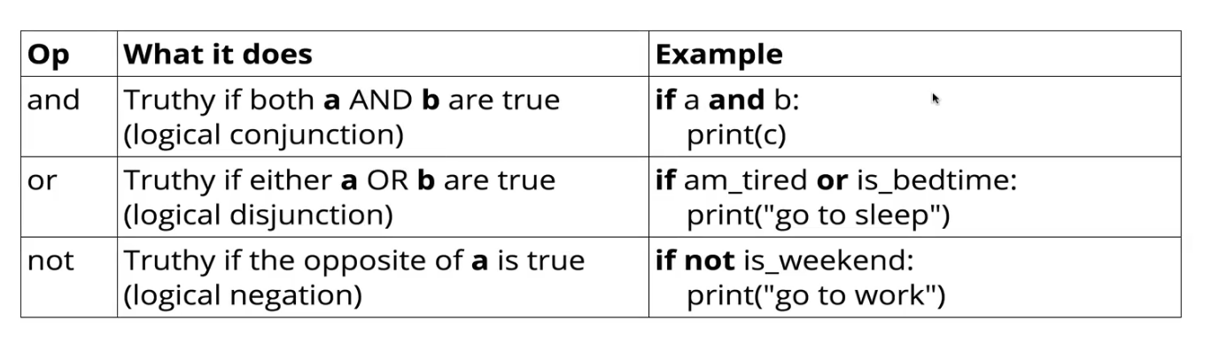
is vs. “==”
Ex 1:
a = 1
a == 1 # True
a is 1 # True

Ex 2:
a = [1, 2, 3] # a list of numbers
b = [1, 2, 3]
a == b # True # Compare in value
a is b # False – because a and b are stored in different location in memory

Ex 3:
c = b
b is c # True
“is” is only truthy if the variables reference the same item in memory.

