SRU
SR UNIVERSITY
Ananthasagar, Hasanparthy, Warangal – 506371, Telangana
SCHOOL OF COMPUTER SCIENCE & ARTIFICIAL INTELLIGENCE
PROJECT REPORT
ACADEMIC PROJECT SUBMISSION

SHIPMENT SALES TRACKING SYSTEM

A PROJECT REPORT
Submitted in partial fulfilment of the requirements for the award of the degree

BACHELOR OF TECHNOLOGY
in
COMPUTER SCIENCE AND ENGINEERING
Submitted by
Student Name | Aarnav Padhy
Roll Number | 2403A52218
Faculty Guide | Dr. N. Sharmila Banu
Academic Year | 2026-27

SR UNIVERSITY
Warangal, Telangana

ABSTRACT
━━━━━━━━━━━━━━━━━━━━━━━━━━━━━━━━━━━━━━━━
The Shipment Sales Tracking System is designed to simplify and improve the management of shipment-related sales activities through a centralized digital platform. In many business environments, shipment information and sales records are maintained across separate files or manual processes, making it difficult to monitor order progress, maintain accurate records, and obtain timely business insights. The proposed system aims to address these challenges by organizing shipment and sales information in one place.
The system provides a structured way to record and manage customer orders, shipment details, sales transactions, and delivery status. It enables users to view shipment progress, update relevant records, and access organized information when required. By maintaining consistent records, the application can help reduce manual effort, minimize data-entry errors, and improve the visibility of day-to-day operations.
In addition, the system can present sales and shipment information in a clear and accessible format to support monitoring and basic analysis. The availability of organized records and summaries helps users understand sales activity, identify pending shipments, and make more informed operational decisions. The proposed solution focuses on usability, data accuracy, and efficient information management.
Overall, the Shipment Sales Tracking System provides a practical approach to coordinating shipment and sales records. It is intended to make routine tracking tasks more systematic, improve access to operational information, and provide a foundation for future enhancements such as automated notifications, advanced analytics, and integration with external logistics services.
Keywords: Shipment Tracking, Sales Management, Order Monitoring, Delivery Status, Reporting.

CHAPTER 1
INTRODUCTION
1.1 Introduction
In today's business environment, managing sales and shipment operations efficiently is essential for the smooth functioning of an organization. Businesses regularly handle customer orders, sales transactions, product information, and shipment details. Managing these activities manually or through separate systems can become difficult, especially when the volume of transactions increases.
The Shipment Sales Tracking System is designed to provide a centralized platform for managing and monitoring shipment-related sales activities. The system helps organize important business information, including customer details, sales records, order information, and shipment status.
The application aims to simplify the process of tracking shipments and maintaining sales records. It provides users with an organized interface to access relevant information, monitor ongoing activities, and understand business performance through available reports and visual summaries.
By bringing shipment and sales information together, the proposed system aims to reduce manual work, improve data accuracy, and make business operations more systematic and efficient.
1.2 Problem Statement
Traditional shipment and sales management methods often involve maintaining records through spreadsheets, paper documentation, or disconnected applications. These methods can create difficulties in managing large amounts of information and monitoring business activities.
Some common problems include:
- Difficulty in maintaining and updating shipment records.
- Lack of centralized sales and shipment information.
- Errors caused by manual data entry.
- Difficulty monitoring shipment progress and delivery status.
- Time-consuming process of generating sales reports.
- Limited visibility into overall sales performance.
- Difficulty accessing accurate and updated business information.
Therefore, there is a need for a centralized system that can simplify shipment tracking, organize sales information, and provide better visibility into business operations.
1.3 Objectives of the Project
The primary objective of the Shipment Sales Tracking System is to develop an organized and user-friendly platform for managing shipment and sales-related information.
The major objectives are:
- To develop a centralized platform for maintaining shipment and sales records.
- To simplify the process of recording and managing sales transactions.
- To maintain organized customer and order information.
- To monitor shipment details and delivery status.
- To reduce manual work and minimize data-entry errors.
- To provide clear summaries of sales and shipment information.
- To improve the accessibility and management of business data.
- To support better operational decision-making through organized information.
1.4 Scope of the Project
The scope of the Shipment Sales Tracking System focuses on improving the management of shipment and sales-related activities through a centralized digital platform.
The system is intended to support the following activities:
- Maintaining customer and sales information.
- Recording and managing shipment details.
- Monitoring shipment progress and delivery status.
- Organizing order-related information.
- Displaying relevant sales and shipment summaries.
- Providing access to stored business information.
- Supporting basic analysis of sales performance.
The project focuses on making routine business operations more organized, accessible, and efficient. Additional functionalities such as automated notifications, advanced analytics, and integration with external logistics platforms can be considered for future development.
1.5 Existing System
In the existing approach, many organizations manage shipment and sales information using spreadsheets, manual registers, or multiple independent applications.
These methods may be sufficient for handling a small number of transactions. However, as business operations expand, maintaining accurate and updated information becomes increasingly challenging.
Some limitations of the existing system include:
- Manual Data Management: Maintaining records manually requires additional time and effort.
- Data Inconsistency: Information stored across multiple files may become inconsistent.
- Tracking Difficulties: Monitoring shipment progress can be challenging without a centralized platform.
- Limited Reporting: Preparing sales reports manually can be time-consuming.
- Reduced Accessibility: Finding specific customer, order, or shipment information may require searching through multiple records.
These limitations highlight the need for a more systematic approach to shipment and sales management.
1.6 Proposed System
The proposed Shipment Sales Tracking System aims to overcome the limitations of traditional shipment and sales management methods by providing a centralized digital solution.
The system organizes shipment-related sales information in a structured manner, allowing users to manage and access relevant records through a user-friendly interface.
The proposed system focuses on the following improvements:
- Centralized storage and management of shipment and sales information.
- Organized maintenance of customer and order records.
- Easier access to shipment-related information.
- Improved monitoring of shipment status.
- Better presentation of sales information through summaries and reports.
- Reduced dependency on manual record management.
- Improved efficiency and accessibility of business information.
Overall, the proposed system provides a structured approach to managing shipment and sales activities. It aims to improve information management, simplify routine operations, and support more effective business monitoring.

CHAPTER 2
LITERATURE SURVEY
2.1 Introduction
A literature survey is an important part of software development that involves studying existing systems, technologies, methods, and approaches related to the proposed project.
The Shipment Sales Tracking System focuses on managing sales information and monitoring shipment activities. Various existing approaches and technologies are used by organizations to manage orders, sales transactions, inventory, and delivery operations.
This chapter discusses the existing approaches to shipment and sales management and identifies the limitations that can be addressed through the proposed system.
2.2 Existing Approaches to Shipment Management
Traditional shipment management systems primarily depend on manual records, spreadsheets, and independent software applications. These approaches help organizations maintain basic shipment information but may become difficult to manage when the number of orders increases.
Modern shipment management solutions provide digital platforms that allow businesses to maintain shipment records, monitor delivery progress, and organize logistics information.
Such systems improve accessibility and reduce the effort required for maintaining shipment-related information.
2.3 Sales Management Systems
Sales management systems help organizations maintain customer information, record transactions, monitor sales activities, and generate reports.
Traditional sales management methods often involve spreadsheets or manual documentation. Modern systems provide centralized platforms that help businesses organize sales data and analyze performance.
Integrating sales information with shipment details can provide better visibility into the relationship between customer orders and their delivery status.
2.4 Technologies Used in Modern Tracking Systems
Modern shipment and sales management applications use different software technologies to improve data handling and system performance.
Some commonly used technologies include:
1. Frontend Technologies
Frontend technologies such as HTML, CSS, JavaScript, and modern frameworks are used to develop interactive and user-friendly interfaces.
2. Backend Technologies
Backend technologies handle application logic, process user requests, and manage communication between the frontend and database.
3. Database Management Systems
Database management systems are used to store, organize, retrieve, and update information such as customer records, sales transactions, and shipment details.
4. Data Visualization
Charts, graphs, and dashboards help users understand sales performance and shipment-related information more easily.
2.5 Limitations of Existing Approaches
Although existing shipment and sales management approaches provide useful functionalities, certain limitations may affect operational efficiency.
The major limitations include:
- Maintaining information across multiple platforms.
- Difficulty accessing updated shipment information.
- Time-consuming manual reporting.
- Possibility of inconsistent or duplicate records.
- Limited integration between sales and shipment information.
- Difficulty analyzing business performance.
2.6 Summary
The literature survey highlights the importance of digital solutions in improving shipment and sales management. Existing approaches demonstrate the benefits of centralized information storage, digital tracking, and data visualization.
Based on the identified limitations, the Shipment Sales Tracking System aims to provide an organized platform for managing sales and shipment information. The proposed application focuses on improving accessibility, reducing manual effort, and supporting efficient business operations.

CHAPTER 3
SYSTEM ANALYSIS
3.1 Introduction
System analysis is an important phase of software development that involves identifying the requirements, understanding the existing problems, and defining the functionalities of the proposed system.
The Shipment and Sales Tracking System is developed to provide an organized platform for managing customer information, sales orders, and shipment activities. The system uses a modern web-based architecture consisting of a frontend, backend, and database.
This chapter describes the functional requirements, non-functional requirements, hardware requirements, and software requirements of the proposed application.
3.2 Functional Requirements
Functional requirements describe the operations and services that the system is expected to provide.
The major functional requirements of the Shipment and Sales Tracking System include:
- User Authentication: The system should provide a secure login mechanism for authorized users.
- User Management: The administrator should be able to manage relevant user information.
- Customer Management: The system should maintain customer details and related information.
- Product Management: The system should allow the management of product information.
- Sales Order Management: Users should be able to create, view, and manage sales orders.
- Shipment Management: The system should maintain shipment details associated with sales orders.
- Shipment Tracking: Users should be able to monitor shipment progress and delivery status.
- Dashboard: The system should display important sales and shipment information.
- Reports: The system should provide organized sales and shipment summaries.
3.3 Non-Functional Requirements
Non-functional requirements describe the quality attributes and performance expectations of the system.
The major non-functional requirements include:
1. Performance
The application should respond to user requests efficiently and provide smooth navigation.
2. Security
The system should implement authentication mechanisms to restrict unauthorized access to protected functionalities.
3. Usability
The application should provide a simple and user-friendly interface that allows users to perform operations easily.
4. Reliability
The system should maintain accurate records and handle operations consistently.
5. Scalability
The application architecture should support future enhancements and an increasing volume of business information.
6. Maintainability
The application should have a structured design that makes debugging, maintenance, and future modifications easier.
3.4 Hardware Requirements
The hardware requirements for developing and running the application are listed below:
Component | Minimum Requirement
Processor | Intel Core i3 or equivalent
RAM | 4 GB
Storage | 10 GB available space
Display | Standard HD Display
Network | Internet or Local Network Connection
3.5 Software Requirements
The software requirements for the development of the Shipment and Sales Tracking System are:
Software | Technology
Operating System | Windows 10 / Windows 11
Frontend | React.js
Build Tool | Vite
Styling | Tailwind CSS
Backend Runtime | Node.js
Backend Framework | Express.js
Database | MySQL / MariaDB
Database Connectivity | mysql2
Authentication | JWT / Session-based Authentication
Local Server Environment | XAMPP
Code Editor | Visual Studio Code
Browser | Google Chrome / Microsoft Edge
3.6 System Architecture Overview
The Shipment and Sales Tracking System follows a three-tier web application architecture.
The architecture consists of the following layers:
1. Presentation Layer
The presentation layer is developed using React.js, Vite, and Tailwind CSS. It provides the user interface through which administrators and customers interact with the application.
2. Application Layer
The application layer is developed using Node.js and Express.js. It processes user requests, performs business logic, handles authentication, and communicates with the database.
3. Database Layer
The database layer uses MySQL or MariaDB to store and manage application information, including customer details, product records, sales orders, and shipment information.
These three layers work together to provide an organized and efficient web-based application.
3.7 Feasibility Study
A feasibility study evaluates whether the proposed system can be developed and implemented successfully.
1. Technical Feasibility
The project uses commonly available technologies such as React.js, Node.js, Express.js, and MySQL. These technologies provide the necessary tools to develop a web-based shipment and sales management application.
2. Economic Feasibility
The project uses open-source development technologies, reducing software licensing and development environment costs.
3. Operational Feasibility
The application is designed with a user-friendly interface that simplifies routine shipment and sales management activities. It can help users access and manage relevant business information efficiently.
3.8 Summary
This chapter presented the system requirements and feasibility analysis of the Shipment and Sales Tracking System. It described the functional and non-functional requirements, hardware and software requirements, system architecture, and feasibility of the proposed application.
The analysis provides a foundation for the system design and implementation phases discussed in the following chapters.

CHAPTER 4
SYSTEM DESIGN
4.1 Introduction
System design is an important phase of software development that defines the overall structure, architecture, components, and interactions of the proposed application.
The Shipment and Sales Tracking System is designed as a web-based application using a three-tier architecture. The system consists of a frontend interface, backend application logic, and a centralized database.
The design focuses on providing a user-friendly interface, efficient data processing, secure access, and organized storage of shipment and sales information.
4.2 System Architecture
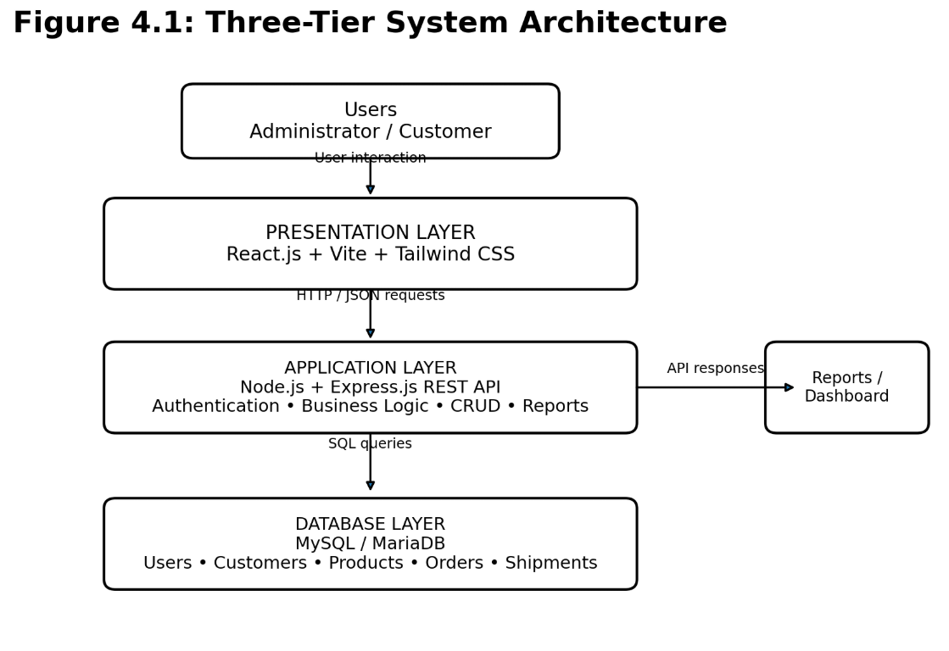
The proposed application follows a three-tier architecture consisting of the following layers:
1. Presentation Layer
The presentation layer is responsible for displaying the application interface to users. It is developed using React.js, Vite, and Tailwind CSS.
It provides interfaces for administrators and customers to interact with the system, manage information, and monitor shipment activities.
2. Application Layer
The application layer handles the business logic and processing of user requests. It is developed using Node.js and Express.js.
Its responsibilities include authentication, processing sales orders, managing shipment information, and communicating with the database.
3. Database Layer
The database layer uses MySQL or MariaDB to store and manage application data.
It maintains information related to users, customers, products, sales orders, and shipments.

4.3 Data Flow Diagram (DFD)
A Data Flow Diagram represents how information moves through the system and how different components interact with each other.
The Shipment and Sales Tracking System involves the following major processes:
- User Authentication
- Customer Management
- Product Management
- Sales Order Processing
- Shipment Management
- Report Generation
Level 0 – Context Diagram
The context diagram represents the entire Shipment and Sales Tracking System as a single process. Administrators and customers interact with the system by providing information and receiving relevant outputs.
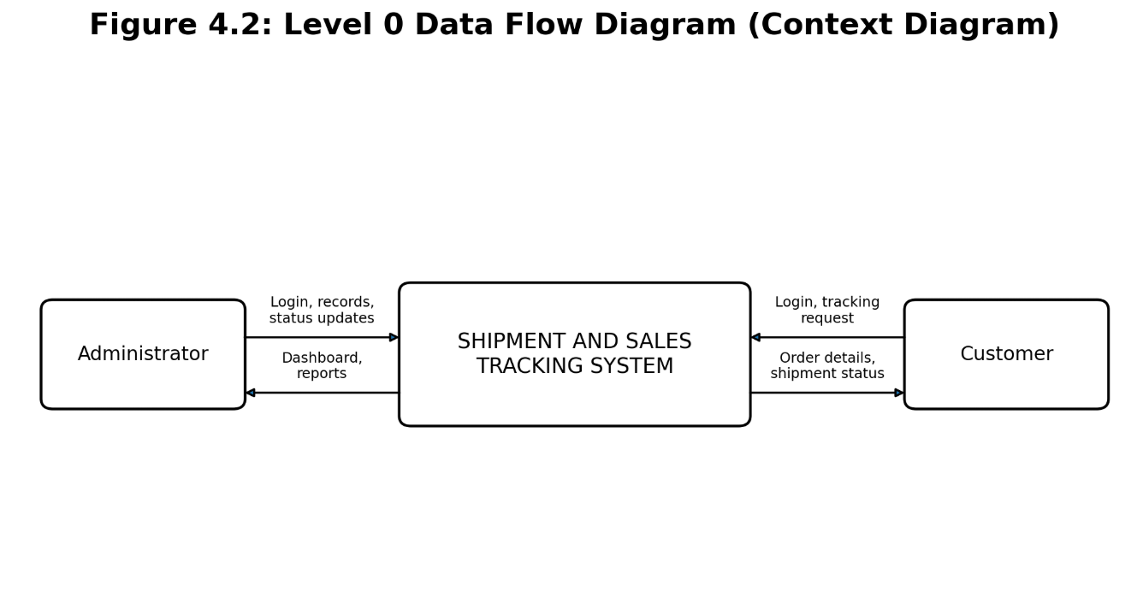

Level 1 – Data Flow Diagram
The Level 1 DFD provides a detailed representation of the major processes within the application.
It illustrates how user information, customer records, product details, sales orders, and shipment information are processed and stored.
Figure 4.3: Level 1 Data Flow Diagram
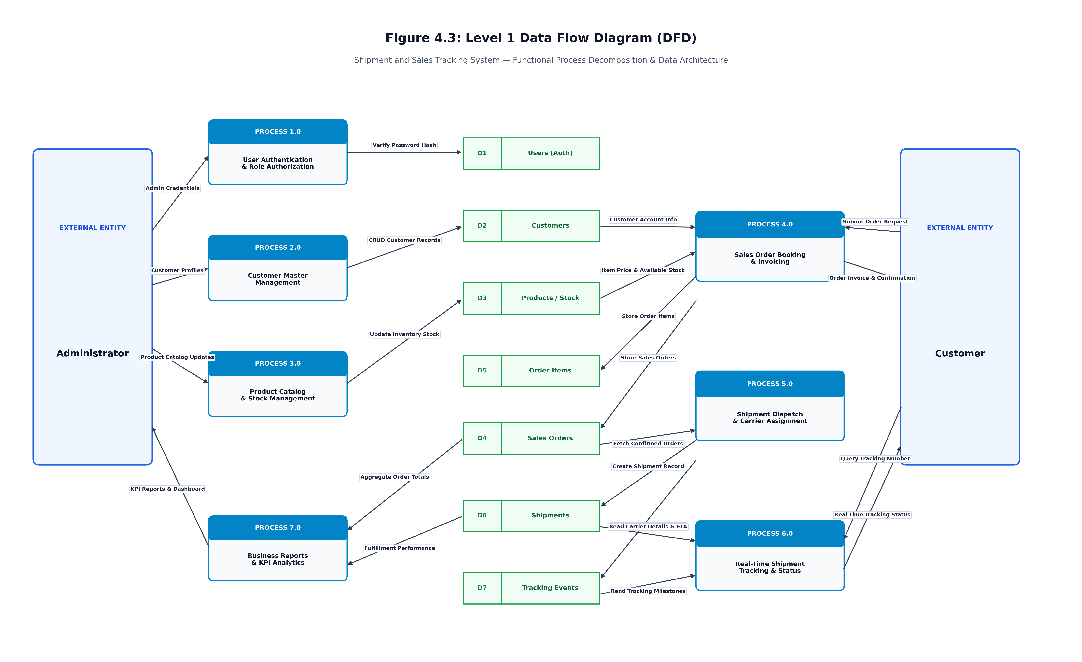
4.4 Use Case Diagram
A Use Case Diagram represents the interaction between different users and the functionalities provided by the application.
The major actors in the proposed system are:
1. Administrator
The administrator is responsible for managing the application and its business information.
Major activities include:
- Login to the application.
- Manage customer information.
- Manage product information.
- Create and manage sales orders.
- Manage shipment information.
- Update shipment status.
- View dashboard information.
- Generate reports.
2. Customer
Customers interact with the application to access relevant order and shipment information.
Major activities include:
- Login to the application.
- View available order information.
- View personal order details.
- Track shipment progress.
- Check delivery status.
Figure 4.4: Use Case Diagram
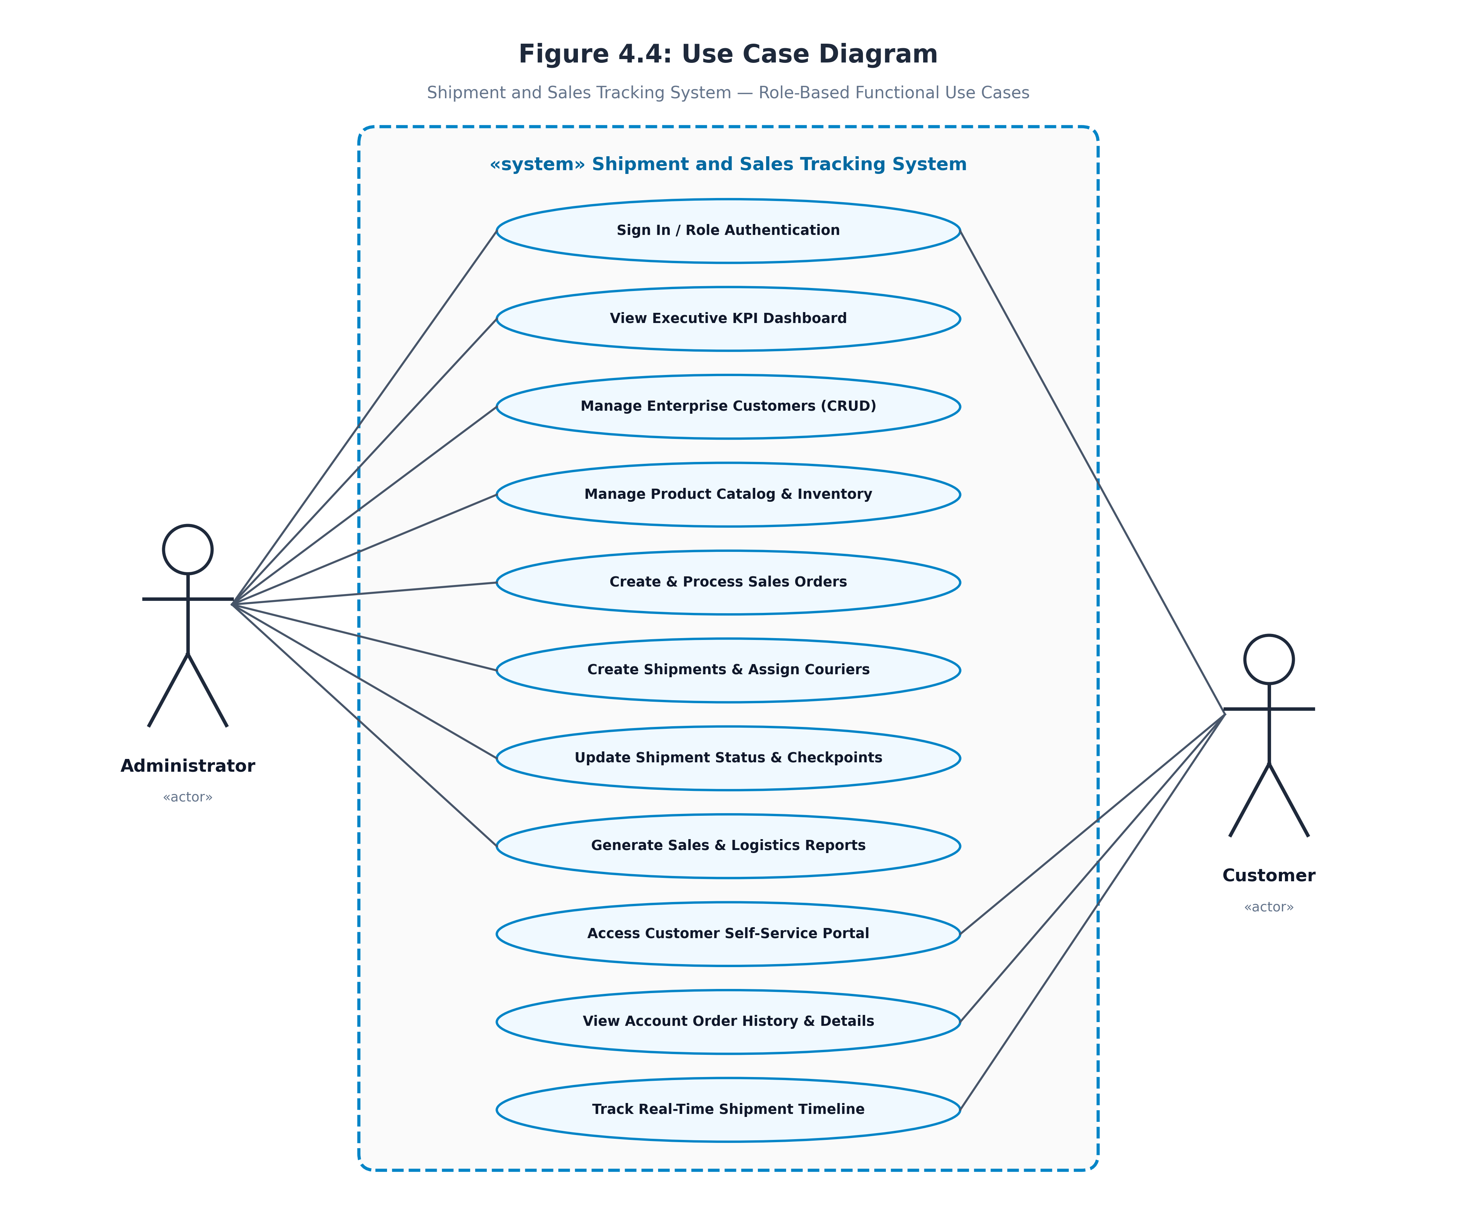

4.5 Entity Relationship Diagram (ER Diagram)
An Entity Relationship Diagram represents the logical structure of the database and the relationships between different entities.
The proposed Shipment and Sales Tracking System includes the following major entities:
1. User
Stores login and authentication-related information.
2. Customer
Maintains customer details such as customer name, contact information, and address.
3. Product
Stores product-related information, including product name, description, and price.
4. Sales Order
Maintains information about customer orders, order dates, and transaction details.
5. Order Items
Stores individual products associated with each sales order, including quantity and price.
6. Shipment
Maintains shipment-related information such as shipment identification, order reference, and delivery status.
7. Shipment Tracking
Maintains continuous status history, event milestones, timestamps, and transit checkpoint updates for every shipment.
These entities are logically connected to maintain consistency and organize information within the database.

Figure 4.5: Entity Relationship Diagram
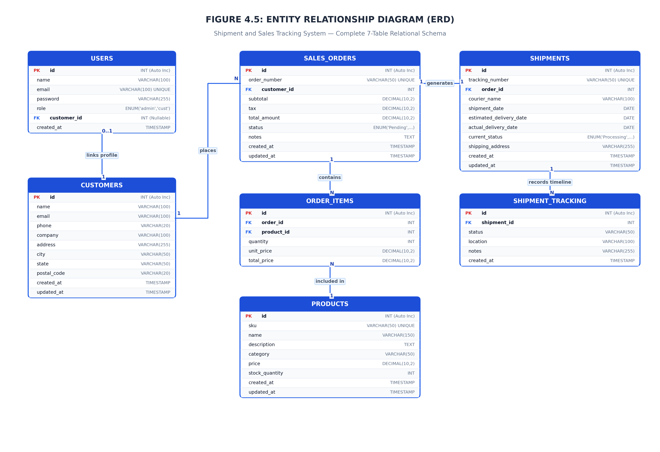

4.6 Database Design
The database is designed using MySQL or MariaDB to store application information in a structured format.
The proposed database contains the following major tables:
Table Name | Purpose
Users | Stores user login information
Customers | Stores customer details
Products | Stores product information
Sales Orders | Stores customer order records
Order Items | Stores products associated with orders
Shipments | Stores shipment and delivery information
shipment_tracking | Stores shipment tracking history and milestone events
The database structure is designed to establish relationships between customers, orders, products, and shipments.
Primary keys and foreign keys are used where appropriate to maintain data integrity and establish relationships between tables.
4.7 Module Design
The application is divided into different modules to simplify development and maintenance.
1. Authentication Module
Handles user login and authentication. It ensures that only authorized users can access protected functionalities.
2. Dashboard Module
Displays important information related to sales, customers, orders, and shipments through an organized interface.
3. Customer Management Module
Maintains customer information and provides functionality for managing customer records.
4. Product Management Module
Handles product information and maintains product-related records.
5. Sales Order Module
Allows users to create and manage sales orders. It also handles order-related information and calculations.
6. Shipment Tracking Module
Manages shipment records and allows users to monitor shipment progress and delivery status.
7. Reporting Module
Presents organized sales and shipment information to help users understand business activities.
4.8 Summary
This chapter presented the overall design of the Shipment and Sales Tracking System. It described the system architecture, data flow diagrams, use case diagram, entity relationship diagram, database design, and application modules.
The proposed design provides a structured foundation for implementing the application using React.js, Node.js, Express.js, and MySQL.

CHAPTER 5
METHODOLOGY
The Shipment and Sales Tracking System follows an iterative software development methodology. The application is divided into different functional modules, and each module is designed, implemented, tested, and improved to ensure proper system functionality.
The methodology focuses on understanding user requirements, designing the system architecture, implementing the required functionalities, testing the application, and preparing the final documentation.
The following phases are followed during development:
1. Requirement Analysis
The initial phase involves identifying the problems associated with manual sales and shipment management. The requirements of administrators and customers are analyzed to determine the necessary system functionalities.
2. System Design
The system architecture, database structure, data flow diagrams, use case diagrams, and entity relationship diagrams are prepared to represent the overall system design.
3. Implementation
The frontend is developed using React.js, Vite, and Tailwind CSS. The backend is implemented using Node.js and Express.js, while MySQL is used for database management.
4. Integration
The frontend, backend APIs, and MySQL database are integrated to enable communication between different application modules.
5. Testing
Individual modules and complete application workflows are tested to verify authentication, customer management, product management, sales order processing, shipment management, and tracking functionalities.
6. Evaluation and Documentation
The completed application is evaluated based on functionality, usability, and correctness. The implementation details, testing results, screenshots, and system documentation are prepared.
5.1 Development Modules
The application is divided into the following major modules:
- Authentication Module: Handles user login, JWT authentication, and role-based access control.
- Admin Module: Provides administrative access to customer, product, order, shipment, and report management.
- Customer Management Module: Maintains customer information and supports CRUD operations.
- Product Management Module: Manages product details, pricing, SKU information, and inventory.
- Sales Order Module: Handles order creation, multiple order items, tax calculation, and order status management.
- Shipment Module: Manages shipment creation, courier assignment, and delivery status updates.
- Tracking Module: Provides shipment tracking through a six-stage delivery timeline.
- Reporting Module: Generates sales summaries, delivery performance statistics, and business analytics.
- Customer Portal Module: Allows customers to access their own orders and shipment information.
5.2 Development Environment
The application is developed and tested using the following environment:
Component | Technology
Operating System | Windows
Code Editor | Visual Studio Code
Frontend | React.js
Build Tool | Vite
Styling | Tailwind CSS
Backend Runtime | Node.js
Backend Framework | Express.js
Database | MySQL
Database Environment | XAMPP
API Architecture | REST API
Authentication | JSON Web Token
Browser | Google Chrome
5.3 Development Approach
An iterative development approach is followed throughout the project. Each module is implemented and tested independently before being integrated with the complete application.
This approach helps identify errors early, simplifies debugging, and allows improvements to be made during development.
The final application integrates all modules into a centralized Shipment and Sales Tracking System.
5.4 Summary
This chapter outlined the iterative software development methodology, core modules, development environment, and iterative implementation approach adopted for the Shipment and Sales Tracking System.

CHAPTER 6
IMPLEMENTATION
6.1 Introduction
System implementation is the phase in which the proposed system design is converted into a working software application. It involves developing the frontend interface, backend services, database connectivity, and different application modules.
The Shipment and Sales Tracking System is implemented as a full-stack web application using React.js, Vite, Node.js, Express.js, and MySQL.
The application follows a client-server architecture in which the frontend communicates with the backend through REST APIs, while the backend manages business operations and database interactions.
6.2 Technologies and Architecture
The following technologies are used in the development of the application:
1. React.js
React.js is used to develop the frontend interface. It allows the application to be divided into reusable components and provides an interactive user experience.
2. Vite
Vite is used as the frontend development and build tool. It provides a fast development environment and efficient application building.
3. Tailwind CSS
Tailwind CSS is used for designing the application's interface, including dashboards, forms, tables, buttons, and responsive layouts.
4. Node.js
Node.js provides the runtime environment for executing JavaScript on the server side.
5. Express.js
Express.js is used to develop the backend REST API. It handles incoming requests, application routes, authentication, and business logic.
6. MySQL
MySQL is used as the relational database management system for storing customer information, product details, sales orders, and shipment records.
7. JWT Authentication
JSON Web Tokens are used to implement authentication and role-based access control for administrators and customers.
6.3 System Architecture Implementation
The application follows a client-server architecture consisting of three major components.
Frontend: Developed using React.js, Vite, and Tailwind CSS. It provides the interface through which administrators and customers interact with the application.
Backend: Developed using Node.js and Express.js. It processes requests, performs business operations, manages authentication, and communicates with the database.
Database: MySQL stores and manages application information through relational tables.
The frontend communicates with the backend using REST API endpoints. The backend processes the requests and retrieves or updates the required information in the database.
6.4 Module Implementation
6.4.1 Authentication and Role-Based Access Control
The authentication module provides secure login functionality for administrators and customers.
The system uses JWT-based authentication and role-based route protection to ensure that users can access only the functionalities permitted by their roles.
6.4.2 Admin Dashboard Module
The administrator dashboard provides an overview of important business activities.
It displays six major KPI indicators:
- Total Customers
- Total Products
- Total Orders and Revenue
- Total Shipments
- Delivered Shipments
- Pending Shipments
It also displays recent sales orders and the shipment pipeline, helping administrators monitor overall business performance.
6.4.3 Customer Management Module
The customer management module allows administrators to create, view, update, and delete customer records.
It includes search functionality, input validation, and relational integrity checks to maintain accurate customer information.
6.4.4 Product Inventory Module
The product inventory module manages product-related information.
Its functionalities include:
- Adding new products.
- Updating product information.
- Deleting product records.
- Searching and filtering products.
- Automatic SKU generation.
- Monitoring stock availability.
- Tracking product prices.
The system also displays stock indicators such as In Stock, Low Stock, and Out of Stock.
6.4.5 Sales Order Management & Calculations
The financial calculations for each sales order are computed using the following formulas:
Subtotal = Sum of (Quantity × Unit Price)
Tax = Subtotal × 8 / 100
Grand Total = Subtotal + Tax
Upon order confirmation, inventory quantities in the database are automatically decremented to maintain real-time stock integrity.
The sales order management module allows administrators to create and manage customer orders.
It supports multiple products within a single order and automatically calculates the subtotal, tax, and grand total.
The system applies an 8% tax calculation and updates the relevant inventory quantities when orders are processed.
Administrators can also monitor and update order statuses.
6.4.6 Shipment Management & Dispatch
The shipment lifecycle is managed through six distinct sequential delivery stages:
1. Processing — Initial order packaging preparation.
2. Packed — Items consolidated and boxed with shipping label.
3. Dispatched — Handed over to assigned courier carrier.
4. In Transit — Moving between transit hubs toward destination.
5. Out for Delivery — Assigned to local courier agent for final drop-off.
6. Delivered — Package successfully handed over to customer.
The shipment management module allows administrators to create shipment records associated with sales orders.
Each shipment receives a unique tracking identification number.
The system supports courier assignments such as FedEx, DHL, UPS, Blue Dart, and SpeedPost.
Administrators can update shipment progress through six delivery stages.
6.4.7 Live Shipment Tracking Module
The live shipment tracking module allows users to monitor the progress of their shipments.
It provides a visual delivery timeline containing six shipment stages, a progress indicator, carrier information, and chronological tracking checkpoints.
Customers can use the tracking functionality to access relevant shipment information.
6.4.8 Reports and Analytics Module
The reports and analytics module provides an overview of business performance.
It includes:
- Total sales revenue.
- Average order value.
- Order status distribution.
- Delivery performance percentage.
- Top-selling products.
- Top customers.
These reports help administrators understand sales performance and monitor shipment operations.
6.4.9 Customer Portal Module
The customer portal provides a dedicated interface for customers.
Customers can access their own order information and monitor shipment progress.
The system implements customer-level data isolation to prevent customers from accessing other customers' private order information.
6.5 Database Implementation
MySQL is used to maintain the application's relational database.
Table 6.1: Database Schema Summary
Table Name | Purpose
users | Stores user accounts and roles
customers | Stores customer information
products | Stores product and inventory details
sales_orders | Stores sales order information
order_items | Stores individual products in orders
shipments | Stores shipment and courier information
shipment_tracking | Stores shipment tracking history
The database stores information related to users, customers, products, sales orders, shipment records, and other supporting entities.
Relational database structures are used to establish connections between different records and maintain data consistency.
Primary keys and foreign keys are used to identify records and establish relationships between database tables.
The database is initialized and populated with sample records to support application development and testing.
6.6 API Implementation
The backend is developed using Express.js and provides REST API endpoints for communication between the frontend and database.
The APIs handle different application operations, including:
- User authentication.
- Customer management.
- Product management.
- Sales order processing.
- Shipment creation and updates.
- Shipment tracking.
- Reports and analytics.
The backend processes incoming requests, performs the required operations, and returns responses to the frontend.
6.7 Security Considerations & Data Protection
Security is an important part of the application.
The system implements the following security mechanisms:
- JWT-based user authentication.
- Role-based access control.
- Protected application routes.
- Customer-level data isolation.
- Input validation.
- Database relational integrity checks.
These mechanisms help protect application information and restrict unauthorized access.
Table 6.2: Integration Test Results and Test Cases
Test ID | Test Case | Expected Result | Result
TC01 | Administrator Login | Admin dashboard displayed | Pass
TC02 | Customer Creation | Customer record created | Pass
TC03 | Product Creation | Product record created | Pass
TC04 | Sales Order Creation | Order and calculations completed | Pass
TC05 | Shipment Creation | Shipment and tracking ID generated | Pass
TC06 | Shipment Status Update | Status updated successfully | Pass
TC07 | Public Shipment Tracking | Tracking details displayed | Pass
TC08 | Customer Data Isolation | Customer accesses only own orders | Pass
6.8 Application Testing and Verification
The implemented application was subjected to integration testing to verify communication between the frontend, backend, and database.
The integration tests covered administrator authentication, customer creation, product creation, sales order processing, shipment creation, shipment status updates, public shipment tracking, and customer data isolation.
According to the recorded integration test results, all eight major test stages passed successfully.
6.9 Summary
This chapter described the implementation of the Shipment and Sales Tracking System using React.js, Vite, Tailwind CSS, Node.js, Express.js, and MySQL.

CHAPTER 7
OUTPUT SCREENSHOTS
This chapter presents the output screens of the Shipment and Sales Tracking System. The screenshots demonstrate the different functionalities available to administrators and customers.
7.1 Login Screen
The login screen allows administrators and customers to authenticate themselves using their registered email addresses and passwords. Access to application features is determined by the assigned user role.
Figure 7.1 — Login Screen
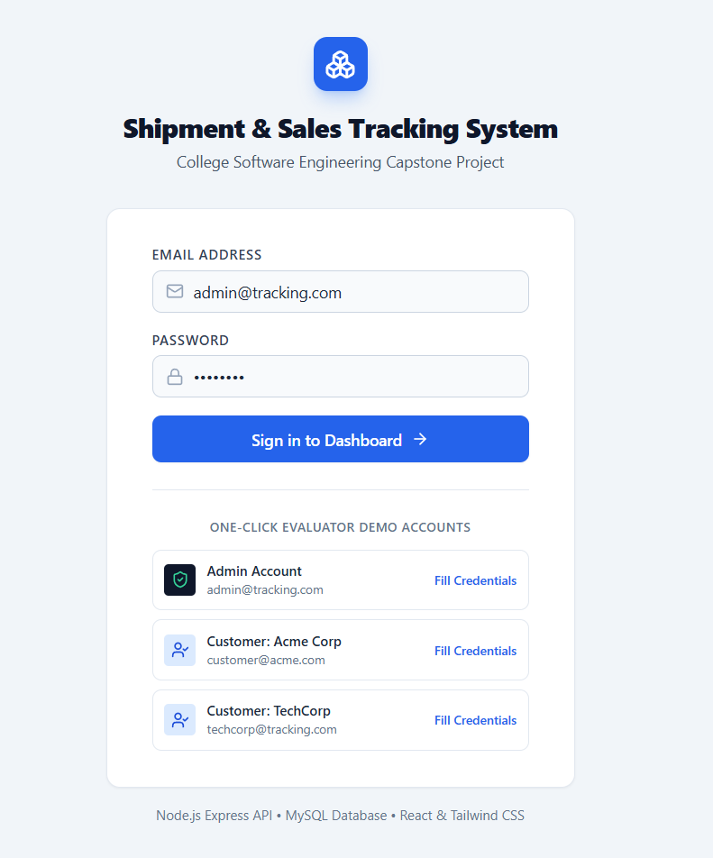
7.2 Admin Dashboard
The admin dashboard provides an overview of the overall system. It displays key performance indicators, recent sales orders, and the shipment pipeline.
Figure 7.2 — Admin Dashboard
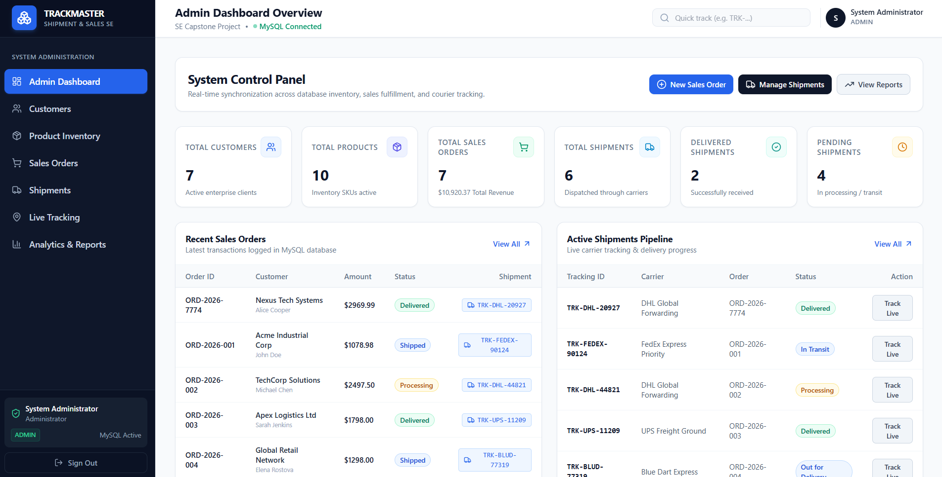
7.3 Customer Management Screen
This screen allows administrators to add, view, update, delete, and search customer records.
Figure 7.3 — Customer Management Screen
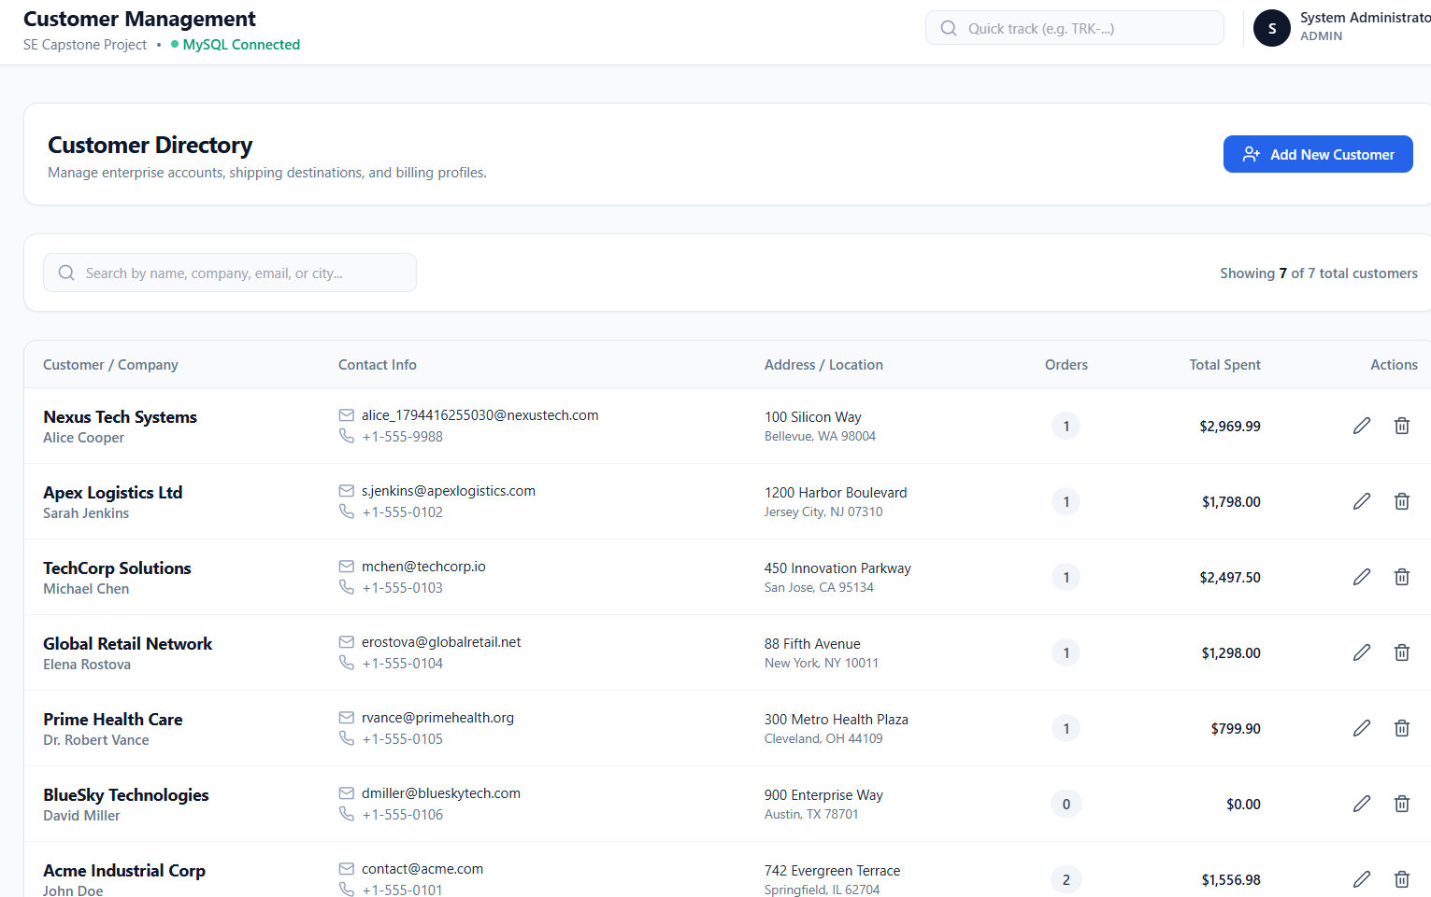
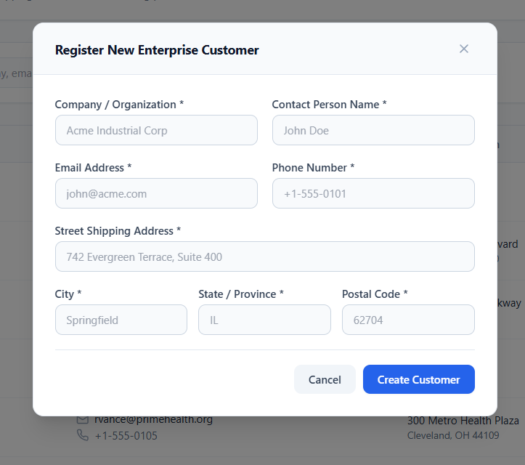
7.4 Product Inventory Screen
The product inventory screen displays product information, SKU details, pricing, categories, and stock availability.
Figure 7.4 — Product Inventory Screen
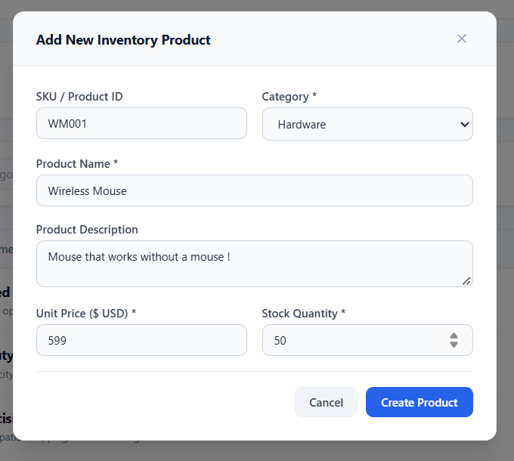
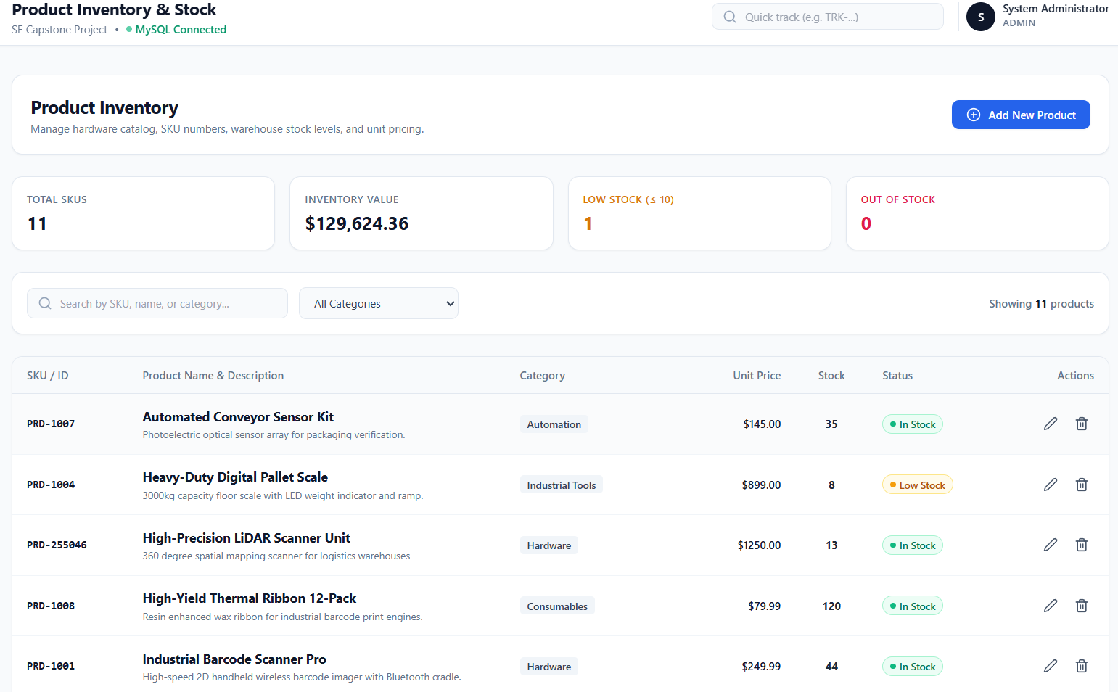
7.5 Sales Order Management Screen
This screen allows administrators to create sales orders containing multiple products. The system automatically calculates the subtotal, applicable tax, and grand total.
Figure 7.5 — Sales Order Management Screen
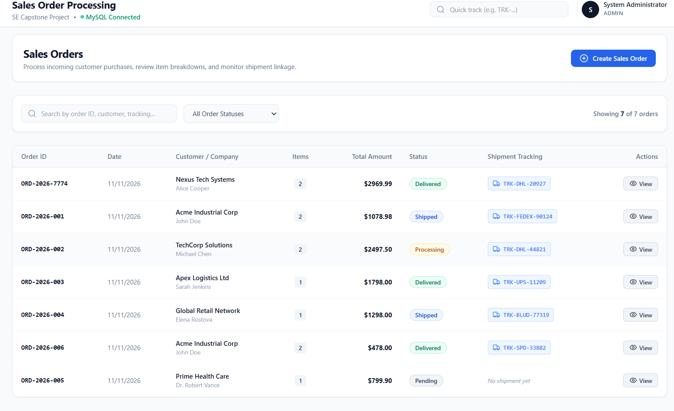
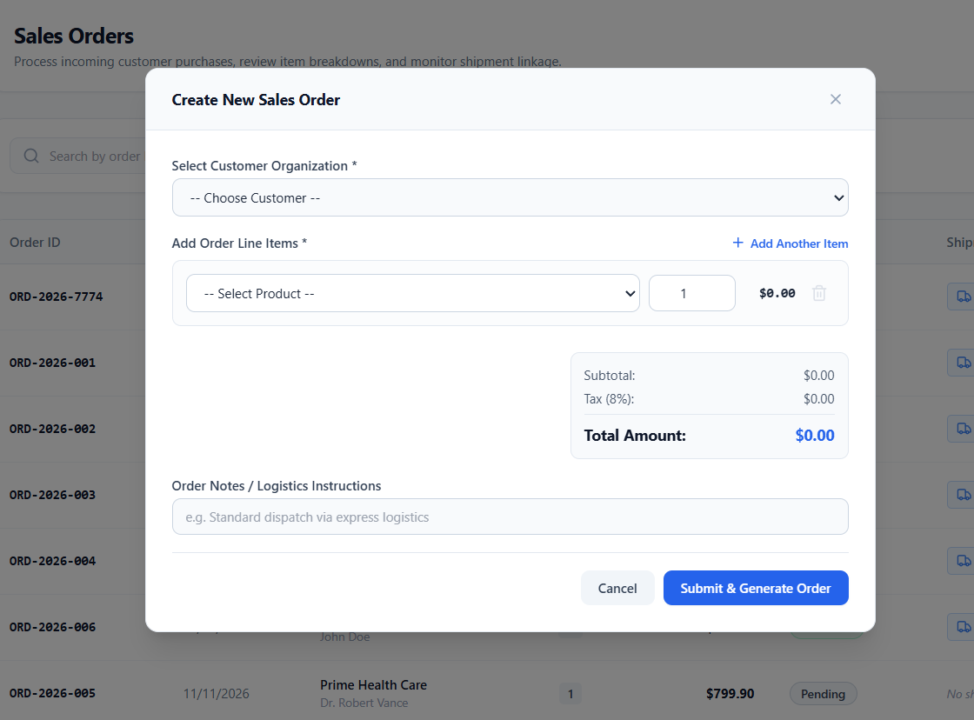
7.6 Shipment Management Screen
The shipment management screen allows administrators to create shipments, assign courier services, generate tracking numbers, and update delivery statuses.
Figure 7.6 — Shipment Management Screen
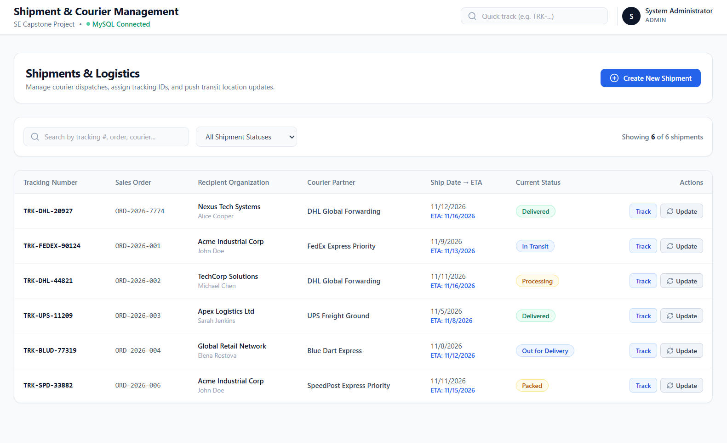
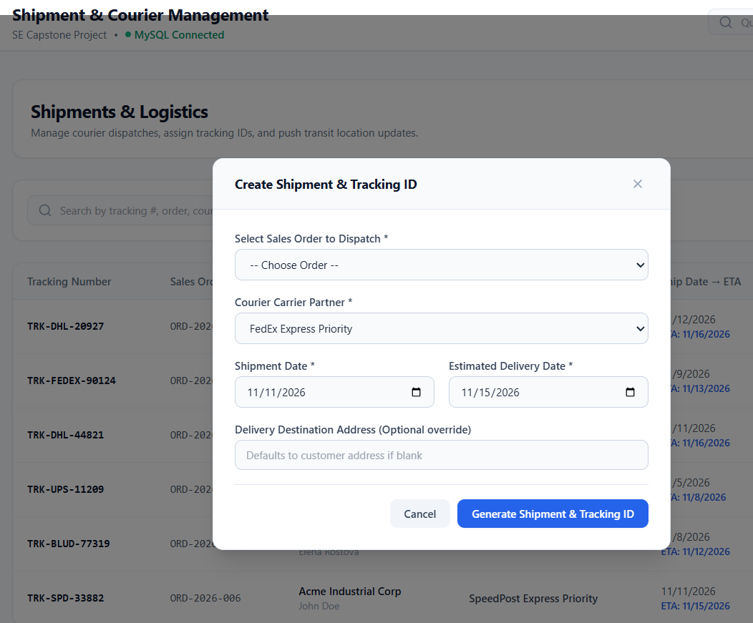
7.7 Live Shipment Tracking Screen
The tracking screen displays shipment progress through a six-stage delivery timeline. It also provides courier details, tracking information, and chronological shipment events.
Figure 7.7 — Live Shipment Tracking Screen
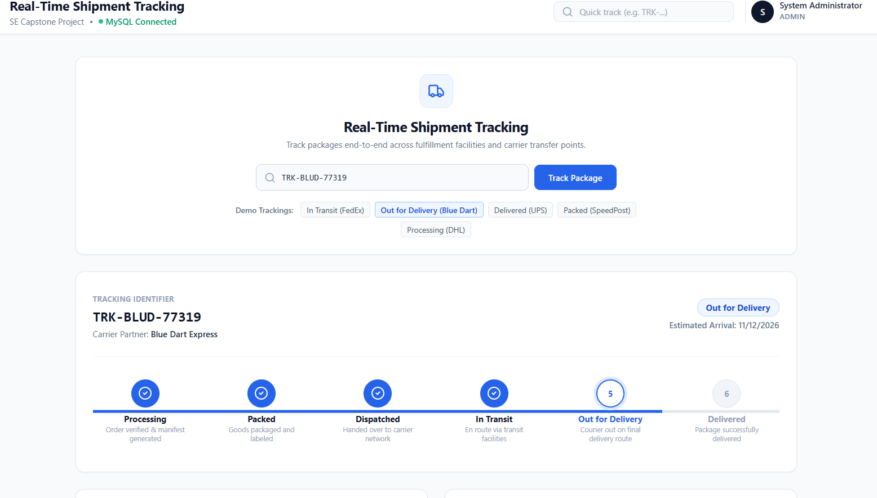
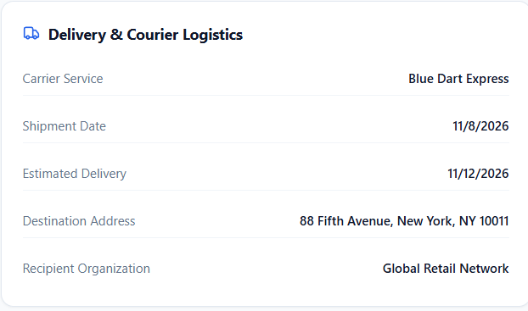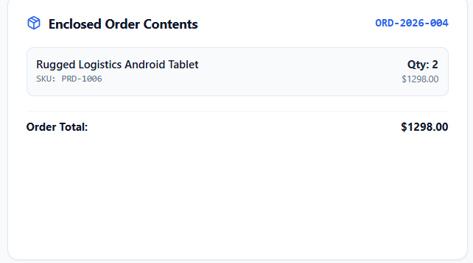
7.8 Reports and Analytics Screen
The reports module displays sales revenue summaries, average order value, order status distribution, delivery performance, top-selling products, and top customers.
Figure 7.8 — Reports and Analytics Screen
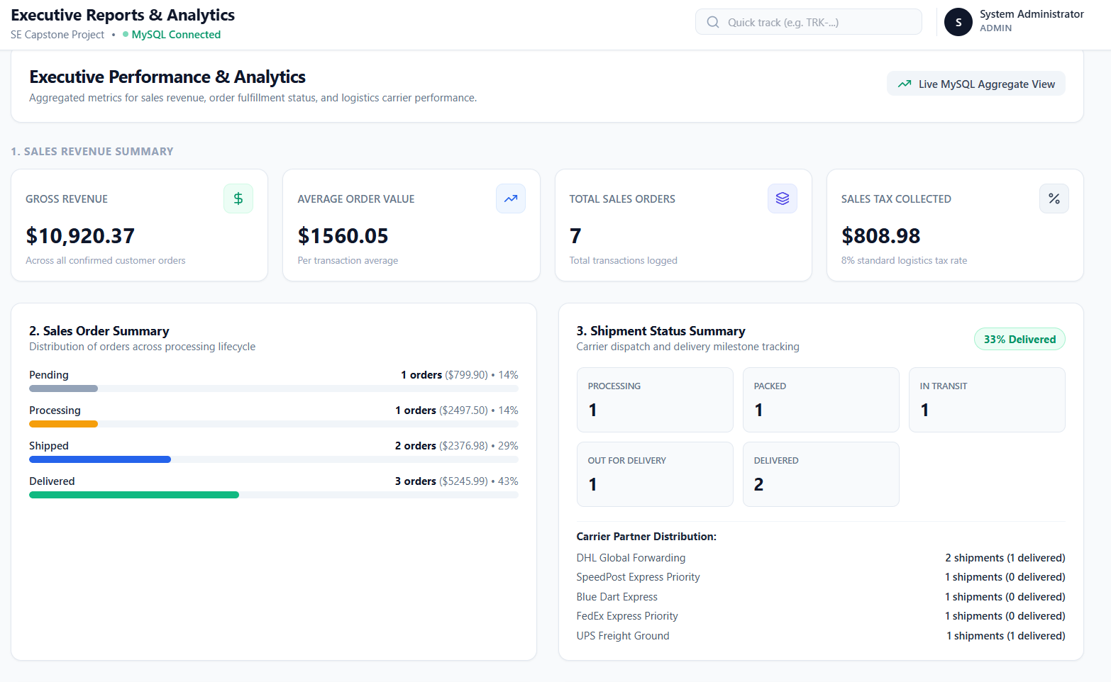
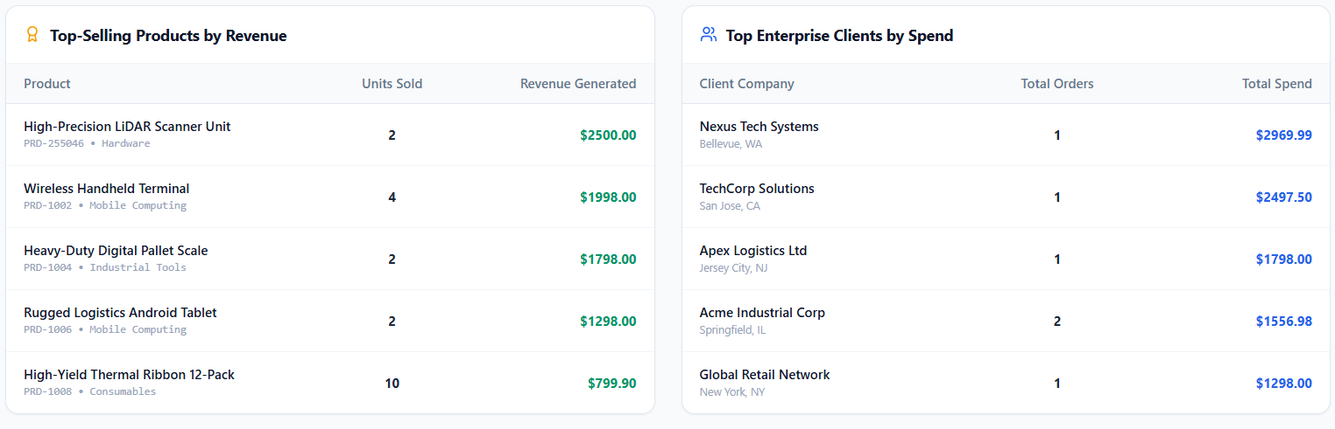
7.9 Customer Portal
The customer portal provides customers with access to their own order details and shipment information. Customer-level data isolation ensures that users cannot access other customers' private records.
Figure 7.9 — Customer Portal Screen
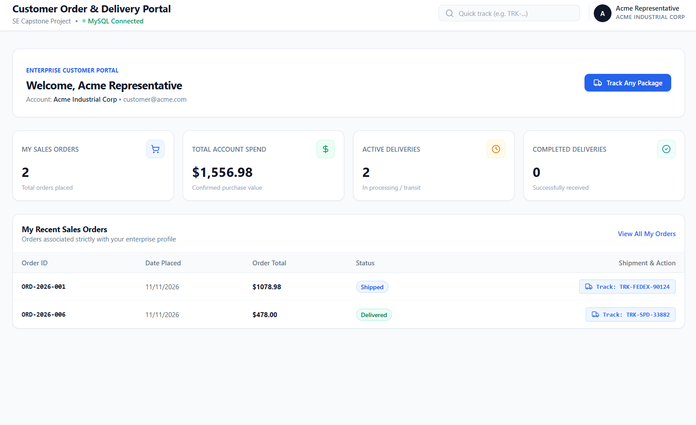
7.10 Summary
The screenshots demonstrate the major functionalities of the completed application. The system provides separate interfaces for administrators and customers and integrates customer management, inventory management, sales order processing, shipment tracking, and reporting functionalities.

CHAPTER 8
CONCLUSION
8.1 Conclusion
The Shipment and Sales Tracking System provides an integrated solution for managing sales orders, customer information, product inventory, and shipment operations.
The developed application combines React.js, Node.js, Express.js, and MySQL to provide a centralized platform for managing business activities.
The system provides separate access for administrators and customers through role-based authentication. Administrators can manage customers, products, sales orders, shipments, and business reports, while customers can view their orders and track shipment progress.
The application also supports automatic sales tax calculations, inventory updates, unique shipment tracking numbers, and a six-stage delivery tracking mechanism.
Integration testing was performed to verify the major functionalities of the application. The recorded test results indicate successful execution of the tested workflows.
Overall, the project demonstrates the practical application of software engineering concepts, including requirement analysis, system design, database management, full-stack development, authentication, integration, and testing.
8.2 Future Enhancements
The system can be further improved by introducing the following features:
- Integration with real courier company APIs for automatic shipment updates.
- Email and SMS notifications for order and delivery updates.
- Online payment gateway integration.
- Mobile application support.
- Advanced business analytics and forecasting.
- Cloud deployment for remote accessibility.
- Barcode and QR-code-based shipment identification.
- Automated invoice generation and downloadable reports.
These enhancements can improve the functionality, scalability, and usability of the system in future versions.

CHAPTER 9
REFERENCES
- Roger S. Pressman and Bruce R. Maxim, Software Engineering: A Practitioner's Approach, McGraw-Hill Education.
- Ian Sommerville, Software Engineering, Pearson Education.
- React Documentation. Available at: https://react.dev/
- Node.js Documentation. Available at: https://nodejs.org/docs/
- Express.js Documentation. Available at: https://expressjs.com/
- MySQL Reference Manual. Available at: https://dev.mysql.com/doc/
- Vite Documentation. Available at: https://vite.dev/guide/
- Tailwind CSS Documentation. Available at: https://tailwindcss.com/docs
- JSON Web Token Documentation. Available at: https://jwt.io/introduction
- Object Management Group, Unified Modeling Language (UML) Specification. Available at: https://www.omg.org/spec/UML/

APPENDIX A
SAMPLE USER WORKFLOW
A.1 Administrator Workflow
Login → Admin Dashboard → Manage Customers → Manage Products → Create Sales Orders → Manage Shipments → Update Shipment Status → Generate Reports → Logout.
A.2 Customer Workflow
Login → Customer Portal → View Orders → Select Order → View Shipment Details → Track Shipment → View Delivery Status → Logout.
A.3 Shipment Tracking Workflow
Create Sales Order → Confirm Order → Create Shipment → Generate Tracking Number → Update Shipment Status → Record Tracking Events → Customer Tracks Shipment → Shipment Delivered.

