World Cup Breakout Players as Private-Equity Assets
A MATLAB analytics framework for valuing post-tournament signings
Technical Report
Note This report demonstrates a valuation methodology. All figures are illustrative and rest on a mix of fetched data, estimated data, and explicit modelling assumptions. They are not investment advice or precise player valuations.

1. Executive Summary
This project values footballers who broke out at a FIFA World Cup as if they were private-equity assets: acquired for a fee, held while paying wages and generating value, and exited at a resale (market) value. Ten players across the 2014, 2018 and 2022 tournaments are analysed through a full pipeline built in MATLAB: data integration, discounted-cash-flow valuation (NPV and IRR), scenario analysis, Monte Carlo simulation, a per-player risk score, and portfolio optimisation.
Central finding: under the model, low-cost breakouts with sustainable underlying numbers offer materially better risk-adjusted returns than expensive marquee signings. The two largest fees in the sample (James Rodriguez, EUR 80m, and Angel Di Maria, EUR 75.6m) post negative NPV in every scenario, while bargain acquisitions such as Sofyan Amrabat (EUR 10m) and Denis Cheryshev (EUR 6m) clear the required return comfortably.
Key signal: expected-goals (xG) overperformance at the tournament behaves as a regression warning. Players who scored far above their xG (Gakpo +2.44, Cheryshev +2.89) are penalised by the risk layer, since a breakout built on unsustainable finishing is more likely to cool off. A volume-and-defence breakout (Amrabat) is treated as the most durable and emerges as the safest asset and the model's clearest value pick.

2. Aim and Framing
Each player is modelled as an investable asset with five attributes: an acquisition cost (transfer fee plus wages), operating performance (on-pitch contribution), an asset value (market value over time), an exit value (resale or contract expiry), and risk (performance volatility and the probability of regression). The transfer window is then treated as a fund: a fixed budget allocated across competing assets to maximise risk-adjusted return.

3. Data and Sources
Ten players were selected as recognised breakout cases: James Rodriguez, Keylor Navas, Guillermo Ochoa, Enner Valencia, Mario Gotze and Angel Di Maria (2014); Benjamin Pavard and Denis Cheryshev (2018); Cody Gakpo and Sofyan Amrabat (2022).
To keep the analysis honest, every input is tagged into one of three categories:
Category | What it covers | Source
Fetched & cited | WC goals, assists, minutes, xG, xA, passes, tackles | StatsBomb open event data (computed)
Estimated & flagged | Transfer fees, market values, wages | Transfermarkt, Capology (estimates)
Modelled assumption | Revenue, discount rate, hold period, risk weights | Analyst's stated choices

Performance data. Advanced metrics for the 2018 and 2022 players were computed directly from StatsBomb's open event data (penalty shootouts excluded), giving genuine xG, xA, shot, pass and defensive figures rather than scraped summaries. The 2014 tournament is not in the open dataset, so those six players carry basic goals, assists and stage only.
Financial data. Transfer fees and dates are well documented. Market values are Transfermarkt estimates (crowd/journalist-sourced, not audited). Wages are Capology-style estimates; signing bonuses and agent fees are almost never disclosed and are left blank rather than invented.

4. Methodology

4.1 Breakout and performance metrics
The headline performance signal is xG overperformance: tournament goals minus expected goals. A large positive figure indicates finishing above the quality of chances created, which historically tends to regress. This single number later drives each player's risk.

4.2 Private-equity cash-flow model
Cash flows run from Year 0 to the exit year N (a four-year hold in the base case): Year 0 pays the transfer fee; Years 1 to N pay wages and receive the value the player generates (a modelled revenue figure); Year N additionally banks the resale value, taken as the player's peak market value where available, otherwise his World Cup value, otherwise the fee.

4.3 Net present value and internal rate of return
NPV discounts every future cash flow to today at a 10% required return (NPV = sum of CF_t / (1+r)^t). A positive NPV means the deal beats the hurdle. IRR is the discount rate at which NPV equals zero, solved numerically so no specialist toolbox is required.

4.4 Scenario analysis
Each deal is re-valued under downside, base and upside cases by flexing the two most uncertain inputs (revenue and resale value). The spread between downside and upside (the swing) is an early read on fragility.

4.5 Monte Carlo simulation
Rather than three fixed cases, 10,000 random futures are drawn for revenue and exit value, producing a full distribution of outcomes. The headline outputs are the probability of a negative NPV, the 5th-percentile NPV (Value-at-Risk), and the distribution of IRR.

4.6 Risk scoring
Each player receives a 0-100 risk score combining four real signals: xG overperformance (weight 0.40), age (0.25), fee size (0.20) and World Cup minutes as a sample-size proxy (0.15). A higher score widens that player's simulated distribution and applies a downward haircut to expected output, so regression-prone breakouts are valued more cautiously than the rest.

4.7 Portfolio optimisation
The transfer window is treated as a fund. Each player's return is expressed per euro of fee; a shared transfer-market factor links players so diversification is meaningful. Thousands of random long-only budget splits are simulated; the efficient frontier is the best return available at each level of risk, and the highest-Sharpe split is the optimal allocation.

5. Results

5.1 Performance findings (StatsBomb-derived)
Player (WC) | Min | Goals | xG | xG over | Profile
Gakpo (2022) | 457 | 3 | 0.56 | +2.44 | Clinical finisher, ran hot
Amrabat (2022) | 696 | 0 | 0.02 | -0.02 | Volume passer / destroyer
Cheryshev (2018) | 308 | 4 | 1.11 | +2.89 | Finisher, very hot
Pavard (2018) | 569 | 1 | 0.14 | +0.86 | Defender, screamer goal

5.2 Base-case valuation ranking
NPV at a 10% discount rate, four-year hold, EUR 8m/yr revenue assumption (wages estimated where undisclosed). Fees in EUR millions.
Rank / player | Fee | NPV (EURm) | Data flag
1 Amrabat (2022) | 10 | +26.7 | exit = WC value
2 Pavard (2018) | 35 | +17.3 | all inputs from data
3 Gakpo (2022) | 40 | +16.8 | wage estimated
4 Ochoa (2014) | 0 | +15.9 | free transfer (IRR infinite)
5 Navas (2014) | 10 | +15.2 | exit = fee
6 Cheryshev (2018) | 6 | +14.0 | wage est.; exit = fee
7 Valencia (2014) | 15 | +11.1 | wage est.; exit = fee
8 James (2014) | 80 | -9.5 | wage estimated
9 Di Maria (2014) | 75.6 | -46.2 | exit = fee
- Gotze (2014) | n/a | n/a | no transfer to value

Reading the table: cheap acquisitions dominate. The bargains all clear the hurdle, while the two EUR 75m-plus signings are deeply negative because an enormous fee needs an enormous value-gain to justify it, and neither delivered one. Gotze cannot be valued as an acquisition because he did not transfer after 2014.
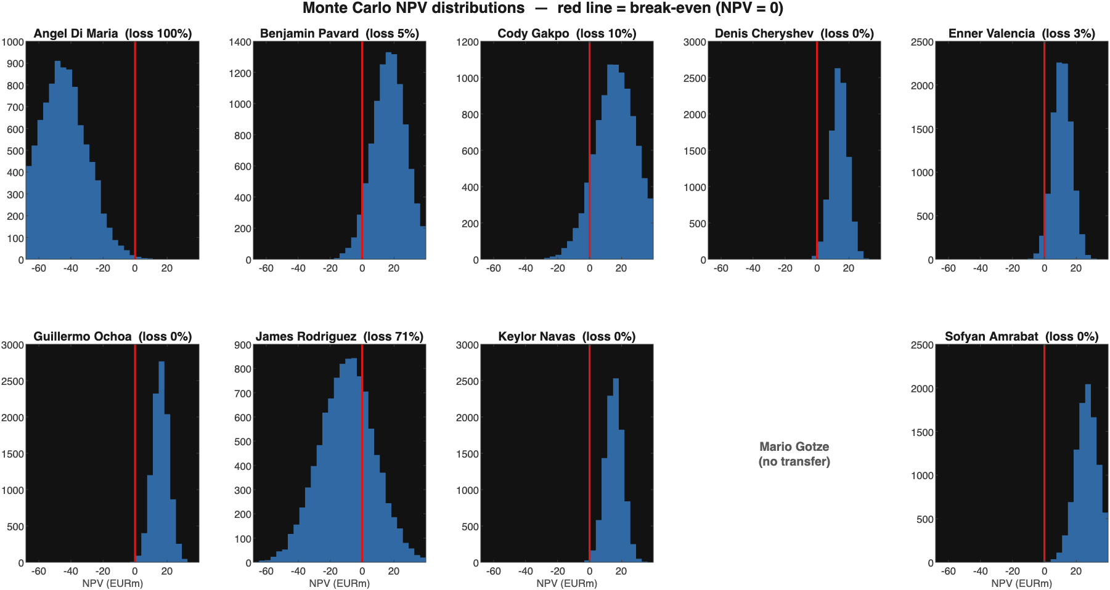
Figure 1. Monte Carlo NPV distributions, 10,000 simulations per player. The red line is break-even; the mass to its left is the probability of loss.

5.3 Monte Carlo risk
On 10,000 simulations, Pavard shows roughly a 5% probability of losing money and Gakpo about 10%, while the cheap, durable assets (Amrabat, Cheryshev, Navas, Ochoa) sit at or close to 0%. At the other extreme, James Rodriguez loses money in about 71% of simulated futures and Angel Di Maria in essentially all of them (100%), confirming the two record fees were indefensible on these assumptions. Figure 1 places every player's distribution side by side on a common scale.

5.4 Risk-adjusted scoring
Player | Risk score | Main drivers | Interpretation
Cheryshev | 60 | +2.89 xG, mid age, tiny fee | Highest: hot finishing, small sample
Di Maria | 57 | huge fee, no xG data | Expensive marquee risk
Gakpo | 50 | +2.44 xG | Overperformance flag
James | 50 | huge fee | Expensive marquee risk
Navas | 42 | no xG (neutral) | Moderate
Ochoa | 42 | older GK, free | Moderate
Valencia | 37 | no xG (neutral) | Moderate
Pavard | 23 | +0.86 xG, young, real wage | Low: sustainable, cheap-ish
Amrabat | 13 | under-performed xG | Lowest: durable, volume-based

Once risk is player-specific, the ranking stops rewarding lucky finishing. Cheryshev's mean NPV falls from about +EUR 14m to roughly +EUR 8m once the overperformance haircut and wider distribution are applied, whereas Amrabat - who slightly under-performed his xG - keeps a tight, low-risk distribution and rises on a risk-adjusted basis.
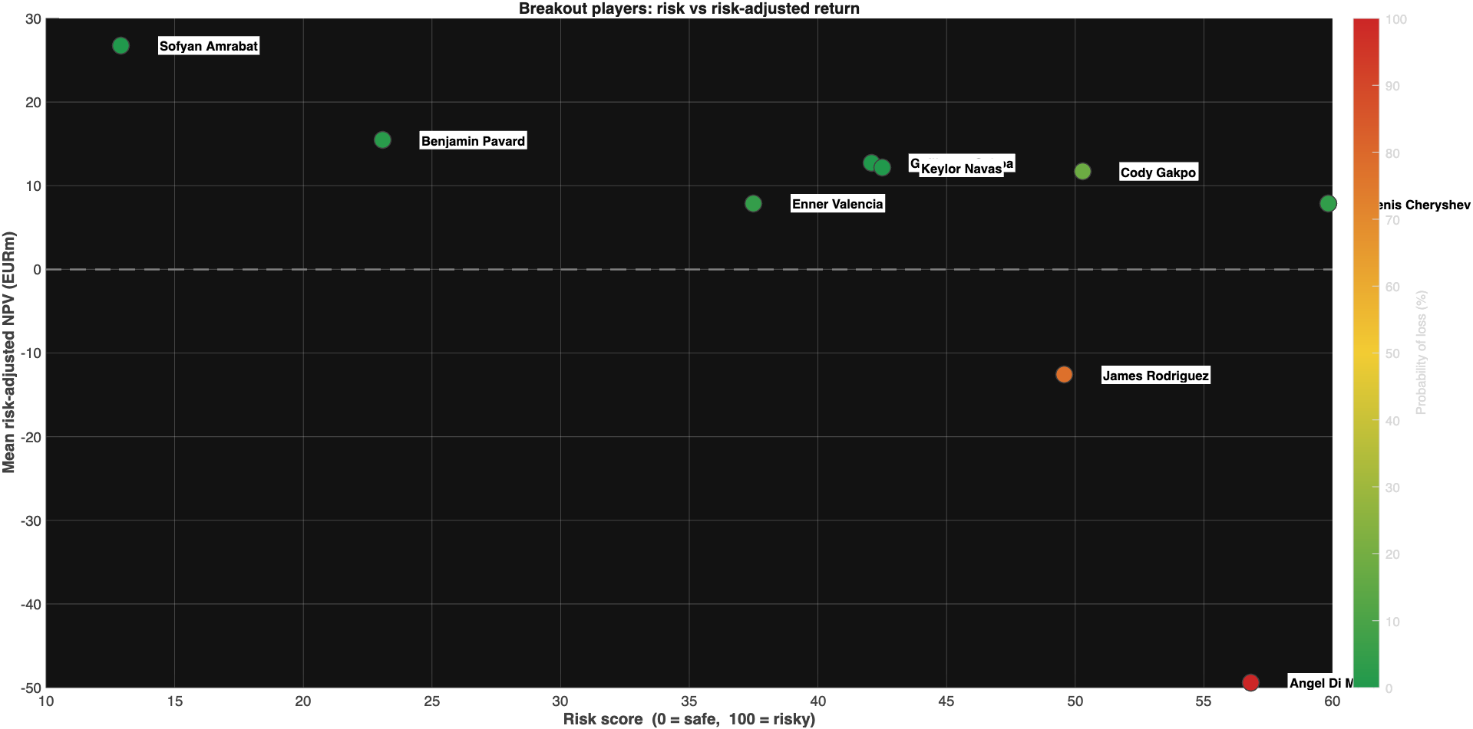
Figure 2. Risk score vs mean risk-adjusted NPV, coloured by probability of loss (green = safe, red = risky).

5.5 Optimal portfolio
Treating the window as a fund, the efficient frontier (Figure 3) shows the best return available at each level of risk. The optimal, highest-Sharpe mix (red star) sits at roughly 47% risk for about a 140% expected four-year return on fee - an interior blend rather than a single player, because spreading the budget across assets lowers volatility. The cheap bargains drive that return: Amrabat (around 267%) and Cheryshev (around 130%) sit furthest right as the highest-return but also highest-volatility individual assets, so the optimiser leans on them while diversifying away their risk. James and Di Maria, the only players with negative expected returns, fall to the bottom-left and are excluded from every efficient portfolio - no rational fund holds an asset that loses money in almost every scenario.
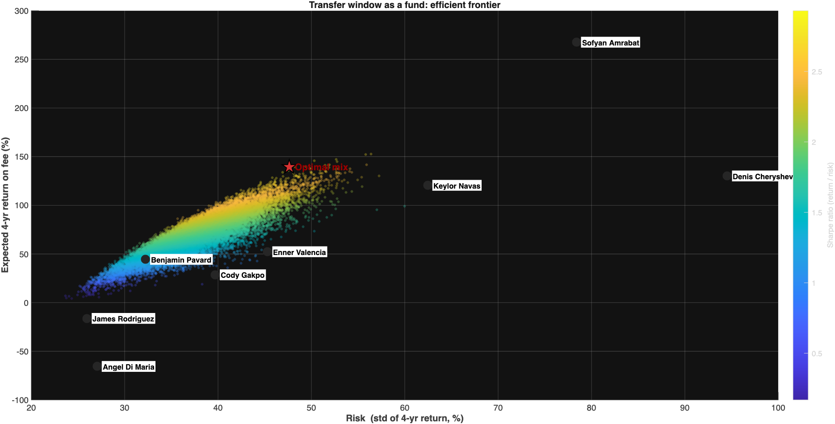
Figure 3. The transfer window as a fund: efficient frontier of random portfolios, with the optimal (max-Sharpe) mix marked by the red star.

6. Recommendations
- Prioritise low-cost breakouts whose output rests on repeatable underlying numbers (minutes, pass volume, defensive actions) over players whose tournament return is built on finishing above xG.
- Treat large xG overperformance as a sell or avoid signal, not a buy signal; it most often regresses.
- Be highly sceptical of premium fees paid on the back of a single tournament; in this sample they never paid back.
- Decide at the portfolio level, not player by player: size positions by risk-adjusted return under a budget, not by reputation.

7. Limitations and Assumptions
- The EUR 8m/yr revenue figure is the single most load-bearing assumption; results are highly sensitive to it and it is a modelling choice, not data.
- Returns are reported over the four-year hold, not annualised, which inflates the headline percentages in the portfolio section.
- The 2014 cohort lacks event-level data, so their risk scores lean on a neutral overperformance assumption.
- Wages, bonuses and agent fees are estimates or blanks; market values are crowd-sourced estimates.
- Portfolio weights treat players as fractionally divisible, so read them as conviction/budget shares rather than literal stakes.

Appendix: code and data map
Pipeline scripts: load_data.m (load and join), slice1_npv_irr.m (single-player valuation), slice2_all_players.m (ranking), slice3_scenarios.m (scenarios), slice4_montecarlo.m and slice4b_histgrid.m (simulation and charts), slice5_riskscore.m (risk scoring), slice6_portfolio.m (efficient frontier). Data: wc_breakout_players_master_v2.csv, wc_performance_stats.csv, statsbomb_wc_pull.py, data_sources.md.

