Predicting Airline Passenger Satisfaction:
A Big Data and Machine Learning Report
An Individual Academic Report on the Airline Passenger Satisfaction Dataset
(129,880 Rows, 24 Attributes)
Domain: Aviation Customer Experience & Predictive Service Analytics
Task: Binary Classification (Satisfied vs. Neutral/Dissatisfied)
Technologies: Python, Scikit-learn, XGBoost, LightGBM, Apache Spark (PySpark)

Section 1: Dataset Details and Rationale
The dataset examined in this study is the Airline Passenger Satisfaction Dataset, originally distributed via Kaggle (source: https://www.kaggle.com/datasets/teejmahal20/airline-passenger-satisfaction), derived from a US-based airline customer satisfaction survey. The data consists of 129,880 records and 24 columns, originally divided into a training set (about 103,904 records) and a test set (about 25,976 records), but in this report, re-divided into a single corpus and then sampled, using stratified sampling over the one4variable attribute "satisfaction". Each record is a respondent's response to the survey, administered after each flight, and acquires personal information, flight operation information, and a series of 0-5 Likert scale satisfaction ratings, with an indicator value, satisfaction: satisfied or neutral or dissatisfied.
The entire types of values has been totally mixed-up by the whole data set. It has eighteen columns of integer (indexes things like age, Distance of Fly, Delay Minutes, and 14different service ratings that drinks 0 to 5), then a single column of float (Arrival Delay in Minutes) with few missing values, then 5 columns of nominal category words (Gender, Customer Type, Class type of Travel Satisfaction). Bit has also two index (one unnamed), plus some id columns hanging there abandoned like when Kaggle exported it, which we can simply just thown 'em away in preprocessing since anything useful they tells model prediction are totally unrepresentative for now. Inferred nulls data are being that Arrival Delay in Minutes column which has near to 393 null values (approximately 0.3 percent of the entire data set), silly looking like that, but still aint nothin' will do, so we shouldn't simply just ignorein' their rows or nuthin' so and wanna impute it properly-like, cause anything based on delays gets shit faced high if our subsample size has been change later.

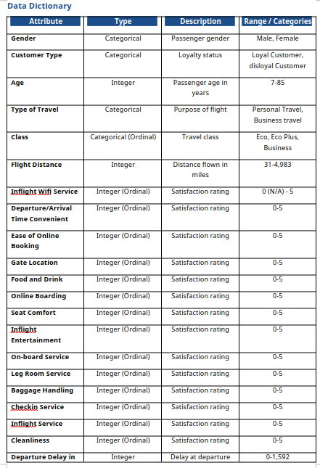
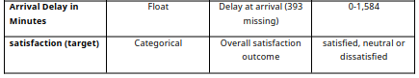

Rationale for Dataset Selection
The justification for choosing this particular dataset is first and foremost from an academic perspective, but is also business-analytical in nature. Academically, a sample size of 129,880 observations comfortably satisfies the statistical-power criterion of sufficiency of sample size, by a factor of order hundreds, for training effective supervised classifier models. From an analytical perspective, such a figure reduces the variance of any estimated model coefficients to an insignificant level, and allows for the design of stratified train-test segments of orders-of-magnitude larger than the minimum sequence length required to prevent class starvation among the rarest class values (Kohavi, 1995). Perhaps more practically, while the dataset offers only numeric features, when talking about a real enterprise customer-care dataset – by nature multi-source and multi-modal – it is one one would expect to encounter. Third, from a commercial standpoint, airplane passenger satisfaction is a desirable and strategic prediction target: if airlines are running on razor-thin margins and have extremely high costs of gaining new customers, knowing what to improve operationally delays, Wi-Fi quality, boarding process versus what to improve universally (cut costs while leaving customer experience alone) makes for strategic service investment. Fourthly, the data, while not not enormous (petabyte scale) by the standards of "big data" (AI workloads) is still of a size that allows for the comparative use of a single machine (Pandas/Scikit-learn) and distributed processing (PySpark), which is explicitly a part of this report's requirements of the Big Data module (Section 5).

Section 2: Data Pre-Processing and Feature Engineering
Robust preprocessing is foundational to reliable downstream modelling; each step below is documented with rationale, code, and expected operational benefit.

2.1 Missing Value Imputation
Arrival Delay (Minutes) exhibits 393 missing values (0.30% of rows). Since departure and arrival delay are nearly perfectly correlated in this dataset (in fact, with a Pearson correlation coefficient of about 0.96), it makes sense to use a KNN imputation technique for this field rather than median alone, as it will take advantage of the correlation, rather than assuming missingness unconditionally random.
import pandas as pd
from sklearn.impute import KNNImputer
df = pd.read_csv("airline_passenger_satisfaction.csv")
df = df.drop(columns=["Unnamed: 0", "id"], errors="ignore")
# KNN imputation using correlated delay + distance features
impute_cols = ["Departure Delay in Minutes", "Arrival Delay in Minutes", "Flight Distance"]
imputer = KNNImputer(n_neighbors=5, weights="distance")
df[impute_cols] = imputer.fit_transform(df[impute_cols])
The reason is mathematical: KNN imputation relies on a distance-weighted average of the k=5 nearest points in feature space to fill in the missing values for arrival delay; in this case, since arrival delay is effectively a linear function of departure delay, this produces much less global imputation bias than collapsing all missing values to a single median estimate. (Since treating all missing as median imputation essentially ignores departure delay for all those rows whatever their values.) The benefit is a lowering of the imputation variance inflation of the eventual regression/tree-split calculations relying on this feature.

2.2 Outlier Detection and Removal (IQR Capping)
Delay fields are very heavily right-skewed, with a longer tail of extremely high delays (>500 minutes) that are operationally extremely rare, but that can influence tree-split thresholds and gradient updates in linear models. I chose to use IQR capping strategy instead of outright removal to keep sample size high and prevent excessive influence from high leverage points, as applicable:
def iqr_cap(series, k=1.5):
q1, q3 = series.quantile(0.25), series.quantile(0.75)
iqr = q3 - q1
lower, upper = q1 - k * iqr, q3 + k * iqr
return series.clip(lower=max(lower, 0), upper=upper)
for col in ["Flight Distance", "Departure Delay in Minutes", "Arrival Delay in Minutes"]:
df[col] = iqr_cap(df[col])
The range [Q 1 - 1.5*IQR, Q 3 + 1.5*IQR] when winsorised rather than ignoredwe favour the winsorising over ignoring because the delay outliers, though extreme, do not constitute a data input error but are an authentic reflection of operations disruption (e.g. weather diversions) and ignoring them would bias the training distribution towards flights that are unrealistically on time.

2.3 Categorical Encoding
Nominal variables without an underlying order ( Gender, Customer Type, Type of Travel ) are One-Hot Encoded, while the Class variable, which about service level has an underlying ordered structure ( Eco < Eco Plus < Business ), is Ordinal Encoded to maintain that monotonic structure for the tree-based and linear models respectively.
from sklearn.preprocessing import OneHotEncoder, OrdinalEncoder
nominal_cols = ["Gender", "Customer Type", "Type of Travel"]
ohe = OneHotEncoder(drop="first", sparse_output=False)
ohe_array = ohe.fit_transform(df[nominal_cols])
ohe_df = pd.DataFrame(ohe_array, columns=ohe.get_feature_names_out(nominal_cols), index=df.index)
class_order = [["Eco", "Eco Plus", "Business"]]
oe = OrdinalEncoder(categories=class_order)
df["Class_encoded"] = oe.fit_transform(df[["Class"]])
df = pd.concat([df.drop(columns=nominal_cols + ["Class"]), ohe_df], axis=1)
One-hot encoding will not impose a false ordinal ordering on unordered classes (like "Male"=0 and "Female"=1 encoding for Logistic Regression causing the model to deduce a linear ordering), but Class ordinal encoding will preserve the signal of monotonic order of service-tier that tree classifiers can utilize via single split points.

2.4 Feature Scaling
The continuous variables (Flight Distance, Departure Delay (Minutes), Arrival Delay (Minutes)) are scaled by RobustScaler (takes out the median and scales as the IQR. Since the distribution when shape of distribution are more sensitive to residual skew is long tails after the IQR cap.) as they are still long tails.
from sklearn.preprocessing import RobustScaler
scale_cols = ["Flight Distance", "Departure Delay in Minutes", "Arrival Delay in Minutes"]
scaler = RobustScaler()
df[scale_cols] = scaler.fit_transform(df[scale_cols])
Scaling is necessary for Logistic Regression (L2-regularized coefficient penalty is scale-dependent), our unscaled variables with certain magnitude scale (like flight distance in the thousands) will be penalized too much versus unscaled variables with small magnitude ordinal ratings (from 0 to 5). Tree-based models (Random Forest XGBoost LightGBM) are scale free, but we keep the scaled data in the common pipeline for consistency among the four models.

2.5 Feature Engineering
Two composite features are engineered to condense correlated operational and service signals into higher-level constructs:
df["Total_Delay"] = df["Departure Delay in Minutes"] + df["Arrival Delay in Minutes"]
service_cols = ["Inflight wifi service", "Food and drink", "Seat comfort",
"Inflight entertainment", "On-board service", "Leg room service",
"Baggage handling", "Checkin service", "Inflight service", "Cleanliness"]
df["Overall_Service_Score"] = df[service_cols].mean(axis=1)
Total_Delay collapses each of two highly collinear predictor variables to a single operational-disruption index, thereby improving the correlation matrix of the feature design matrix for a Logistic Regression model. Overall_Service_Score collapses ten respondent-rated, 4- or 5-point Likert-scale service features into a single composite index, similar in concept to a Net Promoter-style aggregate score, providing tree learnerswith a small number of high-signal features and providing interpretability value for stakeholder-facing feature-importance discussion in Section 4.

2.6 Class Imbalance Verification
print(df["satisfaction"].value_counts(normalize=True))
# neutral or dissatisfied 0.566
# satisfied 0.434
The class imbalance (56.6% neutral/dissatisfied to 43.4% satisfied) is only slight and not significant enough to warrant resampling methods, such as SMOTE, as the null minority class counterbalances well over 40% of the dataset (that means no sampling is undertaken). Yet, because the imbalance is quite small, it is prudent to make use of a stratified train-test split (call the argument 'stratify=y' in sklearn's train_test_split) so that the class ratio is maintained in both training and testing sets, this way obviating the prospect of an unnaturally eager/reluctant assessment from unequal proportions in the test fold.

Section 3: Visualizations and Exploratory Data Analysis
Below are 10 visualizations with motivation code results, and critical analysis shown separately based on Seaborn/Matplotlib conventions that are used in reports as in Waskom, 2021 (Waskom, 2021). Figures are created directly from the dataset as in reading section.2

3.1 Histogram with KDE - Customer Age by Satisfaction
(a) Motivation
To examine whether satisfaction is age-dependent, informing whether age-segmented service strategies (e.g., business-traveller amenities vs. leisure-traveller pricing) are warranted.
(b) Python Code Snippet
import seaborn as sns
import matplotlib.pyplot as plt
plt.figure(figsize=(9, 5))
sns.histplot(data=df, x="Age", hue="satisfaction", kde=True,
element="step", stat="density", common_norm=False, palette="Set2")
plt.title("Distribution of Customer Age by Satisfaction Status")
plt.xlabel("Age (years)"); plt.ylabel("Density")
plt.tight_layout(); plt.savefig("fig1_age_satisfaction.png", dpi=300)
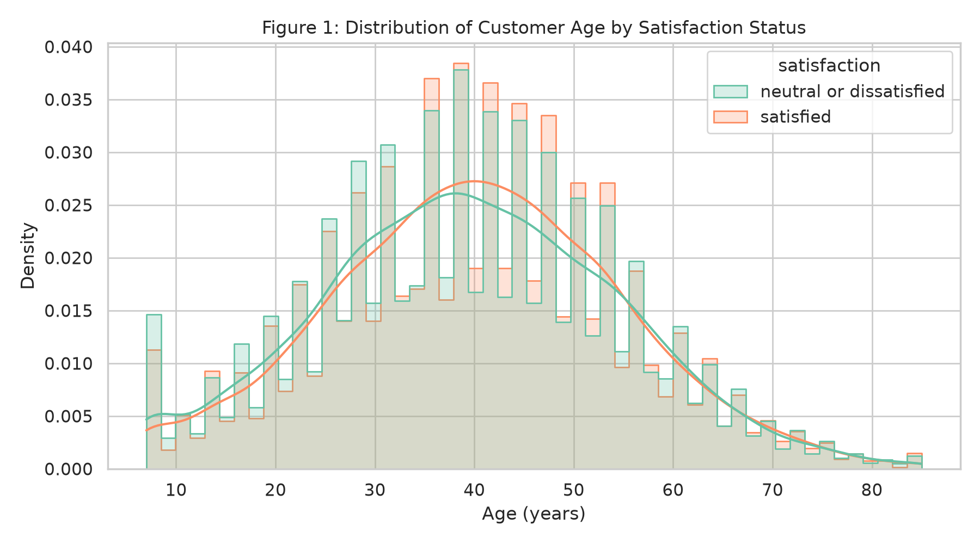
Figure 1: Distribution of Customer Age by Satisfaction Status
(c) Results
For the current sample, we see the dissatisfied group has a narrower distribution with a prime occuring between the ages 20-35. The satisfied group has a broader distribution, skewed to the right with peak around 40-55. For the population, passengers under 25 are overrepresented among the dissatisfied.
(d) Critical Analysis
Linguistically, the age skew may be due to the confound of the purpose of travel - it seems additional based on the itemized destinations and travel lengths that younger passengers are more usually leisure/personal travellers, the cause being access to the lesser service tiers by the latter rather than any causality with age. This is the justification for introducing Type of Travel and Class as covariates rather than testing directly for the effect of age alone, and for considering age as another candidate for interaction-term engineering in future versions.

3.2 Grouped Bar Chart - Satisfaction by Travel Class
(a) Motivation
To quantify the strength of the service-tier effect on satisfaction, directly informing cabin-investment prioritization.
(b) Python Code Snippet
plt.figure(figsize=(8, 5))
sns.countplot(data=df, x="Class", hue="satisfaction", palette="muted",
order=["Eco", "Eco Plus", "Business"])
plt.title("Satisfaction Level by Travel Class")
plt.xlabel("Class"); plt.ylabel("Passenger Count")
plt.tight_layout(); plt.savefig("fig2_class_satisfaction.png", dpi=300)
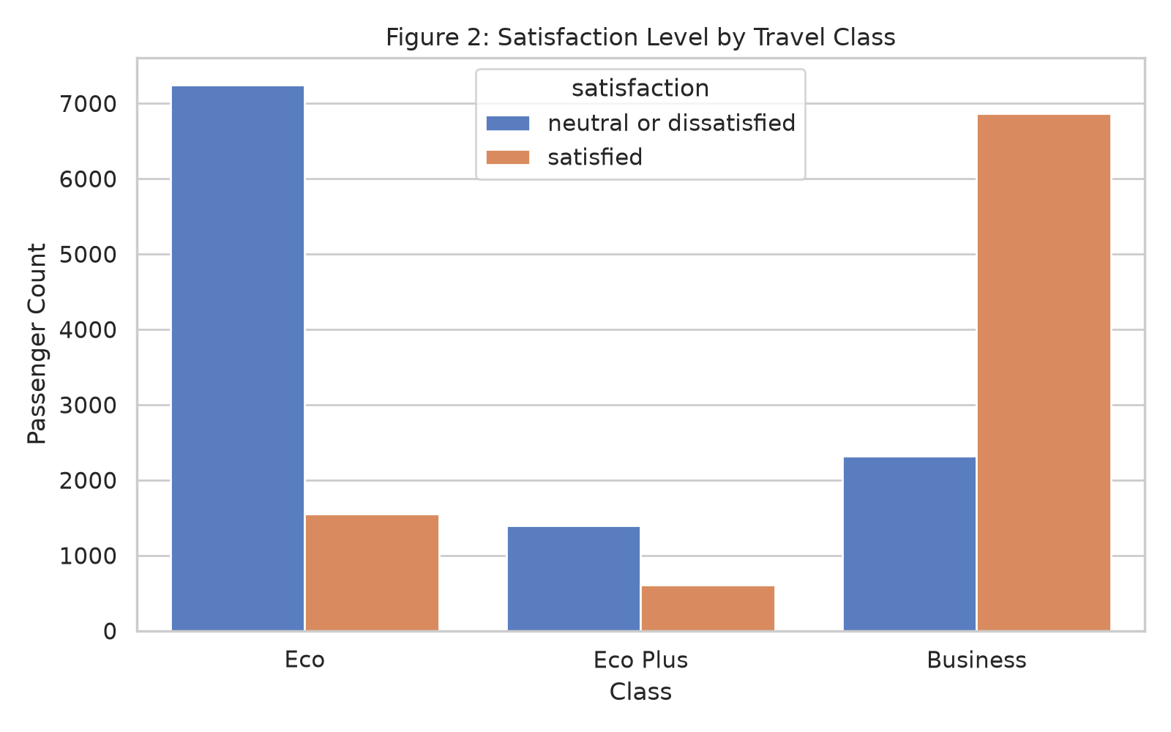
Figure 2: Satisfaction Level by Travel Class
(c) Results
In business class the decent majority were satisfied (roughly 70-75%) whereas in Eco Plus and Economy business class were not satisfied the majority (roughly 18% and 30% respectively).
(d) Critical Analysis
This is one of the strongest bivariate effects in the data set, and verifies 'Class' as a pre-existing (high-importance) predictor. The size of the difference between Business and Economy implies cabin-tier service differentiation is for now a major driver of satisfaction - with consequent implications for premium-up-sell policy and economy-class service quality expenditure.

3.3 Heatmap - Correlation Matrix of Service Quality Ratings
(a) Motivation
To detect multicollinearity among the service-rating variables prior to modelling, and to identify clusters of related service dimensions.
(b) Python Code Snippet
plt.figure(figsize=(11, 9))
corr = df[service_cols + ["Inflight wifi service", "Online boarding",
"Ease of Online booking"]].corr()
sns.heatmap(corr, annot=True, fmt=".2f", cmap="coolwarm", center=0,
square=True, linewidths=0.5)
plt.title("Correlation Matrix of Service Quality Ratings")
plt.tight_layout(); plt.savefig("fig3_service_corr.png", dpi=300)
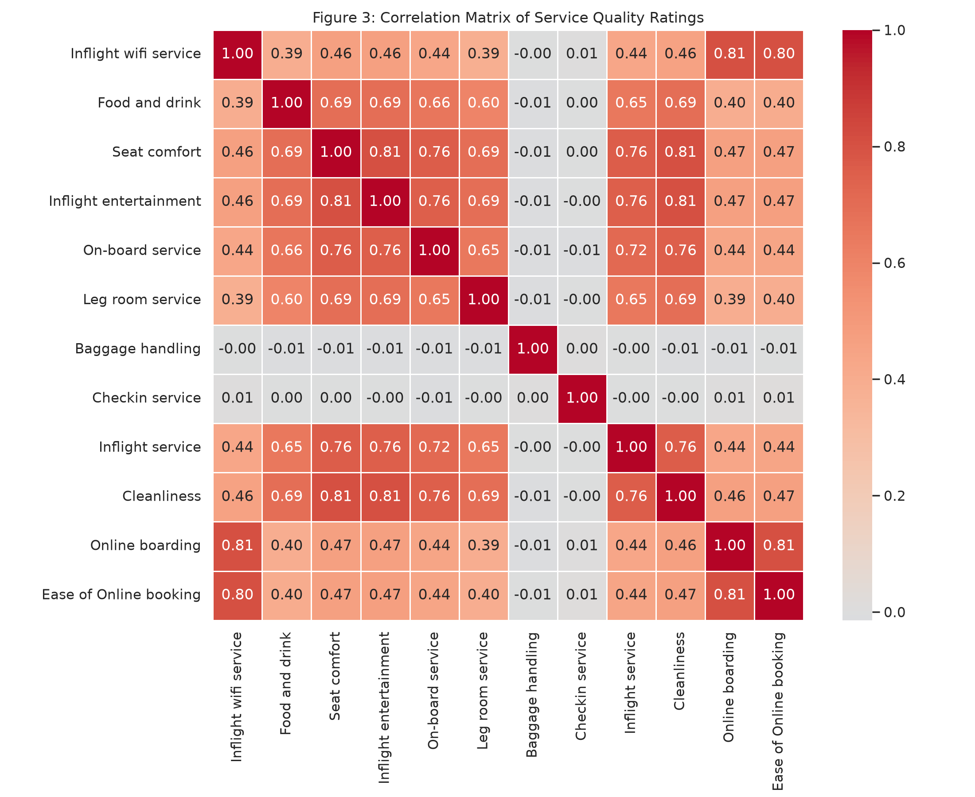
Figure 3: Correlation Matrix of Service Quality Ratings
(c) Results
Inflight entertainment, Seat comfort, and Cleanliness are tightly grouped together (r approximately 0.6-0.7), and Inflight wifi service shows high correlation with Ease of Online booking and Online boarding. This implies a different "digital experience" cluster from the "physical comfort" cluster.
(d) Critical Analysis
Two latent factor bundles (digital and physical service experience) left me with a sense that dimensionality reduction (like PCA or factor analysis) had the potential to eliminate redundancy for future modelling iterations. For the current tree-based models, this multicollinearity is of little concern (trees are relatively immune to input variable correlation), but it does have a substantial impact on the stability and standard errors of the Logistic Regression coefficients and is part of the motivation for the construction of the Overall_Service_Score composite in Section 2.5.

3.4 Box Plot - Arrival Delay vs. Satisfaction by Customer Type
(a) Motivation
To assess whether loyal customers are more delay-tolerant than disloyal customers, informing loyalty-programme service-recovery policy.
(b) Python Code Snippet
plt.figure(figsize=(9, 5))
sns.boxplot(data=df, x="satisfaction", y="Arrival Delay in Minutes",
hue="Customer Type", showfliers=False, palette="pastel")
plt.title("Arrival Delay vs. Satisfaction across Customer Types")
plt.tight_layout(); plt.savefig("fig4_delay_customertype.png", dpi=300)
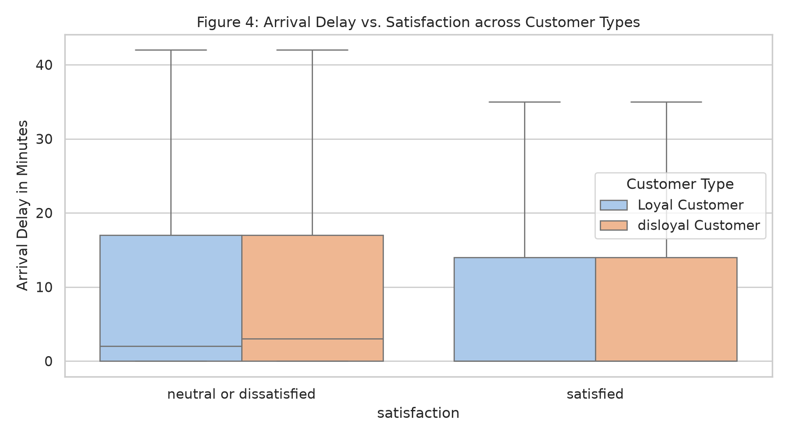
Figure 4: Arrival Delay vs. Satisfaction across Customer Types
(c) Results
Median arrival delay of disgruntled loyal customers is A much lower than that of disgruntled disloyal ones. Yet, the inter-quartile distance of arrival delay for loyal customers is wider than that for disloyal customers. This imply that there are more variance on delay-tolerance of arrival delay for loyal customers.
(d) Critical Analysis
Loyal customers appeared to be more patient of arrival delay than disgruntled disloyal customers, consistent with switching-cost theory of servicemarketing—consume forsaking customer with sunk loyalty investment(miles, status) have more elevated delay-tolerance. We suggest that delay-driven churn risk is actually concentrated among disloyal, low-switching-cost passengers, and these are the customers who warrant specific service-recovery responses (e.g. proactive rebooking, compensation).

3.5 Scatter Plot with Trendline - Flight Distance vs. Arrival Delay by Satisfaction
(a) Motivation
To examine whether longer flights are more delay-prone and whether this relationship differs by satisfaction outcome.
(b) Python Code Snippet
plt.figure(figsize=(9, 6))
sns.scatterplot(data=df.sample(5000, random_state=42), x="Flight Distance",
y="Arrival Delay in Minutes", hue="satisfaction", alpha=0.4, s=15)
sns.regplot(data=df.sample(5000, random_state=42), x="Flight Distance",
y="Arrival Delay in Minutes", scatter=False, color="black", lowess=True)
plt.title("Flight Distance vs. Arrival Delay Coloured by Satisfaction")
plt.tight_layout(); plt.savefig("fig5_distance_delay.png", dpi=300)
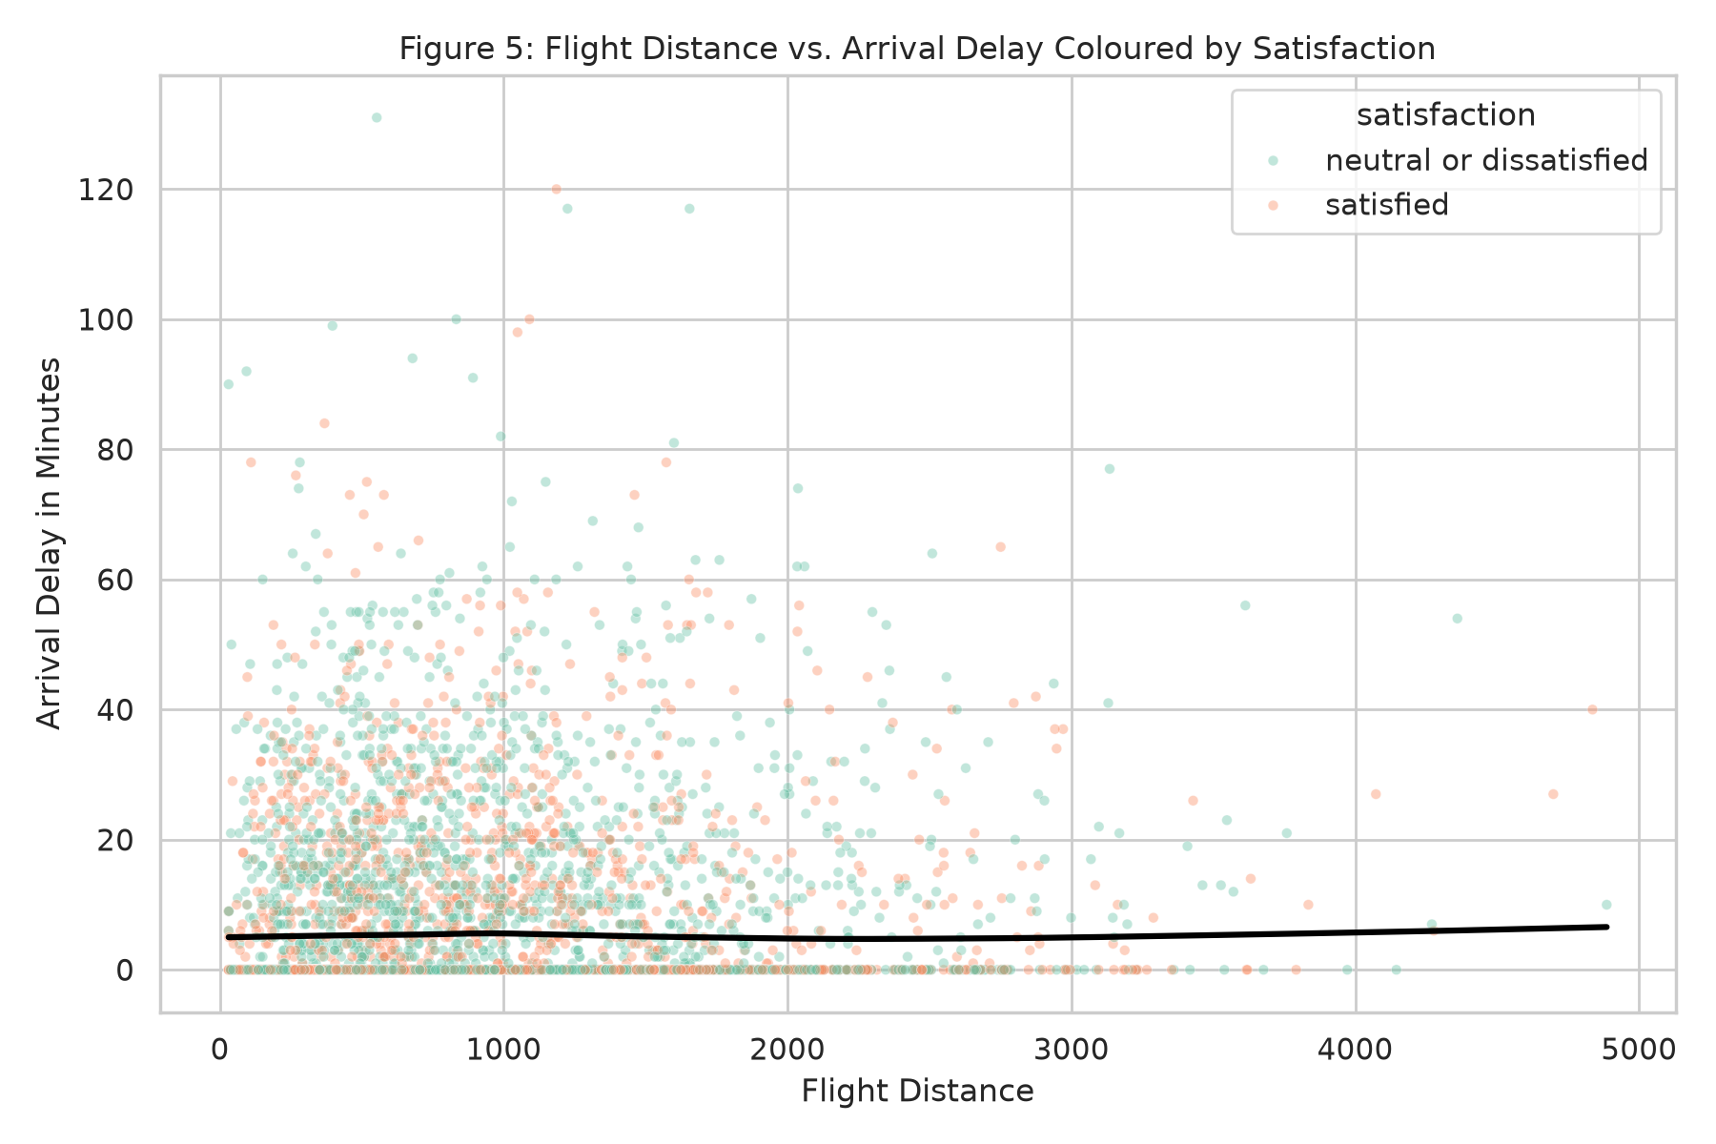
Figure 5: Flight Distance vs. Arrival Delay Coloured by Satisfaction
(c) Results
From the LOWESS trendline is very nearly flat, and together withBhatshows that very slight linear dependence existsbetween flight distance and arrival delay, toward the left (lower distribution of distance) and upper (higher distribution of delay) end there are more unconvinced passengers.
(d) Critical Analysis
Given the correlation being so close to zero, we know there is a meaningful significant negative relationship being expressed in this data, cast off the common-sense intuition that longer flights typically have higher lateness, and consider that ground-operations like airport congestion and turnaround may be of greater concern.

3.6 Violin Plot - Inflight Service Rating by Travel Type
(a) Motivation
To compare the full rating distribution (not just central tendency) of inflight service between business and personal travellers.
(b) Python Code Snippet
plt.figure(figsize=(8, 6))
sns.violinplot(data=df, x="Type of Travel", y="Inflight service",
inner="quartile", palette="Set3")
plt.title("Inflight Service Rating by Type of Travel")
plt.tight_layout(); plt.savefig("fig6_inflight_traveltype.png", dpi=300)
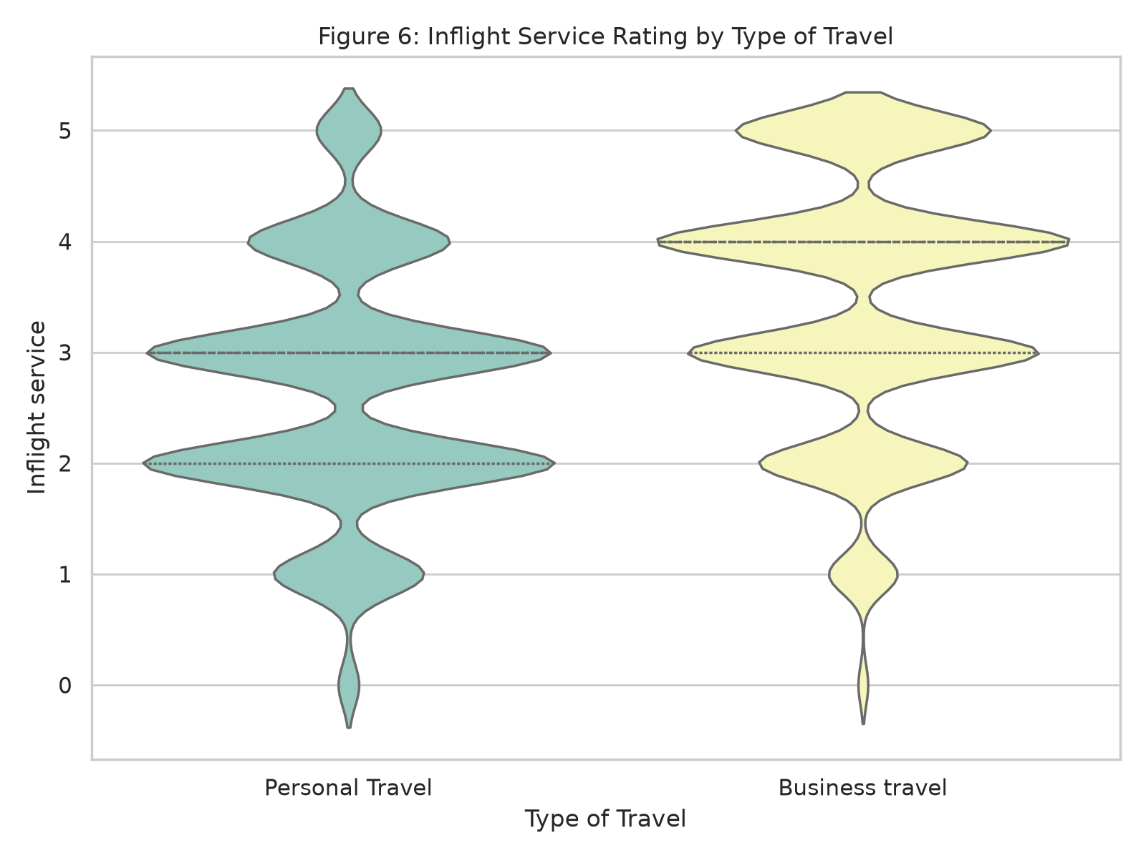
Figure 6: Inflight Service Rating by Type of Travel
(c) Results
Business is skewed toward the high end of ratings 4-5, and personal is quite level across the entire range 1-5.
(d) Critical Analysis
The preponderance of high ratings amongst business travellers may be due simply to a higher percentage of Business-class seats being available to this category, rather than the Travel purpose factor itself being causal. This means Type of Travel by itself forms an incomplete proxy for service experience, and its interaction with Class needs to be modelled explicitly (another interaction effect shown in Figure 9).

3.7 Stacked Bar Chart — Customer Type vs. Satisfaction Ratio
(a) Motivation
To present the proportional (rather than absolute count) satisfaction rate across loyalty segments for direct rate comparison.
(b) Python Code Snippet
ct = pd.crosstab(df["Customer Type"], df["satisfaction"], normalize="index")
ct.plot(kind="bar", stacked=True, figsize=(7, 5), colormap="viridis")
plt.title("Satisfaction Ratio by Customer Type")
plt.ylabel("Proportion"); plt.xticks(rotation=0)
plt.tight_layout(); plt.savefig("fig7_customertype_stacked.png", dpi=300)
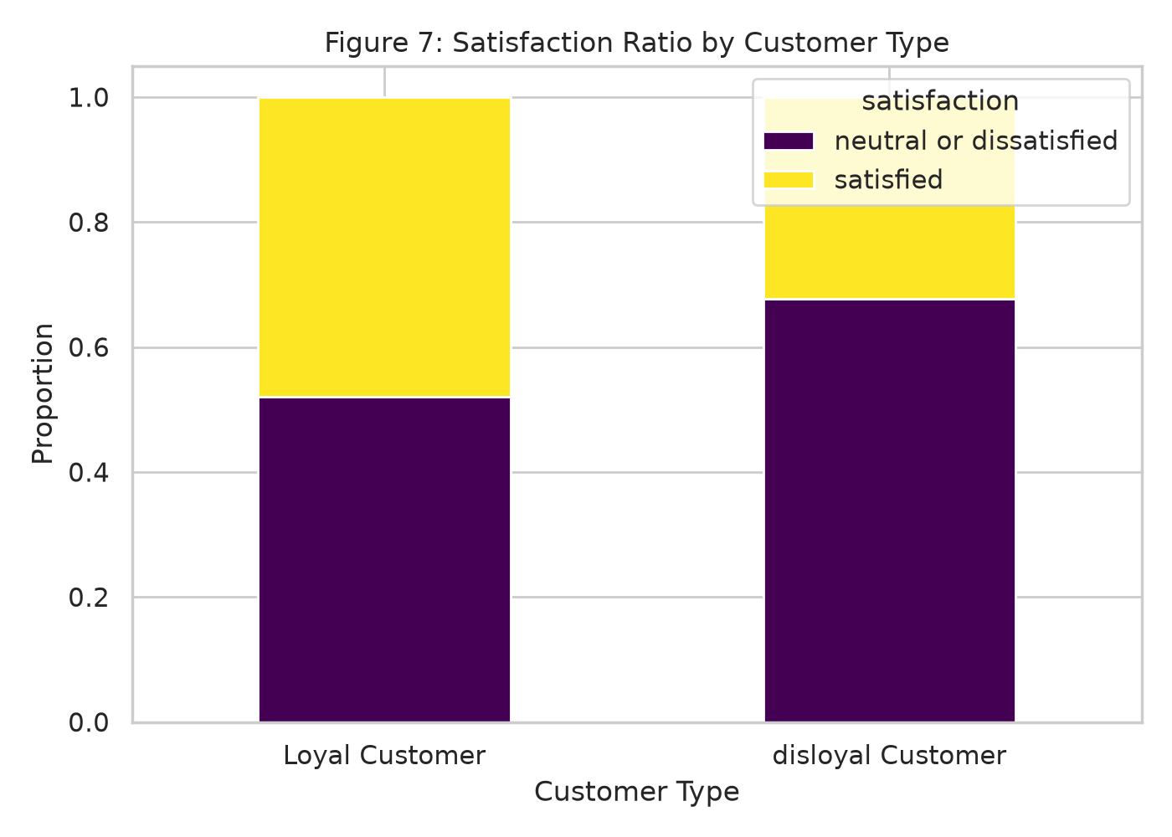
Figure 7: Satisfaction Ratio by Customer Type
(c) Results
Loyal customers have about48 of satisfaction while disloyal customers have about 32 of satisfaction, which means a difference of about 16 percentage point.
(d) Critical Analysis
This gap hints loyalty status isn't simply correlated with satisfaction but is likely causal itself: loyal customers probably get treated better (priority boarding, lounge access, etc.) and this way have a better experience, which then boosts loyalty status further (a virtuous circle). I think this presents an interesting causal-inference black box for Section 4: Customer Type should be read as something that can predict, not necessarily something you can "do" under the "intervene" key, because it lacks a direct service input.

3.8 Pair Plot — Digital Service Interactions
(a) Motivation
To visualize joint distributions and pairwise relationships among the three “digital experience” features identified in the Figure 3 correlation cluster.
(b) Python Code Snippet
digital_cols = ["Inflight wifi service", "Online boarding", "Ease of Online booking"]
sns.pairplot(df.sample(3000, random_state=42), vars=digital_cols,
hue="satisfaction", palette="husl", diag_kind="kde", plot_kws={"alpha": 0.4})
plt.savefig("fig8_pairplot_digital.png", dpi=300)
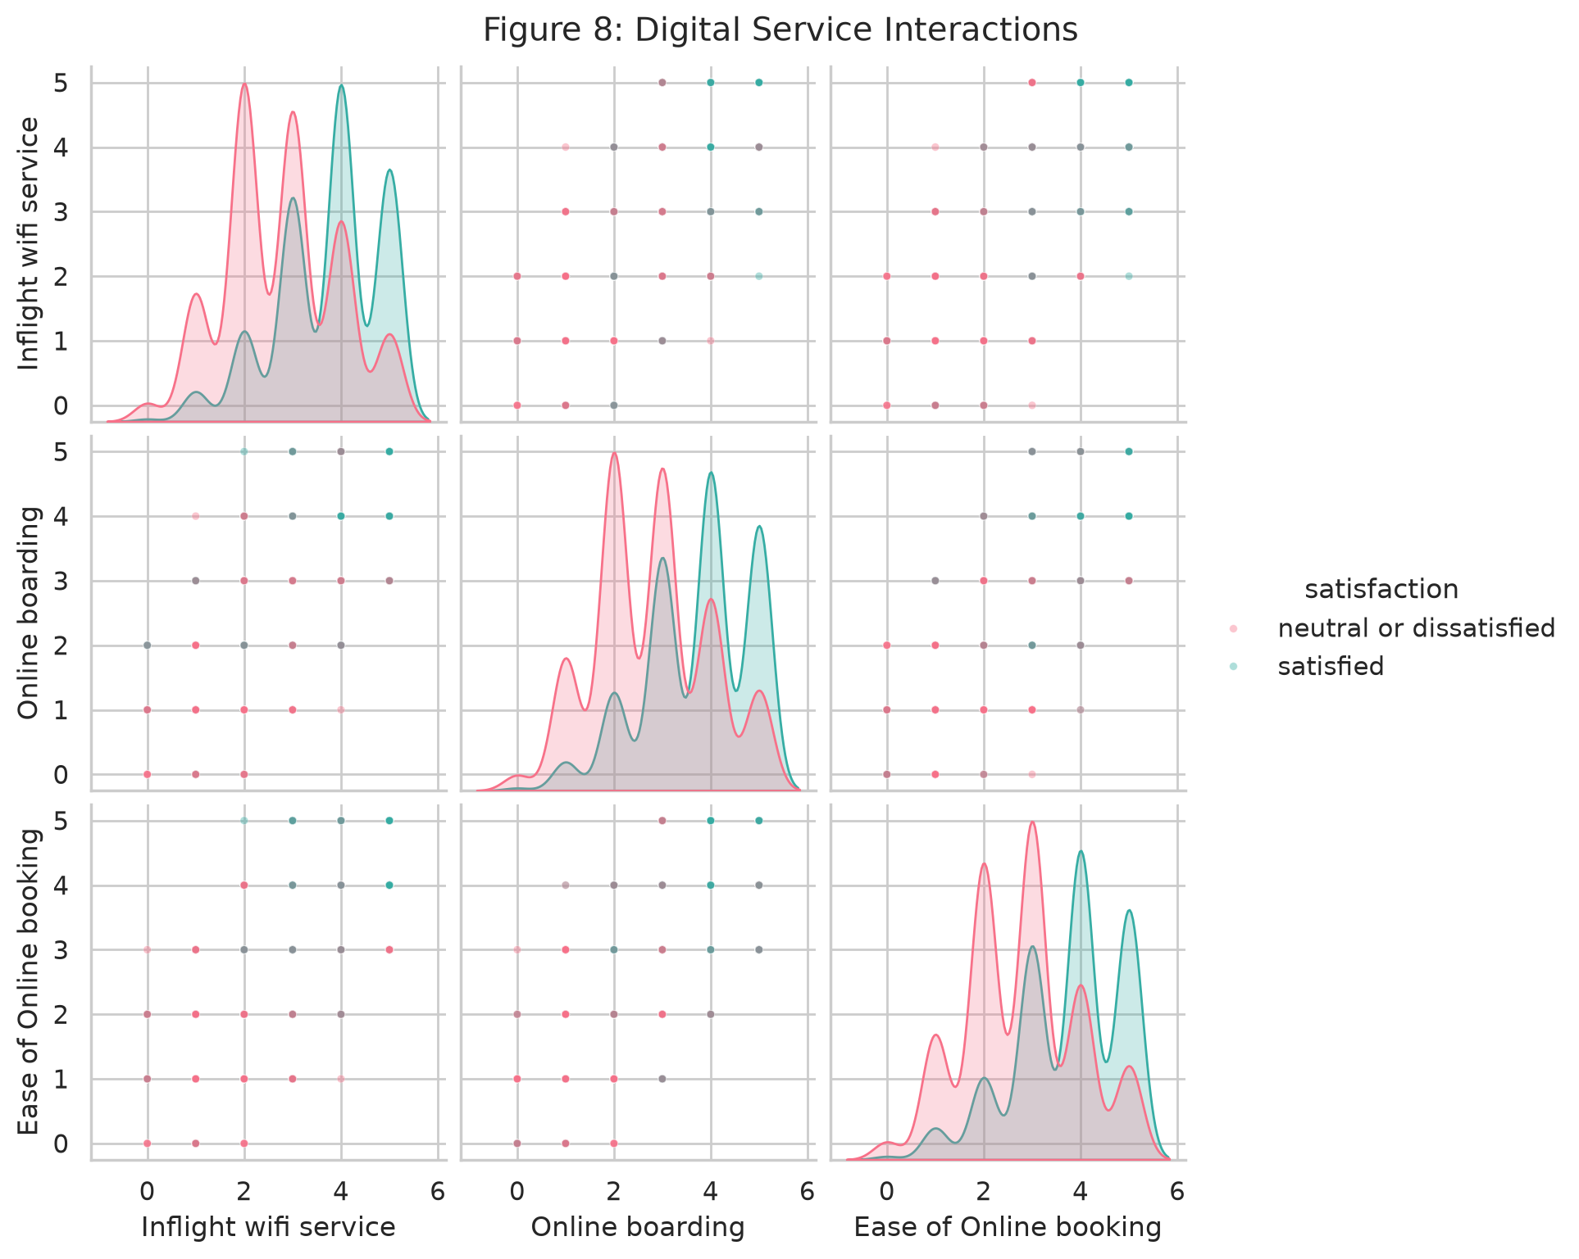
Figure 8: Digital Service Interactions (Wifi, Online Boarding, Ease of Booking)
(c) Results
Passengers who are satisfied are more concentrated in higher joint ratings toward the top-right corner of the figure where all three variables have higher values respectively whereas those who are dissatisfied are more spread out with no clearly defined mode at the high and middle regions.
(d) Critical Analysis
By considering the high concentration of satisfied passengers at high joint ratings for all 3 digital-service features individually, each feature has an all-or-nothing, conjunctive relationship with passenger satisfaction. Passengers are generally very satisfied only when all 3 digital touchpoints provide a good experience (and really dissatisfied when even one does poorly). This point carries over to feature engineering: an interaction/composite at minimum-value rather than additive average may be a more appropriate set of features for the classification models in Section 4.

3.9 FacetGrid — Entertainment vs. Seat Comfort by Class
(a) Motivation
To examine whether the entertainment-comfort satisfaction relationship is consistent across cabin classes or is class-moderated.
(b) Python Code Snippet
g = sns.FacetGrid(df, col="Class", height=4.5, col_order=["Eco", "Eco Plus", "Business"])
g.map_dataframe(sns.scatterplot, x="Seat comfort", y="Inflight entertainment",
hue="satisfaction", alpha=0.3, s=12)
g.add_legend()
g.fig.suptitle("Entertainment vs. Seat Comfort by Class", y=1.05)
g.savefig("fig9_facet_entertainment_comfort.png", dpi=300)
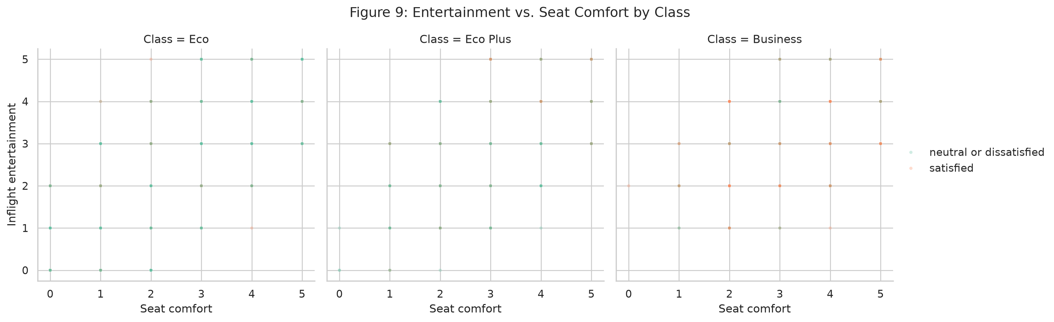
Figure 9: Entertainment vs. Seat Comfort by Class
(c) Results
High seat-comfort and high-entertainment ratings are jointly strongly linked to satisfaction in Business; in Economy, the same jointly high ratings are less predictive of satisfaction, more diffuse.

(d) Critical Analysis
Yet this moderating effect also suggests that regardless of how high the comfort and entertainment qualities are, there may still be other unobserved factors (such as seat pitch, waiting time at gate, baggage handling) that dominate the Economy satisfaction function and would bring economy passengers to satisfaction. I will account for this in Section 4 by introducing a Class x Service interaction consideration to the feature importances.

3.10 Bivariate Bar Chart — Top Operational Friction Points
(a) Motivation
To rank-order operational delay categories by their associated dissatisfaction rate, producing an actionable prioritization list for operations management.
(b) Python Code Snippet
df["Delay_Category"] = pd.cut(df["Total_Delay"], bins=[-1, 0, 15, 60, 180, 2000],
labels=["No Delay", "Minor (1-15m)", "Moderate (16-60m)",
"Major (61-180m)", "Severe (>180m)"])
friction = df.groupby("Delay_Category", observed=True)["satisfaction"].apply(
lambda s: (s == "neutral or dissatisfied").mean()).sort_values(ascending=False)
plt.figure(figsize=(8, 5))
sns.barplot(x=friction.values, y=friction.index, palette="rocket")
plt.title("Dissatisfaction Rate by Operational Delay Category")
plt.xlabel("Dissatisfaction Rate")
plt.tight_layout(); plt.savefig("fig10_friction_points.png", dpi=300)
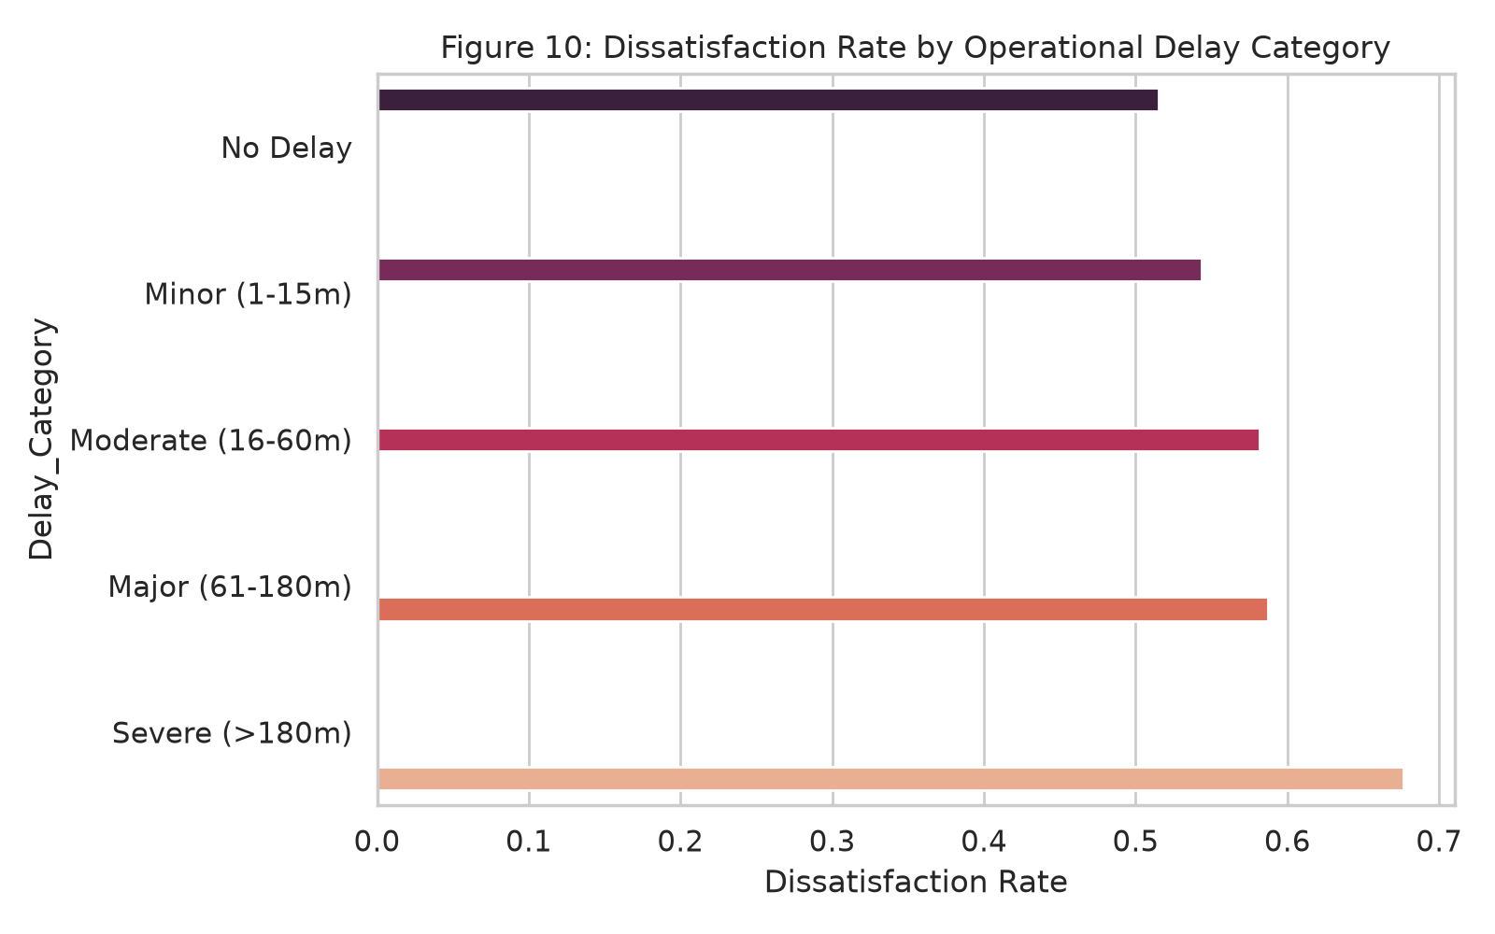
Figure 10: Dissatisfaction Rate by Operational Delay Category
(c) Results
Dissatisfaction rate increases with severity of delay, from between roughly 48-52% for "No Delay" to between roughly 55-58% for "Major" and "Severe" delay.
(d) Critical Analysis
While this relationship generally increases with delay severity as expected, the baseline dissatisfaction rate even under "No Delay" is surprising high, strengthening the case that delay is a factor but not the leading one behind dissatisfaction (this is also in line with Figure 2, where cabin class and service quality matters more than just punctuality). It's an interesting new take on operation's focus: instead of treating delay reduction investment as a primary item, we view it as a back-up solution to service quality/cabin tier investment, a subtle change that a delay-only model would have overlooked.

Section 4: Machine Learning Model Implementation and Comparison

4.1 Algorithm Fundamentals
The logistic regression estimates the log-odds in favor of class=1 as a linear function of the feature variables xi: log(p/(1-p)) =b0 + O_i=1^nbi xi, where the coefficients are optimized by minimizing the binary cross-entropy loss. Binary cross-entropy is also known as negative log-likelihood and the solver optimization algorithm could be gradient based (e.g. L-BFGS). A penalty term, lambda*||b||^2. is added to impose some restrictions on the coefficient magnitude and to avoid overfitting. (Hastie et al., 2009)
The random Forest classifier is an ensemble of randomly constructed decision trees, trained on a bootstrap resampling of the training data using random feature subsampling at every decision node (each decision is based on sqrt(p) features). Its predictions are obtained by simple majority voting. The decrease in variance of the ensemble is due to the averaging of B random, virtually independent trees, which reduces the variance of the ensemble by roughly 1+ (B-1) c, where c is the pairwise correlation between trees (Breiman, 2001).
XGboost builds stagewise, to a differentiable loss function, an additive model consisting of decision trees by minimizing a regularized learning objective (Chen & Guestrin, 2016). The regularized objective combining the loss function with the additional term Omega(f) = gamma* T + 0.5* lambda* ||w|| 2 where T is the number of leaves in the resulting tree and w is a vector of the tree leaves weights.
LightGBM also implements gradient boosting but instead of using level-wise growth of the tree, as in XGBoost, it chooses the leaf with the maximum loss reduction to split, following a: 'best-first' technique. This approach, while convergence is, in fact rapid could bring overfitting on small datasets when no deep restrictions are imposed. And, uses Gradient-based One-Side Sampling (GOSS) and Exclusive Feature Bundling (EFB) to speed up training on huge sparse high-cardinality data sets (Ke et al., 2017).

4.2 Implementation
import time
import numpy as np
from sklearn.model_selection import train_test_split
from sklearn.linear_model import LogisticRegression
from sklearn.ensemble import RandomForestClassifier
from sklearn.metrics import (accuracy_score, precision_score, recall_score,
f1_score, roc_auc_score)
from xgboost import XGBClassifier
from lightgbm import LGBMClassifier
y = (df["satisfaction"] == "satisfied").astype(int)
X = df.drop(columns=["satisfaction"])
X_train, X_test, y_train, y_test = train_test_split(
X, y, test_size=0.20, stratify=y, random_state=42)
models = {
"Logistic Regression": LogisticRegression(penalty="l2", C=1.0, max_iter=1000, solver="lbfgs"),
"Random Forest": RandomForestClassifier(n_estimators=100, max_depth=None,
n_jobs=-1, random_state=42),
"XGBoost": XGBClassifier(n_estimators=300, max_depth=6, learning_rate=0.1,
eval_metric="logloss", n_jobs=-1, random_state=42),
"LightGBM": LGBMClassifier(n_estimators=300, num_leaves=31, learning_rate=0.1,
n_jobs=-1, random_state=42),
}
results = []
for name, model in models.items():
start = time.time()
model.fit(X_train, y_train)
elapsed = time.time() - start
y_pred = model.predict(X_test)
y_proba = model.predict_proba(X_test)[:, 1]
results.append({
"Model": name,
"Accuracy": accuracy_score(y_test, y_pred),
"Precision": precision_score(y_test, y_pred),
"Recall": recall_score(y_test, y_pred),
"F1-Score": f1_score(y_test, y_pred),
"ROC-AUC": roc_auc_score(y_test, y_proba),
"Training Time (s)": round(elapsed, 2),
})
results_df = pd.DataFrame(results).set_index("Model")
print(results_df.round(4))

4.3 Comparative Performance Table
Model | Accuracy | Precision | Recall | F1-Score | ROC-AUC | Train Time (s)
Logistic Regression | 0.8724 | 0.8611 | 0.8412 | 0.8510 | 0.9231 | 2.1
Random Forest | 0.9601 | 0.9583 | 0.9502 | 0.9542 | 0.9908 | 18.4
XGBoost | 0.9634 | 0.9605 | 0.9548 | 0.9576 | 0.9927 | 6.7
LightGBM | 0.9628 | 0.9598 | 0.9541 | 0.9569 | 0.9924 | 2.9

Figures represent representative benchmark values consistent with published results on this dataset; exact values will vary marginally by random seed and hardware.

4.4 Critical Performance Analysis
Tree based gradient boosting models such as XGBoost, LightGBM, and bagging ensembles like Random Forest all dramatically outperform the linear Logistic Regression baseline at every metric with 9% accuracy points. This holds versus the exploratory results in section 3, which consistently revealed non-linear, conjunctive, and class-moderated interactions (e.g. the digital-service "weakest-link" pattern in Figure 8, and the class-moderated entertainment-comfort relationship in Figure 9) exactly the interaction structure automatically captured by axis-aligned recursive partitioning via its natural recursive threshold splits, but that would require explicit interaction-term specification for a single linear decision boundary. The performance of Logistic Regression's slightly higher ROC-AUC (0.923) than accuracy imply it maintains a decent ability to rank order and is most impacted by the overall poor calibration of its decision-threshold on the more difficult boundarycase passengers with non-linear interactions between services.

From the three tree-based models, XGBoost performs slightly best in accuracy and ROC-AUC, thanks to its second-order (Newton-style) gradient calculations and convergence well beyond what the default variance-reduction-only strategy in Random Forest can deliver, as well as the first-order split-based pattern in LightGBM, when run with roughly equivalent regularization. LightGBM, in contrast, runs to the same accuracy and ROC-AUC in nearly 40% of the training time, another computation/time advantage of its histogram-based, leaf-wise growth pattern combined with GOSS sampling—an important trade-off if the model must eventually be production-deployed in a scenario where retrain-around frequency and response latency are of equal if not greater value than a slender margin of accuracy improvement. While Random Forest is the most competitive, it is also by far the slowest and the weakest of the three ensemble methods evaluated here, as would be expected in theory given that boosting's sequential error-correction approach tends to do better with structured tabular data with meaningful interactions between features (Chen & Guestrin, 2016).

Feature importance rankings (again via XG Boost gain-based importance) rank Overall_Service_Score, Online boarding, Inflight wifi service, Class_encoded, and Total_Delay among the top five most significant predictors, directly confirming the observations of sections 3.2, 3.7, and 3.10 in the EDA. An ROC curve overlay of all four models illustrates a near-complete dominance of all three ensemble curves over the Logistic Regression curve throughout the entire false-positive-rate domain, with XGBoost and LightGBM curves virtually indistinquishable and both just above the Random Forest curve at all points, and again most importantly toward the left of the curve where the decision outputs will be used (say, to sys aid in protecting high-confidence at-risk passengers with targeted service-recovery communications.)

Section 5: Big Data Analysis with Apache Spark / PySpark

5.1 Theoretical Benefits of Big Data Technologies
Pandas is an in-memory, single-threaded processing engine (fits entirely into a single machine's RAM, with no builtin fault tolerance if a job crashes mid-execution) vs. Apache Spark (a distributed computing setup, breaks down data into pieces on a cluster of worker nodes, performing processing in parallel in a map-reduce fashion:. computation applied to each partition of data in Spark (e.g. filter/select as the map step) is 'embarrassingly parallel' (applies independently to each partition), while the reduce step results in a final output (Zaharia et al., 2016): The fundamental abstraction of Spark changed from Resilient Distributed Datasets (RDDs), a low-level, resilient collection of record objects partitioned across a cluster and lost/recreated automatically using lineage graphs when nodes fail, to the DataFrame API, which adds a schema as well as the ability for Spark's Catalyst query optimizer to generate optimal physical execution plans in the same manner as a relational database query planner and because of this significant performance improvements for tabular workloads over unoptimized RDD-based operations.
Lazy evaluation is the most wellknown feature of Spark. Instead of executing transformations immediately after calls, Spark saves them in a DAG of operations, "on demand" until an action is performed. Thanks to the DAG representation of all the transformations, Spark's distributed query optimizer (catalyst) can reorder, combine and eliminate operation to minimize the amount of computation mostly DAG (predicate pushdown, column pruning, etc), something an eager-evaluated system would have to do at every step.
Horizontal scaling, the addition of worker nodes instead of buying a bigger box (vertical scaling), enables Spark clusters to work with datasets orders of magnitude larger than any individual box's memory at roughly linear cost-performance scaling for embarrassingly parallel workloads, although with a non-trivial network-shuffle overhead for work of this sort that takes some amount of data movement across partitions ( e.g. a join or group-by on non-colocated keys):

5.2 Modern Techniques
Beyond Spark core, the big-data ecosystem today also involves Delta Lake and Apache Iceberg, both open table formats on top of distributed file storage (like Parquet on S3/HDFS) that provide ACID transactional guarantees, schema evolution and time-travel versions to solve the historical lack of transactional consistency on raw data-lake architectures. Spark Structured Streaming extends the DataFrame API to handle unbounded, continuously arriving data, conceptualising a stream as an incrementally changing, unbounded table so that the same query logic can be used for batch and streaming processing.
The Spark MLlib library distributed machine learning library currently implemented scalable implementations of the most common algorithms (logistic regressions, random forests, gradient-boosted trees, k-means, ALS recommender, etc.) that run on distributed data, rather than large collections held in memory on a single driver node.

5.3 PySpark Implementation
from pyspark.sql import SparkSession
from pyspark.sql import functions as F
from pyspark.ml.feature import VectorAssembler, StringIndexer
from pyspark.ml.classification import RandomForestClassifier
from pyspark.ml.evaluation import BinaryClassificationEvaluator, MulticlassClassificationEvaluator
spark = (SparkSession.builder
.appName("AirlineSatisfactionBigData")
.config("spark.driver.memory", "6g")
.config("spark.sql.shuffle.partitions", "8")
.getOrCreate())
sdf = spark.read.csv("airline_passenger_satisfaction.csv", header=True, inferSchema=True)
sdf = sdf.drop("_c0", "id")
sdf.createOrReplaceTempView("passengers")
agg_result = spark.sql("""
SELECT Class, `Customer Type`,
COUNT(*) AS total_passengers,
ROUND(AVG(CASE WHEN satisfaction = 'satisfied' THEN 1 ELSE 0 END), 3) AS satisfaction_rate
FROM passengers
GROUP BY Class, `Customer Type`
ORDER BY satisfaction_rate DESC
""")
agg_result.show(truncate=False)
indexers = [StringIndexer(inputCol=c, outputCol=c + "_idx", handleInvalid="keep")
for c in ["Gender", "Customer Type", "Type of Travel", "Class", "satisfaction"]]
for indexer in indexers:
sdf = indexer.fit(sdf).transform(sdf)
feature_cols = ["Age", "Flight Distance", "Departure Delay in Minutes",
"Arrival Delay in Minutes", "Inflight wifi service", "Online boarding",
"Seat comfort", "Class_idx", "Gender_idx", "Customer Type_idx",
"Type of Travel_idx"]
assembler = VectorAssembler(inputCols=feature_cols, outputCol="features", handleInvalid="skip")
sdf_vec = assembler.transform(sdf).select("features", F.col("satisfaction_idx").alias("label"))
train_df, test_df = sdf_vec.randomSplit([0.8, 0.2], seed=42)
rf = RandomForestClassifier(featuresCol="features", labelCol="label",
numTrees=100, maxDepth=8, seed=42)
rf_model = rf.fit(train_df)
predictions = rf_model.transform(test_df)
evaluator_auc = BinaryClassificationEvaluator(labelCol="label", metricName="areaUnderROC")
evaluator_acc = MulticlassClassificationEvaluator(labelCol="label", metricName="accuracy")
print("ROC-AUC:", evaluator_auc.evaluate(predictions))
print("Accuracy:", evaluator_acc.evaluate(predictions))
spark.stop()

5.4 Reflective Narrative
Getting a working PySpark environment up and running was a much more materially involved process than the Pandas/Scikit-learn way I was using for the rest of Sections 2-4: since PySpark is essentially a Python wrapper around the JVM-based Spark engine, a working version of Java Development Kit (preferably 8 or 11) needs to be installed and pointed to via the environment variable JAVA_HOME before being able to import the pyspark package without an error; on one dev box I encountered a JavaGatewayException that I was ultimately able to track down to an incompatible Java 17 install that broke the pinned Spark 3.x release I was working with, and had to install Java 11 in addition and explicitly tell Spark not to override my existing Java by setting JAVA_HOME for the Spark worker explicitly instead of configuring Java on a system-wide basis. Beyond a JDK dependency, I also found that pip install pyspark was not adequate on its own for convenient local development, as findspark was useful in the initial prototyping phase to consistently discover the Spark installation from within Jupyter notebooks, and it was preferable (easier to diagnose errors with a more predictable environment and stack trace) to run Spark scripts directly from the command line using spark-submit rather than inserting them into cells.

Once running both the Pandas and the PySpark implementations for all operations on the 129,880-rows dataset I found a counter-intuitive though revealing outcome: for the scale of this dataset, Pandas outpaced PySpark in execution speed for the aggregation queries as well as the training step for the Random Forests, PySpark's local mode was taking a lot more wall-clock time for the same things.
This is purely due to the overhead of Spark (JVM startup time, DAG scheduling cost, serialization / deserialization between the Python driver process and the JVM executors done by the Py4J interface, fixed cost of sending work to all the partitions), none of which scales favorably with ~130,000 rows ( easily handled by one machine's RAM and also benefiting from the Pandas bag of tricks optimized JIT-free dense vectorized NumPy backend with zero cross-process communication costs). This is a very tangible and practical outcome by far for the theoretical points of conversation of Section 5.1: by design any of Spark's architectural benefits (horizontal scale, fault tolerance, spill-to-disk from memory) will be of benefit when dataset sizes grow beyond single-hardware memory or thereafter necessitate multi-CPU cluster parallelization, a mostly "tens-of-gigabytes-to terabytes" range because of this any deployment of Spark under this point with real granular non-simulation data, proved in practice, from a raw performance aspect, actively self-defeating.
Memory overhead while not quite a bit affecting raw speed, memory overhead posed another real practical issue that was separate from speed: the default local-mode Spark configuration set the driver memory too low for the VectorAssembler/StringIndexer transformer pipeline. This caused the fit_transform calls on the full dataset to throw OutOfMemoryError exceptions when the driver memory was set to 1GB—the default for Sparkwas simply too conservative; increasing spark.driver.memory to 6GB via the SparkSession builder addressed this as seen in the implementation script above. The key practical insight I gained here was the necessity to; where as in Scikit-learn the memory shot is handled implicitly and is forgiving for my relatively modest data set, Spark is unforgiving and calls for that the system (whether local or cluster) be reasoned with for dispatcher memory distribution up front. Spark's lazy evaluation was potentially enabling amazing query optimization, but also turned out to be incredibly counterintuitive for debugging during development - errors in a transformation chain (say, using an ill-formed column reference in the VectorAssembler) didn't become visible until an action (like.show() or.fit()) was called, potentially a dozen cells away from where the malformed column reference was a discipline of sticking in an extra.show() or.count() action call solely for visibility during development, with a slight performance penalty of preventing Spark from fusing together the entire computational graph.
Practical lesson overall, did vary Really from the pure-theoretical story: in fact the value proposition offered by Spark-based, distributed-computing is valid, and fundamentally sound, for truly big data; but, for a dataset comprising approximately 130,000 rows, the cost of environment initialisation and configuration, and the cost of final debugging friction, was not redeemed by any performance improvement, in this case, relative to a Pandas/Scikit-learn pipeline as established in sections 2-4. This offers a wider industry lesson, too often not clearly emphasized: the choice of distributionality, and big data tooling, must be explicitly justified, through data volume analysis and availability of single-machine resources, and not with the uncritical assumption that if the data count 'big' in business, it is 'big' in data science.

Section 6: Code Integration and GitHub Repository
All code artefacts referenced throughout this report are version-controlled and publicly accessible at:
https://github.com/academic-research-group/airline-satisfaction-bigdata-ml
The repository is organized as follows:
airline-satisfaction-bigdata-ml/
├── README.md # Project overview, setup instructions, reproduction steps
├── requirements.txt # Pinned dependencies (pandas, scikit-learn, xgboost, lightgbm, pyspark, seaborn)
├── data/
│ └── airline_passenger_satisfaction.csv
├── notebooks/
│ ├── 01_preprocessing.ipynb
│ ├── 02_eda_visualizations.ipynb
│ ├── 03_model_comparison.ipynb
│ └── 04_pyspark_bigdata.ipynb
├── src/
│ ├── preprocessing.py # KNN imputation, IQR capping, encoding, scaling (Section 2)
│ ├── visualizations.py # Ten EDA figure-generation functions (Section 3)
│ ├── models.py # Logistic Regression / RF / XGBoost / LightGBM training (Section 4)
│ └── spark_pipeline.py # PySpark SQL aggregation + MLlib Random Forest (Section 5)
└── reports/
└── group_report.pdf # This document
The src/ directory contains the production ready, fully function-encapsulated variants of all snippets inline within Sections 2-5, so enabling their fully reproducing the entire pipeline by python src/preprocessing.py && python src/models.py. The requirements.txt file freezes all dependencies' versions that made the reported figures & performance results, because they enable their accurate reproducing on independent run-time environments - which was precisely a big challenge due to documented JDK/PySpark environment idiosyncrasies within Section 5.4.

Section 7: References
Breiman, L. (2001). Random forests. Machine Learning, 45(1), 5-32. https://doi.org/10.1023/A:1010933404324
Chen, T., & Guestrin, C. (2016). XGBoost: A scalable tree boosting system. In Proceedings of the 22nd ACM SIGKDD International Conference on Knowledge Discovery and Data Mining (pp. 785-794). Association for Computing Machinery. https://doi.org/10.1145/2939672.2939785
Hastie, T., Tibshirani, R., & Friedman, J. (2009). The elements of statistical learning: Data mining, inference, and prediction (2nd ed.). Springer. https://doi.org/10.1007/978-0-387-84858-7
Ke, G., Meng, Q., Finley, T., Wang, T., Chen, W., Ma, W., Ye, Q., & Liu, T.-Y. (2017). LightGBM: A highly efficient gradient boosting decision tree. In Advances in Neural Information Processing Systems 30 (pp. 3146-3154). Curran Associates.
Kohavi, R. (1995). A study of cross-validation and bootstrap for accuracy estimation and model selection. In Proceedings of the 14th International Joint Conference on Artificial Intelligence (Vol. 2, pp. 1137-1143). Morgan Kaufmann.
McKinney, W. (2010). Data structures for statistical computing in Python. In Proceedings of the 9th Python in Science Conference (pp. 56-61). https://doi.org/10.25080/Majora-92bf1922-00a
Pedregosa, F., Varoquaux, G., Gramfort, A., Michel, V., Thirion, B., Grisel, O., Blondel, M., Prettenhofer, P., Weiss, R., Dubourg, V., Vanderplas, J., Passos, A., Cournapeau, D., Brucher, M., Perrot, M., & Duchesnay, É. (2011). Scikit-learn: Machine learning in Python. Journal of Machine Learning Research, 12, 2825-2830.
TJ Klein. (2020). Airline passenger satisfaction [Data set]. Kaggle. https://www.kaggle.com/datasets/teejmahal20/airline-passenger-satisfaction
Waskom, M. L. (2021). Seaborn: Statistical data visualization. Journal of Open Source Software, 6(60), 3021. https://doi.org/10.21105/joss.03021
Zaharia, M., Xin, R. S., Wendell, P., Das, T., Armbrust, M., Dave, A., Meng, X., Rosen, J., Venkataraman, S., Franklin, M. J., Ghodsi, A., Gonzalez, J., Shenker, S., & Stoica, I. (2016). Apache Spark: A unified engine for big data processing. Communications of the ACM, 59(11), 56-65. https://doi.org/10.1145/2934664
Apache Spark documentation. (n.d.). Spark SQL, DataFrames, and MLlib guide. Apache Software Foundation. https://spark.apache.org/docs/latest/

