LAB-7
Aarohi Saxena
2200291520002
Project: Using CCTV cameras in Railways for crime detection, crowd management and work management (operational flow)

0-LEVEL DFD:
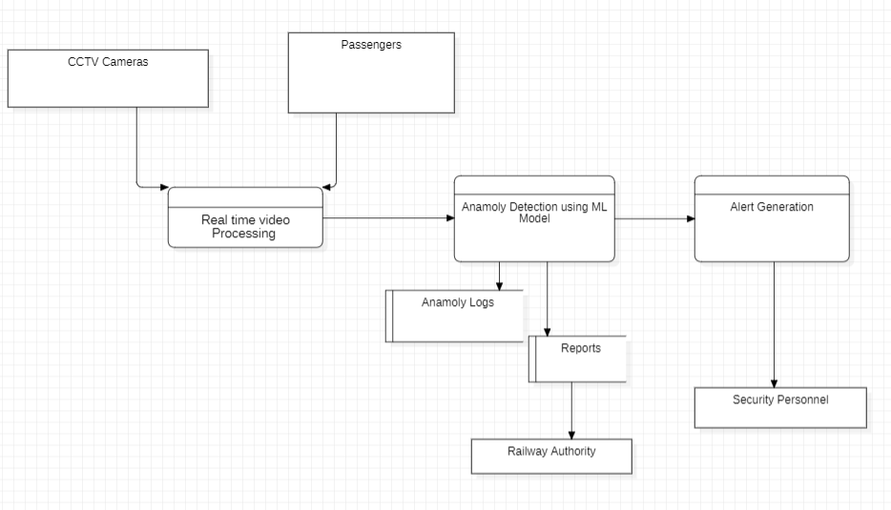

1-Level DFD
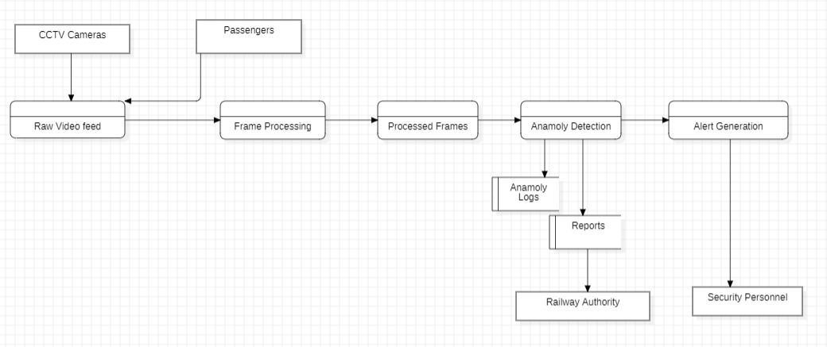
2 Level DFD:
