CS345/545 – CS345/545 Assignment 2

* Review HTML form and write your own .CSS style-sheet
* Learn jQuery;
* Learn Bootstrap;

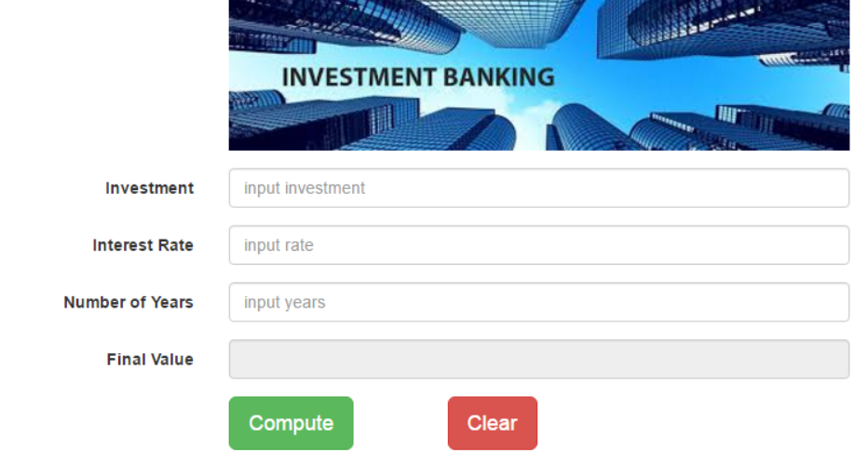

Task I. Create an HTML file like above picture.

Step 1: Create a folder called Investment and create a HTML file called Investement.html

Step 2: Create a container div, inside container create a form.

Step 3: Create an img element, the source picture is banking.jpg. You can find the picture as the attachment of this assignment.

Step 4: Create 4 groups of label+input for Investment, InterestRate, Number of Years and Final Value.

Step 5: Create 2 buttons called Compute and Clear

Step 6: Use bootstrap features to set form layout:

① On extra small device, each label and input box use one line, see picture below:

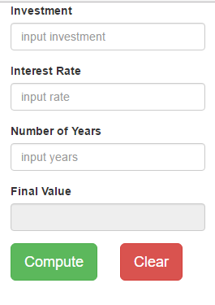

② On small device or larger, labels should on the left of input box and take up 3 grids, image and buttons need to offset 3 grids as well:



Task II. Set up your csmadison server to run our assignments.

A. Map network drive: csmadison.dhcp.bsu.edu/BSUUserName

B. HTTP/Browsing Addrress http://csmadison.dhcp.bsu.edu/~BSUUserName

Task III. Publish your investment page into csmadison server.

1. Create a folder called assignment2 in your csmadison server;

2. Copy Investment folder into assignment2 folder;

3. Run your investment through browser like below:

http://csmadison.dhcp.bsu.edu/assignment2/Investment/Investment.html

Thanks!

Dr. Zhang