

METBK Anemometer Test Report

Control Number: 3305-00027

Version: 1-00

**Date: 2024-04-20**

**Author: I. Duran, J. Edson, S. N. White**

**Approver: A. Plueddemann, 2024-04-20**



Coastal and Global Scale Nodes

Ocean Observatories Initiative

Woods Hole Oceanographic Institution

Oregon State University

**Revision History**

|  |  |  |  |
| --- | --- | --- | --- |
| **Version** | **Description** | **Originator** | **Release Date** |
| 0-01 | Initial Draft | S. N. White, I. Duran, J. Edson |  |
| 0-02 | Results added | S. N. White, J. Edson |  |
| 0-03 | Completed draft for review | J. Edson, S. N. White |  |
| 1-00 | Initial Release | A. Plueddemann | 2024-04-20 |
|  |  |  |  |
|  |  |  |  |

**Table of Contents**

List of Figures iii

List of Tables iii

1.0 Introduction 1

2.0 Reference Documents 4

3.0 Definitions & Acronyms 4

4.0 Test Description 5

4.1. Test Objectives 5

4.2. Test Environment 5

4.3. Test Configuration 6

4.4. Test Schedule 7

5.0 Results 7

5.1. Data Collection & Analysis 7

5.2. More Clues and Next Steps 10

**List of Figures**

Figure 1‑1 – One of the test configurations used in the sonic comparisons during Pioneer 16. 1

Figure 1‑2 – Time series of winds from (top) the R3-50 and Windmaster Pro (WM), and (bottom) the Windmaster Pro and the Wind Observer (WObs). 2

Figure 1‑3 – Comparison between OOI 2-axis and 3-axis anemometers. The R3-50 and WindMasterPro (WM) are FDCHP 3-axis sonic anemometers. In this plot, WObs is the METBK Wind Observer 2-axis sonic anemometer. 2

Figure 1‑4 – A scatter plot of the METBK systems versus the FDCHP. 3

Figure 1‑5 – A timeseries of the METBK and FDCHP system from 9-days of telemetered data. 3

Figure 1‑6 – A timeseries of winds speeds measured by the R/V *Armstrong*, METBK and FDCHP during a 2.5 day period where the ship made measurements near the GI01SUMO-00010 buoy. 4

Figure 4‑1 – Comparison of wind measurements made from a Saildrone and the 3 Pioneer Surface Moorings by Sarah Nickford (personal communication). 5

Figure 4‑2 – Clark South roof test area 6

Figure 5‑1 – Comparison between R3-50 (3-Axis Sonic) and Wind Observer (2-Axis Sonic). 7

Figure 5‑2 – A comparison of the METBK logger and module results from the 2-axis sonic (SWND) and propeller-vane (WND). 8

Figure 5‑3 – Time series of the 2-axis sonic wind speed (SWND) from the logger and module, i.e., the data is from the same sensor. The plot shows the time jumping by one time-step of the logger clock relative to the module clock. 9

Figure 5‑4 – As in Figure 5-2, but with one of the time-stamps adjusted for drift. 9

Figure 5‑5 – A comparison of the non-OOI sonic anemometers versus the METBK anemometers. The SWND logger has been corrected for drift. 10

Figure 5‑6 – A comparison of the average of the SWND module and logger results (after adjustment for drift) versus the average of the non-OOI 2-D and 3-D sonics. 10

Figure 5‑7 – Plots of vector average winds versus scalar averaged winds. The first and second columns are results from the Southern Ocean and Argentine Basin Arrays. The third and fourth columns are results from the Pioneer and Irminger Sea Arrays. 11

**List of Tables**

Table 2‑1 – Reference Documents 4

Table 4‑1 – Test Article Configuration & Sampling 6

# Introduction

The Ocean Observatories Initiative (OOI) deploys bulk meteorology (METBK) and direct covariance flux (FDCHP) instrument packages on surface buoys. These instrument packages include sonic anemometers to make 2-axis or 3-axis wind measurements. Analyses of the data from both types of sonic anemometers have shown that the 2-axis sonic anemometers appear to under-report wind speed at speeds above about 7 m/s relative to the 3-axis anemometer on the FDCHP.

Testing conducted during Coastal Pioneer deployments compared a front-mounted FDCHP anemometer (3-axis) to side-mounted METBK anemometers (2-axis), and a front-mounted METBK anemometer (2-axis) to side-mounted FDCHP instruments with different types of 3-axis anemometers Figure 1‑1).

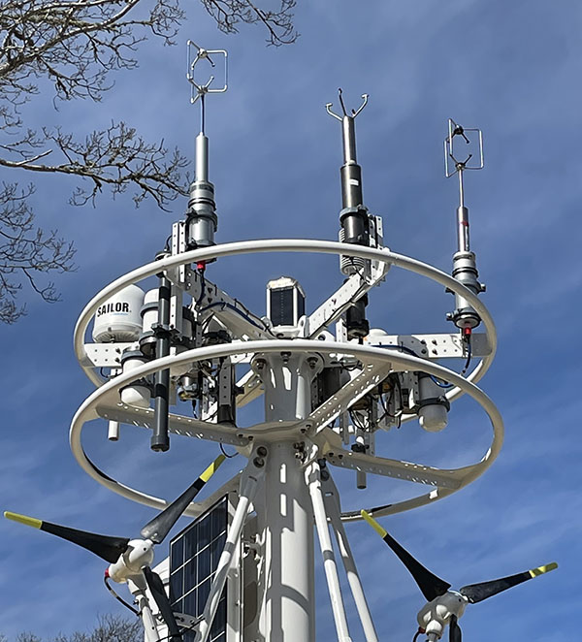

Figure 1‑1 – One of the test configurations used in the sonic comparisons during Pioneer 16.

**The 3-axis Gill R3-50 is at left, the 2-axis Gill Wind Observer is middle, and the 3-axis Gill Windmaster Pro is at right.**

In all cases, the 2-axis anemometers reported lower values at higher wind speeds as shown by the time series in Figure 1‑2. Thus, the location of the instrument does not appear to be the cause. The time series also shows that the two 3-axis anemometers agree extremely well even though they are mounted on either side of the buoy, and are different sensors. Figure 1‑3 takes this one step further by comparing the 3 anemometers as scatter plots. The comparison of the 3-axis sonics, whether raw or motion corrected, show good agreement and little scatter. All comparisons of the 2-axis versus 3-axis show similar behavior, i.e., the 2-axis sonic is noticeably lower than the 3-axis sonics starting at winds speeds as low as 7 m/s.

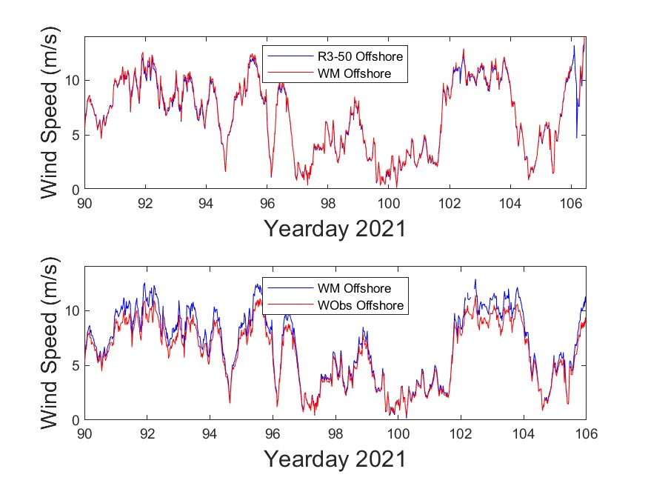

Figure 1‑2 – Time series of winds from (top) the R3-50 and Windmaster Pro (WM), and (bottom) the Windmaster Pro and the Wind Observer (WObs).

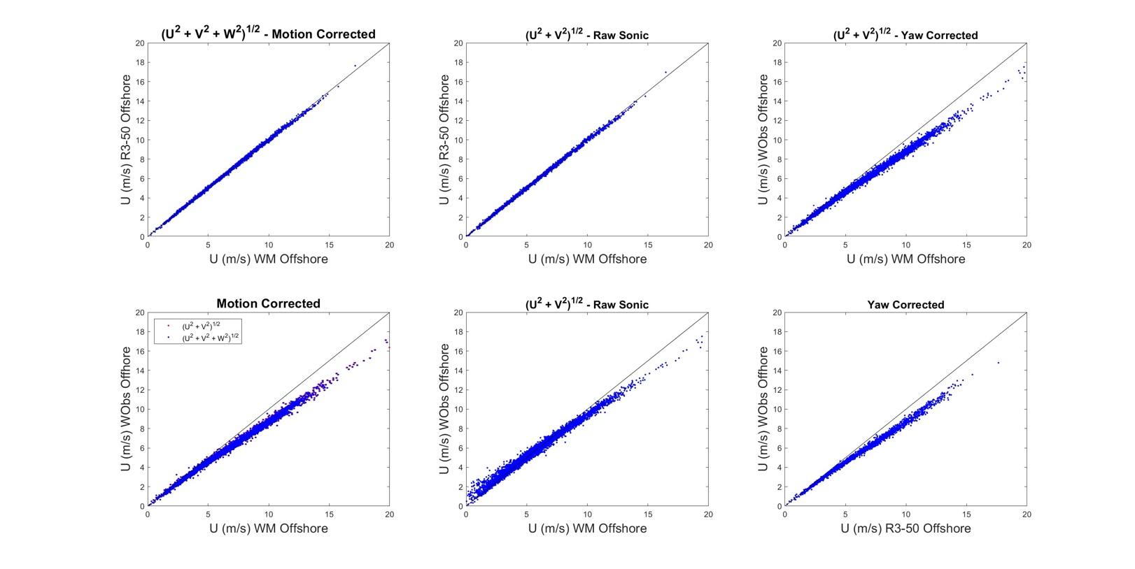

Figure 1‑3 – Comparison between OOI 2-axis and 3-axis anemometers. The R3-50 and WindMasterPro (WM) are FDCHP 3-axis sonic anemometers. In this plot, WObs is the METBK Wind Observer 2-axis sonic anemometer.

One more at sea test was conducted during a recent Irminger Sea turnaround to confirm that it was the METBK system rather than the FDCHP that providing underestimates of the wind speed. After deployment of the GI01SUMO-00010 surface mooring, approximately nine days of data from the METBK and FDCHP systems were telemetered from the buoy. The results are shown in Figure 1‑4 – where the plot on the left is from an earlier year-long Irminger Sea deployment showing the reduction in wind speed for the METBK sensor relative to the FDCHP. The plot on the right shows the results from the telemetered data showing the same behavior during the nine days that included a high wind event. Figure 1‑5 shows the time series from the two systems, which again shows the large discrepancy between the systems.

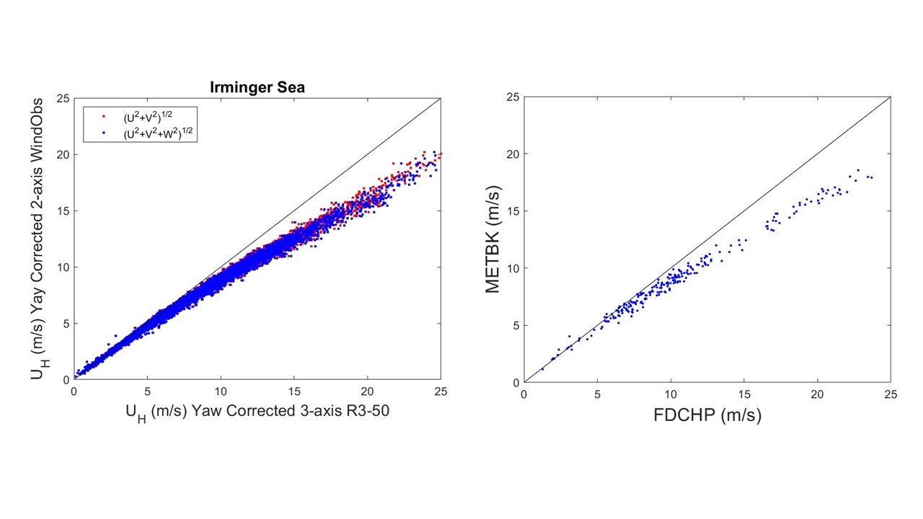

Figure 1‑4 – A scatter plot of the METBK systems versus the FDCHP.

**The left hand plot shows data from a year-long deployment. The right hand plot shows data that was telemetered during the turn-around cruise. The well documented underestimated wind speeds are clearly evident in both plots.**

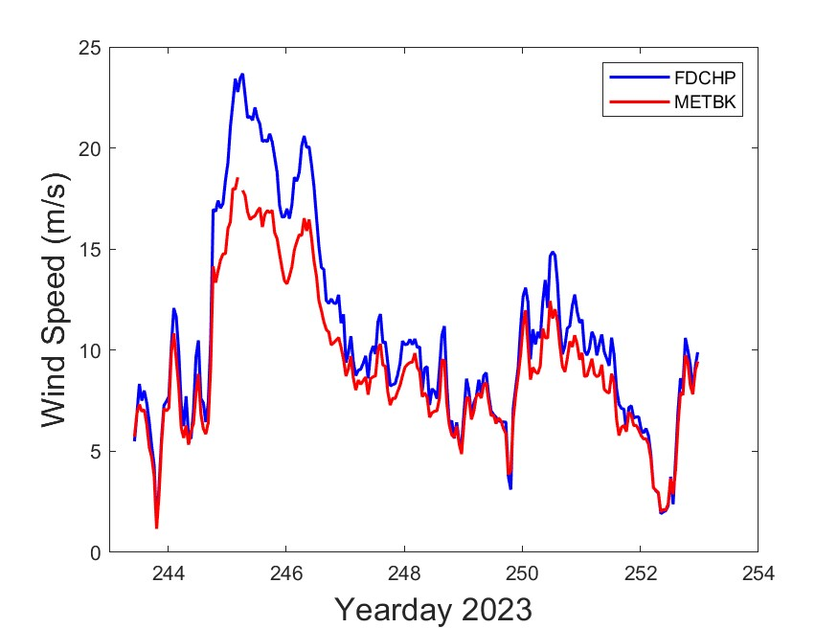

Figure 1‑5 – A timeseries of the METBK and FDCHP system from 9-days of telemetered data.

The CGSN cruise took advantage of conditions and station kept the ship near GI10SUMO-00010 for approximately two and a half days. The time series of the wind speed measured by the two systems on the buoy and from the R/V *Armstrong* are shown in Figure 1‑6. The winds were all adjusted to the same height using similarity theory. The results show good agreement between the ship and FDCHP system, and are perhaps the most conclusive to date that the METBK system is measuring low.

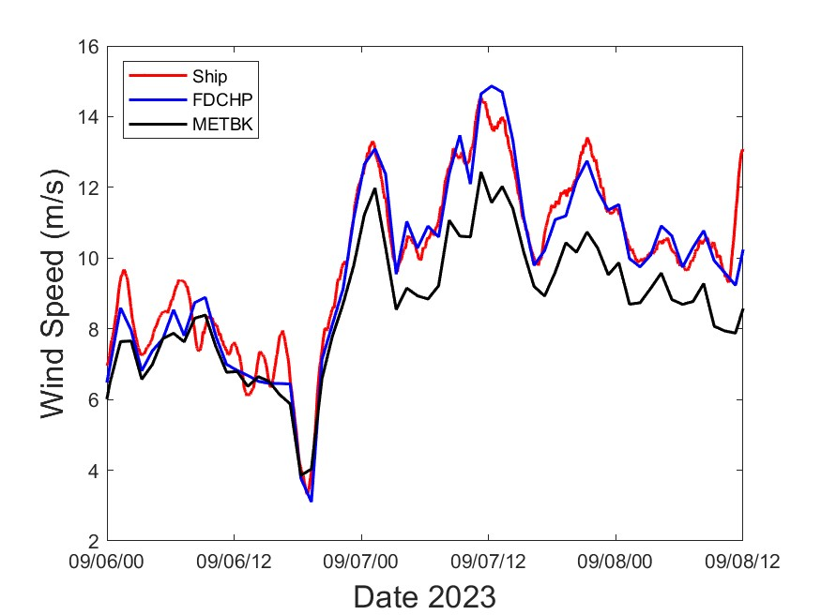

Figure 1‑6 – A timeseries of winds speeds measured by the R/V *Armstrong*, METBK and FDCHP during a 2.5 day period where the ship made measurements near the GI01SUMO-00010 buoy.

# Reference Documents

Table 2‑1 – Reference Documents

|  |  |
| --- | --- |
| **Document Identification** | **Document Title** |
| Edson, et al., 1998 | Direct Covariance Flux Estimates from Mobile Platforms at Sea |

# Definitions & Acronyms

ASIMET Air-Sea Interaction METeorology system

CGSN Coastal & Global Scale Node

EA Endurance Array

METBK OOI bulk meteorological instrument

OOI Ocean Observatories Initiative

OSU Oregon State University

SME Subject Matter Expert

SWND ASIMET sonic wind module

UOP Upper Ocean Processes Group

WHOI Woods Hole Oceanographic Institution

WND ASIMET propeller wind module

# Test Description

A shore-base, roof-top test was conducted to compare a variety of anemometer types and configurations to try to better understand the root cause of the low values. This test was expected to improve the understanding of data from METBK (and possibly FDCHP) instruments deployed at the OOI Global Irminger Sea, Coastal Pioneer, and Coastal Endurance Arrays. Details of the Test Articles and Objectives are captured in the METBK Anemometer Test Plan (3305-00027).

## Test Objectives

The objective of this investigation is to determine the cause of the underestimation of the 2-axis sonic wind measurements compared with the 3-axis sonics. The significant reduction has been observed by a user, who observed that the winds from the Pioneer Array were significantly lower than winds measured by a Sail Drone as it sailed past the moorings as shown in Figure 4‑1. Understanding, and eventually correcting, these discrepancies is important; a 20% reduction in the measured wind speed at high winds generates an even larger percentage reduction in the wind stress.

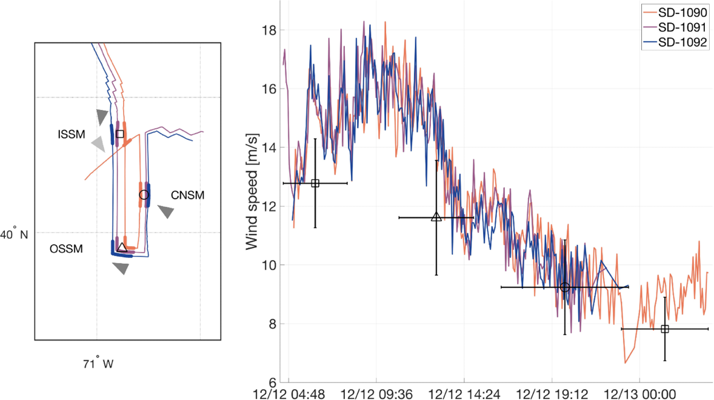

Figure 4‑1 – Comparison of wind measurements made from a Saildrone and the 3 Pioneer Surface Moorings by Sarah Nickford (personal communication).

**The Saildrone uses a modified R3-50 while the Pioneer measurements were made by the METBK Wind Observer. The comparison again show a significant underestimation of the wind speeds measured by the METBK versus the Saildrone at wind speeds above 10 m/s.**

## Test Environment

The test was conducted on the roof of the Clark South building on WHOI's Quissett campus (Figure 4‑2). Framework for mounting instrumentation already exists along with a conduit to run cabling into the building. Testing was conducted during the Fall 2022 time period when Coastal New England is experiences high-wind storms. It should be noted that the location is not ideal for this type of testing. For example, the orientation of Clark South points the measurement array to the ESE. A histogram (not shown) of wind directions shows that wind events are least likely to come from that direction. The dominant wind directions are SW and NNW from which the winds is blowing over heavily forested areas. A different facility will be used for upcoming comparisons.

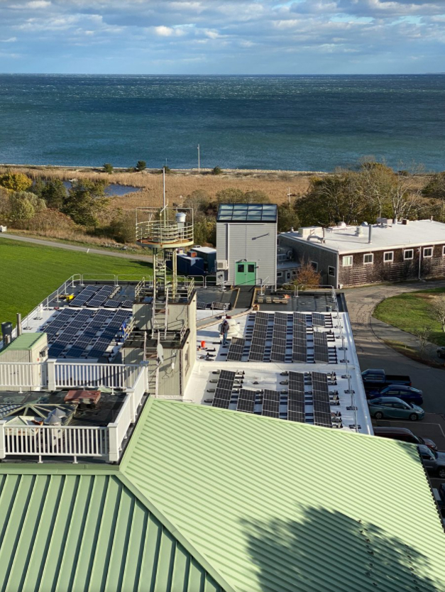

Figure 4‑2 – Clark South roof test area

## Test Configuration

All six test anemometers were mounted in a line facing the SW, which is the dominant wind direction but is not ideal as the wind blows over a heavily forested area. However, the location does allow for comparison of the sensors even if the site is not ideal.

Four different types of anemometers were included in six different configurations. Details on the configuration and sampling are included in Table 4‑1 below.

Table 4‑1 – Test Article Configuration & Sampling

|  |  |  |
| --- | --- | --- |
| **Test Article** | **Data Logger** | **Configuration & Sampling** |
| OOI SWND 2-axis sonic | OOI METBK LGR and Module | Anemometer Sampling at 40 Hz, data polled once every 5 sec; logging 1-minute data averages. The anemometer is a WindObserver II 2-axis sonic. |
| ASIMENT WND propeller-vane anemometer | OOI METBK LGR and Module | Sampling every 5 sec; logging 1-minute data averages. The anemometer is an RM Young propeller-vane |
| R3 3-axis sonic | Laptop | Anemometer logged at 20 Hz and stored |
| WindMasterPro 3-axis sonic | Laptop | Anemometer logged at 10 Hz and stored |
| WindObserver II 2-axis sonic | Laptop | Anemometer logged at 1 Hz and stored |
| RM Young propeller-vane | Laptop | Anemometer logged at 1 Hz and stored |

## Test Schedule

The test was conducted over an approximately 3-month period in the Fall of 2022. Timing was dependent on weather conditions – suitable conditions for mounting and un-mounting equipment, and high-wind conditions during the test duration.

High-level schedule

Sept 6, 2022 Initial Planning Meeting

Sept 6 - October 2 Assembling test articles, mounting components, and power/data cabling

October 3 - 13 Install test components on Clark South Roof

October 13 – Jan 4 Test duration; data will be monitored periodically during the test duration

Dec 2022 – Dec 2023 Data analysis, and results write-up

# Results

## Data Collection & Analysis

The non-OOI instruments, i.e., the 3-axis R3-50 and Windmaster Pro, 2-axis Wind Observer and an RM Young Propellor-Vane were logged to a separate computer. The software running on this computer synchronized the four data streams by opening and closing the data files at the same time to provide the same timestamp for the four sensors. The METBK modules (SWND and WND) were connected to METBK LGRs (loggers) which were connected to power supplies and a laptop for logging. The data is therefore logged on the laptops, and recorded internally on the METBK modules and LGR. All data collected was being processed and analyzed by SME Jim Edson.

Unfortunately, the analysis to date has been inconclusive. The R3-50 sonic agreed well with the 2-axis Wind Observer that were logged on a common laptop as shown in Figure 5‑1.

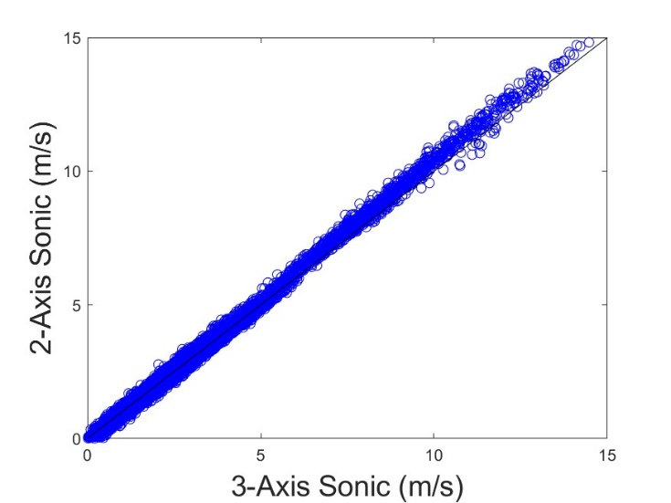

Figure 5‑1 – Comparison between R3-50 (3-Axis Sonic) and Wind Observer (2-Axis Sonic).

Interestingly, the wind speeds measured by the 2-axis sonic is slightly larger than the 3-axis sonic. Comparisons between the OOI instruments (SWND and WND) are not as straight forward as the data stored by the logger and module for the **same sensor** do not always agree. This is shown by the six-panel plot in Figure 5‑2. The propeller-vane module and logger give excellent agreement as would be expect when plotting the same sensor against itself.

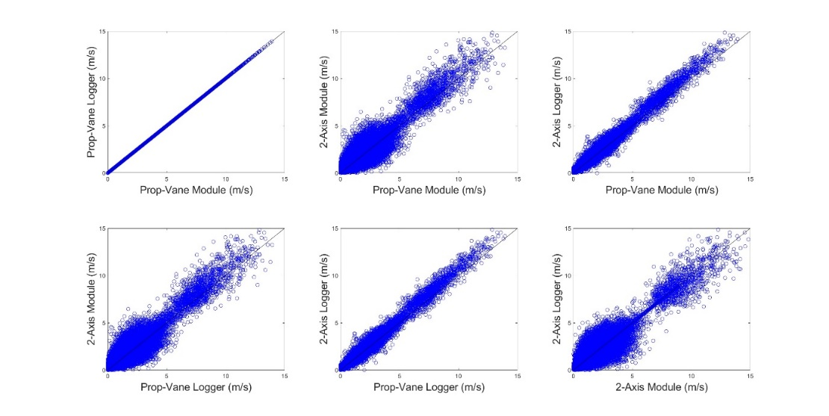

Figure 5‑2 – A comparison of the METBK logger and module results from the 2-axis sonic (SWND) and propeller-vane (WND).

However, the same cannot be said about the 2-axis sonic, which shows a dumbbell-like pattern with good agreement only in the mid-range of wind speeds. A clue as to the cause is found from the fact that the logger and module use two different clocks when determining their time base. A closer examination of the data in Figure 5‑3 shows what can happen when two clocks drift relative to each other. Adjusting one of the clocks relative to the other aligns the time series and provides excellent agreement between the SWND logger and module as would be expected. The adjustment also give better agreement with the WND logger and module.

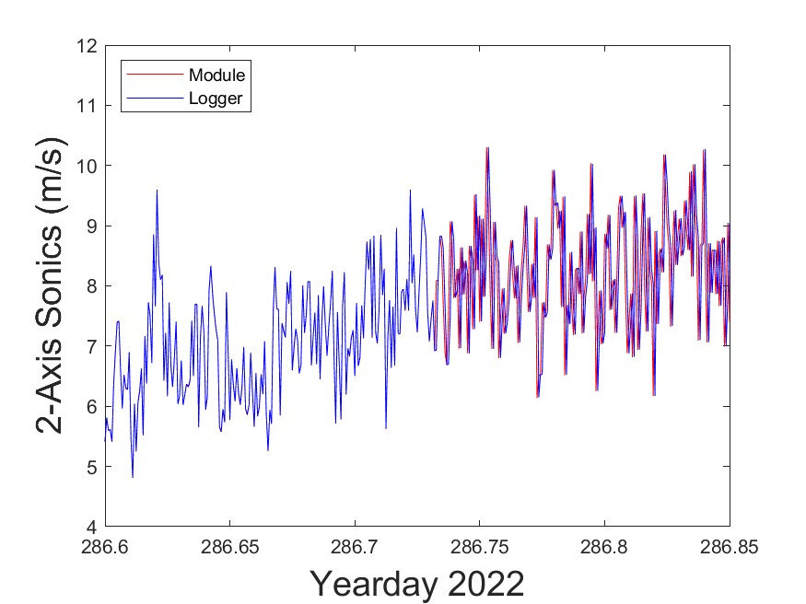

Figure 5‑3 – Time series of the 2-axis sonic wind speed (SWND) from the logger and module, i.e., the data is from the same sensor. The plot shows the time jumping by one time-step of the logger clock relative to the module clock.

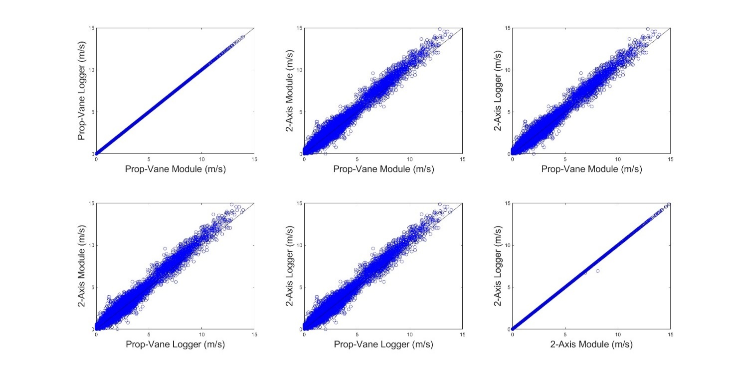

Figure 5‑4 – As in Figure 5-2, but with one of the time-stamps adjusted for drift.

The real purpose of the test, however, is to compare how well the OOI anemometers (WND and SWND) compare with the non-OOI anemometers. One expectation was that the OOI anemometers with processing carried out by the module and logger would give lower values of the wind speed compared with the non-OOI anemometers whose raw data is logged directly into the laptop for processing. Although there are issues with the comparison due to the clock drift, there is no indication of a reduction in wind speed of the OOI anemometers compared to the non-OOI anemometer above 7 m/s as shown in Figure 5‑5. This is clearly shown by Figure 5‑6 where the average of the SWND module and logger results (after adjustment for drift) are compared against the average of the on-OOI 2-D and 3-D sonics. There is no indication of a reduction in wind speed when by the METBK sensors.

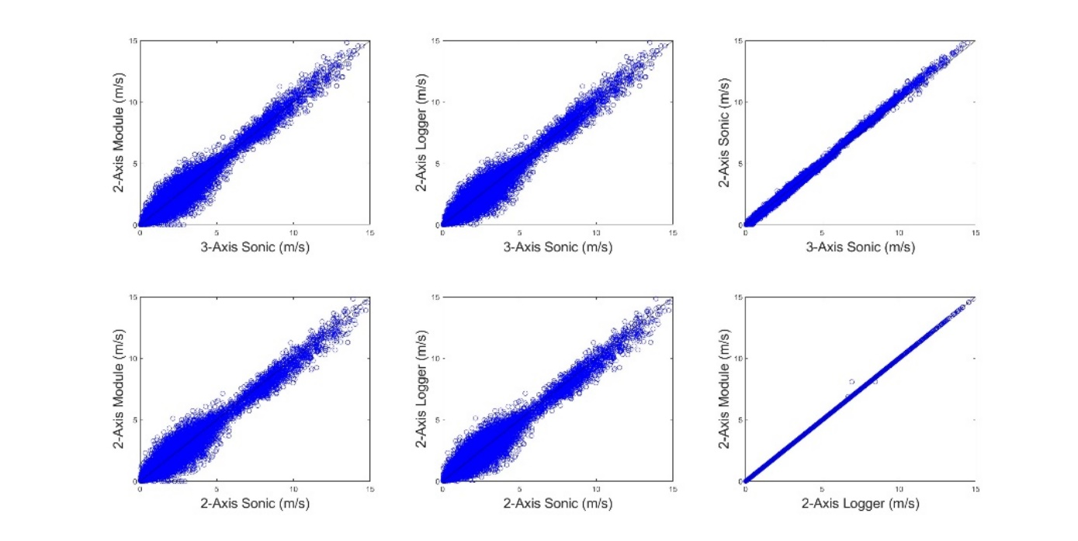

Figure 5‑5 – A comparison of the non-OOI sonic anemometers versus the METBK anemometers. The SWND logger has been corrected for drift.

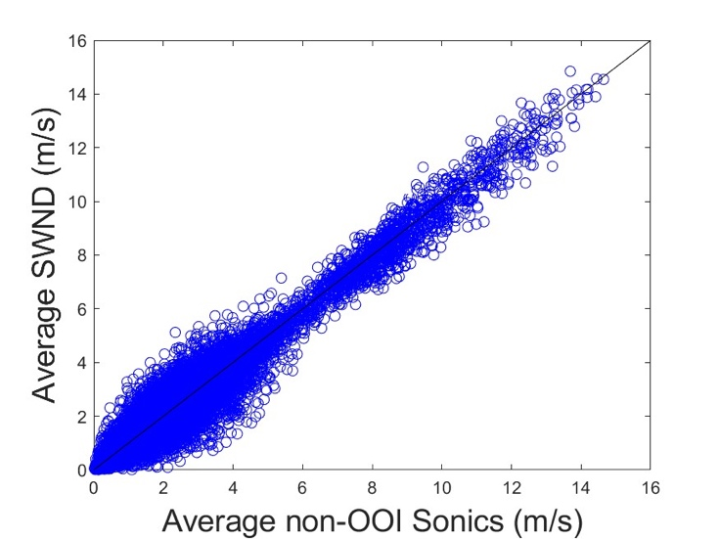

Figure 5‑6 – A comparison of the average of the SWND module and logger results (after adjustment for drift) versus the average of the non-OOI 2-D and 3-D sonics.

## More Clues and Next Steps

One explanation for the inconclusive results from the roof top test is that it was conducted on a stationary platform on the Clark South test area. This is clearly not the case when the METBK sensors are deployed on OOI surface moorings. The moving sensors rely on a compass to correct for heading on the moving platform. The compass is incorporated using a somewhat complicated formulation that may have changed over time. This appears to be borne out by the results shown in Figure 5‑7.

The figure is based on a discovery by the Endurance Array (EA) team at Oregon State University (OSU). They found that the METBK files include estimates of both the vector averaged and scalar averaged wind speeds defined as

where due to gustiness and wave motion. The and components are computed from the 2-axis wind components and a compass. The and components require only the 2-axis wind components. The plots of vector winds versus scalar winds are shown in Figure 5‑7 and tell an interesting story. The two columns on the left are from three deployments at the OOI Southern Ocean and Argentine Basin Arrays. These comparisons show exactly what you would expect, i.e., good agreement between the two estimates with . Although not shown here, comparison with the FDCHP on the Southern Ocean deployments look nearly identical. These two arrays were discontinued early on in the OOI Program and pre-date the results from the two columns on the right. These show three deployments at the Pioneer New England Shelf (NES) and Irminger Sea Arrays. Unlike the earlier deployments in the Southern Ocean and Argentine Basin, these two columns show the same low vector wind speed that we have been addressing in this report. This raises the question “What happened?” between the earlier and more recent deployments. Investigation into possible software and/or hardware changes to instruments deployed at different times and locations is ongoing.

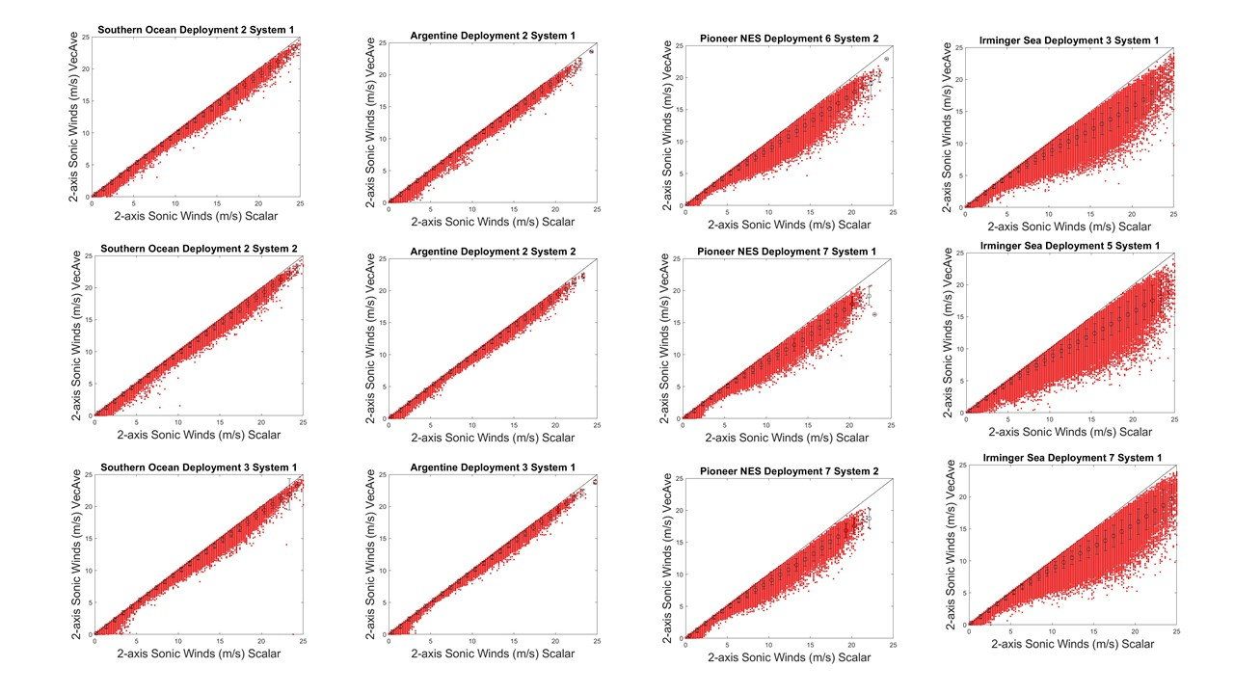

Figure 5‑7 – Plots of vector average winds versus scalar averaged winds. The first and second columns are results from the Southern Ocean and Argentine Basin Arrays. The third and fourth columns are results from the Pioneer and Irminger Sea Arrays.